Seeley's Anatomy and Physiology, 12e (VanPutte)
Chapter 1 The Human Organism

1) Which technique creates a three-dimensional dynamic image of blood vessels?
A) Digital subtraction angiography
B) Magnetic resonance imaging
C) Dynamic spatial reconstruction
D) Positron emission tomography

2) True or False? A CT scan allows for a three-dimensional image to be generated.

3) Magnetic resonance imaging is based on the movement of
A) electrons in a magnetic field.
B) carbons in a magnetic field.
C) protons in a magnetic field.
D) cells in a magnetic field.

4) The delivery of a radioactive compound to the body to study the metabolism of tissues is called ________.
A) MRI
B) PET
C) DSA
D) DSR

5) An anatomical image created from sound waves is a/an ________.
A) radiograph
B) CT scan
C) MRI
D) sonogram

6) A major limitation of radiographs is that they
A) can only visualize bone.
B) give only a flat, two-dimensional image of the body.
C) are old technology that do not give good results.
D) have very few applications.

7) The study of the body's organization by areas is ________.
A) systemic anatomy
B) regional anatomy
C) molecular biology
D) microbiology
E) surface anatomy

8) The study of the external form of the body and its relationship to deeper structures is ________.
A) systemic anatomy
B) regional anatomy
C) molecular biology
D) microbiology
E) surface anatomy

9) The study of tissues is ________.
A) cytology
B) histology
C) molecular biology
D) microbiology
E) surface anatomy

10) Anatomy is
A) the study of function.
B) a branch of physiology.
C) the study of structure.
D) the study of living organisms.
E) the study of homeostasis.

11) The study of the structural features and functions of the cell is ________.
A) cytology
B) histology
C) molecular biology
D) microbiology
E) surface anatomy

12) Microscopic examination of a frozen tissue specimen is an application of which of the following disciplines?
A) Histology
B) Physiology
C) Gross anatomy
D) Radiology
E) Regional anatomy

13) Which subdivision of anatomy involves the study of organs that function together?
A) Regional
B) Developmental
C) Systemic
D) Histology
E) Surface anatomy

14) An investigator who conducts an experiment to determine how changes in pH affect the function of enzymes on digestion is most likely to be a/an ________.
A) neurologist
B) anatomist
C) engineer
D) physiologist
E) histologist

15) An organelle is
A) a small structure within a cell.
B) a structure composed of several tissue types.
C) the basic structural unit of all living organisms.
D) a group of organs with a common set of functions.
E) a group of cells with similar structure and function.

16) An organ is
A) a small structure within a cell.
B) a structure composed of several tissue types.
C) the basic structural unit of all living organisms.
D) a group of molecules with a common set of functions.
E) a group of cells with similar structure and function.

17) A cell is
A) a small structure within a molecule.
B) a structure composed of several tissue types.
C) the basic structural unit of living organisms.
D) a group of organs with a common set of functions.
E) a group of atoms with similar structure and function.

18) A tissue is a
A) structure contained within a cell.
B) lower level of organization than a cell.
C) group of organs that performs specific functions.
D) group of cells with similar structure and function.
E) structure that contains a group of organs.

19) An organ system is
A) a small structure within a cell.
B) a structure composed of several tissue types.
C) the basic structural unit of all living organisms.
D) a group of organs with a common set of functions.
E) a group of cells with similar structure and function.

20) Which of the following systems carries necessary compounds like oxygen and nutrients throughout the body?
A) Nervous
B) Cardiovascular
C) Urinary
D) Lymphatic
E) Respiratory

21) Which organ system is the location of blood cell production?
A) Cardiovascular
B) Skeletal
C) Digestive
D) Nervous
E) Endocrine

22) Which body system would be affected by degeneration of cartilage in joints?
A) Muscular
B) Nervous
C) Cardiovascular
D) Skeletal
E) Lymphatic

23) The gallbladder, liver, and stomach are all part of the ________ system.
A) endocrine
B) cardiovascular
C) skeletal
D) respiratory
E) digestive

24) The integumentary system
A) regulates body temperature.
B) breaks down food into small particles for absorption.
C) controls intellectual functions.
D) produces body movements.
E) coordinates and integrates body function.

25) Which system removes nitrogenous waste products from the blood and regulates blood pH, ion balance, and water balance?
A) Respiratory
B) Lymphatic
C) Cardiovascular
D) Immune
E) Urinary

26) An organism's ability to use energy in order to swim is an example of ________.
A) metabolism
B) responsiveness
C) organization
D) maturation
E) development

27) The changes an organism undergoes through time is called ________.
A) organization
B) metabolism
C) reproduction
D) growth
E) development

28) Nerve cells generate electrical signals in response to changes in the environment. This is an example of ________.
A) respiration
B) digestion
C) movement
D) filtration
E) responsiveness

29) An increase in the number of cells is ________.
A) reproduction
B) growth
C) differentiation
D) metabolism
E) organization

30) Which of the following is most consistent with homeostasis?
A) As blood pressure falls, blood flow to cardiac (heart) muscle decreases.
B) As the mean blood pressure gradually increases in aging people, the blood vessel walls become thinner.
C) Men working in a hot environment drink large quantities of water, and their urine volume increases.
D) As body temperature decreases, blood vessels in the periphery dilate.
E) Elevated blood glucose levels cause insulin secretion to increase, which in turn, causes cells to take up glucose.

31) Which of the following is consistent with homeostasis?
A) As body temperature rises, sweating occurs to cool the body.
B) When a person drinks large quantities of water, urine output decreases to raise blood volume.
C) Elevated blood glucose levels cause insulin secretion to decline.
D) Decreases in blood pressure cause a corresponding decrease in heart rate.
E) As blood pressure falls, blood flow to the heart decreases.

32) In a negative feedback mechanism, the response of the effector
A) reverses the original stimulus.
B) enhances the original stimulus.
C) has no effect on the original stimulus.
D) is usually damaging to the body.
E) creates a cycle that leads away from homeostasis.

33) A researcher discovered a sensory receptor that detects decreasing oxygen concentrations in the blood. According to the principles of negative feedback, it is likely that stimulation of this sensory receptor will produce which of the following types of responses?
A) A decrease in heart rate
B) An increase in the respiratory rate
C) An increase in physical activity
D) Unconsciousness
E) Both a decrease in heart rate and an increase in the respiratory rate will occur.

34) Which of the following is NOT a component of a negative feedback mechanism?
A) Effector
B) Stabilizer
C) Control center
D) Receptor

35) True or False? Positive-feedback mechanisms are always damaging to the body.

36) The anatomical term that means "away from the midline of the body" is ________.
A) medial
B) proximal
C) distal
D) lateral
E) superficial

37) The thumb is ________ to the fifth digit (little finger).
A) distal
B) lateral
C) medial
D) proximal
E) superficial

38) Which of the following describes the position of the nose?
A) Inferior to the chin
B) Superior to the forehead
C) Posterior to the ears
D) Lateral to the eyes
E) Superior to the mouth

39) The shoulder is ________ to the elbow.
A) lateral
B) dorsal
C) distal
D) ventral
E) proximal

40) A term that means "toward the attached end of a limb" is ________.
A) medial
B) lateral
C) superficial
D) distal
E) proximal

41) Which of the following is most inferior in location?
A) Pelvic cavity
B) Mediastinum
C) Diaphragm
D) Pleural cavity
E) Pericardial cavity

42) While Stacy is in the process of passing over the bar during a pole vault, her hips are considered to be
A) anterior to her shoulders.
B) posterior to her shoulders.
C) inferior to her shoulders.
D) superior to her shoulders.
E) cephalic to her shoulders.

43) Cephalic means
A) toward the middle or midline of the body.
B) away from the surface.
C) closer to the head.
D) closer than another structure to the point of attachment to the trunk.
E) toward the back of the body.

44) Posterior means
A) toward the middle or midline of the body.
B) away from the surface.
C) closer to the head.
D) closer than another structure to the point of attachment to the trunk.
E) toward the back of the body.

45) Medial means
A) toward the middle or midline of the body.
B) away from the surface.
C) closer to the head.
D) closer than another structure to the point of attachment to the trunk.
E) toward the back of the body.

46) Proximal means
A) toward the middle or midline of the body.
B) away from the surface.
C) closer to the head.
D) closer than another structure to the point of attachment to the trunk.
E) toward the back of the body.

47) Deep means
A) toward the middle or midline of the body.
B) away from the surface.
C) closer to the head.
D) closer than another structure to the point of attachment to the trunk.
E) toward the back of the body.

48) In the expression "Let your fingers do the walking," which of the following anatomical terms could be substituted for "fingers?"
A) Tarsals
B) Manuals
C) Digits
D) Carpals
E) Metatarsals

49) The anatomical arm refers to the part of the upper limb from the
A) shoulder to the wrist.
B) elbow to the wrist.
C) shoulder to the elbow.
D) elbow to the fingers.
E) shoulder to the fingers.

50) The lumbar region is the
A) area in front of the elbow.
B) chest area.
C) lower back.
D) bottom of foot.
E) forearm.

51) The antecubital region is the
A) area in front of the elbow.
B) chest area.
C) lower back.
D) bottom of foot.
E) forearm.

52) The antebrachial region is the
A) area in front of the elbow.
B) chest area.
C) lower back.
D) bottom of foot.
E) forearm.

53) The pectoral region is the
A) area in front of the elbow.
B) chest area.
C) lower back.
D) bottom of foot.
E) forearm.

54) The plantar surface is the
A) area in front of the elbow.
B) chest area.
C) lower back.
D) bottom of foot.
E) forearm.

55) The brachial region is commonly known as the ________.
A) groin
B) buttock
C) breastbone
D) upper arm
E) navel

56) The inguinal region is commonly known as the ________.
A) groin
B) buttock
C) breastbone
D) upper arm
E) navel

57) The gluteal region is commonly known as the ________.
A) groin
B) buttock
C) breastbone
D) upper arm
E) navel

58) The sternal region is commonly known as the ________.
A) groin
B) buttock
C) breastbone
D) upper arm
E) navel

59) The umbilical region is commonly known as the ________.
A) groin
B) buttock
C) breastbone
D) upper arm
E) navel

60) The cervical region is the ________.
A) calf
B) armpit
C) hollow behind the knee
D) neck
E) thigh

61) The popliteal region is the ________.
A) calf
B) armpit
C) hollow behind the knee
D) neck
E) thigh

62) The sural region is the ________.
A) calf
B) armpit
C) hollow behind the knee
D) neck
E) thigh

63) The femoral region is the ________.
A) calf
B) armpit
C) hollow behind the knee
D) neck
E) thigh

64) The axillary region is the ________.
A) calf
B) armpit
C) hollow behind the knee
D) neck
E) thigh

65) A vertical plane that separates the body into right and left portions is called a ________ plane.
A) sagittal
B) transverse
C) frontal
D) horizontal
E) coronal

66) "Cutting off your nose" would be a section in the ________ plane.
A) coronal
B) nasal
C) median
D) transverse
E) sagittal

67) The cavity of the body immediately inferior to the diaphragm is the ________ cavity.
A) pleural
B) thoracic
C) inguinal
D) pelvic
E) abdominal

68) The suffix "-itis" means inflammation. Which of the following terms means inflammation of the membrane lining the body cavity that contains the liver?
A) Pericarditis
B) Peritonitis
C) Pleurisy
D) Colitis
E) Hepatitis

69) The wall of the abdominopelvic cavity is lined by a serous membrane called the
A) visceral pleural membrane.
B) parietal peritoneum.
C) visceral mediastinal membrane.
D) visceral peritoneum.
E) epicardium.

70) The visceral pleura is
A) a double-layered serous membrane that anchors some of the abdominal organs to the body wall.
B) the serous membrane that covers the lungs.
C) the serous membrane that lines the abdominal and pelvic cavities.
D) the space located between the visceral and parietal pleura.
E) the membrane that lines the pericardial sac.

71) The parietal peritoneum is
A) a double-layered serous membrane that anchors some of the abdominal organs to the body wall.
B) the serous membrane that covers the lungs.
C) the serous membrane that lines the abdominal and pelvic cavities.
D) the space located between the visceral and parietal pleura.
E) the membrane that lines the pericardial sac.

72) The mesentery is
A) a double-layered serous membrane that anchors some of the abdominal organs to the body wall.
B) the serous membrane that covers the lungs.
C) the serous membrane that lines the abdominal and pelvic cavities.
D) the space located between the visceral and parietal pleura.
E) the membrane that lines the pericardial sac.

73) The pleural cavity is
A) a double-layered serous membrane that anchors some of the abdominal organs to the body wall.
B) the serous membrane that covers the lungs.
C) the serous membrane that lines the abdominal and pelvic cavities.
D) the space located between the visceral and parietal pleura.
E) the membrane that lines the pericardial sac.

74) The parietal pericardium is
A) a double-layered serous membrane that anchors some of the abdominal organs to the body wall.
B) the serous membrane that covers the lungs.
C) the serous membrane that lines the abdominal and pelvic cavities.
D) the space located between the visceral and parietal pleura.
E) the membrane that lines the pericardial sac.

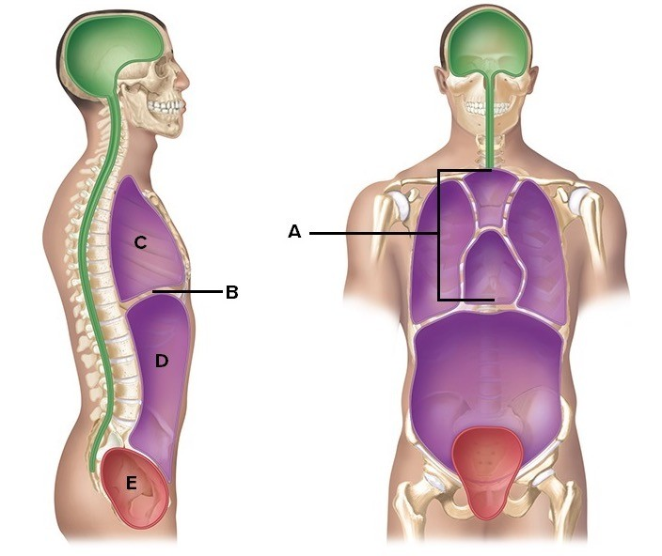

75) Here is a figure showing major body cavities and other structures. What does "A" represent?
A) Diaphragm
B) Mediastinum
C) Pelvic cavity
D) Thoracic cavity
E) Abdominal cavity

76) Here is a figure showing major body cavities and other structures. What does "B" represent?
A) Diaphragm
B) Mediastinum
C) Pelvic cavity
D) Thoracic cavity
E) Abdominal cavity

77) Here is a figure showing major body cavities and other structures. What does "C" represent?
A) Diaphragm
B) Mediastinum
C) Pelvic cavity
D) Thoracic cavity
E) Abdominal cavity

78) Here is a figure showing major body cavities and other structures. What does "D" represent?
A) Diaphragm
B) Mediastinum
C) Pelvic cavity
D) Thoracic cavity
E) Abdominal cavity

79) Here is a figure showing major body cavities and other structures. What does "E" represent?
A) Diaphragm
B) Mediastinum
C) Pelvic cavity
D) Thoracic cavity
E) Abdominal cavity

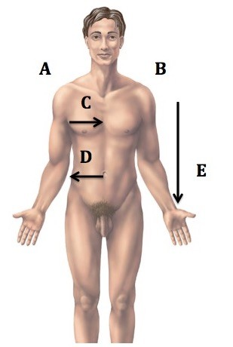

80) Directional terms are important in the study of anatomy. What does "A" represent?
A) Median
B) Right
C) Left
D) Inferior
E) Lateral

81) Directional terms are important in the study of anatomy. What does "B" represent?
A) Median
B) Right
C) Left
D) Inferior
E) Lateral

82) Directional terms are important in the study of anatomy. What does "C" represent?
A) Median
B) Right
C) Left
D) Inferior
E) Lateral

83) Directional terms are important in the study of anatomy. What does "D" represent?
A) Median
B) Right
C) Left
D) Inferior
E) Lateral

84) Directional terms are important in the study of anatomy. What does "E" represent?
A) Median
B) Right
C) Left
D) Inferior
E) Lateral

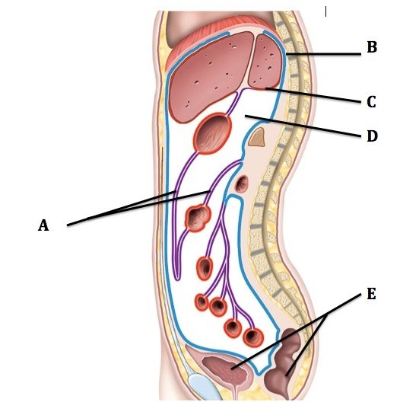

85) This is a sagittal section through the abdominopelvic cavity. What structure does "A" represent?
A) Visceral peritoneum (covers organs)
B) Mesentery
C) Parietal peritoneum (lines cavity)
D) Retroperitoneal organs
E) Peritoneal cavity

86) This is a sagittal section through the abdominopelvic cavity. What serous membrane does "B" represent?
A) Visceral peritoneum (covers organs)
B) Mesentery
C) Parietal peritoneum (lines cavity)
D) Retroperitoneal organs
E) Peritoneal cavity

87) This is a sagittal section through the abdominopelvic cavity. What serous membrane does "C" represent?
A) Visceral peritoneum (covers organs)
B) Mesentery
C) Parietal peritoneum (lines cavity)
D) Retroperitoneal organs
E) Peritoneal cavity

88) This is a sagittal section through the abdominopelvic cavity. What cavity does "D" represent?
A) Visceral peritoneum (covers organs)
B) Mesentery
C) Parietal peritoneum (lines cavity)
D) Retroperitoneal organs
E) Peritoneal cavity

89) This is a sagittal section through the abdominopelvic cavity. What structures does "E" represent?
A) Visceral peritoneum (covers organs)
B) Mesentery
C) Parietal peritoneum (lines cavity)
D) Retroperitoneal organs
E) Peritoneal cavity

90) Which branch of physiology would study the effects of sunbathing on the skin?
A) Cell physiology
B) Systemic physiology
C) Regional physiology
D) Organ physiology

91) True or False? The part of the feedback mechanism that processes information, relates it to other information, and makes a decision of action is the receptor.

92) Which of the following is not a function of the control center within a feedback mechanism?
A) Receives and processes information
B) Controls effectors
C) Establishes a set point
D) Detects a change in the value of a variable

93) In reference to the body temperature in living organisms, the set point can be defined as the
A) ideal normal value.
B) current specific value.
C) amount of change that must occur for a condition to return to ideal normal value.

94) Which of the following is not a characteristic of homeostatic variables?
A) Their values can change.
B) They must remain within a narrow change.
C) They always remain at a fixed value.

95) True or False? The control center compares input from a receptor with the ideal normal value for a condition called a set point.

96) Imagine the following scenario:

Blood pressure decreases below normal levels.→ Blood flow to the heart decreases → Heart is unable to pump as much blood.→ Blood pressure decreases even more.

This is an example of ________ feedback.
A) positive
B) negative

97) This figure illustrates changes in blood pressure when ________ feedback mechanisms are in control.

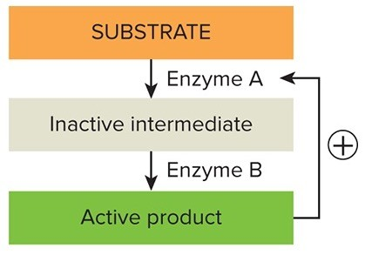
A) positive
B) negative

98) Imagine the following scenario:

Platelets adhere to a damaged blood vessel → Platelets secrete various substances → Platelets adhere to a damaged blood vessel

This is an example of ________ feedback.
A) positive
B) negative

99) True or False? Positive feedback mechanisms are more commonly seen in ________ individuals.
A) healthy
B) unhealthy

100) True or False? Positive feedback mechanisms are less common in healthy individuals than negative feedback mechanisms.

101) A person lying with his/her face down is said to be in what position?
A) Supine
B) Prone
C) Anatomical
D) Reverse

102) Which of the following is not a term that describes a cut that separates the body into left and right portions?
A) Sagittal
B) Median
C) Parasagittal
D) Coronal

103) The plane that cuts the body lengthwise and separates the body into anterior and posterior portions is called ________.
A) Transverse
B) Frontal
C) Sagittal

104) True or False? Whereas a 'plane' describes an imaginary flat surface, a 'section' describes a way to cut an organ.

105) A cut through the long axis of an organ is a/an ________ section.
A) longitudinal
B) oblique
C) transverse

106) True or False? The thoracic cavity is divided into right and left parts by a median partition called the sternum.

107) True or False? Both the spleen and the urinary bladder are contained within the pelvic cavity subdivision of the abdominopelvic cavity.

108) True or False? The kidneys are contained within the pelvic cavity subdivision of the abdominopelvic cavity.

109) An example of a structure contained by the mediastinum is the ________.
A) brain
B) stomach
C) esophagus
D) sternum
E) lung

110) True or False? Scientists believe that any significant change in the composition of the microbiome of the human integumentary system may increase a person's susceptibility to autoimmune diseases.

111) True or False? It has been suggested by some scientists that early exposure to antibiotics that significantly change the makeup of the microbes in the human intestines may increase a person's susceptibility to autoimmune diseases like Crohn's disease and asthma.

112) There are more microbial cells than human cells in your body, and the health of this microbiota clearly influences human well-being. How many microbes are there?
A) For every cell in your body, there are ten microbial cells.
B) For every cell in your body, there are one hundred microbial cells.
C) For every cell in your body, there are one thousand microbial cells.
D) For every cell in your body, there are ten thousand microbial cells.

113) A molecular biologist discovers that if a specific drug effectively treats obesity in mice, what can researchers conclude?
A) If the drug was effective in a large number of mice, it will therefore be effective in humans.
B) If the drug was effective in a small proportion of mice, it will be effective in a small proportion of humans.
C) The mice have provided a positive control in this experiment that proves the drug is effective in humans.
D) The drug is effective in the mouse model; it must still be tested in humans.
E) The effect of the drug on mice has no bearing on the effect of the drug on humans.

114) With regard to the validity of biomedical research in physiological studies, which statement is correct?
A) Although the general homeostatic mechanisms may be the same in some animal species, the individual variables are often very different.
B) Although the individual variables may be the same in some animal species, the general homeostatic mechanisms are often very different.

115) True or False? Many undergraduate anatomy programs study cats and rats in laboratory settings. Use of these animals is ideal because they are inexpensive, and although they are physically smaller, the internal structures are identical to humans.

116) True or False? With regard to biomedical research, because rats, pigs, apes, and other mammals share over 90% of the same genes as humans, these animals are always good predictors for how humans will respond to a specific drug therapy.

117) True or False? With regard to biomedical research, it has been found that drugs that are toxic to one mammal species will be toxic to another mammal species.

118) True or False? Rats and humans share over 90% of the same genes.

119) Which of the following statements is TRUE?
A) The coordinated activity of the organ systems is necessary for normal function.
B) Because organ systems are so interrelated, dysfunction in one organ system can have profound effects on other systems.
C) An organism is any living thing considered as a whole, whether composed of one cell, such as a bacteria, or trillions of cells, such as a human.
D) Living things are highly organized, and disruption of this organized state can lead to loss of function and death.
E) All of these statements are true.

120) True or False? A molecule of water is more complex than a mitochondrion (organelle).

121) True or False? Homeostasis and occupying space are both unique characteristics of living things.

122) Which of the following lists examples of body structures from the simplest to the most complex?
A) Mitochondrion, connective tissue, protein, stomach, adipocyte (fat cell)
B) Protein, mitochondrion, adipocyte (fat cell), connective tissue, stomach
C) Mitochondrion, connective tissue, stomach, protein, adipocyte (fat cell)
D) Protein, adipocyte (fat cell), stomach, connective tissue, mitochondrion
E) Protein, stomach, connective tissue, adipocyte (fat cell), mitochondrion

123) The fact that most of us have five lumbar vertebrae, but some people have six and some have four, is an example of ________ variation among organisms.
A) cellular
B) holistic
C) physiological
D) anatomical
E) reductionist

124) During exercise, one generates excess heat and the body temperature rises. As a response, blood vessels dilate in the skin, warm blood flows closer to the body surface, and heat is lost. This is an example of ________.
A) negative feedback
B) positive feedback
C) dynamic equilibrium
D) integration control
E) set point adjustment

125) When a woman is giving birth, the head of the baby pushes against her cervix and stimulates the release of the hormone oxytocin. Oxytocin travels in the blood and stimulates the uterus to contract. Labor contractions become more and more intense until the baby is expelled. This is an example of ________.
A) negative feedback
B) positive feedback
C) dynamic equilibrium
D) integration control
E) set point adjustment

126) Blood glucose concentration rises after a meal and stimulates the pancreas to release the hormone insulin. Insulin travels in the blood and stimulates the uptake of glucose by body cells from the bloodstream, thus reducing blood glucose concentration. This is an example of ________.
A) negative feedback
B) positive feedback
C) dynamic equilibrium
D) integration control
E) set point adjustment

127) The change in size of the bone marrow (where blood cells are produced) as an infant matures is an example of ________, whereas the transformation of blood stem cells into white blood cells is an example of ________.
A) development; differentiation
B) growth; development
C) growth; differentiation
D) differentiation; growth
E) differentiation; development

128) Which of the following statements provides an accurate description of cellular physiology involving structures of the digestive system?
A) Hepatocytes (liver cells) produce bile to aid in the breakdown of ingested lipids.
B) Hemocytoblasts (blood stem cells) are located in the red bone marrow.
C) Cardiac muscle cells contract to generate pressure that moves the blood through blood vessels.
D) The epidermis, the superficial layer of the skin, is composed of multiple layers of cells.

129) If the thoracic cavity was cut along the midsaggital plane, which of the following descriptions of the two halves would be accurate?
A) The midsaggital cut would create an anterior half that contained portions of the lungs and heart and a posterior half that contained the spinal cord.
B) The midsagittal plane would produce a medial half and a lateral half, each containing a lung.
C) The midsagittal plane would produce a right half that contained one lung and a left half that contained a lung and most of the heart.
D) The midsagittal plane would produce an inferior half that contained portions of the heart and portions of both lungs and a superior half that contained portions of the lungs and the thymus.

130) Aldosterone is a hormone that increase the level of Na+ in the blood. Considering negative-feedback regulation of blood Na+ levels, which of the following events would most likely be an effect of aldosterone on the body in blood Na+ levels decreased?
A) Aldosterone would cause a decrease in the amount of Na+ that was excreted as part of urine.
B) Aldosterone would cause an increase in the amount of Na+ that was excreted as part of urine.
C) Aldosterone would reduce activity in the brain that stimulated salty food cravings.
D) Aldosterone would decrease the amount of Na+ that is absorbed at the small intestine.

131) Which structure is located inferior and lateral to the heart?
A) Liver
B) Brain
C) Urinary bladder
D) Lung

132) Which of the following structures is located in the right-lower quadrant but NOT in the right iliac region?
A) Urinary bladder
B) Appendix
C) Large intestine
D) All of the listed organs are in both the right-lower quadrant and the right iliac region.

133) A construction worker was injured when a metal rod penetrated his abdominal wall inferior to his umbilicus and in the hypogastric region. The rod passed through to the lumbar region. Which of the following structures was most likely damaged?
A) Urinary bladder
B) Stomach
C) Kidney
D) Liver

134) Parathyroid hormone functions to increase calcium ion levels in blood. If its secretion is regulated through negative feedback, under which conditions would this hormone normally be released?
A) Parathyroid hormone secretion occurs when blood calcium levels are too low.
B) Parathyroid hormone secretion occurs when blood calcium levels are too high.
C) Parathyroid secretion is constant to maintain blood calcium levels.
D) Parathyroid hormone secretion increases in the morning and decreases in the afternoon.

135) Which of the following statements provides an example of responsiveness?
A) Sandra began to shiver while she walked from her lab to her dorm room, through the freezing rain.
B) James finally saw the results of working out as the sleeves on his t-shirt were tighter around his biceps.
C) Jarrod was happy to see that the wound he received from falling on the sidewalk was almost completely healed.
D) None of the choices are correct.

136) Which of the following would indicate dysfunction of the respiratory system?
A) Change in blood pH
B) Increase in blood glucose levels
C) Increased blood pressure
D) All of the choices are correct.

137) Which of the following statements best describes research focused on the physiology of the lymphatic system?
A) Dr. Ali studies the signaling that occurs between defense cells and abnormal cells of the body.
B) Dr. Johnson's research focuses on the factors that regulate blood pH.
C) Dr. Salak is interested in the chemical signaling that maintains normal blood glucose levels.
D) Dr. Woods is interested in the development of cell communication junctions associated with memory.

138) If the esophagus were cut from superior to inferior, as it occurs in the thoracic cavity, this would be considered a ________ section.
A) longitudinal
B) transverse
C) oblique
D) cross

139) A cut along which plane would result in the anterior perspective of the body appearing normal, with no evident cuts?
A) Frontal
B) Midsaggital
C) Parasagittal
D) Transverse

140) Which of the following structures is most like the receptor of a homeostatic control mechanism?
A) The mechanism that detects a decrease in tire pressure on an automobile
B) The mechanism that opens the automatic door at the local grocery store
C) The heating element of a hot water heater
D) All of the choices are correct.

