Chapter 1: Payroll Practices and System Fundamentals

Instructor notes
This chapter provides an overview of contemporary payroll practices. The emphasis is on understanding the foundations of the payroll system within the GAAP framework of the United States. Students will explore the evolution of the payroll system over time, legal framework of payroll-related legislation, best practices, and employee classifications. The difference between employees and independent contractors is covered.

When you start this chapter, it would be a good idea to check students’ background knowledge and to stimulate initial discussions. Some sample questions include the following:

- How many students have held a job outside the home?
- What laws affect the workplace?
- What is the purpose of income tax?
- What laws protect employees?

Sample Syllabus

CLASS NUMBER AND NAME: PAYROLL ACCOUNTING
TOTAL CLOCK HOURS / UNITS: XX Hours/ X Units
PREREQUISITES:

TEXTS AND MATERIALS: Landin, J. & Schirmer, P. (2020). Payroll Accounting (6th ed.). New York, NY: McGraw-Hill.
CLASS DESCRIPTION: Basic theory of payroll accounting for a professional enterprise.
STUDENT LEARNING OBJECTIVES: 1. To understand the foundations of U.S. payroll accounting.
2. To calculate employees’ earnings and deductions.
3. To calculate employer payroll taxes.
4. To understand the role of accounting within the framework of a business
5. To explain the role of fringe benefits as a part of employee compensation
6. To complete the payroll process of accounting for employee earnings and employer taxes on the appropriate state and federal tax returns.
7. To complete the accounting entries for the payroll cycle.

CLASS FORMAT OVERVIEW: The material will be presented in a lecture-discussion
format. Assigned work will be completed through Connect Accounting.

REQUIREMENTS: All assigned work must be turned in on the designated day. The student will be given credit for satisfactorily completing work. A numerical grade will be given for work turned in.

TESTING AND FINAL GRADE: Tests must be taken on the scheduled day. If the student misses the regularly scheduled test, a make-up test will be administered with a penalty assessed. Exceptions may be made at the instructor’s discretion.

The final grade for the class will be the average of the chapter tests, homework submissions, and the comprehensive project.

GRADING POLICIES:
Grade | A | A- | B+ | B | B- | C+ | C | C- | D+ | D | D- | F
Percentage | 95+ | 90-94 | 87-89 | 84-86 | 80-83 | 77-79 | 74-76 | 70-73 | 67-69 | 64-66 | 60-63 | <60

ANTICIPATED LEARNING
OUTCOMES: 1. Calculate employee earnings based on an hourly, piece-rate, or commission basis.
2. Determine the payroll deductions for FICA taxes and Federal and State income taxes.
3. Complete a payroll register.
4. Journalize the payroll entries from a payroll register.
5. Maintain employees’ individual earnings records.
6. Compute the monetary value of fringe benefits
7. Calculate the amount of employer’s payroll tax expense and journalize the related entries.
8. Complete employer-related Federal tax forms.
9. Complete a comprehensive project that demonstrates the student’s knowledge of the payroll cycle.
10. Explain the role of payroll accounting within the scope of a firm’s operations.

Vocabulary Definitions
ADA | The Americans with Disabilities Act of 1990
ADAAA | The Americans with Disabilities Act Amendments Act of 2008, which extended the definition of disabilities.
ADEA | The Age Discrimination in Employment Act of 1967
ARRA | The American Reinvestment and Recovery Act of 2009
ATRA | The American Taxpayer Relief Act of 2012.
Certified Payroll | A way that the Federal government keeps track of the money spent as part of government contracts, facilitates governmental internal accountability, and verifies requirements under Davis-Bacon are met
Circular E | See Publication 15
Civil Rights Act of 1964 | Federal legislation that protects employees from discrimination based on race, color, religion, sex, or national origin.
Civil Rights Act of 1991 | Federal law that instituted monetary penalties for companies found guilty of discrimination as described under the Civil Rights Act of 1964.
COBRA | The Consolidated Omnibus Budget Reformation Act of 1986
Copeland Anti-Kickback Act | Protected taxpayers from unethical pay practices for construction projects
Current Tax Payment Act | Created the requirement for the submission of estimated taxes on wages earned during the year of earning
Davis-Bacon Act | Created a standard of wages for governmental contracts over $2,000
DOMA | The Defense of Marriage Act of 1996, which was repealed in 2013.
Due Care | The caution that a reasonable person would exercise to avoid being charged with negligence.
EEOC | Equal Employment Opportunity Commission
Equal Pay Act of 1963 | Federal legislation mandating that males and females receive equal compensation for comparable work.
ERISA | The Employee Retirement Income Security Act of 1974
Ethics | An individual’s definition of right and wrong.
FICA | Federal Insurance Contribution Act
FLSA | Fair Labor Standards Act
FMLA | The Family and Medical Leave Act of 1993
FUTA | Federal Unemployment Tax Act
HIPAA | The Health Insurance Portability and Accountability Act of 1996
Independence | The ability of an accountant to act professionally without external pressures that would cause a third party to question the integrity of actions and decisions.
Independent Contractor | An individual who contracts to do work for a firm using his or her own tools and processes without being subject to direction by a firm’s management.
Integrity | Possessing honesty and high moral principles.
IRCA | The Immigration Reform and Control Act of 1986
Lilly Ledbetter Fair Pay Act of 2009 | Removed the statute of limitations on claims of unequal pay for work that is substantially the same.
Medicare tax | A government-mandated health insurance for individuals over 62 years of age
OASDI | Old-Age, Survivors, and Disability Insurance; synonymous with Social Security.
Objectivity | Making decisions that are free from bias or subjectivity.
OSHA | The Occupational Safety and Health Act of 1970
Personal Responsibility, Work and Family Promotion Act of 2002 | Strengthened child support provisions of PRWOR.
Privacy Act of 1974 | Protected sensitive information like personnel records containing information about an individual’s marital status, children, other dependents, and legal residence
PRWOR | The Personal Responsibility and Work Opportunity Reconciliation Act of 1996
Public Interest | A process reflecting the transparency and public accountability of accounting records.
Sixteenth Amendment to the U.S. Constitution | Allowed the United States government to levy and collect income taxes on individuals.
Social Security Act | An Act that was passed to promote social welfare for old-age workers and surviving families of workers who had been disabled or deceased in the course of their employment.
SOX | The Sarbanes-Oxley Act of 2002
SUTA | State Unemployment Tax Act
Tax Cuts and Jobs Act | An Act to provide budget resolution that represented changes to individual and business tax rates.
USERRA | The Uniformed Services Employment and Reemployment Rights Act of 1994.
VPN | Virtual private network
Walsh-Healey Public Contracts Act | Affected governmental contractors providing goods or services over $10,000
Worker’s Compensation | An insurance policy carried by employers to provide wage continuation and to pay for medical services for workers injured in the course of doing business

Answers to Review Questions
1. To ensure that a firm maintains compliance with payroll laws
2. Large companies may have more internal layers and geographic locations than small companies, may have large employee pools, will have more complex payroll system than small companies.
3. Certified payroll is a way that the Federal government keeps track of the money spent as part of government contracts, facilitates governmental internal accountability, and verifies requirements under Davis-Bacon are met. Not all companies use it because not all companies are subject to Davis-Bacon regulation
4. Employees can manage their own W-4 changes, view payroll records, and obtain a copy of their W-2. A pitfall is that an electronic system is vulnerable to computer hacking.
5. Company oversight and verification of payroll activities, maintenance of accurate payroll records, security of sensitive information
6. Payroll outsourcing involves the use of an external company to maintain payroll activities. A company may consider outsourcing if they do not have a dedicated payroll accountant or have a complex payroll structure
7. FLSA, FICA, FUTA, SUTA, Civil Rights Acts, etc.
8. Computerized payroll and manual payroll
9. 16th Amendment and FICA
10. Wage and hour provisions, overtime provisions
11. It was important because was a social care program. It provided insurance for families of workers.
12. Security, accuracy, timeliness of payroll, timeliness and accuracy in governmental reporting
13. The Affordable Care Act of 2010
14. Employee access to their payroll records, automatic updating of payroll tax rates and computations, employer access to payroll records.
15. The I-9 is a mandatory form to confirm an employee’s eligibility to work in the United State. E-Verify is a voluntary internet-based system that allows employers to obtain information rapidly about an employee’s right to work in the United States. The I-9 does not require the use of the employee’s Social Security number, while the E-Verify system does.

Additional Exercises for Class Discussion
1. Chloe is the costume director for a theater production company. She does not supervise employees and is expected to work 40 hours each week. She determines her own hours and consults with the production manager about her work. Should she be considered an exempt or nonexempt employee? Why?
Answer: Exempt. She controls the scope of her work and her working hours, and oversight is done in consultation with the production manager.

2. Eduardo is a departmental manager at a local amusement park. He hires high school students to work during the summer. What are some legalities that he must observe for these seasonal workers?
Answer: He needs to consider the amount of hours worked per day because of full-time and part-time FLSA guidance, he needs to ensure that employees are taking appropriate breaks, and he needs to make sure that health insurance offerings are in line with the Affordable Care Act legislation.

3. Ya-Ya is the payroll accountant for a firm that has recently opened locations in additional states. With the addition of the new locations, the firm will have approximately 50 employees. Should she outsource her payroll? What are some payroll concerns that she should consider?
Answer: She should consider outsourcing her payroll. Expanding to other states means that she will have additional state tax regulations and new Federal forms to file. She will also have more employees on her payroll, which means increased complexity in her payroll responsibilities.

Critical Thinking Answers
1. Document each instance of the incorrect payments and submit your findings to the firm. Student rationale may vary.

2. The costs involved with outsourcing versus the costs of maintaining the payroll internally.

In the Real World—Guidelines for Discussion
Students should discuss the employer’s responsibility for payroll software in terms of privacy of personal and confidential information. The idea of being a joint employer could lead to a discussion of shared information and privacy laws. The concepts of minimum wage and other pay issues mentioned in the case as they relate to federal and state laws would also be an important consideration. A discussion of payroll software and legal compliance with privacy laws could lead to enhanced student learning.

Activities
Assign students to work individually or in small groups to explore the following websites:

www.jstor.com
www.americanpayroll.org
www.dol.gov/whd
www.taxhistory.com/1943.html
www.workerscompensationinsurance.com
www.Kronos.com
www.adp.com
www.paychex.com

What were the references to payroll legislation that they found?
What did they learn about outsourcing payroll?
What did they notice about workers compensation?

Other classroom activities:

- Using the information found in Appendix F, invite students to investigate state payroll tax requirements for their home state and for one other state. What are some similarities and differences between the two states?
- Have students form teams of 2-4 people. Tell them that they have formed a new business. What form(s) do they need to file immediately before hiring employees? What other decisions should they consider?

A video to assist in the explanation of FLSA coverage is located at https://www.dol.gov/whd/flsa/videos.htm

Continuing Payroll Project

Completion instructions:

Line 1: Enter the legal name of the business, Prevosti Farms and Sugarhouse
Line 2: Leave blank
Line 3: Leave blank
Line 4a: Enter mailing address for the business, 820 Westminster Road
Line 4b: Enter the city/state/zip, Bridgewater, VT 05520
Lines 5a and 5b: Leave blank
Line 6: Enter the county and state, Windsor County VT
Line 7a: Name of the responsible party, Toni Prevosti
Line 7b: Responsible party’s SSN, ITIN, or EIN, 055-22-0443
Line 8a: Is the application for an LLC, check Yes
Line 8b: Leave blank
Line 8c: Check Yes
Line 9a: Type of entity, check the box next to Other and enter LLC
Line 9b: Leave blank
Line 10: Reason for applying, check the box next to Hired Employees
Line 11: Date business started, 2/1/2020
Line 12: Closing month of accounting year, December
Line 13: Highest number of employees in the next 12 months, Agricultural – 3, Other – 3
Line 14: leave blank
Line 15: First date wages or annuities were paid, enter 02/13/2020
Line 16: Principal activity of business, check Other and enter Harvesting, refining, and selling maple items
Line 17: Principal line of merchandise sold, Harvesting, refining, and selling maple syrup
Line 18: Has the applicant shown on line 1 ever applied for and received an EIN, check No
Enter name of owner (Toni Prevosti) and phone number, 802-555-3456

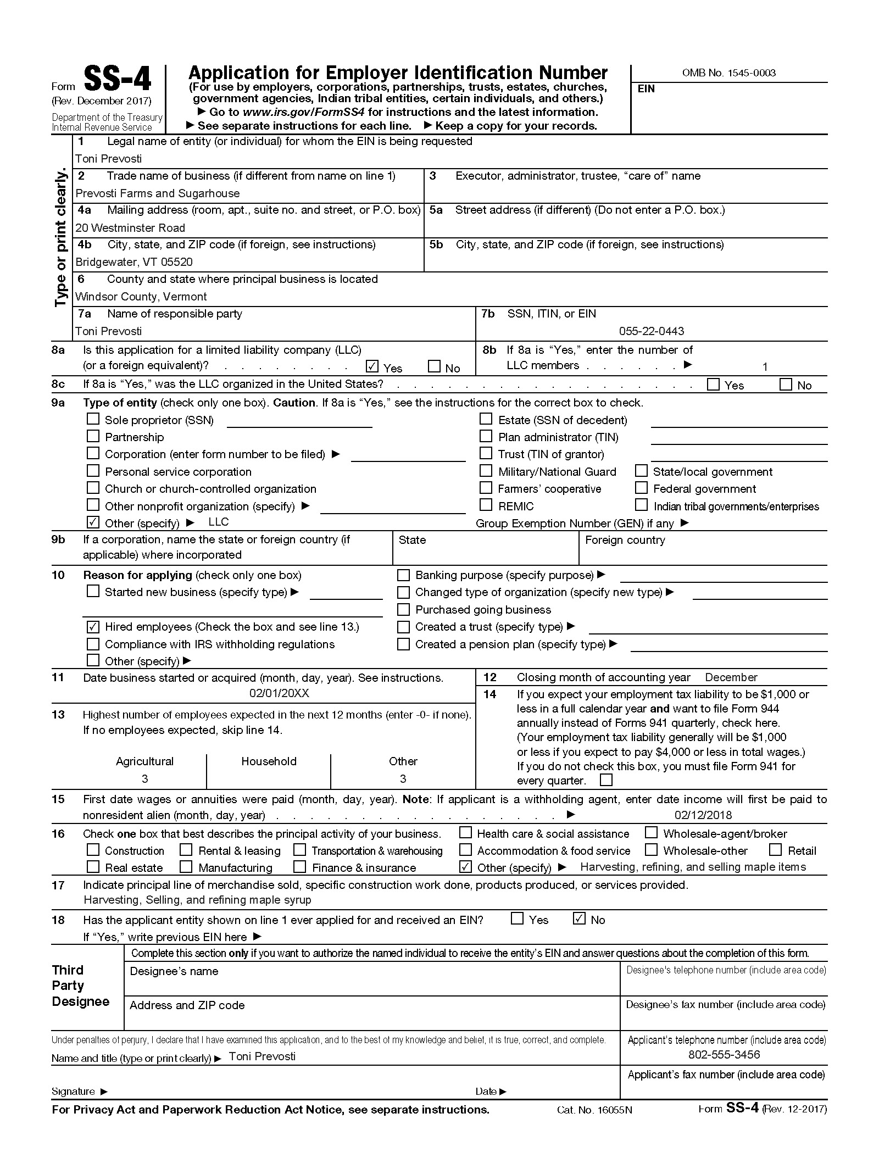
x

