CHAPTER 1 LABS – KEY

(Level 1 Header) Lab 1-0 How to complete labs in this book
Instructor information: This lab is very simple, and exists to help students familiarize themselves with the format of labs and with how to take a screenshot and paste it into a Word Document. This key contains only the screenshots that will be similar to what a student may come up with while completing this lab.

Part 1: Create a new Word document on OneDrive

No Key

Part 2: Take a screenshot of your document
Key screenshot:

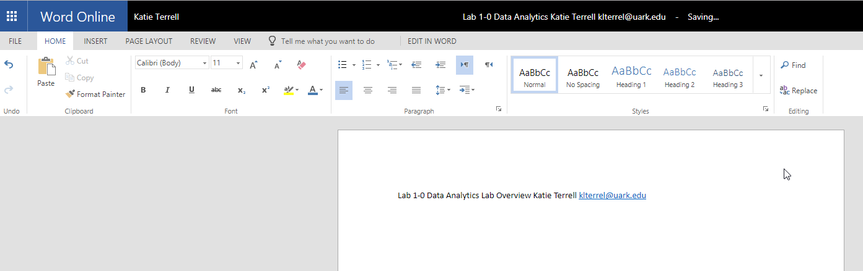

Part 3: Add another screenshot and submit your document
Key screenshot:

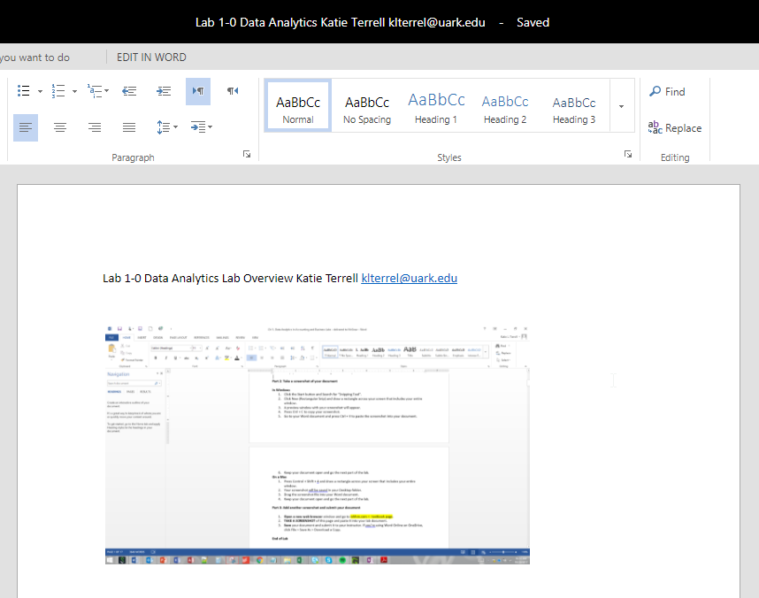
End of Lab
(Level 1 Header) Lab 1-1 Data Analytics in Financial Accounting

Because every question in this lab is open-ended, there is no key provided.

Example solution:
Part 1: Has [Company X’s] gross margin increased in the last three years?
Part 2:
- Apple Inc.’s gross margin has increased slightly in the past three years.
- Company Name = EntitySectorIndustryClassificationPrimary
Gross Margin = GrossProfit
Sales Revenues = SalesRevenueNet
Cost of Goods Sold = CostOfGoodsAndServicesSold
Year = DocumentPeriodEndDate
Part 3:
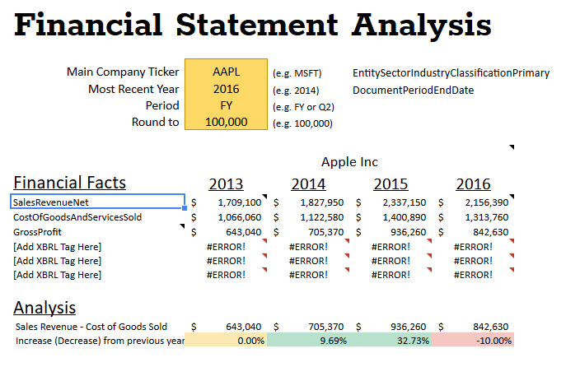
Example Solutions
Part 1: Questions | Part 2: Hypothesized Answer | Part 2:  Tables/Fields/Tags | Other data:
Has [Company X's] current ratio increased over the past four years? | Target's current ratio has increased slightly over the past five years | Company Name=EntitySectorIndustryClassificationPrimary  Current Assets=AssetsCurrent  Current Liabilities=LiabilitiesCurrent  Year=DocumentPeriodEndDate | None
What was [Company X's] rate of increase/decrease of gross profit this past year? | Target's gross profit increased by 3% this past year | Company Name=EntitySectorIndustryClassificationPrimary  Net Income=NetIncomeLoss  Total Assets=Assets  Year=DocumentPeriodEndDate | None
Has [Company X's] debt-to-equity ratio decreased over the past four years? | Target's debt-to-equity ratio has increased over the past 5 years | Company Name=EntitySectorIndustryClassificationPrimary  Total Liabilities=Liabilities  Stockholder's Equity=StockholdersEquity  Year=DocumentPeriodEndDate | None

While these labs should remain open-ended in the textbook, we can guide students a bit in Connect:

Possible Connect Exercises:
Part 1 (Given): How has Apple Inc.’s gross margin changed in the past three years?

Part 2:
- Select an appropriate hypothesized answer to the question above from the list:
- [Correct] Apple Inc.’s gross margin increased by 3% in the past three years.
- Apple Inc.’s revenues declined in the past three years.
- Apple Inc.’s net income as a percentage of sales remained constant in the past three years.
- Apple Inc.’s new product has had a positive impact on sales.

- (If possible, an interesting Connect activity would be to show the original question with drop-down lists and have students select the variables)
e.g. How has [Apple Inc.’s | Company Name] [gross margin | (Sales – Cost of Goods Sold)/Sales ] [changed | Y2/Y1] in the past three [years | Year]?
Distracters:
Company Name
Sales Revenue
Cost of Goods Sold
Sales - Cost of Goods Sold
(Sales - Cost of Goods Sold)/Sales
Year
Industry
Y2/Y1
%

Match data elements from the previous question to XBRL tags that would provide data to answer the question from Part 1. If the data element requires a calculation, choose “Expression”
Company Name = EntitySectorIndustryClassificationPrimary
Gross Margin = Expression
Sales Revenues = SalesRevenueNet
Cost of Goods Sold = CostOfGoodsAndServicesSold
Change = Expression
Year = DocumentPeriodEndDate
Distracters:
Expression
GrossProfit
EntitySectorIndustryClassificationPrimary
SalesRevenueNet
CostOfGoodsAndServicesSold
DocumentPeriodEndDate
ProfitLoss
Part 3: (Currently a live Google Sheet. We could possibly simulate in Connect as a spreadsheet with Apple data. In this case, a student would enter a tag from the previous step and in the background a VLOOKUP could return the data value. Thoughts?)

(Level 1 Header) Lab 1-2 Data Analytics in Managerial Accounting

Because every question in this lab is open-ended, there is no key provided.

Example solution:
Part 1:
2. Where does the customer live?
3. Hypothesis: risky customers likely live in coastal towns.
4. City, state, zip code

Part 2:
- Zip_code, addr_state

Example Solutions
Part 1: Questions | Part 2: Hypothesized Answer | Part 2:  Tables/Fields/Tags | Other data:
Does the customer have many credit accounts? | Risky customers likely have many credit accounts | 1.customer’s member number (member_id)  2.The number of credit accounts a customer has (total_acc)  3.The customer’s total available credit (revol_bal)
How long is the employment time of the customer? | People with short employment time are potential risky customers | 1.customer’s member number (member_id)  2.The length of the employment time (emp_length)  3. the total time of full-time work experience | Total employment length
How long will the customer pay back the loan? | Risky customers are likely to have longer time for payment. | 1.customer’s member number (member_id)  2.The time length customers promised to pay back the loan | Loan term

While these labs should remain open-ended in the textbook, we can guide students a bit in Connect:

Possible Connect Exercises:
Part 1 (Given): Do customers with late payments live in the same areas?

Part 2:
- Select an appropriate hypothesized answer to the question above from the list:
- [Correct] Customers with late payments are evenly geographically distributed.
- Customers with late payments have high credit utilization.
- Customers in some states have more payment plans than others.
- Some areas have customers with a longer employment history.

- (If possible, an interesting Connect activity would be to show the original question with drop-down lists and have students select the variables)
e.g. Do [customers | Name] with [late payments | Number of late payments] live in the same [areas | State]?
Distracters:
Name
State
Number of late payments
Employment length
Debt-to-income ratio
Payment plan
Credit utilization
Application type
Loan date

Match data elements from the previous question to available fields provided by Lending Club that would provide data to answer the question from Part 1. If the data element requires a calculation, choose “Expression”
Name or ID = member_id
Number of late payments = delinq_2y
State = addr_state
Distracters:
member_id
delinq_2y
addr_state
dti
revol_util
purpose
emp_length
open_acc

(Level 1 Header) Lab 1-3 Data Analytics in Auditing

Because every question in this lab is open-ended, there is no key provided.

Example solution:
Part 1:
- Are any shipping managers approving shipments more than two days after they are received?
- Hypothesis: Only 1 or 2 shipping managers are approving shipments more than two days after they are received.
- Approver ID, order date, approval date

Part 2:
- Shipments_Made_YYYYMMDD_YYYYMMDD table and Approved_By, Entered_Date, and Approved_Date fields

Example Solutions
Part 1: Questions | Part 2: Hypothesized Answer | Part 2:  Tables/Fields/Tags | Other data:
How long will it take from receiving sales orders to shipments made? | Good internal control should take 1-3 days from receiving sales orders to shipments made | 1.Sales orders date  2.Shipments date  3.Sales orders id  4.Shipments id  Sales_Orders_YYYYMMDD_YYYYMMDD  Sales_Order_ID  Sales_Order_Date  Shipments_Made_YYYYMMDD_YYYYMMDD  Shipment_ID  Shipment_Date | None
What is the percentage of errors to total shipments? | Good internal control should have error percentage under 1% | 1.the total number of errors concerning shipments for a quarter  2.the total number of shipments for a quarter  3.The shipment id  Shipments_Made_YYYYMMDD_YYYYMMDD  Shipment_ID  Shipment_Period | None
How long will it take from sending sales invoice to opening accounts receivable | Good internal control should finish the process within one day | 1.the date of sending sales invoice  2.invoice id  3.the date of opening accounts receivable  4.the customer membership id  5.the transaction date  6.the balance amount  Invoices_Generated_YYYYMMDD_YYYYMMDD  Invoice_ID  Invoice_Date  Open_Accounts_Receivable_YYYYMMDD  Customer_Account_ID  Transaction_Date  Balance_Amount | None

While these labs should remain open-ended in the textbook, we can guide students a bit in Connect:

Possible Connect Exercises:
Part 1 (Given): Are any shipping managers approving shipments more than two days after the orders are received?

Part 2:
- Select an appropriate hypothesized answer to the question above from the list:
- [Correct] Customers with late payments are evenly geographically distributed.
- Customers with late payments have high credit utilization.
- Customers in some states have more payment plans than others.
- Some areas have customers with a longer employment history.

- (If possible, an interesting Connect activity would be to show the original question with drop-down lists and have students select the variables)
e.g. Are any [shipping managers | Manager ID] [approving shipments | approve date] [more than two days | Approve date – enter date ] after the [orders are entered | entered date]?
Distracters:
Manager ID
Approve date
Enter date
Approve date – enter date
(more distracters)

Match data elements from the previous question to available fields provided by Lending Club that would provide data to answer the question from Part 1. If the data element requires a calculation, choose “Expression”
Manager ID = Approved_By
Approve date = Approved_Date
Enter date = Entered_Date
Number of days = expression
Distracters:
Expression
Entered_Date
Approved_Date
Approved_By
(more distracters)

(Level 1 Header) Lab 1-4 Comprehensive Case: Dillard’s Store Data

Because every question in this lab is open-ended, there is no key provided.

