Functions and Models

Four Ways to Represent a Function
- Find the smallest value in the domain of the function f (x) = √2x − 5.
(A) 2 (B) 5 (C) 5 (D) 2
2
5
(E) −2 (F) 1 (G) 0 (H) −5

Answer: (B)

- Find the smallest value in the range of the function f (x) = 3x² + 24x + 40.

(A) −4 | (B) −5 | (C) −6 | (D) −7
(E) −8  Answer: (E) | (F) −16 | (G) −24 | (H) −40
- The range of the  b − a.  - 1 | function f (x) = √20 + 8x − x2 is a closed interval [a, b]. Find its length  (B) 2 (C) 3 (D) 4
(E) 5 | (F) 6 | (G) 7 | (H) 9
Answer: (F)

- Find the smallest value in the range of the function f (x) = |2x| + |2x + 3|.
(A) 2 (B) 3 (C) 5 (D) 1
2
2

  - 3
2

Answer: (B)
  - 5
(G) 0 (H) 1

- Find the largest value in the domain of the function ( ) = 3 − 2x .
4 + 3x
.f x

- − 3
2

(E) 2
3
Answer: (F)
- − 2
- 3
3
2
(C) 0 (D) 2
- 3 (H) No largest value

1

    - 1 Functions and Models
⎧⎨ x² − 4x if x ≤ 2

- Find the range of the function f (x) =
⎩
.
|x − 4| if x> 2

(A) [0, ∞) (B) (−∞, 2] (C) [−4, ∞) (D) (−∞, 0]
(E) [4, ∞) (F) (−∞, 4] (G) [2, ∞) (H) (−∞, −4]

Answer: (C)

- Find the range of the function f (x) = |x − 1| + x − 1.

(A) [1, ∞) | (B) (1, ∞) | (C) [0, ∞) | (D) (0, ∞)
(E) [−1, ∞) | (F) (−1, ∞) | (G) [0, 1] | (H) R
Answer: (C)

- The function f (x) = x − 1 has as its domain all values of x such that
x
.

(A) x> 0 | (B) x ≥ 1 (C) x ≤ 0 | (D) x ≤ 1
(E) 0 <x ≤ 1 | (F) x ≥ 1 or x< 0 (G) x ≥ −1 | (H) −1 ≤ x< 0
Answer: (F)

- Find the range of the function f (x) = 3x + 4
.
5 − 2x
(A) .−∞, − 3 Σ ∪ .− 3 , ∞Σ (B) .−∞, ⁴ Σ ∪ . 4 , ∞Σ
2
2
5
5
5
5

(C) .−∞, ³ Σ ∪ . 3 , ∞Σ (D) (−∞, −2) ∪ (−2, ∞)
(E) (−∞, 2) ∪ (2, ∞) (F) (−∞, 3) ∪ (3, ∞)
(G) (−∞, 4) ∪ (4, ∞) (H).−∞, − 3 Σ ∪ .− 3 , ∞Σ

2 2

Answer: (A)

1.1 Four Ways to Represent a Function 3

- Which of the following are graphs of functions?
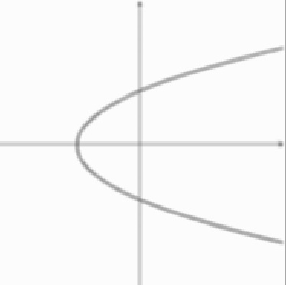
I 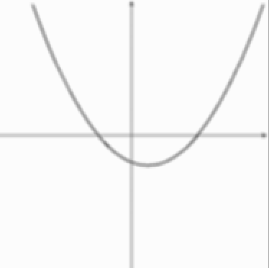 II 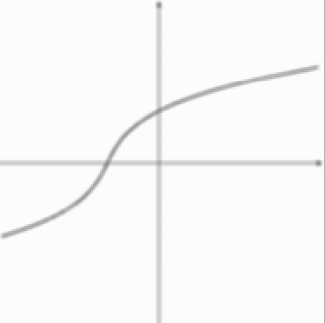 III IV 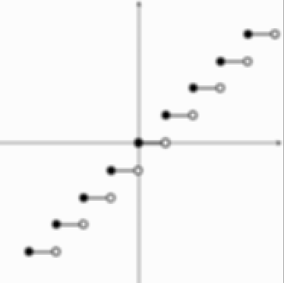 V 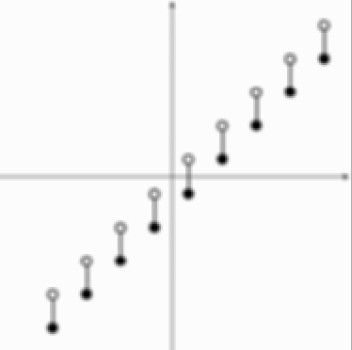
(A) I only (B) II only (C) III only (D) I and II only
(E) I and III only (F) I, II, and IV only (G) II and V only (H) I, II, and III only

Answer: (F)

- Each of the functions in the table below is increasing, but each increases in a diﬀerent way. Select the graph from those given below which best ﬁts each function:

t | 1 | 2 | 3 | 4 | 5 | 6
f (t) | 26 | 34 | 41 | 46 | 48 | 49
g (t) | 16 | 24 | 32 | 40 | 48 | 56
h (t) | 36 | 44 | 53 | 64 | 77 | 93

(A) (B) (C)

Answer: f (t): (B) g (t): (A) h (t): (C)

4 1 Functions and Models

- Each of the functions in the table below is decreasing, but each decreases in a diﬀerent way. Select the graph from those given below which best ﬁts each function:

t | 1 | 2 | 3 | 4 | 5 | 6
f (t) | 98 | 91 | 81 | 69 | 54 | 35
g (t) | 80 | 71 | 63 | 57 | 53 | 52
h (t) | 78 | 69 | 60 | 51 | 42 | 33

(A) (B) (C) Answer: f (t): (B) g (t): (C) h (t): (A)

- Suppose a pet owner decides to wash her dog in the laundry tub. She ﬁlls the laundry tub with warm water, puts the dog into the tub and shampoos it, removes the dog from the tub to towel it, then pulls the plug to drain the tub. Let t be the time in minutes, beginning when she starts to ﬁll the tub, and let h (t) be the water level in the tub at time t. If the total time for ﬁlling and draining the tub and washing the dog was 40 minutes, sketch a possible graph of h (t).
Answer: (One possible answer — answers will vary.)

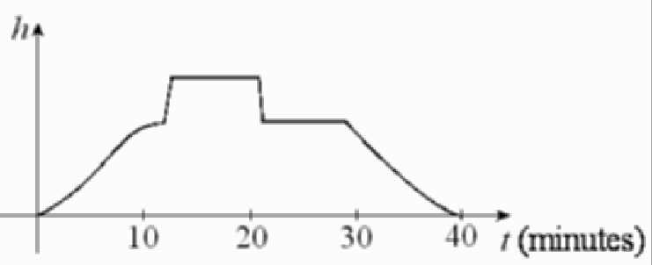

1.1 Four Ways to Represent a Function 5

- A homeowner mowed her lawn on June 1, cutting it to a uniform height of 3jj. She mowed the lawn at one-week intervals after that until she left for a vacation on June 30. A local lawn service put fertilizer on her lawn shortly after she mowed on June 15, causing the grass to
grow more rapidly. She returned from her vacation on July 13 to ﬁnd that the neighborhood boy whom she had hired to mow the lawn while she was away had indeed mowed on June 22 and on June 29, but had forgotten to mow on July 6. Sketch a possible graph of the height of the grass as a function of time over the time period from June 1 through July 13.
Answer: (One possible answer — answers will vary.)
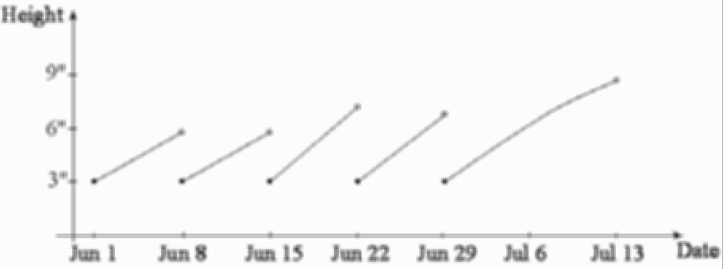

- A professor left the college for a professional meeting, a trip that was expected to take 4 hours. The graph below shows the distance D (t) that the professor has traveled from the college as a function of the time t, in hours. Refer to the graph and answer the questions which follow.
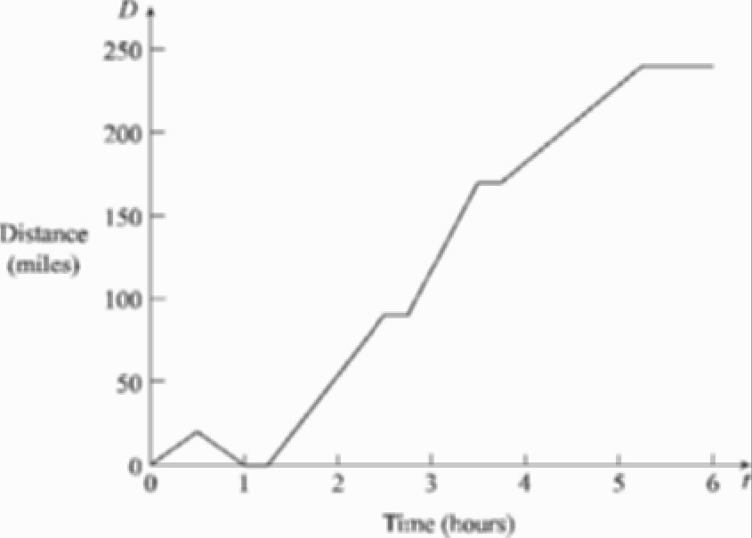

- Describe what might have happened at D (0.5).
- Describe what might have happened at D (1.0).
- Describe what might have happened at D (1.2).
- Describe what might have happened at D (2.5).
- Describe what might have happened at D (3.5). (f) Describe what might have happened at D (3.75).

6 1 Functions and Models

- Describe what might have happened at D (4.0).
- Describe what might have happened at D (5.25).

Answer:

- He was traveling to the meeting.
- He returned to the college (maybe he forgot something.)
- He left the college for the meeting again.
- He stopped to rest.
- He stopped for a second time after traveling at a relatively high rate of speed, perhaps at the request of a highway patrol oﬃcer.
- He continued on his trip but at a substantially lower rate of speed.
- He was traveling to the meeting.
- He arrived at his destination.

- Let f (x) = 4 − x². Find
- the domain of f .
- the range of f .

Answer: (a) (−∞, ∞) (b) (−∞, 4]
- Let f (x) = √2x + 5. Find

- the domain of f .
- the range of f .
Answer: (a) Σ− 2 , ∞Σ (b) [0, ∞)
5
- Let f (x) = √16 − x2. Find
- the domain of f .
- the range of f .

Answer: (a) [−4, 4] (b) [0, 4]

1.1 Four Ways to Represent a Function 7
.f x

- Let ( ) = 3 − x . Find
x + 2

- the domain of f .
- the range of f .

Answer: (a) (−2, 3] (b) (0, ∞)
- Express the area A of a circle as a function of its circumference C.

Answer:
C2
A 4π
=

- Let f (x) =
x² + 3 if x ≤ −1 2 + 3x

Find

⎩ 6 if x> −1
⎧⎨

- the domain of f .
- the range of f .

Answer: (a) (−∞, ∞) (b) .− 1 , ∞Σ
6
- A function has domain [−4, 4] and a portion of its graph is shown.

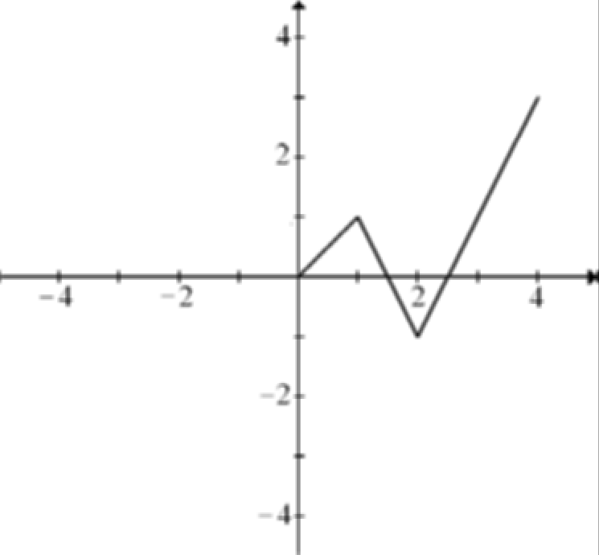
- Complete the graph of f if it is known that f is an even function.
- Complete the graph of f if it is known that f is an odd function.

8 1 Functions and Models

Answer:
- (b)
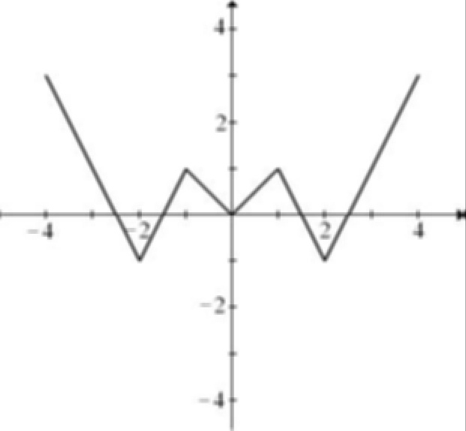
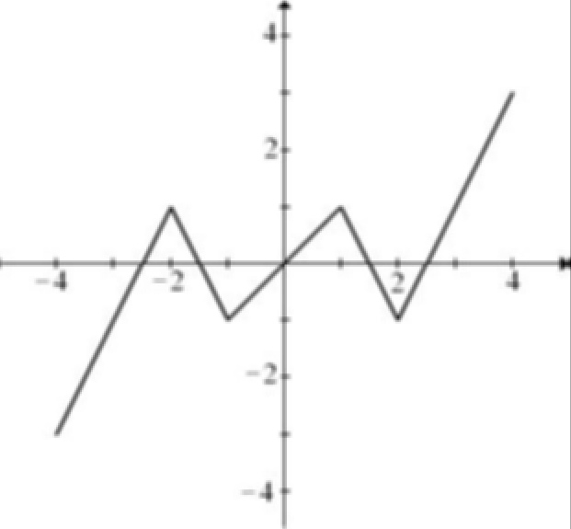

- A function has domain [−4, 4] and a portion of its graph is shown.

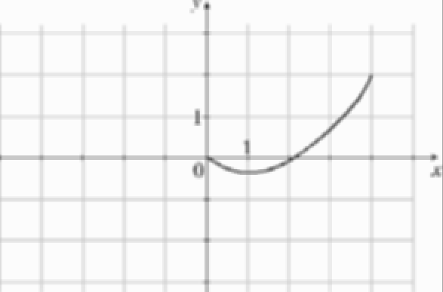

- Complete the graph of f if it is known that f is an even function.

- Complete the graph of f if it is known that f is an odd function.

Answer:
(a) (b)
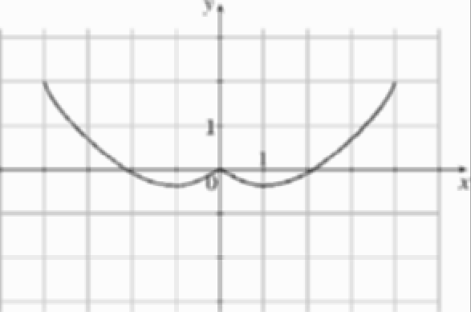
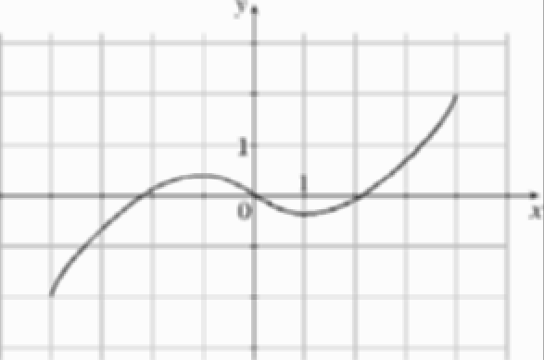

  - Four Ways to Represent a Function 9

- Given the graph of y = f (x):

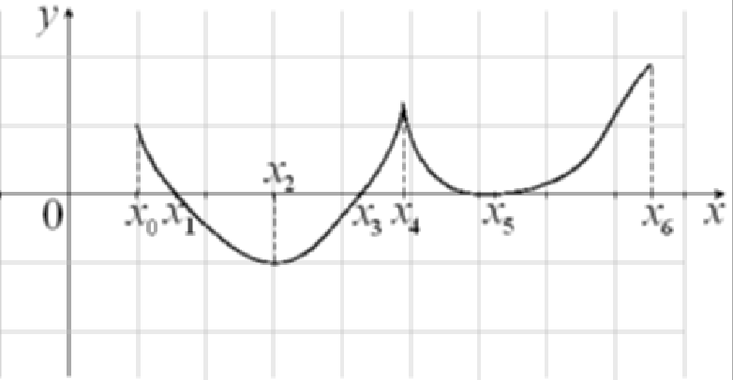

Find all values of x where:

- f is increasing.
- f is decreasing.

Answer: (a) (x₂, x₄) and (x₅, x₆) (b) (x₀, x₂) and (x₄, x₅)

- An ice cream vendor is stopped on the side of a city street 100 feet from a perpendicular intersection of the street with another straight city street. A bicyclist is riding on the perpen- dicular street at a rate of 1320 feet/second. If the bicyclist continues to ride straight ahead at the same rate of speed, write a function for the distance, d, between the ice cream vendor and the bicyclist for time t beginning when the bicyclist is in the intersection.
Answer: d(t) = √1002 + (1320t)2.
- A tank used for portland cement consists of a cylinder mounted on top of a cone, with its vertex pointing downward. The cylinder is 30 feet high, both the cylinder and the cone have radii of 4 feet, and the cone is 6 feet high.
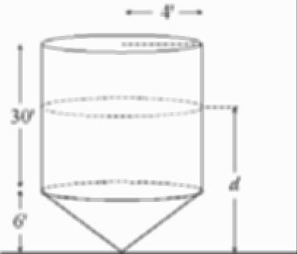

- Determine the volume of cement contained in the tank as a function of the depth d of the cement.
- What is the domain of this function?

10 1 Functions and Models

Answer:

- V (d) =
⎧⎪⎨ 4πd³

if 0

≤ d ≤ 6

(b) d ∈ [0, 36]

⎪⎩ 16πd − 64π if 6 <d ≤ 36
27
- A parking lot light is mounted on top of a 20-foot tall lamppost. A person T feet tall is walking away from the lamppost along a straight path. Determine a function which expresses the length of the person’s shadow in terms of the person’s distance from the lamppost.
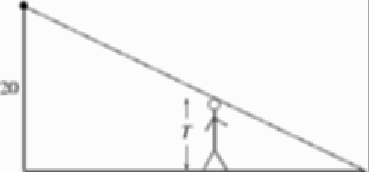

Answer: Let L be the length of the person’s shadow and x be the person’s distance from
the lamppost. Then L = Tx .
(20 − T )

- A small model rocket is launched vertically upward on a calm day. The engine delivers its thrust at a constant rate for 2 seconds, at which point the engine burns out. The rocket continues until it begins to fall from its maximum height of 600 feet. Six seconds into the ﬂight a parachute is automatically deployed and the rocket descends at a constant rate of 30 feet per second. Sketch a possible graph of the altitude, h(t), of the rocket at time t for the ﬁrst 10 seconds of the ﬂight.
Answer: Answers will vary. One possible graph
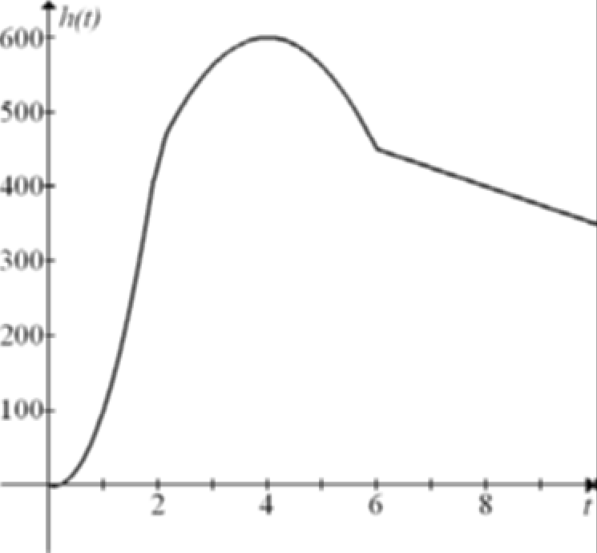

  - Mathematical Models: A Catalog of Essential Functions 11

Mathematical Models: A Catalog of Essential Functions

    - Classify the function f (x) = x2 + π .
x
      - Power function (B) Root function
(C) Polynomial function (D) Rational function
(E) Algebraic function (F) Trigonometric function
(G) Exponential function (H) Logarithmic function

Answer: (D)

    - Classify the function
π² + x²
f (x) = .

e
      - Power function (B) Root function
(C) Polynomial function (D) Rational function
(E) Algebraic function (F) Trigonometric function
(G) Exponential function (H) Logarithmic function

Answer: (C)

    - Classify the function f (x) = sin (5) x² + sin (3) x.
      - Power function (B) Root function
(C) Polynomial function (D) Rational function
(E) Algebraic function (F) Trigonometric function
(G) Exponential function (H) Logarithmic function

Answer: (C)

