________________________________________

Part One

What Is Economics?
________________________________________

This opening Part of the book provides an introduction to economics. The central themes of Chapter 1 are scarcity, choice, opportunity cost, and the self-organizing role of markets. The chapter also examines the gains from specialization and trade, the role of money, the effects of globalization, and ends with a discussion of the various types of economic systems. Chapter 2 examines how economists build their models and test their theories. It also addresses central methodological issues, the most important being the idea that the progress of economics (like all scientific disciplines) depends on relating our theories to what we observe in the world around us. Finally, the chapter has an extensive section on graphing.
***
Chapter 1 opens with a brief tour of some key economic issues in Canada and other countries—from rising protectionism and the dangers of climate change to accelerating technological change and growing income inequality. The purpose is to whet the reader’s appetite for the kinds of issues economists are thinking about today. This offers a natural segue to the discussion of scarcity, without which few of these issues would be very interesting. The chapter addresses the fundamental concepts of scarcity, choice, and opportunity cost, illustrating these ideas with a production possibilities boundary. (It is worth noting that these concepts are relevant to all economies, whether they are organized by central planning or by free markets.) We then examine the complexity of modern market economies, examining the decision makers, production, trade, money, and globalization. Finally, we examine different types of economic systems, including traditional, command, and free-market systems. We emphasize that all actual economies are mixtures, containing elements of all three pure systems.
Chapter 2 provides a longer introduction to the methodological issues of economics than is usually included in introductory texts. We do this because most students believe that the scientific method is limited to the natural sciences. But to appreciate economics, they must understand that its theories are also open to empirical testing and that these theories continually change as a result of what the empirical evidence shows. We understand that some instructors feel their time is so limited that they cannot spend class time on Chapter 2. We believe that even if it is not covered in class, students’ attention should be called to the issues addressed in the chapter. Our experience is that students benefit from some discussion of the scientific method and from the insight that the social sciences are not all that different from the “hard” sciences, at least in their basic approaches.

The chapter begins by making the distinction between positive and normative statements. We then work carefully through the various elements of economic theories, including definitions, assumptions, and predictions. Testing theories is as important as developing them, so we emphasize the interaction between theorizing and empirical observation. We then present various types of economic data, and this gets us into a detailed discussion of index numbers, time-series and cross-section data, and graphs. The final section of the chapter goes through graphing in detail.

_______________________________________

Chapter 1: Economic Issues and Concepts

_______________________________________

This chapter is in three main sections, after a short introductory mention of some key economic issues of the day. The first substantive section develops the concepts of scarcity, choice, and opportunity cost. To ensure the student really understands what opportunity cost is all about, we have a box that examines the opportunity cost of a university or college degree. This should be a familiar example to which students can easily relate. The production possibilities boundary is then introduced, and it is shown to embody the three key concepts of scarcity, choice and opportunity cost. Its nature as a frontier between attainable and unattainable is worth stressing, as is the fact that what is attainable is itself subject to change. Four key economic problems are then discussed, and each one is expressed in terms of the production possibilities boundary. These questions give the student an inkling of the types of questions addressed both in microeconomics and in macroeconomics.
The chapter’s second section examines the complexity of modern economies, asking why the things we want to purchase are almost always available. What produces this remarkable coordination? We discuss the market as an instrument that brings order to the economy as a whole. Along the way, the student is introduced to Adam Smith’s “invisible hand”. The section also discusses who makes the choices in a market economy, and why incentives matter. We show the circular flow of income and expenditure as a way of showing the interaction between consumers and producers. We also examine the nature of maximizing decisions (both utility and profit), and the importance of decisions at the margin. Finally, on the production side, we examine the role of specialization, the division of labour, globalization, and the importance of money in facilitating trade.
The chapter’s third and final section deals with comparative economic systems. Students will read in almost every chapter of this book about a market economy. Contrasting it with planned and traditional economies is a good way to gain some insight into the concept at the outset. We emphasize that actual economies are rarely, if ever, well represented by the extremes; instead, actual economies are mixed economies, with varying degrees of government ownership and planning. Students are introduced to Karl Marx’s argument for a centrally planned economy. While Marx had many things right, we argue that central planning has not been successful in proving itself as an efficient way of organizing an economy, allocating resources, or generating prosperity for a large fraction of the population.

Answers to Study Exercises

Fill-in-the-Blank Questions

Question 1
a) land, labour, capital; factors
b) opportunity cost
c) production possibilities boundary
d) scarcity (because points outside the boundary are unattainable); downward (or negative); the opportunity cost associated with any choice
e) constant; increasing
f) increases (meaning that more units of good B must be given up to get an extra unit of good A)

Question 2
a) self; self-interest
b) incentives created by market prices
c) firms; households; governments
d) increase (maximize); increase (maximize)
e) margin; (marginal) cost

Question 3
a) division; specialization
b) trade
c) money
d) globalization

Review Questions

Question 4
Any realistic production possibilities boundary displays scarcity, the need for choice, and opportunity cost.
Scarcity: The production possibilities boundary (PPB) separates attainable combinations of goods from those that are unattainable. Thus scarcity is shown by the existence of some unattainable bundles of goods.
Choice: Because of scarcity, societies must somehow choose how resources are to be allocated; thus a particular point on the PPB must be chosen.
Opportunity Cost: The slope of the PPB is negative, revealing the opportunity cost that is unavoidable every time a choice is made. For the economy as a whole, the decision to produce more of one good must involve a decision to produce less of some other good.

Question 5
Consider any country’s production possibilities boundary, and suppose the two products are X and Y. A technological improvement in industry X shifts the PPB out (along the X axis), increasing the maximum amount of X that can be produced. Note that the maximum amount of Y that can be produced has not changed. But since the PPB has shifted out, there are many combinations of both goods that are now available that were not before, and some of these involve producing more of both goods. Thus, even though the technology for producing Y has not changed, the technological improvement in X does allow the country to choose to produce more of both products.

Question 6
The central ideas illustrated by the two-good version of the production possibilities boundary (PPB) are scarcity, choice, and opportunity cost. Exactly the same ideas can be illustrated in a more realistic three-good version of the model, which is more complicated to draw, or by the much more realistic N-good version of the model (with N ≥ 4), which is impossible to draw. Thus the assumption of only two goods is merely a simplifying one: it allows us to easily grasp and illustrate some central points that would be more difficult to understand in the more general N-good case.

Question 7
a) If all Canadian families had $80,000 of after-tax income (roughly the Canadian average), it would be difficult to say that real poverty existed in Canada. At this level of income, all families would easily have enough income to provide the essentials of food, shelter, and clothing, and could also have much beyond these essentials. However, there would still be many things that these families could not afford, such as expensive university education, expensive vacations, a cottage in the country, etc. Defining poverty with any precision is difficult, and we will say more about this in Chapter 18.
b) Would scarcity exist in such a setting? Yes, certainly. By scarcity we mean simply an excess of wants over the resources available to satisfy those wants. And scarcity would exist for each of those families because most (if not all) of them would still desire to have more than they actually had.
c) Scarcity is an excess of wants over the resources available to satisfy those wants. Poverty—at least in its “absolute form”—is concerned with a level of resources below some threshold of sufficiency. One can conceivably eliminate poverty, as in part (a), but that would not eliminate scarcity.

Question 8
Microeconomics is the study of the allocation of resources within and across individual markets, and the determination of relative prices and quantities in those specific markets. Little or no attention is paid to the behaviour of the aggregate economy. Macroeconomics is the study of the determination of aggregates such as aggregate output, employment, the price level, the unemployment rate, and the exchange rate. When doing macroeconomics, little or no attention is paid to what is going on in the individual markets for specific products.

Question 9
In the answers that follow, note that the statements are made ceteris paribus. In other words, the predicted result of a change in some specific price is made under the assumption that nothing else changes.
a) As the price of ski-lift tickets rises, you are likely to substitute toward other leisure activities (whose price has not increased) and thus reduce your purchases of ski-lift tickets.
b) As the hourly wage for your weekend job rises, the opportunity cost of not working rises. So you are more likely than before to decide not to go skiing, and to work instead.
c) As the fine for speeding rises, the cost of being caught speeding clearly increases. The benefit of driving over the speed limit is presumably unchanged, however. So an increase in the value of speeding tickets is likely to cause you to reduce your speed (and to watch more carefully for hidden police cars!).
d) The higher the weight placed on the assignment, the greater is the incentive for you to work hard on that assignment (and thus hopefully receive a higher grade on the assignment and on the course). This is one obvious reason why professors like to put significant weight on midterm exams – to get students to work hard early in the course rather than leaving all the work to the few days before the final exam!
e) As tuition fees for one specific institution increase, you are likely to substitute toward other institutions whose fees have not increased, and thus reduce your desire to attend the first institution. (For small changes in tuition fees, this effect may be very small because of the perceived large differences between some educational institutions.)

Question 10
There are two reasons why the specialization of labour is more efficient than self-sufficiency. First, since individual abilities differ, specializing allows each person to focus their energies on what they do best, leaving everything else to be done by others. As a result, total output will rise. Second, as people specialize, they often “learn by doing” and become even better at their specific task. Thus specialization often leads to improvements in ability that would not otherwise occur.

Question 11
The market for doctors’ services depends heavily on the specialization of labour. A person with back pain will not know what is wrong. They go to a general practitioner (GP) who is somewhat familiar with a broad range of symptoms and illnesses. The GP may rule out the simplest possible causes for the pain, and in the process determine that the patient requires the services of a specialist who diagnoses and treats the patient’s back. The patient is referred to this specialist who may diagnose a ruptured disk and perform the delicate surgery necessary to solve the problem. Given this reliance on specialization, the market depends on having relatively more GPs who see a large number of patients and act as “gatekeepers” for patients to the more specific specialists.

Question 12
Traditional systems: Behaviour is based primarily on tradition, custom, and habit.
Command systems: Decisions about production and consumption are determined by a central planning authority.
Free-market systems: Production and consumption decisions are made privately, by decentralized producers and consumers.
Mixed systems: These economic systems contain elements of tradition, command, and free markets.

Question 13
This quote, if put to a group of students, would stimulate much interesting discussion, not only about views on how alternative economic systems work, but also about the words used to describe them. The term planned economy, for example, describes the conscious use of centralized decision making for key economic decisions, but the results of that process often look anything but planned, with shortages in some sectors, surpluses in others, and often a rather dispirited and unmotivated private sector. On the other hand, the unplanned decentralized market economy––though surely not perfect—creates a much more orderly looking set of outcomes.
Problems
Question 14
In general, the opportunity cost (measured in dollars) for any activity includes three things:
• the direct (dollar) cost of the activity, plus
• the dollar value of whatever you give up in order to do the activity, minus
• whatever dollar “savings” the activity generates
In this case, the direct cost of transportation, lift tickets and accommodation of $300 is definitely included. The income of $120 that you give up also counts. Finally, we must deal with the restaurant meals of $75. Surely you would have eaten some food even if you hadn’t gone skiing, so the full $75 is not included. But given the relatively high price of restaurant meals compared to buying your own groceries, you will probably include most of the $75. Thus the opportunity cost of the ski trip is $420 plus some (large) fraction of the $75.

Question 15
a) The budget line is shown below. If all $240,000 is spent on ATVs, you could purchase 30 of them; if all the money is spent on snowmobiles, you could purchase 20 of them. The downward sloping line divides the attainable from the unattainable combinations of ATVs and snowmobiles.
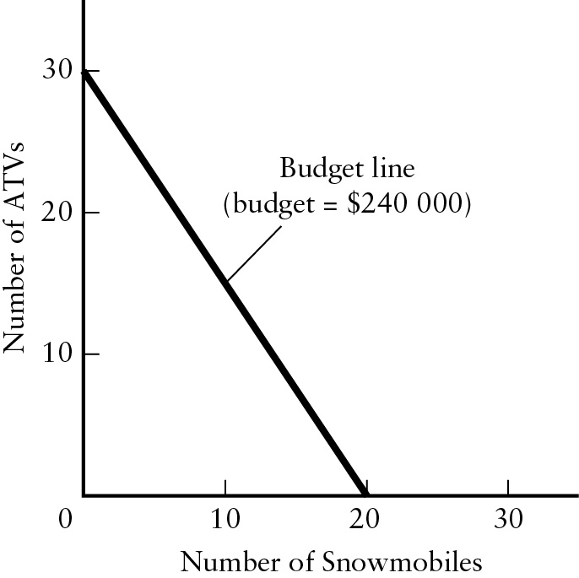
b) The opportunity cost of one ATV is the number of snowmobiles that must be given up to purchase an additional ATV. Since each ATV costs $8000 and each snowmobile costs $12000, the opportunity cost of one ATV is 2/3 of a snowmobile.
c) The opportunity cost of one snowmobile is the number of ATVs that must be given up to purchase an additional snowmobile. It is equal to 1.5 ATVs. Note that the opportunity cost of an ATV (in terms of forgone snowmobiles) is the inverse of the opportunity cost of a snowmobile (in terms of forgone ATVs).
d) In this case, the prices of ATVs and snowmobiles are independent of how many are purchased. This fact is reflected by the budget line being linear (of constant slope). So both of the opportunity costs are independent of how many are purchased.

Question 16
In each scenario, one could choose to plot the production possibilities boundary, where the two numbers provided are the two intercepts along the two axes. The slope of the boundary would show the opportunity cost of each door (or each window). Alternatively, one can compare the two maximum values, as provided in the question.
a) The factory could produce either 1000 windows or 250 doors (or many intermediate combinations). In order to produce one extra door, it must give up 4 (=1000/250) windows. In other words, the opportunity cost of one extra door is 4 windows.
b) The opportunity cost of one extra door is 1 window (=500/500).
c) The opportunity cost of one extra door is 3 windows (=1200/400).
d) The opportunity cost of one extra door is 1.35 windows (=942/697).
e) The opportunity cost of one extra door is 1.33 windows (=600/450).
Question 17
This question is good for forcing students to think through the computation of opportunity cost and also in showing how the allocation of labour in particular ways can maximize total output.
a) You can catch 6 fish or collect 3 bundles of firewood in one day’s work. Thus, your opportunity cost of one additional bundle of firewood is 2 fish. For your friend, the opportunity cost of one additional bundle of firewood is 4 fish.
b) To allocate tasks in the output-maximizing way, each person should do the task for which they have the lower opportunity cost. You have the lower opportunity cost of collecting firewood. Your friend has the lower opportunity cost of catching fish (0.25 of a bundle for your friend as compared to 0.5 of a bundle for you). So for the two of you to collectively maximize output you should specialize in collecting firewood and your friend should specialize in catching fish.
c) What is the total amount of output after two days, if you allocate labour as in part (b)? In two days, you would collect 6 bundles of firewood and your friend would catch 16 fish. The reverse pattern of specialization would yield only 4 bundles of firewood and 12 fish, which is clearly inferior.

Question 18
a) At point A, 2.5 tonnes of clothing and 3 tonnes of food are being produced per year. At point B, annual production is 2.5 tonnes of clothing and 7 tonnes of food. At point C, annual production is 6.5 tonnes of clothing and 3 tonnes of food.
b) At point A the economy is either using its resources inefficiently or it is not using all of its available resources. Point B and C represent full and efficient use of available resources because they are on the PPB.
c) At point B, the opportunity cost of producing one more tonne of food (and increase from 7 to 8) is the 2.5 tonnes of clothing that must be given up. The opportunity cost of producing one more tonne of clothing (from 2.5 to 3.5) appears, from the graph, to be approximately 0.75 tonnes of food that must be given up.
d) Point D is unattainable given the economy’s current technology and resources. Point D can become attainable with a sufficient improvement in technology or increase in available resources.

Question 19
a) As the table shows, there are only 250 workers in Choiceland, and to construct the production possibilities boundary (PPB) we must imagine all the combinations of workers in each sector. Using the two middle columns from the table, we can plot the output levels on a graph to get the following PPB:
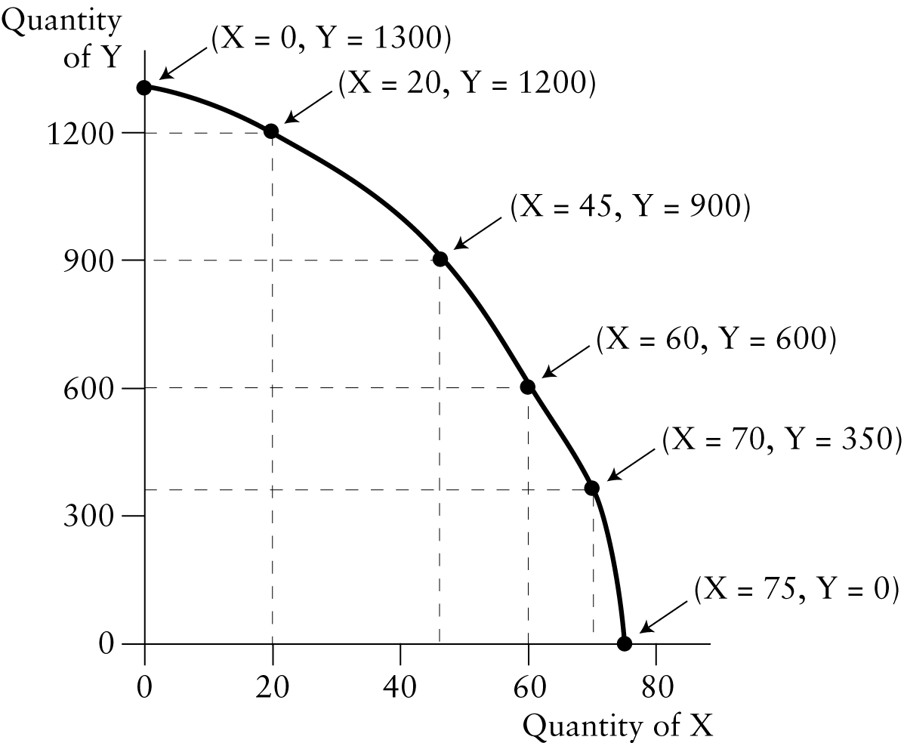
b) If the economy is already producing 45 units of X and 900 units of Y, then 15 extra units of X can only be produced by reducing the production of Y by 300 units. The opportunity cost of 15 units of X is therefore 300 units of Y (or 300/15 = 20 units of Y per unit of X). If the economy is already producing 60 units of X (and 600 units of Y), the opportunity cost of producing an additional 15 units of X is the full 600 units of Y that must be given up. This implies an opportunity cost of 600/15 = 40 units of Y per extra unit of X. Thus, we see that the opportunity cost of X rises when more of X is already being produced.
c) If the economy is producing 40 units of X and 600 units of Y, then either some resources are not being used or they are being used inefficiently; the economy is operating inside the production possibilities boundary. It would thus be possible to improve the use of resources and increase output of X by 20 units without reducing the output of Y at all. In this sense, the extra output of X has no opportunity cost in terms of forgone units of Y.
d) If any given amount of labour can now produce 10 percent more of good Y, then the PPB shifts up in a particular way. Specifically, the Y values increase by 10 percent for any given X value, as shown below.

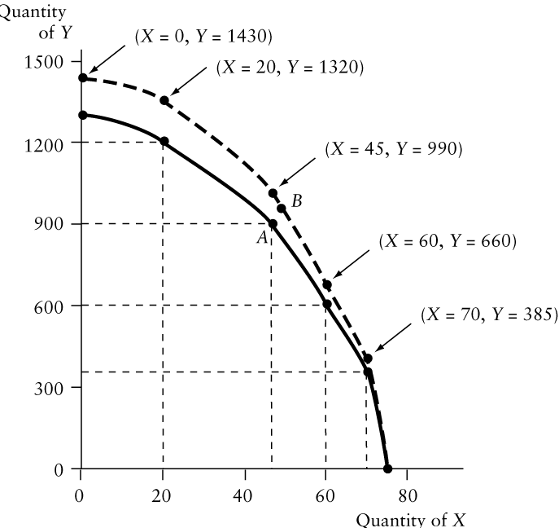

Question 20
a) It doesn’t matter how the two axes are labelled in this case; just label them X and Y. The long civil war destroys much of the country’s infrastructure and likely reduces the country’s ability to produce all products. So the PPB shifts inwards, as shown below in part (a) of the figure.
b) The axes are now labelled Food and Clothing. The new technology doubles the maximum amount of food that can be produced, and so shifts the PPB outward in the manner shown in part (b) of the figure. Note that the vertical intercept (maximum amount of clothing) does not change.
c) The axes are again labelled Food and Clothing, as in part (c). In this situation, the earthquake destroys many clothing factories and so shifts the PPB inward, reducing the maximum possible amount of clothing (but leaving unaffected the maximum possible amount of food).
d) The axes are labelled X and Y, as shown in part (d) of the figure. The immigration increases the labour force and increases the country’s ability to produce all products. The PPB shifts outward, increasing the maximum possible amounts of both X and Y. Since the new level of immigration is occurring each year, every year will see such an outward shift in the PPB.





