Fundamental Financial Accounting Concepts, 10e (Edmonds)
Chapter 1 An Introduction to Accounting

Indicate how each event affects the elements of financial statements. Use the following letters to record your answer in the box shown below each element. You do not need to enter amounts.
(Note that "No Effect" means that the event does not effect that element of the financial statements or that the event causes an increase in that element is offset by a decrease in that same element.)

Increase = I Decrease = D No Effect = NA

1) Walker Co. issued common stock for $150,000 cash.

Assets | Liabilities | Equity | Revenues | Expenses | Net Income | Stmt of Cash Flows

Answer: (I) (NA) (I) (NA) (NA) (NA) (I)
Issuing common stock is an asset source transaction that increases the business's assets (cash) and its stockholders' equity (common stock). It does not affect the income statement, but is reported as a cash flow from financing activities in the statement of cash flows.
Difficulty: 2 Medium
Topic: The Horizontal Financial Statements Model
Learning Objective: 01-10 Record business events using a horizontal financial statements model.
Bloom's: Analyze
AACSB: Analytical Thinking
AICPA: BB Critical Thinking; FN Measurement

2) Nguyen Co. borrowed $50,000 cash from Metropolitan Bank.

Assets | Liabilities | Equity | Revenues | Expenses | Net Income | Stmt of Cash Flows

Answer: (I) (I) (NA) (NA) (NA) (NA) (I)
Borrowing cash is an asset source transaction that increases a business's assets (cash) and its liabilities (notes payable). It does not affect the income statement, but is reported as a cash flow from financing activities in the statement of cash flows.
Difficulty: 2 Medium
Topic: The Horizontal Financial Statements Model
Learning Objective: 01-10 Record business events using a horizontal financial statements model.
Bloom's: Analyze
AACSB: Analytical Thinking
AICPA: BB Critical Thinking; FN Measurement

3) Bell Co. provided consulting services for $20,000 cash.

Assets | Liabilities | Equity | Revenues | Expenses | Net Income | Stmt of Cash Flows

Answer: (I) (NA) (I) (I) (NA) (I) (I)
This is an asset source transaction that increases the business's assets (cash). When a business provides services, it earns revenue. Revenue increases net income, which will increase equity (retained earnings) at the end of the accounting period. This event is reported as a cash flow from operating activities in the statement of cash flows.
Difficulty: 2 Medium
Topic: The Horizontal Financial Statements Model
Learning Objective: 01-10 Record business events using a horizontal financial statements model.
Bloom's: Analyze
AACSB: Analytical Thinking
AICPA: BB Critical Thinking; FN Measurement

4) Pierce Co. paid $40,000 cash to purchase land.

Assets | Liabilities | Equity | Revenues | Expenses | Net Income | Stmt of Cash Flows

Answer: (NA) (NA) (NA) (NA) (NA) (NA) (D)
Purchasing land for cash is an asset exchange transaction that increases one asset (land) and decreases another asset (cash). It does not affect the income statement, and is reported as an investing activity in the statement of cash flows.
Difficulty: 2 Medium
Topic: The Horizontal Financial Statements Model
Learning Objective: 01-10 Record business events using a horizontal financial statements model.
Bloom's: Analyze
AACSB: Analytical Thinking
AICPA: BB Critical Thinking; FN Measurement

5) Perez Co. paid $220,000 cash for salaries expense.

Assets | Liabilities | Equity | Revenues | Expenses | Net Income | Stmt of Cash Flows

Answer: (D) (NA) (D) (NA) (I) (D) (D)
Paying expenses is an asset use transaction that decreases the business's assets (cash) and decreases its equity (retained earnings). Note that the expense decreases net income, and will decrease retained earnings at the end of the accounting period. It is reported as a cash flow for operating activities in the statement of cash flows.
Difficulty: 2 Medium
Topic: The Horizontal Financial Statements Model
Learning Objective: 01-10 Record business events using a horizontal financial statements model.
Bloom's: Analyze
AACSB: Analytical Thinking
AICPA: BB Critical Thinking; FN Measurement

6) Epstein Co. paid $20,000 in cash dividends to its owners.

Assets | Liabilities | Equity | Revenues | Expenses | Net Income | Stmt of Cash Flows

Answer: (D) (NA) (D) (NA) (NA) (NA) (D)
Paying a cash dividend is an asset use transaction that decreases a business's assets (cash) and its equity (retained earnings).The dividends account will decrease the retained earnings at the end of the accounting period. It does not affect net income, and is reported as a cash flow for financing activities in the statement of cash flows.
Difficulty: 2 Medium
Topic: The Horizontal Financial Statements Model
Learning Objective: 01-10 Record business events using a horizontal financial statements model.
Bloom's: Analyze
AACSB: Analytical Thinking
AICPA: BB Critical Thinking; FN Measurement

7) North Co. issued a note to purchase a building.

Assets | Liabilities | Equity | Revenues | Expenses | Net Income | Stmt of Cash Flows

Answer: (I) (I) (NA) (NA) (NA) (NA) (NA)
Issuing a note to purchase a building is an asset source transaction that increases a business's assets (building) and increases its liabilities (notes payable). It does not affect net income or the statement of cash flows.
Difficulty: 2 Medium
Topic: The Horizontal Financial Statements Model
Learning Objective: 01-10 Record business events using a horizontal financial statements model.
Bloom's: Analyze
AACSB: Analytical Thinking
AICPA: BB Critical Thinking; FN Measurement

8) Name the group that has the primary authority for establishing U.S. GAAP.

Answer: The Financial Accounting Standards Board (FASB)
The Financial Accounting Standards Board (FASB) is a privately funded organization with the primary authority for establishing accounting standards in the United States.
Difficulty: 1 Easy
Topic: Role of Accounting in Society
Learning Objective: 01-01 Identify the ways accounting benefits society.
Bloom's: Remember
AACSB: Reflective Thinking
AICPA: BB Critical Thinking; FN Measurement

9) Who are the three distinct types of participants in the market for business resources? Briefly describe the role of each group of participants.

Answer: Markets include consumers, conversion agents, and resource owners. Consumers use resources. Conversion agents are businesses that convert resources to the form that consumers want. Resource owners control the distribution of resources to conversion agents.
Difficulty: 2 Medium
Topic: Role of Accounting in Society
Learning Objective: 01-01 Identify the ways accounting benefits society.
Bloom's: Understand
AACSB: Reflective Thinking
AICPA: BB Industry

10) What is meant by the term "stakeholders"?

Answer: Stakeholders are the parties that are interested in operations of an organization. Stakeholders often are users or potential users of accounting information. Stakeholders include resource providers, financial analysts, brokers, attorneys, government regulators and news reporters.
Difficulty: 2 Medium
Topic: Role of Accounting in Society
Learning Objective: 01-01 Identify the ways accounting benefits society.
Bloom's: Understand
AACSB: Reflective Thinking
AICPA: BB Industry; FN Measurement

11) What is meant by the term "global GAAP"? How does it impact U.S. companies? What body is responsible for setting global standards?

Answer: International Financial Reporting Standards (IFRS) have been adopted by most countries outside of the United States, and are becoming "global GAAP." Many believe that U.S. companies will be allowed to use either IFRS or U.S. GAAP in the future, and there is an ongoing process to reduce the differences between IFRS and GAAP. The International Accounting Standards Board (IASB), headquartered in London, is responsible for forming these standards.
Difficulty: 2 Medium
Topic: Role of Accounting in Society
Learning Objective: 01-01 Identify the ways accounting benefits society.
Bloom's: Understand
AACSB: Diversity
AICPA: BB Global; FN Measurement

12) Briefly distinguish between financial accounting and managerial accounting.

Answer: Financial accounting is designed to satisfy the needs of external resource providers (external users), and must adhere to Generally Accepted Accounting Principles. Managerial accounting, however, provides information that is useful to managers within a business (internal users), and does not have to follow GAAP.
Difficulty: 2 Medium
Topic: Role of Accounting in Society
Learning Objective: 01-01 Identify the ways accounting benefits society.
Bloom's: Understand
AACSB: Communication; Reflective Thinking
AICPA: BB Industry; FN Measurement

13) Explain some of the similarities and differences between not-for-profit organizations and other types of businesses.

Answer: Similarities: Both types of organizations commonly use specific resources to satisfy consumer demand. These resources are financial resources, physical resources, and labor resources. Accounting systems are used by both types of organizations to measure the cost of the goods and services that are provided, the efficiency and effectiveness of the organizations' operations, and the ability of the organizations to continue to provide goods and services.
Differences: Not-for-profit organizations are established primarily for motives other than making a profit, while most other businesses are motivated by profit. As a result, factors other than profitability influence the resource allocation priorities of not-for-profit organizations.
Difficulty: 2 Medium
Topic: Role of Accounting in Society
Learning Objective: 01-01 Identify the ways accounting benefits society.
Bloom's: Understand
AACSB: Communication; Reflective Thinking
AICPA: BB Industry

14) What financial statement elements are reported on a balance sheet?

Answer: A business's balance sheet shows the elements: assets, liabilities, and stockholders' equity.
Difficulty: 1 Easy
Topic: Preparing an Income Statement, a Statement of Changes in Stockholders' Equity and a Balance Sheet
Learning Objective: 01-07 Prepare an income statement, a statement of changes in stockholders' equity, and a balance sheet.
Bloom's: Remember
AACSB: Reflective Thinking
AICPA: BB Critical Thinking; FN Measurement

15) From what three sources does a business obtain its assets?

Answer: A business obtains its assets from creditors, from investors, and from operations.
Difficulty: 2 Medium
Topic: Elements of Financial Statements
Learning Objective: 01-03 Identify the components of the accounting equation.
Bloom's: Remember
AACSB: Reflective Thinking
AICPA: BB Resource Management; FN Risk Analysis

16) How does providing services for cash affect the accounting equation? Is it considered an asset source, asset use, or asset exchange transaction?

Answer: Providing services for cash increases assets and increases equity. It is considered an asset source transaction.
Providing services for cash increases cash, an asset, and revenue increases equity (retained earnings).
Difficulty: 2 Medium
Topic: Recording Business Events Under the Accounting Equation
Learning Objective: 01-04 Show how business events affect the accounting equation.
Bloom's: Understand
AACSB: Reflective Thinking; Analyze
AICPA: BB Critical Thinking; FN Measurement

17) How does the payment of cash dividends to stockholders affect the accounting equation? Is it considered an asset source, asset use, or asset exchange transaction?

Answer: Payment of cash dividends decreases assets and decreases equity. It is considered an asset use transaction.
Paying dividends decreases assets (cash) and decreases equity (retained earnings).
Difficulty: 2 Medium
Topic: Recording Business Events Under the Accounting Equation
Learning Objective: 01-04 Show how business events affect the accounting equation.
Bloom's: Analyze
AACSB: Analytical Thinking
AICPA: BB Critical Thinking; FN Measurement

18) If total stockholder's equity is $150,000 and liabilities are $75,000, what are total assets?

Answer: $225,000
Assets = Liabilities $75,000 + Equity $150,000; Assets = $225,000
Difficulty: 2 Medium
Topic: Elements of Financial Statements
Learning Objective: 01-03 Identify the components of the accounting equation.
Bloom's: Apply
AACSB: Knowledge Application
AICPA: BB Critical Thinking; FN Measurement

19) What is meant by the term stockholders' equity?

Answer: When a business acquires assets from investors, it commits to keep the assets safe and to use the assets in a manner that benefits the investors. The business also grants the investor an ownership interest in the business, thereby allowing the investor (owner) to share in the profits generated by the business. In accounting terms investors are called stockholders. A business's commitment to its stockholders is called stockholders' equity.
Difficulty: 2 Medium
Topic: Elements of Financial Statements
Learning Objective: 01-03 Identify the components of the accounting equation.
Bloom's: Understand
AACSB: Reflective Thinking
AICPA: BB Critical Thinking; FN Measurement

20) Give three examples of asset use transactions.

Answer: Paid loan, paid expense, and paid dividends to stockholders.
Asset use transactions involve a decrease in assets (for example, cash) and will also result in a decrease in either liabilities (paid loan) or equity (paid expense or dividends).
Difficulty: 2 Medium
Topic: Recording Business Events Under the Accounting Equation
Learning Objective: 01-04 Show how business events affect the accounting equation.
Bloom's: Understand
AACSB: Reflective Thinking
AICPA: BB Resource Management; FN Measurement

21) What does a company's statement of cash flows tell you about the company?

Answer: The statement of cash flows tells how a company obtained and used cash during the accounting period.
The statement of cash flows explains the change in cash from the beginning to the end of the period.
Difficulty: 1 Easy
Topic: Preparing a Statement of Cash Flows
Learning Objective: 01-08 Prepare a statement of cash flows.
Bloom's: Understand
AACSB: Reflective Thinking
AICPA: BB Critical Thinking; FN Measurement

22) If a corporation issues common stock for $50,000 cash, in which section of the statement of cash flows will this transaction be reported?

Answer: Issuing stock is reported in the financing activities section.
All cash exchanged between a company and its stockholders is considered a financing activity.
Difficulty: 1 Easy
Topic: Preparing a Statement of Cash Flows
Learning Objective: 01-08 Prepare a statement of cash flows.
Bloom's: Understand
AACSB: Reflective Thinking
AICPA: BB Critical Thinking; FN Measurement

23) Which types of accounts are closed out to the Retained Earnings account at the end of an accounting period?

Answer: Revenues, expenses, and dividends are temporary accounts and are closed at the end of the accounting period.
These accounts are called temporary, or nominal, accounts. Note that dividends are reported on neither the income statement nor the balance sheet.
Difficulty: 1 Easy
Topic: The Closing Process
Learning Objective: 01-09 Close revenue, expense, and dividend accounts.
Bloom's: Understand
AACSB: Reflective Thinking
AICPA: BB Critical Thinking; FN Measurement

24) Name and briefly describe each of the four financial statements.

Answer: The balance sheet lists the assets of a business and corresponding claims (liabilities and stockholders' equity) on those assets. It draws its name from the accounting equation.
The income statement matches revenue (benefits) with the expenses (sacrifices) that were incurred to generate the revenue.
The statement of changes in stockholders' equity is used to explain the effects of transactions on stockholders' equity during an accounting period.
The statement of cash flows explains how a company obtained and used cash during the accounting period. The statement classifies cash receipts (inflows) and payments (outflows) into three categories: financing activities, investing activities, and operating activities.
Difficulty: 3 Hard
Topic: Preparing an Income Statement, a Statement of Changes in Stockholders' Equity and a Balance Sheet; Preparing a Statement of Cash Flows
Learning Objective: 01-07 Prepare an income statement, a statement of changes in stockholders' equity, and a balance sheet.; 01-08 Prepare a statement of cash flows.
Bloom's: Understand
AACSB: Reflective Thinking
AICPA: BB Critical Thinking; FN Measurement

25) Define the term "accounting period." How does this term relate to the "matching concept" as it pertains to the income statement?

Answer: An accounting period is the span of time covered by the financial statements, normally one year; the span of time for which income is measured. The practice of pairing together on the income statement revenues and expenses that were incurred in the same accounting period is known as the matching concept.
Difficulty: 2 Medium
Topic: Preparing an Income Statement, a Statement of Changes in Stockholders' Equity, and a Balance Sheet
Learning Objective: 01-07 Prepare an income statement, a statement of changes in stockholders' equity, and a balance sheet.
Bloom's: Understand
AACSB: Reflective Thinking
AICPA: BB Critical Thinking; FN Measurement

26) Which of the following groups has the primary responsibility for establishing generally accepted accounting principles for business entities in the United States?
A) Securities and Exchange Commission
B) U.S. Congress
C) International Accounting Standards Board
D) Financial Accounting Standards Board

Answer: D
Explanation: The Financial Accounting Standards Board is a privately funded group charged with establishing accounting standards for the U.S. It is not a branch of the U.S. government.
Difficulty: 1 Easy
Topic: Role of Accounting In Society
Learning Objective: 01-01 Identify the ways accounting benefits society.
Bloom's: Remember
AACSB: Reflective Thinking
AICPA: FN Measurement; BB Legal

27) The Heritage Company is a manufacturer of office furniture. Which term best describes Heritage's role in society?
A) Conversion agent
B) Regulatory agency
C) Consumer
D) Resource owner

Answer: A
Explanation: Businesses serve as conversion agents in the marketplace, transforming basic resources provided by resource owners into goods and services that consumers demand. Regulatory agencies set policies that affect the way that businesses operate.
Difficulty: 2 Medium
Topic: Role of Accounting In Society
Learning Objective: 01-01 Identify the ways accounting benefits society.
Bloom's: Understand
AACSB: Reflective Thinking
AICPA: FN Measurement; BB Industry

28) Which resource providers lend financial resources to a business with the expectation of repayment with interest?
A) Consumers
B) Creditors
C) Investors
D) Owners

Answer: B
Explanation: Businesses borrow money from creditors, and repay the amount borrowed, plus an additional fee known as interest. Investors, in contrast, provide financial resources in exchange for ownership interest in the business. Consumers demand goods and services from businesses.
Difficulty: 1 Easy
Topic: Role of Accounting In Society
Learning Objective: 01-01 Identify the ways accounting benefits society.
Bloom's: Remember
AACSB: Reflective Thinking
AICPA: BB Critical Thinking; FN Measurement

29) Which type of accounting information is intended to satisfy the needs of external users of accounting information?
A) Cost accounting
B) Managerial accounting
C) Tax accounting
D) Financial accounting

Answer: D
Explanation: Financial accounting is intended to satisfy the needs of external users of accounting information. Managerial accounting, including cost accounting, is intended for the needs of internal users, or managers, of a business. Tax accounting is specifically intended for tax regulatory agencies.
Difficulty: 1 Easy
Topic: Role of Accounting In Society
Learning Objective: 01-01 Identify the ways accounting benefits society.
Bloom's: Remember
AACSB: Reflective Thinking
AICPA: BB Critical Thinking; FN Measurement

30) Which of the following statements is false regarding managerial accounting information?
A) It is often used by investors.
B) It is more detailed than financial accounting information.
C) It can include nonfinancial information.
D) It focuses on divisional rather than overall profitability.

Answer: A
Explanation: Managerial accounting provides information primarily for internal users, or managers, of businesses. Managers require more detailed information about a business than do external users, and sometimes that information is nonfinancial in nature. Managerial accounting information focuses on divisional rather than overall profitability and is not typically made available to external users, such as investors.
Difficulty: 2 Medium
Topic: Role of Accounting In Society
Learning Objective: 01-01 Identify the ways accounting benefits society.
Bloom's: Understand
AACSB: Reflective Thinking
AICPA: FN Measurement; BB Industry

31) Financial accounting standards are known collectively as GAAP. What does that acronym stand for?
A) Generally Accepted Accounting Principles
B) Generally Applied Accounting Procedures
C) Governmentally Approved Accounting Practices
D) Generally Authorized Auditing Principles

Answer: A
Explanation: Generally Accepted Accounting Principles are established by the Financial Accounting Standards Board.
Difficulty: 1 Easy
Topic: Role of Accounting In Society
Learning Objective: 01-01 Identify the ways accounting benefits society.
Bloom's: Remember
AACSB: Reflective Thinking
AICPA: BB Critical Thinking; FN Measurement

32) International accounting standards are formulated by the IASB. What does that acronym stand for?
A) Internationally Accepted Standards Board
B) International Accounting Standards Board
C) International Accountability Standards Bureau
D) International Accounting and Sustainability Board

Answer: B
Explanation: The International Accounting Standards Board establishes accounting standards for most countries outside of the U.S.
Difficulty: 1 Easy
Topic: Role of Accounting In Society
Learning Objective: 01-01 Identify the ways accounting benefits society.
Bloom's: Remember
AACSB: Reflective Thinking
AICPA: BB Critical Thinking; FN Measurement; BB Global

33) Which of the following is an example of revenue?
A) Cash received as a result of a bank loan
B) Cash received from investors from the sale of common stock
C) Cash received from customers at the time services were provided
D) Cash received from the sale of land for its original selling price

Answer: C
Explanation: Cash received from providing services to customers is an example of revenue, and is an asset source transaction. Cash received from the result of a bank loan results in a liability, notes payable. Cash investments made by owners increase the stockholders' equity account common stock. Cash received from the sale of land for its original selling price is an asset exchange transaction that decreases one asset, land, and increases another asset, cash.
Difficulty: 2 Medium
Topic: Recording Business Events Under the Accounting Equation
Learning Objective: 01-04 Show how business events affect the accounting equation.
Bloom's: Understand
AACSB: Reflective Thinking
AICPA: BB Critical Thinking; FN Measurement

34) Which of the following is not an element of the financial statements?
A) Net income
B) Revenue
C) Assets
D) Cash

Answer: D
Explanation: Cash is not an element of the financial statements. It is an account that is part of the element assets.
Difficulty: 2 Medium
Topic: Elements of Financial Statements
Learning Objective: 01-03 Identify the components of the accounting equation.
Bloom's: Understand
AACSB: Reflective Thinking
AICPA: BB Critical Thinking; FN Measurement

35) Algonquin Company reported assets of $50,000, liabilities of $22,000 and common stock of $15,000. Based on this information only, what is the amount of the company's retained earnings?
A) $7,000.
B) $57,000.
C) $13,000.
D) $87,000.

Answer: C
Explanation: Assets = Liabilities + Equity; Equity includes common stock and retained earnings. $50,000 = $22,000 + $15,000 + Retained earnings; Retained earnings = $13,000
Difficulty: 3 Hard
Topic: Recording Business Events Under the Accounting Equation
Learning Objective: 01-04 Show how business events affect the accounting equation.
Bloom's: Apply
AACSB: Knowledge Application
AICPA: BB Critical Thinking; FN Measurement

36) Stosch Company's balance sheet reported assets of $40,000, liabilities of $15,000 and common stock of $12,000 as of December 31, Year 1. Retained earnings on the December 31, Year 2 balance sheet is $18,000 and Stosch paid a $14,000 dividend during Year 2. What is the amount of net income for Year 2?
A) $17,000
B) $19,000
C) $13,000
D) $21,000

Answer: B
Explanation: If assets on December 31, Year 1 totaled $40,000, total claims (including liabilities, common stock, and retained earnings) on that date must have also been $40,000. If liabilities were $15,000 and common stock was $12,000, retained earnings on December 31, Year 1 must have been $13,000. At the end of Year 2, the company reported $18,000 in retained earnings, a $5,000 increase. During Year 2, Stosch paid a $14,000 cash dividend, which reduced retained earnings. Therefore, Year 2 net income must have been $5,000 greater than the dividend paid. $14,000 + $5,000 = $19,000.
Difficulty: 3 Hard
Topic: Role of Accounting In Society
Learning Objective: 01-07 Prepare an income statement, a statement of changes in stockholders' equity, and a balance sheet.
Bloom's: Apply
AACSB: Knowledge Application
AICPA: BB Critical Thinking; FN Measurement

37) Hazeltine Company issued common stock for $200,000 cash. What happened as a result of this event?
A) Assets increased.
B) Equity increased.
C) Claims increased.
D) Assets, claims, and equity all increased.

Answer: D
Explanation: Issuing common stock increases both assets (cash) and equity (common stock). Equity and liabilities collectively make up claims in the accounting equation.
Difficulty: 2 Medium
Topic: Recording Business Events Under the Accounting Equation
Learning Objective: 01-04 Show how business events affect the accounting equation.
Bloom's: Understand
AACSB: Reflective Thinking
AICPA: BB Critical Thinking; FN Measurement

38) Ballard Company reported assets of $500 and liabilities of $200. What amount will Ballard's report for stockholders' equity?
A) $300
B) $500
C) $700
D) Cannot be determined

Answer: A
Explanation: In the accounting equation, assets equal claims (liabilities + equity). If assets are $500, total claims must also be $500. Therefore, stockholders' equity must be $500 − $200, or $300.
Difficulty: 1 Easy
Topic: Elements of Financial Statements
Learning Objective: 01-03 Identify the components of the accounting equation.
Bloom's: Apply
AACSB: Knowledge Application
AICPA: BB Critical Thinking; FN Measurement

39) A company's total assets increased during the period while its liabilities and common stock were unchanged. No dividends were declared or paid during the period. Which of the following would explain this situation?
A) Revenues were greater than expenses during the period.
B) Retained earnings were less than net income during the period.
C) No dividends were paid during the period.
D) The company must have purchased assets with cash during the period.

Answer: A
Explanation: Assets = Liabilities + Stockholders' equity
Assets = Liabilities + Common stock + Retained earnings

If a company's total assets increased while liabilities and common stock were unchanged, retained earnings must have increased. In order for retained earnings to increase, the company must have reported net income. In other words, its revenues must have been greater than its expenses.
Difficulty: 3 Hard
Topic: Elements of Financial Statements
Learning Objective: 01-03 Identify the components of the accounting equation.
Bloom's: Analyze
AACSB: Analytical Thinking
AICPA: BB Critical Thinking; FN Measurement

40) Li Company paid cash to purchase land. What happened as a result of this business event?
A) Total assets decreased.
B) Total assets were unaffected.
C) Total equity decreased.
D) Both assets and total equity decreased.

Answer: B
Explanation: Paying cash for land is an asset exchange transaction that increases one asset (land) and decreases another asset (cash). The result is no overall change in total assets.
Difficulty: 1 Easy
Topic: Recording Business Events Under the Accounting Equation
Learning Objective: 01-04 Show how business events affect the accounting equation.
Bloom's: Analyze
AACSB: Analytical Thinking
AICPA: BB Critical Thinking; FN Measurement

41) Turner Company reported assets of $20,000 (including cash of $9,000), liabilities of $8,000, common stock of $7,000, and retained earnings of $5,000. Based on this information, what can be concluded?
A) 25% of Turner's assets are the result of prior earnings.
B) $5,000 is the maximum dividend that can be paid to shareholders.
C) 40% of Turner's assets are the result of borrowing from creditors.
D) 25% of Turner's assets are from prior earnings, $5,000 is the maximum possible dividend, and 40% of assets are the result of borrowed resources.

Answer: D
Explanation: Retained earnings of $5,000 is equal to 25% of the company's assets, indicating that 25% of Turner's assets are from prior earnings. $8,000, or 40%, of Turner's assets are liabilities, indicating that those assets are the result of borrowed resources. A company can pay out no more in dividends than it has in its Retained Earnings account.
Difficulty: 3 Hard
Topic: Interpreting Information Shown in the Accounting Equation
Learning Objective: 01-05 Interpret information shown in an accounting equation.
Bloom's: Apply
AACSB: Knowledge Application
AICPA: BB Critical Thinking; FN Measurement

42) At the time of liquidation, Fairchild Company reported assets of $200,000, liabilities of $120,000, common stock of $70,000 and retained earnings of $10,000). What is the maximum amount of Fairchild's assets that the shareholders are entitled to receive?
A) $200,000
B) $80,000
C) $90,000
D) $100,000

Answer: B
Explanation: Creditors receive first priority in asset distribution during a business liquidation. Therefore, creditors would collect the $120,000 owed to them, leaving the shareholders with the remaining $80,000 ($70,000 common stock + $10,000 retained earnings).
Difficulty: 2 Medium
Topic: Interpreting Information Shown in the Accounting Equation
Learning Objective: 01-05 Interpret information shown in an accounting equation.
Bloom's: Apply
AACSB: Knowledge Application
AICPA: FN Measurement; BB Resource Management

43) As of December 31, Year 2, Bristol Company had $100,000 of assets, $40,000 of liabilities and $25,000 of retained earnings. What percentage of Bristol's assets were obtained through investors?
A) 60%
B) 25%
C) 40%
D) 35%

Answer: D
Explanation: If assets total $100,000, claims must also total $100,000. Claims include liabilities, common stock and retained earnings. Because liabilities and retained earnings equal $65,000, common stock must be $35,000. The common stock account represents the assets that were obtained through investors. $35,000 is 35% of $100,000.
Difficulty: 2 Medium
Topic: Interpreting Information Shown in the Accounting Equation
Learning Objective: 01-05 Interpret information shown in an accounting equation.
Bloom's: Apply
AACSB: Knowledge Application
AICPA: BB Critical Thinking; FN Measurement

44) On January 1, Year 2, Chavez Company had beginning balances as follows: total assets of $12,500, total liabilities of $4,500, and common stock of $3,000. During Year 2, Chavez paid dividends to its stockholders of $2,000. Given that retained earnings amounted to $6,000 at the end of Year 2, what was Chavez's net income for Year 2?
A) $3,000
B) $5,000
C) $7,000
D) $2,000

Answer: A
Explanation: On January 1, Year 2:
Assets = Liabilities + Common Stock + Retained Earnings
$12,500 = $4,500 + $3,000 + Retained Earnings
Retained Earnings = $5,000
During Year 2:
Beginning retained earnings + Net income − Dividends = Ending retained earnings
$5,000 + Net Income − $2,000 = $6,000
Net Income = $3,000
Difficulty: 3 Hard
Topic: The Horizontal Financial Statements Model
Learning Objective: 01-10 Record business events using a horizontal financial statements model.
Bloom's: Apply
AACSB: Knowledge Application
AICPA: BB Critical Thinking; FN Measurement

45) When a business provides services for cash, which elements of the accounting equation are affected?
A) Revenue and Expense
B) Cash and Revenue
C) Cash and Expense
D) Cash and Dividends

Answer: B
Explanation: Providing services for cash increases a company's assets (cash) and equity (revenue, which closes to retained earnings).
Difficulty: 1 Easy
Topic: Recording Business Events Under the Accounting Equation
Learning Objective: 01-04 Show how business events affect the accounting equation.
Bloom's: Understand
AACSB: Reflective Thinking
AICPA: FN Measurement; BB Resource Management

46) During Year 2, Millstone Company provided $6,500 of services for cash, paid cash dividends of $1,000 to owners, and paid $4,000 cash for expenses. Liabilities were unchanged. Which of the following statements accurately describes the effect of these events on the elements of the company's financial statements?
A) Assets increased by $6,500.
B) Assets increased by $1,500.
C) Equity increased by $2,500.
D) Assets increased by $5,500.

Answer: B
Explanation: Cash, an asset, increased by $1,500 (calculated as receipts of $6,500 − payment of $1,000 − payment of $4,000). Equity also increased by $1,500 (calculated as revenue of $6,500 − dividends of $1,000 − expenses of $4,000).
Difficulty: 3 Hard
Topic: Recording Business Events Under the Accounting Equation
Learning Objective: 01-04 Show how business events affect the accounting equation.
Bloom's: Apply
AACSB: Knowledge Application
AICPA: FN Measurement; BB Resource Management

47) At the end of Year 2, retained earnings for the Baker Company was $3,500. Revenue earned by the company in Year 2 was $1,500, expenses paid during the period were $800, and dividends paid during the period were $500. Based on this information alone, what was the amount of retained earnings at the beginning of Year 2?
A) $3,300
B) $3,700
C) $2,800
D) $3,800

Answer: A
Explanation: Beginning Retained Earnings + Revenue - Expenses - Dividends = Ending Retained Earnings
Beginning Retained Earnings + $1,500 - $800 - $500 = $3,500
Beginning Retained Earnings = $3,300
Difficulty: 3 Hard
Topic: The Horizontal Financial Statements Model
Learning Objective: 01-10 Record business events using a horizontal financial statements model.
Bloom's: Apply
AACSB: Knowledge Application
AICPA: FN Measurement; BB Resource Management

48) Which of the following is not an example of an asset use transaction?
A) Paying cash dividends
B) Paying cash expenses
C) Paying off the principal of a loan
D) Paying cash to purchase land

Answer: D
Explanation: Paying cash to purchase land is an asset exchange transaction.
Difficulty: 1 Easy
Topic: Recording Business Events Under the Accounting Equation
Learning Objective: 01-04 Show how business events affect the accounting equation.
Bloom's: Understand
AACSB: Reflective Thinking
AICPA: FN Measurement; BB Resource Management

49) Borrowing cash from the bank is an example of which type of transaction?
A) Asset source
B) Claims exchange
C) Asset use
D) Asset exchange

Answer: A
Explanation: Borrowing cash is an asset source transaction that increases a business's assets (cash) and increases its liabilities (notes payable).
Difficulty: 1 Easy
Topic: Recording Business Events Under the Accounting Equation
Learning Objective: 01-04 Show how business events affect the accounting equation.
Bloom's: Understand
AACSB: Reflective Thinking
AICPA: FN Measurement; BB Resource Management

50) Which of the following could describe the effects of an asset exchange transaction on the elements of a company's financial statements?

 | Assets | = | Liab. | + | Equity | Rev. | - | Exp. | = | Net Inc. | Stmt of Cash Flows
A. | NA | = | NA | + | NA | NA | - | NA | = | NA | +OA
B. | + | = | NA | + | + | NA | - | NA | = | NA | +FA
C. | - | = | NA | + | - | NA | - | NA | = | NA | NA
D. | + | = | + | + | NA | NA | - | NA | = | NA | +FA

A) Option A
B) Option B
C) Option C
D) Option D

Answer: A
Explanation: An asset exchange transaction is one that increases one asset account and decreases another, resulting in no net change in assets. There are no changes to the company's liabilities and equity either. If one of the asset accounts affected is cash, there will be an effect on cash flows.
Difficulty: 1 Easy
Topic: The Horizontal Financial Statements Model; Recording Business Events Under the Accounting Equation
Learning Objective: 01-04 Show how business events affect the accounting equation.; 01-10 Record business events using a horizontal financial statements model.
Bloom's: Analyze
AACSB: Analytical Thinking
AICPA: BB Critical Thinking; FN Measurement

51) Which of the following does not describe the effects of an asset use transaction on the elements of a company's financial statements?

 | Assets | = | Liab. | + | Equity | Rev. | - | Exp. | = | Net Inc. | Stmt of Cash Flows
A. | - | = | - | + | NA | NA | - | NA | = | NA | -OA
B. | - | = | - | + | NA | NA | - | NA | = | NA | -FA
C. | - | = | NA | + | - | NA | - | + | = | - | -OA
D. | NA | = | + | + | NA | + | - | + | = | - | NA

A) Option A
B) Option B
C) Option C
D) Option D

Answer: D
Explanation: Asset use transactions decrease the total amount of assets and the total amount of claims.
Difficulty: 2 Medium
Topic: The Horizontal Financial Statements Model; Recording Business Events Under the Accounting Equation
Learning Objective: 01-04 Show how business events affect the accounting equation.; 01-10 Record business events using a horizontal financial statements model.
Bloom's: Analyze
AACSB: Analytical Thinking
AICPA: BB Critical Thinking; FN Measurement

52) Which of the following cash transactions would not affect total assets?
A) Borrowing cash from a bank
B) Issuing common stock for cash
C) Purchasing land for cash
D) Providing services for cash

Answer: C
Explanation: Purchasing land for cash is an asset exchange transaction that does not affect total assets. Issuing stock to owners is an asset source transaction that increases assets. Borrowing cash from a bank is an asset source transaction that increases assets. Expense transactions do not increase assets.
Difficulty: 1 Easy
Topic: Recording Business Events Under the Accounting Equation
Learning Objective: 01-04 Show how business events affect the accounting equation.
Bloom's: Understand
AACSB: Reflective Thinking
AICPA: FN Measurement; BB Resource Management

53) Which of the following appears in the investing activities section of the statement of cash flows?
A) Cash inflow from interest revenue
B) Cash inflow from the issuance of common stock
C) Cash outflow for the payment of dividends
D) Cash outflow for the purchase of land

Answer: D
Explanation: Purchasing land (a long-lived asset) for cash is an investing activity. Issuing common stock and paying dividends are both financing activities. Cash inflow from interest revenue is an operating activity.
Difficulty: 2 Medium
Topic: Preparing a Statement of Cash Flows
Learning Objective: 01-08 Prepare a statement of cash flows.
Bloom's: Understand
AACSB: Reflective Thinking
AICPA: FN Measurement; BB Resource Management

54) Jackson Company had a net increase in cash from operating activities of $10,000 and a net decrease in cash from financing activities of $2,000. If the beginning and ending cash balances for the company were $4,000 and $11,000, what was the net cash change from investing activities?
A) An outflow or decrease of $1,000
B) An inflow or increase of $2,000
C) An inflow or increase of $1,000
D) Zero

Answer: A
Explanation: Beginning cash balance + Increase from operating activities − Decrease from financing activities +/− Increase or decrease from investing activities = Ending cash balance
$4,000 + $10,000 − $2,000 +/− Increase or decrease from investing activities = $11,000
$1,000 = Decrease from investing activities
Difficulty: 3 Hard
Topic: Preparing a Statement of Cash Flows
Learning Objective: 01-08 Prepare a statement of cash flows.
Bloom's: Apply
AACSB: Knowledge Application
AICPA: FN Measurement; BB Resource Management

[The following information applies to the questions displayed below.]

The financial statements of Calloway Company prepared at the end of the current year contained the following elements and corresponding amounts: Assets = $50,000; Liabilities = ?; Common Stock = $15,000; Revenue = $22,000; Dividends = $1,500; Beginning Retained Earnings = $3,500; Ending Retained Earnings = $7,500.

55) Based on this information, what was the amount of expenses reported on Calloway's income statement for the current year?
A) $18,500
B) $13,000
C) $16,500
D) $10,000

Answer: C
Explanation: Beginning retained earnings + Revenue − Expenses − Dividends = Ending retained earnings
$3,500 + $22,000 − Expenses − $1,500 = $7,500
Expenses = $16,500
Difficulty: 3 Hard
Topic: The Horizontal Financial Statements Model
Learning Objective: 01-10 Record business events using a horizontal financial statements model.
Bloom's: Apply
AACSB: Knowledge Application
AICPA: BB Critical Thinking; FN Measurement

56) What was the amount of total liabilities reported on the balance sheet as of the end of the current year?
A) $27,500
B) $31,500
C) $35,000
D) $42,500

Answer: A
Explanation: Assets = Liabilities + Common Stock + Ending Retained Earnings
$50,000 = Liabilities + $15,000 + $7,500
Liabilities = $27,500
Difficulty: 2 Medium
Topic: The Horizontal Financial Statements Model
Learning Objective: 01-10 Record business events using a horizontal financial statements model.
Bloom's: Apply
AACSB: Knowledge Application
AICPA: BB Critical Thinking; FN Measurement

57) Which of the following financial statements provides information about a company as of a specific point in time?
A) Income statement
B) Balance sheet
C) Statement of cash flows
D) Statement of changes in stockholders' equity

Answer: B
Explanation: The balance sheet provides information about a company as of a specific point in time, the other three statements provide information about a period of time such as a month, a quarter, or a year.
Difficulty: 1 Easy
Topic: Preparing an Income Statement, a Statement of Changes in Stockholders' Equity and a Balance Sheet
Learning Objective: 01-07 Prepare an income statement, a statement of changes in stockholders' equity, and a balance sheet.
Bloom's: Remember
AACSB: Reflective Thinking
AICPA: BB Critical Thinking; FN Measurement

58) Which of the following is a (are) permanent account(s)?
A) The Retained Earnings account
B) All income statement accounts
C) The Dividend account
D) All balance sheet accounts and the Dividends account

Answer: A
Explanation: The balance sheet accounts are permanent accounts; they contain information carried forward from one accounting period to the next (that is, the ending account balance of one period becomes the beginning account balance of the next period). Temporary accounts are used to collect retained earnings data applicable to only the current accounting period (that is, revenue, expenses, and distributions). The Dividend account is a temporary account; it collects distributions during the current account period only.
Difficulty: 2 Medium
Topic: The Closing Process
Learning Objective: 01-09 Close revenue, expense, and dividend accounts.
Bloom's: Understand
AACSB: Reflective Thinking
AICPA: BB Critical Thinking; FN Measurement

59) In which section of a statement of cash flows would the payment of cash dividends be reported?
A) Investing activities.
B) Operating activities.
C) Financing activities.
D) Dividends are not reported on the statement of cash flows.

Answer: C
Explanation: Paying cash dividends, and any cash exchanged between a company and its stockholders, is a financing activity.
Difficulty: 1 Easy
Topic: Preparing a Statement of Cash Flows
Learning Objective: 01-08 Prepare a statement of cash flows.
Bloom's: Remember
AACSB: Reflective Thinking
AICPA: BB Critical Thinking; FN Measurement

60) Which financial statement matches asset increases from operating a business with asset decreases from operating the business?
A) Balance sheet
B) Statement of changes in equity
C) Income statement
D) Statement of cash flows

Answer: C
Explanation: The income statement matches asset increases from operations (revenues) with asset decreases from operations (expenses).
Difficulty: 2 Medium
Topic: Preparing an Income Statement, a Statement of Changes in Stockholders' Equity and a Balance Sheet
Learning Objective: 01-07 Prepare an income statement, a statement of changes in stockholders' equity, and a balance sheet.
Bloom's: Understand
AACSB: Reflective Thinking
AICPA: BB Critical Thinking; FN Measurement

61) Chow Company earned $1,500 of cash revenue, paid $1,200 for cash expenses, and paid a $200 cash dividend to its owners. Which of the following statements is true?
A) The net cash inflow from operating activities was $100.
B) The net cash outflow for investing activities was $200.
C) The net cash inflow from operating activities was $300.
D) The net cash outflow for investing activities was $100.

Answer: C
Explanation: Cash revenue and cash expenses are operating activities. Paying dividends is a financing activity. $1,500 revenue − $1,200 expense = $300 cash inflow from operating activities.
Difficulty: 2 Medium
Topic: Preparing a Statement of Cash Flows
Learning Objective: 01-08 Prepare a statement of cash flows.
Bloom's: Understand
AACSB: Knowledge Application
AICPA: BB Critical Thinking; FN Measurement

62) Yi Company provided services to a customer for $5,500 cash. Based on this information alone, which of the following statements is true?
A) Total assets increased and total equity decreased.
B) Total assets were unchanged.
C) Liabilities decreased and net income increased.
D) Total assets increased and net income increased.

Answer: D
Explanation: Providing services to a customer for cash increases assets and equity on the balance sheet. It also increases revenue, and therefore, net income on the income statement.
Difficulty: 2 Medium
Topic: Recording Business Events Under the Accounting Equation
Learning Objective: 01-04 Show how business events affect the accounting equation.
Bloom's: Analyze
AACSB: Analytical Thinking
AICPA: BB Critical Thinking; FN Measurement

63) During Year 2, Chico Company earned $1,950 of cash revenue, paid $1,600 of cash expenses, and paid a $150 cash dividend to its owners. Based on this information alone, which of the following statements is not true?
A) Net income amounted to $350.
B) Total assets increased by $200.
C) Cash inflow from operating activities was $350.
D) Cash inflow from operating activities was $200.

Answer: D
Explanation: Revenue minus expenses equal net income of $350 (calculated as $1,950 − $1,600). Total assets increased by $200 (calculated as $1,950 − $1,600 − $150). Cash from operating activities increased by $350 (calculated as $1,950 − $1,600).
Difficulty: 3 Hard
Topic: The Horizontal Financial Statements Model
Learning Objective: 01-10 Record business events using a horizontal financial statements model.
Bloom's: Analyze
AACSB: Analytical Thinking
AICPA: BB Critical Thinking; FN Measurement

64) Glavine Company repaid a bank loan with cash. How should the cash flow from this event be shown on the horizontal statements model?
A) An operating activity that decreases cash, decreases equity, and decreases net income
B) A financing activity that decreases cash and decreases liabilities
C) A financing activity that decreases cash, decreases equity, and decreases net income
D) An investing activity that decreases cash and decreases liabilities

Answer: B
Explanation: Repaying a bank loan is a cash outflow for financing activities that decreases assets (cash) and decreases liabilities (notes payable).
Difficulty: 2 Medium
Topic: The Horizontal Financial Statements Model
Learning Objective: 01-10 Record business events using a horizontal financial statements model.
Bloom's: Analyze
AACSB: Analytical Thinking
AICPA: BB Critical Thinking; FN Measurement

65) Retained earnings at the beginning and ending of the accounting period were $300 and $800, respectively. Revenues of $1,100 and dividends paid to stockholders of $200 were reported during the period. What was the amount of expenses reported for the period?
A) $500
B) $400
C) $900
D) $700

Answer: B
Explanation: Beginning retained earnings + Revenues − Expenses − Dividends = Ending retained earnings
$300 + $1,100 − Expenses − $200 = $800
Expenses = $400
Difficulty: 3 Hard
Topic: Recording Business Events Under the Accounting Equation
Learning Objective: 01-04 Show how business events affect the accounting equation.
Bloom's: Apply
AACSB: Knowledge Application
AICPA: BB Critical Thinking; FN Measurement

[The following information applies to the questions displayed below.]

Yowell Company began operations on January 1, Year 1. During Year 1, the company engaged in the following cash transactions:
1) issued stock for $40,000
2) borrowed $25,000 from its bank
3) provided consulting services for $39,000
4) paid back $15,000 of the bank loan
5) paid rent expense for $9,000
6) purchased equipment costing $12,000
7) paid $3,000 dividends to stockholders
8) paid employees' salaries, $21,000

66) What is Yowell's net cash flow from operating activities?
A) Inflow of $6,000
B) Inflow of $9,000
C) Inflow of $18,000
D) Inflow of $30,000

Answer: B
Explanation: $39,000 inflow from consulting services − $9,000 outflow for rent expense − $21,000 outflow for salaries expense = $9,000 inflow
Difficulty: 2 Medium
Topic: Preparing a Statement of Cash Flows
Learning Objective: 01-08 Prepare a statement of cash flows.
Bloom's: Apply
AACSB: Knowledge Application
AICPA: BB Critical Thinking; FN Measurement

67) What is Yowell's ending notes payable balance?
A) $0
B) $25,000
C) ($15,000)
D) $10,000

Answer: D
Explanation: Beginning notes payable balance $0 + $25,000 loan − $15,000 repayment = $10,000 ending balance
Difficulty: 2 Medium
Topic: Recording Business Events Under the Accounting Equation
Learning Objective: 01-04 Show how business events affect the accounting equation.
Bloom's: Apply
AACSB: Knowledge Application
AICPA: BB Critical Thinking; FN Measurement

68) What is Yowell's net income?
A) $9,000
B) $30,000
C) $18,000
D) $6,000

Answer: A
Explanation: $39,000 revenue − $9,000 rent expense − $21,000 salaries expense = $9,000 net income
Difficulty: 2 Medium
Topic: The Horizontal Financial Statements Model
Learning Objective: 01-10 Record business events using a horizontal financial statements model.
Bloom's: Apply
AACSB: Knowledge Application
AICPA: BB Critical Thinking; FN Measurement

[The following information applies to the questions displayed below.]

Packard Company engaged in the following transactions during Year 1, its first year of operations: (Assume all transactions are cash transactions.)

1) Acquired $950 cash from the issue of common stock.
2) Borrowed $420 from a bank.
3) Earned $650 of revenues.
4) Paid expenses of $250.
5) Paid a $50 dividend.

During Year 2, Packard engaged in the following transactions: (Assume all transactions are cash transactions.)

1) Issued an additional $325 of common stock.
2) Repaid $220 of its debt to the bank.
3) Earned revenues of $750.
4) Incurred expenses of $360.
5) Paid dividends of $100.

69) What is Packard Company's net cash flow from financing activities for Year 2?
A) $220 outflow
B) $320 outflow
C) $5 inflow
D) $225 inflow

Answer: C
Explanation: Net cash flow from financing activities = $325 inflow from stock − $220 outflow for loan repayment − $100 outflow for dividends = $5
Difficulty: 3 Hard
Topic: Preparing a Statement of Cash Flows
Learning Objective: 01-08 Prepare a statement of cash flows.
Bloom's: Apply
AACSB: Knowledge Application
AICPA: BB Critical Thinking; FN Measurement

70) What was the balance of Packard's Retained Earnings account before closing in Year 1?
A) $400
B) $0
C) $350
D) $450

Answer: B
Explanation: Retained Earnings in the first year of operations is zero until revenues, expenses and dividends are closed to retained earnings.
Difficulty: 2 Medium
Topic: The Closing Process
Learning Objective: 01-09 Close revenue, expense, and dividend accounts.
Bloom's: Understand
AACSB: Knowledge Application
AICPA: BB Critical Thinking; FN Measurement

71) What is the amount of total stockholders' equity that will be reported on Packard's balance sheet at the end of Year 1?
A) $1,350
B) $900
C) $250
D) $1,300

Answer: D
Explanation: Stockholders' equity = Common stock + Retained earnings
At end of Year 1:
Stockholders' equity = $950 common stock issued +
($0 beg. balance + $650 revenue − $250 expenses − $50 dividend) = $1,300
Difficulty: 2 Medium
Topic: The Horizontal Financial Statements Model
Learning Objective: 01-10 Record business events using a horizontal financial statements model.
Bloom's: Apply
AACSB: Knowledge Application
AICPA: BB Critical Thinking; FN Measurement

72) What is the after-closing amount of retained earnings that will be reported on Packard's balance sheet at the end of Year 2? (Assume that closing entries have been passed).
A) $640
B) $800
C) $290
D) $740

Answer: A
Explanation: $350 beg. balance + $750 revenue − $360 expenses − $100 dividends = $640
Difficulty: 2 Medium
Topic: The Horizontal Financial Statements Model
Learning Objective: 01-10 Record business events using a horizontal financial statements model.
Bloom's: Apply
AACSB: Knowledge Application
AICPA: BB Critical Thinking; FN Measurement

73) What is the amount of assets that will be reported on Packard's balance sheet at the end of Year 2?
A) $2,115
B) $440
C) $2,215
D) $395

Answer: A
Explanation: $1,720 beg. balance + $325 − $220 + $750 − $360 − $100 = $2,115
Difficulty: 2 Medium
Topic: The Horizontal Financial Statements Model
Learning Objective: 01-10 Record business events using a horizontal financial statements model.
Bloom's: Apply
AACSB: Knowledge Application
AICPA: BB Critical Thinking; FN Measurement

74) What is the net cash inflow from operating activities that will be reported on Packard's statement of cash flows for Year 1?
A) $400
B) $650
C) $350
D) $820

Answer: A
Explanation: $650 inflow from revenue − $250 outflow for expenses = $400 inflow
Difficulty: 2 Medium
Topic: The Horizontal Financial Statements Model
Learning Objective: 01-10 Record business events using a horizontal financial statements model.
Bloom's: Apply
AACSB: Knowledge Application
AICPA: BB Critical Thinking; FN Measurement

75) Which of the following would be reported in the cash flow from financing activities section of a statement of cash flows?
A) Paid cash for dividends
B) Received cash for common stock
C) Sold land for cash
D) Paying cash for dividends and receiving cash from common stock

Answer: D
Explanation: Paying cash for dividends and receiving cash for common stock are financing activities. Selling land for cash is an investing activity.
Difficulty: 2 Medium
Topic: Preparing a Statement of Cash Flows
Learning Objective: 01-08 Prepare a statement of cash flows.
Bloom's: Understand
AACSB: Reflective Thinking
AICPA: BB Critical Thinking; FN Measurement

76) Santa Fe Company was started on January 1, Year 1, when it acquired $9,000 cash by issuing common stock. During Year 1, the company earned cash revenues of $4,500, paid cash expenses of $3,750, and paid a cash dividend of $250. Which of the following is true based on this information?
A) The December 31, Year 1 balance sheet would show total equity of $8,750.
B) The Year 1 income statement would show net income of $500.
C) The Year 1 statement of cash flows would show net cash inflow from operating activities of $4,500.
D) The Year 1 statement of cash flows would show a net cash inflow from financing activities of $8,750.

Answer: D
Explanation: $9,000 cash inflow from issuing stock − $250 cash outflow for dividends = $8,750 net cash inflow from financing activities
Difficulty: 2 Medium
Topic: Preparing a Statement of Cash Flows
Learning Objective: 01-08 Prepare a statement of cash flows.
Bloom's: Analyze
AACSB: Analytical Thinking
AICPA: BB Critical Thinking; FN Measurement

77) Robertson Company paid $1,850 cash for rent expense. What happened as a result of this business event?
A) Total equity decreased.
B) Liabilities decreased.
C) The net cash flow from operating activities decreased.
D) Both total equity and net cash flow for operating activities decreased.

Answer: D
Explanation: Paying cash for rent expense decreases assets (cash) and decreases equity (expense decreases retained earnings). Liabilities are not affected. It is reported as a cash outflow for operating activities on the statement of cash flows.
Difficulty: 2 Medium
Topic: Recording Business Events Under the Accounting Equation
Learning Objective: 01-08 Prepare a statement of cash flows.
Bloom's: Analyze
AACSB: Analytical Thinking
AICPA: BB Critical Thinking; FN Measurement

78) Mayberry Company paid $30,000 cash to purchase land. What happened as a result of this business event?
A) Total equity was not affected.
B) The net cash flow from investing activities decreased.
C) Total assets were not affected.
D) Total assets and total equity were not affected, and net cash flow from investing activities decreased.

Answer: D
Explanation: Paying cash to purchase land is an asset exchange transaction that decreases one asset (cash) and increases another asset (land); therefore, there is no overall effect on total assets, total liabilities, or total equity. It is reported as a cash outflow for investing activities on the statement of cash flows.
Difficulty: 2 Medium
Topic: Recording Business Events Under the Accounting Equation; Preparing a Statement of Cash Flows
Learning Objective: 01-08 Prepare a statement of cash flows.; 01-04 Show how business events affect the accounting equation.
Bloom's: Analyze
AACSB: Analytical Thinking
AICPA: BB Critical Thinking; FN Measurement

[The following information applies to the questions displayed below.]

Lexington Company engaged in the following transactions during Year 1, its first year in operation: (Assume all transactions are cash transactions)

• Acquired $6,000 cash from issuing common stock.
• Borrowed $4,400 from a bank.
• Earned $6,200 of revenues.
• Incurred $4,800 in expenses.
• Paid dividends of $800.

Lexington Company engaged in the following transactions during Year 2: (Assume all transactions are cash transactions)

• Acquired an additional $1,000 cash from the issue of common stock.
• Repaid $2,600 of its debt to the bank.
• Earned revenues, $9,000.
• Incurred expenses of $5,500.
• Paid dividends of $1,280.

79) What was the net cash flow from financing activities reported on Lexington's statement of cash flows for Year 2?
A) $2,880 outflow
B) $2,880 inflow
C) $1,000 outflow
D) $1,000 inflow

Answer: A
Explanation: $1,000 cash inflow from issuing stock − $2,600 cash outflow for loan repayment − $1,280 cash outflow for dividends = $2,880 cash outflow for financing activities
Difficulty: 3 Hard
Topic: Preparing a Statement of Cash Flows
Learning Objective: 01-08 Prepare a statement of cash flows.
Bloom's: Apply
AACSB: Knowledge Application
AICPA: BB Critical Thinking; FN Measurement

80) What is the amount of total assets that will be reported on Lexington's balance sheet at the end of Year 1?
A) $11,000
B) $12,000
C) $1,600
D) $7,600

Answer: A
Explanation: $0 beginning balance + $6,000 (cash) + $4,400 (cash) + $6,200 (cash) − $4,800 (cash) − $800 (cash) = $11,000
Difficulty: 2 Medium
Topic: Recording Business Events Under the Accounting Equation; Preparing an Income Statement, a Statement of Changes in Stockholders' Equity and a Balance Sheet
Learning Objective: 01-04 Show how business events affect the accounting equation.; 01-07 Prepare an income statement, a statement of changes in stockholders' equity, and a balance sheet.
Bloom's: Apply
AACSB: Knowledge Application
AICPA: BB Critical Thinking; FN Measurement

81) What was the amount of retained earnings that will be reported on Lexington's balance sheet at the end of Year 1?
A) $6,200
B) $5,400
C) $1,400
D) $600

Answer: D
Explanation: $0 beginning balance + $6,200 revenue − $4,800 expense − $800 dividends = $600
Difficulty: 2 Medium
Topic: Recording Business Events Under the Accounting Equation; Preparing an Income Statement, a Statement of Changes in Stockholders' Equity and a Balance Sheet
Learning Objective: 01-04 Show how business events affect the accounting equation.; 01-07 Prepare an income statement, a statement of changes in stockholders' equity, and a balance sheet.
Bloom's: Apply
AACSB: Knowledge Application
AICPA: BB Critical Thinking; FN Measurement

82) What was the amount of liabilities on Lexington's balance sheet at the end of Year 2?
A) $1,000.
B) $1,800.
C) ($2,600).
D) $480.

Answer: B
Explanation: $4,400 beginning balance − $2,600 loan repayment = $1,800
Difficulty: 2 Medium
Topic: Recording Business Events Under the Accounting Equation; Preparing an Income Statement, a Statement of Changes in Stockholders' Equity and a Balance Sheet
Learning Objective: 01-04 Show how business events affect the accounting equation.; 01-07 Prepare an income statement, a statement of changes in stockholders' equity, and a balance sheet.
Bloom's: Apply
AACSB: Knowledge Application
AICPA: BB Critical Thinking; FN Measurement

83) As of December 31, Year 1, Mason Company had $500 cash. During Year 2, Mason earned $1,200 of cash revenue and paid $800 of cash expenses. What is the amount of cash that will be reported on the balance sheet at the end of Year 2?
A) $900
B) $400
C) $1,700
D) $2,500

Answer: A
Explanation: $500 beginning balance + $1,200 revenue − $800 expenses = $900
Difficulty: 1 Easy
Topic: Recording Business Events Under the Accounting Equation; Preparing an Income Statement, a Statement of Changes in Stockholders' Equity and a Balance Sheet
Learning Objective: 01-04 Show how business events affect the accounting equation.; 01-07 Prepare an income statement, a statement of changes in stockholders' equity, and a balance sheet.
Bloom's: Apply
AACSB: Knowledge Application
AICPA: BB Critical Thinking; FN Measurement

84) Expenses are reported on which of the following financial statement(s)?
A) Income statement
B) Balance sheet
C) Statement of changes in stockholders' equity
D) Income statement and statement of changes in stockholders' equity

Answer: A
Explanation: Expenses and revenues are reported on the income statement. Only permanent accounts are reported on the balance sheet. Net income is reported on the statement of stockholders' equity, but expenses are not.
Difficulty: 1 Easy
Topic: Preparing an Income Statement, a Statement of Changes in Stockholders' Equity and a Balance Sheet
Learning Objective: 01-07 Prepare an income statement, a statement of changes in stockholders' equity, and a balance sheet.
Bloom's: Remember
AACSB: Reflective Thinking
AICPA: BB Critical Thinking; FN Measurement

85) Dividends paid by a company are reported on which of the following financial statement(s)?
A) Income statement
B) Statement of changes in stockholders' equity
C) Statement of cash flows
D) Statement of changes in stockholders' equity and statement of cash flows

Answer: D
Explanation: Although the dividends account is a temporary account, dividends are not included on the income statement. They are, however, reported as a deduction from retained earnings on the statement of changes in stockholders' equity and as a cash outflow for financing activities on the statement of cash flows.
Difficulty: 1 Easy
Topic: Preparing a Statement of Cash Flows; Preparing an Income Statement, a Statement of Changes in Stockholders' Equity and a Balance Sheet
Learning Objective: 01-08 Prepare a statement of cash flows.; 01-07 Prepare an income statement, a statement of changes in stockholders' equity, and a balance sheet.
Bloom's: Remember
AACSB: Reflective Thinking
AICPA: BB Critical Thinking; FN Measurement

86) Liabilities are reported on which of the following financial statement(s)?
A) Income statement
B) Balance sheet
C) Statement of cash flows
D) Statement of changes in stockholders' equity

Answer: B
Explanation: Liabilities is an element on the balance sheet. As such, liabilities do not appear on the income statement, statement of cash flows, or the statement of changes in stockholders' equity.
Difficulty: 1 Easy
Topic: Preparing an Income Statement, a Statement of Changes in Stockholders' Equity and a Balance Sheet
Learning Objective: 01-07 Prepare an income statement, a statement of changes in stockholders' equity, and a balance sheet.
Bloom's: Remember
AACSB: Reflective Thinking
AICPA: BB Critical Thinking; FN Measurement

87) Frank Company earned $15,000 of cash revenue. Which of the following accurately reflects how this event affects the company's financial statements?

 | Assets | = | Liab. | + | Equity | Rev. | − | Exp. | = | Net Inc. | Stmt of  Cash Flows
A. | 15,000 | = | NA | + | 15,000 | NA | − | NA | = | NA | 15,000 OA
B. | 15,000 | = | NA | + | 15,000 | 15,000 | − | NA | = | 15,000 | NA
C. | 15,000 | = | NA | + | 15,000 | 15,000 | − | NA | = | 15,000 | 15,000 OA
D. | 15,000 | = | 15,000 | + | NA | 15,000 | − | NA | = | 15,000 | 15,000 OA

A) Option A
B) Option B
C) Option C
D) Option D

Answer: C
Explanation: Earning cash revenue increases assets (cash) and equity (retained earnings) on the balance sheet. It increases both revenue and net income on the income statement and is reported as a cash inflow for operating activities on the statement of cash flows.
Difficulty: 2 Medium
Topic: The Horizontal Financial Statements Model
Learning Objective: 01-10 Record business events using a horizontal financial statements model.
Bloom's: Analyze
AACSB: Analytical Thinking
AICPA: BB Critical Thinking; FN Measurement

88) Jackson Company paid $500 cash for salary expenses. Which of the following accurately reflects how this event affects the company's financial statements?

 | Assets | = | Liab. | + | Equity | Rev. | − | Exp. | = | Net Inc. | Stmt of  Cash Flows
A. | NA | = | 500 | + | (500) | NA | − | 500 | = | (500) | NA
B. | (500) | = | NA | + | (500) | NA | − | 500 | = | (500) | (500) OA
C. | (500) | = | NA | + | (500) | NA | − | NA | = | NA | (500) OA
D. | (500) | = | NA | + | (500) | NA | − | 500 | = | (500) | (500) IA

A) Option A
B) Option B
C) Option C
D) Option D

Answer: B
Explanation: Paying cash for expenses decreases assets (cash) and decreases equity (retained earnings) on the balance sheet. It increases expenses which decreases net income on the income statement, and is reported as a cash outflow for operating activities on the statement of cash flows.
Difficulty: 2 Medium
Topic: The Horizontal Financial Statements Model
Learning Objective: 01-10 Record business events using a horizontal financial statements model.
Bloom's: Analyze
AACSB: Analytical Thinking
AICPA: BB Critical Thinking; FN Measurement

89) Perez Company paid a $300 cash dividend. Which of the following accurately reflects how this event affects the company's financial statements?

 | Assets | = | Liab. | + | Equity | Rev. | − | Exp. | = | Net Inc. | Stmt of  Cash Flows
A. | NA | = | 300 | + | (300) | NA | − | 300 | = | (300) | NA
B. | (300) | = | NA | + | (300) | NA | − | 300 | = | (300) | (300) FA
C. | (300) | = | NA | + | (300) | NA | − | NA | = | NA | (300) FA
D. | (300) | = | NA | + | (300) | NA | − | NA | = | NA | (300) OA

A) Option A
B) Option B
C) Option C
D) Option D

Answer: C
Explanation: Paying cash dividends decreases assets (cash) and decreases equity (retained earnings) on the balance sheet. It does not affect the income statement, but is reported as a cash outflow for financing activities on the statement of cash flows.
Difficulty: 2 Medium
Topic: The Horizontal Financial Statements Model
Learning Objective: 01-10 Record business events using a horizontal financial statements model.
Bloom's: Analyze
AACSB: Analytical Thinking
AICPA: BB Critical Thinking; FN Measurement

90) Garrison Company acquired $23,000 by issuing common stock. Which of the following accurately reflects how this event affects the company's financial statements?

 | Assets | = | Liab. | + | Equity | Rev. | − | Exp. | = | Net Inc. | Stmt of  Cash Flows
A. | 23,000 | = | NA | + | 23,000 | NA | − | NA | = | NA | 23,000 FA
B. | 23,000 | = | NA | + | 23,000 | 23,000 | − | NA | = | 23,000 | 23,000 FA
C. | 23,000 | = | 23,000 | + | NA | 23,000 | − | NA | = | NA | 23,000 FA
D. | 23,000 | = | 23,000 | + | NA | 23,000 | − | NA | = | 23,000 | 23,000 OA

A) Option A
B) Option B
C) Option C
D) Option D

Answer: A
Explanation: Issuing common stock increases assets (cash) and equity (common stock). It does not affect the income statement, but is reported as a cash inflow for financing activities on the statement of cash flows.
Difficulty: 2 Medium
Topic: The Horizontal Financial Statements Model
Learning Objective: 01-10 Record business events using a horizontal financial statements model.
Bloom's: Analyze
AACSB: Analytical Thinking
AICPA: BB Critical Thinking; FN Measurement

91) Tandem Company borrowed $32,000 of cash from a local bank. Which of the following accurately reflects how this event affects the company's financial statements?

 | Assets | = | Liab. | + | Equity | Rev. | − | Exp. | = | Net Inc. | Stmt of  Cash Flows
A. | 32,000 | = | 32,000 | + | NA | 32,000 | − | NA | = | 32,000 | 32,000 FA
B. | 32,000 | = | NA | + | 32,000 | NA | − | NA | = | NA | 32,000 FA
C. | 32,000 | = | NA | + | 32,000 | 32,000 | − | NA | = | 32,000 | 32,000 FA
D. | 32,000 | = | 32,000 | + | NA | NA | − | NA | = | NA | 32,000 FA

A) Option A
B) Option B
C) Option C
D) Option D

Answer: D
Explanation: Borrowing cash increases assets (cash) and increases liabilities (notes payable). It does not affect the income statement, but is reported as a cash inflow for financing activities on the statement of cash flows.
Difficulty: 2 Medium
Topic: The Horizontal Financial Statements Model
Learning Objective: 01-10 Record business events using a horizontal financial statements model.
Bloom's: Analyze
AACSB: Analytical Thinking
AICPA: BB Critical Thinking; FN Measurement

92) Zimmerman Company sold land for $25,000 cash. The original cost of the land was $25,000. Which of the following accurately reflects how this event affects the company's financial statements?

 | Assets | = | Liab. | + | Equity | Rev. | − | Exp. | = | Net Inc. | Stmt of  Cash Flows
A. | NA | = | NA | + | NA | NA | − | NA | = | NA | 25,000 IA
B. | (25,000) | = | NA | + | (25,000) | NA | − | NA | = | NA | (25,000) IA
C. | 25,000 | = | 25,000 | + | NA | NA | − | NA | = | NA | 25,000 FA
D. | None of these.

A) Option A
B) Option B
C) Option C
D) Option D

Answer: A
Explanation: Selling land for cash increases one asset (cash) and decreases another asset (land), so it does not affect overall assets, liabilities or equity. It does not affect the income statement, but is reported as a cash inflow for investing activities on the statement of cash flows.
Difficulty: 2 Medium
Topic: The Horizontal Financial Statements Model
Learning Objective: 01-10 Record business events using a horizontal financial statements model.
Bloom's: Analyze
AACSB: Analytical Thinking
AICPA: BB Critical Thinking; FN Measurement

93) Which of the following could represent the effects of an asset source transaction on a company's financial statements?

 | Assets | = | Liab. | + | Equity | Rev. | − | Exp. | = | Net Inc. | Stmt of  Cash Flows
A. | + | = | NA | + | + | NA | − | NA | = | NA | +OA
B. | + | = | + | + | NA | NA | − | + | = | − | +IA
C. | + | = | NA | + | + | + | − | NA | = | + | +OA
D. | None of these could represent the effects of an asset source transaction.

A) Option A
B) Option B
C) Option C
D) Option D

Answer: C
Explanation: An asset source transaction increases assets and can either increase liabilities (in the case of borrowing cash) or equity (in the case of issuing stock or earning revenue). It may or may not affect revenue and net income. If the asset that increases is cash, it is reported as a cash inflow on the statement of cash flows, and can be either an operating or a financing activity.
Difficulty: 3 Hard
Topic: The Horizontal Financial Statements Model; Recording Business Events Under the Accounting Equation
Learning Objective: 01-04 Show how business events affect the accounting equation.; 01-10 Record business events using a horizontal financial statements model.
Bloom's: Analyze
AACSB: Analytical Thinking
AICPA: BB Critical Thinking; FN Measurement

94) Which of the following could represent the effects of an asset exchange transaction on a company's financial statements?

 | Assets | = | Liab. | + | Equity | Rev. | − | Exp. | = | Net Inc. | Stmt of  Cash Flows
A. | NA | = | NA | + | NA | NA | − | NA | = | NA | −IA
B. | NA | = | + | + | NA | NA | − | + | = | + | NA
C. | − | = | NA | + | − | NA | − | NA | = | NA | −OA
D. | None of these could represent the effects of an asset exchange transaction.

A) Option A
B) Option B
C) Option C
D) Option D

Answer: A
Explanation: An asset exchange transaction increases one asset and decreases another, so it does not affect total assets, liabilities or equity. It does not affect the income statement, and can be reported as a cash inflow or outflow on the statement of cash flow as either an operating or an investing activity.
Difficulty: 3 Hard
Topic: The Horizontal Financial Statements Model; Recording Business Events Under the Accounting Equation
Learning Objective: 01-04 Show how business events affect the accounting equation.; 01-10 Record business events using a horizontal financial statements model.
Bloom's: Analyze
AACSB: Analytical Thinking
AICPA: BB Critical Thinking; FN Measurement

95) Which of the following describes the effects of an asset use transaction on the elements of a company's financial statements?

 | Assets | = | Liab. | + | Equity | Rev. | − | Exp. | = | Net Inc. | Stmt of  Cash Flows
A. | − | = | NA | + | − | NA | − | NA | = | NA | −FA
B. | − | = | − | + | NA | NA | − | + | = | − | −IA
C. | − | = | NA | + | − | - | − | NA | = | − | −OA
D. | None of these could represent the effects of an asset source transaction.

A) Option A
B) Option B
C) Option C
D) Option D

Answer: A
Explanation: An asset use transaction decreases assets and decreases either liabilities (in the case of repaying debt) or equity (in the case of paying dividends or expenses). It may or may not increase expenses and decrease net income. If the asset that decreased is cash, it will be reported as an outflow for financing or operating activities on the statement of cash flows.
Difficulty: 3 Hard
Topic: Recap: Types of Transactions; The Horizontal Financial Statements Model
Learning Objective: 01-04 Show how business events affect the accounting equation.; 01-10 Record business events using a horizontal financial statements model.
Bloom's: Analyze
AACSB: Analytical Thinking
AICPA: BB Critical Thinking; FN Measurement

96) Reynolds Company experienced an accounting event that affected its financial statements as indicated below:

Assets | = | Liab. | + | Equity | Rev. | − | Exp. | = | Net Inc. | Stmt of  Cash Flows
+ |  | NA |  | + | + |  | NA |  | + | +OA

Which of the following accounting events could have caused these effects on the elements of Reynolds' statements?
A) Paid a cash dividend.
B) Earned cash revenue.
C) Borrowed money from a bank.
D) The information provided does not represent a completed event.

Answer: B
Explanation: Earning cash revenue must have been the event that affected the financial statements as indicated because it increased revenue and net income on the income statement and was reported as a cash inflow for operating activities on the statement of cash flows.
Difficulty: 2 Medium
Topic: The Horizontal Financial Statements Model
Learning Objective: 01-10 Record business events using a horizontal financial statements model.
Bloom's: Analyze
AACSB: Analytical Thinking
AICPA: BB Critical Thinking; FN Measurement

97) Chico Company experienced an accounting event that affected its financial statements as indicated below:

Assets | = | Liab. | + | Equity | Rev. | − | Exp. | = | Net Inc. | Stmt of  Cash Flow
+ |  | NA |  | + | NA |  | NA |  | NA | +FA

Which of the following accounting events could have caused these effects on the elements of Chico's financial statements?
A) Issued common stock
B) Earned cash revenue
C) Borrowed money from a bank
D) Paid a cash dividend

Answer: A
Explanation: Issuing common stock would increase assets (cash) and increase equity (common stock). It would not affect net income, but would be reported as a cash inflow from financing activities on the statement of cash flows.
Difficulty: 2 Medium
Topic: The Horizontal Financial Statements Model
Learning Objective: 01-10 Record business events using a horizontal financial statements model.
Bloom's: Analyze
AACSB: Analytical Thinking
AICPA: BB Critical Thinking; FN Measurement

98) Delta Company experienced an accounting event that affected its financial statements as indicated below:

Asset | = | Liab. | + | Equity | Rev. | − | Exp | = | Net Inc. | Stmt of  Cash Flow
− |  | NA |  | − | NA |  | + |  | − | +OA

Which of the following accounting events could have caused these effects on the elements of Delta's statements?
A) Paid a cash dividend
B) Incurred a cash expense
C) Borrowed money from a bank
D) Earned cash revenue

Answer: B
Explanation: Incurring a cash expense would decrease assets (cash) and decrease equity (retained earnings). It would increase expenses and decrease net income, and would be reported as a cash outflow for operating activities on the statement of cash flows.
Difficulty: 2 Medium
Topic: The Horizontal Financial Statements Model
Learning Objective: 01-10 Record business events using a horizontal financial statements model.
Bloom's: Analyze
AACSB: Analytical Thinking
AICPA: BB Critical Thinking; FN Measurement

[The following information applies to the questions displayed below.]

Northern Corporation invested $800 cash in South Company stock.

99) Which of the following describes the effects of this transaction on the elements of Northern Corporation's books?

 | Assets | = | Liab. | + | Equity | Rev. | − | Exp. | = | Net Inc. | Stmt of  Cash Flows
A. | − | = | + | + | NA | NA | − | - | = | − | −IA
B. | + | = | NA | + | + | NA | − | NA | = | NA | +FA
C. | NA | = | NA | + | NA | + | − | NA | = | + | −FA
D. | +/− | = | NA | + | NA | NA | − | NA | = | NA | −IA

A) Option A
B) Option B
C) Option C
D) Option D

Answer: D
Explanation: Investing in another company's stock would be an asset exchange transaction that would increase one asset (investments) and decrease another asset (cash). Therefore, it would have no net impact on assets. It would not affect the income statement, but would be reported as a cash outflow for investing activities on the statement of cash flows.
Difficulty: 2 Medium
Topic: The Horizontal Financial Statements Model
Learning Objective: 01-10 Record business events using a horizontal financial statements model.
Bloom's: Analyze
AACSB: Analytical Thinking
AICPA: BB Critical Thinking; FN Measurement

100) What happened as a result of this transaction?
A) The balance in the Cash account on Northern's books decreased, while the balance in the Cash account on South Company's books increased.
B) South Company has a cash inflow from investing activities.
C) Northern Corporation has a cash outflow from financing activities.
D) All of these statements are true.

Answer: A
Explanation: When Northern Corporation purchases stock in South Company, Northern's cash balance will decrease and South's cash balance will increase. North will report it as a cash outflow for investing activities, and South will report it as a cash inflow from financing activities.
Difficulty: 2 Medium
Topic: The Horizontal Financial Statements Model
Learning Objective: 01-10 Record business events using a horizontal financial statements model.
Bloom's: Analyze
AACSB: Analytical Thinking
AICPA: BB Critical Thinking; FN Measurement

101) Which of the following would not describe the effects of an asset source transaction on the elements of a company's financial statements?

 | Assets | = | Liab. | + | Equity | Rev. | − | Exp. | = | Net Inc. | Stmt of  Cash Flows
A. | + | = | + | + | NA | NA | − | NA | = | NA | +FA
B. | + | = | NA | + | + | NA | − | NA | = | NA | +FA
C. | + | = | NA | + | + | + | − | NA | = | + | +OA
D. | NA | = | NA | + | NA | NA | − | NA | = | NA | −IA

A) Option A
B) Option B
C) Option C
D) Option D

Answer: D
Explanation: An asset source transaction is any transaction that results in a net increase in assets. It could be accompanied by an increase in liabilities (as in the case of borrowing cash), an increase in equity with no effect on the income statement (as in the case of issuing common stock), or an increase in equity that does increase net income (as in the case of earning revenue). It could be reported as either a financing activity or an operating activity on the statement of cash flows.
Difficulty: 2 Medium
Topic: The Horizontal Financial Statements Model; Recording Business Events Under the Accounting Equation
Learning Objective: 01-04 Show how business events affect the accounting equation.; 01-10 Record business events using a horizontal financial statements model.
Bloom's: Analyze
AACSB: Analytical Thinking
AICPA: BB Critical Thinking; FN Measurement

102) Indicate whether each of the following statements about markets is true or false.
________ a) Financial resources can be provided to a business by conversion agents.
________ b) Resource owners are the businesses that transform resources into products that satisfy consumer desires.
________ c) Labor resources include both the physical and intellectual labor of a business's employees.
________ d) Conversion agents purchase their resources from resource owners.
________ e) Consumers are the main providers of resources in any market.

Answer: a) F b) F c) T d) T e) F

Financial resources are provided to a business by investors and creditors. Conversion agents, not resource owners, transform resources into products. Resource owners are the main providers of resources in any market.
Difficulty: 1 Easy
Topic: Role of Accounting in Society
Learning Objective: 01-01 Identify the ways accounting benefits society.
Bloom's: Remember
AACSB: Reflective Thinking
AICPA: BB Critical Thinking; FN Decision Making

103) Indicate whether each of the following statements about accounting information is true or false.
________ a) Financial accounting is primarily intended to satisfy the information needs of internal stakeholders.
________ b) Managerial accounting information includes financial and nonfinancial information.
________ c) The accounting information intended to satisfy the needs of a company's employees is managerial accounting information.
________ d) GAAP requires that companies adhere to financial accounting standards.
________ e) Managerial accounting information is usually less detailed than financial accounting information.

Answer: a) F b) T c) T d) T e) F

Financial accounting is primarily intended for external, not internal, stakeholders. Managerial accounting information is usually more detailed than financial accounting information.
Difficulty: 1 Easy
Topic: Role of Accounting in Society
Learning Objective: 01-01 Identify the ways accounting benefits society.
Bloom's: Remember
AACSB: Reflective Thinking
AICPA: BB Critical Thinking; FN Measurement

104) Indicate whether each of the following statements about liabilities is true or false.
________ a) A net loss on the income statement decreases liabilities.
________ b) The acquisition of a bank loan increases both assets and liabilities.
________ c) The accounting equation requires that liabilities be equal to equity.
________ d) The amount of a company's liabilities is equal to the difference between its assets and its equity.
________ e) Liabilities are reported on the statement of cash flows of a business.

Answer: a) F b) T c) F d) T e) F

A net loss decreases a company's equity, not its liabilities. The accounting equation requires that assets be equal to liabilities plus equity. Liabilities are reported on the balance sheet, not on the statement of cash flows.
Difficulty: 2 Medium
Topic: Elements of Financial Statements; Recording Business Events Under the Accounting Equation; The Horizontal Financial Statements Model
Learning Objective: 01-03 Identify the components of the accounting equation.; 01-04 Show how business events affect the accounting equation.; 01-10 Record business events using a horizontal financial statements model.
Bloom's: Understand
AACSB: Reflective Thinking
AICPA: BB Critical Thinking; FN Measurement

105) Indicate whether each of the following statements about retained earnings is true or false.
________ a) A dividend paid to stockholders decreases retained earnings.
________ b) Issuing common stock for cash increases retained earnings.
________ c) The amount of net income for a period must equal retained earnings.
________ d) The purchase of a truck decreases retained earnings.
________ e) Net income increases retained earnings.

Answer: a) T b) F c) F d) F e) T

Issuing common stock for cash increases the common stock account, not retained earnings. Net income increases retained earnings, but does not necessarily equal its total. The purchase of a truck increases one asset (truck) and decreases another asset (cash) or increases a liability (note payable). Retained earnings includes all net income that a company has earned in its existence that has not been paid out in dividends.
Difficulty: 2 Medium
Topic: Elements of Financial Statements; Recording Business Events Under the Accounting Equation
Learning Objective: 01-03 Identify the components of the accounting equation.; 01-04 Show how business events affect the accounting equation.
Bloom's: Understand
AACSB: Reflective Thinking
AICPA: BB Critical Thinking; FN Measurement

106) Indicate whether each of the following statements about the types of transactions is true or false.
________ a) An asset source transaction increases total assets and increases claims to assets.
________ b) The issuance of stock to owners for cash would be an example of an asset exchange transaction.
________ c) Purchasing equipment for cash is an example of an asset use transaction.
________ d) Paying a dividend to stockholders is an example of an asset use transaction.
________ e) Making a payment on a bank loan is an example of an asset exchange transaction.

Answer: a) T b) F c) F d) T e) F

The issuance of stock to owners for cash is an example of an assets source, not asset exchange, transaction. Purchasing equipment for cash is an example of an asset exchange transaction in which one asset (cash) decreases and another asset (equipment) increases. Making a payment on a bank loan is an example of an asset use, not asset exchange, transaction.
Difficulty: 1 Easy
Topic: Recording Business Events Under the Accounting Equation
Learning Objective: 01-04 Show how business events affect the accounting equation.
Bloom's: Understand
AACSB: Reflective Thinking
AICPA: BB Critical Thinking; FN Measurement

107) Indicate whether each of the following statements about financial statements is true or false.
________ a) A cash dividend paid to stockholders is reported in the investing activities section of the statement of cash flows.
________ b) A cash dividend paid to stockholders is reported on the statement of changes in stockholders' equity.
________ c) A cash dividend paid to stockholders is reported on the income statement.
________ d) The balance sheet reports the ending balances of permanent accounts as of the last day of the accounting period.
________ e) Changes in retained earnings during the accounting period are reported on the income statement.

Answer: a) F b) T c) F d) T e) F

A cash dividend paid to stockholders is reported in the financing activities section of the statement of cash flows. A cash dividend paid to stockholders is reported on the statement of changes in equity, not on the income statement. Changes in retained earnings for the accounting period are reported on the statement of changes in equity, not on the income statement.
Difficulty: 2 Medium
Topic: Preparing an Income Statement, a Statement of Changes in Stockholders' Equity and a Balance Sheet; Preparing a Statement of Cash Flows
Learning Objective: 01-07 Prepare an income statement, a statement of changes in stockholders' equity, and a balance sheet.; 01-08 Prepare a statement of cash flows.
Bloom's: Understand
AACSB: Reflective Thinking
AICPA: BB Critical Thinking; FN Measurement

108) Indicate whether each of the following statements about equity is true or false.
________ a) Expenses decrease retained earnings.
________ b) Stockholders' equity and liabilities can be viewed either as sources of assets or claims to assets of the business.
________ c) Retained earnings is increased by loans received from a bank.
________ d) Dividends paid to stockholders decrease common stock.
________ e) Generally, assets are reported at the actual price paid for them when purchased regardless of subsequent changes in market value.

Answer: a) T b) T c) F d) F e) T

Loans received from a bank increase assets and liabilities, but do not affect retained earnings. Dividends paid to stockholders decrease retained earnings, not common stock.
Difficulty: 2 Medium
Topic: Elements of Financial Statements; Recording Business Events Under the Accounting Equation
Learning Objective: 01-03 Identify the components of the accounting equation.; 01-04 Show how business events affect the accounting equation.
Bloom's: Understand
AACSB: Reflective Thinking
AICPA: BB Critical Thinking; FN Measurement

109) In a market, creditors are resource providers.

Answer: TRUE
Explanation: This is true. Resource providers include creditors and investors.
Difficulty: 1 Easy
Topic: Role of Accounting In Society
Learning Objective: 01-01 Identify the ways accounting benefits society.
Bloom's: Remember
AACSB: Reflective Thinking
AICPA: FN Measurement; BB Resource Management

110) In a market, a company that manufactures cars would be referred to as a conversion agent.

Answer: TRUE
Explanation: This is true. Conversion agents transform resources into goods and services, such as cars, that are desirable to consumers.
Difficulty: 1 Easy
Topic: Role of Accounting In Society
Learning Objective: 01-01 Identify the ways accounting benefits society.
Bloom's: Remember
AACSB: Reflective Thinking
AICPA: FN Measurement; BB Industry

111) The value created by a business is created by its assets.

Answer: FALSE
Explanation: This is false. A business creates value by earning income, so earnings or income describe that value, not assets.
Difficulty: 2 Medium
Topic: Role of Accounting In Society
Learning Objective: 01-01 Identify the ways accounting benefits society.
Bloom's: Remember
AACSB: Reflective Thinking
AICPA: FN Measurement; BB Resource Management

112) The stockholders of a business have a priority claim to its assets in the event of liquidation.

Answer: FALSE
Explanation: This is false. Creditors have priority in business liquidations. This means the business uses its assets first to settle the obligations to the creditors. Any assets remaining after the creditors have been paid are then distributed to the investors.
Difficulty: 1 Easy
Topic: Interpreting Information Shown in the Accounting Equation
Learning Objective: 01-05 Interpret information shown in an accounting equation.
Bloom's: Remember
AACSB: Reflective Thinking
AICPA: FN Measurement; BB Resource Management

113) The types of resources needed by a business are financial, physical, and labor resources.

Answer: TRUE
Explanation: This is true. The types of resources needed by a business are financial, physical, and labor resources.
Difficulty: 1 Easy
Topic: Role of Accounting In Society
Learning Objective: 01-01 Identify the ways accounting benefits society.
Bloom's: Remember
AACSB: Reflective Thinking
AICPA: FN Measurement; BB Resource Management

114) Financial accounting information is usually less detailed than managerial accounting information.

Answer: TRUE
Explanation: This is true. Financial accounting information is usually less detailed than managerial accounting information.
Difficulty: 2 Medium
Topic: Role of Accounting In Society
Learning Objective: 01-01 Identify the ways accounting benefits society.
Bloom's: Understand
AACSB: Reflective Thinking
AICPA: FN Measurement; BB Industry

115) The Financial Accounting Standards Board is a privately funded organization with authority for establishing accounting standards for businesses in the US.

Answer: TRUE
Explanation: This is true. The Financial Accounting Standards Board is charged with establishing accounting standards for US businesses. It is not an agency of the US government, but rather a privately funded organization.
Difficulty: 2 Medium
Topic: Role of Accounting In Society
Learning Objective: 01-01 Identify the ways accounting benefits society.
Bloom's: Understand
AACSB: Reflective Thinking
AICPA: BB Critical Thinking; FN Measurement

116) A business and the person who owns the business are separate reporting entities.

Answer: TRUE
Explanation: This is true. A business must report its income, assets, liabilities and equity separate from the owner of that business.
Difficulty: 1 Easy
Topic: Reporting Entities
Learning Objective: 01-02 Identify reporting entities.
Bloom's: Remember
AACSB: Reflective Thinking
AICPA: BB Critical Thinking; FN Measurement

117) The information reported in financial statements is organized into ten categories known as accounts.

Answer: FALSE
Explanation: This is false. The information reported in financial statements is organized into ten categories known as elements. Detailed information about the elements is maintained in records commonly called accounts.
Difficulty: 1 Easy
Topic: Elements of Financial Statements
Learning Objective: 01-03 Identify the components of the accounting equation.
Bloom's: Remember
AACSB: Reflective Thinking
AICPA: BB Critical Thinking; FN Measurement

118) Liabilities are obligations of a business to relinquish assets, provide services, or accept other obligations.

Answer: TRUE
Explanation: This is true. Liabilities represent the future obligations of a business entity.
Difficulty: 2 Medium
Topic: Elements of Financial Statements
Learning Objective: 01-03 Identify the components of the accounting equation.
Bloom's: Understand
AACSB: Reflective Thinking
AICPA: BB Critical Thinking; FN Measurement

119) Liabilities are not a source of assets for a business.

Answer: FALSE
Explanation: This is false. There are three sources of assets. First, a business can borrow assets from creditors. The second source of assets is investors. The third source of assets is operations.
Difficulty: 2 Medium
Topic: Elements of Financial Statements
Learning Objective: 01-03 Identify the components of the accounting equation.
Bloom's: Understand
AACSB: Reflective Thinking
AICPA: BB Critical Thinking; FN Measurement

120) Retained earnings reduces a company's commitment to use its assets for the benefit of its stockholders.

Answer: FALSE
Explanation: This is false. If a business retains the assets, it commits to use those assets for the benefit of the stockholders. This increase in the business's commitments to its stockholders is normally called retained earnings.
Difficulty: 2 Medium
Topic: Elements of Financial Statements
Learning Objective: 01-03 Identify the components of the accounting equation.
Bloom's: Understand
AACSB: Reflective Thinking
AICPA: FN Measurement; BB Resource Management

121) The historical cost concept requires that most assets be recorded at the amount paid for them, regardless of increases in market value.

Answer: TRUE
Explanation: This is true. Once an asset is recorded, it is not adjusted for increases in market value.
Difficulty: 2 Medium
Topic: Recording Business Events Under the Accounting Equation
Learning Objective: 01-04 Show how business events affect the accounting equation.
Bloom's: Understand
AACSB: Reflective Thinking
AICPA: BB Critical Thinking; FN Measurement

122) An asset source transaction increases a business's assets and the claims to assets.

Answer: TRUE
Explanation: This is true. An asset source transaction increases a business's assets and either liabilities or equity, which make up claims to assets.
Difficulty: 1 Easy
Topic: Recap: Types of Transactions
Learning Objective: 01-04 Show how business events affect the accounting equation.
Bloom's: Understand
AACSB: Reflective Thinking
AICPA: FN Measurement; BB Resource Management

123) Borrowing money from the bank is an example of an asset source transaction.

Answer: TRUE
Explanation: This is true. Borrowing money from the bank is an example of an asset source transaction because the asset cash increases as well as the liability notes payable.
Difficulty: 1 Easy
Topic: Recap: Types of Transactions
Learning Objective: 01-04 Show how business events affect the accounting equation.
Bloom's: Understand
AACSB: Reflective Thinking
AICPA: FN Measurement; BB Resource Management

124) An asset use transaction does not affect the total amount of claims to a company's assets.

Answer: FALSE
Explanation: This is false. Because asset use transactions result in a decrease in total assets, total claims must decrease as well.
Difficulty: 2 Medium
Topic: Recording Business Events Under the Accounting Equation
Learning Objective: 01-04 Show how business events affect the accounting equation.
Bloom's: Understand
AACSB: Reflective Thinking
AICPA: BB Critical Thinking; FN Measurement

125) The four financial statements prepared by a business bear no relationship to each other.

Answer: FALSE
Explanation: This is false. All four financial statements are interconnected.
Difficulty: 1 Easy
Topic: Preparing a Statement of Cash Flows; Preparing an Income Statement, a Statement of Changes in Stockholders' Equity and a Balance Sheet
Learning Objective: 01-08 Prepare a statement of cash flows.; 01-07 Prepare an income statement, a statement of changes in stockholders' equity, and a balance sheet.
Bloom's: Understand
AACSB: Reflective Thinking
AICPA: BB Critical Thinking; FN Measurement

126) All of a business's temporary accounts appear on the income statement.

Answer: FALSE
Explanation: This is false. A business's temporary accounts include revenues, expenses, and dividends. Dividends do not appear on the income statement.
Difficulty: 2 Medium
Topic: The Closing Process
Learning Objective: 01-09 Close revenue, expense, and dividend accounts.
Bloom's: Understand
AACSB: Reflective Thinking
AICPA: BB Critical Thinking; FN Measurement

127) Jessup Company was founded in Year 1. It acquired $45,000 cash by issuing stock to investors and an additional $15,000 cash by borrowing from creditors. During Year 1 it received $25,000 cash revenues and paid $32,000 in cash expenses. The company then went out of business.
Required:
a) Explain the term, "business liquidation."
b) What amount of cash should Jessup Company have had on hand immediately before going out of business?
c) What amount of cash will Jessup's creditors receive?
d) What amount of cash will Jessup's stockholders receive?

Answer: a) Liquidation is the process of dividing up assets and allocating them to resource providers (creditors and investors).
b) Amount of cash on hand = $53,000
c) $15,000
d) $38,000
Difficulty: 2 Medium
Topic: Recording Business Events Under the Accounting Equation; Interpreting Information Shown in the Accounting Equation
Learning Objective: 01-04 Show how business events affect the accounting equation.; 01-05 Interpret information shown in an accounting equation.
Bloom's: Apply
AACSB: Knowledge Application
AICPA: BB Critical Thinking; FN Measurement

128) Bates Company entered into the following transactions during its first year in business. Assume that all transactions involve the receipt or payment of cash.
1) Issued common stock to investors for $25,000 cash.
2) Borrowed $18,000 from the local bank.
3) Provided services to customers for $28,000.
4) Paid expenses amounting to $21,400.
5) Purchased a plot of land costing $22,000.
6) Paid a dividend of $15,000 to its stockholders.
7) Repaid $12,000 of the loan listed in item 2.

Required:
(a) Fill in the three column headings of the accounting equation in the first row of the table shown below.
(b) Show the effects of the above transactions on the accounting equation.

(a) ________ = ________ + ________
(b)
Event No.
1)
2)
3)
4)
5)
6)
7)
Totals

Answer:
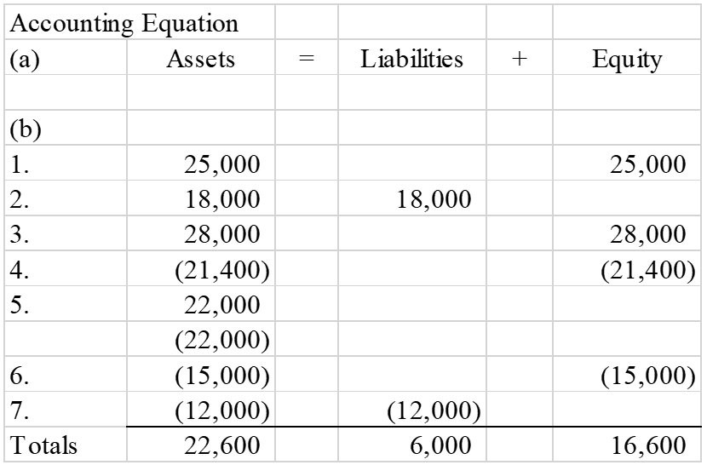
Difficulty: 2 Medium
Topic: Recording Business Events Under the Accounting Equation
Learning Objective: 01-04 Show how business events affect the accounting equation.
Bloom's: Apply
AACSB: Knowledge Application
AICPA: BB Critical Thinking; FN Measurement

129) Each of the following requirements is independent of the others.
a) Valdez Corporation has liabilities of $95,000 and equity of $115,000. What is the amount of Valdez's assets?
b) Global Company has assets of $320,000 and liabilities of $95,000. What is the amount of Global's equity?
c) Brown Company has assets of $90,000 and liabilities of $25,000. What is the amount of Brown's claims?

Answer:
a) $210,000
b) $225,000
c) $90,000
Difficulty: 2 Medium
Topic: Elements of Financial Statements
Learning Objective: 01-03 Identify the components of the accounting equation.
Bloom's: Apply
AACSB: Knowledge Application
AICPA: BB Critical Thinking; FN Measurement

130) The following business events occurred for Ringgold Company during Year 1, its first year in operation:
1. Issued stock to investors for $45,000 cash
2. Borrowed $25,000 cash from the local bank
3. Provided services to its customers and received $32,000 cash
4. Paid expenses of $28,000
5. Paid $22,000 cash for land
6. Paid dividend of $12,000 to stockholders
7. Repaid $10,000 of the loan listed in item 2

Required:
a) Show the effects of the above transactions on the accounting equation, below. Include dollar amounts of increases and decreases. Enter "NA" for elements of the accounting equation that are not affected by the transaction. If one element of the accounting equation is affected by an increase and also by a decrease, enter each part on a separate line. (The effects of the first transaction is shown below.)
b) After entering all the events, calculate the total amounts of assets, liabilities, and equity at the end of the year.

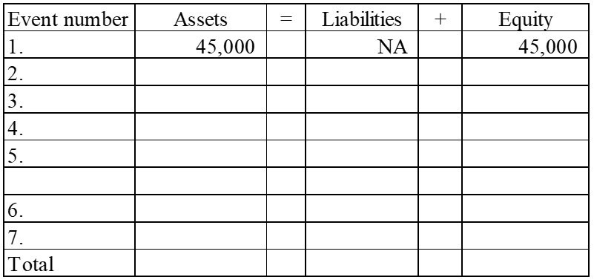

Answer:
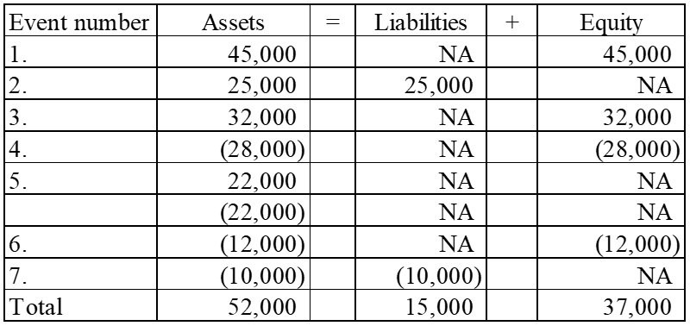
Difficulty: 2 Medium
Topic: Recording Business Events Under the Accounting Equation
Learning Objective: 01-04 Show how business events affect the accounting equation.
Bloom's: Apply
AACSB: Knowledge Application
AICPA: BB Critical Thinking; FN Measurement

131) Ramirez Company experienced the following events during Year 1:
1. Acquired $50,000 cash by issuing common stock
2. Borrowed $25,000 cash from a creditor
3. Provided services to customers for $38,000 cash
4. Paid $32,000 cash for operating expenses
5. Paid a cash dividend of $2,500 to stockholders
6. Purchased land with cash, $30,000

Required:
a) Show how each of these events affects the accounting equation. Enter "NA" for elements of the accounting equation that are not affected by the transaction. If one element of the accounting equation is affected by an increase and also by a decrease, enter each part on a separate line. (The effects of the first event are shown below.)
b) Calculate the total amount of assets, liabilities, common stock, and retained earnings at the end of the period.

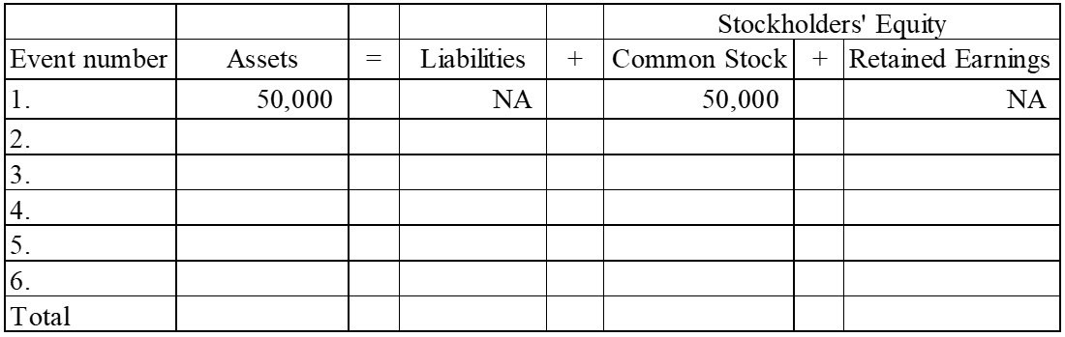

Answer: Stockholders' Equity
Event number | Assets | = | Liabilities | + | Common Stock | + | Retained Earnings
1. | 50,000 |  | NA |  | 50,000 |  | NA
2. | 25,000 |  | 25,000 |  | NA |  | NA
3. | 38,000 |  | NA |  | NA |  | 38,000
4. | (32,000) |  | NA |  | NA |  | (32,000)
5. | (2,500) |  | NA |  | NA |  | (2,500)
6. | 20,000  (20,000) |  | NA |  | NA |  | NA
Total | 78,500 |  | 25,000 |  | 50,000 |  | 3,500

Difficulty: 2 Medium
Topic: Recording Business Events Under the Accounting Equation
Learning Objective: 01-04 Show how business events affect the accounting equation.
Bloom's: Apply
AACSB: Knowledge Application
AICPA: BB Critical Thinking; FN Measurement

132) At the beginning of Year 2, the accounting records of Grace Company included the accounts and balances shown on the first row of the table below. During Year 2, the following transactions occurred:
1. Received $95,000 cash for providing services to customers
2. Paid salaries expense, $50,000
3. Purchased land for $12,000 cash
4. Paid $4,000 on note payable
5. Paid operating expenses, $22,000
6. Paid cash dividend, $2,500

Required:
a) Record the transactions in the appropriate accounts. Record the amounts of revenue, expense, and dividends in the retained earnings column. Enter 0 for items not affected. Provide appropriate titles for these accounts in the last column of the table. (The effects of the first event are shown below.)

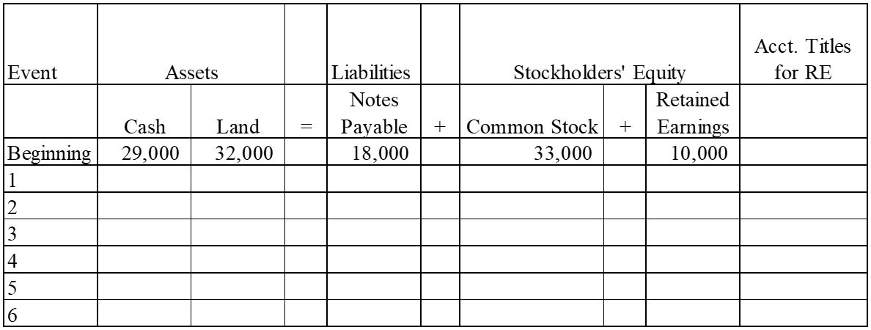

b) What is the amount of total assets as of December 31, Year 2?
c) What is the amount of total stockholders' equity as of December 31, Year 2?

Answer:
a)
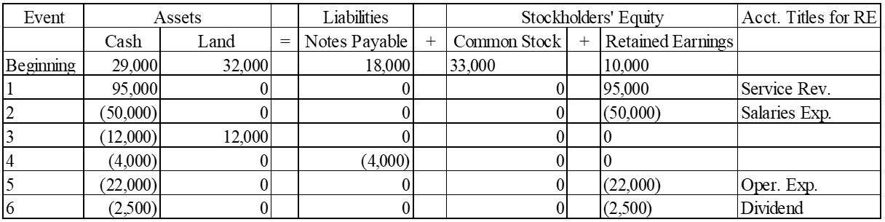

b) Total assets = $33,500 + $44,000 = $77,500
c) Total stockholders' equity = $33,000 + $30,500 = $63,500
Difficulty: 2 Medium
Topic: Recording Business Events Under the Accounting Equation
Learning Objective: 01-04 Show how business events affect the accounting equation.
Bloom's: Apply
AACSB: Knowledge Application
AICPA: BB Critical Thinking; FN Measurement

133) Montgomery Company experienced the following events during Year 1 (all were cash events):
1. Issued a note
2. Paid operating expenses
3. Issued common stock
4. Provided services to customers
5. Repaid part of the note in event 1
6. Paid dividends to stockholders

Required:
Indicate how each of these events affects the accounting equation by writing the letter "I" for increase, the letter "D" for decrease, and "NA" for no effect under each of the components of the accounting equation. Use only one item of entry in each column. (The effects of the first event are shown below.)

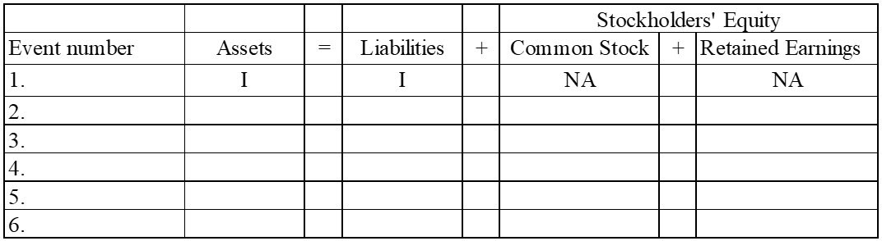

Answer:
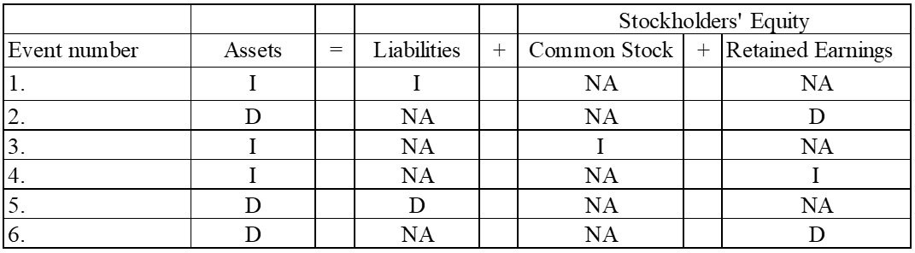
Difficulty: 2 Medium
Topic: Recording Business Events Under the Accounting Equation
Learning Objective: 01-04 Show how business events affect the accounting equation.
Bloom's: Analyze
AACSB: Analytical Thinking
AICPA: BB Critical Thinking; FN Measurement

134) Indicate how each of the following transactions affects assets by entering "+" for increase, "−-" for decrease, or "NA" if total assets are not affected. Enter only one item for each answer.
________ 1) Issued stock to investors.
________ 2) Borrowed cash from the bank.
________ 3) Provided services for cash.
________ 4) Paid operating expenses.
________ 5) Purchased land for cash.
________ 6) Paid cash dividend to the stockholders.
________ 7) Repaid the bank loan.

Answer: 1) +, 2) +, 3) +, 4) −, 5) NA, 6) −, 7) −
Difficulty: 2 Medium
Topic: Recording Business Events Under the Accounting Equation
Learning Objective: 01-04 Show how business events affect the accounting equation.
Bloom's: Analyze
AACSB: Analytical Thinking
AICPA: BB Critical Thinking; FN Measurement

135) Classify each of the following events as an asset source (designate as "AS"), asset use (designate as "AU"), asset exchange (designate as "AX"), or not an asset source (designate as "NA").
________ 1) Borrowed cash from the bank
________ 2) Issued stock for cash
________ 3) Invested cash in the common stock of another company
________ 4) Performed services and collected cash
________ 5) P aid cash for operating expense
________ 6) Purchased equipment for cash
________ 7) Paid dividends to stockholders
________ 8) Repaid the bank loan with cash

Answer: 1) AS 2) AS 3) AX 4) AS 5) AU 6) AX 7) AU 8) AU
Difficulty: 2 Medium
Topic: Types of Transactions
Learning Objective: 01-04 Show how business events affect the accounting equation.
Bloom's: Analyze
AACSB: Analytical Thinking
AICPA: BB Critical Thinking; FN Measurement

136) Grimes Corporation reports the following cash transactions for the year ending December 31, Year 1, its first year of operation:
1) Issued common stock for $35,000
2) Borrowed $25,000 from a local bank
3) Purchased land for $40,000
4) Provided services to clients for $38,000
5) Paid operating expenses of $30,500
6) Paid $2,000 cash dividends to stockholders
Required:
a) What are the total assets for Grimes Corporation at December 31, Year 1?
b) Prepare an income statement for Year 1.

Answer:
a) Total assets = $35,000 + $25,000 + $38,000 − $30,500 − $2,000 = $65,500
b)
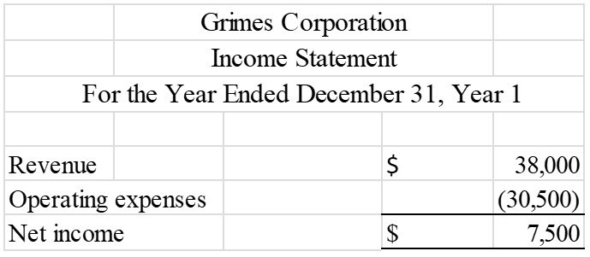
Difficulty: 2 Medium
Topic: Recording Business Events Under the Accounting Equation; Preparing an Income Statement, a Statement of Changes in Stockholders' Equity and a Balance Sheet
Learning Objective: 01-04 Show how business events affect the accounting equation.; 01-07 Prepare an income statement, a statement of changes in stockholders' equity, and a balance sheet.
Bloom's: Apply
AACSB: Knowledge Application
AICPA: BB Critical Thinking; FN Measurement

137) Young Company reported the following balance sheet for the end of Year 1:

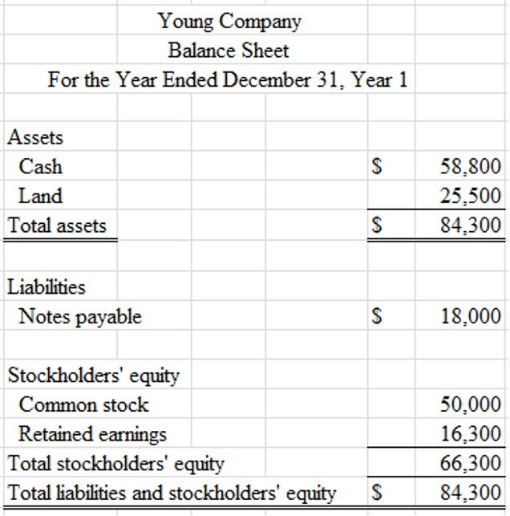

During Year 2, Young reported the following transactions:
• Repaid $9,000 to a local bank on a note payable
• Provided services to clients for $27,400 cash
• Paid operating expenses of $20,200
• Paid $4,500 cash dividends to stockholders
Required:
Prepare Young Company's balance sheet as of December 31, Year 2.

Answer:
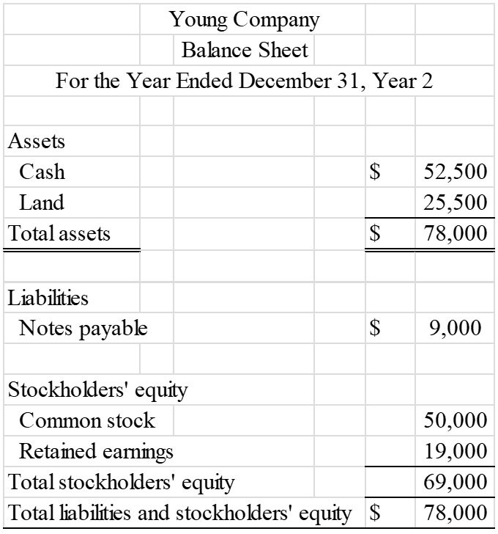

Ending balances: Cash ($58,800−$9,000+$27,400−$20,200−$4,500); Land − No change; Notes payable ($18,000 − $9,000); Common stock − No change; Retained earnings ($16,300+$27,400−$20,200−$4,500)
Difficulty: 2 Medium
Topic: Preparing an Income Statement, a Statement of Changes in Stockholders' Equity and a Balance Sheet
Learning Objective: 01-07 Prepare an income statement, a statement of changes in stockholders' equity, and a balance sheet.
Bloom's: Apply
AACSB: Knowledge Application
AICPA: BB Critical Thinking; FN Measurement

138) Use the following information to prepare an income statement for Penelope Company for the period ending December 31, Year 1. All transactions were for cash.
A) Received revenue from services provided to customers, $30,500.
B) Paid $19,000 cash for land.
C) Issued $16,000 of common stock.
D) Paid dividends to stockholders, $3,000.
E) Paid operating expenses, $25,400.

Answer:
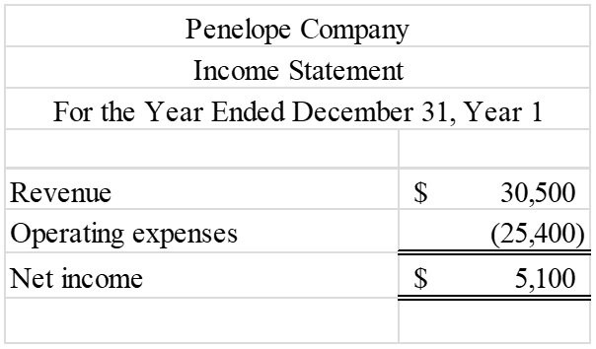

Only revenue and expenses are reported on the income statement. Purchasing land, paying dividends, and issuing common stock do not affect the income statement.
Difficulty: 1 Easy
Topic: Preparing an Income Statement, a Statement of Changes in Stockholders' Equity and a Balance Sheet
Learning Objective: 01-07 Prepare an income statement, a statement of changes in stockholders' equity, and a balance sheet.
Bloom's: Apply
AACSB: Knowledge Application
AICPA: BB Critical Thinking; FN Measurement

139) The following events are for Holiday Travel Services for Year 1, the first year of operations. Assume that all transactions involve the receipt or payment of cash.
1) The business acquired $50,000 from stock issued to owners.
2) Creditors loaned the company $27,500.
3) The company provided services to its customers and received $75,400.
4) The company paid expenses amounting to $63,250.
5) The company purchased land for $25,000.
6) The company paid a dividend of $5,500 to its owners.
Required:
a) Show the effects of the above transactions on the accounting equation. (Start by using appropriate element and account headings). For those events that affect retained earnings, indicate in a separate column the appropriate temporary account. Enter a "0" if a transaction does not affect a given account.

 |  |  |  | = |  | +
Event No. |  | + |  | = |  | + |  | + |  | Other Account Titles
1
2
3
4
5
6
Totals

b) Prepare an income statement and balance sheet for and as of the end of Year 1.

Answer:
a)
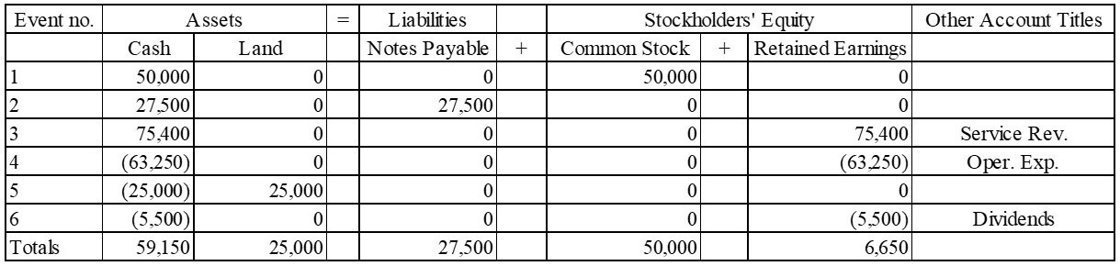

b)
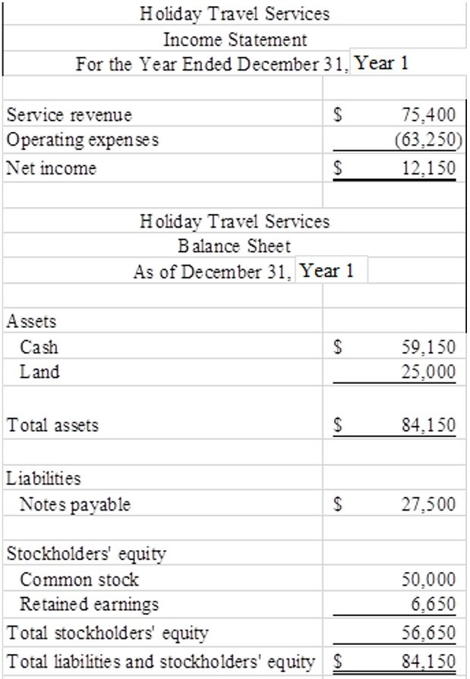
Difficulty: 2 Medium
Topic: Recording Business Events Under the Accounting Equation; Preparing an Income Statement, a Statement of Changes in Stockholders' Equity and a Balance Sheet
Learning Objective: 01-04 Show how business events affect the accounting equation.; 01-07 Prepare an income statement, a statement of changes in stockholders' equity, and a balance sheet.
Bloom's: Apply
AACSB: Knowledge Application
AICPA: BB Critical Thinking; FN Measurement

140) The following transactions apply to Wilson Fitness Center for Year 1.
1) Started the business by issuing $48,000 of common stock for cash.
2) Provided services to clients and received $65,500 cash.
3) Borrowed $10,500 from the bank.
4) Paid $8,500 for rent of equipment.
5) Purchased land for $15,000.
5) Paid $46,600 of salary expense.
6) Cash dividends of $4,000 were paid to the stockholders.

Required:
a) What are the total assets of the business at the end of Year 1?
b) Prepare a statement of cash flows for Year 1.

Answer:
a) Total assets = $48,000 + $65,500 + $10,500 − $8,500 + $15,000 − $15,000 − $46,600 − $4,000 = $64,900
b)
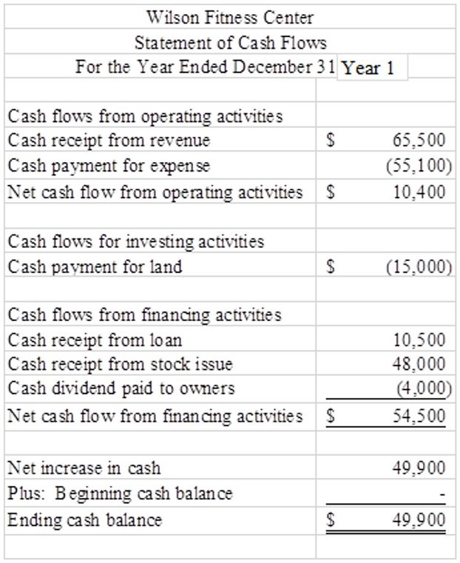
Difficulty: 3 Hard
Topic: Recording Business Events Under the Accounting Equation; Preparing a Statement of Cash Flows
Learning Objective: 01-04 Show how business events affect the accounting equation.; 01-08 Prepare a statement of cash flows.
Bloom's: Apply
AACSB: Knowledge Application
AICPA: BB Critical Thinking; FN Measurement

141) The following is a partial set of financial statements prepared for the company's first year of operations. All transactions were for cash.

Required:
Fill in the missing information by determining the amounts represented by letters a through d.

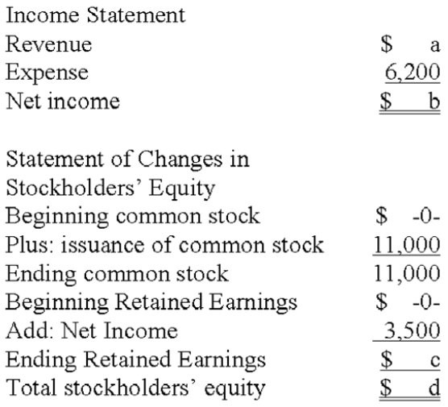

Answer: a) $9,700, b) $3,500, c) $3,500, d) $14,500
Difficulty: 2 Medium
Topic: Preparing an Income Statement, a Statement of Changes in Stockholders' Equity and a Balance Sheet
Learning Objective: 01-07 Prepare an income statement, a statement of changes in stockholders' equity, and a balance sheet.
Bloom's: Apply
AACSB: Knowledge Application
AICPA: BB Critical Thinking; FN Measurement

142) The following is a partial set of financial statements prepared for the company's first year of operations. All transactions were for cash.

Required:
Fill in the blanks indicated by the alphabetic letters in the following financial statements.

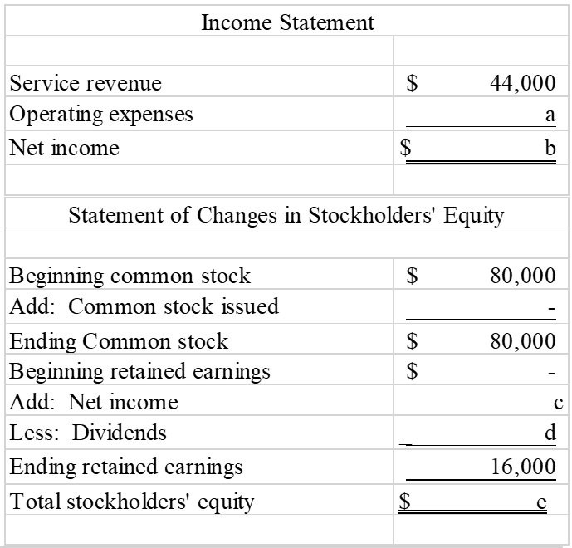
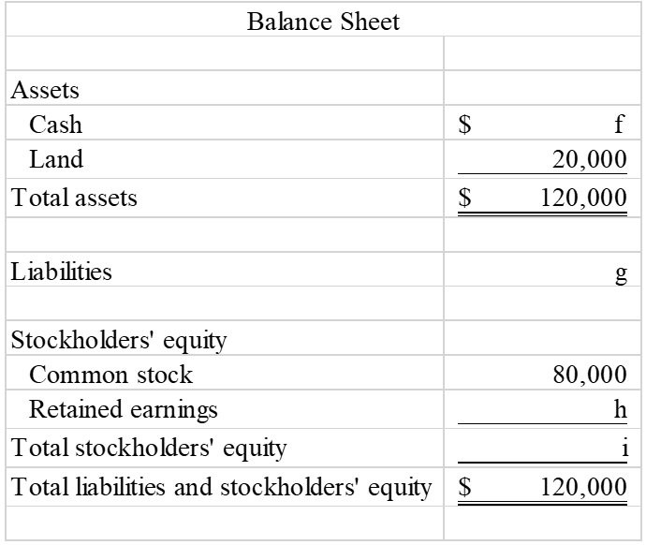
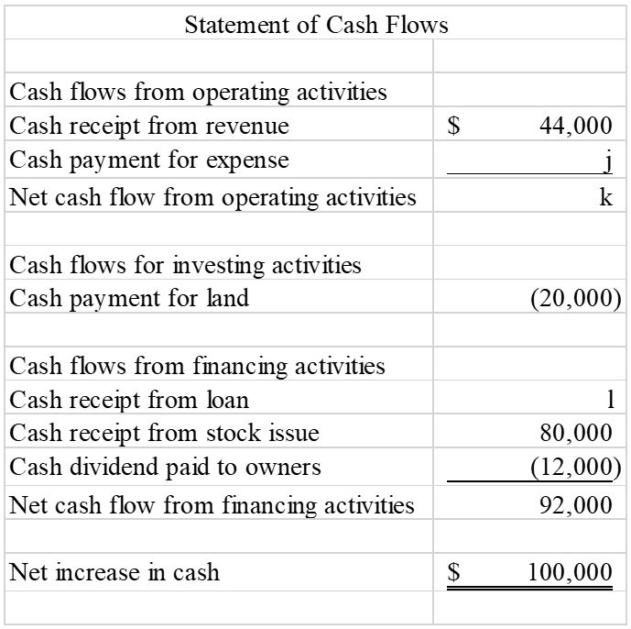

Answer: a = 16,000
b = 28,000
c = 28,000
d = 12,000
e = 96,000
f = 100,000
g = 24,000
h = 16,000
i = 96,000
j = (16,000)
k = 28,000
l = 24,000
Difficulty: 3 Hard
Topic: Preparing an Income Statement, a Statement of Changes in Stockholders' Equity and a Balance Sheet
Learning Objective: 01-05 Interpret information shown in an accounting equation.; 01-06 Classify business events as asset source, use, or exchange transactions.
Bloom's: Apply
AACSB: Knowledge Application
AICPA: BB Critical Thinking; FN Measurement

143) The following transactions apply to the Garber Corporation for Year 1, its first year in business.
1) Issued stock to investors, $48,000.
2) The company borrowed $42,000 cash from the bank.
3) Services were provided to customers and $50,000 cash was received.
4) The company acquired land for $44,000.
5) The company paid $34,000 rent for the building where it does its business.
6) The company paid $3,200 for supplies that were used during the period.
7) The company sold the land acquired in item 5 for $44,000.
8) A dividend of $1,000 was paid to the owners.
9) Repaid $20,000 of the loan described in item 2.

Required:
a. Prepare an income statement, statement of changes in equity, and balance sheet for Year 1.
b. Prepare a statement of cash flows for Year 1.

Answer:
a.
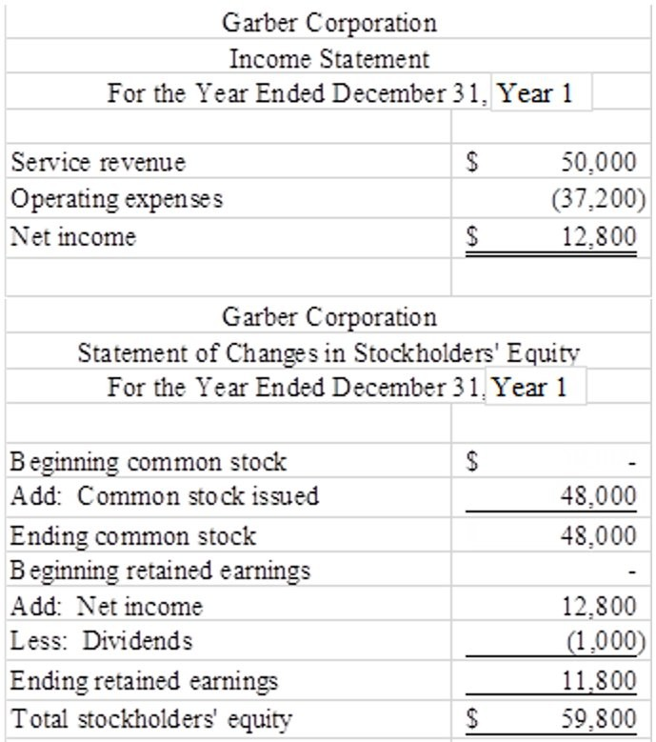
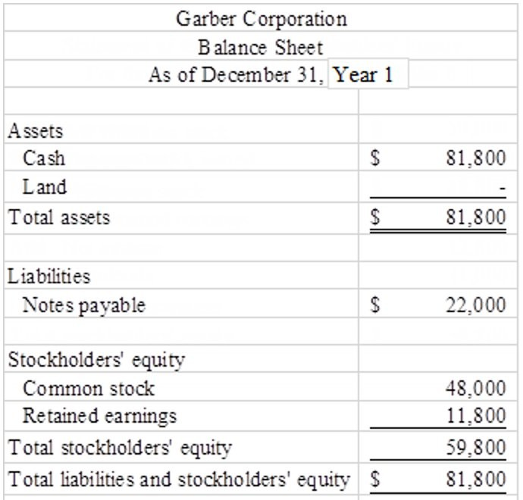

b.
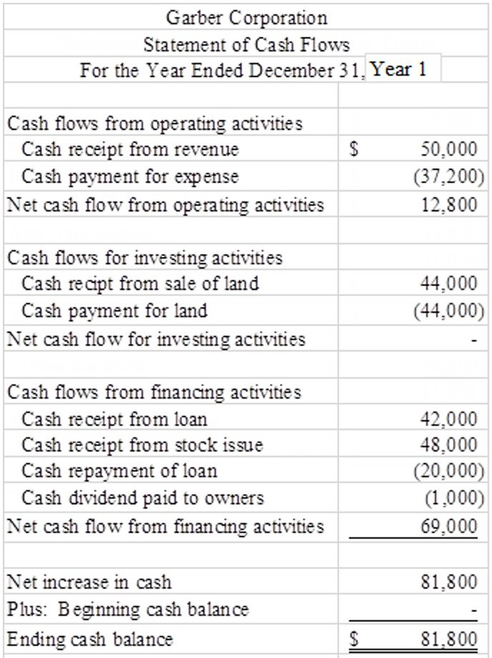
Difficulty: 3 Hard
Topic: Preparing an Income Statement, a Statement of Changes in Stockholders' Equity and a Balance Sheet; Preparing a Statement of Cash Flows
Learning Objective: 01-07 Prepare an income statement, a statement of changes in stockholders' equity, and a balance sheet.; 01-08 Prepare a statement of cash flows.
Bloom's: Apply
AACSB: Knowledge Application
AICPA: BB Critical Thinking; FN Measurement

144) Rosemont Company began operations on January 1, Year 1, and on that date issued stock for $60,000 cash. In addition, Rosemont borrowed $50,000 cash from the local bank. The company provided services to its customers during Year 1 and received $35,000. It purchased land for $70,000. During the year, it paid $10,000 cash for salaries and $9,000 cash for supplies that were used up in its operations. Stockholders were paid cash dividends of $8,000 during the year.

Required:
a) List the transactions from the information above (for example, issued common stock for $60,000) and indicate in which section of the statement of cash flows each transaction would be reported.
b) What would the amount be for net cash flows from operating activities?
c) What would be the end-of-year balance for the cash account?
d) What would be the amount of the total assets for the Rosemont Company at the end of Year 1?
e) What would be the end-of-year balance for the Retained Earnings account?

Answer: a)
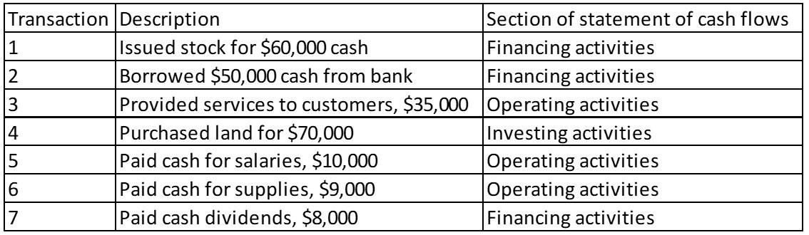

b) Net cash flows from operating activities = $16,000 ($35,000 − 10,000 − 9,000)
c) Cash account balance: $48,000 ($60,000 + $50,000 + $35,000 − $70,000 − $10,000 − $9,000 −- $8,000)
d) Total Assets = $118,000 (Cash = $48,000; Land = $70,000)
e) Retained earnings balance: $8,000 ($35,000 − 10,000 − 9,000 − 8,000)
Difficulty: 3 Hard
Topic: Recording Business Events Under the Accounting Equation; Preparing a Statement of Cash Flows
Learning Objective: 01-04 Show how business events affect the accounting equation.; 01-08 Prepare a statement of cash flows.
Bloom's: Apply
AACSB: Knowledge Application
AICPA: BB Critical Thinking; FN Measurement

145) The Campbell Company began operations on January 1, Year 1 and on that date issued $60,000 of common stock for cash. In addition, the company borrowed $40,000 from the bank. It provided services to its customers during Year 1 and received $72,000 cash. During the year, it paid $80,000 cash for land, $50,000 for salaries, and $10,000 in cash dividends to the owners.

Required:
1) Show the effects of the above transactions on the accounting equation. (Start by using appropriate element and account headings). Enter a "0" if a transaction does not affect a given account.
2) Prepare an income statement and a balance sheet for the Year 1 accounting period.

Answer:
1)
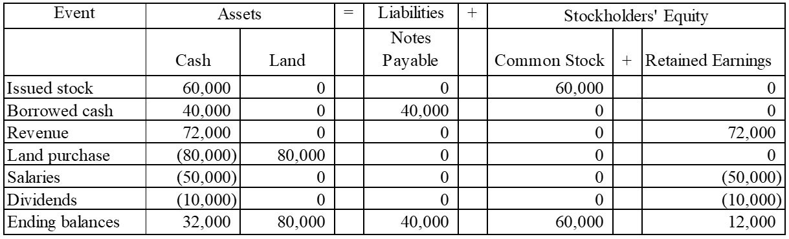

2)
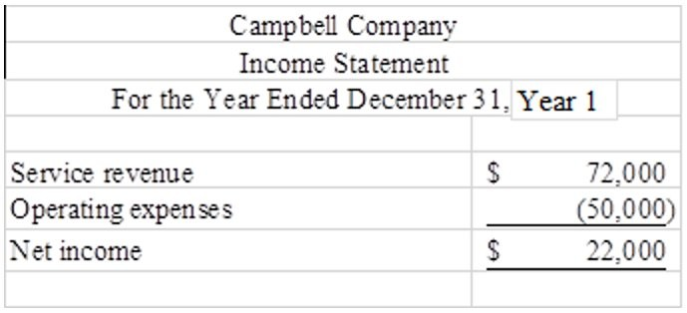

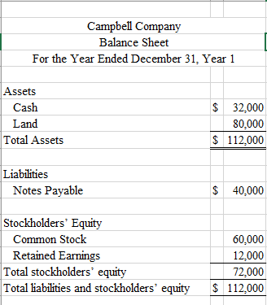
Difficulty: 2 Medium
Topic: Recording Business Events Under the Accounting Equation; Preparing an Income Statement, a Statement of Changes in Stockholders' Equity and a Balance Sheet
Learning Objective: 01-04 Show how business events affect the accounting equation.; 01-07 Prepare an income statement, a statement of changes in stockholders' equity, and a balance sheet.
Bloom's: Apply
AACSB: Knowledge Application
AICPA: BB Critical Thinking; FN Measurement

146) Pinehurst Company was formed in Year 1 and experienced the following accounting events during the year:
1. Issued common stock for $15,000 cash
2. Earned cash revenue of $28,000
3. Paid cash expenses of $20,500.
These were the only events that affected the company during the year.

Required:
a) Show the effects of the above transactions on the accounting equation. (Start by using appropriate element and account headings). Leave the cell blank if a transaction does not affect a given account.
b) Prepare an income statement for Year 1 and a balance sheet as of December 31, Year 1.

Answer:
a)
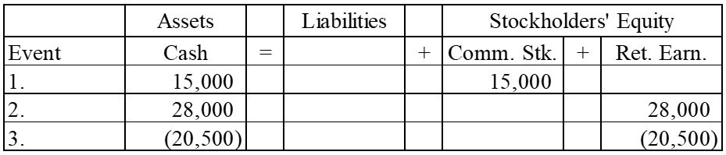

b)
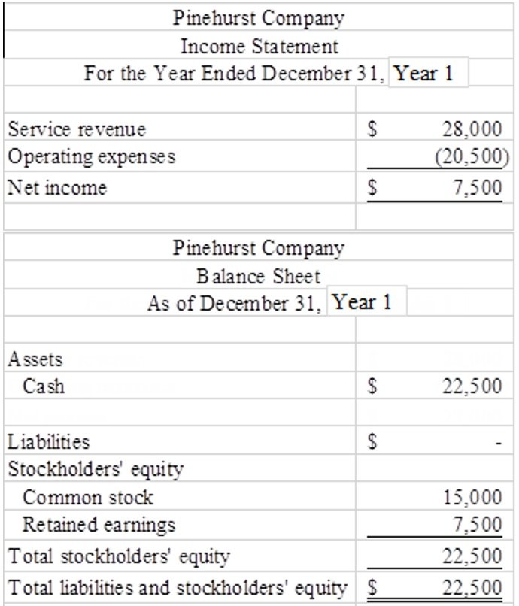
Difficulty: 2 Medium
Topic: Recording Business Events Under the Accounting Equation; Preparing an Income Statement, a Statement of Changes in Stockholders' Equity and a Balance Sheet
Learning Objective: 01-04 Show how business events affect the accounting equation.; 01-07 Prepare an income statement, a statement of changes in stockholders' equity, and a balance sheet.
Bloom's: Apply
AACSB: Knowledge Application
AICPA: BB Critical Thinking; FN Measurement

147) Fieldstone Company was founded on January 1, Year 1. During Year 1, the company experienced the following events:
1. Received cash revenue of $25,500
2. Paid cash expenses of $20,000
3. Issued common stock for $30,000 cash
4. Paid cash dividend of $2,000 to owners.

Required:
a) Show the effects of the above transactions on the accounting equation. (Start by using appropriate element and account headings). Leave the cell blank if a transaction does not affect a given account.
b) Prepare the Year 1 income statement and balance sheet for Fieldstone Company.

Answer:
a)
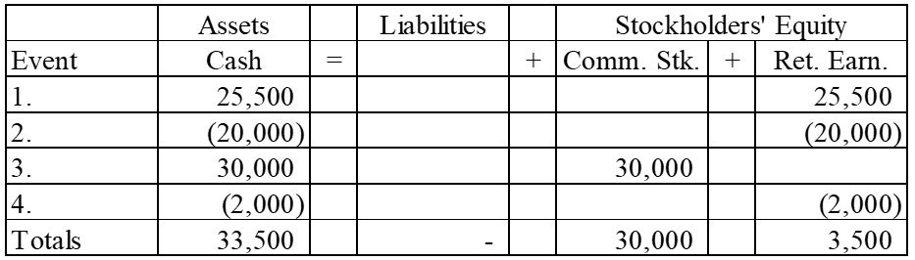

b)
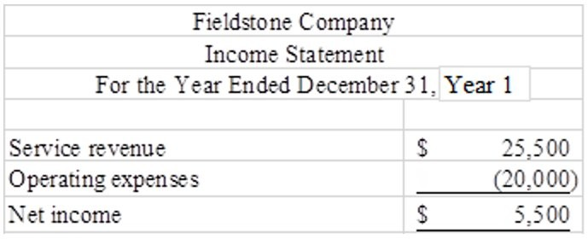
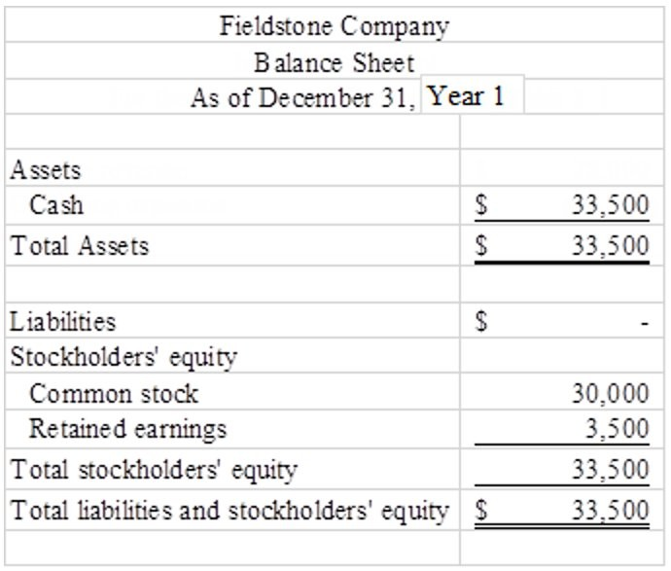
Difficulty: 2 Medium
Topic: Recording Business Events Under the Accounting Equation; Preparing an Income Statement, a Statement of Changes in Stockholders' Equity and a Balance Sheet
Learning Objective: 01-04 Show how business events affect the accounting equation.; 01-07 Prepare an income statement, a statement of changes in stockholders' equity, and a balance sheet.
Bloom's: Apply
AACSB: Knowledge Application
AICPA: BB Critical Thinking; FN Measurement

148) During Year 1, Sawyer Company earned $42,000 of cash revenue and paid $28,200 of cash expenses and $1,600 in dividends to the company's owners. Enter each of these three events into the horizontal financial statements model, below. Indicate dollar amounts of increases and decreases. For cash flows, show whether they are operating activities (OA), investing activities (IA), or financing activities (FA). Enter "NA" if a given transaction does not affect a financial statement element.

Event | Assets | = | Liab. | + | Equity | Rev. | - | Exp. | = | Net Inc. | Stmt of Cash Flows
a)
b)
c)

Answer:
Event | Assets | = | Liab. | + | Equity | Rev. | - | Exp. | = | Net Inc. | Stmt of Cash Flows
a) | 12,000 |  | NA |  | 12,000 | 12,000 |  | NA |  | 12,000 | 12,000 OA
b) | (8,200) |  | NA |  | (8,200) | NA |  | 8,200 |  | (8,200) | (8,200) OA
c) | (600) |  | NA |  | (600) | NA |  | NA |  | NA | (600) FA

Difficulty: 2 Medium
Topic: The Horizontal Financial Statements Model
Learning Objective: 01-10 Record business events using a horizontal financial statements model.
Bloom's: Apply
AACSB: Knowledge Application
AICPA: BB Critical Thinking; FN Measurement

149) During Year 1, Pace Company
issued common stock to stockholders for $12,000, purchased land for $3,200 cash, and paid cash dividends of $1,000 to the company's owners.

Required:
Enter each of these three events into the horizontal financial statements model, below. Indicate dollar amounts of increases and decreases. For cash flows, show whether they are operating activities (OA), investing activities (IA), or financing activities (FA).
Enter 0 if there would be no entry in a column.

Event | Assets | = | Liab. | + | Equity | Rev. | - | Exp. | = | Net Inc. | Stmt of Cash Flows
a)
b)
c)

Answer:
Event | Assets | = | Liab. | + | Equity | Rev. | - | Exp. | = | Net Inc. | Stmt of Cash Flows
a) | 12,000 |  | 0 |  | 12,000 | 0 |  | 0 |  | 0 | 12,000 FA
b) | (3,200) |  | 0 |  | 0 | 0 |  | 0 |  | 0 | (3,200) IA
 | 3,200 |  | 0 |  | 0 | 0 |  | 0 |  | 0 | 0
c) | (1,000) |  | 0 |  | (1,000) | 0 |  | 0 |  | 0 | (1,000) FA

Difficulty: 2 Medium
Topic: The Horizontal Financial Statements Model
Learning Objective: 01-10 Record business events using a horizontal financial statements model.
Bloom's: Apply
AACSB: Knowledge Application
AICPA: BB Critical Thinking; FN Measurement

150) During Year 1, Morsch Company issued common stock to stockholders for $10,000; purchased land for $2,000 cash; provided services to customers for $8,000; paid cash operating expenses of $6,200; and paid cash dividends of $1,000 to the company's owners.

Required:
Enter each of these events into the horizontal financial statements model, below. Indicate dollar amounts of increases and decreases. For cash flows, show whether they are operating activities (OA), investing activities (IA), or financing activities (FA). Enter a "0" if a transaction does not affect a given element of the accounting equation.

Event | Assets | = | Liab. | + | Equity | Rev. | - | Exp. | = | Net Inc. | Stmt of Cash Flows
a)
b)
c)

Answer:
Event | Assets | = | Liab. | + | Equity | Rev. | - | Exp. | = | Net Inc. | Stmt of Cash Flows
a) | 10,000 |  | 0 |  | 0 | 0 |  | 0 |  | 0 | 10,000 FA
b) | (2,000) |  | 0 |  | 0 | 0 |  | 0 |  | 0 | (2,000) IA
 | 2,000 |  | 0 |  | 0 | 0 |  | 0 |  | 0 | 0
c) | 8,000 |  | 0 |  | 8,000 | 8,000 |  | 0 |  | 8,000 | 8,000 OA
d) | (6,200) |  | 0 |  | 0 | 0 |  | 6,200 |  | 6,200 | (6,200) OA
e) | (1,000) |  | 0 |  | (1,000) | 0 |  | 0 |  | 0 | (1,000) FA

Difficulty: 2 Medium
Topic: The Horizontal Financial Statements Model
Learning Objective: 01-10 Record business events using a horizontal financial statements model.
Bloom's: Apply
AACSB: Knowledge Application
AICPA: BB Critical Thinking; FN Measurement

