Chapter 1

Introduction to Texas History and Politics

MULTIPLE CHOICE

- The first modern European nation to lay claim to the territory of Texas was
a. France.
b. Spain.
c. England.
d. Portugal.
Answer: b
Critical Thinking: Knowledge
Difficulty: 1
Text Answer Hint: The Six Flags of Texas: From Spain to Statehood
Topic: Introduction to Texas History and Politics

Texas Standards: L0-1. Explain the origin and development of the Texas constitution.

- Of the six flags flown over Texas, which represented republics?
a. Texas and Mexico
b. the CSA and France
c. Spain and France
d. France and Mexico
Answer: a
Critical Thinking: Comprehension
Difficulty: 2
Text Answer Hint: The Six Flags of Texas: From Spain to Statehood
Topic: Introduction to Texas History and Politics

Texas Standards: L0-1. Explain the origin and development of the Texas constitution.

- The war that led to the declaration of the Republic of Texas began
a. with the battle at the Alamo.
b. in 1835.
c. within months of the arrival of the first American settlers.
d. when the Spanish government imposed restrictions on American settlers.
Answer: b
Critical Thinking: Knowledge
Difficulty: 1
Text Answer Hint: The Six Flags of Texas: From Spain to Statehood
Topic: Introduction to Texas History and Politics

Texas Standards: L0-1. Explain the origin and development of the Texas constitution.

- Who won the battle that led to the independence of Texas from Mexico?
a. Steve Austin
b. James Fannin
c. Sam Houston
d. General Santa Anna
Answer: c
Critical Thinking: Knowledge
Difficulty: 1
Text Answer Hint: The Six Flags of Texas: From Spain to Statehood
Topic: Introduction to Texas History and Politics

Texas Standards: L0-1. Explain the origin and development of the Texas constitution.

- What is the main reason why early petitions by the Republic of Texas to join the United States were rejected?
a. Texas residents favored monarchy, not republicanism.
b. Texas was composed almost entirely of Catholic Spanish speakers.
c. The American government feared sparking a war with Spain.
d. There was controversy over Texas becoming a slave state.
Answer: d
Critical Thinking: Comprehension
Difficulty: 2
Text Answer Hint: The Six Flags of Texas: From Spain to Statehood
Topic: Introduction to Texas History and Politics

Texas Standards: L0-1. Explain the origin and development of the Texas constitution.

- The Adelsverien Society promoted the immigration of _________ settlers in Texas.
a. French
b. Spanish
c. Mexican
d. German
Answer: d
Critical Thinking: Knowledge
Difficulty: 1
Text Answer Hint: The Six Flags of Texas: From Spain to Statehood
Topic: Introduction to Texas History and Politics

Texas Standards: L0-1. Explain the origin and development of the Texas constitution.

- Which of the following statements about Spanish influence in Texas is FALSE:
  - Many rivers, features, and cities still have Spanish names
  - The Spanish introduced slavery to Texas
  - The Spanish introduced horses, sheep, and cattle to Texas
  - Current landownership laws still reflect early Spanish legal systems

Answer: b

Critical Thinking: Apply

Difficulty: 2

Text Answer Hint: The Six Flags of Texas: From Spain to Statehood

Topic: Introduction to Texas History and Politics

Texas Standards: L0-1. Explain the origin and development of the Texas constitution.

- Which flag was the fifth to fly over Texas?
a. Spanish flag
b. United States flag
c. Confederate flag
d. Mexican flag
Answer: b
Critical Thinking: Knowledge
Difficulty: 2
Text Answer Hint: The Six Flags of Texas: From Spain to Statehood
Topic: Introduction to Texas History and Politics

Texas Standards: L0-1. Explain the origin and development of the Texas constitution.

- Texas’ first petition for statehood was denied because:
  - The vast majority of Anglo settlers did not consider themselves American
  - The U.S. felt that Mexico still had a valid claim to the land
  - The Spanish and Mexican settlers who remained in Texas threatened revolt
  - There was not a free state to balance the admittance of Texas as a slave state

Answer: d

Critical Thinking: Comprehension

Difficulty: 2

Text Answer Hint: The Six Flags of Texas: From Spain to Statehood

Topic: Introduction to Texas History and Politics

Texas Standards: L0-1. Explain the origin and development of the Texas constitution.

- Who led the Army of the Gulf in a show of force designed to discourage French support of the Confederacy?
a. Joseph “Black Jack” Pershing
b. Ulysses S. Grant
c. Alfred H. Terry
d. Nathaniel P. Banks
Answer: d
Critical Thinking: Knowledge
Difficulty: 2
Text Answer Hint: Civil War and Reconstruction: A Time of Transition
Topic: Introduction to Texas History and Politics

Texas Standards: L0-1. Explain the origin and development of the Texas constitution.

- Which of the following is an example of “luck” that limited Texas’s exposure to the ravages of the Civil War?
a. official French support of the Confederacy
b. the successful show of force by the Army of the Gulf
c. Native American occupation west of the Balcones Escarpment
d. Maximilian’s long reign in Mexico
Answer: c
Critical Thinking: Comprehension
Difficulty: 2
Text Answer Hint: Civil War and Reconstruction: A Time of Transition
Topic: Introduction to Texas History and Politics

Texas Standards: L0-1. Explain the origin and development of the Texas constitution.

- One of the primary political goals for Reconstruction was
  - to allow Northern states to be readmitted to the Union.
  - to undermine the economy in the Southern states.
  - to restore law and order to a society recovering from war.
  - to reintroduct slavery, in a limited way, in several Southern states.

Answer: c

Critical Thinking: Comprehension

Difficulty: 2

Text Answer Hint: Civil War and Reconstruction: A Time of Transition

Topic: Introduction to Texas History and Politics

Texas Standards: L0-1. Explain the origin and development of the Texas constitution.

- The “carpetbagger’s constitution” reversed which right of whites who had participated in the Civil War?
a. right to bear arms
b. right to vote
c. habeas corpus
d. freedom of assembly
Answer: b
Critical Thinking: Comprehension
Difficulty: 2
Text Answer Hint: Civil War and Reconstruction: A Time of Transition
Topic: Introduction to Texas History and Politics

Texas Standards: L0-1. Explain the origin and development of the Texas constitution.

- Southern Democrats were able to regain control of state government with the election of ________.
a. 1864
b. 1866
c. 1874
d. 1878
Answer: c
Critical Thinking: Knowledge
Difficulty: 1
Text Answer Hint: Civil War and Reconstruction: A Time of Transition
Topic: Introduction to Texas History and Politics

Texas Standards: L0-1. Explain the origin and development of the Texas constitution.

- Approximately how long did one-party Democratic rule last in Texas?
a. 10 years
b. 50 years
c. 100 years
d. 150 years
Answer: c
Critical Thinking: Knowledge
Difficulty: 1
Text Answer Hint: Civil War and Reconstruction: A Time of Transition
Topic: Introduction to Texas History and Politics

Texas Standards: L0-1. Explain the origin and development of the Texas constitution.

- Which of the following elements dominated the land-based economy of post-Reconstruction Texas and is/are still important today?
a. cattle only
b. cotton and oil only
c. oil and cattle only
d. oil, cotton, and cattle
Answer: d
Critical Thinking: Knowledge
Difficulty: 1
Text Answer Hint: Post-Reconstruction Texas
Topic: Introduction to Texas History and Politics

Texas Standards: L0-1. Explain the origin and development of the Texas constitution.

- The discovery of oil transformed Texas by:
  - Accelerating the growth of Texas’s population
  - Sparking the transition to an agricultural economy
  - Increasing the number of Texans who lived in rural areas
  - Reinforcing and even narrowing Texans’ ideas about government

Answer: a

Critical Thinking: Comprehension

Difficulty: 1

Text Answer Hint: Post-Reconstruction Texas

Topic: Introduction to Texas History and Politics

Texas Standards: L0-1. Explain the origin and development of the Texas constitution.

- Mexican governments provided generous land grants to any family willing to settle in the state. The sitio or legua each family could receive was how large?
a. 40 acres and a mule
b. 640 acres or a section
c. 1,500 acres
d. more than 4,000 acres
Answer: d
Critical Thinking: Knowledge
Difficulty: 2
Text Answer Hint: Post-Reconstruction Texas
Topic: Introduction to Texas History and Politics

Texas Standards: L0-1. Explain the origin and development of the Texas constitution.

- What was the primary use of land in Texas from the 1820s to the 1860s?
a. cattle
b. cotton
c. oil
d. Land use in the period was about equally divided among these three.
Answer: b
Critical Thinking: Knowledge
Difficulty: 1
Text Answer Hint: Post-Reconstruction Texas
Topic: Introduction to Texas History and Politics

Texas Standards: L0-1. Explain the origin and development of the Texas constitution.

- In the years following the Civil War, ________ became Texas’s economic mainstay.
a. cattle
b. cotton
c. oil
d. None of these answers is correct.
Answer: a
Critical Thinking: Knowledge
Difficulty: 1
Text Answer Hint: Post-Reconstruction Texas
Topic: Introduction to Texas History and Politics

Texas Standards: L0-1. Explain the origin and development of the Texas constitution.

- Between 1900 and 1950, what was the primary factor that accelerated the demographic shift from a rural society to an urban society in Texas?
a. oil
b. the Civil Rights movement
c. WWI and WWII
d. the automobile
Answer: a
Critical Thinking: Knowledge
Difficulty: 1
Text Answer Hint: Post-Reconstruction Texas
Topic: Introduction to Texas History and Politics

Texas Standards: L0-1. Explain the origin and development of the Texas constitution.

- Today, what industry dominates the Texas economy, employing about 76 percent of the private sector workforce?
a. oil and petrochemical processing
b. the service industry
c. agriculture and cattle
d. manufacturing and the high tech industry
Answer: b
Critical Thinking: Knowledge
Difficulty: 1
Text Answer Hint: Post-Reconstruction Texas
Topic: Introduction to Texas History and Politics

Texas Standards: L0-1. Explain the origin and development of the Texas constitution.

- Currently, the top export of Texas is
a. machinery.
b. computers and electronics.
c. chemicals.
d. petroleum and coal products.
Answer: b
Critical Thinking: Knowledge
Difficulty: 1
Text Answer Hint: Post-Reconstruction Texas
Topic: Introduction to Texas History and Politics

Texas Standards: L0-1. Explain the origin and development of the Texas constitution.

- Which region of the state is of the state is known primarily for its production of citrus fruits and vegetables?
a. Central Corridor
b. Gulf Coast region
c. border area
d. Central Corridor
Answer: c
Critical Thinking: Knowledge
Difficulty: 1
Text Answer Hint: Post-Reconstruction Texas
Topic: Introduction to Texas History and Politics

Texas Standards: L0-1. Explain the origin and development of the Texas constitution.

- The Democratic Party was able to retain power during the Progressive Era by:
  - Passing laws that made it more difficult for Republicans to vote
  - Adopting progressive reforms into its own platform
  - Recruiting more diverse candidates to run for office
  - Purging the party of the “Yellow Dog Democrats”

Answer: b

Critical Thinking: Comprehension

Difficulty: 2

Text Answer Hint: Post-Reconstruction Texas

Topic: Introduction to Texas History and Politics

Texas Standards: L0-1. Explain the origin and development of the Texas constitution.

- The most economically diversified region in Texas is the:
  - Metroplex
  - Border area
  - Central corridor
  - Plains region

Answer: a

Critical Thinking: Knowledge

Difficulty: 1

Text Answer Hint: Post-Reconstruction Texas

Topic: Introduction to Texas History and Politics

Texas Standards: L0-1. Explain the origin and development of the Texas constitution.

- What BEST explains why Texas turned from a Democratic stronghold in the 1930s to a Republican stronghold in the 2000s?
a. Texans on average became more conservative over time.
b. The Democratic Party paid little attention to recruiting strong candidates for political office.
c. The Democratic Party become more liberal over time.
d. The national Democratic Party just assumed it would always control Texas.
Answer: c
Critical Thinking: Analysis
Difficulty: 2
Text Answer Hint: Post-Reconstruction Texas
Topic: Introduction to Texas History and Politics

Texas LO-8. Analyze issues, policies, and political culture of Texas.

- Which of the following best characterizes the partisan nature of Texas over the past 60 years?
  - Texas has evolved from a one-party Republican state to a one-party Democratic state.
  - Texas has evolved from a one-party state to a mulitiparty state.
  - Texas has evolved from a one-party Democratic state to a one-party Repubican state.
  - Texas has evolved from a one-party Democratic state to a conservative state.

Answer: c

Critical Thinking: Comprehension

Difficulty: 3

Text Answer Hint: Post-Reconstruction Texas

Topic: Introduction to Texas History and Politics

Texas Standards: L0-1. Explain the origin and development of the Texas constitution.

Texas Standards: LO-8. Analyze issues, policies, and political culture of Texas.

- As Texas shifted from Democratic to Republican:
  - Its ideological landscape shifted from conservative to liberal
  - Its ideological landscape shifted from liberal to libertarian
  - Its ideological landscape did not really change
  - Its ideological landscape shifted liberal to conservative

Answer: c

Critical Thinking: Comprehension

Difficulty: 3

Text Answer Hint: Post-Reconstruction Texas

Topic: Introduction to Texas History and Politics

Texas Standards: L0-1. Explain the origin and development of the Texas constitution.

Texas Standards: LO-8. Analyze issues, policies, and political culture of Texas.

- Based on the state and national electoral results in the 2014 and 2016 elections, one can conclude that
  - Texas will become a Democratic state once again.
  - Texas will become a more liberal state in the future.
  - Texas will become a two-party state once again.
  - Texas will continue to be a strong Republican state.

Answer: d

Critical Thinking: Comprehension

Difficulty: 3

Text Answer Hint: Post-Reconstruction Texas

Topic: Introduction to Texas History and Politics

Texas LO-8. Analyze issues, policies, and political culture of Texas.

- “Battleground Texas”
  - is a conservative political action committee launched in 2013.
  - is a Democrat political action committee launched in 2013.
  - is a Republican political action committee launched in 2013.
  - is a successful Democratic political action committee.

Answer: b

Critical Thinking: Knowledge

Difficulty: 1

Text Answer Hint: Post-Reconstruction Texas

Topic: Introduction to Texas History and Politics

Texas LO-8. Analyze issues, policies, and political culture of Texas.

- Political Action Committees or PACs enage in activities such as
  - raising and utilizing campaign contributions.
  - appointing candidates to public office.
  - covering candidates for media outlets.
  - developing pieces of legislation.

Answer: a

Critical Thinking: Comprehension

Difficulty: 2

Text Answer Hint: Post-Reconstruction Texas

Topic: Introduction to Texas History and Politics

Texas LO-8. Analyze issues, policies, and political culture of Texas.

- Which of the following characterizes the evolution of the political climate in Texas over the past 50 years?
  - While ideology has shifted, partisanship has remained relatively constant
  - While partisanship has shifted, ideology has remained relatively constant
  - Both partisanship and ideology have changed significantly
  - Neither partisanship nor ideology have changed significantly

Answer: b

Critical Thinking: Comprehension

Difficulty: 3

Text Answer Hint: Post-Reconstruction Texas

Topic: Introduction to Texas History and Politics

Texas Standards: L0-1. Explain the origin and development of the Texas constitution.

Texas LO-8. Analyze issues, policies, and political culture of Texas.

- Polls show that a Texan is MOST likely to identify as a
a. moderate.
b. liberal.
c. independent.
d. conservative
Answer: d
Critical Thinking: Knowledge
Difficulty: 1
Text Answer Hint: Post-Reconstruction Texas
Topic: Introduction to Texas History and Politics

Texas LO-8. Analyze issues, policies, and political culture of Texas.

- In terms of population size, Texas ranks _________ in the nation in comparison to other states.
a. first
b. second
c. third
d. fourth
Answer: b
Critical Thinking: Knowledge
Difficulty: 1
Text Answer Hint: Post-Reconstruction Texas
Topic: Introduction to Texas History and Politics

Texas LO-8. Analyze issues, policies, and political culture of Texas.

- In terms of total land size, Texas ranks _________ in the nation in comparison to other states.
a. first
b. second
c. third
d. fourth
Answer: b
Critical Thinking: Knowledge
Difficulty: 1
Text Answer Hint: Post-Reconstruction Texas
Topic: Introduction to Texas History and Politics

Texas LO-8. Analyze issues, policies, and political culture of Texas.

- The rate of population growth in Texas over the last decade can be characterized as
  - Slow
  - Rapid
  - Negative
  - Bi-generational

Answer: b

Critical Thinking: Knowledge

Difficulty: 1

Text Answer Hint: Post-Reconstruction Texas

Topic: Introduction to Texas History and Politics

Texas LO-8. Analyze issues, policies, and political culture of Texas.

- Which of the following is NOT a reason the population in Texas has been growing?
  - Migration from other countries
  - Migration from other states
  - Federal relocation programs
  - Increasing birth rates

Answer: c

Critical Thinking: Knowledge

Difficulty: 1

Text Answer Hint: Post-Reconstruction Texas

Topic: Introduction to Texas History and Politics

Texas LO-8. Analyze issues, policies, and political culture of Texas.

- Based on the number of seats award to Texas after the 2010 Census, what can be concluded about population change in Texas?
  - Texas has grown more than other states from 2000-2010.
  - Texas has grown less than other states from 2000-2010.
  - Texas has not grown from 2000-2010.
  - Texas will continue to grow for the next two decades.

Answer: a

Critical Thinking: Apply

Difficulty: 3

Text Answer Hint: Post-Reconstruction Texas

Topic: Introduction to Texas History and Politics

Texas LO-8. Analyze issues, policies, and political culture of Texas.

Figure 1.3
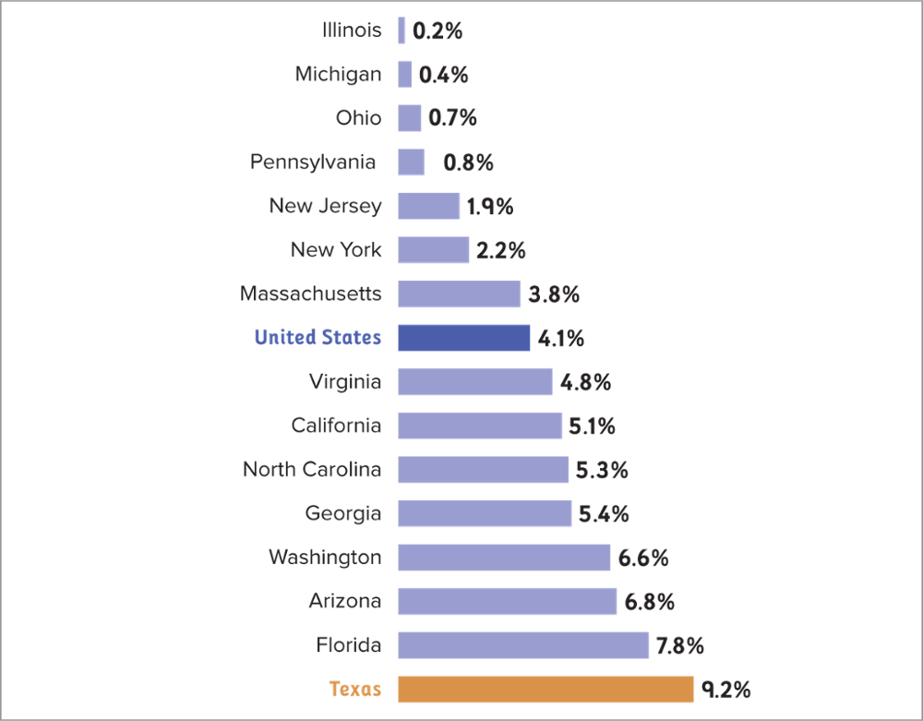
Percentage Change in Population for the 15 Most Populous States, 2010—2015
SOURCE: Adapted from U.S. Census Bureau, Population Estimates, Table 2. Cumulative Estimates of Resident Population Change for the United States, Regions, States, and Puerto Rico and Region and State Rankings: April 1, 2010 to July 1, 2015; http://www.census.gov/popest/data/State/totals/2015/index.html.

- According to Figure 1.3 in the text, what can be determined about population change in Texas?
  - Population growth in texas is about the same as most states.
  - Population growth in Texas is lower than the national average
  - Population growth in Texas is the same as the national average.
  - Population in Texas has grown about twice the national rate.

Answer: d

Critical Thinking: Application

Difficulty: 3

Text Answer Hint: Post-Reconstruction Texas

Topic: Introduction to Texas History and Politics

Texas LO-8. Analyze issues, policies, and political culture of Texas.

Figure 1.3
Percentage Change in Population for the 15 Most Populous States, 2010—2015
SOURCE: Adapted from U.S. Census Bureau, Population Estimates, Table 2. Cumulative Estimates of Resident Population Change for the United States, Regions, States, and Puerto Rico and Region and State Rankings: April 1, 2010 to July 1, 2015; http://www.census.gov/popest/data/State/totals/2015/index.html.

- According to Figure 1.3 in the text, the population in Southern states, such as Texas,
  - is growing at an above average rate.
  - is growing at a below average rate.
  - is growing less than Northern states.
  - is not growing.

Answer: a

Critical Thinking: Application

Difficulty: 3

Text Answer Hint: Post-Reconstruction Texas

Topic: Introduction to Texas History and Politics

Texas LO-8. Analyze issues, policies, and political culture of Texas.

- In terms of the number of Texans living in urban and rural locales, what is the trend that can be seen based on U.S. Census Bureau data?
  - Texas is becoming more rural.
  - Texas is stable in terms of its urban vs. rural population.
  - The Census Bureau does not track this information.
  - Texas is becoming more urban.

Answer: d

Critical Thinking: Knowledge

Difficulty: 1

Text Answer Hint: Post-Reconstruction Texas

Topic: Introduction to Texas History and Politics

Texas LO-8. Analyze issues, policies, and political culture of Texas.

- Minority groups in Texas:
  - Have no influence on politics and policy decisions
  - Are shrinking due to an influx of whites in other states
  - Outnumber non-Hispanic whites
  - Are primarily concentrated in rural areas

Answer: c

Critical Thinking: Comprehension

Difficulty: 2

Text Answer Hint: Post-Reconstruction Texas

Topic: Introduction to Texas History and Politics

Texas LO-8. Analyze issues, policies, and political culture of Texas

Figure 1.4 Party Identification of Texas Voters by Religious Affiliation
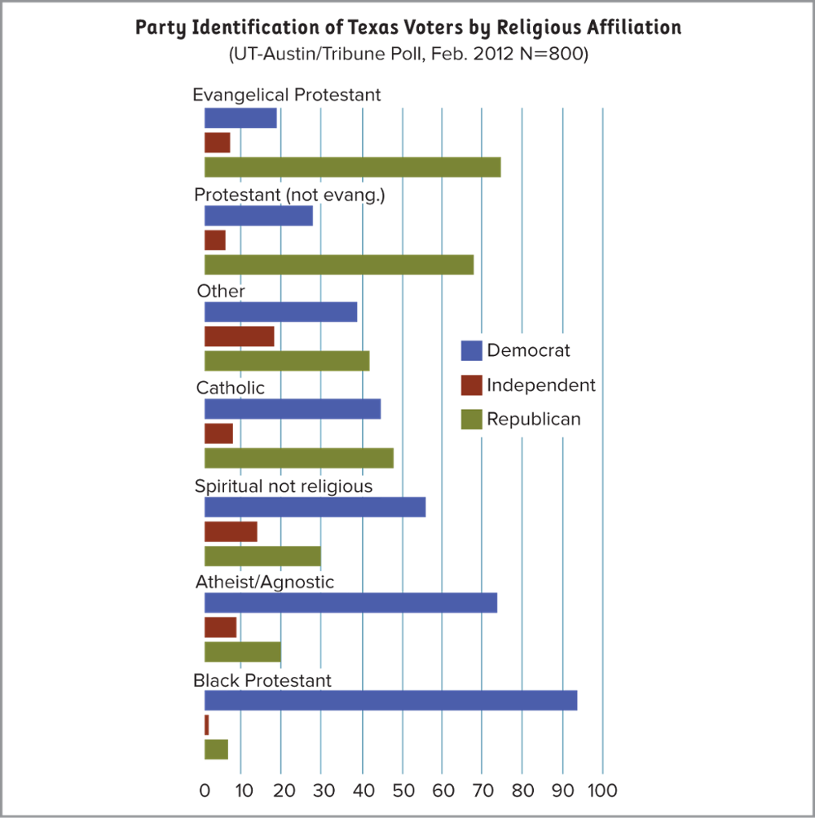

- Given the information in Figure 1.4, a candidate attempting to appeal to the largest number of Protestant voters using a socially conservative message would seek to build relationships with
  - Evangelical ministers and non-denominational congregants
  - African American ministers and African American protestant congregants
  - Catholic priests and their congregants
  - Methodist and Episcopalian ministers and their congregants

Answer: a

Critical Thinking: Comprehension

Difficulty: 2

Text Answer Hint: Post-Reconstruction Texas

Topic: Introduction to Texas History and Politics

Texas LO-8. Analyze issues, policies, and political culture of Texas

- As of 2014, white non-Hispanics made up about ___ percent of the state’s population.
a. 34
b. 44
c. 54
d. 64
Answer: b
Critical Thinking: Knowledge
Difficulty: 1
Text Answer Hint: Post-Reconstruction Texas
Topic: Introduction to Texas History and Politics

Texas LO-8. Analyze issues, policies, and political culture of Texas.

- As of 2014, Hispanics made up about ___ percent of the state’s population.
a. 14
b. 27
c. 39
d. 52
Answer: c
Critical Thinking: Knowledge
Difficulty: 1
Text Answer Hint: Post-Reconstruction Texas
Page: 16
Topic: Introduction to Texas History and Politics

- Members of which of the following groups are most likely to identify themselves as Republican?
a. evangelical Protestants
b. Protestants of the black church tradition
c. Roman Catholics
d. agnostics
Answer: a
Critical Thinking: Knowledge
Difficulty: 1
Text Answer Hint: Post-Reconstruction Texas
Topic: Introduction to Texas History and Politics

Texas LO-8. Analyze issues, policies, and political culture of Texas.

- Compared to other states, Texas has:
  - Lower poverty rates and higher population growth
  - Higher poverty rates and higher population growth
  - Lower poverty rates and lower population growth
  - Higher poverty rates and lower population growth

Answer: b

Critical Thinking: Knowledge

Difficulty: 2

Text Answer Hint: Post-Reconstruction Texas

Topic: Introduction to Texas History and Politics

Texas LO-8. Analyze issues, policies, and political culture of Texas.

- From 2008-2012, Texas’s unemployment rate
a. was the highest in the nation.
b. was among the highest in the nation.
c. was about the national average.
d. was lower than the national average.
Answer: d
Critical Thinking: Knowledge
Difficulty: 1
Text Answer Hint: Current Challenges: Texas Today
Topic: Introduction to Texas History and Politics

Texas LO-8. Analyze issues, policies, and political culture of Texas.

- A belief that government is a positive instrument for change and a means for promoting the general welfare of all citizens defines which political subculture?
a. traditionalistic
b. individualistic
c. moralistic
d. neoconservative
Answer: c
Critical Thinking: Comprehension
Difficulty: 2
Text Answer Hint: Texas Political Culture
Topic: Introduction to Texas History and Politics

Texas LO-8. Analyze issues, policies, and political culture of Texas.

- Opposition to laws that increase government involvement in private business is an example of which political subculture?
  - Moralistic
  - Mercantilistic
  - Individualistic
  - Traditionalistic

Answer: c

Critical Thinking: Comprehension

Difficulty: 2

Text Answer Hint: Texas Political Culture

Topic: Introduction to Texas History and Politics

Texas LO-8. Analyze issues, policies, and political culture of Texas.

- John believes that government’s primary purpose is to defend the country and build roads. Additionally, he believes in low pay and term limits for political offices. John is demonstrating the beliefs of which political subculture?
a. traditionalistic
b. individualistic
c. moralistic
d. neoconservative
Answer: b
Critical Thinking: Application
Difficulty: 2
Text Answer Hint: Texas Political Culture
Topic: Introduction to Texas History and Politics

Texas LO-8. Analyze issues, policies, and political culture of Texas.

- Which political subculture was a natural extension of the practice of slavery?
a. traditionalistic
b. individualistic
c. moralistic
d. neoconservative
Answer: a
Critical Thinking: Analysis
Difficulty: 2
Text Answer Hint: Texas Political Culture
Topic: Introduction to Texas History and Politics

Texas LO-8. Analyze issues, policies, and political culture of Texas.
- Which group was forced to adopt the traditionalistic political subculture because of their subservient role?
a. Anglos
b. African American slaves
c. Mexicans
d. German and Midwestern settlers
Answer: b
Critical Thinking: Comprehension
Difficulty: 2
Text Answer Hint: Texas Political Culture
Topic: Introduction to Texas History and Politics

Texas LO-8. Analyze issues, policies, and political culture of Texas.

- Classical liberalism focuses on the protection of
a. group rights.
b. large government.
c. judicial activism.
d. a generally free market economy.
Answer: d
Critical Thinking: Comprehension
Difficulty: 2
Text Answer Hint: Texas Political Culture
Topic: Introduction to Texas History and Politics

Texas LO-8. Analyze issues, policies, and political culture of Texas.

- Many Texans oppose same-sex marriage and abortion. This is a reflection of ___________ in the state’s ideology:
  - Mercantilism
  - Modern liberalism
  - Populism
  - Social Conservatism

Answer: d

Critical Thinking: Comprehension

Difficulty: 2

Text Answer Hint: Texas Political Culture

Topic: Introduction to Texas History and Politics

Texas LO-8. Analyze issues, policies, and political culture of Texas.

- Given Texas’ political culture, which of the following best reflects a governmental policy the majority would be supportive of
  - Creating a state income tax to ensure public schools are sufficiently funded
  - Expansion of Medicaid to ensure people at 200% of the poverty level are afforded health coverage
  - Expanding regulations of hydraulic fracturing (fracking) to protect the underground water table
  - Expanded tax credits for enticing businesses to move to Texas

Answer: d

Critical Thinking: Analysis

Difficulty: 3

Text Answer Hint: Texas Political Culture

Topic: Introduction to Texas History and Politics

Texas LO-8. Analyze issues, policies, and political culture of Texas.

ESSAY

- In what areas did the Tejanos principally settle in Texas? Give examples of how Spain’s colonialism still influences Texas today.

- What was the principle cause of the Mexican-American War? How did the war end? What territorial gains were made because of the war?

- Prior to 1850, why were there so few Anglo settlers west of the Balcones Escarpment? What efforts were made by the U.S. government to encourage settlement?
- What is the history of the production of oil and petroleum products in Texas? How has it helped shape the state’s economy?

- Describe and explain the changes in political party dominance in Texas from the end of the Civil War to the present.

- Why is the Democratic Party currently at a distinct disadvantage in Texas? What could possibly reverse the party’s fortunes and bring them back to power in the state?
- What have been recent patterns of immigration and in-migration to Texas, and what explains them?

- Why is the traditional political subculture a natural extension of the practice of slavery? Is the traditional political subculture in harmony with democracy? Why or why not?

- Compare and contrast classical and modern liberalism with an emphasis on how they view economics, government, and the individual.

