1. The solution of the initial value problem is , where
(Select the correct answer.)
​
 | a. | 2
 | b. | -2
 | c. | 3
 | d. | -3
 | e. | 1

ANSWER: | a

2. The solution of the initial value problem 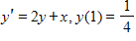is 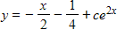, where
Select the correct answer.
​
 | a. | 2
 | b.
 | c.
 | d.
 | e. | 1

ANSWER: | b

3. The initial value problem 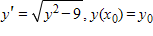has a unique solution guaranteed by Theorem 1.1 if
Select the correct answer.
​
a.
b.
c.
d.
e.

ANSWER: | c

4. The solution of the initial value problem is , where
(Select the correct answer.)
​
 | a.
 | b. | 3
 | c.
 | d.
 | e.

ANSWER: | a

5. The solution of the initial value problem 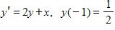is , where
(Select the correct answer.)
​
 | a. | 2
 | b.
 | c.
 | d.
 | e. | 1

ANSWER: | b

6. The initial value problem 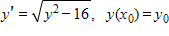has a unique solution guaranteed by Theorem 1.1 if
Select the correct answer.
​
a.
b.
c.
d.
e.

ANSWER: | d

