1

Core Network Concepts and Terminology
Last Name: _____________________________________
First Name: _____________________________________
Due Date: ___________________

Instructions
Homework files are in Word for Windows format.
You download them from the book’s website.
In a chapter, your teacher may assign you questions to complete.
To begin typing your answer, click after the right angle brackets.

A State of Siege
1. a) What is a DDoS attack?
>>>
b) In what two ways was the KrebsOnSecurity.com DDoS attack unusual?
>>>
c) What do we mean by the “Internet of Things”?
>>>
d) What happens when a host cannot reach a Domain Name System server?
>>>
e) What specific security weakness did the Mirai malware use to propagate from machine to machine?
>>>

Anything, Anytime, Anywhere
2. When was commercial activity on the Internet first allowed?
>>>
3. a) What services do Internet service providers provide?
>>>
b) In Figure 1-2, through which ISP(s) will traffic pass if a packet from Hawaii.edu goes to Panko.com?
>>>
c) Through which ISP(s) will traffic pass if a packet from Microsoft.com goes to the mobile phone in the lower right of Figure 1-2?
>>>
d) In Figure 1-2, through which ISP(s) may traffic pass if a packet from Microsoft.com goes to Panko.com? (Hint. There are multiple possible answers.)
>>>
4. a) What do we call any device connected to the Internet?
>>>
b) When you use a laptop to connect to the Internet, is it a host? Explain in terms of the definition of host.
>>>
c) When you use the Internet, are you a host? Explain in terms of the definition.
>>>
5. a) What continuing changes in the Internet are contributing to its ability to support new applications constantly?
>>>
b) What are the characteristics of the Internet of Things?
>>>
6. a) Who owns the Internet?
>>>
b) Who is in charge of the Internet?
>>>
c) What is the role of the IETF?
>>>
7. a) Why is the Internet’s ability to give broad access a good thing?
>>>
b) What danger does it bring?
>>>
8. a) What does “Inter” in Internet mean.
>>>
b) Why is this significant?
>>>

Outside the Internet
9. a) Why is the Internet often depicted as a cloud?
>>>
b) Why is the Internet not about sending messages between hosts?
>>>
10. a) Distinguish between client and server hosts.
>>>
b) What type of devices are most servers?
>>>
11. a) What are networked applications?
>>>
b) Is the client always a browser?
>>>
c) Is the server always a webserver?
>>>
12. a) What two processes does the network stack provide?
>>>
b) What is the maximum size of an IP packet?
>>>
c) What does the transport process do to the application message if it is short enough to fit in a single packet If the application message is too long?
>>>
d) What does the transport process add to the application message or fragment?
>>>
e) What is the resulting message called?
>>>
f) What does the internet process do with each TCP segment?
>>>
13. What are the three parts of an IP packet?
>>>
14. a) What does the internet process on the destination host do when a packet arrives for it?
>>>
b) What does the transport process on the destination host do with multiple TCP segments from a single application message? (This answer is not short.)
>>>

Inside the Internet
15. a) How many bits long are IPv4 addresses?
>>>
b) Convert 00000001 00000010 00000000 11111111 to dotted decimal notation (spaces have been added). (Note: 00000001 is 1).
>>>
c) Convert 5.6.0.255 to a 32-bit IP address (add spaces between groups of 8 bits). (Note: 5 is 0000101, not 101.)
>>>
16. a) What are the three parts of an IP packet? (Yes, this is a repeat of an earlier question.)
>>>
b) In which part will you find the source and destination IP addresses?
>>>
c) Which of these addresses will routers use to deliver the IP packet?
>>>
17. a) What does a router do when an IP packet arrives?
>>>
b) What is router forwarding called?
>>>
c) In Figure 1-17, suppose that 60.3.27.47 transmits a packet to 128.171.17.13. When Router C receives the packet, what will be its routing choices?
>>>
18. a) Distinguish between data links and routes.
>>>
b) In Figure 1-15, how many data links are there when the packet travels to Host 5.6.7.8?
>>>
c) How many routes will there be?
>>>
d) In general, when a source host sends a packet to a destination host, will there probably be more data links or routes along the way? Explain. (The answer is not in the text.)
>>>
19. a) There are six routers between the source and destination host. How many transport processes will be involved? Explain.
>>>
b) How many internet processes will be involved? Explain.
>>>
20. Why does the Internet need supervisory protocols?
>>>
21 a) What type of host gets a dynamic IP address?
>>>
b) What type of host gets a static IP address?
>>>
c) Why is a static IP address needed for this type of host?
>>>
d) Does a DHCP server give a host the same IP address each time?
>>>
22. a) Distinguish between the originating host, the DNS server, and the target host.
>>>
b) What is the purpose of a DNS lookup?
>>>
c) Does the originating host need to contact the DNS host each time it sends a packet to the target host? Explain.
>>>

Single Networks, Data Links, and Physical Links
23. a) Distinguish between physical links and data links.
>>>
b) In a point-to-point single network, how many physical links will there be when a packet is transmitted?
>>>
c) How many data links?
>>>
24. a) In Figure 1-22, how many physical links will there be when Router A sends a Packet to Router B.
>>>
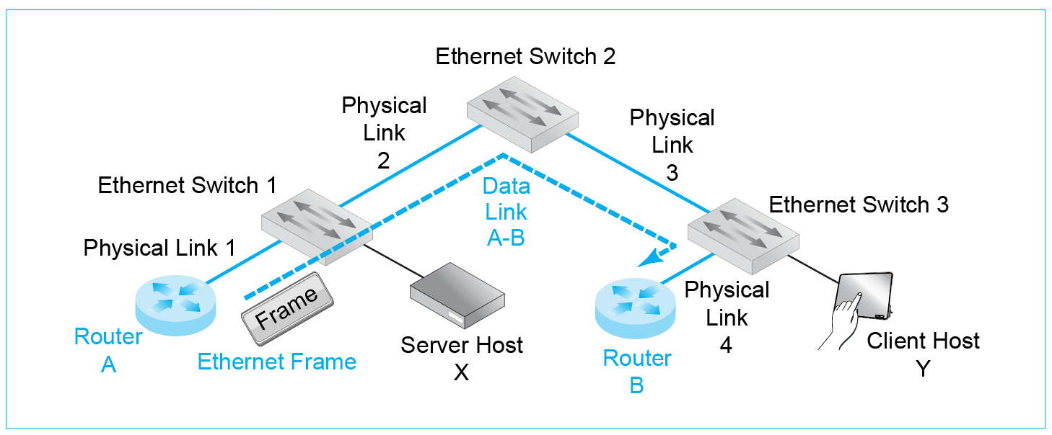
b) How many data links will there be?
>>>
c) When Client Host Y sends a packet to Router B, how many physical links will there be?
>>>
d) Data links?
>>>
e) When Client Host Y sends a packet to Server Host X, how many physical links will there be?
>>>
f) Data links?
>>>
25. a) Are packets carried inside frames, or are frames carried inside packets?
>>>
b) A host sends a packet to another host. There are ten single networks along the way. How many hosts will there be?
>>>
c) How many data links?
>>>
d) How many routes?
>>>
e) How many frames?
>>>
f) How many packets?
>>>
g) To what device will the first host transmit a frame containing a packet?
>>>
h) To what device will the final router address a frame?
>>>
26. a) Are all data link addresses EUI-48 addresses?
>>>
b) In which header are source and destination IP addresses found?
>>>
c) In which header are source and destination data link addresses found?
>>>
d) What kind of data link address do Ethernet networks use?
>>>
e) What kind of data link address do Wi-Fi networks use.
>>>
f) Why do hosts need two addresses?
>>>

Internet Routers and Personal Access Routers
27. a) Compare Internet core routers with home access routers in terms of functionality.
>>>
b) Compare them in terms of routing complexity.
>>>
c) Compare corporate access points and Internet access routers with wireless access point capabilities.
>>>

End of Chapter Questions
Thought Questions
1-1. In Figure 1-28, when Host A transmits a packet to Host B, how many physical links, data links, and routes will there be along the way? How many packets and frames? How many switches and routers? (Hint: the answers are in the figure, but work it out yourself.)
>>>
1-2 Repeat for Host C sending a packet to Host E.
>>>
1-3. Repeat for Host A to Host C.
>>>
1-4. Repeat for Host E and Router 3.
>>>
1.5. Repeat for Router 1 and Router 3.
>>>
1-6. Repeat for Router 1 and Router 2.
>>>
Perspective Questions
1-7. What was the most surprising thing you learned in this chapter?
>>>
1-8. What was the most difficult thing in this chapter for you? Why was it difficult?

