1. Give the ground-state electron configuration for carbon (atomic number 6).
ANSWER: | 1s²2s²2p_{x}¹2p_{y}¹ or 1s²2s²2p²
POINTS: | 1

2. Give the ground-state electron configuration for fluorine (atomic number 9).
ANSWER: | 1s²2s²2p_{x}² 2p_{y}² 2p_{z}¹ or 1s²2s²2p⁵
POINTS: | 1

3. Give the ground-state electron configuration for magnesium (atomic number 12).
ANSWER: | 1s²2s²2p⁶3s²
POINTS: | 1

4. How many electrons does silicon have in its valence shell?
ANSWER: | four
POINTS: | 1

Exhibit 1-1
Write valid Lewis (electron-dot) structures for each formula below. Show all electrons as dots and show all non-bonding electrons.

5. C₂Cl₄ tetrachloroethylene
ANSWER:
POINTS: | 1

6. CO₂ carbon dioxide
ANSWER:
POINTS: | 1

7. CH₄O methanol
ANSWER:
POINTS: | 1

Exhibit 1-2
Consider the structure of urea, shown below, to answer the following question(s).
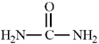

8. Refer to Exhibit 1-2. Fill in any non-bonding valence electrons that are missing from the line-bond structure.
ANSWER:
POINTS: | 1

9. Refer to Exhibit 1-2. The carbon atom in urea is:
a. | sp³ hybridized
b. | sp² hybridized
c. | sp hybridized
d. | not hybridized

ANSWER: | b
POINTS: | 1

10. Refer to Exhibit 1-2. The predicted NH₂−C=O bond angle in urea is:
a. | 109.5°
b. | 120°
c. | 180°
d. | not predictable

ANSWER: | b
POINTS: | 1

Exhibit 1-3
Determine the hybridization for the indicated atoms in each structure below.
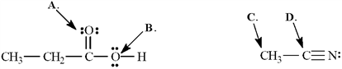

11. Refer to Exhibit 1-3. The hybridization of this oxygen atom (A) is ______.
ANSWER: | sp²
POINTS: | 1

12. Refer to Exhibit 1-3. The hybridization of this oxygen atom (B) is ______.
ANSWER: | sp³
POINTS: | 1

13. Refer to Exhibit 1-3. The hybridization of this carbon atom (C) is ______.
ANSWER: | sp³
POINTS: | 1

14. Refer to Exhibit 1-3. The hybridization of this carbon atom (D) is ______.
ANSWER: | sp
POINTS: | 1

15. The molecular formula C₂H₄O can be converted into three-line bond (Kekulé) structures that are consistent with valence rules.
a. |  | b. |  | c. |  | d.

a. | Which one of the Kekulé structures is not consistent with valence rules?
b. | Explain why the structure you chose in part a is not consistent with valence rules.

ANSWER: | a. d  b. The carbon bonded to the oxygen atom in structure d is pentavalent; it has 10 valence electrons. Carbon can only have eight valence electrons. In addition, the other carbon has only six valence electrons when it would prefer to have eight.
POINTS: | 1

16. The original question was combined with #15. This placeholder question is here to maintain the integrity of the numbering system between the printed copy and ExamView. Therefore, it has been marked "do not use on test" in ExamView's question information dialog. As a result, this placeholder question is automatically prevented from being chosen as a test question.
ANSWER: | Answer not provided.
POINTS: | 1

17. Convert the following structure to a skeletal drawing and give its molecular formula.
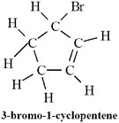
ANSWER: | Molecular formula: C₅H₇Br
POINTS: | 1

18. Draw an orbital picture for acetylene, C₂H₂. Clearly label each bond type and indicate the type of orbitals involved in each bond.
ANSWER:
POINTS: | 1

Exhibit 1-4
Propose possible structures for a molecule that meets each of the following descriptions.

19. Refer to Exhibit 1-4. Contains two sp³ hybridized carbons and two sp hybridized carbons.
ANSWER:
POINTS: | 1

20. Refer to Exhibit 1-4. Contains one sp³ hybridized carbon and two sp² hybridized carbons.
ANSWER:
POINTS: | 1

21. Convert the following molecular model into a condensed structure and a skeletal structure.
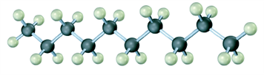
ANSWER:
POINTS: | 1

22. Convert the following molecular model into a condensed structure and a skeletal structure.
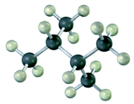
ANSWER:
POINTS: | 1

23. Convert the following molecular model into a condensed structure and a skeletal structure.
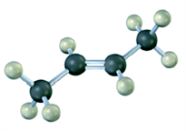
ANSWER: | or more specifically;
POINTS: | 1

24. Indicate the hybridization on each of the carbon atoms indicated with a number in the molecular model shown.
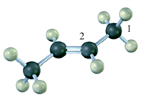
ANSWER: | Carbon 1: sp³  Carbon 2: sp²
POINTS: | 1

25. Draw the orbital diagram showing the ground-state electron configuration of sulfur.
ANSWER:
POINTS: | 1

26. Fill in any nonbonding valence electrons that are missing from the following structural representation of the amino acid cysteine.
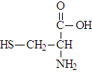
ANSWER:
POINTS: | 1

27. There are two substances with the molecular formula C₂H₇N. Draw them and describe how they differ.
ANSWER: | The two structures differ in the number of hydrogen atoms and carbon atoms bonded to the nitrogen atom. The first structure contains the carbon atoms bonded in a two carbon chain while in the second structure the two carbons atoms are isolated from each other by the nitrogen atom.
POINTS: | 1

28. Overlap of the two atomic orbitals shown could result in a:
 | a. | σ bond
 | b. | π bond
 | c. | σ or π depending on the direction of the overlap.

ANSWER: | c
POINTS: | 1

29. Hybridization of the atomic orbitals shown would result in:
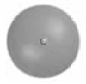
 | a. | sp³ hybridization
 | b. | sp² hybridization
 | c. | sp hybridization

ANSWER: | b
POINTS: | 1

30. Which of the following represents a hybrid orbital?
 | a. |  | b.
 | c. |  | d.

ANSWER: | d
POINTS: | 1

31. What type of hybridization is exhibited by carbon in the following substance?:
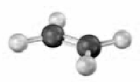
 | a. | sp³ hybridization
 | b. | sp² hybridization
 | c. | sp hybridization

ANSWER: | b
POINTS: | 1

32. What type of hybridization is exhibited by carbon in the following substance?:
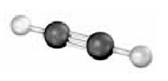
 | a. | sp³ hybridization
 | b. | sp² hybridization
 | c. | sp hybridization

ANSWER: | c
POINTS: | 1

33. What type of hybridization is exhibited by the nitrogen atom in the following substance and how many lone pairs are present on the nitrogen?:
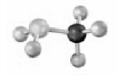
 | a. | sp³ hybridization and 1 lone pair
 | b. | sp² hybridization and l lone pair
 | c. | sp hybridization and 1 lone pair
 | d. | sp³ hybridization and 2 lone pairs
 | e. | sp² hybridization and 2 lone pairs
 | f. | sp hybridization and 2 lone pairs

ANSWER: | a
POINTS: | 1

34. If all the missing bonds in the following structure are sigma bonds to hydrogen atoms, how many hydrogen atoms are missing from this structure? Atoms other than carbon are labeled.
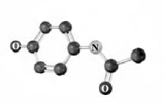

 | a. | 7
 | b. | 10
 | c. | 12
 | d. | 14
 | e. | None of these is the correct number.

ANSWER: | e
POINTS: | 1

