Macroeconomics, 12e, Global Edition (Parkin)
Chapter 1 What Is Economics?

1 Definition of Economics

1) All economic questions are about
A) how to make money.
B) what to produce.
C) how to cope with scarcity.
D) how to satisfy all our wants.
Answer: C
Topic: Scarcity
Skill: Recognition
AACSB: Reflective thinking

2) All economic questions arise because we
A) want more than we can get.
B) want more than we need.
C) have an abundance of resources.
D) have limited wants that need to be satisfied.
Answer: A
Topic: Scarcity
Skill: Recognition
AACSB: Reflective thinking

3) Economics is best defined as the study of how people, businesses, governments, and societies
A) choose abundance over scarcity.
B) make choices to cope with scarcity.
C) use their infinite resources.
D) attain wealth.
Answer: B
Topic: Scarcity
Skill: Conceptual
AACSB: Reflective thinking

4) Scarcity is a situation in which
A) people cannot satisfy all their wants.
B) most people can get only bare necessities.
C) people can satisfy all their wants.
D) some people can get all they want and some cannot.
Answer: A
Topic: Scarcity
Skill: Recognition
AACSB: Reflective thinking
5) Economists point out that scarcity confronts
A) neither the poor nor the rich.
B) the poor but not the rich.
C) the rich but not the poor.
D) both the poor and the rich.
Answer: D
Topic: Scarcity
Skill: Conceptual
AACSB: Ethical understanding and reasoning

6) Scarcity is
A) our inability to satisfy all our wants.
B) a situation that exists during economic recessions but not during economic booms.
C) eliminated by choices.
D) an economic problem only for poor people.
Answer: A
Topic: Scarcity
Skill: Recognition
AACSB: Reflective thinking

7) When an economist talks of scarcity, the economist is referring to the
A) ability of society to employ all of its resources.
B) ability of society to consume all that it produces.
C) inability of society to satisfy all human wants because of limited resources.
D) ability of society to continually make technological breakthroughs and increase production.
Answer: C
Topic: Scarcity
Skill: Recognition
AACSB: Reflective thinking

8) Fundamental economic problems basically arise from
A) the fact that society has more than it needs.
B) turmoil in the stock market.
C) the unequal distribution of income.
D) our wants exceeding our scarce resources.
Answer: D
Topic: Scarcity
Skill: Recognition
AACSB: Reflective thinking

9) Scarcity exists because
A) society and people are greedy and wasteful.
B) our wants exceed the resources available to satisfy them.
C) of the inefficient choices we make.
D) poor people need more food and other goods.
Answer: B
Topic: Scarcity
Skill: Recognition
AACSB: Reflective thinking
10) Scarcity can be eliminated through
A) the use of market mechanisms.
B) exploration that helps us find new resources.
C) wise use of our resources.
D) None of the above because scarcity cannot be eliminated.
Answer: D
Topic: Scarcity
Skill: Recognition
AACSB: Reflective thinking

11) As an economic concept, scarcity applies to
A) both money and time.
B) money but not time.
C) time but not money.
D) neither time nor money.
Answer: A
Topic: Scarcity
Skill: Conceptual
AACSB: Reflective thinking

12) In every economic system, choices must be made because resources are ________ and our wants are ________.
A) unlimited; limited
B) limited; unlimited
C) unlimited; unlimited
D) limited; limited
Answer: B
Topic: Scarcity
Skill: Conceptual
AACSB: Reflective thinking

13) The problem of "scarcity" applies
A) only in industrially developed countries because resources are scarce in these countries.
B) only in underdeveloped countries because there are few productive resources in these countries.
C) only in economic systems that are just beginning to develop because specialized resources are scarce.
D) to all economic systems, regardless of their level of development.
Answer: D
Topic: Scarcity
Skill: Conceptual
AACSB: Reflective thinking

14) Scarcity requires that people must
A) cooperate.
B) compete.
C) trade.
D) make choices.
Answer: D
Topic: Scarcity
Skill: Conceptual
AACSB: Reflective thinking
15) People must make choices because
A) most people enjoy shopping.
B) of scarcity.
C) there are many goods available.
D) None of the above answers is correct.
Answer: B
Topic: Scarcity
Skill: Conceptual
AACSB: Reflective thinking

16) An incentive
A) could be a reward but could not be a penalty.
B) could be a penalty but could not be a reward.
C) could be either a reward or a penalty.
D) is the opposite of a tradeoff.
Answer: C
Topic: Incentive
Skill: Recognition
AACSB: Reflective thinking

17) An inducement to take a particular action is called
A) the marginal benefit.
B) the marginal cost.
C) opportunity cost.
D) an incentive.
Answer: D
Topic: Incentive
Skill: Recognition
AACSB: Reflective thinking

18) Economics is best defined as
A) how people make money and profits in the stock market.
B) making choices from an unlimited supply of goods and services.
C) making choices with unlimited wants but facing a scarcity of resources.
D) controlling a budget for a household.
Answer: C
Topic: Definition of Economics
Skill: Recognition
AACSB: Reflective thinking

19) The study of economics
A) focuses mainly on individual consumers.
B) arises from the fact that our wants exceed available resources.
C) recognizes that scarcity does not affect rich nations.
D) deals mainly with microeconomics.
Answer: B
Topic: Definition of Economics
Skill: Recognition
AACSB: Reflective thinking
20) Economics is best defined as the science of choice and how people cope with
A) differences in wants.
B) differences in needs.
C) scarcity.
D) different economic systems.
Answer: C
Topic: Definition of Economics
Skill: Recognition
AACSB: Reflective thinking

21) Economics is the study of
A) the distribution of surplus goods to those in need.
B) affluence in a morally bankrupt world.
C) the choices we make because of scarcity.
D) ways to reduce wants to eliminate the problem of scarcity.
Answer: C
Topic: Definition of Economics
Skill: Conceptual
AACSB: Reflective thinking

22) The study of the choices made by individuals is part of the definition of
A) microeconomics.
B) positive economics.
C) macroeconomics.
D) normative economics.
Answer: A
Topic: Microeconomics and Macroeconomics
Skill: Recognition
AACSB: Reflective thinking

23) In part, microeconomics is concerned with
A) how a business firm decides upon the amount it produces and the price it sets.
B) changes in the economy's total output of goods and services over long periods of time.
C) factors that explain changes in the unemployment rate over time.
D) the Federal Reserve's policy decisions.
Answer: A
Topic: Microeconomics and Macroeconomics
Skill: Recognition
AACSB: Reflective thinking

24) The study of the decisions of individual units in the economy is known as
A) macroeconomics.
B) microeconomics.
C) the study of incentives.
D) ceteris paribus study.
Answer: B
Topic: Microeconomics and Macroeconomics
Skill: Recognition
AACSB: Reflective thinking
25) Studying the determination of prices in individual markets is primarily a concern of
A) positive economics.
B) negative economics.
C) macroeconomics.
D) microeconomics.
Answer: D
Topic: Microeconomics and Macroeconomics
Skill: Recognition
AACSB: Reflective thinking

26) The analysis of the behavior of individual decision-making units is the definition of
A) microeconomics.
B) positive economics.
C) macroeconomics.
D) normative economics.
Answer: A
Topic: Microeconomics and Macroeconomics
Skill: Recognition
AACSB: Reflective thinking

27) Which of the following is a microeconomic topic?
A) how a trade agreement between the United States and Mexico affects both nations' unemployment rates
B) comparing inflation rates across countries
C) how rent ceilings impact the supply of apartments
D) how a tax rate increase will impact total production
Answer: C
Topic: Microeconomics and Macroeconomics
Skill: Conceptual
AACSB: Reflective thinking

28) Which of the following questions is NOT a microeconomic question?
A) Can the Federal Reserve keep income growing by cutting interest rates?
B) How would a tax on e-commerce affect eBay?
C) What is Britney's opportunity cost of having another baby?
D) Does the United States have a comparative advantage in information technology services?
Answer: A
Topic: Microeconomics and Macroeconomics
Skill: Conceptual
AACSB: Reflective thinking

29) Which of the following is an example of a microeconomic decision?
A) an individual deciding how to allocate the time he or she has for work and leisure
B) a small shoe factory deciding how much leather to purchase for the next quarter's production need
C) a multinational company deciding where to relocate its world headquarter
D) All of the above answers are correct.
Answer: D
Topic: Microeconomics and Macroeconomics
Skill: Recognition
AACSB: Reflective thinking
30) Which of the following is a microeconomic topic?
A) the reasons why Kathy buys less orange juice
B) the reasons for a decline in average prices
C) the reasons why total employment decreases
D) the effect of the government budget deficit on inflation
Answer: A
Topic: Microeconomics and Macroeconomics
Skill: Recognition
AACSB: Reflective thinking

31) Which of the following questions is a topic that would be studied by microeconomics?
A) Why did production and the number of jobs shrink in 2009?
B) Will the current budget deficit affect the well-being of the next generation?
C) How will a lower price of digital cameras affect the quantity of cameras sold?
D) What is the current unemployment rate in the United States?
Answer: C
Topic: Microeconomics and Macroeconomics
Skill: Conceptual
AACSB: Reflective thinking

32) An example of a question that might be explored in microeconomics is to determine
A) the number of workers employed by Intel.
B) savings by the household sector.
C) why the U.S. economy has grown more rapidly than the Japanese economy.
D) the total employment within the U.S. economy.
Answer: A
Topic: Microeconomics and Macroeconomics
Skill: Conceptual
AACSB: Reflective thinking

33) In part, microeconomics is concerned with the study of
A) unemployment and economic growth.
B) the Federal Reserve's policies.
C) the effect government regulation has on the price of a product.
D) national output of goods and services.
Answer: C
Topic: Microeconomics and Macroeconomics
Skill: Conceptual
AACSB: Reflective thinking

34) The branch of economics that deals with the analysis of the whole economy is called
A) macroeconomics.
B) marginal analysis.
C) microeconomics.
D) metroanalysis.
Answer: A
Topic: Microeconomics and Macroeconomics
Skill: Recognition
AACSB: Reflective thinking
35) Macroeconomics is concerned with
A) individual consumers.
B) government decision making concerning farm price supports.
C) economy-wide variables.
D) the effects on Ford Motor of a strike by the United Auto Workers.
Answer: C
Topic: Microeconomics and Macroeconomics
Skill: Recognition
AACSB: Reflective thinking

36) Macroeconomics differs from microeconomics in that
A) macroeconomics studies the decisions of individuals.
B) microeconomics looks at the economy as a whole.
C) macroeconomics studies the behavior of government while microeconomics looks at private corporations.
D) macroeconomics focuses on the national economy and the global economy.
Answer: D
Topic: Microeconomics and Macroeconomics
Skill: Recognition
AACSB: Reflective thinking

37) Which of the following is a macroeconomic decision or concept?
A) the price of oil
B) how many television sets to produce
C) the unemployment rate for the entire economy
D) the unemployment rate for each firm
Answer: C
Topic: Microeconomics and Macroeconomics
Skill: Conceptual
AACSB: Reflective thinking

38) Which of the following questions is a macroeconomic issue?
A) How many more pounds of cookies will a consumer purchase if the price of cookies decreases?
B) What effect would a cure for Mad Cow Disease have on the market for beef?
C) What is the future growth prospect for an economy?
D) How many workers should the owner of a business hire?
Answer: C
Topic: Microeconomics and Macroeconomics
Skill: Conceptual
AACSB: Reflective thinking
39) In broad terms the difference between microeconomics and macroeconomics is that
A) they use different sets of tools and ideas.
B) microeconomics studies decisions of individual people and firms and macroeconomics studies the entire national economy.
C) macroeconomics studies the effects of government regulation and taxes on the price of individual goods and services whereas microeconomics does not.
D) microeconomics studies the effects of government taxes on the national unemployment rate.
Answer: B
Topic: Microeconomics and Macroeconomics
Skill: Recognition
AACSB: Reflective thinking

40) Which of the following is a macroeconomic issue?
A) how a rise in the price of sugar affects the market for sodas
B) how federal government budget deficits affect interest rates
C) what determines the amount a firm will produce
D) the cause of a decline in the price of peanut butter
Answer: B
Topic: Microeconomics and Macroeconomics
Skill: Conceptual
AACSB: Reflective thinking

41) Which of the following is a macroeconomic issue?
A) the purchasing decisions that an individual consumer makes
B) the effect of increasing the money supply on inflation
C) the hiring decisions that a business makes
D) the effect of an increase in the tax on cigarettes on cigarette sales
Answer: B
Topic: Microeconomics and Macroeconomics
Skill: Conceptual
AACSB: Reflective thinking

42) Macroeconomic topics include
A) total, nationwide employment.
B) studying what factors influence the price and quantity of automobiles.
C) studying the determination of wages and production costs in the software industry.
D) the impact of government regulation of markets.
Answer: A
Topic: Microeconomics and Macroeconomics
Skill: Conceptual
AACSB: Reflective thinking

43) The fact that wants cannot be fully satisfied with available resources reflects the definition of
A) the what tradeoff.
B) scarcity.
C) the big tradeoff.
D) for whom to produce.
Answer: B
Topic: Study Guide Question, Definition of Economics
Skill: Recognition
AACSB: Reflective thinking
44) Studying the effects choices have on the individual markets within the economy is part of
A) scarcity.
B) microeconomics.
C) macroeconomics.
D) incentives.
Answer: B
Topic: Study Guide Question, Macroeconomics
Skill: Recognition
AACSB: Reflective thinking

45) Economics can be defined as the social science that explains the ________.
A) choices made by politicians
B) choices we make when we trade in markets
C) choices that we make as we cope with scarcity
D) choices made by households
Answer: C
Topic: MyEconLab Questions
Skill: Conceptual
AACSB: Reflective thinking

46) Scarcity is a situation in which ________.
A) some people are poor and others are rich
B) something is being wasted
C) we are unable to satisfy all our wants
D) long lines form at gas stations
Answer: C
Topic: MyEconLab Questions
Skill: Conceptual
AACSB: Reflective thinking

47) Microeconomics is the study of ________.
A) the choices that individuals and businesses make
B) all aspects of scarcity
C) the global economy
D) the national economy
Answer: A
Topic: MyEconLab Questions
Skill: Conceptual
AACSB: Reflective thinking

2 Two Big Economic Questions

1) When an economy produces more houses and fewer typewriters, it is answering the ________ part of one of the two big economic questions.
A) "what"
B) "how"
C) "where"
D) "for whom"
Answer: A
Topic: What Goods and Services Are Produced?
Skill: Conceptual
AACSB: Reflective thinking
2) When firms in an economy start producing more computers and fewer televisions, they are answering the ________ part of one of the two big economic questions.
A) "when"
B) "for whom"
C) "what"
D) "where"
Answer: C
Topic: What Goods and Services Are Produced?
Skill: Conceptual
AACSB: Reflective thinking

3) If Taco Bell decides to produce more tacos and fewer burritos, Taco Bell is answering the ________ part of one of the two big economic questions.
A) "what"
B) "why"
C) "when"
D) "scarcity"
Answer: A
Topic: What Goods and Services Are Produced?
Skill: Conceptual
AACSB: Reflective thinking

4) When a farmer decides to raise hogs instead of cattle, the farmer is answering the ________ part of one of the two big economic questions.
A) "what"
B) "for whom"
C) "how"
D) "why"
Answer: A
Topic: What Goods and Services Are Produced?
Skill: Conceptual
AACSB: Reflective thinking

5) When a country decides to produce fewer bombers and more public housing projects, it is answering the ________ part of one of the two big economic questions.
A) "how"
B) "what"
C) "defense"
D) "for whom"
Answer: B
Topic: What Goods and Services Are Produced?
Skill: Conceptual
AACSB: Reflective thinking
6) When a firm decides to produce more electric cars and conventional gas powered cars, it is most directly answering the ________ part of one of the two big economic questions.
A) "how"
B) "scarcity"
C) "what"
D) "for whom"
Answer: C
Topic: What Goods and Services Are Produced?
Skill: Conceptual
AACSB: Reflective thinking

7) U.S. producers decide to produce more compact cars and fewer SUVs as the price of gasoline rises. Producers are answering the ________ part of one of the two big economic questions.
A) "what"
B) "how"
C) "when"
D) "how many"
Answer: A
Topic: What Goods and Services Are Produced?
Skill: Conceptual
AACSB: Reflective thinking

8) Which of the following statements is CORRECT?
A) The United States produces more goods than services.
B) The United States produces more services than goods.
C) The United States produces more agricultural goods than manufactured goods.
D) The United States produces an equal amount of goods and services.
Answer: B
Topic: Trends in Production
Skill: Recognition
AACSB: Reflective thinking

9) In the U.S. economy, which of the following statements is TRUE?
A) More goods are produced than services.
B) More services are produced than goods.
C) Production is divided evenly between goods and services.
D) The economy is too complex to determine the proportion of production that is devoted to producing services.
Answer: B
Topic: Trends in Production
Skill: Recognition
AACSB: Reflective thinking

10) The largest part of what the United States produces today is ________ such as ________.
A) goods; food and electronic equipment
B) goods; education and entertainment
C) services; trade and health care
D) services; textbooks and computers
Answer: C
Topic: Trends in Production
Skill: Recognition
AACSB: Reflective thinking
11) When China builds a dam using few machines and a great deal of labor, it is answering the ________ part of one of the two big economic questions.
A) "what"
B) "how"
C) "where"
D) "for whom"
Answer: B
Topic: How Are Goods and Services Produced?
Skill: Conceptual
AACSB: Reflective thinking

12) When a textile company keeps track of its inventory using a computer and its competitor uses a pad of paper and a pencil, they are both answering the ________ part of one of the two big economic questions.
A) "what"
B) "how"
C) "for whom"
D) "where"
Answer: B
Topic: How Are Goods and Services Produced?
Skill: Conceptual
AACSB: Reflective thinking

13) When a California farmer decides to harvest lettuce using machines instead of by migrant workers, the farmer is answering the ________ part of one of the two big economic questions.
A) "how"
B) "for whom"
C) "scarcity"
D) "what"
Answer: A
Topic: How Are Goods Produced?
Skill: Conceptual
AACSB: Reflective thinking

14) An art museum decides to offer tours by having visitors listen to cassette tapes rather than have tour guides. The museum is answering the ________ part of one of the two big economic questions.
A) "scarcity"
B) "what"
C) "why"
D) "how"
Answer: D
Topic: How Are Goods and Services Produced?
Skill: Conceptual
AACSB: Reflective thinking
15) The fact that people with higher incomes get to consume more goods and services addresses the ________ part of one of the two big economic questions.
A) "for whom"
B) "when"
C) "where"
D) "how"
Answer: A
Topic: For Whom Are Goods and Services Produced?
Skill: Conceptual
AACSB: Ethical understanding and reasoning

16) Which of the following is NOT a factor of production?
A) the water used to cool a nuclear power plant.
B) the effort of farmers raising cattle.
C) the wages paid to workers.
D) the management skill of a small business owner.
Answer: C
Topic: Factors of Production
Skill: Conceptual
AACSB: Reflective thinking

17) Which of the following are considered factors of production used to produce goods and services?
I. Land
II. Labor
III. Capital
IV. Entrepreneurship
A) I and II only
B) I and III only
C) I, II and III only
D) I, II, III and IV
Answer: D
Topic: Factors of Production
Skill: Recognition
AACSB: Reflective thinking

18) Which of the following is CORRECT? Factors of production are
A) land, labor, the price system, and capital.
B) the inputs used to produce goods and services.
C) the fundamental source of abundance.
D) only land and labor.
Answer: B
Topic: Factors of Production
Skill: Recognition
AACSB: Reflective thinking
19) Factors of production include
A) the economic system.
B) land, labor, capital and entrepreneurship.
C) labor and capital (not land, which is fixed).
D) only capital, land, and labor.
Answer: B
Topic: Factors of Production
Skill: Recognition
AACSB: Reflective thinking

20) Factors of production include all of the following EXCEPT ________.
A) machines made in past years.
B) money
C) entrepreneurship
D) a wheat field that is not irrigated
Answer: B
Topic: Factors of Production
Skill: Recognition
AACSB: Reflective thinking

21) Factors of production are grouped into four categories
A) land, labor, capital, entrepreneurship.
B) land, labor, capital, money.
C) land, capital, money, entrepreneurship.
D) labor, capital, money, entrepreneurship.
Answer: A
Topic: Factors of Production
Skill: Recognition
AACSB: Reflective thinking

22) Which of the following is NOT a factor of production?
A) vans used by a bakery company for deliveries
B) a person developing a production schedule for a new product
C) 175 shares of Microsoft stock
D) wilderness areas that have yet to be developed
Answer: C
Topic: Factors of Production
Skill: Conceptual
AACSB: Reflective thinking

23) Keeping in mind economists' definition of factors of production, which of the following is NOT a factor of production?
A) money
B) low-skilled labor
C) coal
D) an engineer
Answer: A
Topic: Factors of Production
Skill: Recognition
AACSB: Reflective thinking
24) Which of the following is NOT a factor of production?
A) mineral resources
B) a university professor
C) an apartment building
D) 100 shares of Microsoft stock
Answer: D
Topic: Factors of Production
Skill: Recognition
AACSB: Reflective thinking

25) The income earned by the people who sell the services of the factor of production ________ is called ________.
A) capital; rent
B) entrepreneurship; wages
C) land; profit
D) entrepreneurship; profit
Answer: D
Topic: Factors of Production
Skill: Recognition
AACSB: Reflective thinking

26) Which factor of production earns profit?
A) land
B) human capital
C) money
D) entrepreneurship
Answer: D
Topic: Factors of Production
Skill: Recognition
AACSB: Reflective thinking

27) Which factor of production earns most income in the United States?
A) capital
B) labor
C) money
D) entrepreneurship
Answer: B
Topic: Factors of Production
Skill: Recognition
AACSB: Reflective thinking

28) Which of the following best defines capital as a factor of production?
A) the gifts of nature that businesses use to produce goods and services
B) the knowledge and skills that people obtain from education and use in production of goods and services
C) financial assets used by businesses
D) instruments, machines, and buildings used in production
Answer: D
Topic: Capital Stock
Skill: Conceptual
AACSB: Reflective thinking
29) In economics, the term "land" means
A) only land that is used in agricultural production.
B) land, mineral resources, and nature's other bounties.
C) land that is devoted to economic pursuits.
D) land used for agricultural and urban purposes.
Answer: B
Topic: Land
Skill: Recognition
AACSB: Reflective thinking

30) A natural resource, such as fishing territories, is considered an example of
A) both land and labor.
B) land, labor, capital and entrepreneurship.
C) land only.
D) only capital.
Answer: C
Topic: Land
Skill: Recognition
AACSB: Reflective thinking

31) The "gifts of nature" are included as part of which factor of production?
A) labor
B) land
C) capital
D) entrepreneurship
Answer: B
Topic: Land
Skill: Conceptual
AACSB: Reflective thinking

32) Copper falls into which factor of production category?
A) land
B) labor
C) capital
D) entrepreneurship
Answer: A
Topic: Land
Skill: Conceptual
AACSB: Reflective thinking

33) Overtime worked by a JCPenney associate is considered ________ and earns ________.
A) labor; wages
B) entrepreneurship; profit
C) human capital; interest
D) labor; profit
Answer: A
Topic: Labor
Skill: Conceptual
AACSB: Reflective thinking
34) The term human capital refers to
A) labor resources used to make capital equipment.
B) buildings and machinery.
C) people's knowledge and skill.
D) entrepreneurship and risk-taking.
Answer: C
Topic: Human Capital
Skill: Recognition
AACSB: Reflective thinking

35) Human capital is
A) all capital owned by individuals, but not by corporations or governments.
B) all capital owned by individuals or corporations, but not by governments.
C) machinery that meets or exceeds federal safety standards for use by humans.
D) the skill and knowledge of workers.
Answer: D
Topic: Human Capital
Skill: Recognition
AACSB: Reflective thinking

36) Joy is training to become a chef. The skills she is obtaining from her training and education will increase Joy's ________.
A) human capital
B) physical capital
C) entrepreneurship
D) None of the above answers are correct.
Answer: A
Topic: Human Capital
Skill: Conceptual
AACSB: Reflective thinking

37) Which of the following is NOT an investment in human capital?
A) A business student takes a seminar in using a laptop computer.
B) A student purchases a laptop computer.
C) A computer science student learns how to repair a laptop computer.
D) A computer science student takes a course on programming a laptop computer.
Answer: B
Topic: Human Capital
Skill: Conceptual
AACSB: Reflective thinking

38) Samantha goes to college to become an engineer. This is an example of an
A) investment in physical capital.
B) investment in human capital.
C) increase in entrepreneurship.
D) increase in labor.
Answer: B
Topic: Human Capital
Skill: Conceptual
AACSB: Reflective thinking
39) In economics, the term "capital" refers to
A) the money in one's pocket.
B) buildings and equipment.
C) mineral resources.
D) consumer goods.
Answer: B
Topic: Capital
Skill: Recognition
AACSB: Reflective thinking

40) Human resources that perform the functions of organizing, managing, and assembling the other resources are called
A) physical capital.
B) venture capital.
C) entrepreneurship.
D) productive capital.
Answer: C
Topic: Entrepreneurship
Skill: Recognition
AACSB: Reflective thinking

41) The economic resource that organizes the use of other economic resources is called
A) labor.
B) capital.
C) entrepreneurship.
D) land.
Answer: C
Topic: Entrepreneurship
Skill: Recognition
AACSB: Reflective thinking

42) Entrepreneurs do all of the following EXCEPT
A) organize labor, land, and capital.
B) come up with new ideas about what and how to produce.
C) bear risk from business decisions.
D) own all the other resources used in the production process.
Answer: D
Topic: Entrepreneurship
Skill: Recognition
AACSB: Reflective thinking

43) Entrepreneurs directly do all of the following except
A) create new ideas about what and how to produce.
B) make business decisions.
C) face risks that arise from making business decisions.
D) decide for whom goods and services are produced.
Answer: D
Topic: Entrepreneurship
Skill: Recognition
AACSB: Reflective thinking
44) Differences in income are most directly related to which of the following economic question?
A) What goods and services are produced?
B) In what quantities are various goods and services produced?
C) How are goods and services produced?
D) Who consumes the goods and services that are produced?
Answer: D
Topic: For Whom Are Goods and Services Produced?
Skill: Conceptual
AACSB: Reflective thinking

45) The fact that some people can afford to live in beautiful homes while others are homeless, is most directly an example of an economy facing the ________ part of one of the two big economic questions.
A) "for whom"
B) "when"
C) "how"
D) "why"
Answer: A
Topic: For Whom Are Goods and Services Produced?
Skill: Conceptual
AACSB: Ethical understanding and reasoning

46) The fact that a rock star earns $5 million a year while a teacher earns $25,000 annually is most directly an example of an economy answering the ________ part of one of the two big economic questions.
A) "when"
B) "for whom"
C) "how"
D) "why"
Answer: B
Topic: For Whom Are Goods and Services Produced?
Skill: Conceptual
AACSB: Ethical understanding and reasoning

47) One economist says that raising taxes on gas would be in the social interest. What does this economist mean?
A) Higher taxes on gas would benefit society as a whole.
B) Raising taxes on gas would benefit most of the people.
C) Higher taxes on gas would benefit everyone.
D) Both answers A and C are correct.
Answer: A
Topic: Social Interest
Skill: Conceptual
AACSB: Reflective thinking
48) An outcome is considered efficient if
A) it is not possible to make someone better off without making anyone else worse off.
B) it is the best available choice for an individual.
C) it results in fair shares for everyone involved.
D) it is possible to make someone better off without making anyone else worse off.
Answer: A
Topic: Self-Interest and Social Interest
Skill: Definition
AACSB: Reflective thinking

49) Suppose Company A's profits increase by $10 million and nobody is made worse off. The CEO of Company A keeps all $10 million for herself. This situation
A) is definitely efficient.
B) is definitely not in the self-interest of Company A.
C) is definitely not in the social interest.
D) is definitely fair.
Answer: A
Topic: Self-Interest and Social Interest
Skill: Conceptual
AACSB: Analytical thinking

50) The Occupy Wall Street movement advocates
A) a shift away from market capitalism.
B) a shift towards more market capitalism.
C) centrally planned socialism.
D) following the teachings of Adam Smith.
Answer: A
Topic: At Issue: The Protest Against Market Capitalism
Skill: Conceptual
AACSB: Analytical thinking

51) An economic system in which the government decides what, how, and for whom to produce, directs workers to jobs, and owns all the land and capital is
A) centrally planned socialism.
B) market capitalism.
C) mixed economy.
D) supported by economists as the best system available.
Answer: A
Topic: At Issue: The Protest Against Market Capitalism
Skill: Definition
AACSB: Reflective thinking
52) According to Adam Smith
A) government intervention in markets is not desirable because an invisible hand leads decisions made in pursuit of self-interest to unintentionally promote the social interest.
B) politicians are well-equipped to regulate corporations and intervene in markets to improve market outcomes.
C) when big corporations pursue their self-interest of maximum profit, they will inevitably conflict with social interest.
D) in a market transaction buyers can either get what they want for less than they would be willing to pay or sellers can earn a profit, but both buyers and sellers can't gain simultaneously.
Answer: A
Topic: At Issue: The Protest Against Market Capitalism
Skill: Conceptual
AACSB: Reflective thinking

53) The 2010 Patient Protection and Affordable Care Act (Obamacare) contains a provision that may require individuals to either purchase private health insurance or pay a tax. This is an example of
A) a mixed economy.
B) market capitalism.
C) centrally planned socialism.
D) the invisible hand.
Answer: A
Topic: At Issue: The Protest Against Market Capitalism
Skill: Conceptual
AACSB: Analytical thinking

54) According to economists
A) market capitalism is the best system available and some government intervention and regulation can either help or harm the social interest.
B) market capitalism is the best system available and any government intervention and regulation will inevitably harm the social interest.
C) centrally planned socialism is the best system available since governments generally make decisions that are in social interest.
D) centrally planned socialism and pure market capitalism are equally capable of promoting social interest, but a mixed economy is an undesirable compromise between the two that will harm social interest.
Answer: A
Topic: At Issue: The Protest Against Market Capitalism
Skill: Conceptual
AACSB: Reflective thinking

55) Which of the following is NOT part of the first big economic question?
A) What goods and services are produced?
B) How are goods and services produced?
C) For whom are goods and services produced?
D) Why do incentives affect only marginal costs?
Answer: D
Topic: Study Guide Question, Two Big Economic Questions
Skill: Analytical
AACSB: Reflective thinking
3 The Economic Way of Thinking

1) In economics we learn that
A) tradeoffs allow us to have more of everything we value.
B) tradeoffs allow us to avoid the problem of opportunity cost.
C) opportunity costs are all of the possible alternatives given up when we make a choice.
D) None of the above answers is correct.
Answer: D
Topic: Tradeoff
Skill: Conceptual
AACSB: Reflective thinking

2) Because we face scarcity, every choice involves
A) money.
B) the question "what."
C) giving up something for nothing.
D) an opportunity cost.
Answer: D
Topic: Tradeoff and Opportunity Cost
Skill: Conceptual
AACSB: Reflective thinking

3) The term used to emphasize that making choices in the face of scarcity involves a cost is
A) substitution cost.
B) opportunity cost.
C) utility cost.
D) accounting cost.
Answer: B
Topic: Opportunity Cost
Skill: Recognition
AACSB: Reflective thinking

4) The loss of the highest-valued alternative defines the concept of
A) marginal benefit.
B) scarcity.
C) entrepreneurship.
D) opportunity cost.
Answer: D
Topic: Opportunity Cost
Skill: Recognition
AACSB: Reflective thinking

5) Opportunity cost means the
A) accounting cost minus the marginal cost.
B) highest-valued alternative forgone.
C) accounting cost minus the marginal benefit.
D) monetary costs of an activity.
Answer: B
Topic: Opportunity Cost
Skill: Recognition
AACSB: Reflective thinking
6) The opportunity cost of any action is
A) all the possible alternatives given up.
B) the highest-valued alternative given up.
C) the benefit from the action minus the cost of the action.
D) the dollars the action cost.
Answer: B
Topic: Opportunity Cost
Skill: Recognition
AACSB: Reflective thinking

7) The opportunity cost of something you decide to get is
A) all the possible alternatives that you give up to get it.
B) the highest valued alternative you give up to get it.
C) the value of the item minus the cost you paid for it.
D) the amount of money you pay to get it.
Answer: B
Topic: Opportunity Cost
Skill: Recognition
AACSB: Reflective thinking

8) Opportunity cost is best defined as
A) how much money is paid for something.
B) how much money is paid for something, taking inflation into account.
C) the highest-valued alternative that is given up to get something.
D) all the alternatives that are given up to get something.
Answer: C
Topic: Opportunity Cost
Skill: Recognition
AACSB: Reflective thinking

9) Which of the following statements are CORRECT?
I. The "highest-valued alternative given up to get something" is the opportunity cost.
II. Wealthy economies don't experience opportunity costs.
III. Scarcity creates opportunity costs.
A) I only
B) I and II
C) I and III
D) I, II, and III
Answer: C
Topic: Opportunity Cost
Skill: Recognition
AACSB: Reflective thinking

10) Opportunity cost is defined as the
A) total value of all the alternatives given up.
B) highest-valued alternative given up.
C) cost of not doing all of the things you would like to do.
D) lowest-valued alternative given up.
Answer: B
Topic: Opportunity Cost
Skill: Recognition
AACSB: Reflective thinking
11) You have the choice of going on vacation to Florida for one week, staying at work for the week, or spending the week doing fix-up projects around your house. If you decide to go to Florida, the opportunity cost of the trip is
A) working and doing fix-up projects.
B) working or doing fix-up projects, depending on which you would have done otherwise.
C) working, because you would be giving up income.
D) nothing because you will enjoy the trip to Florida.
Answer: B
Topic: Opportunity Cost
Skill: Conceptual
AACSB: Reflective thinking

12) The night before a midterm exam, you decide to go to the movies instead of studying for the exam. You score 60 percent on your exam. If you had studied the night before, you'd have scored 70 percent. What was the opportunity cost of your evening at the movies?
A) 10 percent off your grade
B) 60 percent
C) 70 percent
D) zero
Answer: A
Topic: Opportunity Cost
Skill: Conceptual
AACSB: Analytical thinking

13) On Saturday morning, you rank your choices for activities in the following order: go to the library, work out at the gym, have breakfast with friends, and sleep late. Suppose you decide to go to the library. Your opportunity cost is
A) working out at the gym, having breakfast with friends, and sleeping late.
B) working out at the gym.
C) zero because you do not have to pay money to use the library.
D) not clear because not enough information is given.
Answer: B
Topic: Opportunity Cost
Skill: Conceptual
AACSB: Reflective thinking

14) Fred and Ann are both given free tickets to see a movie. Both decide to see the same movie. We know that
A) both bear an opportunity cost of seeing the movie because they could have done other things instead of seeing the movie.
B) both bear the same opportunity cost of seeing the movie because they are doing the same thing.
C) it is not possible to calculate the opportunity cost of seeing the movie because the tickets were free.
D) the opportunity cost of seeing the movie is zero because the tickets were free.
Answer: A
Topic: Opportunity Cost
Skill: Conceptual
AACSB: Reflective thinking
15) You have the choice of going to Hawaii for a week, staying at work for the week, or spending the week skiing. If you decide to go to Hawaii, the opportunity cost is
A) the value of working and skiing.
B) the value of working or skiing, depending on which you would have done rather than go to Hawaii.
C) working, because you would be giving up a week's pay.
D) none of the above if you enjoy the time spent in Hawaii.
Answer: B
Topic: Opportunity Cost
Skill: Conceptual
AACSB: Reflective thinking

16) Today, Julie attended her 12:30 Economics class. If she hadn't gone to class, Julie would have gone out to lunch with friends. She had other options; she could have worked or slept in. Julie's opportunity cost of going to class is the
A) income from working she gave up.
B) lunch she gave up.
C) sleep she gave up.
D) income from working, lunch, and sleep she gave up.
Answer: B
Topic: Opportunity Cost
Skill: Conceptual
AACSB: Reflective thinking

17) Joe likes to sleep late in the mornings and play tennis in the afternoons. The opportunity cost of Joe attending his morning class for one hour is
A) an hour of tennis given up.
B) an hour of sleep given up.
C) both the tennis given up and the sleep given up.
D) nothing because he is paying for his class.
Answer: B
Topic: Opportunity Cost
Skill: Conceptual
AACSB: Reflective thinking

18) John has two hours of free time this evening. He ranked his alternatives, first go to a concert, second go to a movie, third study for an economics exam, and fourth answer his e-mail. What is the opportunity cost of attending the concert for John?
A) attending a movie
B) studying for an economics exam
C) answering his e-mail
D) attending a movie, studying for an economics exam, and answering his e-mail
Answer: A
Topic: Opportunity Cost
Skill: Conceptual
AACSB: Reflective thinking
19) You decide to take a vacation and the trip costs you $2,000. While you are on vacation, you do not go to work where you could have earned $750. In terms of dollars, the opportunity cost of the vacation is
A) $2,000.
B) $750.
C) $2,750.
D) $1,250
Answer: C
Topic: Opportunity Cost
Skill: Conceptual
AACSB: Analytical thinking

20) The opportunity cost of attending college includes the cost of
A) the tuition but not the job at which you would otherwise have worked.
B) the highest valued alternative to attending college.
C) the highest valued alternative to attending college plus the cost of tuition.
D) tuition, books, and the lost wages for the hours spent studying.
Answer: C
Topic: Opportunity Cost
Skill: Conceptual
AACSB: Reflective thinking

21) Misty has the option of purchasing one of three products: Brand A, Brand B, or Brand C. Each costs ten dollars. If she decides that Brand A meets her needs best, then the opportunity cost of this decision is
A) Brand B plus Brand C.
B) twenty dollars.
C) Brand A.
D) Brand B or Brand C, depending on which is considered the highest-value alternative forgone.
Answer: D
Topic: Opportunity Cost
Skill: Conceptual
AACSB: Reflective thinking

22) Which of the following is NOT an example of an opportunity cost?
A) By spending Thursday night studying for an economics exam, a student was unable to complete a homework assignment for calculus class.
B) Because David used all of his vacation time to paint his house, he was unable to visit the Caribbean last year.
C) Because Mary is now being paid a higher wage, she can afford to buy a new car even though she is moving into a bigger apartment.
D) By choosing to attend college, Jean was not able to continue working as an electrician; as a result, she gave up more than $85,000 in earnings while she was in college.
Answer: C
Topic: Opportunity Cost
Skill: Conceptual
AACSB: Reflective thinking
23) From 8 to 11 p.m., Sam can either attend a basketball game, a hockey match or the symphony. Suppose that Sam decides to attend the hockey match and thinks to herself that if she did not go to the match she would go to the symphony. Then the opportunity cost of attending the hockey match is
A) going to the symphony and the basketball game.
B) going to the symphony.
C) going to the basketball game.
D) three hours of time.
Answer: B
Topic: Opportunity Cost
Skill: Conceptual
AACSB: Reflective thinking

24) After you graduate, you have decided to accept a position working at the Bureau of Labor Statistics for $45,000.00 a year. The two other offers you received were working for Wal-Mart for $38,000 and working for Ernst and Young consulting for $42,000. Of these two offers, you would have preferred the job at Ernst and Young. What is the opportunity cost of accepting the position at the Bureau of Labor Statistics?
A) the $45,000 you are paid for working at the Bureau of Labor Statistics
B) the $42,000 you would have been paid working for Ernst and Young
C) the $38,000 you would have been paid working for Wal-Mart
D) the $42,000 you would have been paid working for Ernst and Young and the $38,000 you would have been paid working for Wal-Mart
Answer: B
Topic: Opportunity Cost
Skill: Analytical
AACSB: Analytical thinking

25) Bill Bonecrusher graduates from college with a choice of playing professional football at $2 million a year or coaching for $50,000 a year. He decides to play football, but eight years later, though he could continue to play football at $2 million a year, he quits football to make movies for $3 million a year. His opportunity cost of playing football at graduation was ________ and eight years later the opportunity cost of making movies was ________.
A) $50,000; $2 million
B) $2 million; $2 million
C) $2 million; $3 million
D) $50,000; $50,000
Answer: A
Topic: Opportunity Cost
Skill: Analytical
AACSB: Analytical thinking
26) During the summer you have made the decision to attend summer school, which prevents you from working at your usual summer job in which you normally earn $6,000 for the summer. Your tuition cost is $3,000 and books and supplies cost $1,300. In terms of dollars, the opportunity cost of attending summer school is
A) $10,300.
B) $6,000.
C) $4,300.
D) $3,300.
Answer: A
Topic: Opportunity Cost
Skill: Analytical
AACSB: Analytical thinking

27) The term "opportunity cost" points out that
A) there may be such a thing as a free lunch.
B) not all individuals will make the most of life's opportunities because some will fail to achieve their goals.
C) executives do not always recognize opportunities for profit as quickly as they should.
D) any decision regarding the use of a resource involves a costly choice.
Answer: D
Topic: Opportunity Cost
Skill: Conceptual
AACSB: Reflective thinking

28) When the government chooses to use resources to build a dam, these sources are no longer available to build a highway. This choice illustrates the concept of
A) a market mechanism.
B) macroeconomics.
C) opportunity cost.
D) a fallacy of composition.
Answer: C
Topic: Opportunity Cost
Skill: Analytical
AACSB: Reflective thinking

29) Jill, an economics student, has already spent 5 hours cleaning her room. In deciding whether or not to continue cleaning for another hour, she applies the economic principle of
A) scarcity.
B) ceteris paribus.
C) choosing at the margin.
D) productivity.
Answer: C
Topic: Choices at the Margin
Skill: Conceptual
AACSB: Reflective thinking
30) Marginal benefit is the benefit
A) that your activity provides to someone else.
B) of an activity that exceeds its cost.
C) that arises from the secondary effects of an activity.
D) that arises from an increase in an activity.
Answer: D
Topic: Marginal Benefit and Marginal Cost
Skill: Recognition
AACSB: Reflective thinking

31) A benefit from an increase in activity is called the
A) marginal benefit.
B) economic benefit.
C) total benefit.
D) opportunity benefit.
Answer: A
Topic: Marginal Benefit
Skill: Recognition
AACSB: Reflective thinking

32) The marginal benefit is the
A) additional gain from one more unit of an activity.
B) additional cost from one more unit of an activity.
C) loss of the highest-valued alternative.
D) additional gain from one more unit of an activity minus the additional cost from one more unit of the activity.
Answer: A
Topic: Marginal Benefit
Skill: Recognition
AACSB: Reflective thinking

33) In terms of dollars, the marginal benefit of working five days a week instead of four days a week is
A) the wages received for the fifth day of work.
B) the wages received for 5 days of work.
C) the wages received for 4 days of work.
D) None of the above answers is correct.
Answer: A
Topic: Marginal Benefit
Skill: Recognition
AACSB: Reflective thinking
34) Your employer has asked you to start working overtime and has offered to pay $18 per hour for every hour you work beyond forty hours a week. The wage rate for each of the first forty hours will continue to be the usual $15 per hour. In terms of dollars, what is the marginal benefit of working each hour of overtime?
A) zero
B) $3.00
C) $15.00
D) $18.00
Answer: D
Topic: Marginal Benefit
Skill: Analytical
AACSB: Reflective thinking

35) A student is studying for an exam 2 hours a day and is debating whether to study an extra hour. The student's marginal benefit
A) depends on the grade the student earns on the exam.
B) is the benefit the student receives from studying all 3 hours.
C) is the benefit the student receives from studying the extra hour.
D) is greater than the student's marginal cost.
Answer: C
Topic: Marginal Benefit
Skill: Analytical
AACSB: Reflective thinking

36) A student athlete is deciding whether to work out for an extra hour. Her marginal benefit from another hour of exercise
A) is the benefit she gets from all the hours she's worked out all week.
B) is the benefit she receives from exercising the additional hour.
C) is less than the marginal cost of the additional hour.
D) depends on the cost of the workout.
Answer: B
Topic: Marginal Benefit
Skill: Analytical
AACSB: Reflective thinking

37) Suppose that you are spending two hours a day studying economics, and your grade is 85 percent. You want a higher grade and decide to study for an extra hour a day. As a result, your grade rises to 90 percent. Your marginal benefit is the
A) 5 point increase in your grade minus the opportunity cost to you of spending the hour studying.
B) extra hour per day you spend on studying.
C) 5 point increase in your grade.
D) three hours per day you spend on studying.
Answer: C
Topic: Marginal Benefit
Skill: Conceptual
AACSB: Reflective thinking
38) Marginal cost is the cost
A) that your activity imposes on someone else.
B) that arises from an increase in an activity.
C) of an activity that exceeds its benefit.
D) that arises from the secondary effects of an activity.
Answer: B
Topic: Marginal Cost
Skill: Recognition
AACSB: Reflective thinking

39) A cost due to an increase in activity is called
A) an incentive loss.
B) a marginal cost.
C) a negative marginal benefit.
D) the total cost.
Answer: B
Topic: Marginal Cost
Skill: Recognition
AACSB: Reflective thinking

40) Marginal cost is the
A) cost of an increase in an activity.
B) total cost of an activity.
C) cost of an activity minus the benefits of the activity.
D) cost of all forgone alternatives.
Answer: A
Topic: Marginal Cost
Skill: Recognition
AACSB: Reflective thinking

41) Laura is a manager for HP. When Laura must decide whether to produce a few additional printers, she is choosing at the margin when she compares
A) the total revenue from sales of printers to the total cost of producing all the printers.
B) the extra revenue from selling a few additional printers to the extra costs of producing the printers.
C) the extra revenue from selling a few additional printers to the average cost of producing the additional printers.
D) HP's printers to printers from competing companies, such as Lexmark.
Answer: B
Topic: Marginal Analysis
Skill: Conceptual
AACSB: Reflective thinking
42) A lawn service is deciding whether to add an additional employee to its summer crew. The marginal cost of hiring this worker depends on the
A) total amount paid to only the new worker.
B) total amount paid to all previously hired workers.
C) the total amount paid to all the workers, both the new one and the previously hired workers.
D) the additional revenue created by having an additional worker minus the cost of hiring the worker.
Answer: A
Topic: Marginal Cost
Skill: Analytical
AACSB: Analytical thinking

43) If the marginal cost of an activity exceeds the marginal benefit, then
A) the activity will occur because the high marginal cost means it must be highly valued.
B) the forgone alternatives' costs must be increased.
C) an alternative action will be selected.
D) the person must concentrate on the activity's total benefits.
Answer: C
Topic: Marginal Benefit and Marginal Cost
Skill: Conceptual
AACSB: Analytical thinking

44) A store remains open from 8 a.m. to 4 p.m. each weekday. The store owner is deciding whether to stay open an extra hour each evening. The owner's marginal benefit
A) is the benefit the owner receives from staying open from 8 a.m. to 5 pm.
B) depends on the revenues the owner makes during the day.
C) must be greater than or equal to the owner's marginal cost if the owner decides to stay open.
D) is the benefit the owner receives from staying open from 8 a.m. to 6 pm.
Answer: C
Topic: Marginal Benefit and Marginal Cost
Skill: Analytical
AACSB: Reflective thinking

45) Which of the following creates an incentive to increase the amount of an activity?
A) an increase in the marginal cost of the activity and a decrease in the marginal benefit of the activity
B) a decrease in the marginal cost of the activity and an increase in the marginal benefit of the activity
C) constant marginal cost and constant marginal benefit of the activity
D) None of the above create an incentive to increase the amount of an activity.
Answer: B
Topic: Incentives, Marginal Cost and Marginal Benefit
Skill: Conceptual
AACSB: Reflective thinking
46) Suppose that the government of New York state promises to decrease taxes to a firm if it decides to stay in New York instead of moving to another state. This policy on the part of the state constitutes ________, to make the ________ of the firm remaining in New York.
A) an incentive; marginal benefit exceed the marginal cost
B) an incentive; marginal cost exceed the marginal benefit
C) a command; marginal benefit exceed the marginal cost
D) a command; marginal cost exceed the marginal benefit
Answer: A
Topic: Incentives, Marginal Cost and Marginal Benefit
Skill: Conceptual
AACSB: Reflective thinking

47) Jed had an exam score of 50 percentage points. There is an extra credit assignment that Jed can complete that will raise his exam score by 20 percentage points. Jed has determined that the extra credit assignment will take 10 hours of his time. Jed will complete the assignment he values the
A) 20 percentage points more than the 10 hours of his time.
B) 10 hours of his time more than the 20 percentage points.
C) 70 percentage points more than the 10 hours of his time.
D) wants a higher score.
Answer: A
Topic: Incentives, Marginal Cost and Marginal Benefit
Skill: Analytical
AACSB: Analytical thinking

48) From 8 P.M. to 10 P.M., Susan can attend a movie, study, or talk with friends. Suppose that Susan decides to go to the movie but thinks that, if she hadn't, she would otherwise have talked with friends. The opportunity cost of attending the movie is
A) talking with friends and studying.
B) studying.
C) talking with friends.
D) two hours of time.
Answer: C
Topic: Study Guide Question, Opportunity Cost
Skill: Conceptual
AACSB: Reflective thinking

49) When the government hires people to serve in the army, these people are no longer available to do other work. This choice illustrates the concept of
A) an incentive.
B) a social interest/private interest conflict.
C) opportunity cost.
D) marginal benefit.
Answer: C
Topic: Study Guide Question, Opportunity Cost
Skill: Conceptual
AACSB: Reflective thinking
50) When the government chooses to spend the tax dollars that it collects on homeland security, its choice
A) involves a tradeoff of other goods and services such as education for more homeland security.
B) illustrates that scarcity does not always exist.
C) involves no tradeoff because the defense is necessary.
D) primarily affects who gets the goods and services produced.
Answer: A
Topic: MyEconLab Questions
Skill: Conceptual
AACSB: Reflective thinking

51) Making a choice at the margin means
A) letting someone else choose for you.
B) waiting until the last minute to make a choice.
C) deciding to do a little bit more or a little bit less of an activity.
D) making a choice by comparing the total benefit and the total cost.
Answer: C
Topic: MyEconLab Questions
Skill: Recognition
AACSB: Reflective thinking

52) Suppose that for the past two months, you have studied economics one hour a day. You now decide to study economics two hours a day. For the past two months
A) your marginal cost of studying economics for an hour must have exceeded its marginal benefit.
B) the marginal cost of studying economics must have fallen.
C) your marginal benefit from studying economics an hour must have been greater than its marginal cost.
D) the opportunity cost of studying economics must have risen.
Answer: C
Topic: MyEconLab Questions
Skill: Recognition
AACSB: Reflective thinking

4 Economics as Social Science and Policy Tool

1) In economics, positive statements are about
A) the way things ought to be.
B) the way things are.
C) macroeconomics, not microeconomics.
D) microeconomics, not macroeconomics.
Answer: B
Topic: Positive and Normative
Skill: Recognition
AACSB: Reflective thinking
2) A positive statement is
A) about what ought to be.
B) about what is.
C) the result of a model's normative assumptions.
D) valid only in the context of a model with simple assumptions.
Answer: B
Topic: Positive and Normative
Skill: Recognition
AACSB: Reflective thinking

3) A positive statement is
A) about what ought to be.
B) about what is.
C) always true.
D) one that does not use marginal concepts.
Answer: B
Topic: Positive and Normative
Skill: Recognition
AACSB: Reflective thinking

4) Which of the following are TRUE regarding "positive" statements?
I. They describe what "ought to be."
II. They describe what is believed about how the world appears.
III. They can be tested as to their accuracy.
A) I and II
B) II and III
C) I and III
D) I, II and III
Answer: B
Topic: Positive and Normative
Skill: Recognition
AACSB: Reflective thinking

5) Positive and normative statements differ in that
A) positive statements can be tested, whereas normative statements cannot.
B) normative statements can be tested, whereas positive statements cannot.
C) normative statements depict "what is" and positive statements depict "what ought to be."
D) normative statements never use the word "should."
Answer: A
Topic: Positive and Normative
Skill: Recognition
AACSB: Reflective thinking

6) Positive economic statements
A) prescribe what should be.
B) are related only to microeconomics.
C) can be tested against the facts.
D) cannot be tested against the facts.
Answer: C
Topic: Positive and Normative
Skill: Recognition
AACSB: Reflective thinking
7) Which of the following is a positive statement?
A) An unemployment rate of 9 percent is a national disgrace.
B) Unemployment is a more important problem than inflation.
C) When the national unemployment rate is 9 percent, the unemployment rate for inner-city youth is often close to 40 percent.
D) Unemployment and inflation are equally important problems.
Answer: C
Topic: Positive and Normative
Skill: Conceptual
AACSB: Reflective thinking

8) Which of the following is a positive statement?
A) The United States should fight inflation even if it raises unemployment.
B) What to do with Social Security is the most important economic issue today.
C) A 5 percent increase in income leads to a 3 percent increase in the consumption of orange juice.
D) Because they decrease productivity, labor unions should be eliminated.
Answer: C
Topic: Positive and Normative
Skill: Conceptual
AACSB: Reflective thinking

9) Which of the following is a positive statement?
A) People buy more of a good or service when its price falls.
B) The distribution of income is fair.
C) The government ought to provide health care to everyone.
D) Corporations should be more socially responsible.
Answer: A
Topic: Positive and Normative
Skill: Conceptual
AACSB: Reflective thinking

10) Which of the following is an example of a positive statement?
A) Government should not redistribute income.
B) Business firms ought to contribute more to charities.
C) Households are the primary source of saving.
D) The foreign sector should be more tightly controlled.
Answer: C
Topic: Positive and Normative
Skill: Conceptual
AACSB: Reflective thinking

11) Which of the following is an example of a positive statement?
A) We should cut back on our use of carbon-based fuels such as coal and oil.
B) Increasing the minimum wage results in more unemployment.
C) Every American should have equal access to health care.
D) The Federal Reserve ought to cut the interest rate.
Answer: B
Topic: Positive and Normative
Skill: Conceptual
AACSB: Reflective thinking
12) Which of the following is a positive statement?
A) Taxes should be lower because then people get to keep more of what they earn.
B) My economics class should last for two terms because it is my favorite class.
C) A 10 percent increase in income leads to a 4 percent increase in the consumption of beef.
D) Given their negative impact on productivity, the government should eliminate labor unions.
Answer: C
Topic: Positive and Normative
Skill: Conceptual
AACSB: Reflective thinking

13) Which of the following is a positive statement?
A) Our planet is warming because of an increased carbon dioxide buildup in the atmosphere.
B) A minimum wage of $7.50 per hour is a shame for a rich country like the United States.
C) Both these statements are positive.
D) Neither of these statements is positive.
Answer: A
Topic: Positive and Normative
Skill: Conceptual
AACSB: Reflective thinking

14) Which of the following is a positive statement?
A) The government must lower the price of a pizza so that more students can afford to buy it.
B) The best level of taxation is zero percent because then people get to keep everything they earn.
C) My economics class should last for two terms because it is my favorite class.
D) An increase in tuition means fewer students will apply to college.
Answer: D
Topic: Positive and Normative
Skill: Conceptual
AACSB: Reflective thinking

15) Which of the following is a positive statement?
A) Low rents decrease the amount of housing landlords make available for rent.
B) Low rents are good because they make apartments more affordable.
C) Housing costs too much.
D) Owners of apartment buildings ought to be free to charge whatever rent they want.
Answer: A
Topic: Positive and Normative
Skill: Conceptual
AACSB: Reflective thinking
16) When Al makes the statement, "The cost of living has increased 10 percent over the past 10 years," he is
A) making a normative statement.
B) making a positive statement.
C) testing an economic model.
D) facing the standard of living tradeoff.
Answer: B
Topic: Positive and Normative
Skill: Conceptual
AACSB: Reflective thinking

17) Which of the following is a positive statement?
A) State lotteries are good methods to use for raising revenues.
B) Increased prison sentences are the best way to reduce the crime rate.
C) An increase in gas prices leads people to car pool more.
D) Inflation is a more serious problem than is deflation.
Answer: C
Topic: Positive and Normative
Skill: Conceptual
AACSB: Reflective thinking

18) The statement "Managers with a college education earn $18 an hour while ski instructors who did not complete college earn $10" is
A) a political statement.
B) a positive statement.
C) a normative statement.
D) an ethical statement.
Answer: B
Topic: Positive and Normative
Skill: Conceptual
AACSB: Reflective thinking

19) The statement "An increase in the price of gasoline will lead to a decrease in the amount purchased" is
A) a political statement.
B) a positive statement.
C) a normative statement.
D) a scientific statement.
Answer: B
Topic: Positive and Normative
Skill: Conceptual
AACSB: Reflective thinking

20) The statement "The unemployment rate for teens is higher than that for adults" is
A) a political statement.
B) a positive statement.
C) a normative statement.
D) an ethical statement.
Answer: B
Topic: Positive and Normative
Skill: Conceptual
AACSB: Reflective thinking
21) Which of the following is NOT a normative statement?
A) People buy more of a good or service when its price falls.
B) The distribution of income is fair.
C) The government ought to provide health care to everyone.
D) Corporations should be more socially responsible.
Answer: A
Topic: Positive and Normative
Skill: Conceptual
AACSB: Reflective thinking

22) A normative statement concerns
A) what is provable.
B) what is correct.
C) what is incorrect.
D) a value judgment.
Answer: D
Topic: Positive and Normative
Skill: Recognition
AACSB: Reflective thinking

23) Normative economic statements
A) describe what ought to be.
B) describe what is rather than what ought to be.
C) describe the process of economic policy-making.
D) deal with economic hypotheses that are not well-established laws.
Answer: A
Topic: Positive and Normative
Skill: Recognition
AACSB: Reflective thinking

24) The statement that "peach ice cream is better than chocolate ice cream"
A) can be tested using the scientific approach.
B) is a normative statement.
C) is a positive statement.
D) provides a basis for predicting which type of ice cream will exhibit the most sales.
Answer: B
Topic: Positive and Normative
Skill: Conceptual
AACSB: Reflective thinking

25) The statement "Unemployment should be below 6 percent" is
A) a positive statement.
B) a normative statement.
C) a prediction.
D) an assumption.
Answer: B
Topic: Positive and Normative
Skill: Conceptual
AACSB: Reflective thinking
26) Statements about what ought to be are called
A) positive statements.
B) normative statements.
C) assumptions.
D) implications.
Answer: B
Topic: Positive and Normative
Skill: Recognition
AACSB: Reflective thinking

27) Normative statements are statements about
A) prices.
B) quantities.
C) what is.
D) what ought to be.
Answer: D
Topic: Positive and Normative
Skill: Recognition
AACSB: Reflective thinking

28) A normative statement is
A) about what ought to be.
B) about what is.
C) always true.
D) one that does not use marginal concepts.
Answer: A
Topic: Positive and Normative
Skill: Recognition
AACSB: Reflective thinking

29) In economics, normative statements are about
A) the way things ought to be.
B) the way things are.
C) marginal benefits, not marginal costs.
D) marginal costs, not marginal benefits.
Answer: A
Topic: Positive and Normative
Skill: Recognition
AACSB: Reflective thinking

30) Which of the following is a normative statement?
A) The price of candy bars is $1.25 each.
B) Candy bars are more expensive than newspapers.
C) You should eat less candy.
D) Popcorn and candy are sold in movie theaters.
Answer: C
Topic: Positive and Normative
Skill: Conceptual
AACSB: Reflective thinking
31) Which of the following is a normative statement?
A) The unemployment rate is too high.
B) Forty percent of the public believes that the unemployment rate is too high.
C) The unemployment rate rose last month.
D) None of the above are normative statements.
Answer: A
Topic: Positive and Normative
Skill: Conceptual
AACSB: Reflective thinking

32) Which of the following is a normative statement?
A) The United States has a comparative advantage compared to the European Union in the production of wheat.
B) The main reason why the United States has a trade deficit with China is because China's trade practices are unfair.
C) Both these statements are normative.
D) Neither of these statements is normative.
Answer: B
Topic: Positive and Normative
Skill: Conceptual
AACSB: Reflective thinking

33) "Government should act to reduce poverty levels."
A) This statement is a normative statement.
B) This statement is a positive statement.
C) This statement is an example of the fallacy of composition.
D) This statement is an example of the post hoc fallacy.
Answer: A
Topic: Positive and Normative
Skill: Conceptual
AACSB: Reflective thinking

34) When Susan makes the statement, "The government should spend less money to take care of national parks," she is
A) making a normative statement.
B) making a positive statement.
C) testing an economic model.
D) not dealing with scarcity.
Answer: A
Topic: Positive and Normative
Skill: Conceptual
AACSB: Reflective thinking

35) "The rich should pay higher income tax rates than the poor" is an example of a
A) normative statement.
B) positive statement.
C) descriptive statement.
D) theoretical statement.
Answer: A
Topic: Positive and Normative
Skill: Conceptual
AACSB: Reflective thinking
36) Which of the following is a normative statement?
A) Studying more hours leads to an increase in your GPA.
B) An increase in tax rates means people work fewer hours.
C) Taking extra vitamin C prevents catching a cold.
D) States should require all motorcycle riders to wear helmets to reduce the number of riders killed.
Answer: D
Topic: Positive and Normative
Skill: Conceptual
AACSB: Reflective thinking

37) Which of the following is a normative statement?
A) Low rents will restrict the supply of housing.
B) Low rents are good because they make apartments more affordable.
C) Housing costs are rising.
D) Owners of apartment buildings are free to charge whatever rent they want.
Answer: B
Topic: Positive and Normative
Skill: Conceptual
AACSB: Reflective thinking

38) Which of the following is a normative statement?
A) Next year's inflation rate will be under 4 percent.
B) Consumers will buy more gasoline over the Christmas holiday even if the price of gas is 10 cents higher than it was during the Thanksgiving holiday.
C) The government's cuts in welfare spending impose an unfair hardship on the poor.
D) The current butter surplus is the result of federal policies.
Answer: C
Topic: Positive and Normative
Skill: Conceptual
AACSB: Reflective thinking

39) Economic models
A) are essentially different from those used in other sciences.
B) always use graphs.
C) simplify reality.
D) include all relevant facts.
Answer: C
Topic: Model Building
Skill: Recognition
AACSB: Reflective thinking

40) A good economic model
A) describes every aspect of the economic world, with no exception.
B) includes all those features of the world that can be described numerically.
C) includes only those features of the world that are needed for the purpose at hand.
D) should not include more than two variables.
Answer: C
Topic: Model Building
Skill: Recognition
AACSB: Reflective thinking
41) An economic model is
A) a generalization that summarizes all the normative assumptions we make about a particular issue.
B) a description of some aspect of the economic world that includes only those features of the world that are needed for the purpose at hand.
C) a statement that describes how the world should be.
D) a collection of facts that describe the real world.
Answer: B
Topic: Models
Skill: Recognition
AACSB: Reflective thinking

42) A normative statement is
A) about what ought to be.
B) about what is.
C) always true.
D) one that is based on an economic experiment.
Answer: A
Topic: Study Guide Question, Positive and Normative
Skill: Recognition
AACSB: Reflective thinking

43) Which of the following is a positive statement?
A) The government must provide health insurance so that the poor can obtain decent medical treatment.
B) The government should spend more on education.
C) My favorite dinner is pizza and soda.
D) An increase in the price of pizza will lead fewer students to buy pizza.
Answer: D
Topic: Study Guide Question, Positive and Normative
Skill: Recognition
AACSB: Reflective thinking

44) An economic model includes
A) only normative statements.
B) no use of marginal concepts.
C) all known details in order to increase its accuracy.
D) only details considered essential.
Answer: D
Topic: Study Guide Question, Economic Model
Skill: Recognition
AACSB: Reflective thinking

45) The statement that ________ is a positive statement.
A) more students should study economics
B) the price of gasoline is too high
C) too many people in the United States have no health care insurance
D) the price of sugar in the United States is higher than the price in Australia
Answer: D
Topic: Positive and Normative
Skill: Recognition
AACSB: Reflective thinking
46) Mark Zuckerberg believes everyone in the world should have Internet access.
A) This is a positive statement and is not in the social interest if the marginal benefit of Internet access exceeds the marginal cost.
B) This is a positive statement and is not in the social interest if the marginal cost of Internet access exceeds the marginal benefit.
C) This is a normative statement and is not in the social interest if the marginal benefit of Internet access exceeds the marginal cost.
D) This is a normative statement and is not in the social interest if the marginal cost of Internet access exceeds the marginal benefit.
Answer: D
Topic: Positive and Normative
Skill: Recognition
AACSB: Reflective thinking

5 News Based Questions

1) Janet Yellen, Chair of the Federal Reserve, must choose whether tomorrow she meets with the Secretary of the Treasury or with the Congress regarding the financial crisis. This choice reflects the
A) fact that Ms. Yellen faces scarcity.
B) concept of entrepreneurship.
C) fact that Ms. Yellen responds to incentives.
D) use of capital.
Answer: A
Topic: Scarcity
Skill: Conceptual
AACSB: Reflective thinking

2) When the president of the Bank of America addresses Congress regarding lending standards in that industry, he is discussing
A) a macroeconomic topic.
B) a microeconomic topic.
C) incentives.
D) the big tradeoff.
Answer: B
Topic: Microeconomics and Macroeconomics
Skill: Conceptual
AACSB: Reflective thinking

3) When Janet Yellen, Chair of the Federal Reserve, addresses Congress regarding the United States role in the world economy, she is discussing
A) a macroeconomic topic.
B) a microeconomic topic.
C) scarcity.
D) incentives.
Answer: A
Topic: Microeconomics and Macroeconomics
Skill: Conceptual
AACSB: Reflective thinking
4) Dell Computers decides to produce PCs and sell them directly over the Internet and via Best Buy. This is an example of
A) incentives.
B) a microeconomic decision.
C) a macroeconomic decision.
D) scarcity.
Answer: B
Topic: Microeconomics
Skill: Conceptual
AACSB: Reflective thinking

5) Consider the following events:
I. Samsung hires associates to market their HDTV sets to Best Buy.
II. The Dallas Cowboys build a new football stadium.
III. eBay fires 10 percent of its workforce.
IV. Ten million stocks were traded on the New York Stock Exchange in one day.
V. Pennsylvania builds a new state park.

Which of the events describe use of factors of production?
A) i, II, III, and v
B) II, iv, and v
C) i and III only
D) iv only
Answer: A
Topic: Factors of Production
Skill: Conceptual
AACSB: Reflective thinking

6) Panasonic sends its HDTV salespeople to training sessions. This is an example of
A) a macroeconomic decision.
B) scarcity.
C) a firm investing in workers' human capital.
D) entrepreneurship.
Answer: C
Topic: Human Capital
Skill: Conceptual
AACSB: Reflective thinking

7) "When OPEC increases the supply of oil to the market, the price of gasoline falls." This is an example of
A) a normative statement.
B) the failure of opportunity cost to determine prices.
C) a positive statement.
D) a macroeconomic statement.
Answer: C
Topic: Positive and Normative
Skill: Conceptual
AACSB: Reflective thinking
8) "As part of the financial crisis bailout plan in 2009, the Federal Reserve bought stakes in banks. This policy will result in an increase in the inflation rate." This is an example of
A) a positive statement.
B) a normative statement.
C) a microeconomic statement.
D) an economic model.
Answer: A
Topic: Positive and Normative
Skill: Conceptual
AACSB: Reflective thinking

9) "As part of the financial crisis bailout plan in 2008, the Federal Reserve should not bail out banks that made risky loans." This is an example of
A) a positive statement.
B) the Federal Reserve taking actions that are not at the margin.
C) opportunity costs.
D) a normative statement.
Answer: D
Topic: Positive and Normative
Skill: Conceptual
AACSB: Reflective thinking

10) "OPEC should supply more oil so that the world's economies can grow more rapidly." This is an example of
A) a normative statement.
B) a positive statement.
C) a decision at the margin.
D) OPEC overcoming scarcity.
Answer: A
Topic: Positive and Normative
Skill: Conceptual
AACSB: Reflective thinking

6 Essay Questions

1) What do economists mean when they discuss "scarcity"?
Answer: Scarcity occurs whenever people's wants exceed the ability of the available resources to meet these wants. Because people's wants are effectively infinite—it is always possible to imagine more good things to want to have—wants will always exceed what can be produced with the available resources, and so scarcity will always be present.
Topic: Scarcity
Skill: Recognition
AACSB: Written and oral communication
2) What is the relationship between wants, factors of production, scarcity, and choices? Discuss the relationship for an individual and for a society.
Answer: A person faces scarcity whenever his or her wants exceed what he or she can obtain using his or her resources. Because the person cannot fulfill all of his or her wants, the person is forced to choose which wants will be satisfied and which wants will remain unsatisfied. The same results hold true for a society. All societies face scarcity because people's wants are essentially infinite, so that the factors of production available are not sufficient to fulfill everyone's wants. Because of this fact, societies must make choices about which (and whose) wants will be satisfied and which (and whose) wants will remain unsatisfied.
Topic: Scarcity
Skill: Conceptual
AACSB: Written and oral communication

3) Why do economists say that even very rich people face scarcity?
Answer: A person faces scarcity whenever his or her wants exceed what he or she can obtain using his or her resources. Even very rich people want things that they cannot have. An older rich person, for instance, might want to have all of his or her youthful energy, but medical science cannot (yet) provide this service. Alternatively, another rich person might enjoy life so much that he or she wants 25 hours in a day in order to have more time for more enjoyment. But, such a want is impossible. By way of another, perhaps more realistic example, Malcolm Forbes was the founder of Forbes magazine and was very rich. However, he did not win every piece of art that he bid upon at auctions. Even though Mr. Forbes was very rich, he still passed on some art when the price got so high that he thought given his resources, the price exceeded what he was willing to pay. Mr. Forbes wanted the art, but he was not willing to bid higher in order to win it. Mr. Forbes faced scarcity.
Topic: Scarcity
Skill: Conceptual
AACSB: Ethical understanding and reasoning

4) Explain why both rich and poor people experience scarcity.
Answer: Scarcity exists when people's wants exceed their ability to satisfy the wants. People's wants are literally infinite, so just as a poor person can want more, so too can a richer person. Therefore both rich and poor experience scarcity.
Topic: Scarcity
Skill: Conceptual
AACSB: Ethical understanding and reasoning

5) What is the difference between scarcity and poverty?
Answer: Scarcity exists when availability is less than people want. Poverty exists when availability is less than people need. Everyone suffers scarcity; only an unfortunate minority suffers poverty.
Topic: Scarcity
Skill: Conceptual
AACSB: Ethical understanding and reasoning
6) Define economics and describe its branches of study.
Answer: Economics is the social science that studies the choices made by individuals, businesses, government, and entire societies as they cope with scarcity. It has two branches, microeconomics and macroeconomics. Microeconomics is the study of the choices made by individuals and businesses, the way they interact, and the influence that governments exert on these choices. Macroeconomics is the study of the aggregate (total) effects on the national economy and the global economy of the choices that individuals, businesses, and governments make.
Topic: Definition of Economics
Skill: Recognition
AACSB: Written and oral communication

7) What is the difference between microeconomics and macroeconomics?
Answer: Microeconomics studies the decisions of smaller economic actors, such as individual consumers or individual firms, and how the government can affect these decisions, say through how it regulates an industry. Macroeconomics studies the aggregate, or economy-wide, consequences of the decisions made by individuals and firms. Macroeconomics also studies the aggregate effects of government policies, such as the Federal Reserve's decisions to raise or lower interest rates.
Topic: Microeconomics and Macroeconomics
Skill: Recognition
AACSB: Written and oral communication

8) What is the difference between microeconomics and macroeconomics? Give an example of an issue each studies.
Answer: Essentially microeconomics studies individual units within the economy, such as the choices made by individual consumers or individual firms. Macroeconomics studies the overall or aggregate economy. Microeconomics examines the factors that affect employment at an individual firm. Macroeconomics examines the factors that affect economy-wide unemployment.
Topic: Microeconomics and Macroeconomics
Skill: Conceptual
AACSB: Written and oral communication

9) Below is a student's answer to the question "What is microeconomics?" If you were the instructor, how would you correct the student's answer?
"Microeconomics is the study of how government influences the choices made by individuals and businesses and of the performance of the whole national economy."
Answer: The answer is partially correct. Microeconomics is the study of the choices that individuals and businesses make, the way these choices interact in markets, and the influence of the government. But the performance of the national economy is the subject of macroeconomics, not microeconomics.
Topic: Microeconomics and Macroeconomics
Skill: Conceptual
AACSB: Written and oral communication
10) China's population is over 1.5 billion, while the population of the United States is about 300 million. This fact means that China has much more human capital than the U.S. does. True or false? Explain your answer.
Answer: False. Population can measure the quantity of a nation's labor resource, but the population numbers don't tell us anything about skills that this labor force obtained from education, on-the-job training, and work experience, which are called human capital. Thus, the population numbers in the statement only tell us that China is likely to have more labor than the United States, but it does not necessarily mean that it also has more human capital.
Topic: Human Capital
Skill: Conceptual
AACSB: Written and oral communication

11) Explain what entrepreneurship is and why it is considered a factor of production.
Answer: Entrepreneurship is the resource (the people) that runs businesses. Entrepreneurs organize the other resources, land, labor, and capital. It is a factor of production because people with the desire and talent to successfully organize a business are needed to run businesses.
Topic: Entrepreneurship
Skill: Recognition
AACSB: Written and oral communication

12) An analyst on a local news channel argues that the recent corporate scandals "demonstrated very clearly that self-interest always contradicts social interest." Do you agree or disagree? Substantiate your answer.
Answer: You should disagree. The recent corporate scandals only show that self-interest might contradict social interest. But they don't prove that this is necessarily the case as we can find many real-world examples of how people guided by self-interest promote society's well-being. In fact, under the market system the whole economy operates through the decisions made by self-interested individuals. And countries such as the United States have proven to be more successful in promoting social interest than were centrally planned, or communist, economies where people's self-interest was suppressed and all important economic decisions were made by government.
Topic: Self-Interest and Social Interest
Skill: Conceptual
AACSB: Ethical understanding and reasoning

13) What is a tradeoff? Give an example.
Answer: A tradeoff occurs when one thing must be given up to get another. Tradeoffs are pervasive; at the personal level, students tradeoff time spent studying for time they otherwise could have spent socializing.
Topic: Tradeoff
Skill: Conceptual
AACSB: Written and oral communication

14) What is opportunity cost?
Answer: Opportunity cost is the highest-valued alternative given up when selecting an action. For instance, the opportunity cost of studying an hour is whatever the highest-valued alternative would have been for the hour spent studying.
Topic: Opportunity Cost
Skill: Recognition
AACSB: Written and oral communication
15) Your friend is preparing for this exam and in your practice session makes the following statement: "Instead of attending microeconomics class for two hours, Kiki could have played tennis or watched a movie. Therefore, the opportunity cost of attending class is the tennis and the movie she had to give up." Is your friend's analysis correct or not? Explain your answer.
Answer: Your friend's analysis is incorrect. The opportunity cost of an action is the highest-valued alternative forgone, not all alternatives forgone. Kiki's opportunity cost of studying for her exam is either the tennis or the movie, whichever she would have done had she not studied.
Topic: Opportunity Cost
Skill: Conceptual
AACSB: Written and oral communication

16) Rather than go out to eat by yourself, you decide to stay at home and fix dinner for yourself and your two roommates. Your roommates applaud your decision. Your first roommate tells you that your decision to eat at home has no opportunity cost because you already have all the dinner ingredients in your pantry. Is this roommate's comment correct?
Answer: Your first roommate's comment is incorrect. The opportunity cost of preparing dinner at home is whatever is the highest-valued alternative forgone, which, given your choice boiled down to staying home or going out, is going out to eat. Hence the opportunity cost of fixing dinner at home is going out to eat.
Topic: Opportunity Cost
Skill: Conceptual
AACSB: Written and oral communication

17) Define marginal cost and marginal benefit.
Answer: Marginal cost is the opportunity cost of an increase in an activity. Marginal benefit is the benefit of an increase in an activity.
Topic: Marginal Benefit and Marginal Cost
Skill: Recognition
AACSB: Written and oral communication

18) In New State, the bottling law requires that people get a refund of five cents when they return an empty bottle or can. Why does the state pay people to return bottles? In your answer, be sure to mention the role played by incentives.
Answer: Policy makers know that people making choices respond to incentives. Instead of throwing away bottles and cans, people will now bring the used bottles and cans to the designated areas for recycling in order to receive their payment. Thus policy makers have taken advantage of people's decision making by increasing the marginal benefit of returning bottles in order to reduce litter and clean the environment.
Topic: Incentives, Marginal Cost and Marginal Benefit
Skill: Conceptual
AACSB: Written and oral communication

19) If the government raises the tax on cigarettes, what is the effect on people's incentives and choices?
Answer: The government raises the tax on cigarettes to discourage smoking. With a higher tax the price of cigarettes rises. The opportunity cost of smoking increases, which gives people incentive to cut their consumption of cigarettes.
Topic: Incentives, Marginal Cost and Marginal Benefit
Skill: Conceptual
AACSB: Written and oral communication
20) What is the difference between positive and normative statements?
Answer: Positive statements tell what is and normative statements tell what ought to be. Positive statements can be tested to determine if they are correct or not, while normative statements use value judgments and so cannot be tested. For example, two economists might agree on the positive assertion that if the government spent its funds purchasing pharmaceutical drugs for poor older Americans rather than poor children, then poor older Americans would use more drugs and poor children would use fewer. But they might disagree on the normative conclusion of whether the government should pursue this policy. One economist might argue "It is not fair to have senior citizens suffer because they cannot afford medicine" and the other economist might argue "It is not fair to have children suffer because their parents cannot afford medicine."
Topic: Positive and Normative
Skill: Recognition
AACSB: Written and oral communication

21) "The difference between positive and normative statements is that a positive statement is always true while a normative statement might or might not be true." True or false? Explain.
Answer: False. The difference between positive and normative statements is that a positive statement is about what is, while a normative statement is about what ought to be. A positive statement can be tested against the facts and may be proved to be right or wrong, whereas a normative statement depends on values and cannot be tested.
Topic: Positive and Normative
Skill: Recognition
AACSB: Written and oral communication

22) Two economists can agree that raising the minimum wage creates unemployment yet one might argue that raising the minimum wage is a good policy and the other that it is a bad policy. Why can this difference exist? Be sure to use the terms positive and normative in your answer.
Answer: Positive statements are statements that describe how the world is. Positive statements can be tested and so, ultimately, any disagreements about positive statements should be resolved. The statement that "Raising the minimum wage creates unemployment" is a positive statement and, on the basis of repeated testing, most economists agree that it is a correct positive statement. Normative statements, however, are statements that describe how the world ought to be. Normative statements depend on people's values and cannot be tested. So one economist might argue that raising the minimum wage is a good policy because this economist thinks that, although it is unfortunate that some people lose their jobs, the fact that others retain their jobs and their wages rise more than outweighs the harm created by the unemployment. Another economist might strongly differ because the second economist thinks that the harm inflicted on people who lose their jobs more than outweighs any good from some workers being paid more. This difference of opinion can last indefinitely because there is no way to test the two economists' beliefs to determine which is correct.
Topic: Positive and Normative
Skill: Conceptual
AACSB: Ethical understanding and reasoning
23) Explain whether the statement, "There is life on Mars," is a normative or positive statement.
Answer: The statement is a positive statement because it does not depend on a value judgment. Instead, it is a statement that tries to describe "what is" and hence is testable. Of course, in order to test the assertion, it would be necessary to go to Mars to ascertain if there is life present. While it is difficult (!) at present to actually carry out the test, nonetheless the statement is testable and hence is a positive statement.
Topic: Positive and Normative
Skill: Conceptual
AACSB: Written and oral communication

24) Explain whether the statement, "Hillary Clinton was elected President of the United States in 2012," is a normative or positive statement.
Answer: The statement is a positive statement because it does not depend on a value judgment. Instead, it is a statement that tries to describe "what is" and hence is testable. Now, it is indeed the case that Ms. Clinton was not elected president in 2012, so when we test the statement we discover that it is incorrect. But, whether the statement is correct or not has no bearing on whether the statement is positive or normative. Thus, the statement "Hillary Clinton was elected President in 2012" is a positive, albeit incorrect, statement.
Topic: Positive and Normative
Skill: Conceptual
AACSB: Written and oral communication

25) What is a normative statement? Give an example.
Answer: A normative statement is a statement about what ought to be. It is a value judgment or opinion and so cannot be proven true or false. An example of a normative statement is "Students should attend school year round to receive a better education."
Topic: Positive and Normative
Skill: Conceptual
AACSB: Written and oral communication

26) Explain whether the statement "The government should increase tariffs on Japanese cars to protect the American car industry from competition," is a normative or positive statement.
Answer: The statement is normative. The statement is a normative statement because it depends on a value judgment, namely that the government should protect the American car industry from competition.
Topic: Positive and Normative
Skill: Conceptual
AACSB: Written and oral communication

7 Numeric and Graphing Questions

1) Suppose you are working four nights per week at your courses and your grade point average is 3.5. You want a higher grade and decide to study an extra night each week. Your GPA now rises to 3.8. What is your marginal benefit from studying for one additional night a week?
Answer: Marginal benefit is the benefit that arises from an increase in an activity. Your marginal benefit is the 0.3 increase in your grade. It's not the 3.8 grade because you already have the benefit from studying for four nights a week and should not count this benefit as resulting from the decision you are now making.
Topic: Marginal Benefit
Skill: Analytical
AACSB: Analytical thinking
2) Jerry is studying three nights per week and his grade point average is 3.1. He wants a higher GPA and decides to study an extra night each week. His GPA now rises to 3.5. Had Jerry not decided to study an extra night, he would have spent this night with his friends. What is Jerry's marginal benefit from studying for one additional night a week? What is his marginal cost of increasing the study time by one night per week? Why does Jerry decide to study an extra night?
Answer: Marginal benefit is the benefit that arises from an increase in an activity. Jerry's marginal benefit is the 0.4 increase in his grade. Marginal cost is the opportunity cost of an increase in an activity. Jerry's marginal cost is a night spent with his friends that he gives up. Jerry decides to stud an extra night because he values the marginal benefit from it (the 0.4 increase in his grade) more highly than its marginal cost (a night spent with his friends).
Topic: Marginal Benefit and Marginal Cost
Skill: Analytical
AACSB: Analytical thinking

8 True or False

1) Scarcity applies to both the rich and the poor.
Answer: TRUE
Topic: Scarcity
Skill: Conceptual
AACSB: Reflective thinking

2) Scarcity affects only those who are in need.
Answer: FALSE
Topic: Scarcity
Skill: Conceptual
AACSB: Reflective thinking

3) Microeconomics is the study of topics such as national production and unemployment.
Answer: FALSE
Topic: Microeconomics
Skill: Conceptual
AACSB: Reflective thinking

4) Macroeconomics is the study of aggregate variables such as national production and unemployment.
Answer: TRUE
Topic: Macroeconomics
Skill: Conceptual
AACSB: Reflective thinking

5) The tools, instruments, machines, and buildings that people use to produce goods and services are called human capital.
Answer: FALSE
Topic: Human Capital
Skill: Recognition
AACSB: Reflective thinking
6) Most income in the United States is earned by business owners as profit.
Answer: FALSE
Topic: Labor
Skill: Conceptual
AACSB: Reflective thinking

7) The United States produces more services than goods.
Answer: TRUE
Topic: Production Trends
Skill: Conceptual
AACSB: Reflective thinking

8) When I buy an $12.00 movie ticket rather than two paperback books, the opportunity cost of going to the movie is the two paperback books I did not buy.
Answer: TRUE
Topic: Opportunity Cost
Skill: Conceptual
AACSB: Reflective thinking

9 Extended Problems

1) Suppose you plan to go to school this summer. The cost of tuition and textbooks is $1,400 and housing, board, and entertainment will cost you $500. If you didn't go to school, you'd live in your parents' house for free, but your other living expenses would be about the same. Also, if you didn't go to school you'd work full time and could earn $8,000. You can still work part time while attending the summer school, but you will earn only $3,000.
a) What will the summer school cost you in terms of money explicitly paid?
b) What are the opportunity costs of going to summer school that you don't pay explicitly? Explain.
c) What is your total opportunity costs of going to school this summer? Explain your answer.
Answer:
a) You explicitly pay the cost of tuition and textbooks ($1,400) and the cost of housing ($500), so your total explicit costs are $1,900.
b) Your opportunity cost is what your give up to go to summer school. You forego a fulltime job, at which you would earn $8,000, in exchange for a part-time job, where you earn $3,000, which means you give up $5,000. Although you don't pay this money explicitly, you lose the opportunity to earn it and so it's an opportunity cost of attending summer school.
c) First, your opportunity cost includes the cost that you pay explicitly ($1,900), which you have to pay only if you go to school. If you decide not to go to school, you can use this money to buy something else—an opportunity you are giving up. Second, as explained in the previous part, you are also giving up $5,000, although not paying this money explicitly. So your full opportunity cost of going to school is $1,900 + $5,000 = $6,900.
Topic: Opportunity Cost
Skill: Analytical
AACSB: Analytical thinking
2) Jane is deciding whether to go to school for 8 weeks this summer. The cost of tuition and textbooks is $1,700 and housing and other expenses will cost her $600. If she does not go to school, she will live in her parents' house for free and they will cover her food and other expenses for her. Also, if Jane does not go to summer school she could work fulltime. But the best job she can get pays only $600 per week, and Jane would only agree to give up her free time for no less than $750 per week. However, if she goes to summer school, she'll have to spend
40 hours a week attending classes and studying.
a) What will the summer school cost Jane in terms of money spent?
b) What are the opportunity costs of going to summer school that Jane does not pay explicitly? Explain.
c) What is Jane's total opportunity cost of going to school this summer? Explain your answer.
d) Suppose that if Jane does not go to summer school, she will eventually take the classes anyway. What is Jane's marginal benefit of going to summer school?
e) Suppose Jane decides to go to school in the summer. Explain her decision using the concepts of marginal cost and marginal benefit.
Answer:
a) Jane explicitly pays the cost of tuition and textbooks ($1,700) and the cost of housing ($600), so her total explicit costs are $2,300.
b) Jane's opportunity cost is what she gives up (her best alternative forgone) to go to summer school. In this case she forgoes 40 hours per week of her free time, which she values more highly then the income from the best job she could find. To place a dollar value on this time, notice that the value that she places on this time is the amount of money she is willing to accept to give it up: $750 per week. So for the eight weeks, her free time has a value of $750 × 8 = $6,000. Although she does not pay $6,000 explicitly, she gives up this value of her free time and hence it's an opportunity cost to her.
c) Jane's total opportunity cost includes the cost that she pays explicitly, $2,300, which she has to pay only if she goes to school. Also, as explained in the previous part, Jane is giving up the value of her free time, $6,000. Thus, her full opportunity cost of going to school is
$2,300 + $6,000 = $8,300.
d) Jane's marginal benefit of going to summer school is the possibility of getting her degree faster. For instance, if the summer school allows her to graduate one semester earlier, she can start to work and earn income earlier. The additional income and work experience that she gets because of her earlier graduation is what she gains if she decides to go to school in the summer.
e) Jane decides to go to school in the summer if her marginal benefit from this decision, the value of extra income and work experience that she gets if she graduates earlier, is greater than the marginal cost of her summer school, $8,300.
Topic: Marginal Analysis
Skill: Analytical
AACSB: Analytical thinking
3) Suppose Canon Inc. decided to invest 45 billion yen in developing and launching a new model of its digital camera, expecting that it will bring additional sales of 60 billion yen. The company has already invested 38 billion yen when the marketing department suddenly finds out that the introduction of a similar camera by Sony will reduce Canon's expected additional sales to 30 billion yen. The company's management is trying to decide whether to continue investing in the new product or close the project. Canon hires you as an economic consultant. So, think like an economist to help the company's management make their decision:
a) At this point in time, what is Canon's marginal cost of introducing the new product?
b) What is Canon's marginal benefit from introducing the new product?
c) Will you advise Canon to finish the project and introduce the new product? Why or why not? What principles of economic thinking will help you analyze the situation and make the right choice?
Answer:
a) Canon's marginal cost is the additional investment needed to finish the project, which is 7 billion yen.
b) Canon's marginal benefit is the benefit that arises from the new product, the additional revenue from sales, which in the changed situation is expected to be 30 billion yen.
c) The principle of choosing at the margin will help. According to this principle, the amount of money already spent is irrelevant to the decision you are making now. That is, you should only consider the marginal costs and marginal benefits that will result from the decision in question. Now, if Canon goes ahead, finishes the project and introduces the new camera, it will cost them additional 7 billion yen, but they will gain additional sales of 30 billion yen. The marginal benefit of introducing the new product exceeds the marginal cost, which means the company should invest 7 billion yen to finish development and introduce the new product. Notice also that if Canon abandons the project, there will be no additional money costs, but the opportunity cost will be the additional sales (30 million yen) that the company is potentially losing. Thus, the concept of opportunity cost also helps to clarify the situation.
Topic: Marginal Analysis
Skill: Analytical
AACSB: Analytical thinking
4) Your student association is looking for an auditorium to rent for an all-day conference. The university's Performing Arts Center is vacant on that day, so the association wants to rent it. The physical plant manager tells you that the daily rent is $660, which includes $400 to cover part of the cost paid to build the Center, $40 to cover part of its regular maintenance cost, $50 to help pay for the building's insurance, $100 to cover the extra cost of electricity that the university would incur because of the conference, and $70 to pay for additional janitorial services for the conference. You know that no one else wants to rent the Center on that day and you think that the price that the manager charges is too high. But how much should you pay? Use the economic way of thinking to answer this question and to convince the manager to accept your offer:
a) If you rent the Center, what will be the university's marginal cost of renting the center to you?
b) If you rent the Center, what will be the university's marginal benefit of renting the center to you?
c) What amount of rent should you offer? Convince the manager to accept your offer.
Answer:
a) The university's marginal cost is $170. These are the extra cost of electricity ($100) and janitorial services ($70) that the university will only pay if you rent the Center. The costs of building the Center, insurance, and regular maintenance costs are not extra costs incurred because you rent the Center. The university has already paid for building it and pays the cost of insurance and regular maintenance no matter whether you rent the Center or not. Therefore these costs are not marginal costs of renting the center to you.
b) The university's marginal benefit is the amount of rent that you pay.
c) You should start negotiating from $171. Because the university's marginal cost is $170 and the amount you pay is its marginal benefit, the university will be better off if it accepts any amount greater than $170. If the manager is still not convinced, tell the manager that, since no one else wants to rent the Center on that day, declining your offer is not cost free. The opportunity cost of not accepting it will be the difference between the offered rent and $170. In practice, of course, there are transaction costs, such as the time spent by both parties to negotiate and sign the agreement, and accepting your offer will cost the manager some extra time and organizational effort. Also, as you learnt in this chapter, people are guided by self-interest when they make their decisions and the manager's self-interest is not necessarily the same as the university's interest. On the other hand, you might want to support your university. Therefore the amount of rent you will agree upon is likely to be higher than $171.
Topic: Marginal Analysis
Skill: Analytical
AACSB: Analytical thinking

10 Appendix: Graphing Data

1) The horizontal axis in a graph
A) measures time in a scatter diagram.
B) measures the quality of a variable.
C) is named the y-axis.
D) is named the x-axis.
Answer: D
Topic: Graphing Data
Skill: Recognition
AACSB: Analytical thinking
2) The vertical axis in a graph
A) is named the y-axis.
B) is named the x-axis.
C) is not used in a scatter diagram.
D) has no origin.
Answer: A
Topic: Graphing Data
Skill: Recognition
AACSB: Analytical thinking

3) The value of the y-coordinate of a point in a graph is the length of a line from the point to the
A) origin.
B) scalar.
C) x-axis.
D) y-axis.
Answer: C
Topic: Graphing Data
Skill: Recognition
AACSB: Analytical thinking

4) The value of the x-coordinate of a point in a graph is the length of a line from the point to the
A) origin.
B) scalar.
C) x-axis.
D) y-axis.
Answer: D
Topic: Graphing Data
Skill: Conceptual
AACSB: Analytical thinking

5) On the horizontal axis of a graph, generally
A) values increase from left to right.
B) values increase from right to left.
C) values can be positive and/or negative.
D) Both answers A and C are correct.
Answer: D
Topic: Graphing Data
Skill: Recognition
AACSB: Analytical thinking
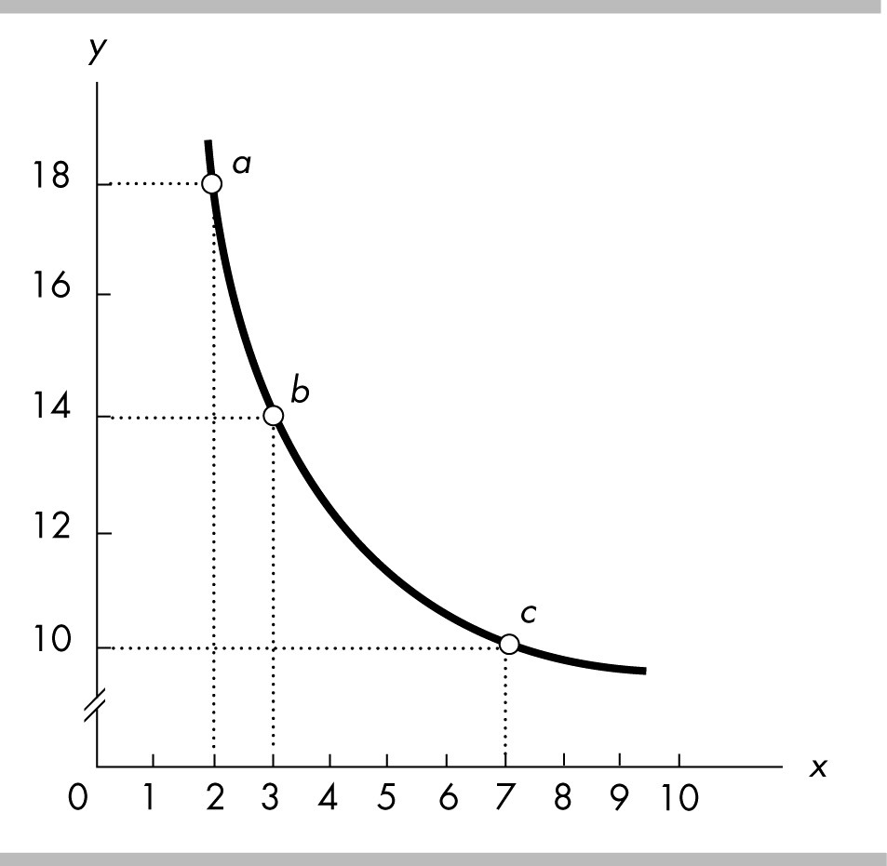

6) In the above figure, the x-coordinate of point b is
A) 1.
B) 2.
C) 3.
D) 14.
Answer: C
Topic: Graphing Data
Skill: Analytical
AACSB: Analytical thinking

7) In the above figure, the y-coordinate of point b is
A) 1.
B) 2.
C) 3.
D) 14.
Answer: D
Topic: Graphing Data
Skill: Analytical
AACSB: Analytical thinking
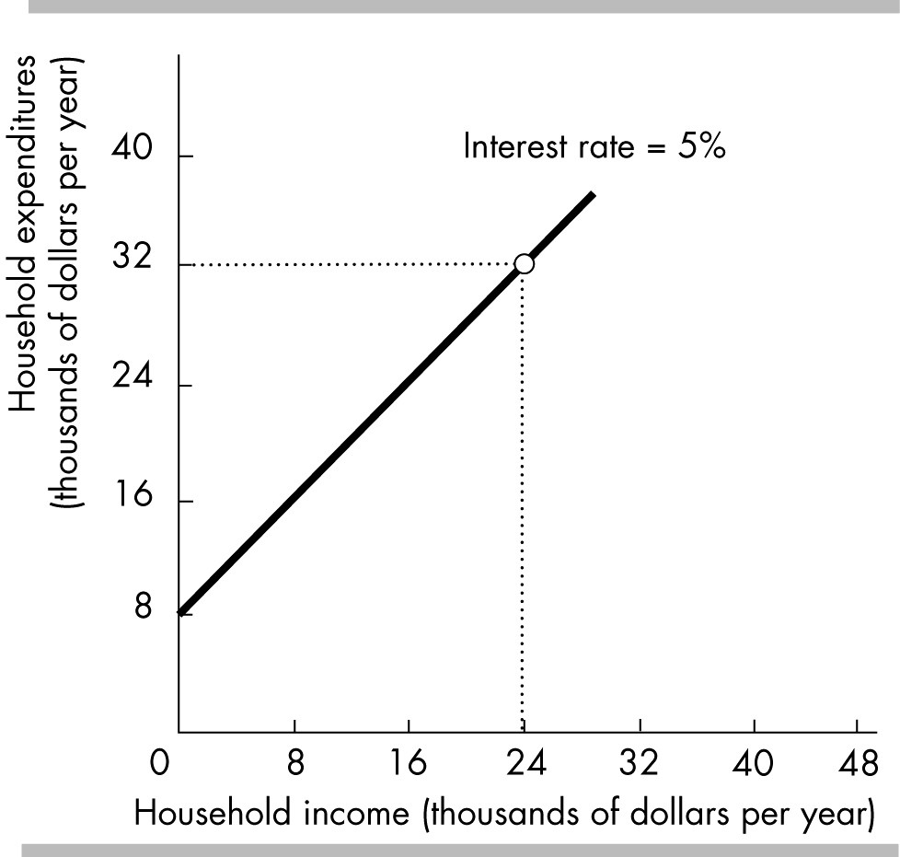

8) In the above figure, when income is zero, household expenditures equal
A) 0.
B) $1000.
C) $4000.
D) $8000.
Answer: D
Topic: Graphing Data
Skill: Analytical
AACSB: Analytical thinking
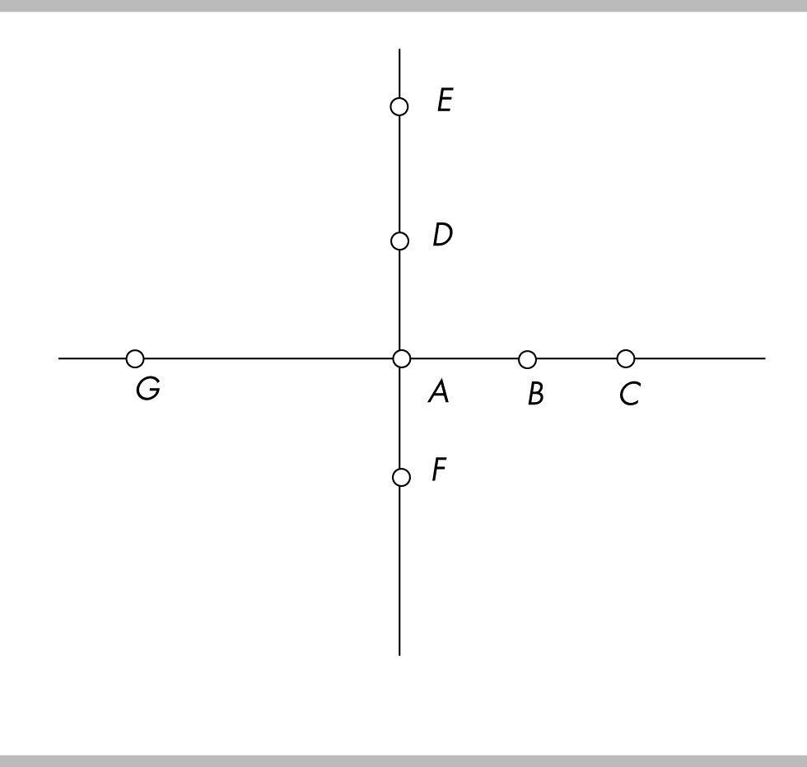

9) In the figure above, the value on the x-axis increases as we move from
A) point G to point A.
B) point C to point A.
C) point F to point A.
D) point E to point A.
Answer: A
Topic: Graphing Data
Skill: Analytical
AACSB: Analytical thinking

10) In the figure above, the value on the y-axis decreases as we move from
A) point G to point A.
B) point C to point A.
C) point F to point A.
D) point E to point A.
Answer: D
Topic: Graphing Data
Skill: Analytical
AACSB: Analytical thinking

11) In the figure above, point B is ________.
A) on the x-axis
B) on the y-axis
C) at the origin
D) a coordinate
Answer: A
Topic: Graphing Data
Skill: Analytical
AACSB: Analytical thinking
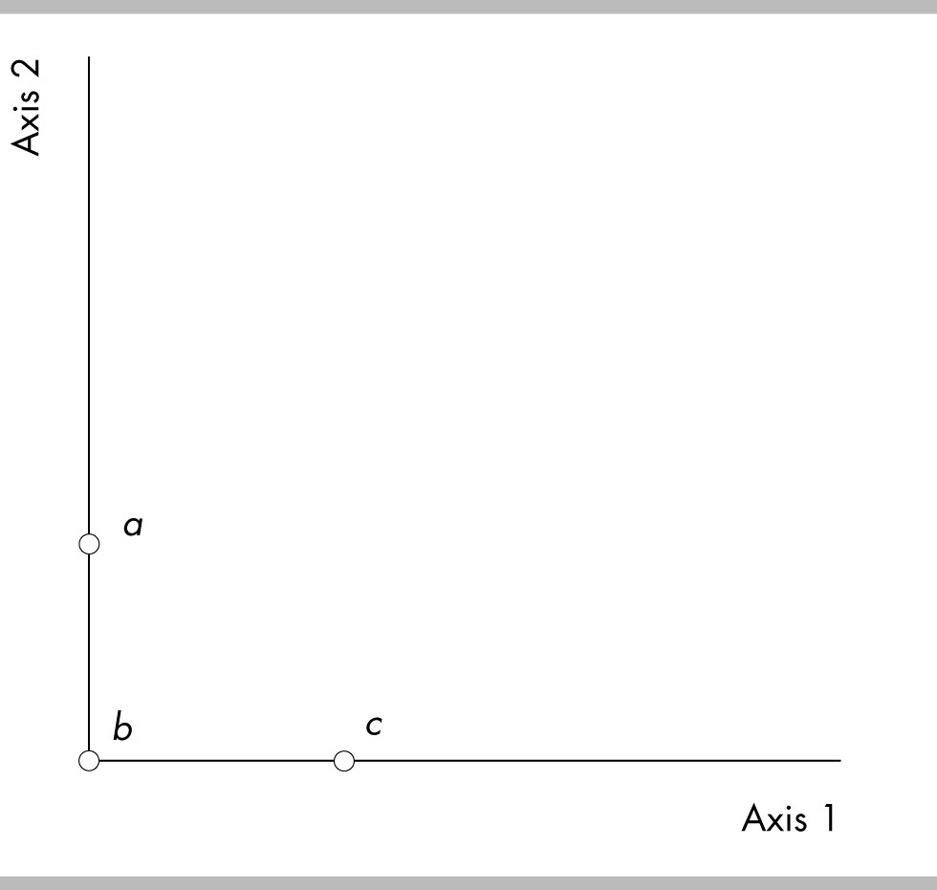

12) Using the above figure, the origin is at which point?
A) point a
B) point b
C) point c
D) None of the points in the figure is the origin.
Answer: B
Topic: Graphing Data
Skill: Analytical
AACSB: Analytical thinking

13) Using the above figure, which of the following is TRUE?
A) Axis 1 is typically called the y-axis.
B) Axis 1 is also known as the origin.
C) Axis 2 is typically called the x-axis.
D) Point b is known as the origin.
Answer: D
Topic: Graphing Data
Skill: Analytical
AACSB: Analytical thinking

14) A scatter diagram shows the
A) level of one variable over time.
B) change in one variable over time.
C) relationship between two variables.
D) evolution of a variable.
Answer: C
Topic: Scatter Diagrams
Skill: Recognition
AACSB: Analytical thinking
15) A scatter diagram will be most useful
A) in discerning a possible relationship between height and weight for individuals.
B) in resolving a dispute over two normative assertions.
C) in predicting next year's rate of unemployment.
D) All of the above are correct.
Answer: A
Topic: Scatter Diagrams
Skill: Conceptual
AACSB: Analytical thinking

16) You notice that when interest rates increases, new residential housing prices tend to decrease. This observation indicates that
A) there must be false causality between interest rates and housing prices.
B) higher interest rates must cause low housing prices.
C) a scatter diagram between interest rates and housing prices will show a negative relationship.
D) a scatter diagram between interest rates and housing prices will show a direct relationship.
Answer: C
Topic: Scatter Diagrams
Skill: Conceptual
AACSB: Analytical thinking

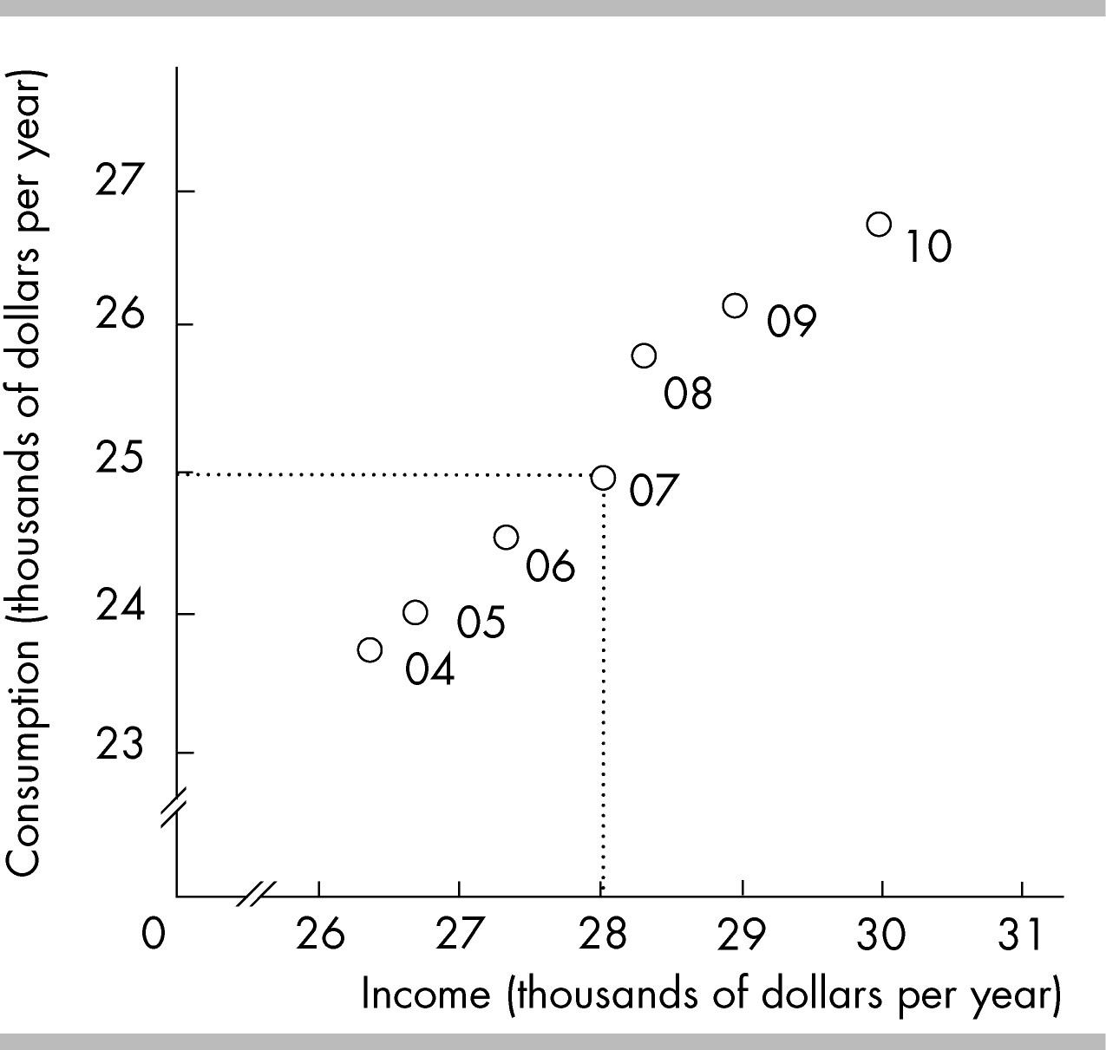

17) The above figure plots income and consumption in a nation. In 2007
A) consumption was equal to $25,000 and income was equal to $28,000.
B) consumption was equal to $28,000 and income was equal to $25,000.
C) consumption was equal to $25,000 and income was equal to $25,000.
D) consumption was equal to $27,000 and income was equal to $31,000.
Answer: A
Topic: Scatter Diagrams
Skill: Conceptual
AACSB: Analytical thinking
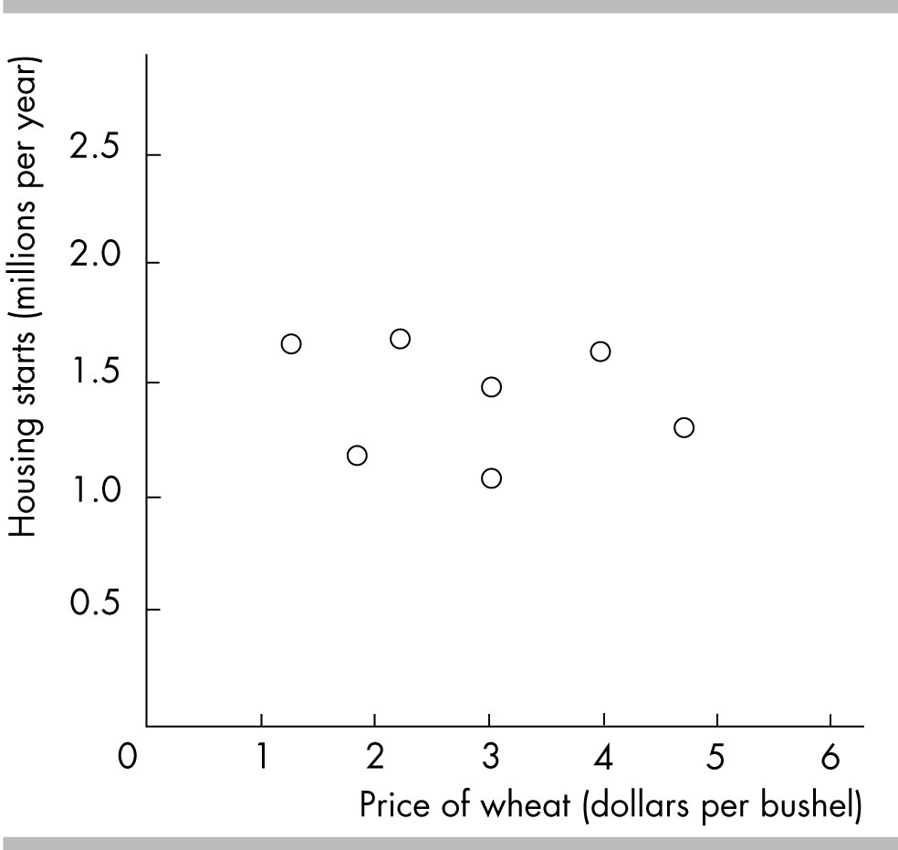

18) The above figure graphs the price of a bushel of wheat and housing starts. The graph shows the variables are
A) strongly positively related.
B) strongly negatively related.
C) not related.
D) related via an indirect relationship.
Answer: C
Topic: Scatter Diagrams
Skill: Analytical
AACSB: Analytical thinking
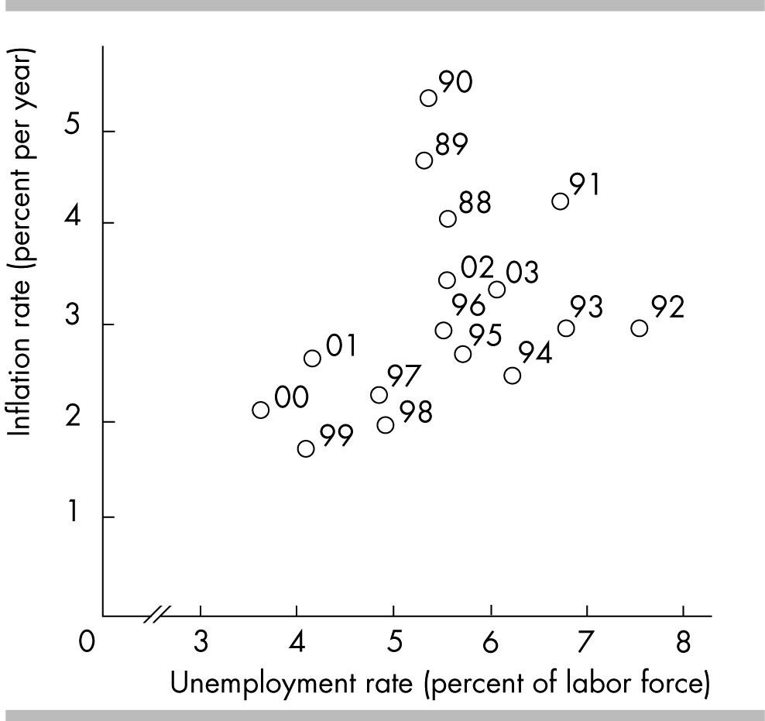

19) The figure above shows that in 1996, unemployment was equal to about ________ and the inflation rate was equal to about ________.
A) 7.0 percent; 3.0 percent
B) 3.0 percent; 5.5 percent
C) 5.5 percent; 3.0 percent
D) 6.0 percent; 4.0 percent
Answer: C
Topic: Scatter Diagrams
Skill: Analytical
AACSB: Analytical thinking
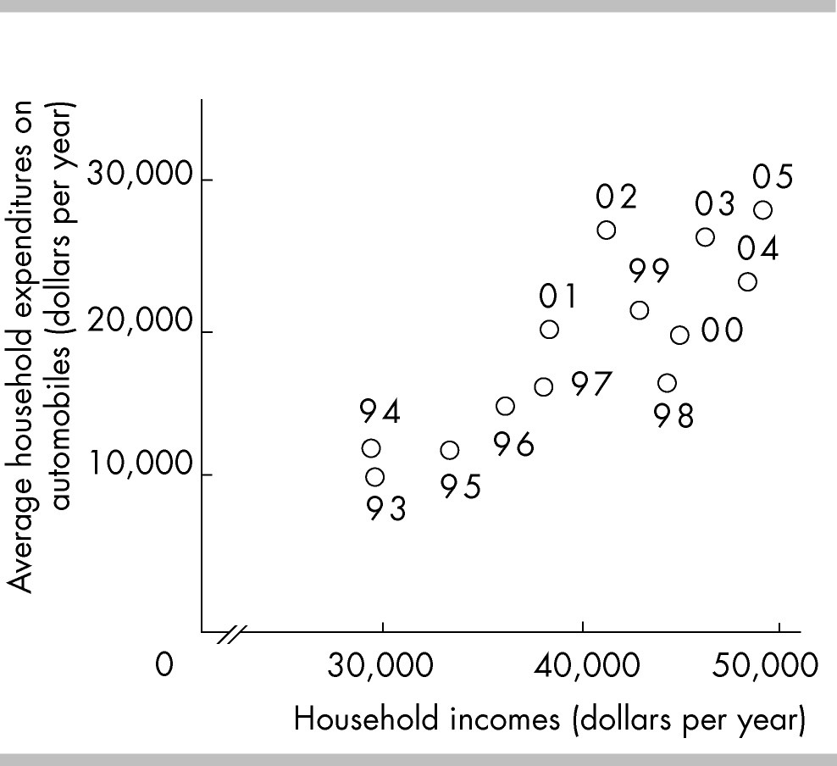

20) The above figure reveals
A) no relationship between household income and average household expenditure on automobiles.
B) that as household income increases the average household expenditure on automobiles decreases.
C) that as household income increases the average household expenditure on automobiles increases.
D) all of the above are possible.
Answer: C
Topic: Scatter Diagrams
Skill: Analytical
AACSB: Analytical thinking
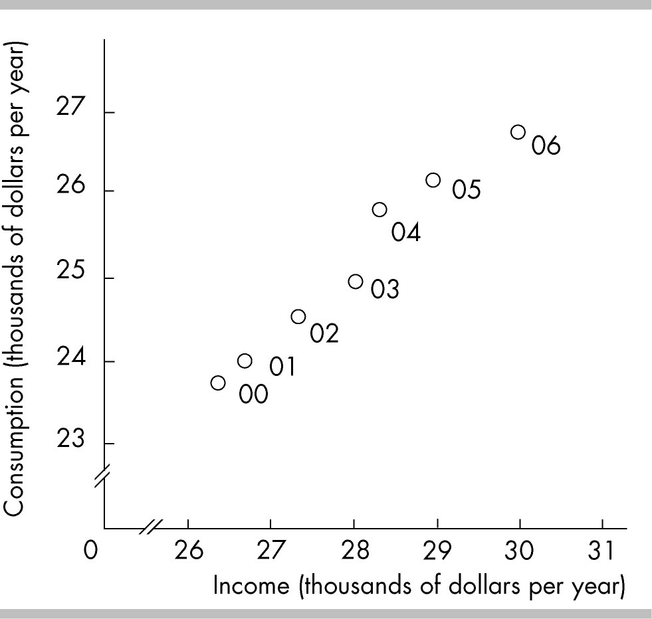

21) In the above figure, the axis breaks are used
A) to create a misleading graph.
B) to indicate that there are jumps from the origin, 0, to the first values recorded along the axes.
C) to indicate that there are not enough data to be included in the graph.
D) to show that there are no data available for the omitted ranges.
Answer: B
Topic: Breaks in the Axes
Skill: Recognition
AACSB: Analytical thinking
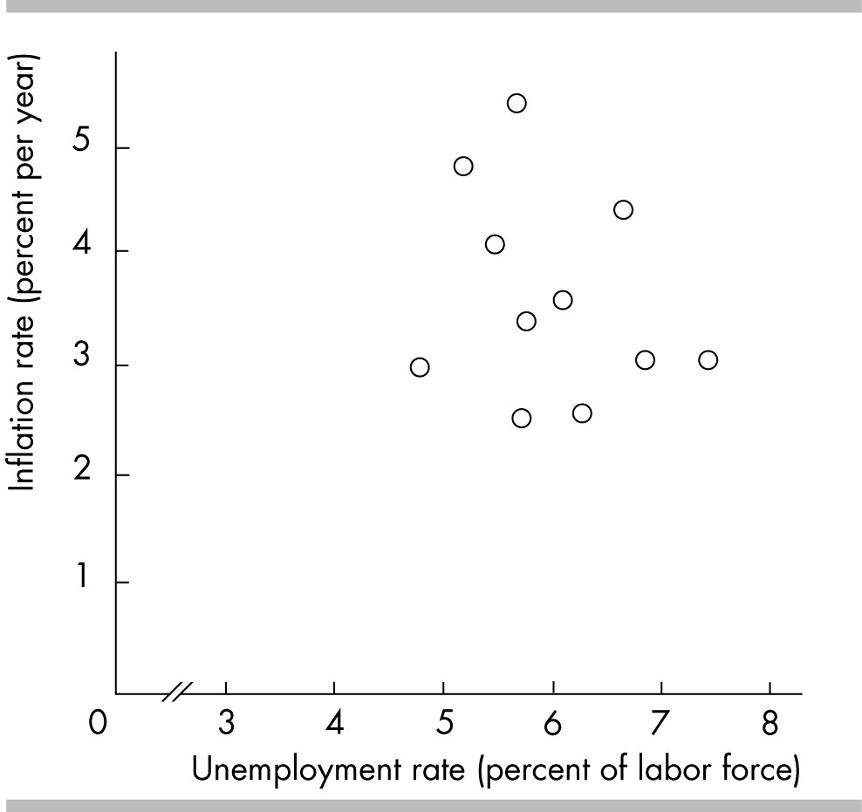

22) In the above figure, the axis break in the x-axis
A) reflects the fact that for the years covered in the figure, the unemployment rate was never less than 3 percent.
B) shows that there is no relationship between inflation and unemployment.
C) misleadingly shows that inflation has changed very little even though the unemployment rate has increased a great deal.
D) implies that for the years covered in the figure, the inflation rate was always greater than 1 percent.
Answer: A
Topic: Breaks in the Axes
Skill: Analytical
AACSB: Analytical thinking

23) On a graph, high correlation between the variable measured along the x-axis and the variable measured along the y-axis
A) means that changes in the variable measured along the x-axis must cause changes in the variable measured along the y-axis.
B) means that changes in the variable measured along the y-axis must cause changes in the variable measured along the x-axis.
C) means that changes in either variable must cause changes in the other variable.
D) does NOT mean that a change in the variable measured along the x-axis must cause a change in the variable measured along the y-axis.
Answer: D
Topic: Correlation and Causation
Skill: Conceptual
AACSB: Analytical thinking
24) You notice that when the inflation rate increases, the interest rate tends to increase. This observation indicates that
A) there might be false causality between inflation and the interest rate.
B) higher inflation rates must cause a higher interest rate.
C) a scatter diagram of the inflation rate and the interest rate will show a positive relationship.
D) the variables have an inverse relationship.
Answer: C
Topic: Study Guide Question, Scatter Diagrams
Skill: Conceptual
AACSB: Analytical thinking

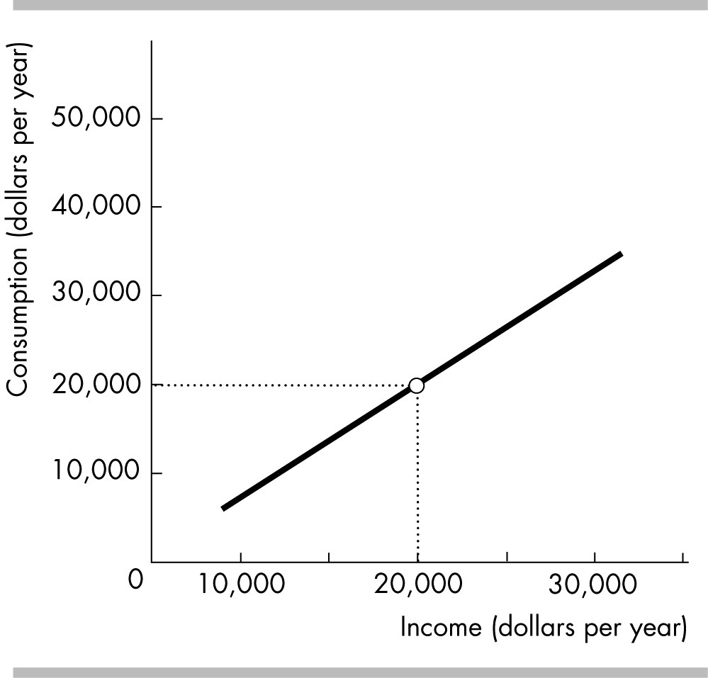

25) In the figure above, when income equals $20,000, what does consumption equal?
A) $0
B) $10,000
C) $20,000
D) impossible to tell
Answer: C
Topic: Study Guide Question, Scatter Diagrams
Skill: Conceptual
AACSB: Analytical thinking

11 Appendix: Graphs Used in Economic Models

1) If two variables are positively related, then
A) they move in opposite directions.
B) they are independent of each other.
C) they move in the same direction.
D) their graph will have a negative slope.
Answer: C
Topic: Variables That Move in the Same Direction
Skill: Recognition
AACSB: Analytical thinking
2) If two variables both increase at the same time or decrease at the same time, they are
A) unrelated to each other.
B) positively related.
C) negatively related.
D) conversely related.
Answer: B
Topic: Variables That Move in the Same Direction
Skill: Recognition
AACSB: Analytical thinking

3) If there is a direct relationship between two variables
A) the graph of the relationship will be upward-sloping.
B) the graph of the relationship will be downward-sloping.
C) the slope of the line (or the slope of a tangent line to the curve) will be negative.
D) Both answers A and C are correct.
Answer: A
Topic: Variables That Move in the Same Direction
Skill: Recognition
AACSB: Analytical thinking

4) The variable measured on the y-axis increases whenever the variable measured on the x-axis increases. As a result, the relationship between the variables will
A) be negatively sloped.
B) have a slope of zero.
C) be a vertical line.
D) be none of the above.
Answer: D
Topic: Variables That Move in the Same Direction
Skill: Recognition
AACSB: Analytical thinking

5) A positive relationship exists between two variables if
A) one variable has "positively" no effect on the other variable.
B) a reduction in one variable is associated with an increase in the other variable.
C) a reduction in one variable is associated with a decrease in the other variable.
D) both variables are inflation-distorted.
Answer: C
Topic: Variables That Move in the Same Direction
Skill: Recognition
AACSB: Analytical thinking

6) If the slope of a line that graphs the relationship between variable x and variable y is positive, then we know that
A) when the value of variable x increases, then the value of variable y decreases.
B) when the value of variable x decreases, then the value of variable y decreases.
C) the two variables are unrelated.
D) the two variables have an inverse relationship.
Answer: B
Topic: Variables That Move in the Same Direction
Skill: Conceptual
AACSB: Analytical thinking
7) For the Jones household it has been estimated that for every ten degrees increase in the outdoor temperature the consumption of ice tea increases by 5 glasses. What type of relationship exists between temperature change and the consumption of ice tea?
A) negative relationship
B) positive relationship
C) no relationship
D) maximum relationship
Answer: B
Topic: Variables That Move in the Same Direction
Skill: Recognition
AACSB: Analytical thinking

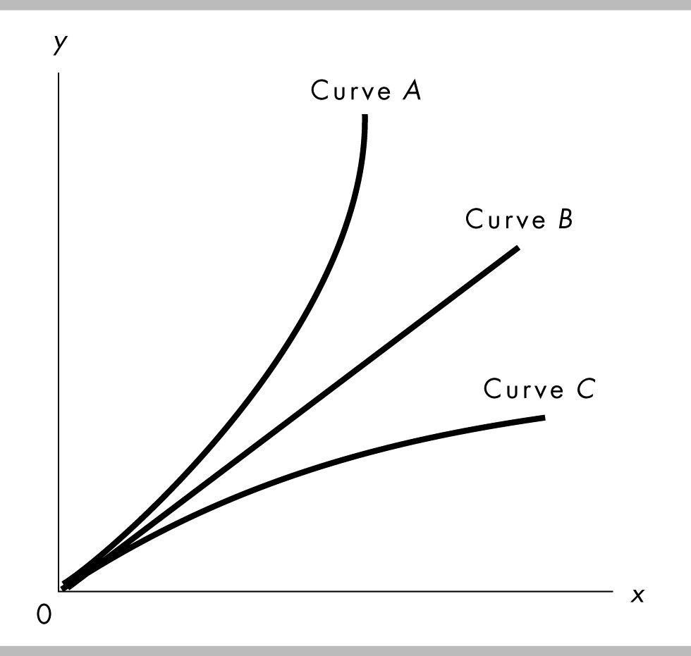

8) In the above figure, which curve shows a positive relationship between x and y?
A) only curve A
B) only curve B
C) only curve C
D) All the curves show a positive relationship.
Answer: D
Topic: Variables That Move in the Same Direction
Skill: Conceptual
AACSB: Analytical thinking

9) In the above figure, which curve shows a negative relationship between x and y?
A) only curve A
B) only curve B
C) only curve C
D) None of the curves show a negative relationship.
Answer: D
Topic: Variables That Move in the Same Direction
Skill: Conceptual
AACSB: Analytical thinking
10) A scatter diagram with the price of vacations to Mexico on the vertical axis and the price of vacations to California on the horizontal axis shows a positive relationship. If the price of vacations to Mexico were placed on the horizontal axis, and the price of vacations to California on the vertical axis, the relationship would be
A) negative relationship, also called a direct relationship.
B) negative relationship, also called an inverse relationship.
C) positive relationship, also called a direct relationship.
D) positive relationship, also called an inverse relationship.
Answer: C
Topic: Variables That Move in the Same Direction
Skill: Conceptual
AACSB: Analytical thinking

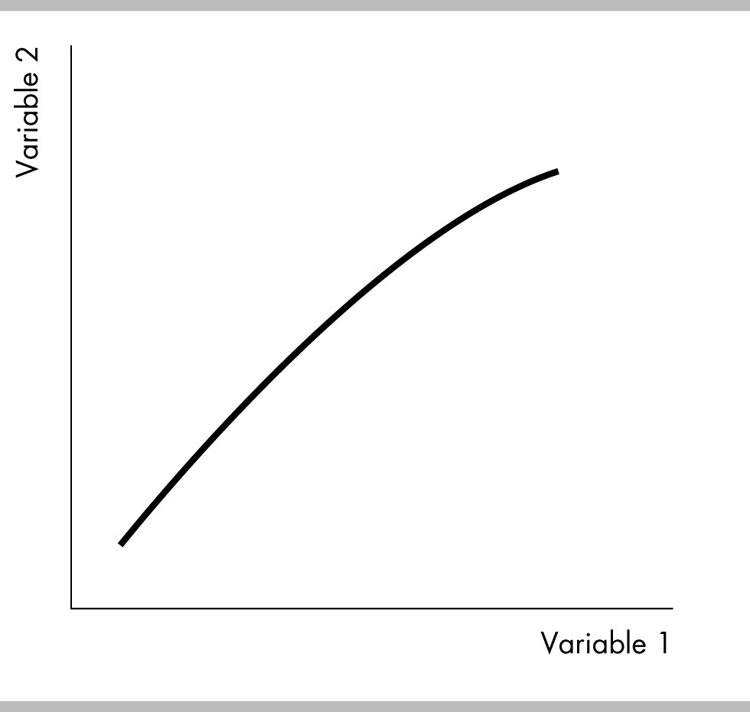

11) The figure above shows ________ relationship between the two variables.
A) a positive
B) a negative
C) no
D) an inverse
Answer: A
Topic: Variables That Move in the Same Direction
Skill: Recognition
AACSB: Analytical thinking

12) "As you devote more hours to studying, your GPA increases." A graph of this relationship would show
A) a positive relationship.
B) a direct relationship.
C) an inverse relationship.
D) Both answers A and B are correct.
Answer: D
Topic: Variables That Move in the Same Direction
Skill: Conceptual
AACSB: Analytical thinking
13) "As interest rates rise, people save more money." A graph displaying this relationship would show
A) an inverse relationship.
B) a positive relationship.
C) a cross-section graph.
D) a positive then a negative relationship.
Answer: B
Topic: Variables That Move in the Same Direction
Skill: Conceptual
AACSB: Analytical thinking

14) "If you hire 1 worker, the worker can produce 20 pizzas a day. If you hire a 2nd worker, that worker can produce 10 more pizzas. If you hire a 3rd worker, that worker can produce 2 more pizzas a day." A graph displaying this relationship between the number of employees and total pizza output per day would show
A) a positive linear relationship.
B) an upward-sloping curve that becomes less steep.
C) a negative linear relationship.
D) a negatively-sloped curve that becomes less steep.
Answer: B
Topic: Variables That Move in the Same Direction
Skill: Conceptual
AACSB: Analytical thinking

15) If you study 3 hours for an exam, you can raise your score by 30 points. If you study for another 3 hours your score increases by 10 points. And if you study for another 3 hours, your score will increase by 5 more points. A graph displaying this relationship between the number of hours studied and your total exam score would show
A) a positive linear relationship.
B) an upward-sloping curve that becomes less steep.
C) a negative linear relationship.
D) an upward-sloping curve that becomes more steep.
Answer: B
Topic: Variables That Move in the Same Direction
Skill: Conceptual
AACSB: Analytical thinking

16) Suppose you produce 10 bikes a day for a total cost of $1000. Total costs increase to $1100 when you produce 15 bikes. Finally, total costs increase to $1300 if you make 20 bikes. A graph showing the relationship between total costs and the number of bikes produced would be
A) a negatively-sloped line that becomes steeper.
B) a positively-sloped line that becomes steeper.
C) a negatively-sloped line that becomes flatter.
D) a positively-sloped line that becomes flatter.
Answer: B
Topic: Variables That Move in the Same Direction
Skill: Conceptual
AACSB: Analytical thinking

Total household income (dollars) | Total consumption (dollars)
30,000 | 27,000
40,000 | 35,000
50,000 | 38,000

17) The data in the table above shows the relationship between the Joneses' total consumption and total household income. Based on these data, total consumption varies
A) directly with their total household income.
B) independently of their total household income.
C) inversely with their total household income.
D) negatively with their income.
Answer: A
Topic: Variables That Move in the Same Direction
Skill: Recognition
AACSB: Analytical thinking

x | y
0 | 0
2 | 6
4 | 12
6 | 18
8 | 24
10 | 30

18) In the above table, when x increases from 4 units to 6 units, y changes by ________ units.
A) 2
B) -2
C) 6
D) -6
Answer: C
Topic: Variables That Move in the Same Direction
Skill: Analytical
AACSB: Analytical thinking

19) The above table indicates that variables x and y are
A) positively related.
B) inversely related.
C) negatively related.
D) not related.
Answer: A
Topic: Variables That Move in the Same Direction
Skill: Analytical
AACSB: Analytical thinking

x | y
0 | 2
1 | 5
2 | 8
3 | 11
4 | 14
5 | 17

20) Given the information in the above table, the relationship between x and y is
A) positive, and the curve becomes flatter as x increases.
B) positive, and the curve becomes steeper as x increases.
C) positive and linear.
D) negative and linear.
Answer: C
Topic: Variables That Move in the Same Direction
Skill: Analytical
AACSB: Analytical thinking

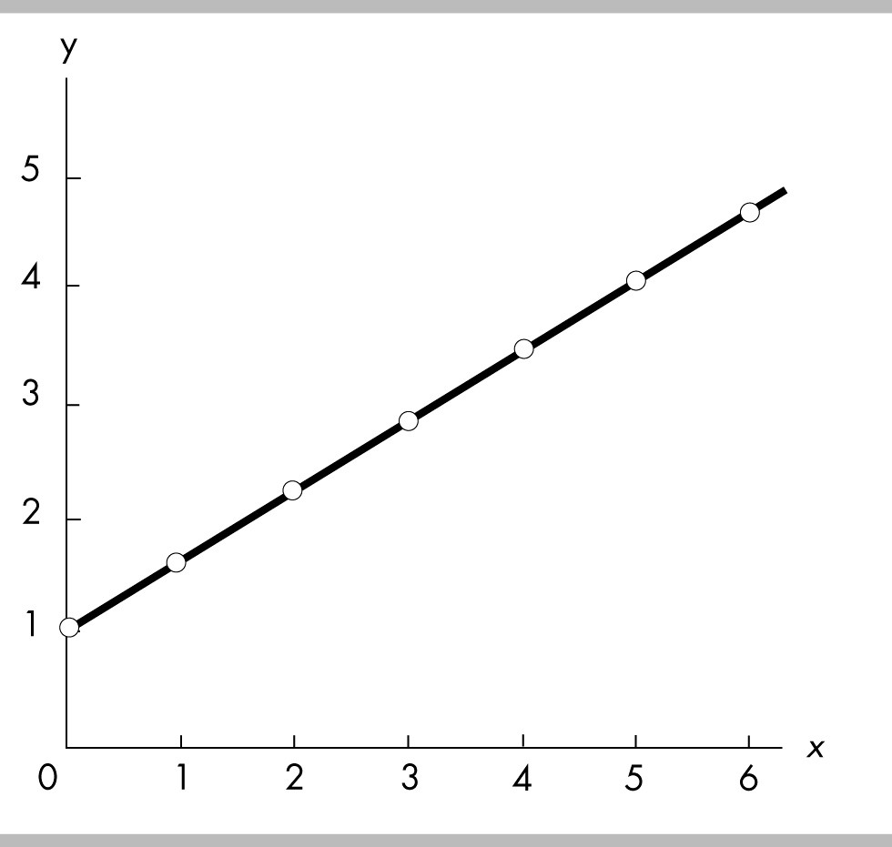

21) In the above figure, the relationship between x and y is
A) positive, and the curve becomes flatter as x increases.
B) positive, and the curve becomes steeper as x increases.
C) positive and linear.
D) negative and linear.
Answer: C
Topic: Variables That Move in the Same Direction
Skill: Analytical
AACSB: Analytical thinking
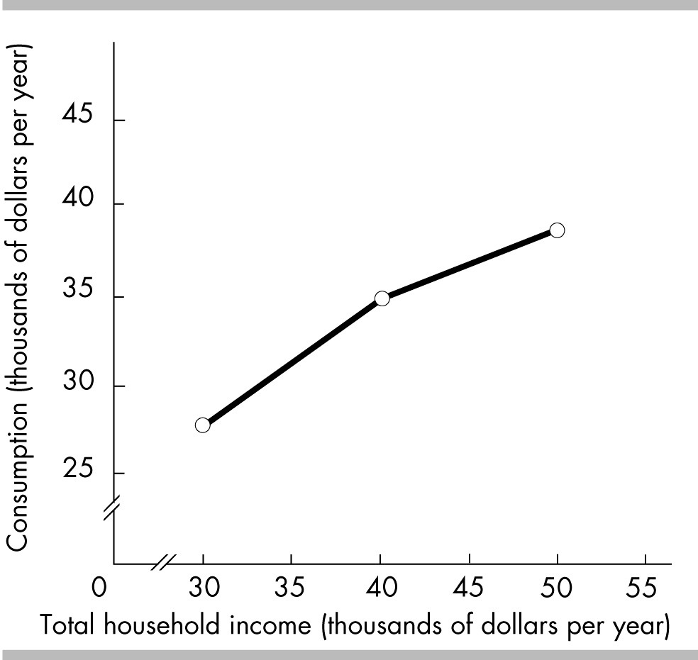

22) The above figure shows the relationship between the Joneses' total consumption and total household income. The figure illustrates that the Joneses' total consumption varies
A) directly with their total household income.
B) independently of their total household income.
C) inversely with their total household income.
D) negatively with their income.
Answer: A
Topic: Variables That Move in the Same Direction
Skill: Analytical
AACSB: Analytical thinking
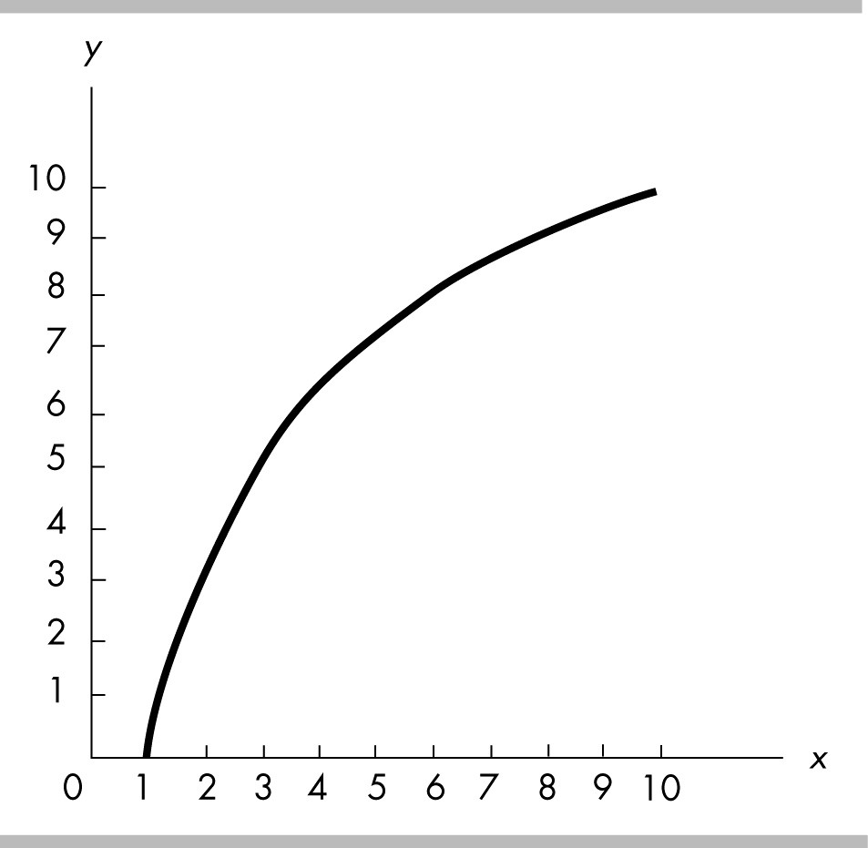

23) The relationship depicted in the above figure is
A) a negative linear relationship.
B) a positive linear relationship.
C) a positive becoming less steep relationship.
D) a positive becoming steeper relationship.
Answer: C
Topic: Variables That Move in the Same Direction
Skill: Recognition
AACSB: Analytical thinking

24) Whenever one variable increases, another variable decreases. The two variables are
A) definitely related through a third variable.
B) negatively related.
C) positively related.
D) unrelated to each other.
Answer: B
Topic: Variables That Move in Opposite Directions
Skill: Recognition
AACSB: Analytical thinking

25) If variable x always increases when variable y decreases, x and y are said to be
A) positively related.
B) negatively related.
C) unrelated.
D) trend related.
Answer: B
Topic: Variables That Move in Opposite Directions
Skill: Recognition
AACSB: Analytical thinking
26) If there is an inverse relationship between variable x and variable y, then an increase in the value of variable x will be accompanied by
A) an increase in the value of variable y.
B) a decrease in the value of variable y.
C) no change in the value of variable y.
D) variable y reaching its maximum value.
Answer: B
Topic: Variables That Move in Opposite Directions
Skill: Recognition
AACSB: Analytical thinking

27) If there is an inverse relationship between two variables, the graph of this relationship
A) will be a horizontal line.
B) will be downward-sloping.
C) might be horizontal.
D) will be upward-sloping.
Answer: B
Topic: Variables That Move in Opposite Directions
Skill: Recognition
AACSB: Analytical thinking

28) A negative relationship exists between the variable measured along the y-axis and the variable measured along the x-axis if
A) a reduction in the variable measured along the x-axis is associated with a reduction in the variable measured along the y-axis.
B) an increase in the variable measured along the x-axis is associated with an increase in the variable measured along the y-axis.
C) the variable measured along the x-axis and the variable measured along the y-axis move in the opposite direction.
D) the variable measured along the x-axis and the variable measured along the y-axis move in the same direction.
Answer: C
Topic: Variables That Move in Opposite Directions
Skill: Recognition
AACSB: Analytical thinking

29) Along a curve, when one variable increases, the other variable decreases. The curve showing this relationship
A) might be horizontal.
B) has a positive slope.
C) has a negative slope.
D) has an increasing then a decreasing slope.
Answer: C
Topic: Variables That Move in Opposite Directions
Skill: Recognition
AACSB: Analytical thinking
30) "As the price of gasoline increases, fewer people buy cars that are gas guzzlers." A graph showing this relationship would have
A) a negative slope.
B) a positive relationship.
C) a direct relationship.
D) a horizontal line.
Answer: A
Topic: Variables That Move in Opposite Directions
Skill: Conceptual
AACSB: Analytical thinking

31) A graph shows that as fees to use ATM machines increase, people use them less frequently. The graph of this relationship would show
A) an inverse relationship.
B) a negative relationship.
C) a direct relationship.
D) Both answers A and B are correct.
Answer: D
Topic: Variables That Move in Opposite Directions
Skill: Conceptual
AACSB: Analytical thinking

32) As the number of days without rain increases, the amount of wheat per acre grown declines. A graph showing this relationship would have a curve
A) that is a horizontal line.
B) that is a vertical line.
C) showing a positive relationship.
D) None of the above answers are correct.
Answer: D
Topic: Variables That Move in Opposite Directions
Skill: Conceptual
AACSB: Analytical thinking

33) As a firm produces more and more DVDs, the average cost of producing each DVD falls. A curve showing the behavior of the average cost of a DVD as more DVDs are produced
A) would be positively and then negatively sloped.
B) would be positively sloped.
C) would be horizontal.
D) would be negatively sloped.
Answer: D
Topic: Variables That Move in Opposite Directions
Skill: Conceptual
AACSB: Analytical thinking
34) Suppose that we find that student grades and time spent at parties move in opposite directions. A graph of the relationship between these two variables would curve
A) upward and be linear.
B) upward and may be linear or nonlinear.
C) downward and be linear.
D) downward and may be linear or nonlinear.
Answer: D
Topic: Variables That Move in Opposite Directions
Skill: Conceptual
AACSB: Analytical thinking

35) The faster an automobile is driven (speed), the lower the miles per gallon (mpg) for that automobile. Given this information, we say that an automobile's speed and mpg have
A) a direct relationship.
B) an inverse relationship.
C) a linear relationship.
D) a maximum relationship.
Answer: B
Topic: Variables That Move in Opposite Directions
Skill: Recognition
AACSB: Analytical thinking

36) If the quantity of wood purchased decreases when the price of wood rises, a graph representing these variables would have
A) time on the vertical axis.
B) the slope on the vertical axis.
C) a negative slope.
D) a positive slope.
Answer: C
Topic: Variables That Move in Opposite Directions
Skill: Conceptual
AACSB: Analytical thinking

37) A scatter diagram with the price of peanut butter on the vertical axis and the price of jelly on the horizontal axis shows a negative relationship. If the price of jelly was placed on the vertical axis and the price of peanut butter was placed on the horizontal axis, the relationship would be a
A) negative relationship, also called a direct relationship.
B) negative relationship, also called an inverse relationship.
C) positive relationship, also called a direct relationship.
D) positive relationship, also called an inverse relationship.
Answer: B
Topic: Variables That Move in Opposite Directions
Skill: Conceptual
AACSB: Analytical thinking
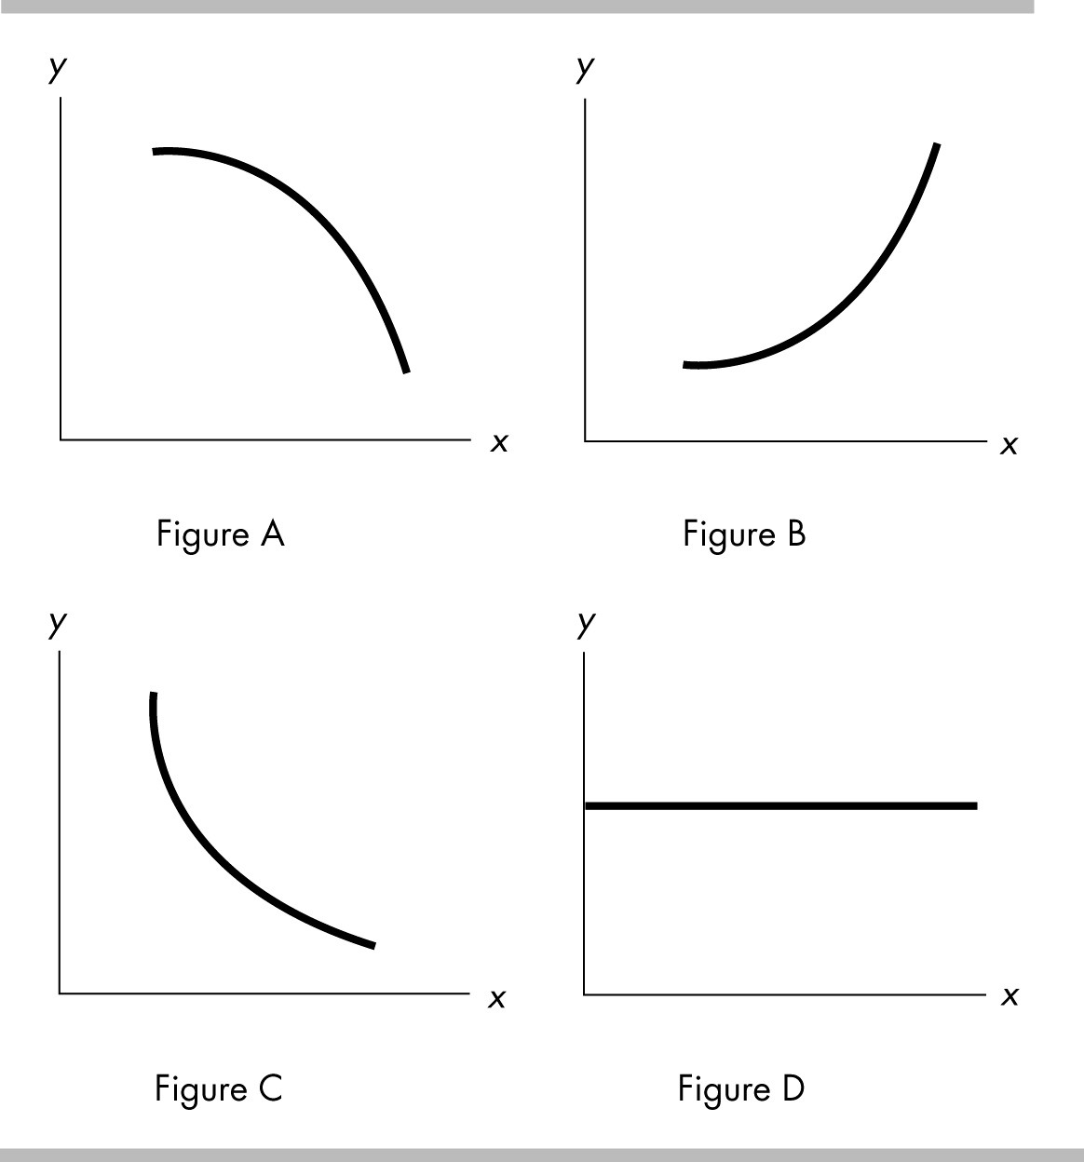

38) In the above figure, if there is a negative relationship between the variables x and y, which of the graphs above can be used to indicate this?
A) Figure A
B) Figure B
C) Figure C
D) both Figure A and Figure C
Answer: D
Topic: Variables That Move in Opposite Directions
Skill: Recognition
AACSB: Analytical thinking

39) In the above figure, which of the graphs demonstrates a curve with a decreasing slope, that is, a slope getting smaller in magnitude as x increases?
A) Figure A
B) Figure B
C) Figure C
D) Figure D
Answer: C
Topic: The Slope of a Relationship
Skill: Analytical
AACSB: Analytical thinking
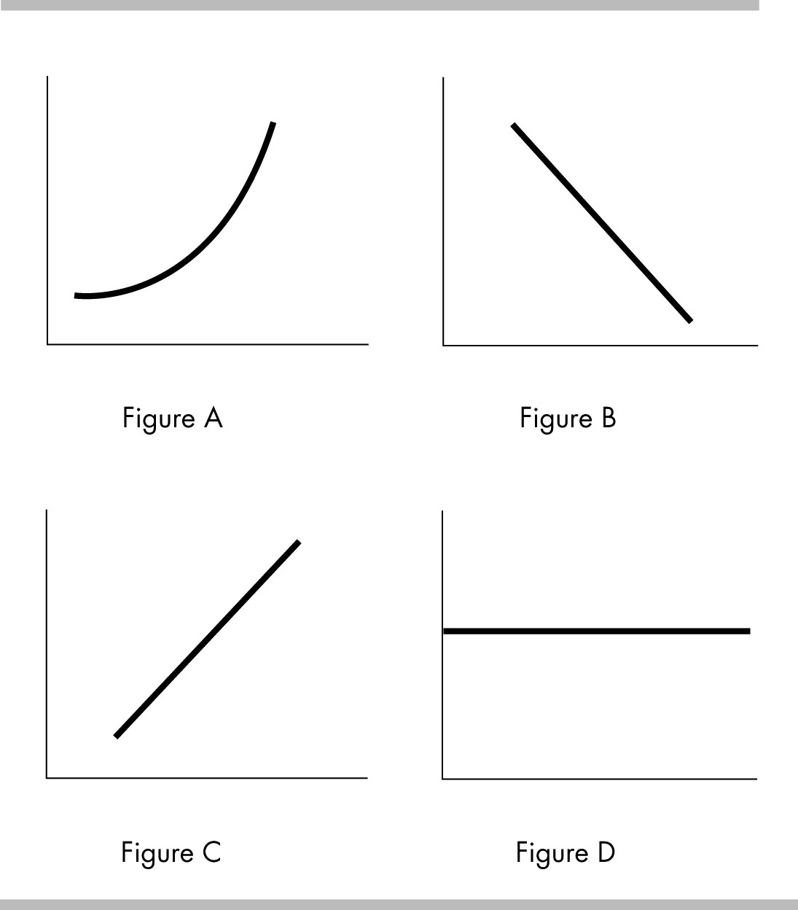

40) In the above figure, a negative relationship is demonstrated in which of the graphs?
A) Figure A
B) Figure B
C) Figure C
D) Figure D
Answer: B
Topic: Variables That Move in Opposite Directions
Skill: Recognition
AACSB: Analytical thinking
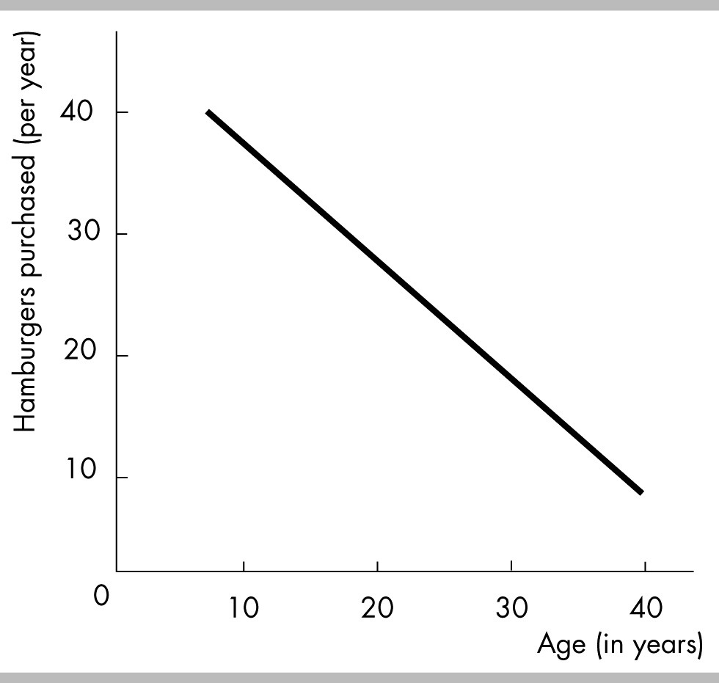

41) The above figure depicts a
A) positive non-linear relationship between age and the number of hamburgers purchased per year.
B) negative non-linear relationship between age and the number of hamburgers purchased per year.
C) positive linear relationship between age and the number of hamburgers purchased per year.
D) negative linear relationship between age and the number of hamburgers purchased per year.
Answer: D
Topic: Variables That Move in Opposite Directions
Skill: Analytical
AACSB: Analytical thinking
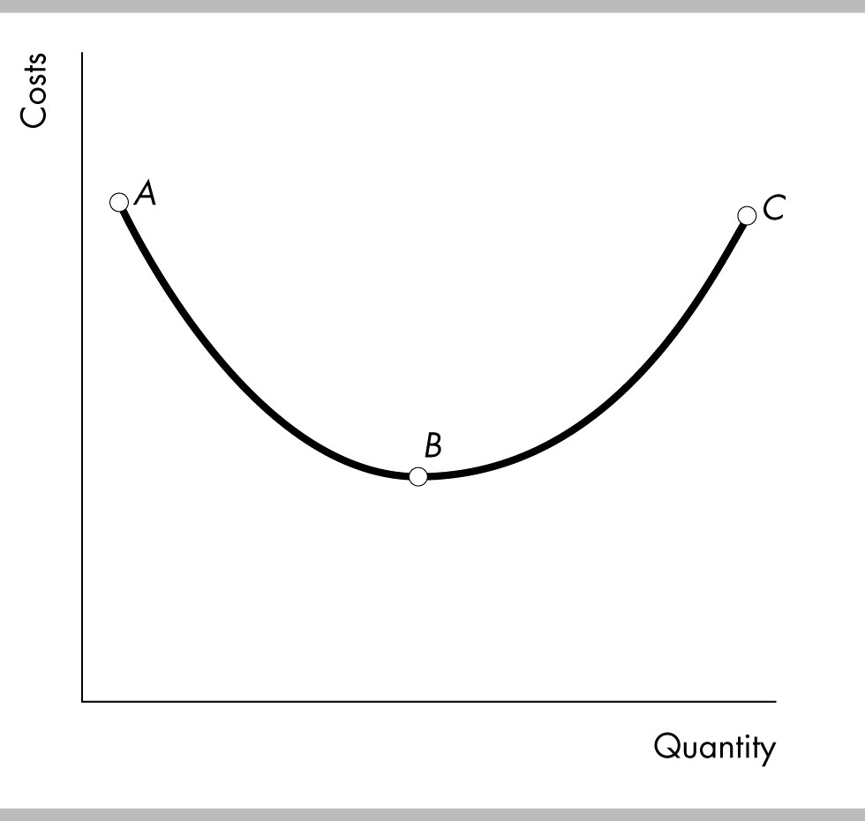

42) In the above figure, the relationship between costs and quantity is negative
A) between point A and point B.
B) between point B and point C.
C) along the entire curve.
D) nowhere along the curve.
Answer: A
Topic: Variables That Move in Opposite Directions
Skill: Analytical
AACSB: Analytical thinking

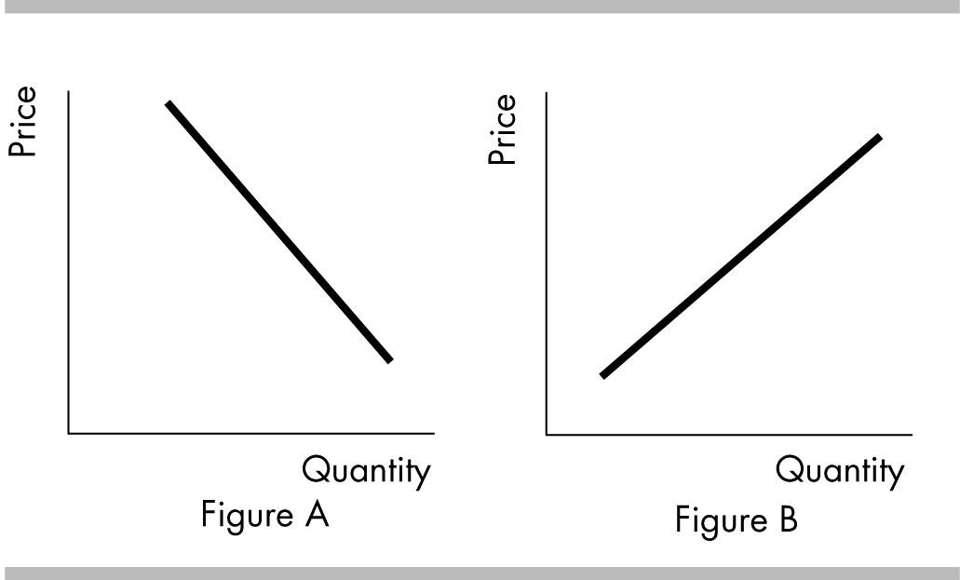

43) In the above, a positive relationship between price and quantity is shown in
A) Figure A.
B) Figure B.
C) both Figure A and Figure B.
D) neither Figure A nor Figure B.
Answer: B
Topic: Variables That Move in the Same Direction
Skill: Analytical
AACSB: Analytical thinking
44) In the above figure, a negative relationship between price and quantity is shown in
A) Figure A.
B) Figure B.
C) both Figure A and Figure B.
D) neither Figure A nor Figure B.
Answer: A
Topic: Variables That Move in Opposite Directions
Skill: Analytical
AACSB: Analytical thinking

45) If a graph shows a negative relationship between two variables which then becomes a positive relationship, this curve would
A) always be an upward-sloping line.
B) have a minimum point.
C) have a maximum point.
D) always be a downward-sloping line.
Answer: B
Topic: Maximum and Minimum Points
Skill: Recognition
AACSB: Analytical thinking

46) As a firm expands its output, cost per unit of output (average cost) decreases and then increases. Average cost and output have
A) a relationship with a minimum.
B) a relationship with a maximum.
C) no relationship.
D) a linear positive relationship.
Answer: A
Topic: Variables That Have a Maximum or Minimum
Skill: Conceptual
AACSB: Analytical thinking
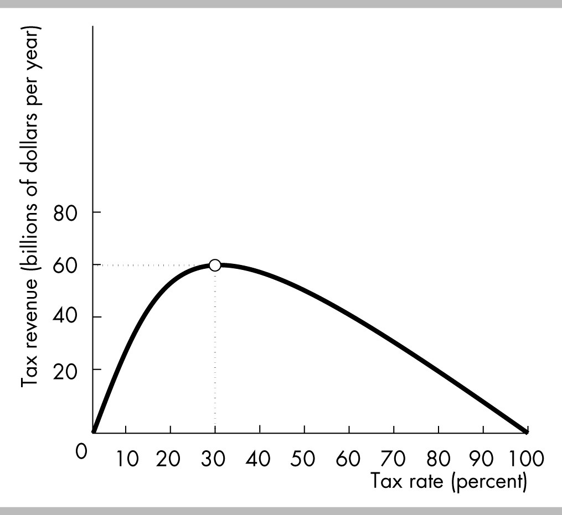

47) In the above figure, the relationship between the tax rate and tax revenue is positive and becoming less steep between tax rates of
A) 0 percent and 30 percent.
B) 30 percent and 100 percent.
C) 0 percent and 100 percent.
D) None of the above answers are correct.
Answer: A
Topic: Variables That Have a Maximum or Minimum
Skill: Analytical
AACSB: Analytical thinking

48) In the above figure, if the tax rate is increased from 20 percent to 30 percent, tax revenue
A) decreases.
B) is constant.
C) increases.
D) may increase or decrease.
Answer: C
Topic: Variables That Have a Maximum or Minimum
Skill: Analytical
AACSB: Analytical thinking

49) In the above figure, tax revenue is at a maximum when the tax rate is
A) 0 percent.
B) 30 percent.
C) 50 percent.
D) 100 percent.
Answer: B
Topic: Variables That Have a Maximum or Minimum
Skill: Analytical
AACSB: Analytical thinking
50) As a curve approaches a maximum point, the slope will
A) be positive, then negative after the maximum point.
B) be negative, then positive after the maximum point.
C) remain constant on either side of the maximum point.
D) increase before and after the maximum point.
Answer: A
Topic: Maximum and Minimum Points
Skill: Conceptual
AACSB: Analytical thinking

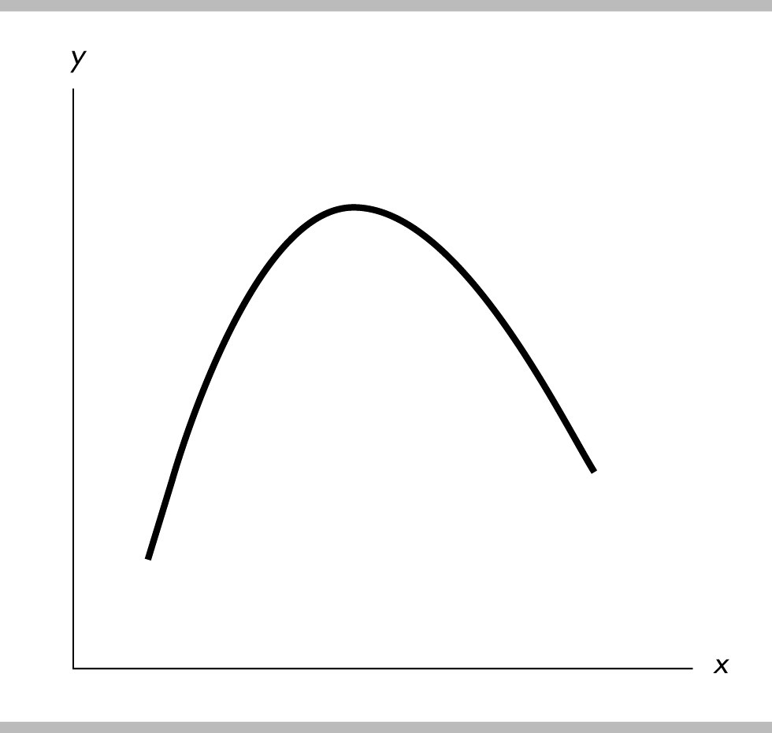

51) In the figure above, the relationship between the x variable and the y variable
A) is positive.
B) is negative.
C) starts by being positive and then becomes negative.
D) starts by being negative and then becomes positive.
Answer: C
Topic: Variables That Have a Maximum or Minimum
Skill: Analytical
AACSB: Analytical thinking

Total number of workers | Average cost of producing a television set (dollars)
4 | 1,250
10 | 750
13 | 770
15 | 850

52) Graphing the data in the above table with the number of workers on the horizontal axis and the average cost on the vertical axis, the graph would show
A) first a negative and then a positive relationship.
B) a horizontal line.
C) no relationship.
D) a linear relationship.
Answer: A
Topic: Variables That Have a Maximum or Minimum
Skill: Analytical
AACSB: Analytical thinking

53) If a curve rises and then falls, it shows a
A) maximum.
B) minimum.
C) linear relationship.
D) constant slope relationship.
Answer: A
Topic: Maximum and Minimum Points
Skill: Analytical
AACSB: Analytical thinking

54) If a curve falls and then rises, it shows
A) a maximum.
B) a minimum.
C) a linear relationship.
D) a constant slope relationship.
Answer: B
Topic: Maximum and Minimum Points
Skill: Analytical
AACSB: Analytical thinking

55) When y changes, x stays the same. The line depicting this relationship would be
A) vertical.
B) horizontal.
C) linear with a negative slope.
D) linear with a positive slope.
Answer: A
Topic: Variables That Are Unrelated
Skill: Recognition
AACSB: Analytical thinking
56) A graph measures y on the vertical axis and x on the horizontal. The curve on the graph is a horizontal line. From this fact we know that
A) the value of x never changes.
B) the value of y does not depend on the value of x.
C) the ratio of x to y is constant.
D) the slope of the line is not defined because y never changes.
Answer: B
Topic: Variables That Are Unrelated
Skill: Analytical
AACSB: Analytical thinking

57) A graph measures y on the vertical axis and x on the horizontal. The curve on the graph is a vertical line. From this fact we know that
A) the value of x does not change when the value of y changes.
B) the value of y is constant.
C) the ratio of x to y is constant.
D) the ratio of y to x is constant.
Answer: A
Topic: Variables That Are Unrelated
Skill: Analytical
AACSB: Analytical thinking

58) The graph of two variables, x and y, is a horizontal line. This result indicates that x and y are
A) positively related.
B) negatively related.
C) not related.
D) falsely related.
Answer: C
Topic: Variables That Are Unrelated
Skill: Conceptual
AACSB: Analytical thinking

59) A diagram shows the quantity of tomatoes on the horizontal axis and the quantity of coffee on the vertical axis. The quantity of tomatoes remains constant as the quantity of coffee increases. The graph of these data is
A) a horizontal line.
B) a vertical line.
C) a positively sloped line.
D) a negatively sloped line
Answer: B
Topic: Variables That Are Unrelated
Skill: Analytical
AACSB: Analytical thinking
60) A graph shows the price of a pound of cucumbers on the vertical axis and the quantity of new cars sold by GM on the horizontal axis. The price of a pound of cucumbers remains constant as the quantity of new cars sold increases. The graph of these data is
A) a horizontal line.
B) a vertical line.
C) a curve with a maximum.
D) a positively-sloped line.
Answer: A
Topic: Variables That Are Unrelated
Skill: Analytical
AACSB: Analytical thinking

61) If two variables are unrelated, a scatter diagram of those variables will
A) be a vertical line.
B) be a horizontal line.
C) be either a vertical or horizontal line.
D) have a constant positive slope.
Answer: C
Topic: Variables That Are Unrelated
Skill: Analytical
AACSB: Analytical thinking
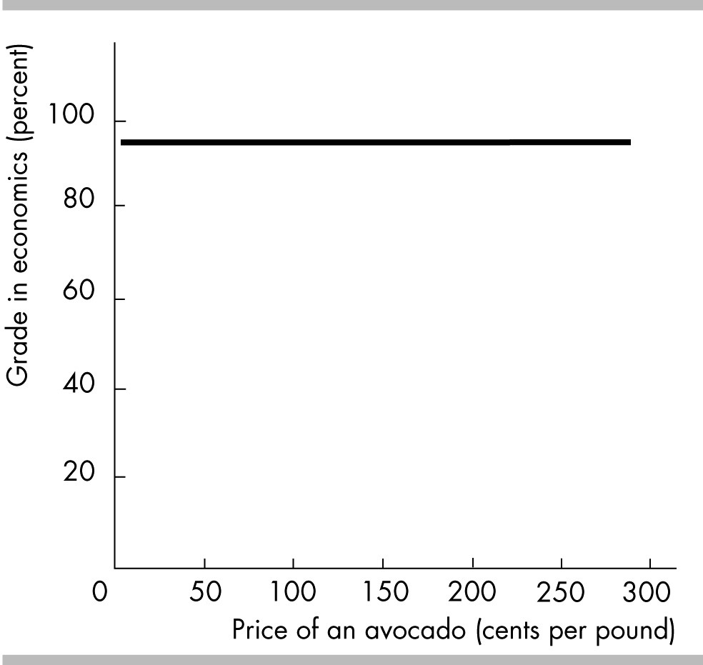

62) Which of the following CORRECTLY describes the above figure?
I) There is no relationship between the price of an avocado and a student's grade in economics.
II) The value of variable measured on the y-axis is constant as the variable measured on the x-axis increases.
III) As a student's grade in economics increases, the price of an avocado increases.
A) I
B) I and II
C) II and III
D) I, II, and III
Answer: B
Topic: Variables That Are Unrelated
Skill: Analytical
AACSB: Analytical thinking
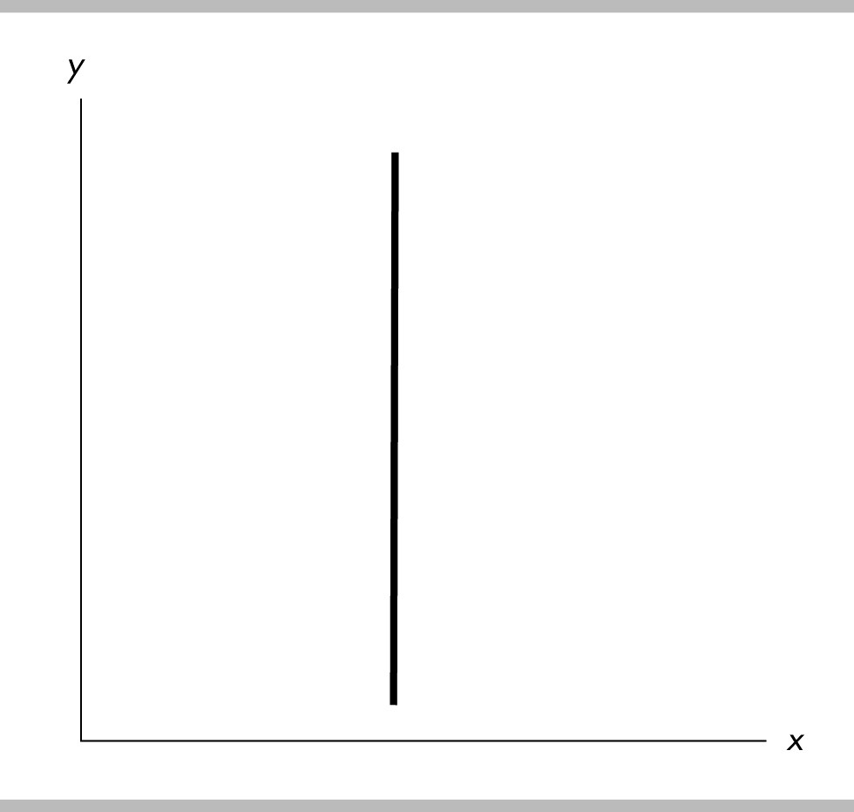

63) In the above, as the y variable increases
A) the x variable is constant.
B) the x variable increases.
C) the x variable decreases.
D) the x variable at first increases but then decreases.
Answer: A
Topic: Variables That Are Unrelated
Skill: Analytical
AACSB: Analytical thinking
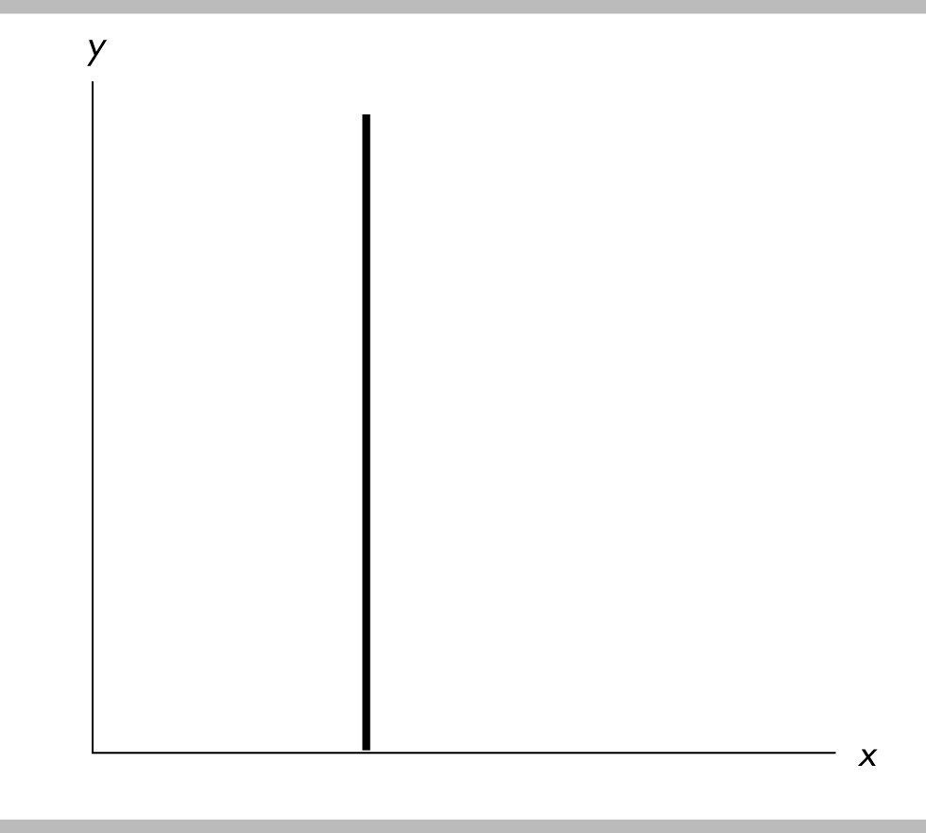

64) Which of the following CORRECTLY describes the above figure?
A) There is no relationship between x and y.
B) There is a positive relationship between x and y.
C) There is a negative relationship between x and y.
D) None of the above answers are correct.
Answer: A
Topic: Variables That Are Unrelated
Skill: Analytical
AACSB: Analytical thinking
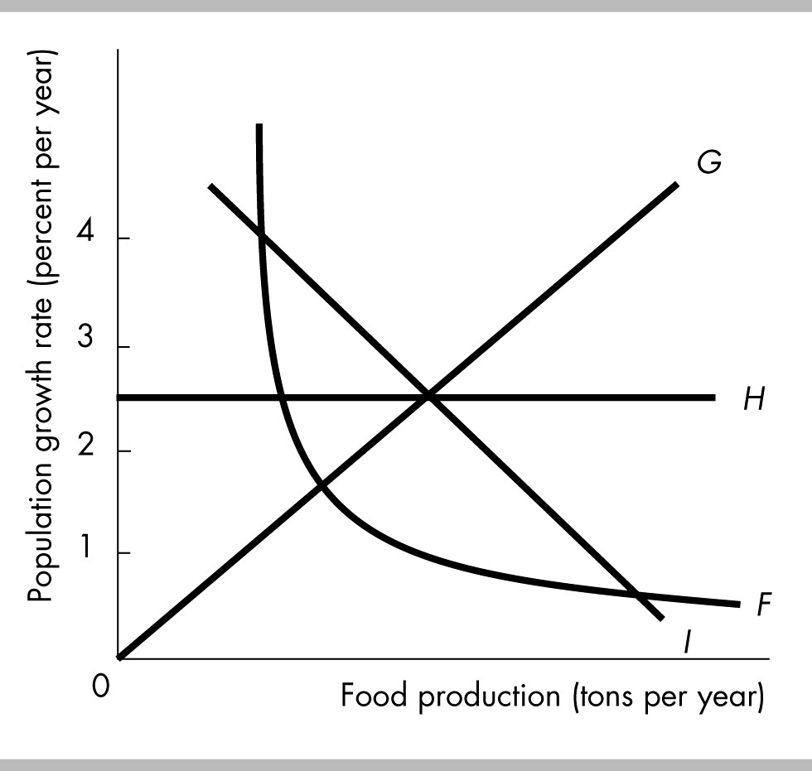

65) In the above figure, which curve indicates that the level of food production does not affect the population growth rate?
A) F
B) G
C) H
D) I
Answer: C
Topic: Variables That Are Unrelated
Skill: Analytical
AACSB: Analytical thinking

66) In the above figure, the relationship between income and expenditures is
A) positive.
B) negative.
C) independent.
D) random.
Answer: A
Topic: Variables That Move in the Same Direction
Skill: Analytical
AACSB: Analytical thinking

67) The relationship in the above figure suggests that when the interest rate is 5 percent
A) a decrease in income will be associated with a decrease in expenditures.
B) a decrease in income will be associated with an increase in expenditures.
C) an increase in income will be associated with a decrease in expenditures.
D) there is no relationship between expenditures and income.
Answer: A
Topic: Variables That Move in the Same Direction
Skill: Analytical
AACSB: Analytical thinking

68) If variables x and y move up and down together, they are
A) positively related.
B) negative related.
C) unrelated.
D) trend related.
Answer: A
Topic: Study Guide Question, Variables That Move Same Direction
Skill: Recognition
AACSB: Analytical thinking
69) The term "direct relationship" means the same as
A) correlation.
B) trend.
C) positive relationship.
D) negative relationship.
Answer: C
Topic: Study Guide Question, Variables That Move Same Direction
Skill: Recognition
AACSB: Analytical thinking

70) The relationship between income and consumption illustrated in the figure above is
A) positive and linear.
B) positive and nonlinear.
C) negative and linear.
D) negative and nonlinear.
Answer: A
Topic: Study Guide Question, Variables That Move Same Direction
Skill: Analytical
AACSB: Analytical thinking
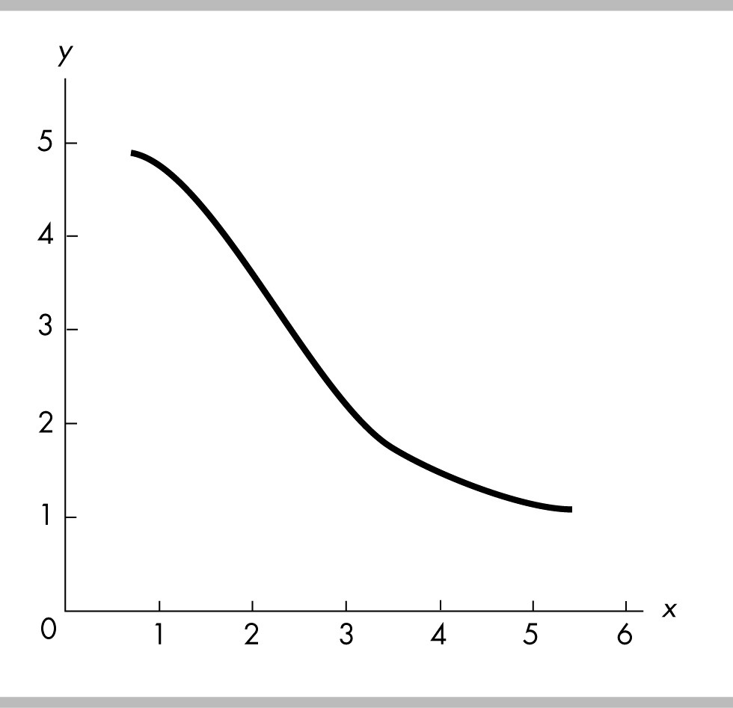

71) The figure above shows
A) a positive relationship.
B) a direct relationship.
C) a negative relationship.
D) no relationship between the variables.
Answer: C
Topic: Study Guide Question, Variables That Move Opposite Direction
Skill: Analytical
AACSB: Analytical thinking

72) The relationship between two variables, x and y, is a vertical line. Thus x and y are
A) positively correlated.
B) negatively correlated.
C) not related.
D) falsely related.
Answer: C
Topic: Study Guide Question, Variables That Are Unrelated
Skill: Analytical
AACSB: Analytical thinking
12 Appendix: The Slope of a Relationship

1) The slope of a line equals the
A) change in the variable measured along the x-axis divided by the change in the variable measured along the y-axis.
B) change in the variable measured along the y-axis divided by the change in the variable measured along the x-axis.
C) change in the variable measured along the x-axis minus the change in the variable measured along the y-axis.
D) change in the variable measured along the x-axis multiplied by the change in the variable measured along the y-axis.
Answer: B
Topic: The Slope of a Relationship
Skill: Recognition
AACSB: Analytical thinking

2) A curve is plotted with y measured on the vertical axis and x measured on the horizontal axis. The slope of the curve equals
A) y divided by x.
B) the change in y divided by x.
C) the change in y divided by the change in x.
D) y divided by the change in x.
Answer: C
Topic: The Slope of a Relationship
Skill: Recognition
AACSB: Analytical thinking

3) The slope of a line
A) can never equal zero.
B) is always a constant.
C) measures the ratio of the change in the value of the y-axis variable relative to the change in the value of the x-axis variable.
D) measures the value of the y-axis variable relative to the value of the x-axis variable.
Answer: C
Topic: The Slope of a Relationship
Skill: Recognition
AACSB: Analytical thinking

4) The slope of a positive relationship is
A) positive.
B) undefined.
C) positive to the right of the maximum point and negative to the left.
D) constant as long as the relationship is nonlinear.
Answer: A
Topic: The Slope of a Relationship
Skill: Analytical
AACSB: Analytical thinking
5) In which of the following cases is the slope of a line positive?
A) As x increases, y increases.
B) As x increases, y decreases.
C) As x increases, y remains the same.
D) As x increases, y equals a positive number.
Answer: A
Topic: The Slope of a Relationship
Skill: Conceptual
AACSB: Analytical thinking

6) If a large change in the variable measured on the x-axis is associated with a small change of the variable measured on the y-axis, the line is ________ and the slope is ________.
A) downward-sloping; large
B) downward-sloping; small
C) upward-sloping; small
D) either downward or upward-sloping; small
Answer: D
Topic: The Slope of a Relationship
Skill: Conceptual
AACSB: Analytical thinking

7) Suppose we are considering the relationship between two variables y and x. y is measured on the y-axis and x is measured on the x-axis, and the relationship between then is a straight line. Suppose that the slope of the line is positive and is less than 1. This slope means that a change in x is associated with
A) a bigger change in y.
B) a smaller change in y.
C) no change in y.
D) an equal change in y.
Answer: B
Topic: The Slope of a Relationship
Skill: Analytical
AACSB: Analytical thinking

8) Suppose we are considering the relationship between two variables y and x. y is measured on the y-axis and x is measured on the x-axis, and the relationship between then is a straight line. Suppose that the slope of the line is equal to 1. This slope means that
A) a change in x is associated with a bigger change in y.
B) a change in x is associated with a smaller change in y.
C) a change in x is associated with no change in y.
D) a change in x is associated with an equal change in y.
Answer: D
Topic: The Slope of a Relationship
Skill: Analytical
AACSB: Analytical thinking
9) Suppose we are considering the relationship between two variables y and x. y is measured on the y-axis and x is measured on the x-axis, and the relationship between then is a straight line. Suppose that the slope of the line is greater than 1. This slope means that
A) a change in x is associated with a bigger change in y.
B) a change in x is associated with a smaller change in y.
C) a change in x is associated with no change in y.
D) a change in x is associated with an equal change in y.
Answer: A
Topic: The Slope of a Relationship
Skill: Analytical
AACSB: Analytical thinking

10) In which of the following cases is the slope of a line positive and less than infinity?
A) As the variable measured on the x-axis decreases, the variable measured on the y-axis decreases.
B) As the variable measured on the x-axis increases, the variable measured on the y-axis decreases.
C) As the variable measured on the y-axis increases, the variable measured on the x-axis does not change.
D) As the variable measured on the y-axis increases, the variable measured on the x-axis decreases.
Answer: A
Topic: The Slope of a Relationship
Skill: Conceptual
AACSB: Analytical thinking

11) In a graph, a line has a negative slope if
A) the line is vertical.
B) the line is horizontal.
C) the line rises from right to left.
D) the line rises from left to right.
Answer: C
Topic: The Slope of a Relationship
Skill: Conceptual
AACSB: Analytical thinking

12) Suppose that for a curve, as the variable measured on the x-axis increases, the variable measured on the y-axis decreases. The curve has a ________ slope.
A) tangent
B) positive
C) negative
D) hypothetical
Answer: C
Topic: The Slope of a Relationship
Skill: Conceptual
AACSB: Analytical thinking
13) If the slope of the relationship between savings and interest rates is 0.5, then
A) savings and interest rates have a positive relationship.
B) savings and interest rates have a negative relationship.
C) savings and interest rates have no relationship.
D) savings and interest rates have an inverse relationship.
Answer: A
Topic: The Slope of a Relationship
Skill: Conceptual
AACSB: Analytical thinking

14) If an increase in x (the variable on the horizontal axis) from 6 to 8 units causes a decrease in y (the variable on the vertical axis) from 4 to 3 units, the slope equals
A) 2.
B) -2.
C) 1/2.
D) -1/2.
Answer: D
Topic: The Slope of a Relationship
Skill: Analytical
AACSB: Analytical thinking

x | y
0 | 0
2 | 6
4 | 12
6 | 18
8 | 24
10 | 30

15) In the table above, y is measured along the y-axis and x along the x-axis. The slope of the relationship between x = 0 and x = 2 is
A) -6.
B) 2.
C) 3.
D) 6.
Answer: C
Topic: The Slope of a Relationship
Skill: Analytical
AACSB: Analytical thinking

x | y
10 | 50
9 | 70
8 | 100
7 | 130
6 | 170
5 | 220

16) In the table above, y is measured along the y-axis and x along the x-axis. What is the value of the slope between the x = 8 and x = 6?
A) -0.057
B) -19.28
C) -35
D) 70
Answer: C
Topic: The Slope of a Relationship
Skill: Analytical
AACSB: Analytical thinking

Point | X | Y
a | 100 | 50
b | 200 | 75
c | 300 | 100
d | 400 | 100
e | 500 | 75
f | 600 | 50

17) In the table above, Y is measured along the y-axis and X along the x-axis. The slope between points a and b is
A) 25.
B) 4.
C) 0.25.
D) -0.25.
Answer: C
Topic: The Slope of a Relationship
Skill: Analytical
AACSB: Analytical thinking

18) In the table above, Y is measured along the y-axis and X along the x-axis. The slope between points c and d is
A) 100.
B) 0.
C) 0.25.
D) -4.
Answer: B
Topic: The Slope of a Relationship
Skill: Analytical
AACSB: Analytical thinking
19) In the table above, Y is measured along the y-axis and X along the x-axis. The slope between points e and f is
A) -25.
B) 4.
C) 0.25.
D) -0.25.
Answer: D
Topic: The Slope of a Relationship
Skill: Analytical
AACSB: Analytical thinking

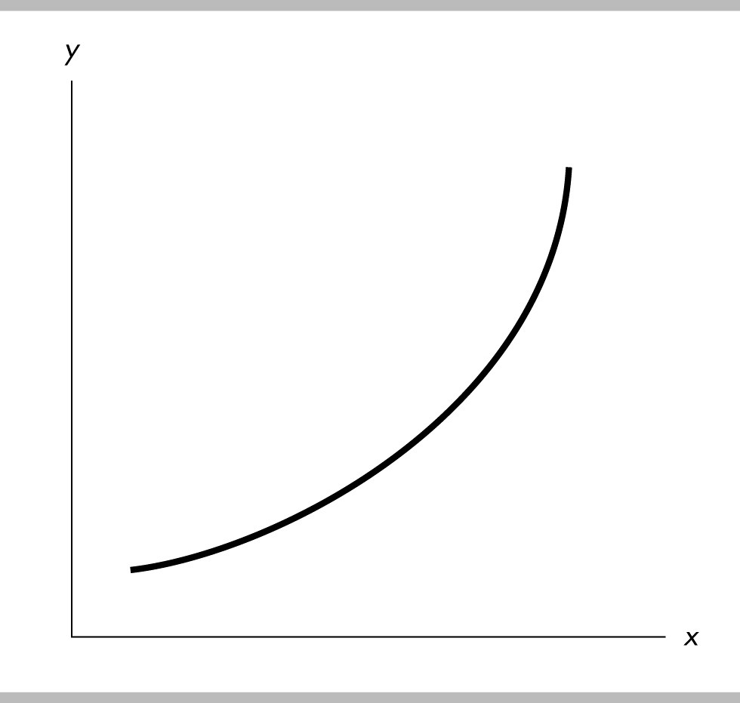

20) In the above figure, the curve has a slope that is ________.
A) positive and becoming larger in magnitude
B) positive and becoming smaller in magnitude
C) negative and becoming larger in magnitude
D) negative and becoming smaller in magnitude
Answer: A
Topic: The Slope of a Relationship
Skill: Analytical
AACSB: Analytical thinking
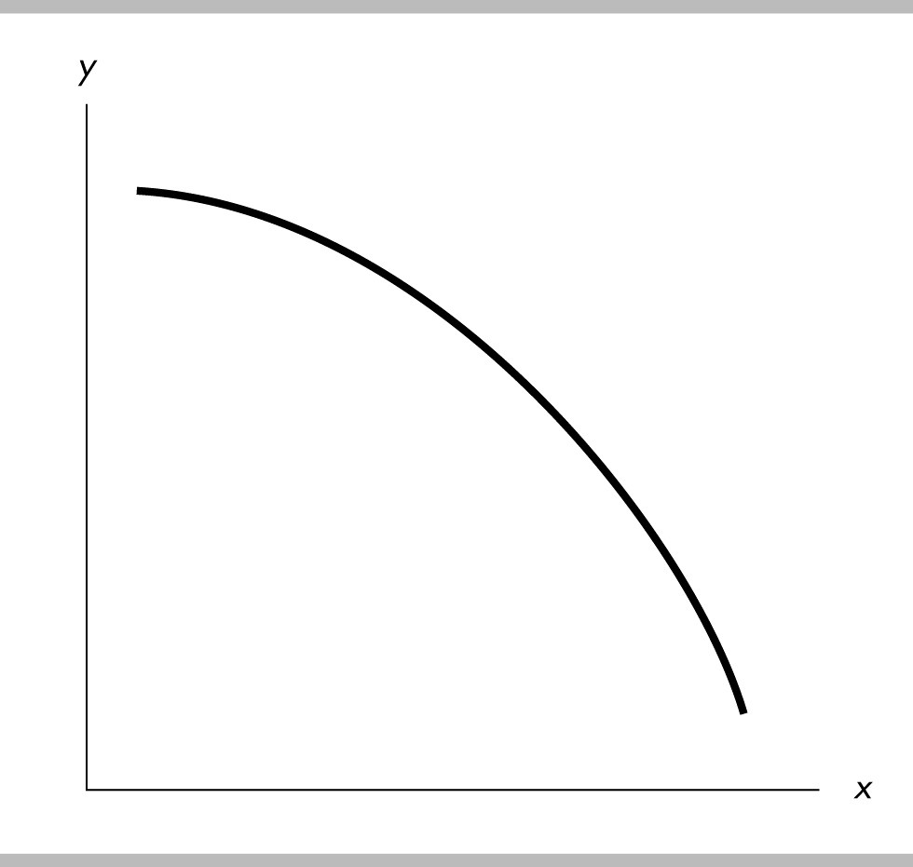

21) In the above figure, the curve has a slope that is ________.
A) positive and becoming larger in magnitude
B) positive and becoming smaller in magnitude
C) negative and becoming larger in magnitude
D) negative and becoming smaller in magnitude
Answer: C
Topic: The Slope of a Relationship
Skill: Analytical
AACSB: Analytical thinking

x | y
0 | 4
1 | 5
2 | 8
3 | 13
4 | 20

22) In the above table, the relationship between x and y is ________ and, with y measured on the vertical axis, the slope between y = 5 and y = 8 is equal to ________.
A) negative; 8
B) negative; 6
C) positive; 5
D) positive; 3
Answer: D
Topic: The Slope of a Relationship
Skill: Analytical
AACSB: Analytical thinking
23) The slope of a straight line is
A) variable.
B) increasing.
C) decreasing.
D) constant.
Answer: D
Topic: The Slope of a Straight Line
Skill: Recognition
AACSB: Analytical thinking

24) The slope of a straight line is
A) always equal to zero.
B) calculated as y/x at any point.
C) constant.
D) always greater than zero.
Answer: C
Topic: The Slope of a Straight Line
Skill: Recognition
AACSB: Analytical thinking

25) With y measured on the vertical axis and x measured on the horizontal axis, the slope of a straight line is defined as
A) y/x.
B) x/y.
C) (change in y)/ (change in x).
D) (change in x)/ (change in y).
Answer: C
Topic: The Slope of a Straight Line
Skill: Analytical
AACSB: Analytical thinking

26) Along a straight line, when x equals 90, then y equals 30. When x equals 120, then y equals 40. The slope of the straight line is
A) 1/3.
B) -1/3.
C) 3.
D) -3.
Answer: A
Topic: The Slope of a Straight Line
Skill: Analytical
AACSB: Analytical thinking

27) Along a straight line, the value of y is always equal to the value of x. The slope of the line is
A) -1.
B) 0.
C) 1.
D) infinite.
Answer: C
Topic: The Slope of a Straight Line
Skill: Analytical
AACSB: Analytical thinking

x | y
0 | 0
1 | 3
2 | 6
3 | 9
4 | 12
5 | 15

28) Using the data in the table above, with y measured on the vertical axis, the slope of the line relating y to x is
A) 1/3.
B) 1.
C) 3.
D) 6.
Answer: C
Topic: The Slope of a Straight Line
Skill: Analytical
AACSB: Analytical thinking

x-variable  (on the horizontal axis) | y-variable  (on the vertical axis)
10 | 28
15 | 31
20 | 34

29) The above table shows data on two variables. If these data were graphed, the slope of the line would be
A) 3/5.
B) 3.
C) 5/3.
D) impossible to determine from the information given.
Answer: A
Topic: The Slope of a Straight Line
Skill: Analytical
AACSB: Analytical thinking

x-variable  (on the horizontal axis) | y-variable  (on the vertical axis)
8 | 14
10 | 18
12 | 22

30) The above table gives data on two variables. If these data were graphed, the slope of the line would be
A) 1.
B) -2.
C) 2.
D) -4.
Answer: C
Topic: The Slope of a Straight Line
Skill: Analytical
AACSB: Analytical thinking

31) The above table gives data on two variables. If these data were graphed, their relationship would
A) be a straight line.
B) be a curved line.
C) show a negative relationship.
D) nonexistent.
Answer: A
Topic: The Slope of a Straight Line
Skill: Analytical
AACSB: Analytical thinking

x-variable  (on the horizontal axis) | y-variable  (on the vertical axis)
100 | 50
200 | 125
300 | 200

32) The above table shows data on two variables. If these data were graphed, the slope of the line would be
A) 1/2.
B) 4/3.
C) 2/3.
D) 3/4.
Answer: D
Topic: The Slope of a Straight Line
Skill: Analytical
AACSB: Analytical thinking

Quantity | Price
0 | 50
8 | 40
16 | 30
24 | 20
32 | 10
36 | 5

33) Using the data in the above table
A) the variables quantity and price are positively related.
B) the variables quantity and price are negatively related.
C) the variables quantity and price are neither positively nor negatively related.
D) an increase in price is likely to cause an increase in quantity.
Answer: B
Topic: Variables That Move in Opposite Directions
Skill: Conceptual
AACSB: Analytical thinking

34) If we use the numbers in the above table to draw a graph, with the price on the vertical axis and the quantity on the horizontal axis, the line relating price and quantity has a slope of
A) 0.8.
B) -8.0.
C) -1.25.
D) 8.0.
Answer: C
Topic: The Slope of a Relationship
Skill: Analytical
AACSB: Analytical thinking

Income  (dollars per month) | Amount spent on restaurant meals  (dollars per month)
50 | 20
100 | 40
150 | 60
200 | 80

35) Using the data in the above table, if income is on the x-axis and the amount spent on restaurant meals is on the y-axis, the graph of the two variables would be
A) upward sloping.
B) downward sloping.
C) vertical.
D) horizontal.
Answer: A
Topic: Variables That Move in the Same Direction
Skill: Recognition
AACSB: Analytical thinking
36) Using the data in the above table, if income is on the x-axis and the amount spent on restaurant meals is on the y-axis, the slope of the straight line graph equals
A) 0.2.
B) 0.4.
C) 0.5.
D) 2.5.
Answer: B
Topic: The Slope of a Relationship
Skill: Analytical
AACSB: Analytical thinking

x | y
100 | 500
200 | 300
300 | 100
400 | -100

37) Based on the information in the table above, what is the relationship between x and y?
A) direct
B) inverse
C) positive
D) No relationship exists between x and y.
Answer: B
Topic: Variables That Move in Opposite Directions
Skill: Analytical
AACSB: Analytical thinking

38) Using the information in the table above, what does the slope of the line between x and y equal?
A) 5
B) -0.5
C) 2
D) -2
Answer: D
Topic: The Slope of a Straight Line
Skill: Analytical
AACSB: Analytical thinking
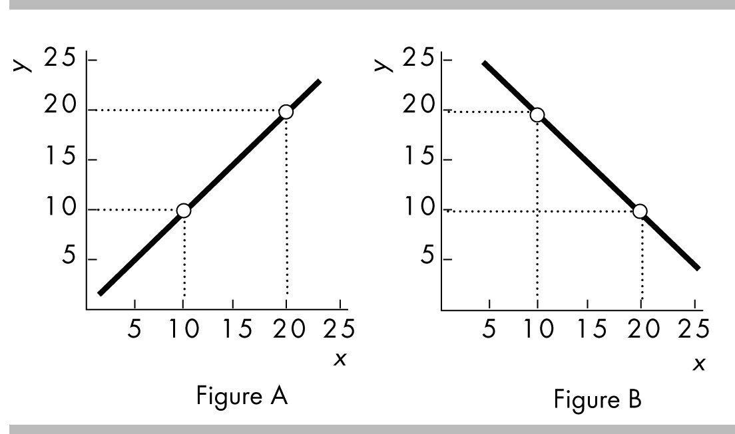

39) In the above, which figure shows a linear relationship?
A) Figure A
B) Figure B
C) both Figure A and Figure B
D) neither Figure A nor Figure B
Answer: C
Topic: Linear Relationship
Skill: Analytical
AACSB: Analytical thinking

40) In the above, which figure shows a line with a slope of 1.0?
A) Figure A
B) Figure B
C) both Figure A and Figure B
D) neither Figure A nor Figure B
Answer: A
Topic: The Slope of a Straight Line
Skill: Analytical
AACSB: Analytical thinking
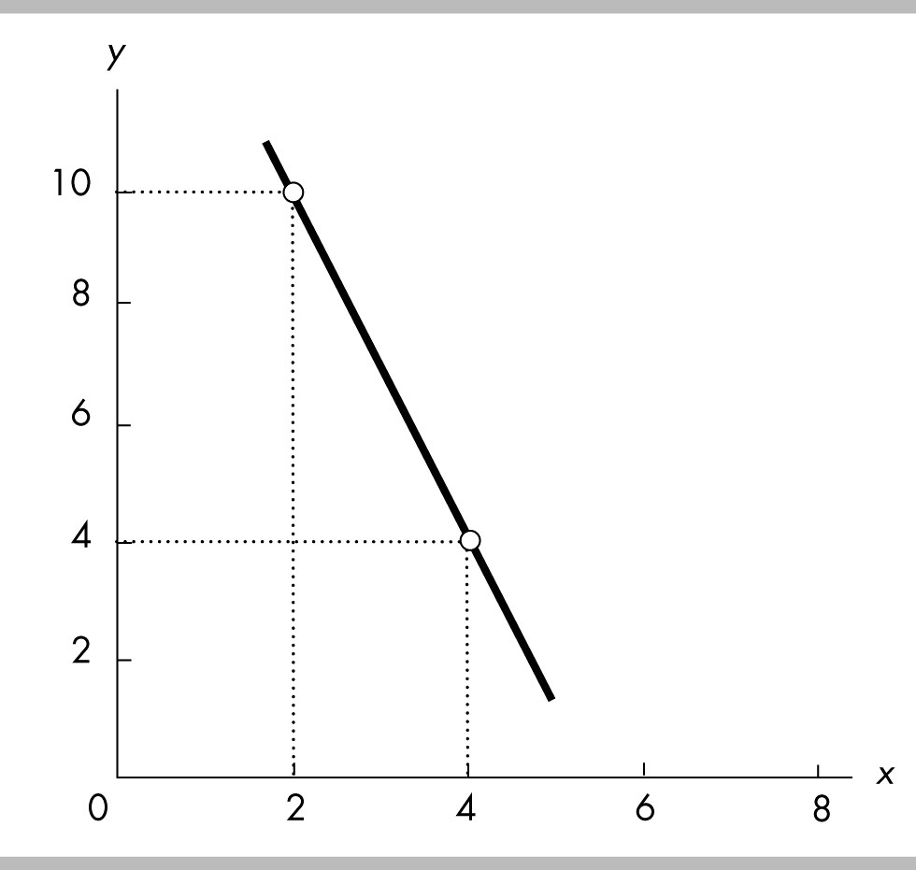

41) The slope of the line shown in the above figure is
A) -1/3.
B) -5.
C) -1.
D) -3.
Answer: D
Topic: The Slope of a Straight Line
Skill: Analytical
AACSB: Analytical thinking
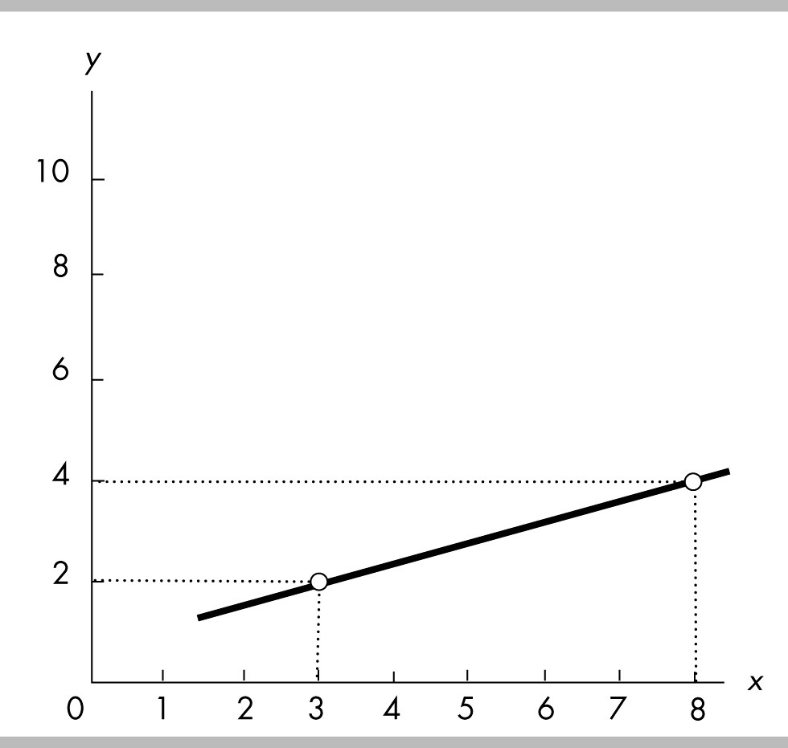

42) The slope of the line shown in the above figure is
A) 5.
B) 2/5.
C) 2/3.
D) 5/2.
Answer: B
Topic: The Slope of a Straight Line
Skill: Analytical
AACSB: Analytical thinking
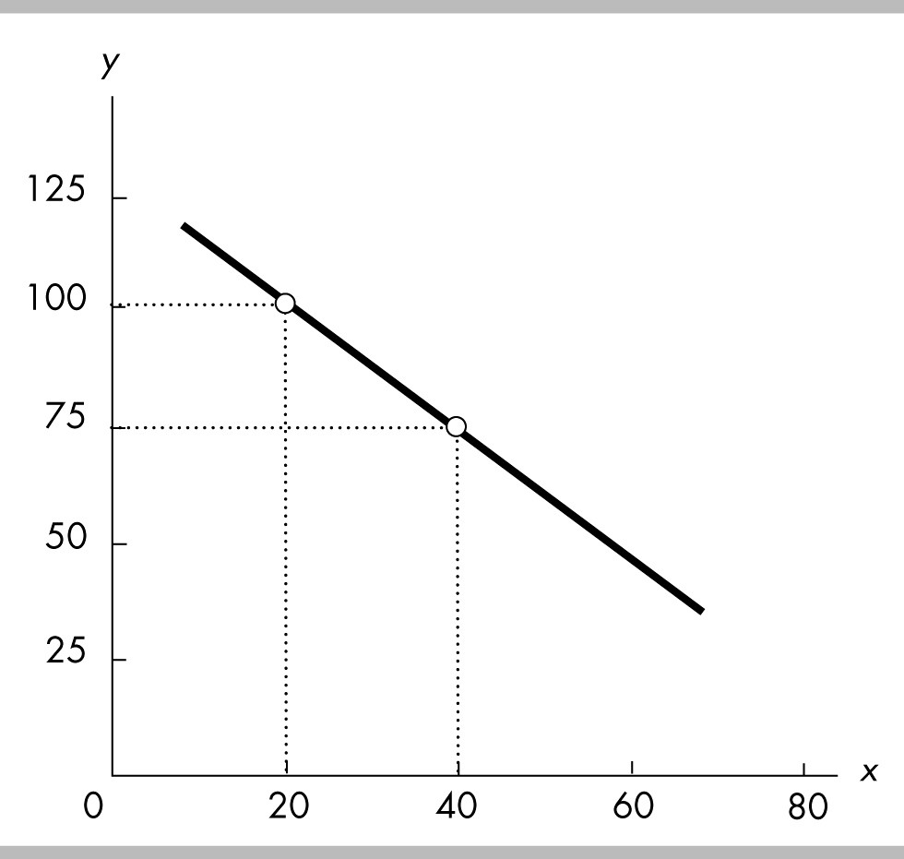

43) The slope of the line shown in the above figure is
A) -1 1/3.
B) -1 2/3.
C) -1.25.
D) -0.80.
Answer: C
Topic: The Slope of a Straight Line
Skill: Analytical
AACSB: Analytical thinking
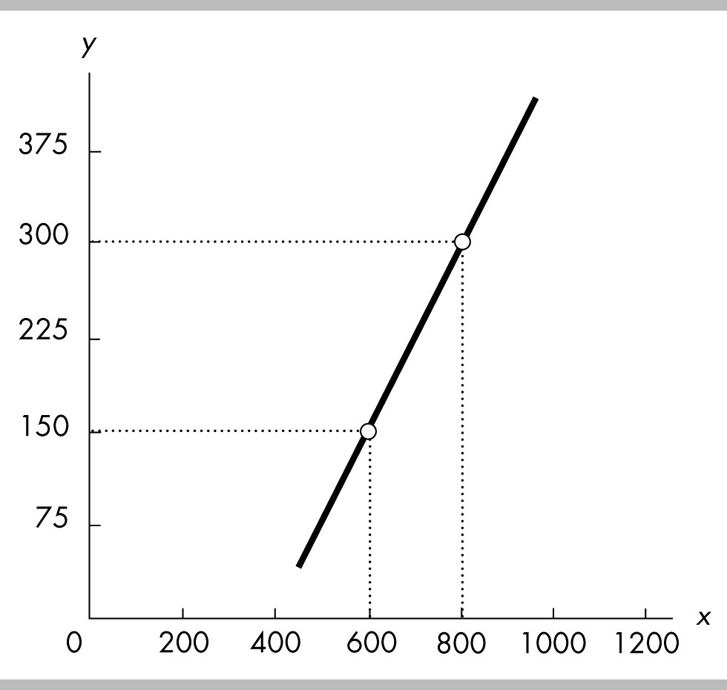

44) The slope of the line shown in the above figure is
A) 2.
B) 0.75.
C) 0.25.
D) 1 1/3.
Answer: B
Topic: The Slope of a Straight Line
Skill: Analytical
AACSB: Analytical thinking
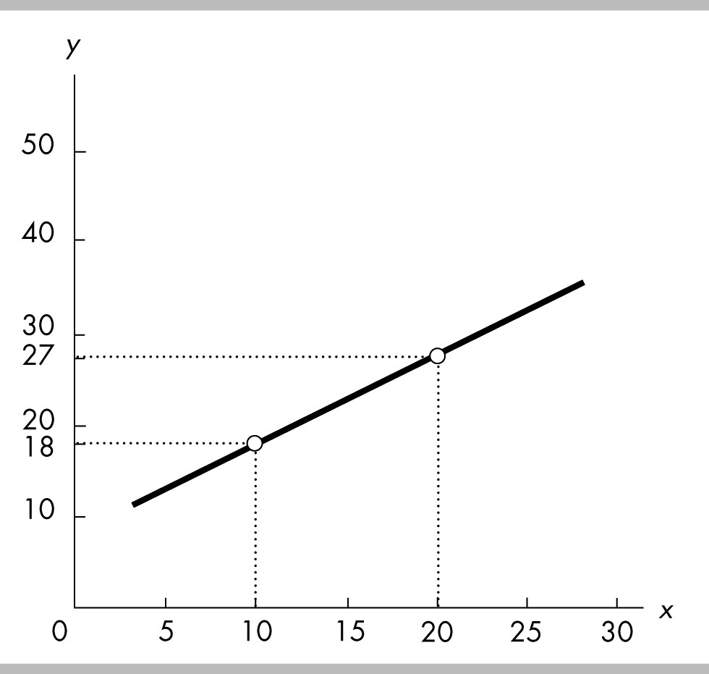

45) The slope of the line shown in the above figure is
A) 0.90.
B) 1.5.
C) 1.11.
D) 2.
Answer: A
Topic: The Slope of a Straight Line
Skill: Analytical
AACSB: Analytical thinking
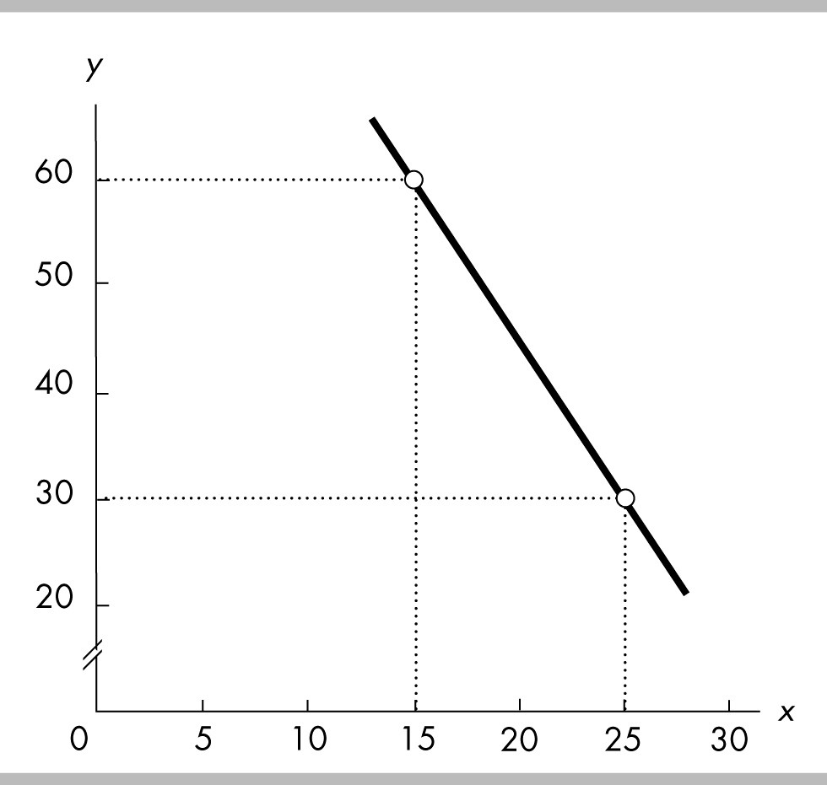

46) The slope of the line in the above figure is
A) -1/2.
B) -3.
C) -4.
D) -1/3.
Answer: B
Topic: The Slope of a Straight Line
Skill: Analytical
AACSB: Analytical thinking
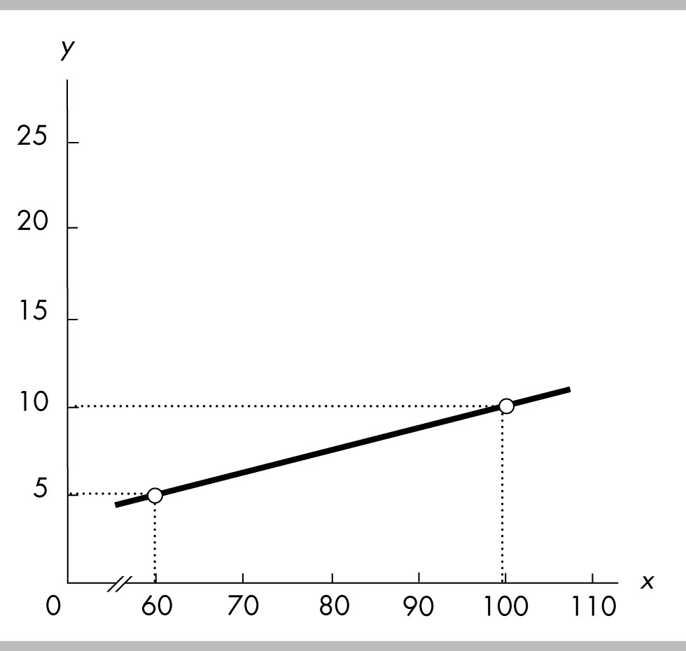

47) The slope of the line in the above figure is
A) 8.
B) 0.05.
C) 0.125.
D) 0.10.
Answer: C
Topic: The Slope of a Straight Line
Skill: Analytical
AACSB: Analytical thinking
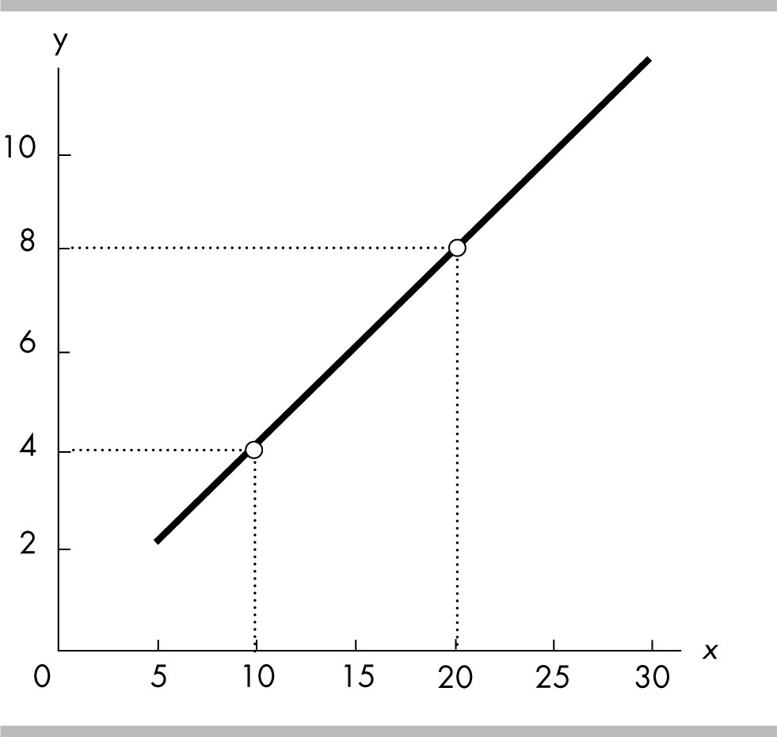

48) The slope of the line in the above figure is
A) 2/5 = 0.4.
B) 5/2 = 2.5.
C) -2/5 = -0.4.
D) -5/2 = -2.5.
Answer: A
Topic: The Slope of a Straight Line
Skill: Analytical
AACSB: Analytical thinking
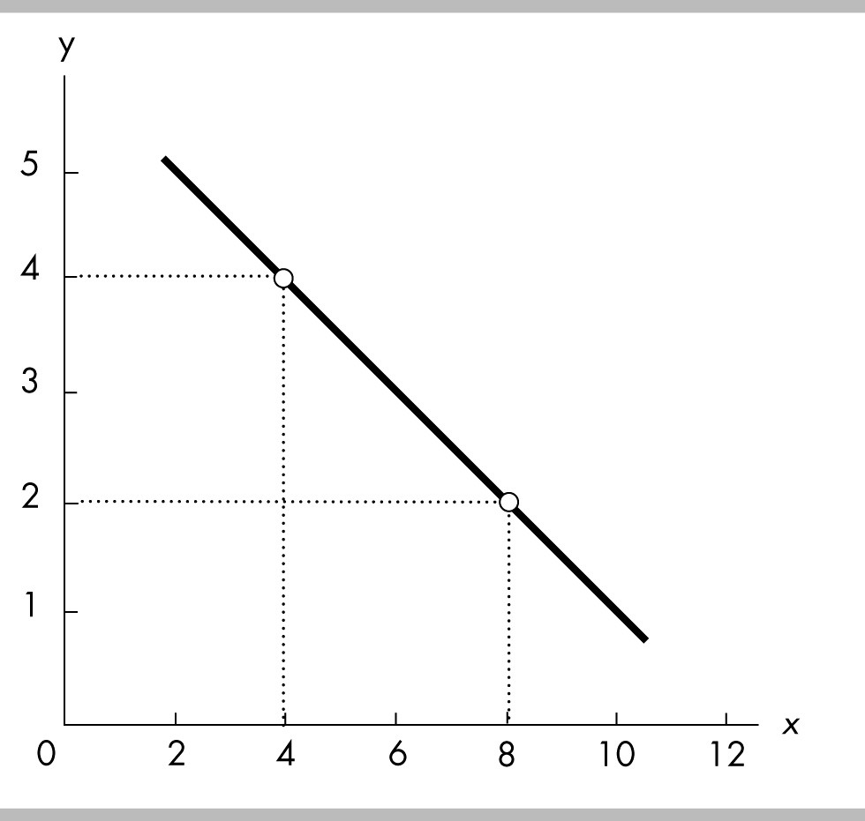

49) The slope of the line in the above figure is
A) 1/2 = 0.5.
B) 2.
C) -1/2 = -0.5.
D) -2.
Answer: C
Topic: The Slope of a Straight Line
Skill: Analytical
AACSB: Analytical thinking
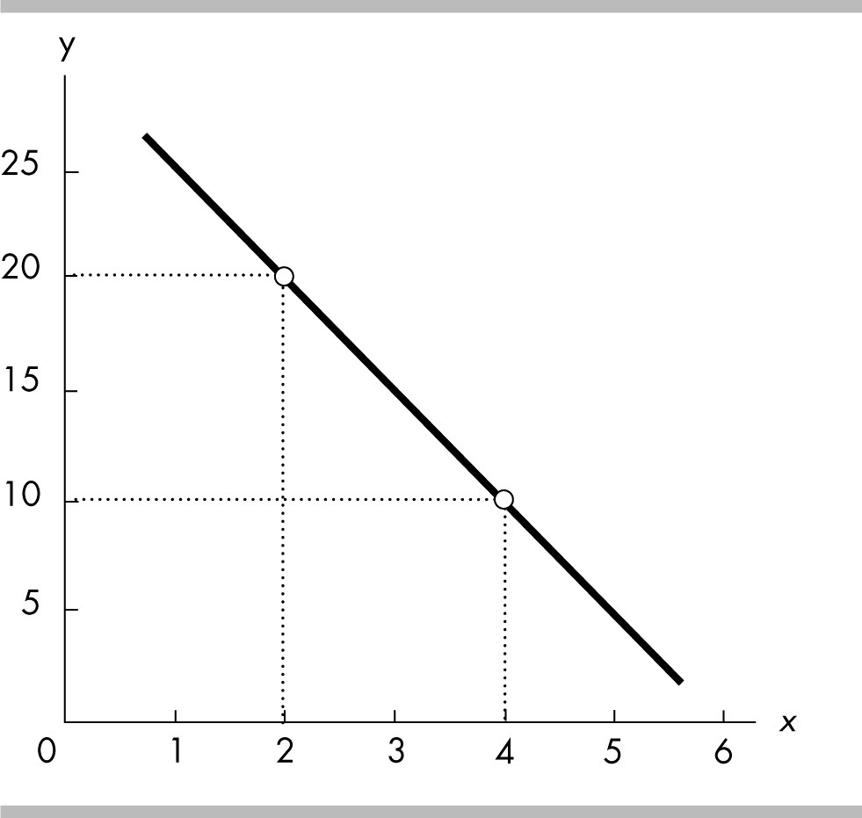

50) The slope of the line in the above figure is
A) -10.
B) 10.
C) 5.
D) -5.
Answer: D
Topic: The Slope of a Straight Line
Skill: Analytical
AACSB: Analytical thinking
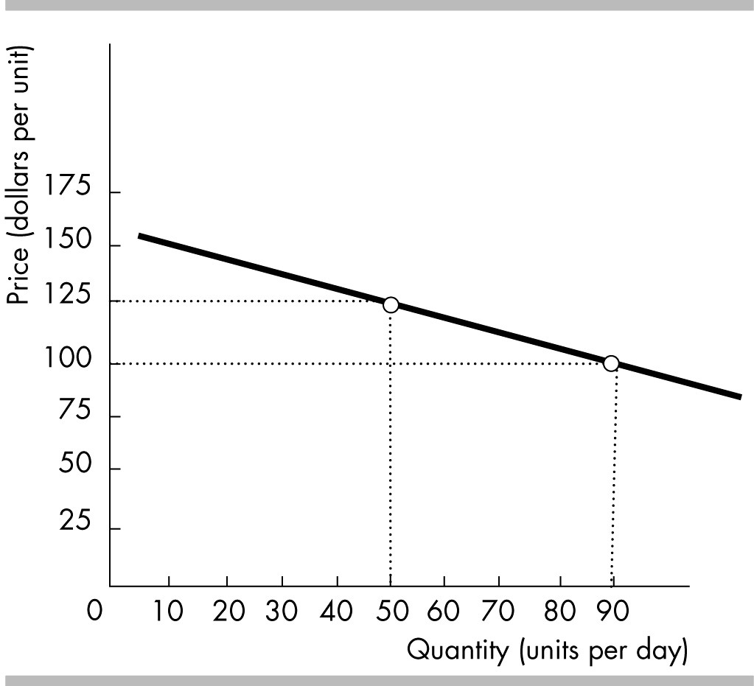

51) The slope of the line shown in the above figure is
A) -1 3/8.
B) -1 2/3.
C) 5/8.
D) -0.625.
Answer: D
Topic: The Slope of a Straight Line
Skill: Analytical
AACSB: Analytical thinking
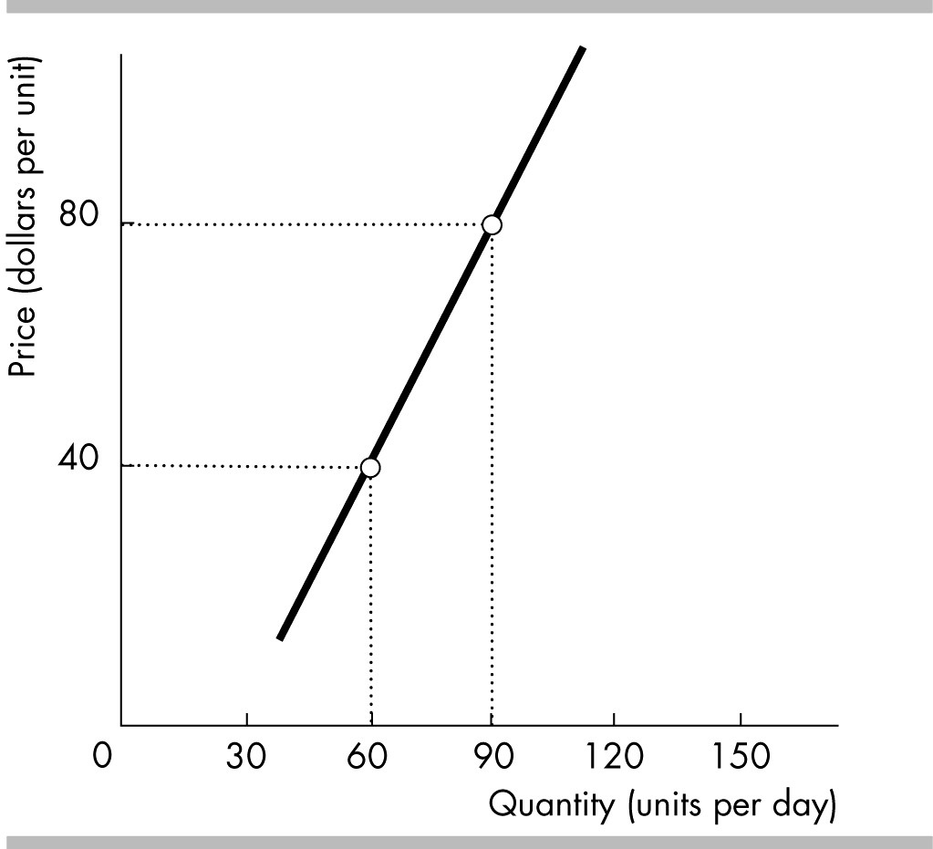

52) The slope of the line shown in the above figure is
A) 3/4.
B) 2/3.
C) 1 1/3.
D) 1 3/4.
Answer: C
Topic: The Slope of a Straight Line
Skill: Analytical
AACSB: Analytical thinking

53) The slope of the line in the above figure is
A) -4.
B) -2.5.
C) -1.0.
D) 1.0.
Answer: D
Topic: The Slope of a Straight Line
Skill: Analytical
AACSB: Analytical thinking

54) On a graph, an upward-sloping curve that is flatter as you move away from the origin indicates a
A) positive relationship with an increasing slope.
B) positive relationship with a decreasing slope.
C) negative relationship with an increasing slope.
D) negative relationship with a decreasing slope.
Answer: B
Topic: The Slope of a Curved Line
Skill: Conceptual
AACSB: Analytical thinking
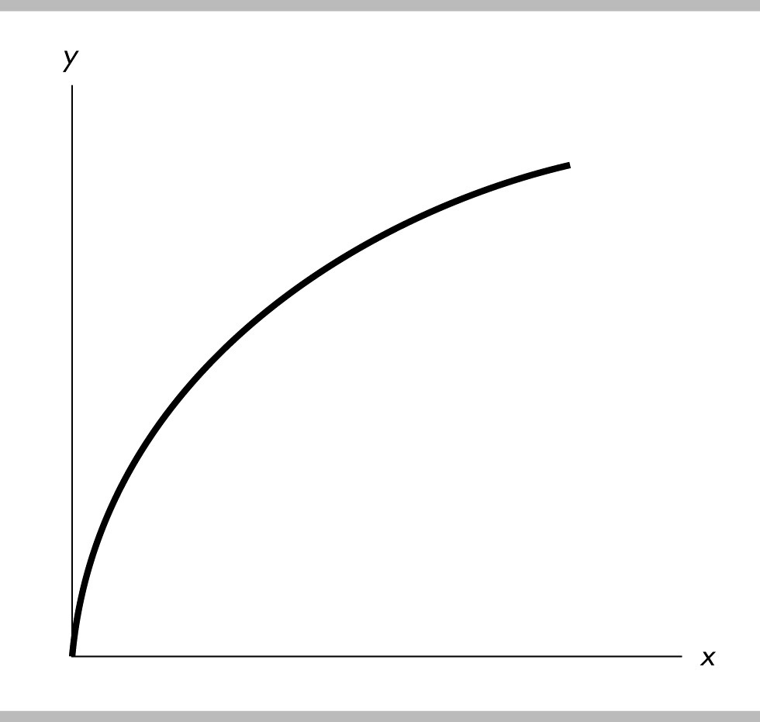

55) In the above figure, the curve's slope is
A) positive and is becoming steeper.
B) positive and is becoming less steep.
C) negative and is becoming steeper.
D) negative and is becoming less steep.
Answer: B
Topic: Slope of a Curved Line
Skill: Analytical
AACSB: Analytical thinking

56) If the price of apples is on the vertical axis and the quantity of apples demanded is on the horizontal axis, the slope between two points on the line describing the relationship between price and quantity is
A) the change in price multiplied by the change in quantity.
B) the change in price divided by the change in quantity.
C) the change in quantity divided by the change in price.
D) price divided by quantity.
Answer: B
Topic: The Slope of a Curved Line
Skill: Analytical
AACSB: Analytical thinking

57) The formula for the slope across an arc is used to approximate the slope for
A) linear relationships only.
B) a curved line.
C) a positive relationship only.
D) a negative relationship only.
Answer: B
Topic: The Slope Across an Arc
Skill: Conceptual
AACSB: Analytical thinking
58) The slope of a curved line can be approximated by
A) the average of the variable measured along the y-axis divided by the average of the variable measured along the x-axis.
B) the inverse of the straight-line method.
C) the average of the variable measured along the x-axis divided by the average of the variable measured along the y-axis.
D) the slope across an arc from one point on the curve to another point on the curve.
Answer: D
Topic: The Slope Across an Arc
Skill: Conceptual
AACSB: Analytical thinking

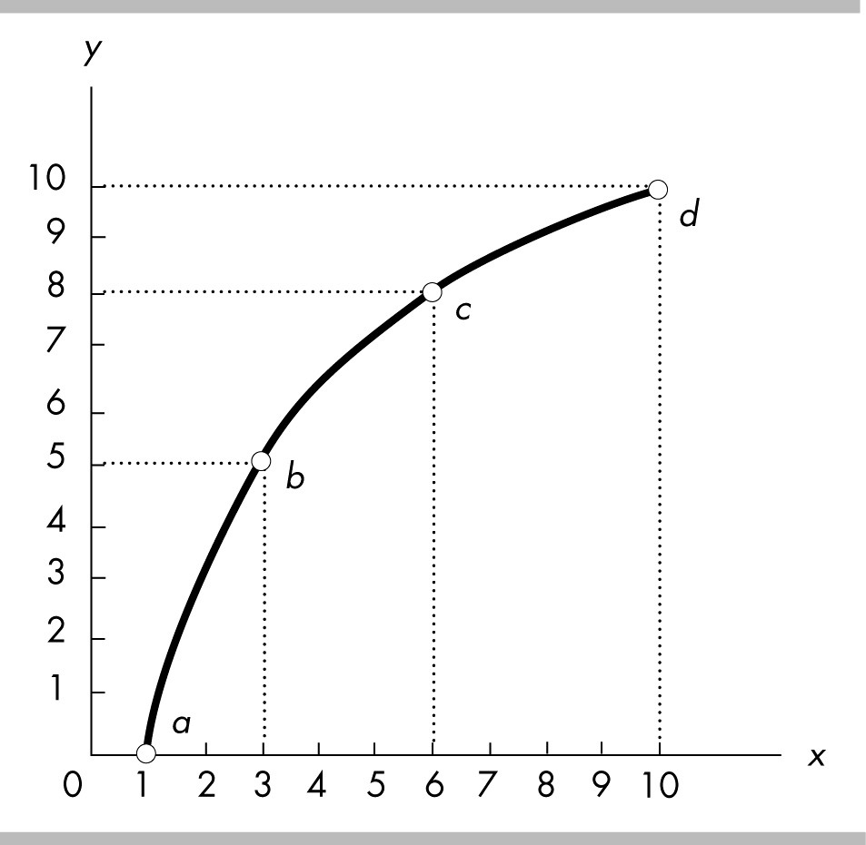

59) In the above figure, the slope across the arc between c and d is
A) 1/2.
B) 1.
C) 4/3.
D) 2.
Answer: A
Topic: The Slope Across an Arc
Skill: Analytical
AACSB: Analytical thinking

60) In the above figure, the slope across the arc between b and c is
A) 1/2.
B) 2/3.
C) 1.
D) 2.
Answer: C
Topic: The Slope Across an Arc
Skill: Analytical
AACSB: Analytical thinking
61) In the above figure, the slope across the arc between a and b is
A) 2/5.
B) 1.
C) 3/2.
D) 5/2.
Answer: D
Topic: The Slope Across an Arc
Skill: Analytical
AACSB: Analytical thinking

62) In the above figure, the slope at point b is
A) 1.
B) 5/2.
C) between 1 and 5/2.
D) greater than 5/2.
Answer: C
Topic: The Slope at a Point
Skill: Analytical
AACSB: Analytical thinking

63) In the above figure, the relationship between x and y is
A) positive, with slope decreasing as x increases.
B) negative, with slope decreasing as x increases.
C) negative, with slope increasing as x increases.
D) positive, with slope increasing as x increases.
Answer: A
Topic: The Slope of a Relationship
Skill: Analytical
AACSB: Analytical thinking

64) The slope in the above figure is
A) negative and increasing.
B) negative and decreasing.
C) positive and increasing.
D) positive and decreasing.
Answer: D
Topic: The Slope of a Relationship
Skill: Analytical
AACSB: Analytical thinking
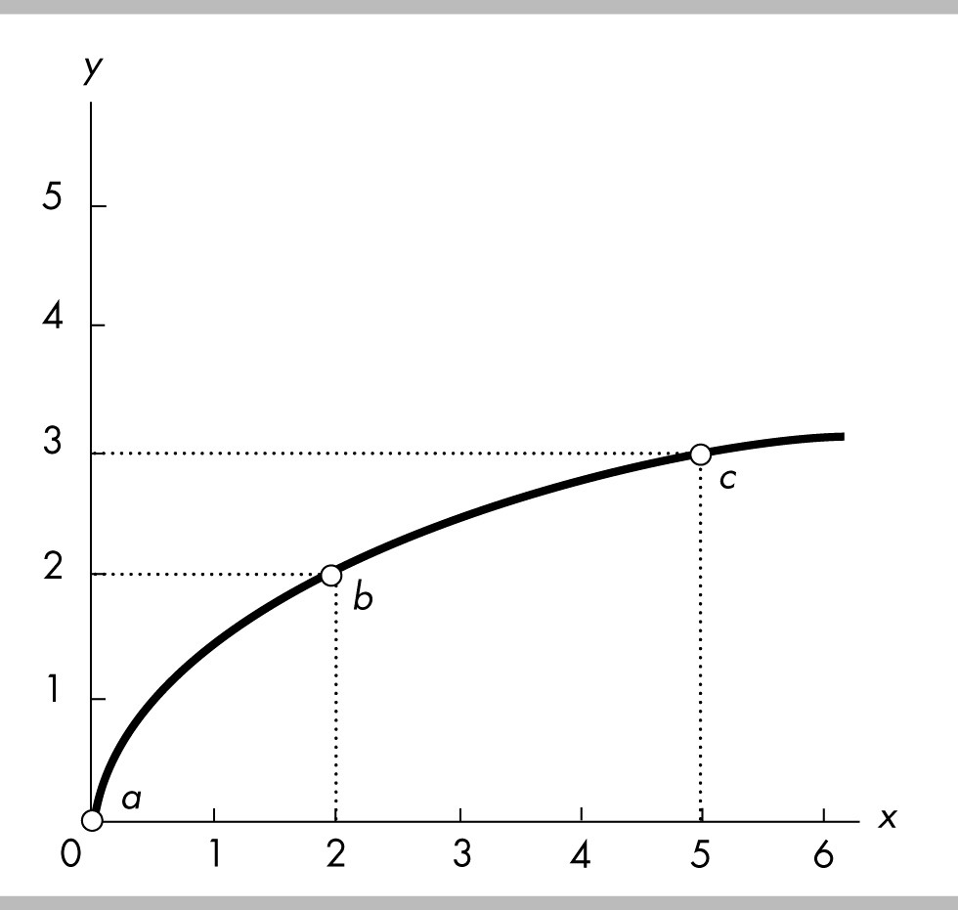

65) In the above figure, using the slope across an arc, the slope of the curve between points b and c is
A) 1/3.
B) -1/3.
C) 3.
D) -3.
Answer: A
Topic: Slope Across an Arc
Skill: Analytical
AACSB: Analytical thinking

66) In the above figure, using the slope across an arc, the slope of the curve between points a and c is
A) -3/5.
B) 3/5.
C) 5/3.
D) -5/3.
Answer: B
Topic: Slope Across an Arc
Skill: Analytical
AACSB: Analytical thinking
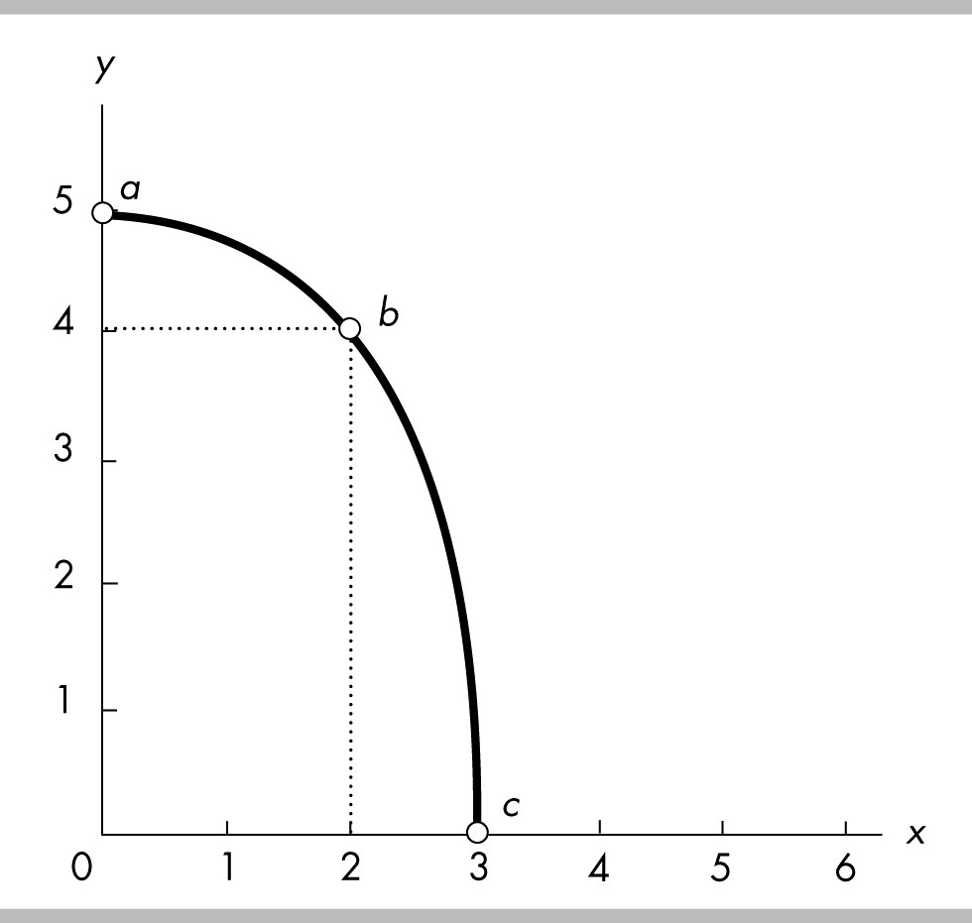

67) In the above figure, using the slope across an arc, the slope of the curve between points a and b is
A) 1/2.
B) -1/2.
C) 2.
D) -2.
Answer: B
Topic: Slope Across an Arc
Skill: Analytical
AACSB: Analytical thinking

68) In the above figure, using the slope across an arc, the slope of the curve between points a and c is
A) 3/5.
B) 5/3.
C) -3/5.
D) -5/3.
Answer: D
Topic: Slope Across an Arc
Skill: Analytical
AACSB: Analytical thinking

69) In the above figure, the slope across the arc between a and b is
A) 1.
B) -4.
C) 1/4.
D) -1/4.
Answer: B
Topic: The Slope Across an Arc
Skill: Analytical
AACSB: Analytical thinking
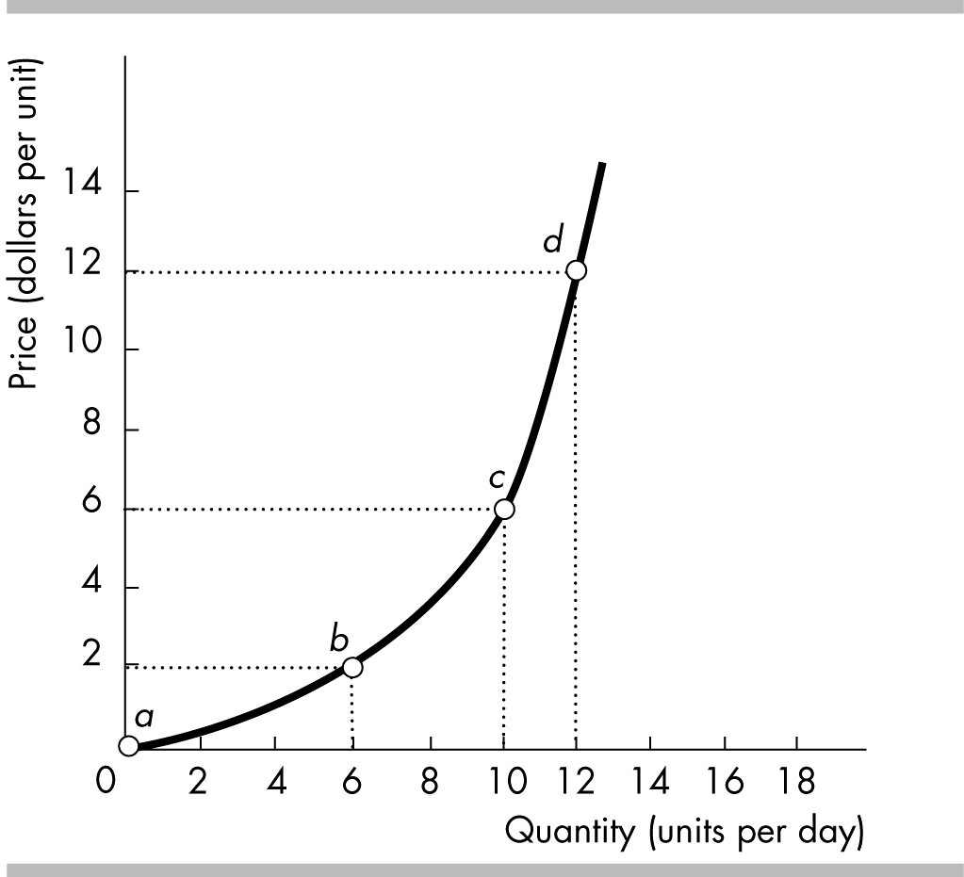

70) In the above figure, the slope across the arc between b and d is
A) 1/2.
B) 1/3.
C) 5/3.
D) 6/5.
Answer: C
Topic: Slope Across an Arc
Skill: Analytical
AACSB: Analytical thinking

71) In the above figure, the slope at point b
A) lies between 1/3 and 1.
B) equals 1.
C) lies between 1 and 2.
D) exceeds 2.
Answer: A
Topic: Slope Across an Arc
Skill: Analytical
AACSB: Analytical thinking

72) In the above figure, the slope across the arc between c and d is
A) 1/6.
B) 12/11.
C) 3.
D) 4.
Answer: C
Topic: Slope Across an Arc
Skill: Analytical
AACSB: Analytical thinking
73) In the above figure, the slope across the arc between a and b is
A) 3.
B) 1.
C) 3/5.
D) 1/3.
Answer: D
Topic: Slope Across an Arc
Skill: Analytical
AACSB: Analytical thinking

74) Along a curved line, the slope at the maximum
A) is greater than zero.
B) is zero.
C) is less than zero.
D) may be greater than, less than, or equal to zero.
Answer: B
Topic: Maximum and Minimum Points
Skill: Conceptual
AACSB: Analytical thinking

75) Consider a diagram in which the variable measured on the y-axis remains constant while the variable measured on the x-axis increases. The graph is of this relationship is a
A) perpendicular line.
B) line with slope equal to zero.
C) line that has positive slope.
D) line that has a negative slope.
Answer: B
Topic: Variables That Are Unrelated
Skill: Analytical
AACSB: Analytical thinking

76) The slope of a negative relationship is
A) negative.
B) undefined.
C) positive to the right of the maximum point and negative to the left.
D) constant as long as the relationship is nonlinear.
Answer: A
Topic: Study Guide Question, The Slope of a Relationship
Skill: Analytical
AACSB: Analytical thinking

77) A linear relationship
A) always has a maximum.
B) always has a constant slope.
C) always slopes up to the right.
D) never has a constant slope.
Answer: B
Topic: Study Guide Question, The Slope of a Straight Line
Skill: Recognition
AACSB: Analytical thinking
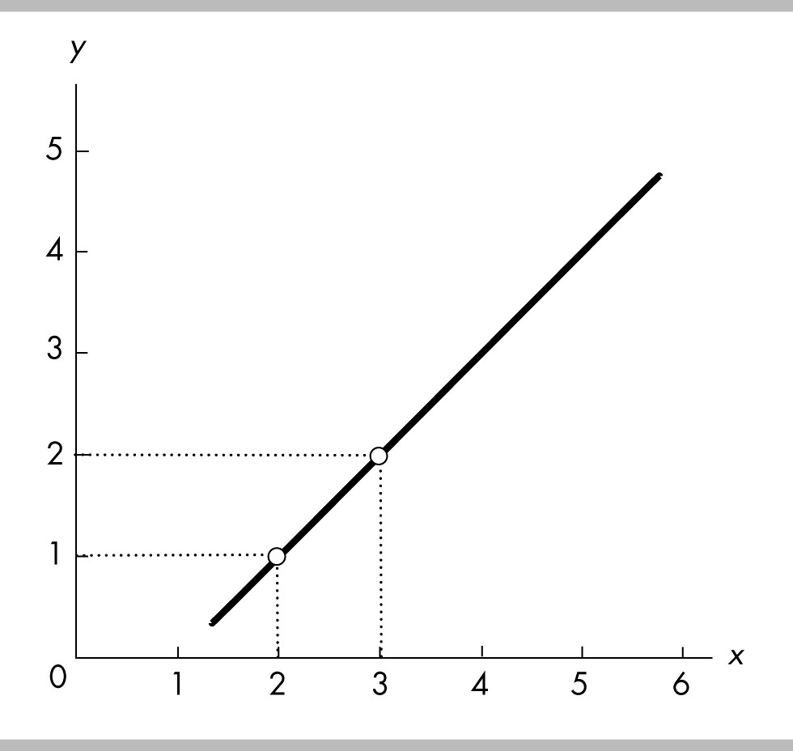

78) In the above figure, between x = 2 and x = 3, what is the slope of the line?
A) 1
B) -1
C) 2
D) 3
Answer: A
Topic: Study Guide Question, The Slope of a Straight Line
Skill: Analytical
AACSB: Analytical thinking

79) In the above figure, how does the slope of the line between x = 4 and x = 5 compare with the slope between x = 2 and x = 3?
A) The slope is greater between x = 4 and x = 5.
B) The slope is greater between x = 2 and x = 3.
C) The slope is the same.
D) The slope is not comparable.
Answer: C
Topic: Study Guide Question, The Slope of a Straight Line
Skill: Analytical
AACSB: Analytical thinking
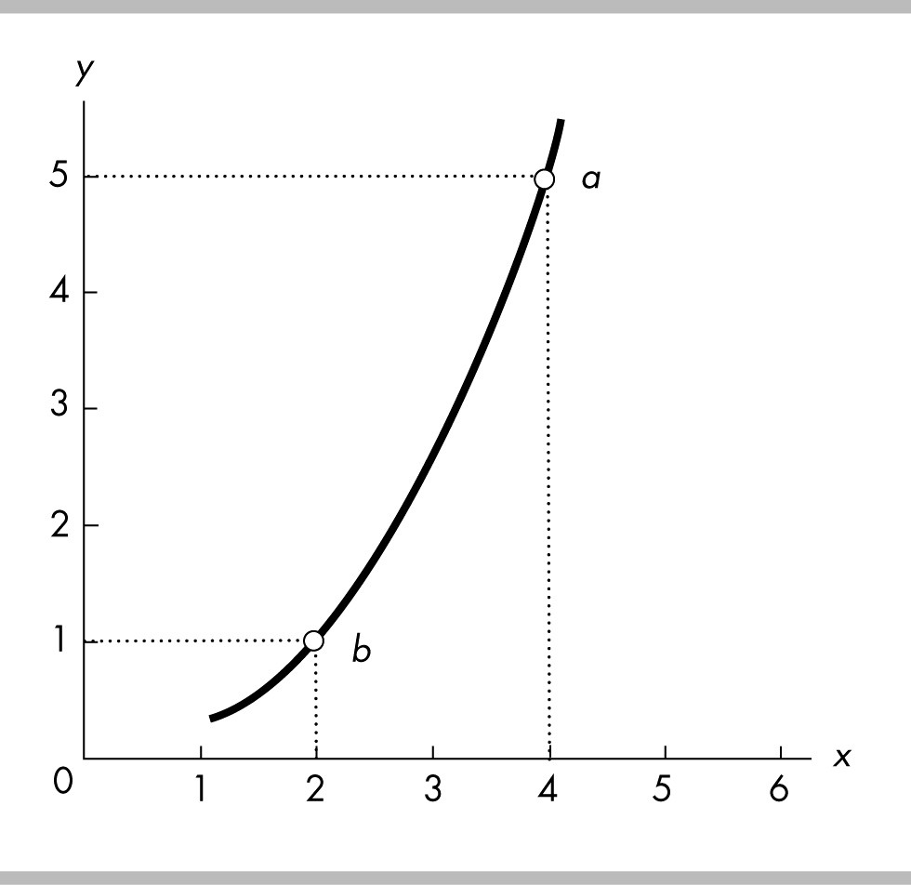

80) The relationship between x and y in the above figure is
A) positive with an increasing slope.
B) positive with a decreasing slope.
C) negative with an increasing slope.
D) negative with a decreasing slope.
Answer: A
Topic: Study Guide Question, The Slope Across an Arc
Skill: Analytical
AACSB: Analytical thinking

81) In the above figure, the slope across the arc between points a and b equals
A) 5.
B) 4.
C) 2.
D) 1.
Answer: C
Topic: Study Guide Question, The Slope Across an Arc
Skill: Analytical
AACSB: Analytical thinking

13 Appendix: Graphing Relationships Among More Than Two Variables

1) Ceteris paribus when graphing a relationship refers to
A) letting all the variables change at once.
B) changing the origin of the graph.
C) holding constant all but two variables.
D) rescaling the coordinates.
Answer: C
Topic: Graphing Relationships, Two+ Variables, Ceteris Paribus
Skill: Recognition
AACSB: Reflective thinking
2) In evaluating a relationship between x and y, ceteris paribus means other variables
A) are not relevant to x and y.
B) move in opposite directions to x and y.
C) are not changing while x and y change.
D) move in the same direction as x and y.
Answer: C
Topic: Graphing Relationships, Two+ Variables, Ceteris Paribus
Skill: Conceptual
AACSB: Reflective thinking

3) On a graph showing the relationship between x and y, the ceteris paribus condition implies that
A) no other variables are related to x and y.
B) the value of x is held constant.
C) the value of y is held constant.
D) other variables not shown are held constant.
Answer: D
Topic: Graphing Relationships, Two+ Variables, Ceteris Paribus
Skill: Conceptual
AACSB: Reflective thinking

4) Assume that the quantity consumed of pizza is dependent on three factors: the price of a pizza, the income of pizza purchasers, and consumers' taste for pizza. When graphing the relationship between the price of a pizza and the quantity of pizza consumed
A) the price of a pizza and the income of pizza consumers are the only variables that are allowed to change.
B) the price of pizza and quantity consumed of pizza are the only variables that are allowed to change.
C) consumers' taste for pizza and the income of pizza purchasers are the only variables that are allowed to change.
D) None of the above answers are correct.
Answer: B
Topic: Graphing Relationships, Two+ Variables, Ceteris Paribus
Skill: Conceptual
AACSB: Analytical thinking

5) To graph a relationship among several variables, we hold all but ________ variable(s) constant and use the ________ assumption.
A) one; scarcity
B) two; ceteris paribus
C) three; marginal benefit
D) one; ceteris paribus
Answer: B
Topic: Graph Relationships-More than Two Variables, Ceteris Paribus
Skill: Recognition
AACSB: Analytical thinking

6) In the above figure, while moving along the line showing the relationship between household income and expenditure
A) household expenditures are held constant.
B) household income is held constant.
C) the interest rate is held constant.
D) no variable is held constant.
Answer: C
Topic: Graphing Relationships Among More Than Two Variables
Skill: Analytical
AACSB: Analytical thinking

7) In the above figure, if the interest rate is negatively related to household expenditures for any given level of household income, an increase in the interest rate will
A) shift the line vertically upward.
B) shift the line vertically downward.
C) make the line negatively sloped.
D) cause no change in the line's position.
Answer: B
Topic: Graphing Relationships Among More Than Two Variables
Skill: Analytical
AACSB: Analytical thinking
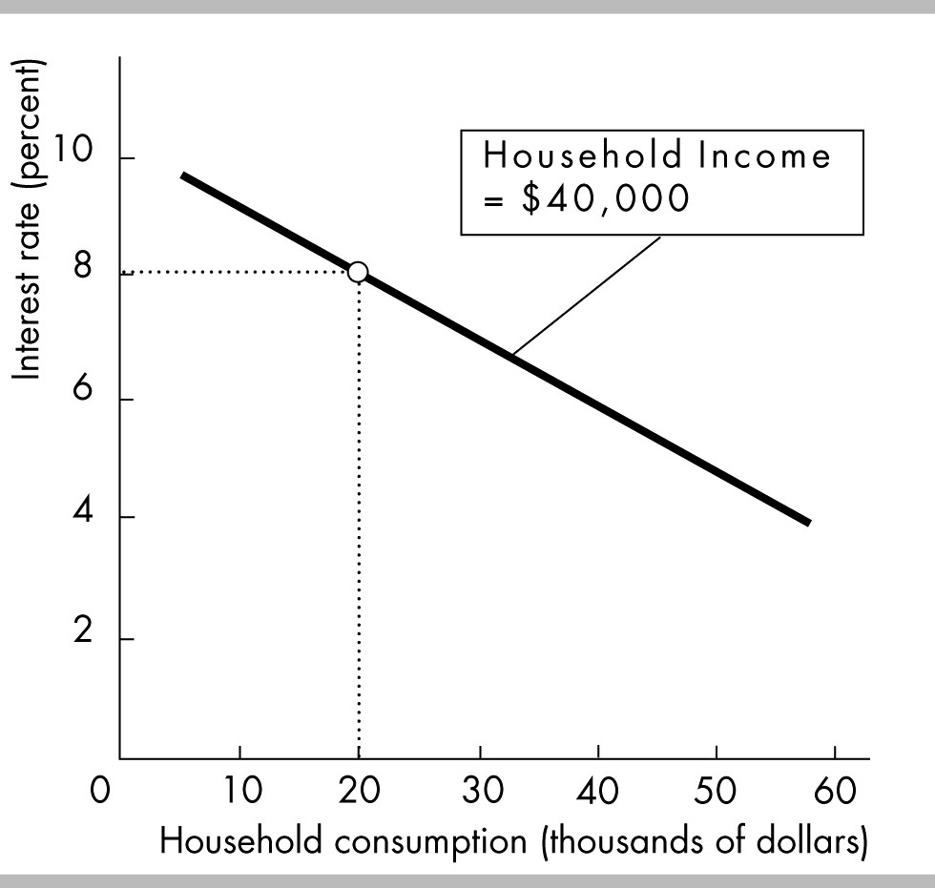

8) The slope of the line in the above figure is
A) positive.
B) negative.
C) direct.
D) independent.
Answer: B
Topic: Graphing Relationships Among More Than Two Variables
Skill: Analytical
AACSB: Analytical thinking

9) In the above figure, when the interest rate is 8 percent and household income is $40,000, household consumption is
A) $0.
B) $20,000.
C) $35.000.
D) $60,000.
Answer: B
Topic: Graphing Relationships Among More Than Two Variables
Skill: Analytical
AACSB: Analytical thinking

10) The relationship in the above figure indicates that
A) a decrease in the interest rate leads to a decrease in household income.
B) a decrease in household consumption leads to a decrease in interest rates.
C) a decrease in household income will lead household consumption to increase.
D) none of the above.
Answer: D
Topic: Graphing Relationships Among More Than Two Variables
Skill: Analytical
AACSB: Analytical thinking
11) Household consumption depends on both income and interest rates. In the above figure
A) household consumption is held constant.
B) interest rates are held constant.
C) household income is held constant.
D) no variable is held constant.
Answer: C
Topic: Graphing Relationships Among More Than Two Variables
Skill: Analytical
AACSB: Analytical thinking

12) In the above figure, if household consumption is positively related to household income, then an increase in household income will
A) shift the line rightward.
B) shift the line leftward.
C) make the line positively sloped.
D) cause a movement along the line.
Answer: A
Topic: Graphing Relationships Among More Than Two Variables
Skill: Analytical
AACSB: Analytical thinking

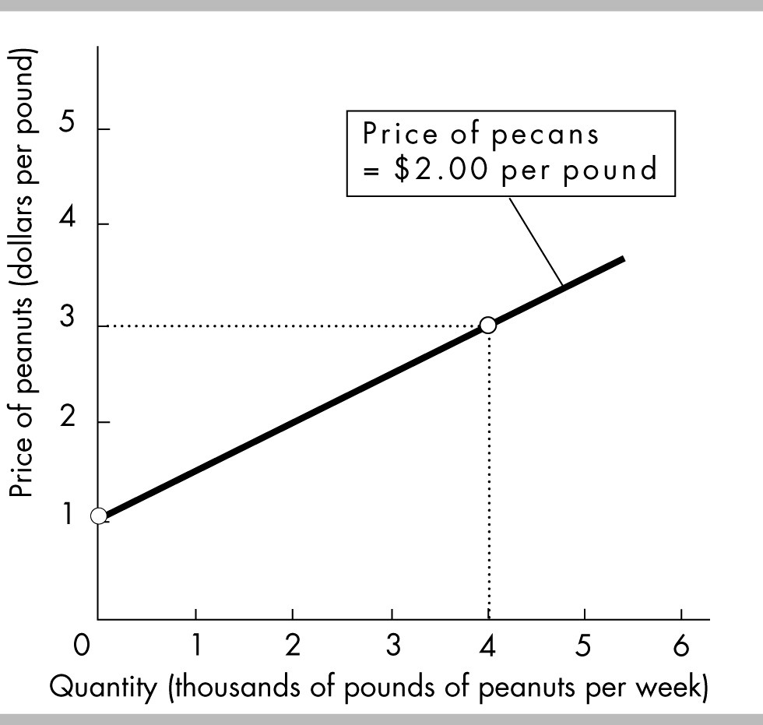

13) The above figure shows how many pounds of peanuts farmers are willing to sell at different prices per pound of peanuts. If the price of a pound of peanuts is $1 and the price of a pound of pecans is $2, peanut farmers are willing to sell
A) no peanuts.
B) 1000 pounds of peanuts.
C) 2000 pounds of peanuts.
D) 4000 pounds of peanuts.
Answer: A
Topic: Graphing Relationships Among More Than Two Variables
Skill: Analytical
AACSB: Analytical thinking
14) In the above figure, while drawing the line showing the relationship between the price of a pound of peanuts and the quantity sold, the
A) price of a pound of pecans is held constant.
B) price of a pound of peanuts is held constant.
C) quantity of peanuts that farmers supply is constant.
D) Both answers A and B are true.
Answer: A
Topic: Graphing Relationships Among More Than Two Variables
Skill: Analytical
AACSB: Analytical thinking

15) In the figure above, suppose the price of a pound of pecans is negatively related to the quantity of peanuts that farmers are willing to supply. If the price of pecans increases
A) the curve will shift rightward.
B) the curve will shift leftward.
C) there is a movement along the curve.
D) the curve will be unaffected.
Answer: B
Topic: Graphing Relationships Among More Than Two Variables
Skill: Analytical
AACSB: Analytical thinking

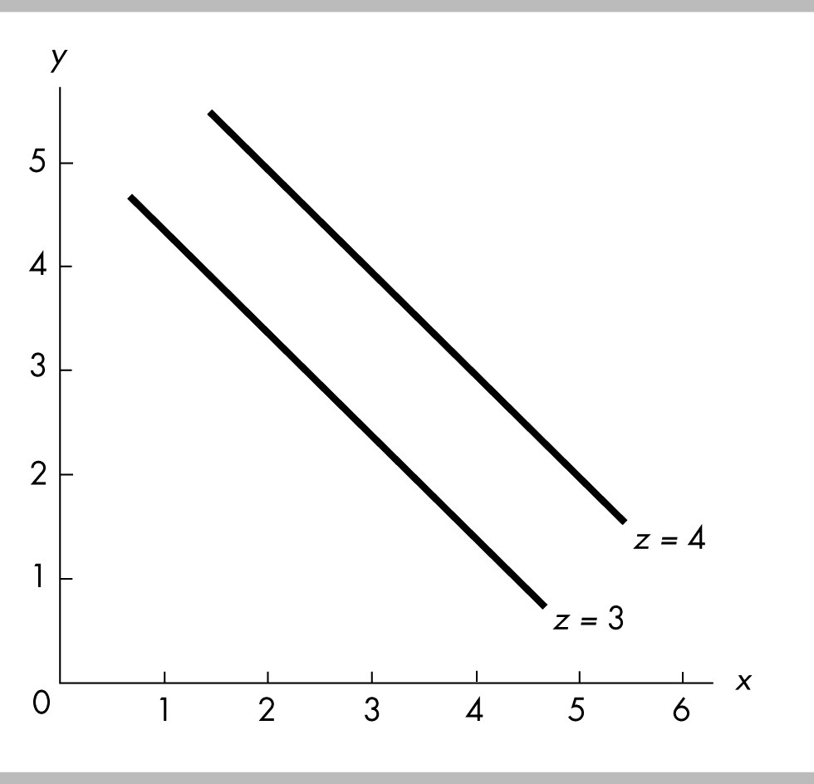

16) In the above figure, x is
A) positively related to y and negatively related to z.
B) positively related to both y and z.
C) negatively related to y and positively related to z.
D) negatively related to both y and z.
Answer: C
Topic: Study Guide Question, Graphing Relationships Among 2+ Var.
Skill: Analytical
AACSB: Analytical thinking
17) In the figure above, ceteris paribus, an increase in x is associated with
A) an increase in y.
B) a decrease in y.
C) a decrease in z.
D) None of the above answers is correct.
Answer: A
Topic: Study Guide Question, Graphing Relationships Among 2+ Var.
Skill: Analytical
AACSB: Analytical thinking

18) In the figure above, an increase in z leads to a
A) movement up along one of the lines showing the relationship between x and y.
B) movement down along one of the lines showing the relationship between x and y.
C) rightward shift of the line showing the relationship between x and y.
D) leftward shift of the line showing the relationship between x and y.
Answer: C
Topic: Study Guide Question, Graphing Relationships Among 2+ Var.
Skill: Analytical
AACSB: Analytical thinking

14 Appendix: Essay Questions

1) Why do economists use graphs?
Answer: Graphs help economists, and others, to visualize the relationships between economic variables. Graphs that plot variables together help economists understand if the variables are related and how they are related. Graphs also help provide a visual picture of economic models that link different variables. Indeed, many other disciplines use such visual models. For example, architects work with blueprints (their model) and the blueprints represent every detail of a building. Economists' models do not reflect of every detail of the real world, but the graphs that they use nonetheless are valuable because they help clarify the linkages between the variables.
Topic: Graphing Data
Skill: Recognition
AACSB: Analytical thinking

2) What are the two different types of relationships that variables can have? Explain each. What do these relationships look like when they are graphed?
Answer: Variables can have two relationships: positive (or direct) and negative (or inverse). A positive relationship occurs when the variables move in the same direction, so that when one increases, the other also increases. A negative relationship occurs when the variables move in the opposite direction, so that when one increases, the other decreases. When a positive relationship is graphed, the line slopes upward to the right. When a negative relationship is graphed, the line slopes downward to the right.
Topic: Relationships
Skill: Recognition
AACSB: Analytical thinking
3) What is the difference between a positive and a negative relationship?
Answer: Two variables are positively related when an increase (decrease) in one is associated with an increase (decrease) in the other. In this case, the variables move together, in the same direction. Two variables are negatively related when an increase (decrease) in one is associated with a decrease (increase) in the other. In this case, the variables move in the opposite direction.
Topic: Relationships
Skill: Recognition
AACSB: Analytical thinking

4) A graph of two variables is a vertical line. What is the interpretation of this result?
Answer: When the graph of two variables is a vertical line, the variables are not related because, with this graph, whenever the variable measured along the vertical axis changes, the variable measured along the horizontal axis does not change.
Topic: Unrelated Variables
Skill: Recognition
AACSB: Analytical thinking

5) What does the slope of a straight line equal? How is the slope of a curved line calculated at a point on the curve?
Answer: The slope of a straight line is calculated between two points on the line. Between the two points on the line, the slope equals the change in the value of the variable measured on the vertical axis (the y-axis) divided by the change in the value of the variable measured on the horizontal axis (the x-axis). The slope of a curved line calculated at a point on the curve is equal to the slope of a tangent straight line. At that point on the curved line, draw a straight line that touches the curved line at only that point. Then, calculate the slope of the straight line. The slope of the curved line at that point equals the slope of the straight line.
Topic: Slope
Skill: Recognition
AACSB: Analytical thinking

6) "It is impossible to represent a three variable relationship in a two-dimensional graph." Is this statement true or false? Explain your answer.
Answer: The statement is false because it is possible to represent a three variable relationship in a two dimensional graph. To do so, start by focusing on two of the variables. Assume that the third variable does not change (the ceteris paribus assumption) and then graph the relationship between the two variables. The graph shows how these two variables are related when the third variable does not change. When the third variable does change, then the entire relationship between the two graphed variables changes. In other words, the line showing the relationship between the two graphed variables shifts so that it becomes an entirely new line. The shift in the line shows how the third variable influences the other two.
Topic: Graphing Relationships Among More Than Two Variables
Skill: Recognition
AACSB: Analytical thinking
15 Appendix: Numeric and Graphing Questions

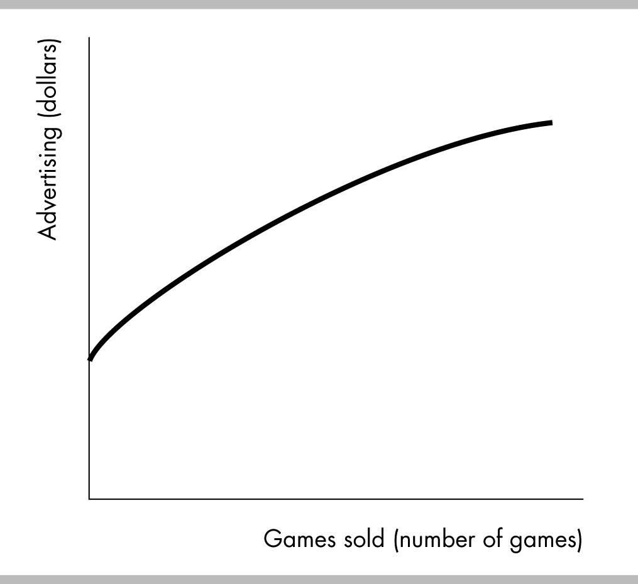

1) The figure above shows how the sales of the video game "Tomb Raider—Lara Retires" change when the advertising spent on the game changes. Is the relationship between advertising and the number of games sold positive, negative, or neither? Explain your answer.
Answer: The figure shows that there is a positive relationship between advertising and the number of video games sold. The relationship is positive because the two variables move together: If advertising increases, so, too, does the number of games sold.
Topic: Positive Relationship
Skill: Recognition
AACSB: Analytical thinking
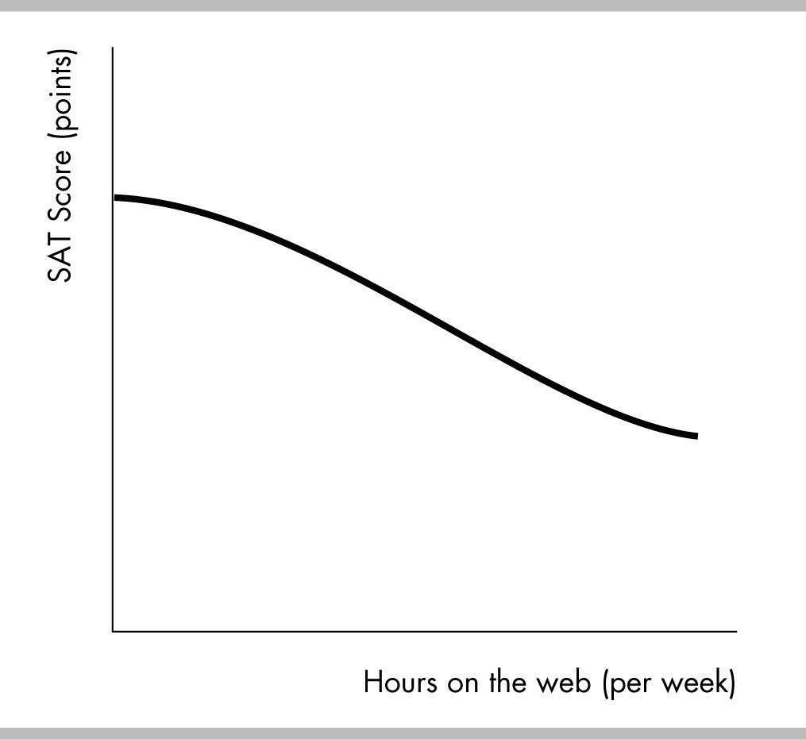

2) The figure above shows how the relationship between the number of hours per week a high school student spends on the web and the student's SAT score. Is the relationship between hours on the web and the SAT score positive, negative, neither? Explain your answer.
Answer: The figure shows that there is a negative relationship between hours on the web and the student's SAT score. The relationship is negative because the two variables move in opposite directions: If hours on the web increase, the SAT score decreases.
Topic: Negative Relationship
Skill: Recognition
AACSB: Analytical thinking
3) A graph has a point that is either a maximum or a minimum. To the left of the point, the slope of relationship is positive. To the right of the point, the slope is negative. Is the point a maximum point or a minimum point? Be sure to draw a figure that supports your answer.
Answer:
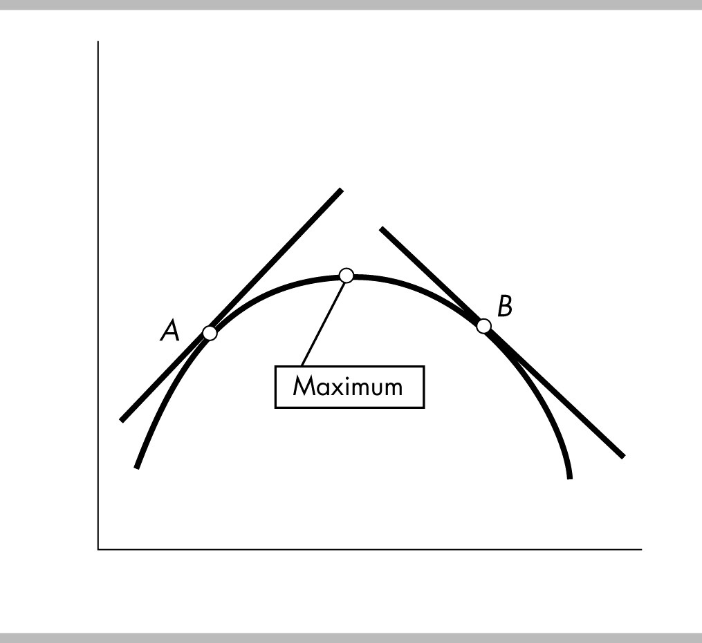

The point is a maximum point. Examine the figure above. The slope of a curved line at any point equals the slope of a straight line that touches the curved line at only that one point. Thus to the left of the maximum point, take point A. The slope of the straight line that touches the curved line at only point A is positive, so the slope of the relationship is positive. Similarly, take point B to the right of the maximum point. As the straight line shows, the slope of the relationship at point B is negative. Indeed, whenever there is a maximum point, the slope of the relationship to the left of the maximum is positive and the slope to the right is negative.
Topic: Maximum
Skill: Recognition
AACSB: Analytical thinking
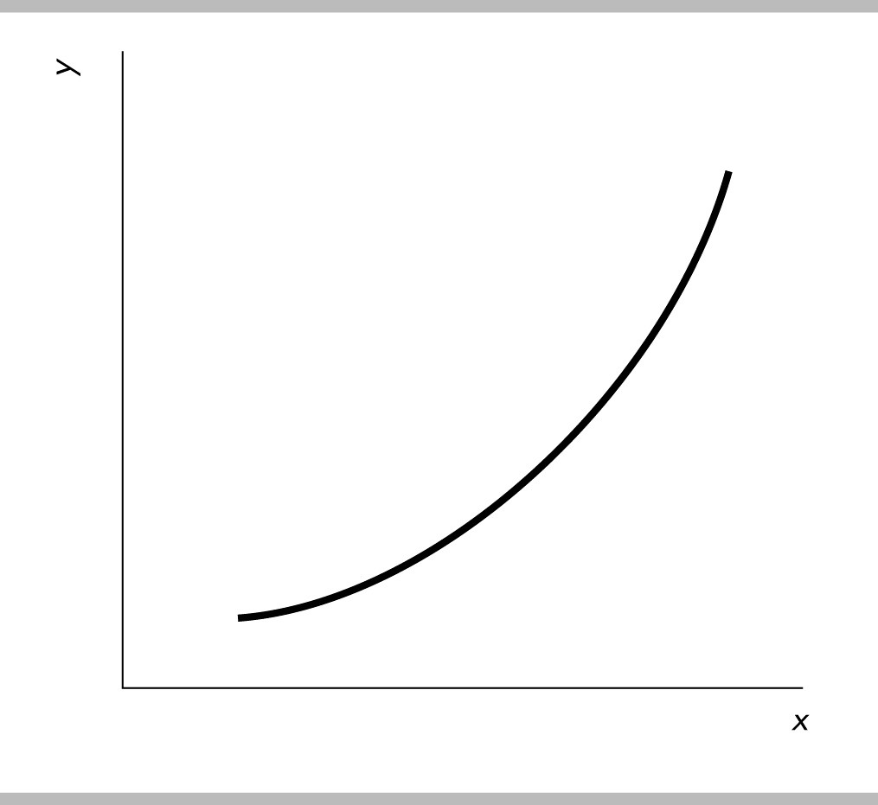

4) In the figure above, what can you deduce about the slope of the curve?
Answer: The slope is positive and increasing in size as we move rightward along the curve.
Topic: Slope
Skill: Conceptual
AACSB: Analytical thinking

5) If two points on a line are x = 2, y = 5 and x = 7, y = 10, what is the slope of this line?
Answer: The slope equals the change in the y-variable divided by the change in the x-variable. So, the slope equals (10 - 5)/(7 - 2) = (5)/(5) = 1.00.
Topic: Slope
Skill: Analytical
AACSB: Analytical thinking

Katie's income  (dollars per year) | Katie's purchases  (books per year)
50,000 | 14
70,000 | 16
90,000 | 18
110,000 | 20

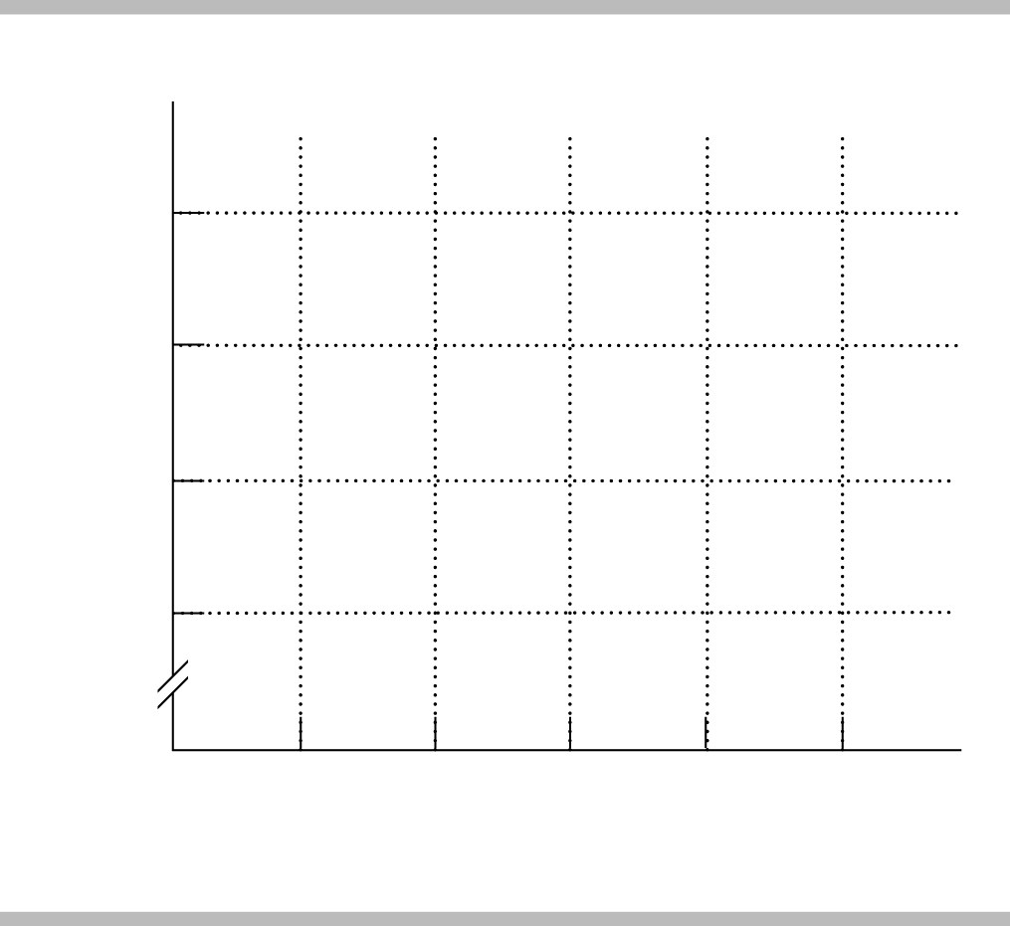

6) The table above shows how the number of books Katie buys each year depends on her income.
a) What kind of relationship exists between Katie's income and the number of books she purchases?
b) Plot the relationship between Katie's income and the number of books she purchases in the above figure. Measure income along the vertical axis and the number of books along the horizontal axis. Be sure to label the axes.
c) What is the slope of the relationship between $50,000 and $70,000 of income?
d) What is the slope of the relationship between $90,000 and $110,000 of income?
e) Comment on the similarity or dissimilarity of your answers to parts (c) and (d).
Answer:
a) There is a positive relationship. When Katie's income increases, so too does her purchase of books.

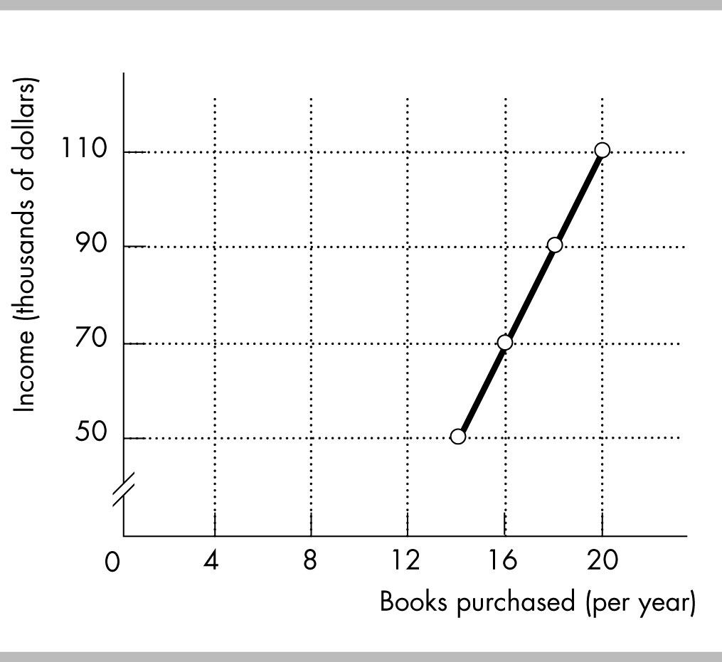

b) The relationship is plotted in the figure above.
c) The slope equals the change in the value of the variable measured on the vertical axis, income, divided by the change in the value of the variable measured along the horizontal axis, the number of books. Between $50,000 and $70,000 of income, the number of books purchased increases from 14 to 16. Hence income increases by $20,000 and the number of books increases by 2, so the slope equals $20,000/2 = 10,000.
d) As with the previous answer, the slope equals the change in income divided by the change in books. Between $90,000 and $110,000 of income, the number of books purchased increases from 18 to 20. Hence income increases by $20,000 and the number of books increases by 2, so the slope equals $20,000/2 = 10,000.
e) The slopes in parts (c) and (d) are equal. But, they must be equal because the relationship between Katie's income and the number of books she purchases is linear. For a linear relationship, the slope is the same regardless of where it is measured.
Topic: Slope of a Straight Line
Skill: Analytical
AACSB: Analytical thinking

X | Y
2 | 20
4 | 16
6 | 12
8 | 8

7) Graph the data in the table above in the figure. Label the axes.
a) Is the relationship between X and Y positive or negative?
b) What is the slope when X = 4?
c) What is the slope when X = 8?
Answer:
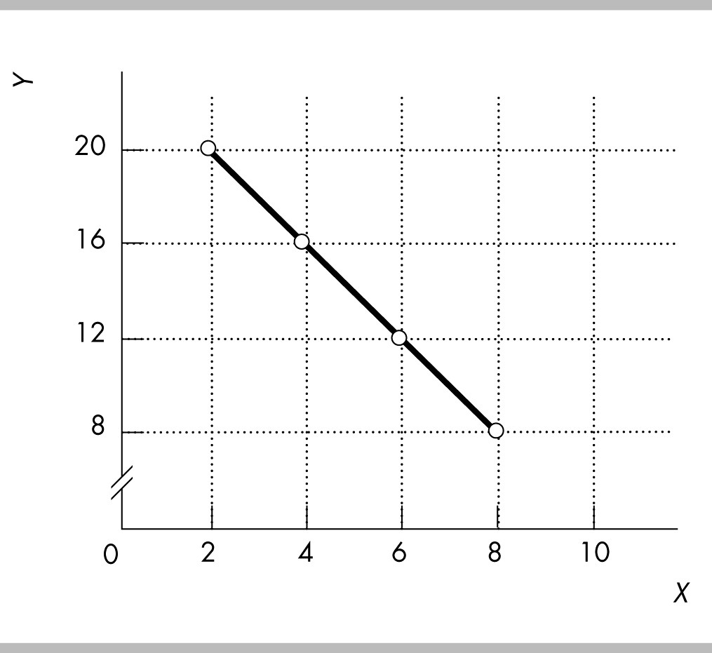

The figure labels the axes and graphs the relationship.
a) The relationship between X and Y is negative.
b) The slope equals -2.
c) The slope equals -2.
Topic: Slope of a Straight Line
Skill: Analytical
AACSB: Analytical thinking

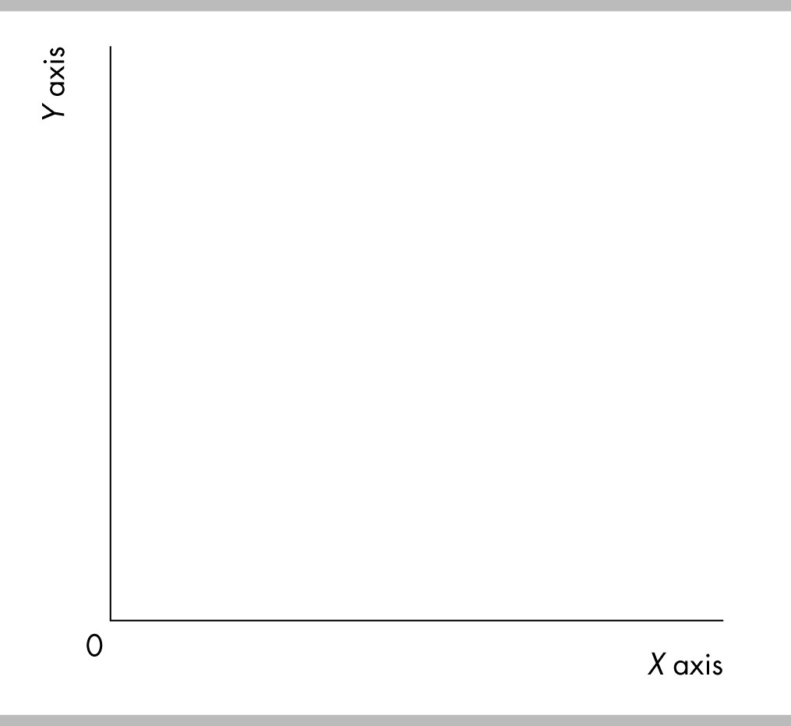

8) In the above diagram, draw a straight line with a slope of zero.
Answer:
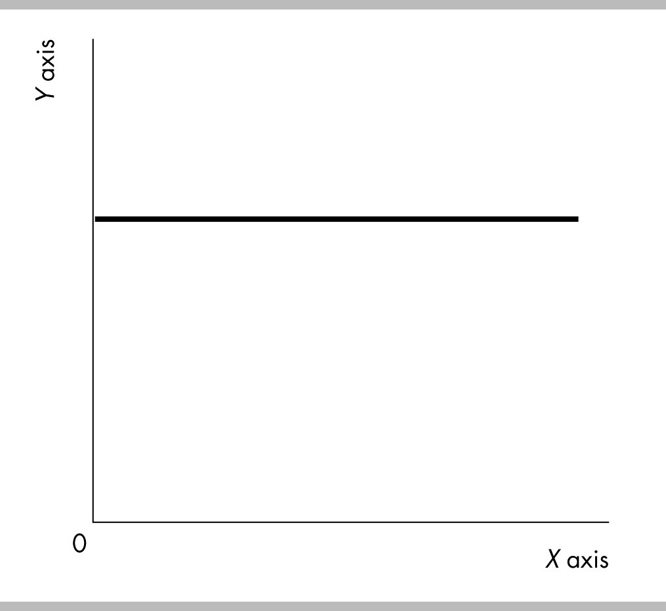

A horizontal line has a slope of zero. The figure above shows a horizontal line with a slope of zero.
Topic: Slope of a Straight Line
Skill: Analytical
AACSB: Analytical thinking

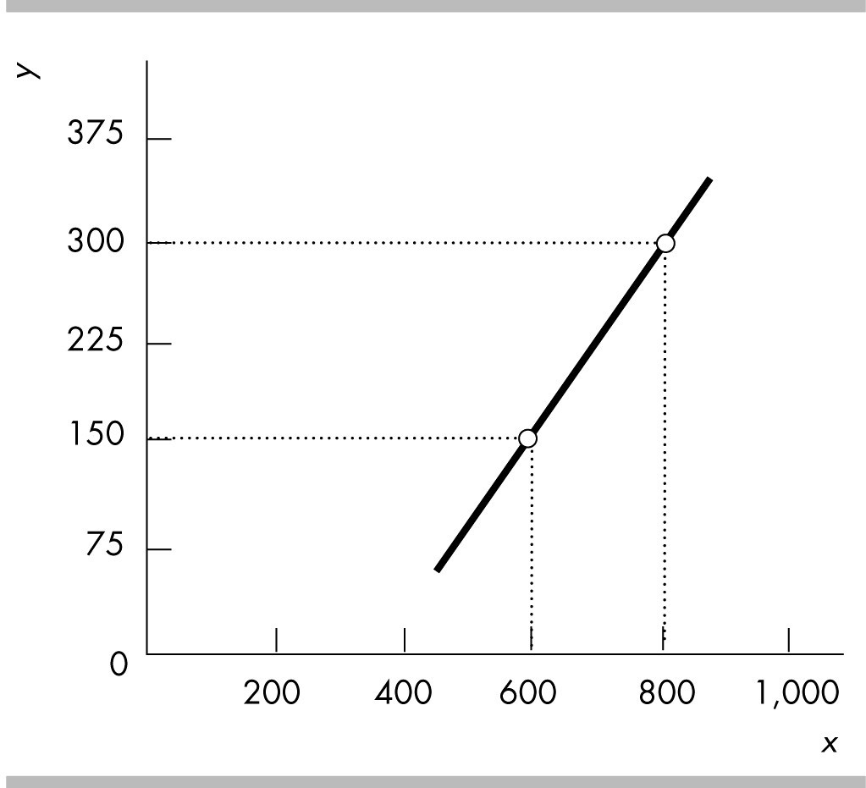

9) What does the slope of the line shown in the above figure equal?
Answer: The slope equals the change in variable on the y-axis divided by the change in the variable on the x-axis, or (150 - 300)/(600 - 800) = 0.75.
Topic: Slope of a Straight Line
Skill: Analytical
AACSB: Analytical thinking
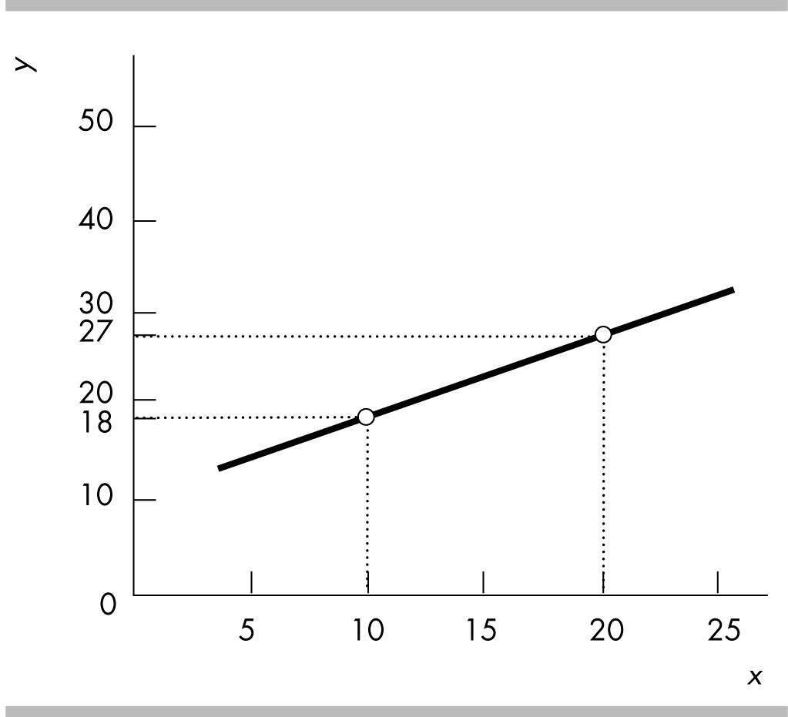

10) What does the slope of the line shown in the above figure equal?
Answer: The slope equals the change in variable on the y-axis divided by the change in the variable on the x-axis, or (18 - 27)/(10 - 20) = 0.90.
Topic: Slope of a Straight Line
Skill: Analytical
AACSB: Analytical thinking

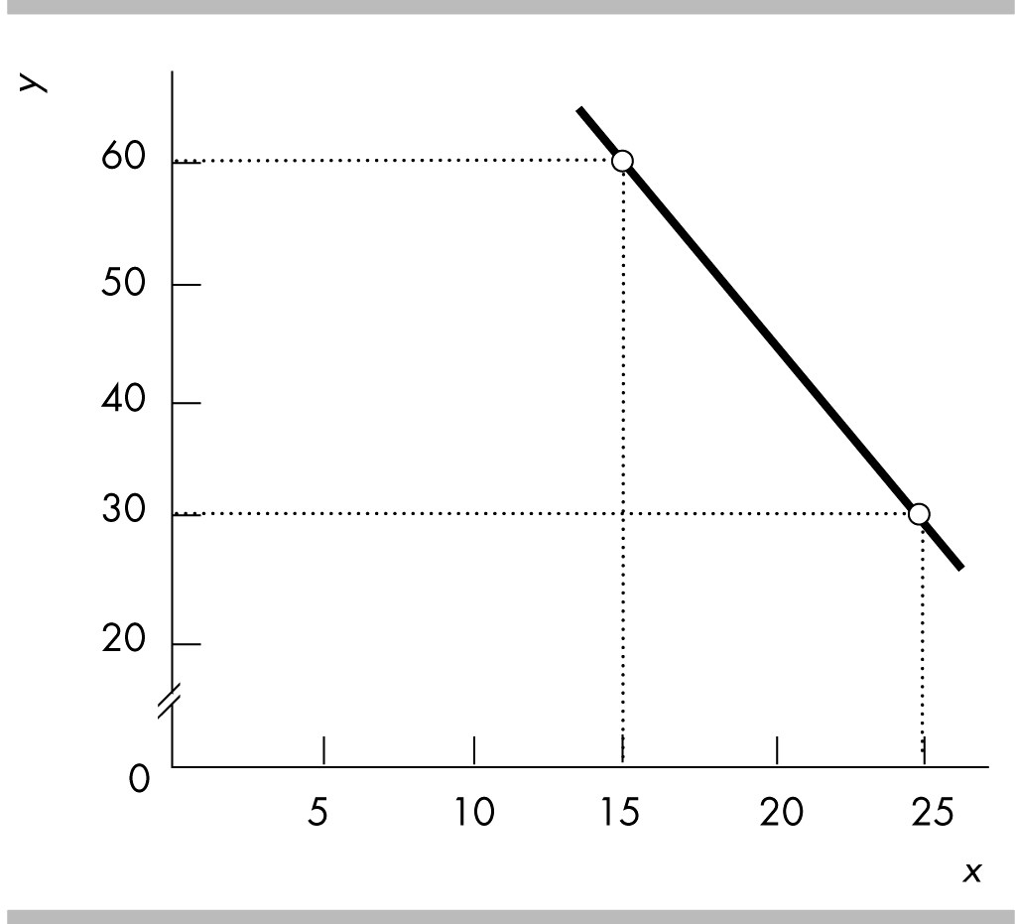

11) What does the slope of the line shown in the above figure equal?
Answer: The slope equals the change in variable on the y-axis divided by the change in the variable on the x-axis, or (30 - 60)/(25 - 15) = -3.0.
Topic: Slope of a Straight Line
Skill: Analytical
AACSB: Analytical thinking
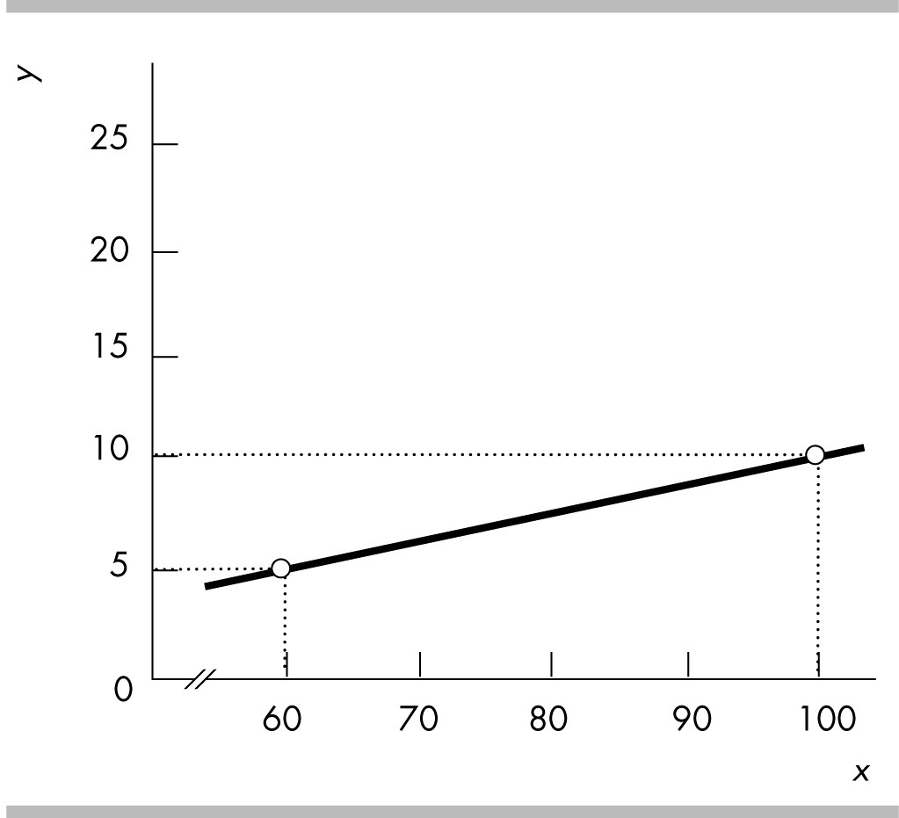

12) What does the slope of the line shown in the above figure equal?
Answer: The slope equals the change in variable on the y-axis divided by the change in the variable on the x-axis, or (5 - 10)/(60 - 100) = 0.125.
Topic: Slope of a Straight Line
Skill: Analytical
AACSB: Analytical thinking
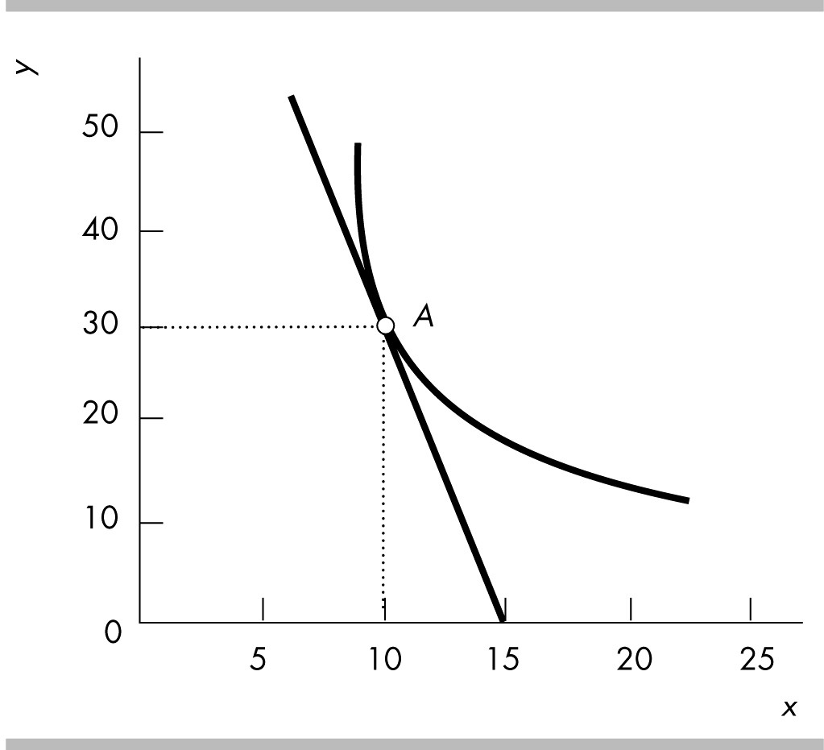

13) What does the slope of the curved line at point A shown in the above figure equal?
Answer: The slope of a curved line equals the slope of a straight line that touches the curved line at only that point. And, the slope of a straight line equals the change in variable on the y-axis divided by the change in the variable on the x-axis. Measure the slope of the straight line from point A to where the line crosses the x-axis, at 15. Thus the straight line has a slope of (30 - 0)/(10 - 15) = -6. Therefore the curve line at point A also has a slope equal to -6.
Topic: Slope of a Curved Line
Skill: Analytical
AACSB: Analytical thinking

Hours studies  (per week) | SAT scores
2 | 900
4 | 1000
6 | 1050
8 | 1075
10 | 1090

14) Jamie is preparing to take his SAT tests. The table above shows how Jamie's score depends on the number of hours a week Jamie studies.
a) Plot the relationship in the figure, putting the hours studied on the horizontal axis.
b) Is the relationship you plotted positive or negative?
c) What happens to the slope of the relationship as hours studied increase?
d) Suppose Jamie can enroll in an SAT prep course and, by so doing, for every possible number of hours he studies, his score will be 100 points higher. Plot the new relationship between the number of hours studied and Jamie's SAT score in the figure.
e) How many variables are involved in the figure you just completed?
Answer:
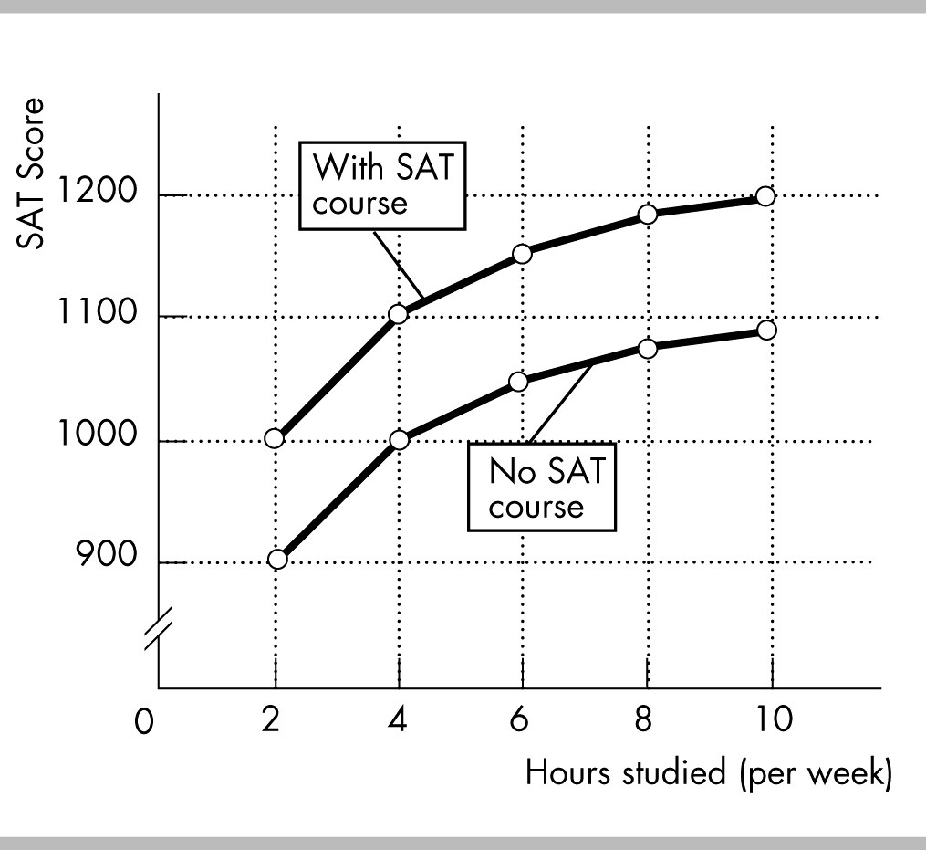

a) The figure above plots the relationship between the number of hours Jamie studies and his SAT score.
b) The relationship is positive: As Jamie increases the hours he studies, his SAT score increases.
c) The relationship is nonlinear, so the slope of the relationship changes as the number of hours studied changes. In the figure, the slope of the relationship decreases in size as the number of hours studied increases.
d) The figure above also plots the relationship between the hours Jamie studies and his SAT score if Jamie takes an SAT preparation course.
e) There are three variables: The number of hours Jamie studies, whether or not he takes an SAT preparation course, and his SAT score.
Topic: Graphing Relationships Among More Than Two Variables
Skill: Analytical
AACSB: Analytical thinking

16 Appendix: True or False

1) The vertical axis of a graph shows only positive values.
Answer: FALSE
Topic: Graphing Data
Skill: Recognition
AACSB: Analytical thinking

2) A scatter diagram plots the value of one economic variable against time.
Answer: FALSE
Topic: Graphing Data
Skill: Recognition
AACSB: Analytical thinking

3) A cross-section graph can show how economic variables for different groups of people vary over time.
Answer: FALSE
Topic: Graphing Data
Skill: Recognition
AACSB: Analytical thinking

4) If the x-axis variable increases while the y-axis variable decreases, the variables x and y are negatively related.
Answer: TRUE
Topic: Graphs Used in Economic Models
Skill: Conceptual
AACSB: Analytical thinking

5) A graph cannot be used to show that two variables are unrelated.
Answer: FALSE
Topic: Graphs Used in Economic Models
Skill: Conceptual
AACSB: Analytical thinking

6) When graphed, variables that are unrelated are shown by either a horizontal or a vertical line.
Answer: TRUE
Topic: Graphs Used in Economic Models
Skill: Recognition
AACSB: Analytical thinking
7) The slope of a line is the change in the y-axis variable divided by the change in the x-axis variable.
Answer: TRUE
Topic: The Slope of a Relationship
Skill: Recognition
AACSB: Analytical thinking

8) The slope of a straight line increases as the numbers on the x-axis become larger.
Answer: FALSE
Topic: The Slope of a Relationship
Skill: Conceptual
AACSB: Analytical thinking

9) To calculate the slope of a curved line, you can calculate the slope at a point on the curve or across an arc of the curve.
Answer: TRUE
Topic: The Slope of a Relationship
Skill: Conceptual
AACSB: Analytical thinking

10) If the change in the y-axis variable is 4 and the change in the x-axis variable is 2, the slope of this line is 1/2.
Answer: FALSE
Topic: The Slope of a Relationship
Skill: Analytical
AACSB: Analytical thinking

11) If the change in the y-axis variable is 6 and the change in the x-axis variable is 5, the slope of this line is 6/5.
Answer: TRUE
Topic: The Slope of a Relationship
Skill: Analytical
AACSB: Analytical thinking

12) To graph a relationship that involves more than two variables, we use the "ceteris paribus" assumption.
Answer: TRUE
Topic: Graphing Relationships Among More Than Two Variables
Skill: Conceptual
AACSB: Analytical thinking

13) "Ceteris paribus" refers to the idea that if more than two variables are graphed, only one variable must be held constant.
Answer: FALSE
Topic: Graphing Relationships Among More Than Two Variables
Skill: Conceptual
AACSB: Analytical thinking

