Exploring Geology, 5e (Reynolds)
Chapter 1 The Nature of Geology

1) Which of the following was mentioned in the opening two-page spread of Chapter 1?
A) Oil beneath the Arctic National Wildlife Reserve
B) The scenery of Glacier National Park
C) Earthquakes along the San Andreas fault
D) Oil beneath the Gulf Coast of the United States

Answer: B
Section: 01.00
Topic: Study of Geology
Bloom's: 1. Remember
Gradable: automatic
Accessibility: Keyboard Navigation

2) Which of the following is probably least at risk for geologic hazards?
A) Next to a river in low areas
B) Near an active fault
C) On soils that gently expand when wet
D) On gentle slopes away from mountains
E) Close to, but upwind of, an active volcano

Answer: D
Section: 01.01
Topic: Geology and the Human Environment
Bloom's: 3. Apply
Gradable: automatic
Accessibility: Keyboard Navigation

3) Which potential geologic hazard is NOT represented by a feature on this figure?

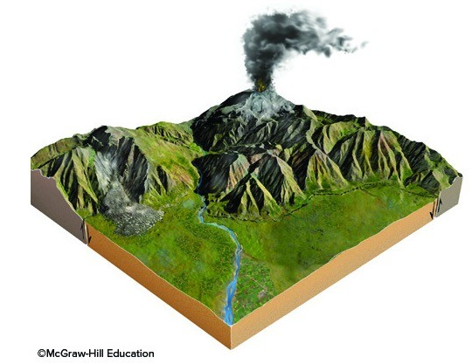

A) An earthquake
B) A volcano
C) Contaminated groundwater
D) A landslide
E) Flood-prone areas

Answer: C
Section: 01.01
Topic: Geology and the Human Environment
Bloom's: 4. Analyze
Gradable: automatic
Accessibility: Keyboard Navigation

4) Which of the following geologic aspects influence our lives based on the photograph showing horses and cows on a grassy field?
A) The presence of mountains, which influence the formation of clouds and precipitation
B) The steepness of slopes
C) The availability of water
D) All of these choices are correct.

Answer: D
Section: 01.01
Topic: Geology and the Human Environment
Bloom's: 1. Remember
Gradable: automatic
Accessibility: Keyboard Navigation

5) The distribution of natural resources is influenced by the
A) type of rocks.
B) age of the rocks.
C) way in which the rocks formed.
D) All of these choices are correct.

Answer: D
Section: 01.01
Topic: Rocks
Bloom's: 1. Remember
Gradable: automatic
Accessibility: Keyboard Navigation

6) Which of the following factors was most important in controlling the distribution of copper mines in the western U.S. versus iron mines in the Great Lakes region?
A) The amount of precipitation (rain and snow).
B) The time of year when precipitation occurs.
C) Different ages and geologic histories of the rocks.
D) The latitude (distance south or north from the equator).

Answer: C
Section: 01.01
Topic: Mineral Resource
Bloom's: 1. Remember
Gradable: automatic
Accessibility: Keyboard Navigation

7) Geology can help us learn about Earth's past by studying
A) why continents and oceans are different.
B) why a landscape looks the way it does.
C) how life in the past was different than today.
D) how global climate has changed since the ice ages.
E) All of these choices are correct.

Answer: E
Section: 01.02
Topic: Study of Geology
Bloom's: 2. Understand
Gradable: automatic
Accessibility: Keyboard Navigation

8) Which of the following is NOT a way geology informs us about Earth's past?
A) How the first second of the universe differed from a second today
B) Why continents and oceans are different
C) Why a landscape looks the way it does today
D) How life in the past was different than today
E) How past global climate was different than today

Answer: A
Section: 01.02
Topic: Study of Geology
Bloom's: 2. Understand
Gradable: automatic
Accessibility: Keyboard Navigation

9) Continents differ in appearance from ocean basins because
A) each has its own geologic history.
B) each contains different fossils.
C) each has its own climate.

Answer: A
Section: 01.02
Topic: Sea Floor and Continental Margins
Bloom's: 1. Remember
Gradable: automatic
Accessibility: Keyboard Navigation

10) Continental ice sheets were more common 28,000 years ago than they are today because

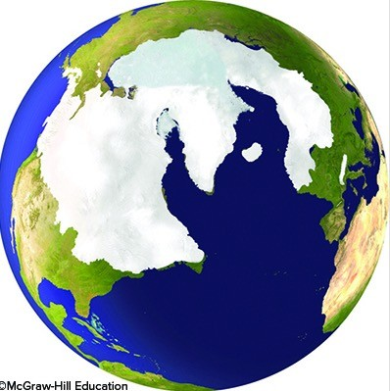

A) the Earth had more water then than now.
B) the Earth was cooler then than now.
C) the Earth was farther away from the Sun then than now.

Answer: B
Section: 01.02
Topic: Geologic Time
Bloom's: 1. Remember
Gradable: automatic
Accessibility: Keyboard Navigation

11) The main layers of the Earth in correct order, from the surface moving down, are
A) upper crust, outer core, inner core, mantle.
B) outer core, inner core, upper mantle, lower crust.
C) crust, mantle, outer core, inner core.
D) upper mantle, lower mantle, inner core, crust.

Answer: C
Section: 01.03
Topic: Earth's Interior
Bloom's: 1. Remember
Gradable: automatic
Accessibility: Keyboard Navigation

12) Which of the following Earth layers is the thinnest?
A) Oceanic crust
B) Upper mantle
C) Lower mantle
D) Outer core
E) Inner core

Answer: A
Section: 01.03
Topic: Sea Floor and Continental Margins
Bloom's: 1. Remember
Gradable: automatic
Accessibility: Keyboard Navigation

13) Which layer on this figure is the upper mantle?

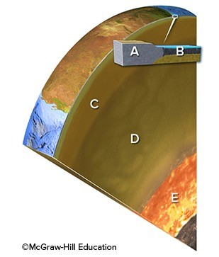

A) A
B) B
C) C
D) D
E) E

Answer: C
Section: 01.03
Topic: Earth's Interior
Bloom's: 1. Remember
Gradable: automatic
Accessibility: Keyboard Navigation

14) Which layer on this figure is the continental crust?

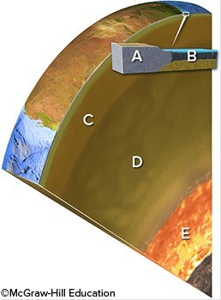

A) A
B) B
C) C
D) D
E) E

Answer: A
Section: 01.03
Topic: Sea Floor and Continental Margins
Bloom's: 1. Remember
Gradable: automatic
Accessibility: Keyboard Navigation

15) Which layer on this figure is the oceanic crust?

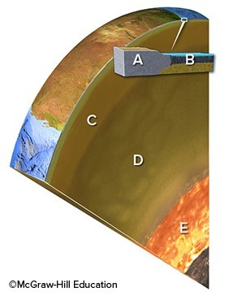

A) A
B) B
C) C
D) D
E) E

Answer: B
Section: 01.03
Topic: Sea Floor and Continental Margins
Bloom's: 1. Remember
Gradable: automatic
Accessibility: Keyboard Navigation

16) Which layer in the earth is similar to the composition of granite?
A) Continental crust
B) Oceanic crust
C) Upper mantle
D) Lower mantle
E) Core

Answer: A
Section: 01.03
Topic: Sea Floor and Continental Margins
Bloom's: 1. Remember
Gradable: automatic
Accessibility: Keyboard Navigation

17) Which layer in the earth is similar in composition to basalt, a dark lava rock?
A) Continental crust
B) Oceanic crust
C) Upper mantle
D) Lower mantle
E) Core

Answer: B
Section: 01.03
Topic: Sea Floor and Continental Margins
Bloom's: 1. Remember
Gradable: automatic
Accessibility: Keyboard Navigation

18) Which layer in the earth is similar to the green mineral olivine?
A) Continental crust
B) Oceanic crust
C) Mantle
D) Core

Answer: C
Section: 01.03
Topic: Sea Floor and Continental Margins; Earth's Interior
Bloom's: 1. Remember
Gradable: automatic
Accessibility: Keyboard Navigation

19) Which layer in the earth is similar in composition to an iron-nickel meteorite?
A) Continental crust
B) Oceanic crust
C) Upper mantle
D) Lower mantle
E) Core

Answer: E
Section: 01.03
Topic: Earth's Interior
Bloom's: 1. Remember
Gradable: automatic
Accessibility: Keyboard Navigation

20) Which of the following is NOT a possible reason for why a region is higher in elevation than adjacent regions?
A) The lithosphere is hotter.
B) It has continental crust, but adjacent regions have oceanic crust.
C) The crust is thicker.
D) The crust is more dense.

Answer: D
Section: 01.03
Topic: Sea Floor and Continental Margins
Bloom's: 2. Understand
Gradable: automatic
Accessibility: Keyboard Navigation

21) What is the most likely reason why a region is higher than adjacent regions?
A) There is a hot spot beneath it.
B) The crust is thicker.
C) It is underlain by oceanic crust.
D) The asthenosphere is hotter.
E) The crust is hotter.

Answer: B
Section: 01.03
Topic: Sea Floor and Continental Margins
Bloom's: 2. Understand
Gradable: automatic
Accessibility: Keyboard Navigation

22) Which of the following is the best description of what the lithosphere contains?
A) Continental and oceanic crust
B) Both types of crust and the uppermost mantle
C) Weak part of the upper mantle
D) Upper and lower mantle
E) Lower mantle and outer core

Answer: B
Section: 01.03
Topic: Earth's Interior
Bloom's: 1. Remember
Gradable: automatic
Accessibility: Keyboard Navigation

23) Which of the following Earth layers is the thickest?
A) Continental crust
B) Oceanic crust
C) Mantle
D) Outer core

Answer: C
Section: 01.03
Topic: Earth's Interior
Bloom's: 1. Remember
Gradable: automatic
Accessibility: Keyboard Navigation

24) The principle of isostasy refers to
A) the difference in the strength of the mantle versus the crust.
B) the relationship between regional elevations and thickness of crust.
C) how the outer core differs from the inner core.
D) how the upper mantle differs from the lower mantle.

Answer: B
Section: 01.03
Topic: Sea Floor and Continental Margins
Bloom's: 1. Remember
Gradable: automatic
Accessibility: Keyboard Navigation

25) Which of the following is NOT an important difference between continents and oceans?
A) Thickness of the crust
B) Composition of the crust
C) Density of the crust
D) Whether it is part of the lithosphere
E) Elevation

Answer: D
Section: 01.03
Topic: Sea Floor and Continental Margins
Bloom's: 1. Remember
Gradable: automatic
Accessibility: Keyboard Navigation

26) Which of the following combinations would result in the highest regional elevations?
A) Thin, dense crust
B) Thick, dense crust
C) Thin, less dense crust
D) Thick, less dense crust

Answer: D
Section: 01.03
Topic: Sea Floor and Continental Margins
Bloom's: 3. Apply
Gradable: automatic
Accessibility: Keyboard Navigation

27) Which layer on this figure is the outer core?

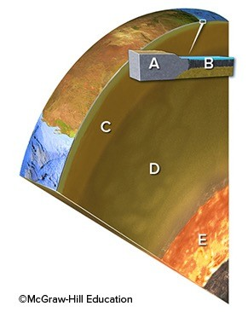

A) A
B) B
C) C
D) D
E) E

Answer: E
Section: 01.03
Topic: Earth's Interior
Bloom's: 1. Remember
Gradable: automatic
Accessibility: Keyboard Navigation

28) Compared to oceanic crust, continental crust is
A) thinner.
B) more dense.
C) lighter in color.
D) All of these choices are correct.

Answer: C
Section: 01.03
Topic: Sea Floor and Continental Margins
Bloom's: 1. Remember
Gradable: automatic
Accessibility: Keyboard Navigation

29) The main difference between the lithosphere and the asthenosphere is the
A) asthenosphere is less rigid.
B) asthenosphere flows less easily.
C) asthenosphere is cooler.
D) asthenosphere has more oceanic crust.
E) asthenosphere has more continental crust.

Answer: A
Section: 01.03
Topic: Earth's Interior
Bloom's: 1. Remember
Gradable: automatic
Accessibility: Keyboard Navigation

30) Based on this topographic profile across the central United States, which region probably has the thickest crust?

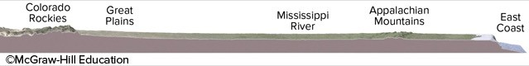

A) Colorado Rockies
B) Great Plains
C) Mississippi River
D) Appalachian Mountains
E) East Coast

Answer: A
Section: 01.03
Topic: Sea Floor and Continental Margins
Bloom's: 4. Analyze
Gradable: automatic
Accessibility: Keyboard Navigation
31) Based on this topographic profile across the central United States, which region probably has neither the thinnest nor thickest crust?

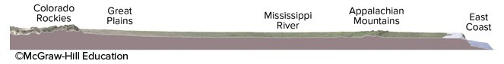

A) Colorado Rockies
B) Mississippi River
C) East Coast

Answer: B
Section: 01.03
Topic: Sea Floor and Continental Margins
Bloom's: 4. Analyze
Gradable: automatic
Accessibility: Keyboard Navigation

32) Based on this topographic profile across the central United States, which region probably has the thinnest crust?

A) Colorado Rockies
B) Great Plains
C) Mississippi River
D) Appalachian Mountains
E) East Coast

Answer: E
Section: 01.03
Topic: Sea Floor and Continental Margins
Bloom's: 4. Analyze
Gradable: automatic
Accessibility: Keyboard Navigation

33) Which of these best describes the location of the core within the Earth?
A) The core is located in the central zone of the Earth, beneath the mantle.
B) The core is located between the thin surface crust and the thick mantle.
C) The core is located at the surface of the Earth, forming a thin skin.

Answer: A
Section: 01.03
Topic: Earth's Interior
Bloom's: 1. Remember
Gradable: automatic
Accessibility: Keyboard Navigation

34) What is the largest of Earth's concentric zones by volume?
A) The crust
B) The mantle
C) The core

Answer: B
Section: 01.03
Topic: Earth's Interior
Bloom's: 1. Remember
Gradable: automatic
Accessibility: Keyboard Navigation

35) The asthenosphere is part of the
A) mantle.
B) lithosphere.

Answer: A
Section: 01.03
Topic: Earth's Interior
Bloom's: 1. Remember
Gradable: automatic
Accessibility: Keyboard Navigation

36) The asthenosphere is beneath the
A) lithosphere.
B) mantle.
C) outer core.

Answer: A
Section: 01.03
Topic: Earth's Interior
Bloom's: 1. Remember
Gradable: automatic
Accessibility: Keyboard Navigation
37) What happens to a mountain in terms of isostatic adjustment following a period of significant erosion?
A) The continent underneath will be uplifted.
B) The continent underneath will subside.
C) Erosion does not affect isostasy.

Answer: A
Section: 01.03
Topic: Sea Floor and Continental Margins
Bloom's: 1. Remember
Gradable: automatic
Accessibility: Keyboard Navigation

38) What is the condition of equilibrium or balance in a system called? Geologists often use this term to describe crustal blocks floating on the asthenosphere.
A) Isostasy
B) Convection
C) Curie point
D) Geothermal gradient

Answer: A
Section: 01.03
Topic: Sea Floor and Continental Margins
Bloom's: 1. Remember
Gradable: automatic
Accessibility: Keyboard Navigation

39) The lithosphere is
A) also called the crust.
B) also called the mantle.
C) the rigid portion of the Earth (crust and upper mantle).
D) where convection occurs in the mantle.

Answer: C
Section: 01.03
Topic: Earth's Interior
Bloom's: 1. Remember
Gradable: automatic
Accessibility: Keyboard Navigation

40) Which type of crust has the greater thickness?
A) Continental
B) Oceanic

Answer: A
Section: 01.03
Topic: Sea Floor and Continental Margins
Bloom's: 1. Remember
Gradable: automatic
Accessibility: Keyboard Navigation

41) Which of the following is true about processes that affect Earth?
A) Atmospheric pressure is less at sea level than in high mountains.
B) Forces decrease downward within Earth.
C) Forces are imposed on deep rocks from all directions.
D) All heat inside Earth comes from magma.
E) None of these choices are correct.

Answer: C
Section: 01.04
Topic: Earth's Interior
Bloom's: 2. Understand
Gradable: automatic
Accessibility: Keyboard Navigation

42) Which of the following is true about gravity?
A) Gravity of the Sun and moon exerts a pull on Earth.
B) The mass of the Earth causes a downward pull on objects on Earth.
C) Gravity causes ice, water, and rocks to move downhill.
D) All of these choices are correct.

Answer: D
Section: 01.04
Topic: Earth and Space
Bloom's: 2. Understand
Gradable: automatic
Accessibility: Keyboard Navigation

43) Which of the following is true about forces and energy imposed on Earth from space?
A) Internal processes within the Moon produce light during the night.
B) Sun's electromagnetic energy is all blocked by Earth's protective atmosphere.
C) Our massive Sun is the only object that exerts a gravitational pull on Earth.
D) All of these choices are correct.
E) None of these choices are correct.

Answer: E
Section: 01.04
Topic: Earth and Space
Bloom's: 2. Understand
Gradable: automatic
Accessibility: Keyboard Navigation

44) Which arrow(s) in this figure indicate(s) infrared energy, which has been converted from ultraviolet energy?

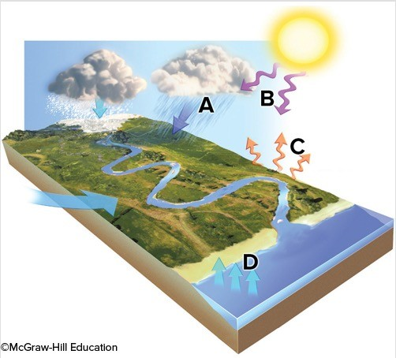
A) A
B) B
C) C
D) D

Answer: C
Section: 01.04
Topic: Atmosphere
Bloom's: 2. Understand
Gradable: automatic
Accessibility: Keyboard Navigation

45) Which arrow(s) in this figure indicate(s) evaporation?

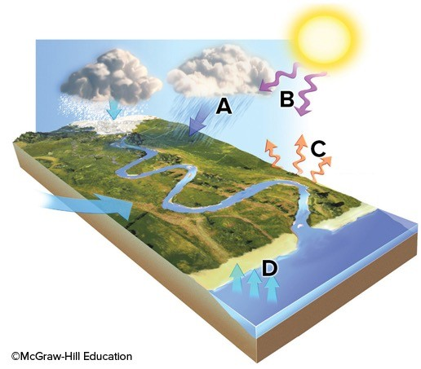
A) A
B) B
C) C
D) D

Answer: D
Section: 01.04
Topic: Atmosphere; Water Resources
Bloom's: 2. Understand
Gradable: automatic
Accessibility: Keyboard Navigation

46) Which arrow(s) in this figure indicate(s) ultraviolet energy, an external energy source?

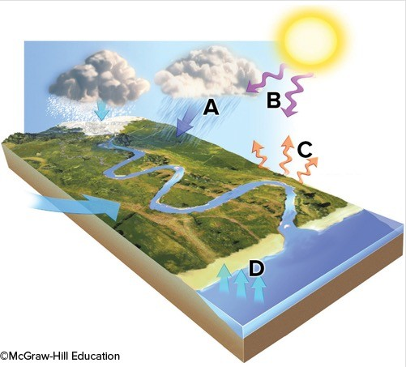
A) A
B) B
C) C
D) D

Answer: B
Section: 01.04
Topic: Atmosphere
Bloom's: 2. Understand
Gradable: automatic
Accessibility: Keyboard Navigation

47) Which of the following are ways that the atmosphere interacts with Earth's surface?
A) Liquid water on the surface can evaporate, becoming water vapor in the atmosphere.
B) The atmosphere includes a low percentage of water vapor, most of which comes from the oceans.
C) Earth's atmosphere blocks most of the Sun's harmful ultraviolet radiation.
D) Some energy that strikes the Earth is converted into infrared energy.
E) All of these choices are correct.

Answer: E
Section: 01.04
Topic: Atmosphere
Bloom's: 2. Understand
Gradable: automatic
Accessibility: Keyboard Navigation

48) What happens to material that is hotter than its surrounding material deep within the Earth?
A) The hot material slowly moves up toward the surface.
B) The hot material moves slowly down toward the core.
C) Nothing. The hot material doesn't move at all.

Answer: A
Section: 01.04
Topic: Earth's Interior
Bloom's: 2. Understand
Gradable: automatic
Accessibility: Keyboard Navigation

49) Radioactive decay in the Earth, especially in the Earth's crust, creates a tremendous amount of
A) pressure.
B) heat.

Answer: B
Section: 01.04
Topic: Earth's Interior
Bloom's: 2. Understand
Gradable: automatic
Accessibility: Keyboard Navigation

50) Radioactive decay within the Earth produces heat; the other form of heat produced by the Earth comes from
A) heat trapped when the Earth was formed.
B) solar radiation trapped in the rock on the Earth's surface.
C) heat produced by air as it moves across the oceans.

Answer: A
Section: 01.04
Topic: Earth's Interior
Bloom's: 1. Remember
Gradable: automatic
Accessibility: Keyboard Navigation

51) Which of the following locations would contain a wide variety of sediment, from large, angular blocks to fine rock powder, produced from grinding of the rocks?

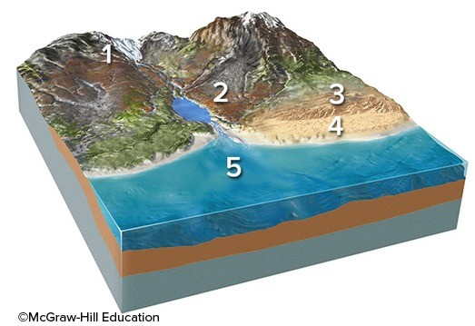

A) Location 1, along the margins of a glacier
B) Location 2, along a steep mountain front
C) Location 3, in sand dunes
D) Location 4, along a beach
E) Location 5, on a relatively deep sea floor

Answer: A
Section: 01.05
Topic: Rocks
Bloom's: 3. Apply
Gradable: automatic
Accessibility: Keyboard Navigation

52) Which of the following locations would contain large, angular rocks that broke away from bedrock and moved downhill?

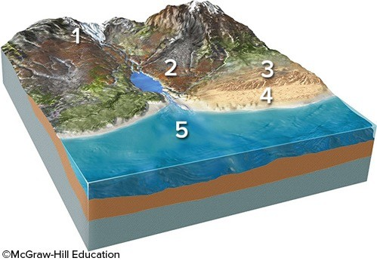

A) Location 1, along the margins of a glacier
B) Location 2, along a steep mountain front
C) Location 3, in sand dunes
D) Location 4, along a beach
E) Location 5, on a relatively deep sea floor

Answer: B
Section: 01.05
Topic: Rocks
Bloom's: 3. Apply
Gradable: automatic
Accessibility: Keyboard Navigation

53) Which of the following locations would contain sand, rounded stones, and broken shells?

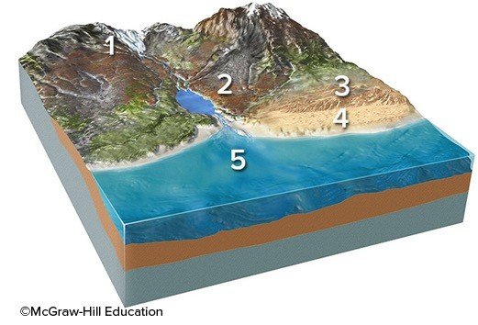

A) Location 1, along the margins of a glacier
B) Location 2, along a steep mountain front
C) Location 3, in sand dunes
D) Location 4, along a beach
E) Location 5, on a relatively deep sea floor

Answer: D
Section: 01.05
Topic: Rocks
Bloom's: 3. Apply
Gradable: automatic
Accessibility: Keyboard Navigation

54) Which of the following locations would contain mud and the remains of small creatures?

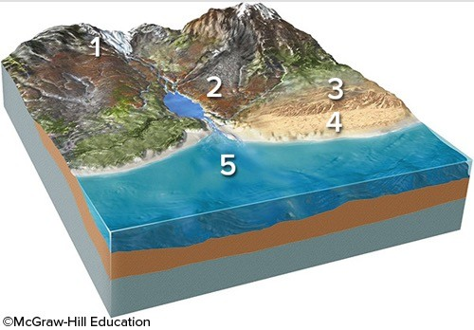

A) Location 1, along the margins of a glacier
B) Location 2, along a steep mountain front
C) Location 3, in sand dunes
D) Location 4, along a beach
E) Location 5, on a relatively deep sea floor

Answer: E
Section: 01.05
Topic: Rocks
Bloom's: 3. Apply
Gradable: automatic
Accessibility: Keyboard Navigation

55) Which of the following locations would most likely contain large, angular rocks?

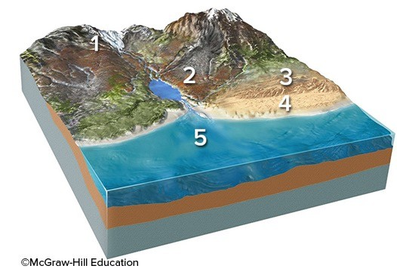

A) Location 1, along the margins of a glacier
B) Location 2, along a steep mountain front
C) Location 3, in sand dunes
D) Locations 1 and 2
E) Locations 2 and 3

Answer: D
Section: 01.05
Topic: Rocks
Bloom's: 3. Apply
Gradable: automatic
Accessibility: Keyboard Navigation

56) Which of the following locations would most likely contain a high percentage of sand?

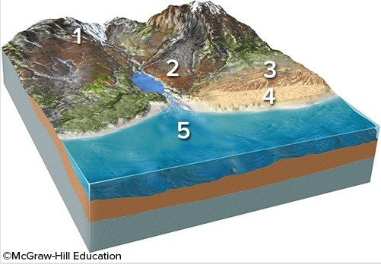

A) Location 2, along a steep mountain front
B) Location 3, in sand dunes
C) Location 4, along a beach
D) Locations 2 and 3
E) Locations 3 and 4

Answer: E
Section: 01.05
Topic: Rocks
Bloom's: 3. Apply
Gradable: automatic
Accessibility: Keyboard Navigation

57) Which of the following surface environments is the most likely site for deposits in this photograph?

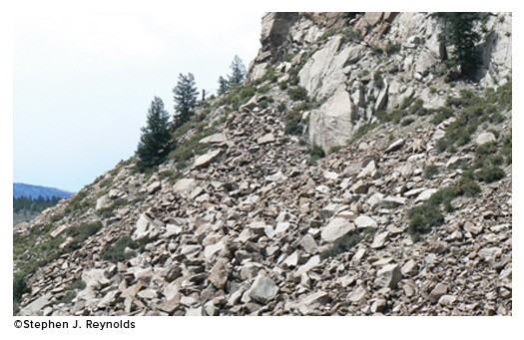

A) Steep mountain front
B) River channel
C) Sand dunes
D) Beach
E) Lake

Answer: A
Section: 01.05
Topic: Rocks
Bloom's: 3. Apply
Gradable: automatic
Accessibility: Keyboard Navigation

58) Which of the following surface environments is the most likely site for deposits in this photograph?

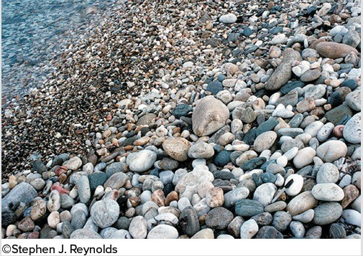

A) Steep mountain front
B) Glacier
C) Sand dunes
D) Beach
E) Lake

Answer: D
Section: 01.05
Topic: Rocks
Bloom's: 3. Apply
Gradable: automatic
Accessibility: Keyboard Navigation

59) What type of rock would the materials shown in this photograph produce?

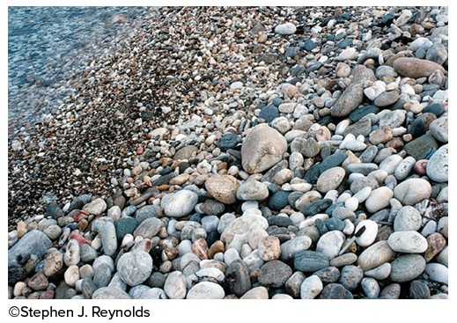

A) Sedimentary
B) Igneous
C) Metamorphic
D) Hydrothermal

Answer: A
Section: 01.05
Topic: Rocks
Bloom's: 3. Apply
Gradable: automatic
Accessibility: Keyboard Navigation

60) Which of the following locations would form an igneous rock?

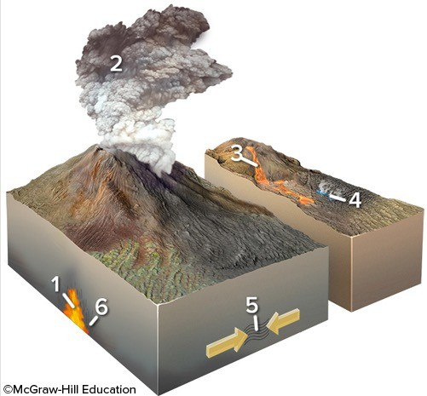

A) Locations 1 and 2
B) Locations 2 and 3
C) Locations 3 and 4
D) Locations 1, 2, and 3
E) Locations 5 and 6

Answer: D
Section: 01.05
Topic: Rocks
Bloom's: 2. Understand
Gradable: automatic
Accessibility: Keyboard Navigation

61) Which of the following locations would form a metamorphic rock?

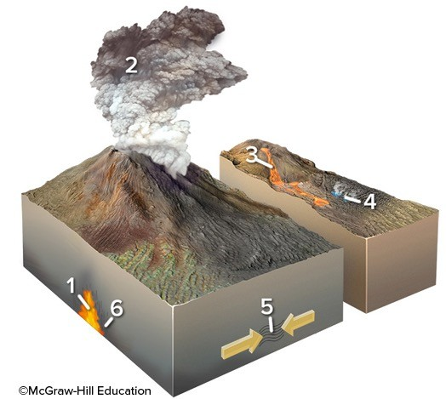

A) Locations 1 and 2
B) Locations 2 and 3
C) Locations 3 and 4
D) Locations 1, 2, and 3
E) Locations 5 and 6

Answer: E
Section: 01.05
Topic: Rocks
Bloom's: 2. Understand
Gradable: automatic
Accessibility: Keyboard Navigation

62) Which of the following locations would form a hydrothermal rock?

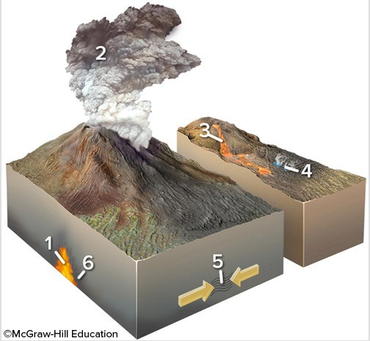

A) Location 1
B) Location 2
C) Location 3
D) Location 4
E) Locations 2 and 3

Answer: D
Section: 01.05
Topic: Rocks
Bloom's: 2. Understand
Gradable: automatic
Accessibility: Keyboard Navigation

63) Which of the following is NOT a typical environment in which a metamorphic rock forms?
A) Solidification of lava
B) Heating adjacent to underground magma
C) Squeezing by tectonic forces
D) Burial to great depths

Answer: A
Section: 01.05
Topic: Rocks
Bloom's: 3. Apply
Gradable: automatic
Accessibility: Keyboard Navigation

64) Which of the following is NOT one of the main families of rocks?
A) Sedimentary
B) Igneous
C) Metamorphic
D) Meteorites

Answer: D
Section: 01.05
Topic: Rocks
Bloom's: 1. Remember
Gradable: automatic
Accessibility: Keyboard Navigation

65) Which of the following is NOT a typical environment in which a sedimentary rock forms?
A) Beside glaciers
B) River channels
C) Heating next to a magma
D) Deep sea floor
E) Shoreline of a lake

Answer: C
Section: 01.05
Topic: Rocks
Bloom's: 2. Understand
Gradable: automatic
Accessibility: Keyboard Navigation

66) Which of the following is NOT an environment in which an igneous rock forms?
A) Explosive eruption of volcanic ash
B) Cooling and solidification of lava
C) Solidification of magma at depth
D) Intense squeezing from tectonic forces
E) All of these are environments that form igneous rock.

Answer: D
Section: 01.05
Topic: Rocks
Bloom's: 2. Understand
Gradable: automatic
Accessibility: Keyboard Navigation

67) Rock that has formed from cooling magma or lava is
A) igneous rock.
B) metamorphic rock.
C) sedimentary rock.

Answer: A
Section: 01.05
Topic: Rocks
Bloom's: 1. Remember
Gradable: automatic
Accessibility: Keyboard Navigation

68) Heat, pressure, and deformation are processes that can create
A) metamorphic rocks.
B) igneous rocks.
C) sedimentary rocks.

Answer: A
Section: 01.05
Topic: Rocks
Bloom's: 2. Understand
Gradable: automatic
Accessibility: Keyboard Navigation

69) A type of rock that forms directly from precipitates of hot water is called a(n)
A) hydrothermal rock.
B) sedimentary rock.
C) igneous rock.

Answer: A
Section: 01.05
Topic: Rocks
Bloom's: 2. Understand
Gradable: automatic
Accessibility: Keyboard Navigation

70) Lava is molten rock that cools
A) on the surface.
B) underground.

Answer: A
Section: 01.05
Topic: Rocks
Bloom's: 1. Remember
Gradable: automatic
Accessibility: Keyboard Navigation

71) Which of the following locations would have weathering of bedrock or loose sediment?

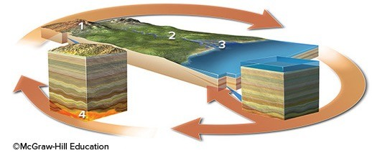

A) Location 1
B) Location 2
C) Location 3
D) Location 4
E) Locations 1 and 2

Answer: E
Section: 01.06
Topic: Rocks
Bloom's: 2. Understand
Gradable: automatic
Accessibility: Keyboard Navigation

72) Which of the following best indicates a location where sediment is transported?

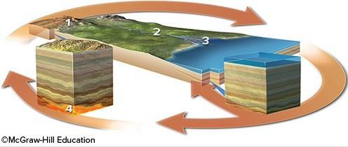

A) Location 1
B) Location 2
C) Location 3
D) Location 4

Answer: B
Section: 01.06
Topic: Soils
Bloom's: 2. Understand
Gradable: automatic
Accessibility: Keyboard Navigation

73) Which of the following best indicates a location where sediment is deposited but not eroded?

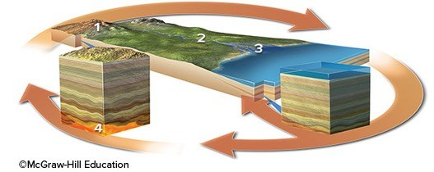

A) Location 1
B) Location 2
C) Location 3
D) Location 4

Answer: C
Section: 01.06
Topic: Soils
Bloom's: 2. Understand
Gradable: automatic
Accessibility: Keyboard Navigation

74) Which of the following settings would result in the formation of igneous rocks?

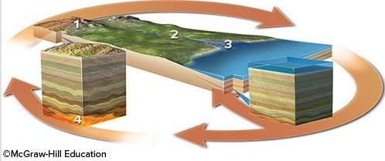

A) Location 1
B) Location 2
C) Location 3
D) Location 4

Answer: D
Section: 01.06
Topic: Rocks
Bloom's: 2. Understand
Gradable: automatic
Accessibility: Keyboard Navigation

75) Which of the following does NOT list processes in an order consistent with a logical progression through the rock cycle?
A) Weathering, erosion, deposition
B) Solidification, melting, burial
C) Erosion, deposition, burial
D) Uplift, weathering, erosion
E) Burial, metamorphism, melting

Answer: B
Section: 01.06
Topic: Rocks
Bloom's: 4. Analyze
Gradable: automatic
Accessibility: Keyboard Navigation

76) According to the rock cycle, sediment that is being transported by a river could become a metamorphic rock after
A) uplift and weathering.
B) melting and solidification.
C) deposition and burial.
D) solidification and uplift.

Answer: C
Section: 01.06
Topic: Rocks
Bloom's: 4. Analyze
Gradable: automatic
Accessibility: Keyboard Navigation

77) Uplift can occur during the rock cycle
A) only after deformation and metamorphism.
B) only after melting and solidification.
C) only after metamorphism or solidification.
D) at any point after burial.

Answer: D
Section: 01.06
Topic: Rocks
Bloom's: 4. Analyze
Gradable: automatic
Accessibility: Keyboard Navigation

78) The rock cycle shows that rock is transformed after partial melting during metamorphism into
A) magma.
B) sediment.
C) igneous rock.

Answer: A
Section: 01.06
Topic: Rocks
Bloom's: 1. Remember
Gradable: automatic
Accessibility: Keyboard Navigation

79) If rock is exposed to enough heat after metamorphism it will eventually
A) melt into magma.
B) crystallize into magma.
C) weather into magma.
D) solidify into magma.

Answer: A
Section: 01.06
Topic: Rocks
Bloom's: 2. Understand
Gradable: automatic
Accessibility: Keyboard Navigation

80) Magma is molten rock that occurs
A) on the surface.
B) underground.

Answer: B
Section: 01.06
Topic: Rocks
Bloom's: 1. Remember
Gradable: automatic
Accessibility: Keyboard Navigation

81) Choose the answer that best explains why a rock might not go through the complete rock cycle.
A) The exposed rock may never weather, thus never enter the rock cycle again.
B) Rock may be involved in a variety of processes in different sequences.
C) Some rocks are forever trapped in the magma of the Earth.

Answer: B
Section: 01.06
Topic: Rocks
Bloom's: 1. Remember
Gradable: automatic
Accessibility: Keyboard Navigation

82) The rock cycle was conceived by James Hutton in an attempt to explain how
A) older rocks become new sediment.
B) the Earth was formed.
C) sedimentary rocks are formed deep within Earth.
D) metamorphism occurs in surface environments.

Answer: A
Section: 01.06
Topic: Rocks
Bloom's: 1. Remember
Gradable: automatic
Accessibility: Keyboard Navigation

83) Name the cycle that describes water processes that occur on land, in the atmosphere, and in the oceans.
A) Hydrologic
B) Rock
C) Spin
D) Life

Answer: A
Section: 01.06
Topic: Water Resources
Bloom's: 1. Remember
Gradable: automatic
Accessibility: Keyboard Navigation

84) Which of the following is NOT true about how water moves on our planet?
A) Rainfall can coat rocks and soil with a thin film of water, helping them to weather.
B) Moving water and its sediment can erode into solid rock, sculpting Earth's surface.
C) Groundwater typically rises towards higher areas where it emerges as springs.
D) Wind causes waves in the oceans and helps guide ocean currents.
E) Glaciers can transport sediment and carve the underlying landscape.

Answer: C
Section: 01.07
Topic: Water Resources
Bloom's: 3. Apply
Gradable: automatic
Accessibility: Keyboard Navigation

85) Of Earth's four overlapping spheres, which of the following does NOT involve material above Earth's surface?
A) Atmosphere
B) Lithosphere
C) Biosphere
D) Hydrosphere

Answer: B
Section: 01.07
Topic: Earth's Interior
Bloom's: 4. Analyze
Gradable: automatic
Accessibility: Keyboard Navigation

86) Of Earth's four overlapping spheres, which of the following is (are) mostly between the lithosphere and atmosphere?
A) Atmosphere
B) Lithosphere
C) Biosphere
D) Hydrosphere
E) Both the biosphere and hydrosphere

Answer: E
Section: 01.07
Topic: Water Resources
Bloom's: 4. Analyze
Gradable: automatic
Accessibility: Keyboard Navigation

87) The uppermost part of the oceans, as expressed by normal ocean waves, are in constant motion due to the effects of the
A) wind.
B) ultraviolet radiation.
C) gravity.
D) tides.

Answer: A
Section: 01.07
Topic: Water Resources
Bloom's: 2. Understand
Gradable: automatic
Accessibility: Keyboard Navigation

88) The most important agent for sculpting the landscape is

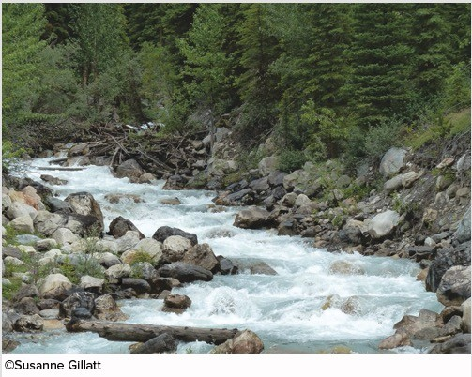

A) flowing water.
B) blowing wind.
C) gravity.
D) wave action.

Answer: A
Section: 01.07
Topic: Streams and Floods
Bloom's: 1. Remember
Gradable: automatic
Accessibility: Keyboard Navigation

89) What system is comprised of the Sun, planets, their moons, and other bodies that orbit the Sun?
A) Solar system
B) Planetary system
C) Galactic system
D) Ecosystem

Answer: A
Section: 01.07
Topic: Earth and Space
Bloom's: 1. Remember
Gradable: automatic
Accessibility: Keyboard Navigation

90) Compared to the outer planets in our solar system, the inner planets
A) are larger.
B) contain more gas.
C) are rocky and so are called terrestrial planets.
D) have better developed planetary rings.
E) None of these choices are correct.

Answer: C
Section: 01.08
Topic: Earth and Space
Bloom's: 1. Remember; 2. Understand
Gradable: automatic
Accessibility: Keyboard Navigation

91) The largest object in the solar system is
A) Earth.
B) the Earth's moon.
C) Saturn.
D) Jupiter.
E) the Sun.

Answer: E
Section: 01.08
Topic: Earth and Space
Bloom's: 1. Remember; 2. Understand
Gradable: automatic
Accessibility: Keyboard Navigation

92) Which of the following is considered one of the outer planets?
A) Mars
B) Jupiter
C) Venus
D) Moon
E) None of these choices are correct.

Answer: B
Section: 01.08
Topic: Earth and Space
Bloom's: 1. Remember
Gradable: automatic
Accessibility: Keyboard Navigation

93) The closest object to the Earth is
A) the moon.
B) the Sun.
C) Venus.
D) Mars.

Answer: A
Section: 01.08
Topic: Earth and Space
Bloom's: 1. Remember
Gradable: automatic
Accessibility: Keyboard Navigation

94) The Moon and Sun cause the tides in Earth's oceans because of
A) gravity.
B) heat.
C) magnetic pull.

Answer: A
Section: 01.08
Topic: Earth and Space
Bloom's: 2. Understand
Gradable: automatic
Accessibility: Keyboard Navigation

95) In a process called nuclear fusion, what is the most common type of atoms joined together?
A) Oxygen
B) Nitrogen
C) Carbon
D) Hydrogen

Answer: D
Section: 01.08
Topic: Rocks
Bloom's: 1. Remember
Gradable: automatic
Accessibility: Keyboard Navigation

96) Rocky fragments left over from the formation of the solar system are called
A) asteroids.
B) plutoids.
C) galaxies.

Answer: A
Section: 01.08
Topic: Earth and Space
Bloom's: 1. Remember
Gradable: automatic
Accessibility: Keyboard Navigation

97) The Earth's orbit around the Sun is almost circular. Therefore, Earth receives about the same amount of year-round
A) heat and light.
B) heat and precipitation.
C) light and precipitation.

Answer: A
Section: 01.08
Topic: Earth and Space
Bloom's: 2. Understand
Gradable: automatic
Accessibility: Keyboard Navigation

98) Which of the following is a way that geology influences Rapid City and areas of the Black Hills, either presently or in the past?
A) Flooding along creeks that drain the Black Hills
B) Tilted rock layers that control the steepness of slopes
C) Tourism from presidents' faces chiseled into granite
D) Large gold deposits
E) All of these choices are correct.

Answer: E
Section: 01.09
Topic: Study of Geology
Bloom's: 1. Remember
Gradable: automatic
Accessibility: Keyboard Navigation

99) The main cause of the Rapid City flood of 1972 was
A) rapid melting of glaciers in the Black Hills because of global warming.
B) failure of a dam because of a large landslide into the reservoir.
C) poor design and poor construction of a large concrete dam.
D) intense rainfall from a thunderstorm that resulted in a flash flood.
E) All of these choices are correct.

Answer: D
Section: 01.09
Topic: Streams and Floods
Bloom's: 1. Remember
Gradable: automatic
Accessibility: Keyboard Navigation

100) Mt. Rushmore is composed of which type of rock?
A) Granite
B) Sandstone
C) Magma
D) Basalt

Answer: A
Section: 01.09
Topic: Rocks
Bloom's: 1. Remember
Gradable: automatic
Accessibility: Keyboard Navigation

101) Devils Tower was formed by
A) solidification of a magma chamber.
B) sedimentation from river deposits.
C) accumulations of windblown sand.

Answer: A
Section: 01.09
Topic: Rocks
Bloom's: 1. Remember
Gradable: automatic
Accessibility: Keyboard Navigation

102) Which of the following geologic hazards was NOT discussed for the area around St. George, Utah?
A) Volcanic eruptions
B) Earthquakes from a fault along the Hurricane cliffs
C) Flooding from the main river
D) Flash flooding from the mountains
E) All of these choices were discussed.

Answer: E
Section: 01.10
Topic: Geology and the Human Environment
Bloom's: 1. Remember
Gradable: automatic
Accessibility: Keyboard Navigation

103) Which of the features labeled on this figure was discussed as a possible source of earthquakes?

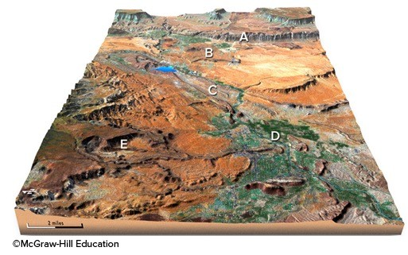
A) The cliff at A
B) The volcano at B
C) Pumping of the oil field at C
D) Shaking during large floods at D
E) Landslides off the mountains at E

Answer: A
Section: 01.10
Topic: Earthquakes
Bloom's: 1. Remember
Gradable: automatic
Accessibility: Keyboard Navigation

104) Which of the following geologic resources was discussed for the area around St. George, Utah?
A) Oil field
B) Floodplains with fertile soils
C) A large cement plant
D) All of these choices are correct.
E) Both oil fields and flood plains with fertile soil

Answer: E
Section: 01.10
Topic: Geology and the Human Environment
Bloom's: 1. Remember
Gradable: automatic
Accessibility: Keyboard Navigation

105) A dry climate might impact how people live by increasing
A) the risk of drought and other water shortages.
B) irrigation needs.
C) the likelihood of volcanic activity.
D) the likelihood of earthquakes.
E) both the risk of drought and other water shortages and irrigation needs.

Answer: E
Section: 01.10
Topic: Water Resources
Bloom's: 3. Apply
Gradable: automatic
Accessibility: Keyboard Navigation

106) Choose the appropriate way that steep cliffs might impact people living nearby.
A) Easy to build houses on steep cliffs
B) Favorable location for livestock grazing
C) Increases area available to grow crops
D) Increases landslide hazard

Answer: D
Section: 01.10
Topic: Geology and the Human Environment
Bloom's: 3. Apply
Gradable: automatic
Accessibility: Keyboard Navigation

107) Rainfall in mountain ranges might impact people living nearby by
A) increasing erosion in mountains.
B) increasing flooding hazards.
C) increasing mudslide hazards.
D) water flowing into streams and rivers, increasing water supply.
E) All of these choices are correct.

Answer: E
Section: 01.10
Topic: Water Resources
Bloom's: 3. Apply
Gradable: automatic
Accessibility: Keyboard Navigation

108) Choose the appropriate way that hot springs might impact people living nearby.
A) Provides geothermal power
B) Enables easy transportation of goods
C) Increases likelihood of earthquakes

Answer: A
Section: 01.10
Topic: Alternative Energy Resources
Bloom's: 3. Apply
Gradable: automatic
Accessibility: Keyboard Navigation

109) Choose the appropriate way that volcanoes might impact people living nearby.
A) Releases steam and noxious gases into the atmosphere
B) Volcanic ash provides fertile sediment for growing crops
C) Ash ejected into the atmosphere blocks sunlight
D) Projectiles thrown into the air can hit your house
E) All of these choices impact people living nearby.

Answer: E
Section: 01.10
Topic: Volcanoes
Bloom's: 3. Apply
Gradable: automatic
Accessibility: Keyboard Navigation

110) Which of the following is NOT a way that an oil field might impact people living nearby?
A) Increasing job opportunities
B) Improving the local economy
C) Increasing likelihood of volcanic eruptions
D) Increasing likelihood of an oil spill

Answer: C
Section: 01.10
Topic: Geology and the Human Environment
Bloom's: 3. Apply
Gradable: automatic
Accessibility: Keyboard Navigation

