1. ​Use back-substitution to solve the system of linear equations.
​
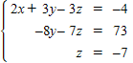
​
 | a. | ​
 | b. | ​
 | c. | ​
 | d. | ​
 | e. | ​

ANSWER: | b
POINTS: | 1
QUESTION TYPE: | Multiple Choice
HAS VARIABLES: | True
DATE CREATED: | 1/21/2016 10:51 AM
DATE MODIFIED: | 1/21/2016 10:51 AM

2. ​Solve the system of equations by using graphical methods.
​
​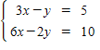
​
 | a. | ​
 | b. | ​
 | c. | ​
 | d. | ​
 | e. | ​There are infinitely many solutions.

ANSWER: | e
POINTS: | 1
QUESTION TYPE: | Multiple Choice
HAS VARIABLES: | True
DATE CREATED: | 1/21/2016 10:51 AM
DATE MODIFIED: | 1/21/2016 10:51 AM

3. ​Solve the system of equations by using graphical methods.
​
​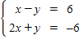
​
 | a. | ​
 | b. | ​
 | c. | ​
 | d. | ​
 | e. | ​There is no solution to the equations.

ANSWER: | a
POINTS: | 1
QUESTION TYPE: | Multiple Choice
HAS VARIABLES: | True
DATE CREATED: | 1/21/2016 10:51 AM
DATE MODIFIED: | 1/21/2016 10:51 AM

4. ​Solve using any method.
​
​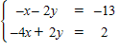
​
 | a. | ​
 | b. | ​
 | c. | ​
 | d. | ​, where a is any real number
 | e. | ​inconsistent

ANSWER: | a
POINTS: | 1
QUESTION TYPE: | Multiple Choice
HAS VARIABLES: | True
DATE CREATED: | 1/21/2016 10:51 AM
DATE MODIFIED: | 1/21/2016 10:51 AM

5. Solve the system.
​
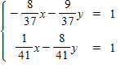
​
 | a. | ​
 | b. | ​
 | c. | ​
 | d. | ​
 | e. | ​

ANSWER: | a
POINTS: | 1
QUESTION TYPE: | Multiple Choice
HAS VARIABLES: | True
DATE CREATED: | 1/21/2016 10:51 AM
DATE MODIFIED: | 1/21/2016 10:51 AM

6. ​Solve the system of linear equations.
​
​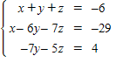
​
 | a. | ​
 | b. | ​
 | c. | ​
 | d. | ​
 | e. | ​

ANSWER: | c
POINTS: | 1
QUESTION TYPE: | Multiple Choice
HAS VARIABLES: | True
DATE CREATED: | 1/21/2016 10:51 AM
DATE MODIFIED: | 1/21/2016 10:51 AM

7. ​Solve the system of linear equations.
​
​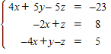

 | a. | ​
 | b. | ​
 | c. | ​
 | d. | ​
 | e. | ​

ANSWER: | b
POINTS: | 1
QUESTION TYPE: | Multiple Choice
HAS VARIABLES: | True
DATE CREATED: | 1/21/2016 10:51 AM
DATE MODIFIED: | 1/21/2016 10:51 AM

8. ​Solve the system of linear equations.
​
​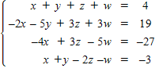
​
 | a. | ​
 | b. | ​
 | c. | ​
 | d. | ​
 | e. | ​

ANSWER: | b
POINTS: | 1
QUESTION TYPE: | Multiple Choice
HAS VARIABLES: | True
DATE CREATED: | 1/21/2016 10:51 AM
DATE MODIFIED: | 1/21/2016 10:51 AM

9. ​Determine whether the matrix is in row-echelon form. If it is, determine if it is also in reduced row-echelon form.
​
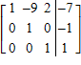
​
 | a. | ​row-echelon form
 | b. | ​row-echelon form and reduced row-echelon form
 | c. | ​neither

ANSWER: | a
POINTS: | 1
QUESTION TYPE: | Multiple Choice
HAS VARIABLES: | True
DATE CREATED: | 1/21/2016 10:51 AM
DATE MODIFIED: | 1/21/2016 10:51 AM

10. ​Find the solution set of the system of linear equations in the variables x and y (in that order) that has the following augmented matrix.
​
​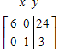
​
 | a. | ​
 | b. | ​
 | c. | ​
 | d. | ​
 | e. | ​

ANSWER: | b
POINTS: | 1
QUESTION TYPE: | Multiple Choice
HAS VARIABLES: | True
DATE CREATED: | 1/21/2016 10:51 AM
DATE MODIFIED: | 1/21/2016 10:51 AM

11. ​Write the system of linear equations represented by the augmented matrix. Then use back-substitution to solve. (Use variables x, y, and z.)
​
​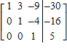
​
 | a. | ​
 | b. | ​
 | c. | ​
 | d. | ​
 | e. | ​

ANSWER: | a
POINTS: | 1
QUESTION TYPE: | Multiple Choice
HAS VARIABLES: | True
DATE CREATED: | 1/21/2016 10:51 AM
DATE MODIFIED: | 1/21/2016 10:51 AM

12. ​The given matrix is an augmented matrix representing a system of linear equations. Find the solution of the system.
​
​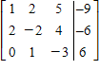
​
 | a. | ​
 | b. | ​
 | c. | ​
 | d. | ​
 | e. | ​

ANSWER: | e
POINTS: | 1
QUESTION TYPE: | Multiple Choice
HAS VARIABLES: | True
DATE CREATED: | 1/21/2016 10:51 AM
DATE MODIFIED: | 1/21/2016 10:51 AM

13. ​Use matrices to solve the system of equations (if possible). Use Gaussian elimination with back-substitution or Gauss-Jordan elimination.
​
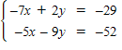​
​
 | a. | ​
 | b. | ​
 | c. | ​
 | d. | ​
 | e. | ​no solution

ANSWER: | b
POINTS: | 1
QUESTION TYPE: | Multiple Choice
HAS VARIABLES: | True
DATE CREATED: | 1/21/2016 10:51 AM
DATE MODIFIED: | 1/21/2016 10:51 AM

14. ​Use Gaussian elimination method to solve the system of linear equations.
​
​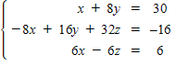
​
 | a. | ​
 | b. | ​
 | c. | ​
 | d. | ​
 | e. | ​inconsistent system

ANSWER: | c
POINTS: | 1
QUESTION TYPE: | Multiple Choice
HAS VARIABLES: | True
DATE CREATED: | 1/21/2016 10:51 AM
DATE MODIFIED: | 1/21/2016 10:51 AM

15. ​Solve the following system using either Gaussian elimination with back-substitution or Gauss-Jordan elimination. If there is no solution, state that the system is inconsistent.
​
​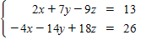
​
 | a. | ​
 | b. | ​
 | c. | ​
 | d. | ​inconsistent system
 | e. | ​

ANSWER: | d
POINTS: | 1
QUESTION TYPE: | Multiple Choice
HAS VARIABLES: | True
DATE CREATED: | 1/21/2016 10:51 AM
DATE MODIFIED: | 1/21/2016 10:51 AM

16. ​Find the equation of the parabola that passes through the points .
​
 | a. | ​
 | b. | ​
 | c. | ​
 | d. | ​
 | e. | ​

ANSWER: | e
POINTS: | 1
QUESTION TYPE: | Multiple Choice
HAS VARIABLES: | False
DATE CREATED: | 1/21/2016 10:51 AM
DATE MODIFIED: | 1/21/2016 10:51 AM

17. Find the equation of the circle
​
that passes through the points .
​
 | a. | ​
 | b. | ​
 | c. | ​
 | d. | ​
 | e. | ​

ANSWER: | a
POINTS: | 1
QUESTION TYPE: | Multiple Choice
HAS VARIABLES: | False
DATE CREATED: | 1/21/2016 10:51 AM
DATE MODIFIED: | 1/21/2016 10:51 AM

18. ​Suppose that the U. S. population for the years 1920, 1930, 1940, and 1950 is shown in the table below. Let x represent the number of decades since 1920. Find a cubic polynomial that fits these data.
​
Year | 1920 | 1930 | 1940 | 1950
Population (in millions) | 101 | 118 | 119 | 122
​
 | a. | ​
 | b. | ​
 | c. | ​
 | d. | ​
 | e. | ​

ANSWER: | b
POINTS: | 1
QUESTION TYPE: | Multiple Choice
HAS VARIABLES: | True
DATE CREATED: | 1/21/2016 10:51 AM
DATE MODIFIED: | 1/21/2016 10:51 AM

19. ​Suppose that the U. S. population for the years 1920, 1930, 1940, and 1950 is shown in the table below. Let x represent the number of decades since 1920. Estimate the population in 1970 by using a cubic polynomial that fits these data.
​
Year | 1920 | 1930 | 1940 | 1950
Population (in millions) | 118 | 138 | 148 | 166
​​
 | a. | ​448 million
 | b. | ​278 million
 | c. | ​236 million
 | d. | ​298 million
 | e. | ​210 million

ANSWER: | d
POINTS: | 1
QUESTION TYPE: | Multiple Choice
HAS VARIABLES: | True
DATE CREATED: | 1/21/2016 10:51 AM
DATE MODIFIED: | 1/21/2016 10:51 AM

20. ​Suppose that the net profit (in millions of dollars) for Microsoft from 2000 to 2007 is shown in the table below.
​
Year | 2000 | 2001 | 2002 | 2003 | 2004 | 2005 | 2006 | 2007
Net Profit | 9,381 | 10,023 | 10,394 | 10,486 | 11,330 | 12,355 | 12,489 | 14,400
​
​A cubic model that matches the data for the years 2001, 2003, 2005, and 2007 is to be determined where x represents the number of years since 2000. Set up a system of equations to solve for the coefficients a₀, a₁, a₂ and a₃.
​
 | a. | ​
 | b. | ​
 | c. | ​
 | d. | ​
 | e. | ​

ANSWER: | c
POINTS: | 1
QUESTION TYPE: | Multiple Choice
HAS VARIABLES: | True
DATE CREATED: | 1/21/2016 10:51 AM
DATE MODIFIED: | 1/21/2016 10:51 AM

21. ​Irrigation. An irrigation system allows water to flow in the pattern shown in the figure below. Water flows into the system at A and exits at B, C, D, and E with the amounts shown. Using the fact that at each point the water entering equals the water leaving, formulate an equation for water flow at each of the five points and solve the system.
​
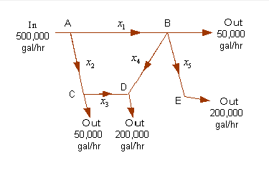
​
 | a. | ​, , , , (in thousands of gallons)
 | b. | ​, , , , (in thousands of gallons)
 | c. | ​, , , , (in thousands of gallons)
 | d. | ​, , , , (in thousands of gallons)
 | e. | ​, , , , (in thousands of gallons)

ANSWER: | e
POINTS: | 1
QUESTION TYPE: | Multiple Choice
HAS VARIABLES: | True
DATE CREATED: | 1/21/2016 10:51 AM
DATE MODIFIED: | 1/21/2016 10:51 AM

22. Traffic flow. In the analysis of traffic flow, a certain city estimates the following situation for the “square” of its downtown district. In the following figure, the arrows indicate the flow of traffic. If x₁ represents the number of cars traveling between intersections A and B, x₂ represents the number of cars traveling between B and C, x₃ the number between C and D, and x₄ the number between D and A, we can formulate equations based on the principle that the number of vehicles entering an intersection equals the number leaving it. That is, for intersection A we obtain​
​
​
Formulate equations for the traffic at B, C, and D. Solve the system of these four equations.
​
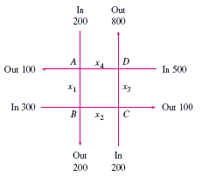
​
 | a. | ​, , ,
 | b. | ​, , ,
 | c. | ​, , ,
 | d. | ​​, , ,
 | e. | ​, , ,

ANSWER: | b
POINTS: | 1
QUESTION TYPE: | Multiple Choice
HAS VARIABLES: | True
DATE CREATED: | 1/21/2016 10:51 AM
DATE MODIFIED: | 1/21/2016 10:51 AM

23. ​Applying Kirchhoff's Laws to the electrical network in the figure, the currents I₁, I₂, and I₃ are the solution of the system
​
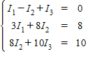
​
volts, volts
Ω, Ω, Ω

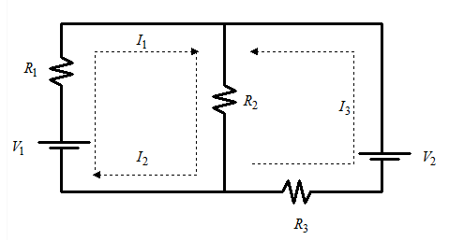​
​

 | a. | ​amperes; amperes; amperes
 | b. | ​amperes; amperes; amperes
 | c. | ​amperes; amperes; amperes
 | d. | ​amperes; amperes; amperes
 | e. | ​amperes; amperes; amperes

ANSWER: | d
POINTS: | 1
QUESTION TYPE: | Multiple Choice
HAS VARIABLES: | True
DATE CREATED: | 1/21/2016 10:51 AM
DATE MODIFIED: | 1/21/2016 10:51 AM

24. ​Write the partial fraction decomposition of the rational expression.
​
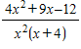
​
 | a. | ​
 | b. | ​
 | c. | ​
 | d. | ​
 | e. | ​

ANSWER: | e
POINTS: | 1
QUESTION TYPE: | Multiple Choice
HAS VARIABLES: | True
DATE CREATED: | 1/21/2016 10:51 AM
DATE MODIFIED: | 1/21/2016 10:51 AM

25. ​Use a system of equations to write the partial fraction decomposition of the rational expression 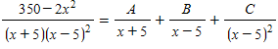. Then solve the system using matrices.
​
 | a. | ​
 | b. | ​
 | c. | ​
 | d. | ​
 | e. | ​

ANSWER: | a
POINTS: | 1
QUESTION TYPE: | Multiple Choice
HAS VARIABLES: | True
DATE CREATED: | 1/21/2016 10:51 AM
DATE MODIFIED: | 1/21/2016 10:51 AM

