CHAPTER 1

Managerial Accounting

ASSIGNMENT CLASSIFICATION TABLE
Study Objectives |  | Self-Study  Questions |  | Do It!  Review |  | Exercises |  | A  Problems |  | B  Problems
*1. Explain the distinguishing features of managerial accounting. |  | 1, 6, 7, 8 |  | 1 |  | 3, 7, 8
*2. Identify the three broad functions of management and the role of management accountants in an organizational structure. |  | 3 |  | 1 |  | 5, 6
*3. Explain the importance of business ethics. |  | 2, 10 |  | 1 |  | 4
*4. Identify changes and trends in managerial accounting. |  | 4, 5, 9 |  | 2 |  | 9

Correlation Chart between Bloom’s Taxonomy, Study Objectives and End-of-Chapter Exercises and Problems

Study Objective | Knowledge | Comprehension |  | Application |  |  | Analysis | Synthesis | Evaluation
* 1. Explain the distinguishing features of managerial accounting. | D-1, E-8 | E-3, E-7
* 2. Identify the three functions of management and the role of management accountants in an organizational structure. | D-1, E-5, E-6
* 3. Explain the importance of business ethics. | D-1, E-4
* 4. Identify changes trends in managerial accounting. | D-2, E-9

A note about the correlation between CPA competencies and the end-of-chapter exercises and problems.

The CPA competencies are divided into enabling competencies and terminal competencies. Unless otherwise specified, the terminal competency being tested by the end-of-chapter material in this course is cpa-t003 (Management Accounting). The enabling competency being tested will differ between questions. The following questions test enabling competency cpa-e001 Professional and Ethical Behaviour:

E1.4,C1.11

© 2018 For Instructor Use Only 1-2

BLOOM’S TAXONOMY TABLE
SOLUTIONS TO DO IT! REVIEW

DO IT! REVIEW 1.1
1. False. Preparation of budgets is part of managerial accounting.
2. False. Financial accounting reports pertain to the entity as a whole and are highly aggregated. It is managerial accounting reports that pertain to subunits of the business and are very detailed.
3. False. Financial accounting must adhere to generally accepted accounting principles and are subject to an audit by chartered professional accountants.
4. True.
5. True.
6. True.

DO IT! REVIEW 1.2
1. (f) Just-in-time (JIT) inventory
2. (a) Activity-based costing (ABC)
3. (c) Total quality management (TQM)
4. (d) Research and development, and product design
5. (e) Service industries
6. (b) Balanced scorecard

SOLUTIONS TO EXERCISES

EXERCISE 1.3

 |  | Financial Accounting |  | Managerial Accounting
Primary users |  | External users |  | Internal users
Types of reports |  | Financial statements |  | Internal reports
Frequency of reports |  | Quarterly and annually |  | As frequently as needed
Purpose of reports |  | General-purpose |  | Special-purpose for specific decisions
Content of reports |  | Highly aggregated  Generally accepted  accounting principles |  | Very detailed  Relevance to decisions
Verification |  | Annual audit by CPA (chartered professional accountant) |  | No independent audits

EXERCISE 1.4

The four specific standards are:
(1) Competence
(2) Confidentiality
(3) Integrity
(4) Credibility

EXERCISE 1.5

(a) (1) Planning
(b) (2) Directing
(c) (3) Controlling

SOLUTIONS TO EXERCISES (Continued)

EXERCISE 1.6

(a) (6) Chief executive officer
(b) (5) Line position
(c) (2) Chief financial officer
(d) (1) Board of directors
(e) (7) Staff position
(f) (4) Controller
(g) (3) Treasurer

EXERCISE 1.7

1. F 6. M
2. M 7. F
3. F 8. F
4. M 9. M
5. F 10. F

EXERCISE 1.8

1. False. Financial accounting focuses on providing information to external users.
2. True.
3. False. Preparation of budgets is part of managerial accounting.
4. False. Managerial accounting applies to service, merchandising, and manufacturing companies.
5. True.
6. False. Managerial accounting reports are prepared as frequently as needed.
7. True.
8. True.
9. False. Financial accounting reports must comply with generally accepted accounting principles.
10. False. Managerial accountants are expected to behave ethically, and there is a code of ethical standards for managerial accountants.

SOLUTIONS TO EXERCISES (Continued)

EXERCISE 1.9

(a) 3. Balanced scorecard
(b) 4. Value chain
(c) 2. Just-in-time inventory
(d) 1. Activity-based costing

SOLUTIONS TO CASES

CASE 1.10

Since the questions were fairly open-ended, the following are only suggested results. The class may be able to think of others, or of more items for each one.

(a) Hayley Geagea Needs information on sales, perhaps by salesperson and by territory
Luc Lemieux Needs cost information for his department
Gary Richardson Needs all accounting information
Manny Cordoza Needs product cost information
Patrick Dumoulin Needs information on component costs and costs for his department
(b) Hayley Geagea Income statement
Luc Lemieux Specialized cost reports
Gary Richardson All
Manny Cordoza Income statement and cost of goods manufactured schedule
Patrick Dumoulin Specialized cost reports
(c) Hayley Geagea Sales by territory—Detailed information, possibly by product line, issued daily or weekly
Luc Lemieux Cost of computer programs—Accumulated cost incurred for each major program used including maintenance and updates of program, issued monthly
Gary Richardson Cost of preparing reports—Detailed analysis of all reports provided, their frequency, time, and estimated cost to prepare, issued monthly
Manny Cordoza Cost of product—Detailed cost by product line, comparing actual with estimated costs, issued as each batch of production is completed
Patrick Dumoulin Cost of product design—Accumulated total costs of each new product, issued at end of each project

SOLUTIONS TO CASES (Continued)

CASE 1.11

(1) It is ethical to use different performance measures to evaluate employees, if and only if, the performance that is being measured is performance that is under the direct control or responsibility of the individual being evaluated. This is not as much an ethics problem as it is a management problem—management is responsible for putting systems in place that are fair to all employees.

(2) First, a company can establish a code of conduct that provides guidelines to employees who are unsure of what should be done in questionable situations. Second, a company can practise transparent reporting—allow all employees to see the financial statements, and encourage them to question what they do not understand, or what they think might not be right.

SOLUTION TO “ALL ABOUT YOU” ACTIVITY

CASE 1.12

Student responses will vary, especially since this is Chapter 1 and they will not have been introduced to more sophisticated accounting and business concepts. We have provided some examples that may represent common responses.

- Students can look in the companies’ annual reports’ financial statements to see amounts of net income.

- Students can look up online the relative cost of living, average housing and rent prices, public transit rates, and other costs for each city.

- Students can look in the companies’ annual reports to see how many years they have been in business, whether profitability has been rising or falling, and management’s discussion of its expectations for the future. They can also look up online to see what the companies’ share prices have been over time.

- Students can look in the companies’ annual reports, websites, and news releases to see the size of their workforce and whether there have been any recent increases or decreases in staffing levels.
SOLUTION TO DECISION-MAKING AT CURRENT DESIGNS

DM1.1

The answers to parts (a) and (b) may vary from student to student.
(a) Mike Cichanowski, CEO, needs to know the overall financial picture of the company. He also needs to have a general picture of sales by territory and product line, and of cost per unit by product line.

Diane Buswell, Controller, needs all accounting-related information.

Deb Welch, Purchasing Manager, needs to know the costs of the components for each product.

Bill Johnson, Sales Manager, needs to know sales by territory and product line.

Dave Thill, Kayak Plant Manager, needs to know all the costs of producing each type of kayak.

Rick Thrune, Production Manager for Composite Kayaks, needs to know the costs related to the composite kayak production.
DM1.1 (Continued)

(b)
Manager | Name of report | Information report would contain | How frequently should it be issued?
Mike Cichanowski | Analysis of proposed new product line | Projected revenues and expenses for a possible new product line | As needed and requested
Diane Buswell | Company-wide budget analysis | Revenues, expenses, and net income compared to the budgeted amounts for each | Monthly
Deb Welch | Purchasing History | List of items purchased and most recent cost for each item | Monthly or available on-line
Bill Johnson | Sales Summary | Sales by product line and by customer | Monthly or weekly
Dave Thill | Cost of Production Report | Direct materials, direct labour, and manufacturing overhead costs assigned to each product line | Monthly or weekly
Rick Thrune | Cost of Production Report for Composite Kayaks | Detailed direct materials, direct labour, and manufacturing overhead costs for the composite kayaks | Weekly

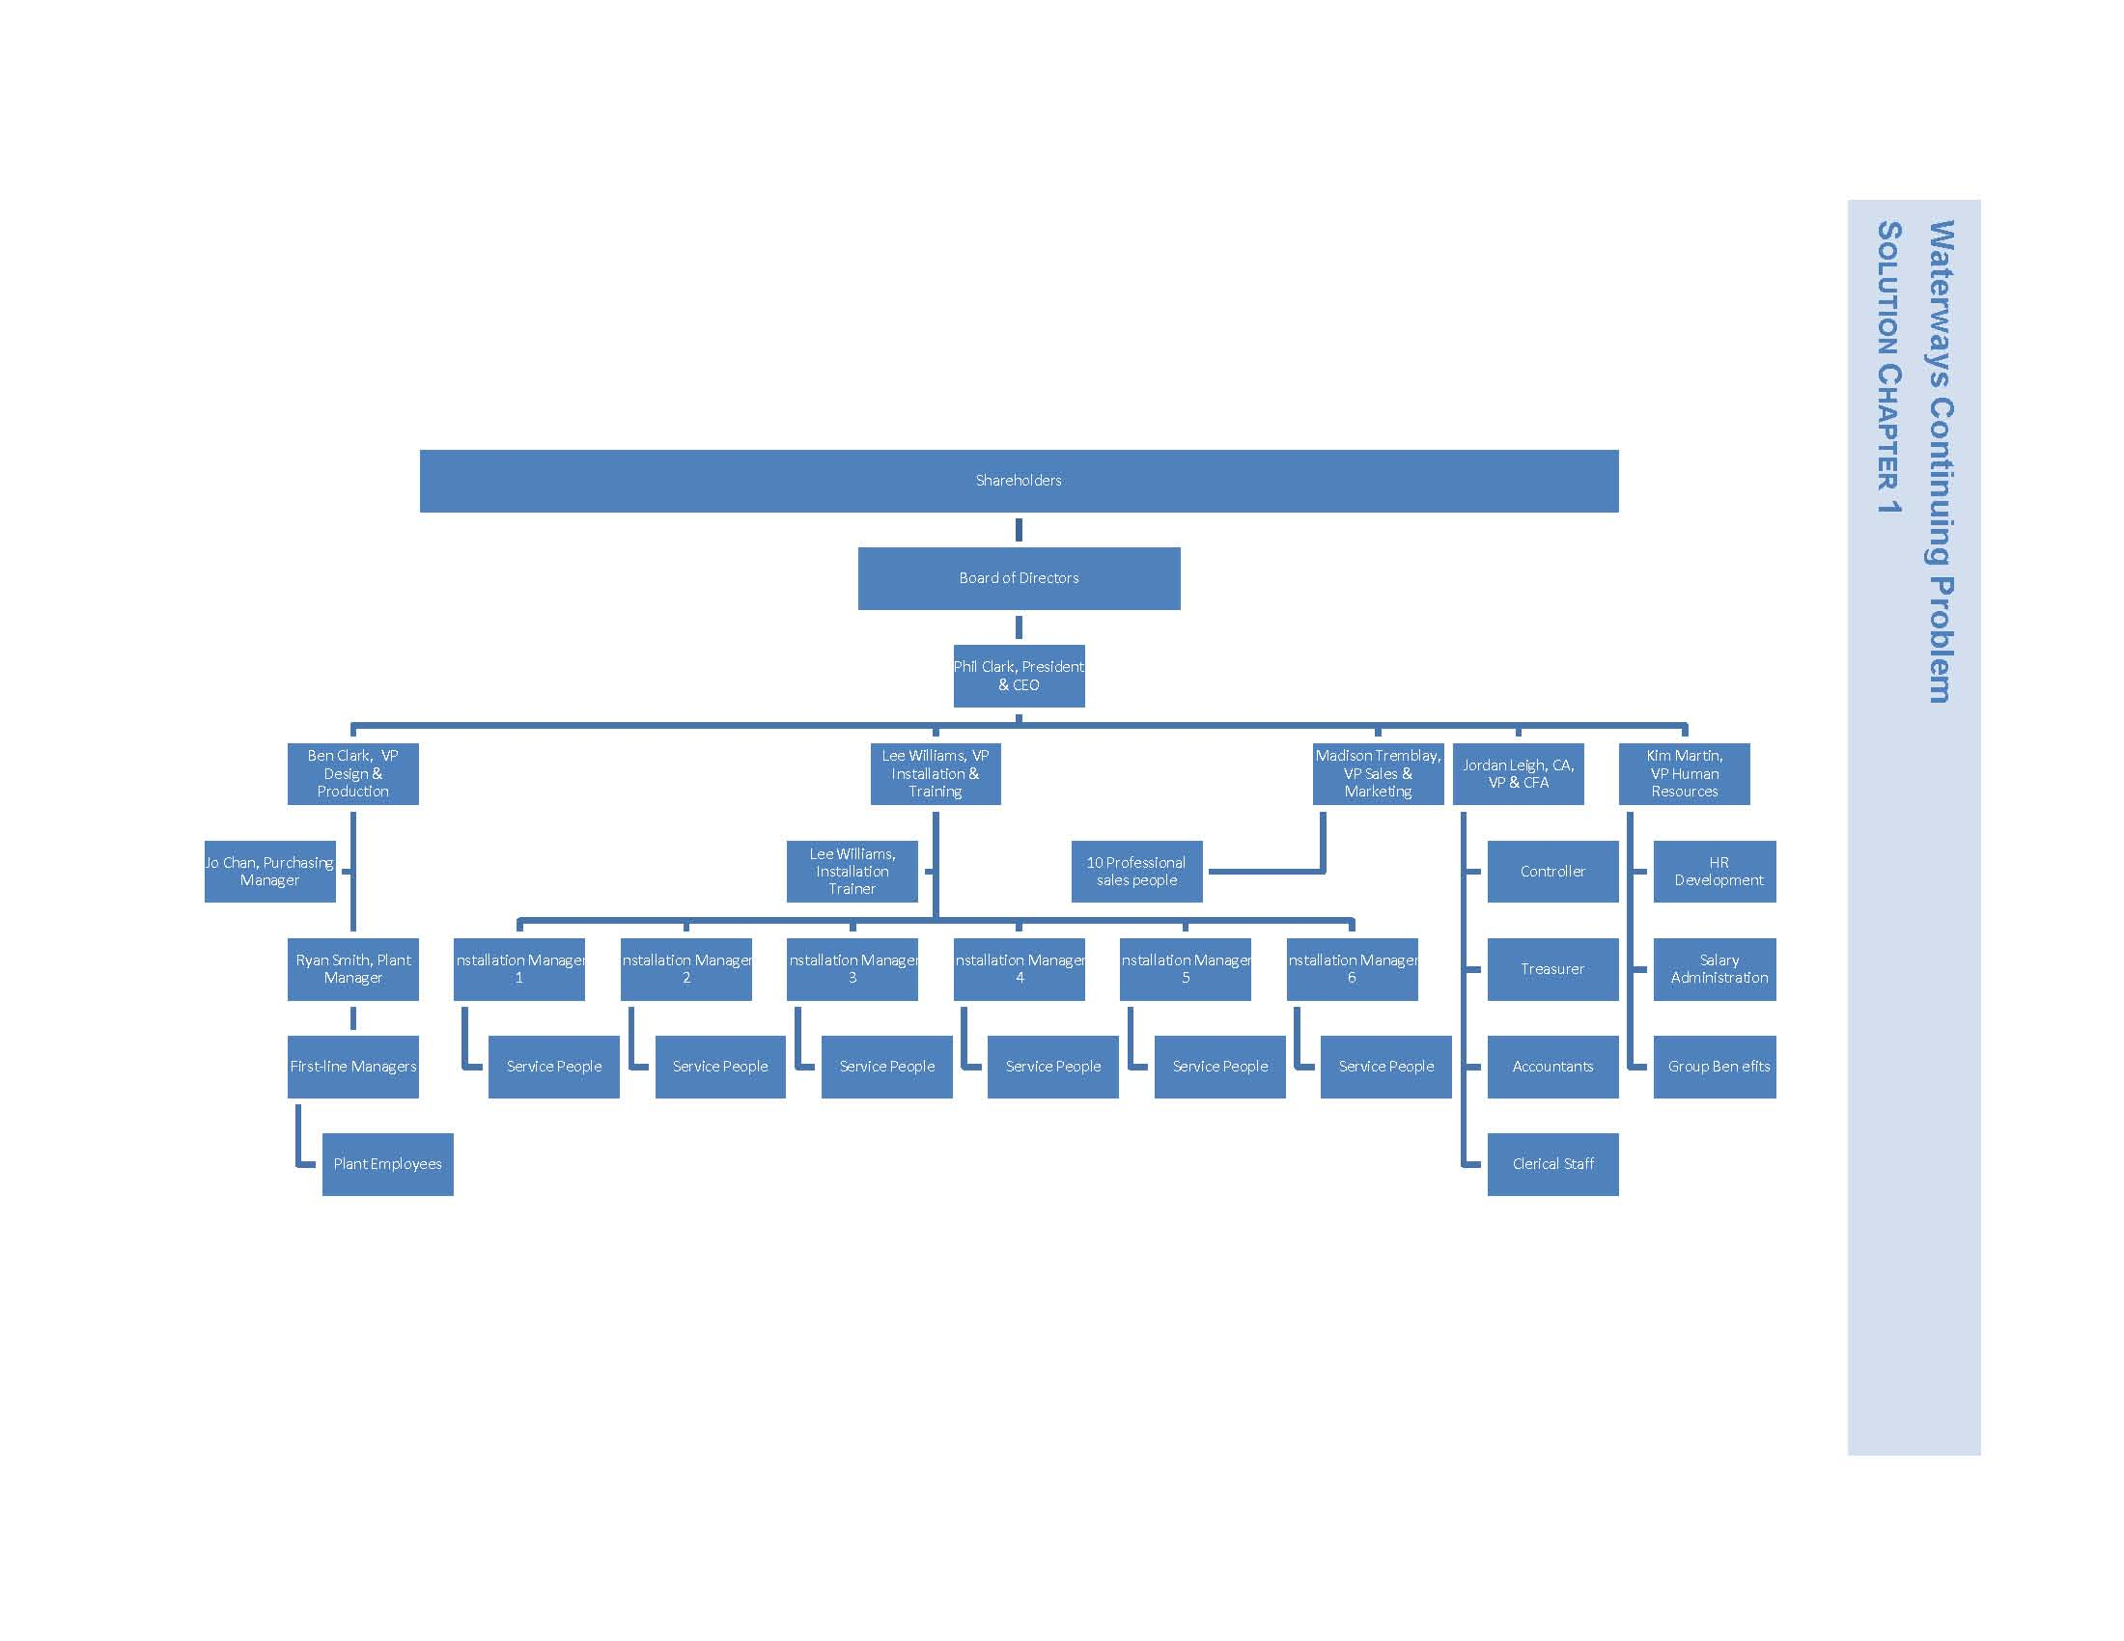
Legal Notice

Copyright

Copyright © 2018 by John Wiley & Sons Canada, Ltd. or related companies. All rights reserved.

The data contained in these files are protected by copyright. This manual is furnished under licence and may be used only in accordance with the terms of such licence.

The material provided herein may not be downloaded, reproduced, stored in a retrieval system, modified, made available on a network, used to create derivative works, or transmitted in any form or by any means, electronic, mechanical, photocopying, recording, scanning, or otherwise without the prior written permission of John Wiley & Sons Canada, Ltd.

MMXVII xii F1

