CHAPTER 1
Limits, Alternatives, and Choices

A. Short-Answer, Essays, and Problems

1. What is a brief definition of economics? What are the conditions that give rise to this definition?

2. What are the three interrelated features of the economic perspective?

3. What do economists mean when they say that “there is no free lunch”? Give another example to which this statement applies.

4. Discuss a time when you experienced a business giving something away for “free.” Was this item really free?

5. (Consider This) Some stores give “free” products to consumer. An economist would say the products are not free. Why the difference?

6. Is rational self-interest the same thing as selfishness? Explain.

7. Use marginal analysis to explain why it is possible to “have too much of a good thing.” Use education as an example.

8. (Consider This) How can the economic perspective help us understand the behavior of fast-food consumers? Explain several insights it provides about customer behavior.

9. Discuss how an economist might use the scientific method to determine the effect of a change in price of pizza on the quantity sold at the student union.

10. The distinguished economist Kenneth Boulding stated: “Theories without facts may be barren, but facts without theories are meaningless.” Explain what he meant.

11. What are the distinctions made in the text among the terms “hypotheses,” “theories,” “laws,” and “principles”?

12. Why are economic theories and principles imprecise? Shouldn’t they apply to everyone?

13. Explain the importance of the ceteris paribus or “other-things-equal” assumption.

14. “Bad theories are abstract and therefore unrealistic; good theories are fully realistic and fit all the facts.” Evaluate.

15. “Gathering economic facts is futile unless accompanied by economic analysis.” Explain.

16. “To be sure, any theoretical model must be abstracted ‘from the richness and complexity of behavior.’ However, abstraction becomes falsification when it so simplifies human behavior as to leave it unrecognizable and unexplained.” Explain.

17. Distinguish between microeconomics and macroeconomics.

18. Below are six statements. Indicate whether each one pertains to microeconomics (MIC) or macroeconomics (MAC).
(a) “Last year, IBM was the U.S. business with the most patents registered with the U.S. government.”
(b) “The U.S. economy grew at an annual rate of 4.2 percent last year.”
(c) “Snow in the northeast has reduced the number of holiday shoppers at clothing stores and clothing prices are falling.”
(d) “More workers are being hired by the nation’s businesses.”
(e) “The U.S. economy imported more goods and services than it exported last year.”
(f) “New discoveries in medicine are leading to strong growth in the biotech industry.”

19. Below are six statements. Indicate whether each one pertains to microeconomics (MIC) or macroeconomics (MAC).
(a) “The inflation rate in the United States hit its lowest level in the last twenty years.”
(b) “The profits of Microsoft rose 20 percent during the past quarter.”
(c) “Rains from El Nino again hit the California region causing severe flooding in farms. The prices for citrus and produce are expected to rise sharply.”
(d) “The nation’s economy grew at an annual rate of 3.7 percent in the final quarter of the year.”
(e) “The trade deficit in the United States was $20 billion last month.”
(f) “General Motors plans to spend $800 million on a new automobile plant.”

20. Give one example of a positive economic statement and one example of a normative economic statement.

21. Explain the dual role of economics and economists, to inform the economy and advise on economic policy.

22. Below are six statements. Identify whether each is a positive or normative statement.
(a) The national economy grew at a 6.2 percentage rate in the last quarter as the economy continues to recovers from the past recession.
(b) The unemployment rate fell to 5.7 percent this month, and is expected to fall to 5.5 percent next month.
(c) The rate of inflation should be reduced to zero to maintain the value of the U.S. dollar.
(d) The government should take action to reduce the prices of prescription drugs charged by drug companies.
(e) Interest rates for home mortgages are at their lowest rate in thirty years.
(f) The Federal government should increase income taxes on the wealthy to reduce the budget deficit.

23. Below are six statements. Identify whether each is a positive or normative statement.
(a) The minimum wage would be increased so low-income workers can earn a living wage.
(b) The unemployment rate is too high and should be reduced through government actions.
(c) The rate of inflation was about 2 percent last year, a low for the past decade.
(d) The government should take action to break up the monopoly power of Google.
(e) Interest rates should be lower in the United States so that people can afford to build a home.
(f) The Federal government achieved a budget surplus for the first time in thirty years.

24. “Economists are scientists and therefore should not become involved in making value judgments which policy formulation necessarily entails.” Do you agree?

25. “Economics cannot be scientific because it is based upon the value judgment that ‘more (output) is better’.” Do you agree?

26. What is shown by the budget line in a two-product (A and B) case? Describe what happens when there is a change in income or the price of a product.

27. Suppose a consumer has a daily income of $48 and purchases just two goods, A and B. The price of A is $8 and the price of B is $6. In the graph below, draw the budget line for the consumer. Indicate the area of the graph that is attainable given the income and the area that is unattainable.
28. Below is the budget line for George. Answer the following questions based on his monthly budget constraint.
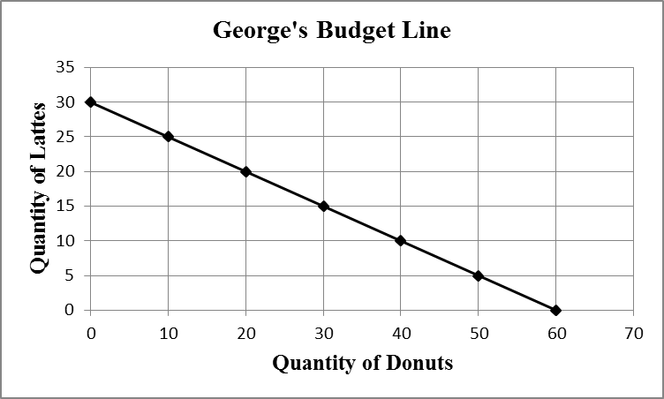

a. Suppose the price of lattes is $4.00. What is George’s monthly income?
b. Based on the income found in Part A. What is the price of donuts?
c. Suppose the price of lattes increased to $5.00. Draw the new budget line.
d. Assume George’s monthly income changes to $60 (Keep the price of lattes at $4.00). Draw the new budget line.

29. How will an increase in income affect the budget line for two goods, all other things equal?

30. Explain: “It is in the nature of all economic problems that absolute solutions are denied us.”

31. Comment on the statement from an opportunity cost perspective: “The major cost of going to college is the $15,000 per year in tuition.” Assume that a person could have earned $30,000 a year if the person did not go to college.

32. (Consider This) Why might it be a good economic decision for a person such as Ryan Seacrest or Mark Zuckerberg to drop out of college? Give an economic justification for such a decision.

33. What is meant by the “economizing problem”?

34. List the four resource categories and give a brief description of each.

35. What four basic functions does the entrepreneur perform for the economy?

36. What do economists mean when they say that economic resources or factors of production are scarce or limited in supply?

37. Explain and evaluate: “If resources were infinitely abundant in relation to the demand for them, the economizing problem would dissolve in a sea of affluence.”

38. “The relative scarcity of resources makes the operation of any economy a matter of choosing between alternatives.” Explain.

39. “The two cornerstones of economics are the scarcity of resources and the multiplicity of wants. True economy consists of deriving maximum want satisfaction from available resources.” Explain.

40. The production possibilities curve below show the hypothetical relationship between the production of food and clothing in an economy.
Combination | Food | Clothing
A | 0 | 4
B | 7 | 3
C | 13 | 2
D | 18 | 1
E | 22 | 0

(a) What is the marginal opportunity cost of producing the second unit of clothing?
(b) What is the total opportunity cost of producing the second unit of clothing?
(c) What is the marginal opportunity cost of producing the third unit of clothing?
(d) What is the total opportunity cost of producing the third unit of clothing?

41. The production possibilities curve below shows the hypothetical relationship between the production of guns (national defense) and butter (social goods) in an economy.
Combination | Guns | Butter
A | 0 | 4
B | 14 | 3
C | 26 | 2
D | 36 | 1
E | 44 | 0

(a) What is the marginal opportunity cost of producing the second unit of butter?
(b) What is the total opportunity cost of producing the second unit of butter?
(c) What is the marginal opportunity cost of producing the third unit of butter?
(d) What is the total opportunity cost of producing the third unit of butter?

42. A production possibilities table for two products, grain and airplanes, is found below. Usual assumptions regarding production possibilities are implied. Grain is measured in metric tons and airplanes are measured in units of 1,000.
Combination | Grain  (metric tons) | Airplanes  (1,000s)
A | 0 | 7
B | 14 | 6
C | 26 | 5
D | 36 | 4
E | 44 | 3
F | 50 | 2
G | 54 | 1
H | 56 | 0

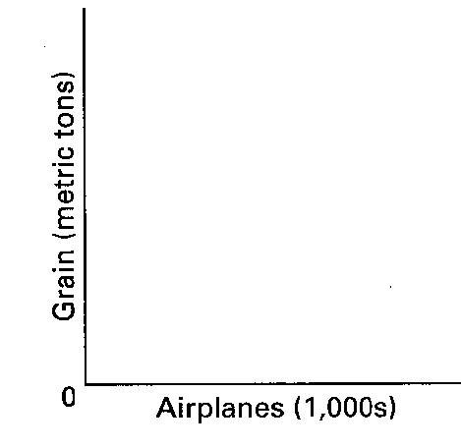
(a) Using the below graph construct a production possibilities curve from this information placing grain on the vertical axis and airplanes on the horizontal axis.

(b) What is the opportunity cost of producing the first unit of airplanes? The marginal opportunity cost of producing the fourth unit of airplanes?

43. A production possibilities table for two products, corn and paper, is found below. Usual assumptions regarding production possibilities are implied. Corn is measured in tons, and paper is measured per unit.
Combination | Corn | Paper
A | 0 | 6
B | 18 | 5
C | 33 | 4
D | 45 | 3
E | 54 | 2
F | 60 | 1
G | 63 | 0

(a) Using the following graph construct a production possibilities curve from this information placing corn on the vertical axis and paper on the horizontal axis.

(b) What is the marginal opportunity cost of producing the first unit of paper? The marginal opportunity cost of producing the fourth unit of paper?

44. How are tradeoffs illustrated by the production possibilities curve? Consider the case of Federal government spending on national defense and spending on social programs.

45. What is the economic rationale for the law of increasing opportunity costs?

46. Explain how increasing opportunity costs are reflected graphically in the production possibilities curve. How would the curve appear if opportunity costs were constant? (Answer verbally or illustrate your response with diagrams.)

47. How is the most-valued or optimal point on the production possibilities curve determined?

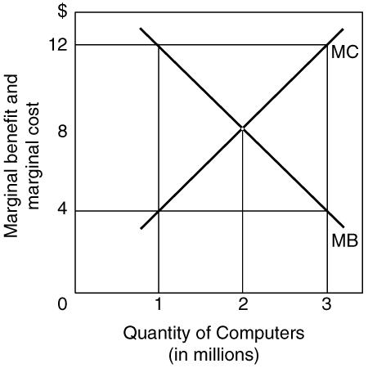
48. In the following graph, explain the relationship between marginal cost and marginal benefit at 1 million units of output, 2 million units of output, and 3 million units of output for the production of computers. In your explanation discuss the overallocation of resources, underallocation of resources, and optimal allocation of resources for the production of computers.
49. Suppose the United States can produce cattle or corn with a given amount of resources. Below is a graph depicting the production possibility frontier for the United States and the marginal benefit and cost of a bushel of corn. Discuss the relationship between the marginal cost and marginal benefit of corn and the production of both corn and cattle.
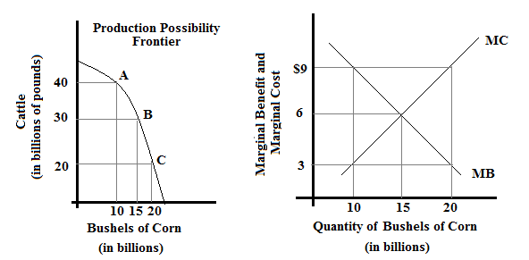
(a) Discuss the overallocation of resources, underallocation of resources, and optimal allocation of resources.
(b) When operating at the optimal level of corn production, what is the optimal level of cattle production? Why is this the optimal amount (why not more or less cattle)?

50. Comment: “We could do a better job of solving the economizing problem by setting our consumption goals lower rather than by setting our production goals higher.”

51. (Consider This) Explain what happened to Iraq’s production possibilities curve as a result of: (a) the war with the United States in 2003; and (b) the rebuilding of the nation after the war.

52. What changes must occur for the potential total output of the economy to grow?

53. Look at the following production possibilities curve illustrating the possibilities in Sluggerville for producing bats and/or peanuts with the existing level of resources and technology.
(a) Show a point U that would indicate unemployed resources in Sluggerville.
(b) Draw a new curve B that illustrates the results of improved technology in the production of bats, but no change in the production efficiency of peanuts.
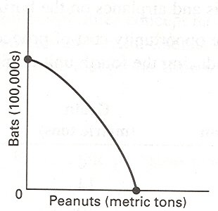
(c) Show a point G that would indicate a point that is currently unattainable in the production of peanuts and bats in Sluggerville.

54. Cattletown Steakhouse is a restaurant known for its steak meal and hamburger basket.
(a) Using the below graph draw a production possibility frontier exhibiting increasing opportunity costs.
(b) On the graph label the areas that are attainable and unattainable.
(c) On the graph label a point where resources are fully employed and one where they are underemployed.
(d) Suppose the patty machine (used to produce hamburgers) breaks down, increasing the time it takes to produce a hamburger basket. Depict this situation on the production possibility frontier.
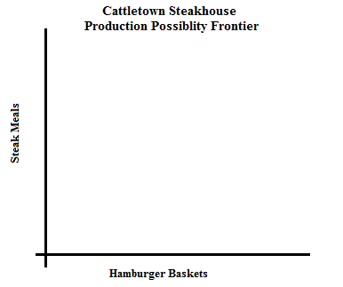

55. Economic growth is the result of what two factors?

56. What do economists mean when they state that investment is spending on “goods for the future”?

57. One application of the production possibilities concept has been to explain the difference in growth patterns of a nation with a high level of investment (Alta) and an equivalent nation with a low level of investment (Zorn). Use the concept to explain why Alta’s economic growth would be greater than that of Zorn over time.

58. The production possibilities curve suggests that a nation cannot live beyond its means or production potential. Explain why international trade would cause this statement to be modified.

59. Explain how each event affects production possibilities.
(a) The population becomes more educated over time as the number of high school dropouts falls and the number of college graduates rises.
(b) The unemployment rate declines from 7.3 to 4.5 percent of the labor force.
(c) Businesses and government are unable to solve a major computer problem, thus reducing economic efficiency and national output.
(d) Advances in telecommunications and new technology significantly contribute to economic growth over time.
(e) The Congress and the President decide to allocate more resources to national defense.
(f) A nation participates in increased international trade with other nations of the world.

60. Describe the adjustments in the production possibilities curves in each of the following situations for the U.S. economy.
(a) the economy moves from full employment into a deep recession
(b) the economy makes great strides in eliminating discrimination
(c) the end of the cold war leads to cuts in military spending
(d) Congress significantly increases government spending for health and education

61. (Last Word) List and give examples of the five pitfalls to economic thinking.

62. (Last Word) Below are four statements. Each of them is an example of one of the pitfalls often encountered in the study of economics. Indicate following each statement the type of pitfall involved.
(a) “July is the month with the most ice cream sales and also the month with the most drownings. Therefore, the more ice cream people eat, the more likely they are to drown.”
(b) “Dry weather in the county where Farmer Brown lives decreased his income because his crop was so poor. Therefore, when there is dry weather in the nation as a whole all farm incomes will suffer.”
(c) “I have to live within my income. Therefore, governments should not be allowed to borrow money.”
(d) “National health insurance plans are socialistic.”

63. (Last Word) What is the fallacy of composition? Give an economic and a non-economic example.

64. (Last Word) Explain the economic fallacy in the statement: “If the Jones family would just cut up their credit cards and live within their means, they’d be better off. And if consumers in this nation cut up their credit cards and lived within their means, the nation would be better off.”

65. (Last Word) Explain what the post hoc fallacy is. Give an example.

66. (Last Word) Explain the difference between correlation and causation and give an example.

67. (Last Word) Suppose the following were facts relating years of education to average annual income of individuals. Can you conclude that years of education cause income to increase?
Years of education | Income
0–10 | $ 8,000
11–12 | 15,000
13–15 | 22,000
16–18 | 30,000
19–21 | 35,000
22 and over | 52,000
B. Answers to Short-Answer, Essays, and Problems

1. What is a brief definition of economics? What are the conditions that give rise to this definition?

It is the social science concerned with the efficient use of scarce resources to achieve the maximum satisfaction of economic wants. Economic wants are many and diverse. People seek many goods and services to satisfy their wants. Society uses productive resources to produce goods and services that meet these wants. Unfortunately, the economic wants of society exceeds the productive capacity of the economy to produce the goods and services to satisfy those wants.

2. What are the three interrelated features of the economic perspective?

First, economics recognizes that there is a general condition of scarcity that forces individuals and society to make choices. Human and property resources are scarce, so choices must be made about how best to use those limited resources. Second, economics assumes that private or public decision-making is based on “rational self-interest.” People make rational decisions to achieve the maximum satisfaction of a goal. Consumers try to get the best value for their expenditures. Workers try to get the best job given their skills and abilities. Businesses try to maximize their profits. Elected representatives try to enact policies that best promote the national interest. Third, economics focuses on marginal analysis when making an economic decision. The marginal or “additional” costs from an economic choice are weighed against the additional benefit. If the marginal benefit outweighs the marginal costs, then a decision will be made to take the beneficial action. If the marginal cost is greater than the marginal benefit, then the action will not be taken.

3. What do economists mean when they say that “there is no free lunch”? Give another example to which this statement applies.

Anything of any value that is offered for “free” still has a cost. Economists refer to this sacrifice as an opportunity cost. In this case, the resources that were used to provide the free lunch could have been put to an alternative use. The opportunity cost is the next best alternative use for those resources. As another example, consider the case of a bank that offers you a “free” sports bag to open an account at the bank. The bag may be free to you as a new bank customer, but there is still a cost paid by the bank in the form of resources that could have been put to alternative uses.

4. Discuss a time when you experienced a business giving something away for “free.” Was this item really free?

Answers will vary. Students should include the following in their discussion: The items provided were not actually “free.” Scarce resources were used to produce the goods/services. It was also not “free” in terms of their time, they had to give something up (likely time) to receive the “free” item.

5. (Consider This) Some stores give “free” products to consumer. An economist would say the products are not free. Why the difference?

The products may be given free to the consumers for marketing purposes, such as to attract customers to the store. The products, however, are not free to the store. Scarce resources had to be used to produce the “free” products and those resources had to be paid for by the store. Ultimately, whenever a product (food, brochure, toy) is given away free by a business to a consumer, the business still had to pay for the product because scarce resources were required to produce it.

6. Is rational self-interest the same thing as selfishness? Explain.

No, they are not the same. Selfishness means that a person is only concerned with himself or herself to the exclusion of others. Rational self-interest simply means that people strive to achieve personal satisfaction. This personal satisfaction can be achieved in many ways, from both selfish and unselfish acts. For example, a person may be unselfish and volunteer time to help other people or make donations to charities because the person derives personal satisfaction from doing so. In this case the person is not being selfish, but is acting to maximize the person’s well-being by helping others.

7. Use marginal analysis to explain why it is possible to “have too much of a good thing.” Use education as an example.

This explanation is based on an evaluation of the marginal costs and marginal benefit of providing a good or service. We may want more education for our society, but at some point the marginal cost of providing additional education is greater than the marginal benefit of the additional education. We would have to give up too many other things to obtain the additional education. For example, would it make sense to provide additional education resources for everyone so that they can earn a Ph.D. degree? The answer is no. In this case, the marginal cost of these additional educational resources (for example, lost labor time or inefficient use of people’s abilities) would not be worth the marginal benefit to society of having everyone earn a Ph.D. degree.

8. (Consider This) How can the economic perspective help us understand the behavior of fast-food consumers? Explain several insights it provides about customer behavior.

Several insights come from the economic perspective as it applies to this example: (1) People choose the shortest line to reduce time cost. (2) Lines often have equal lengths as people shift from longer to shorter lines in an effort to save time. (3) Lines are chosen based on length without much other information—the cost of obtaining more information is not worth the benefit. In this case, imperfect information may lead to an unexpected wait, or it may cause some people to leave when then see a long line. (4) When a customer reaches the counter, other economic decisions are made about what to order. From an economic perspective, these choices will be made after the customer compares the costs and benefits of possible choices.

9. Discuss how an economist might use the scientific method to determine the effect of a change in price of pizza on the quantity sold at the student union.

Answers may vary, but may include the following points. An economist would begin by observing the quantity of pizza sold at the student union. The economist would make a prediction after observing student behavior, formulating a hypothesis. To test their hypothesis, the economist would increase/decrease the price of pizza. After observing the quantity of pizzas sold after the change in price they would accept, reject, or modify their hypothesis. They may repeat the experiment multiple times to further test the hypothesis.

10. The distinguished economist Kenneth Boulding stated: “Theories without facts may be barren, but facts without theories are meaningless.” Explain what he meant.

Economic theories are generalizations about the economic behavior of individuals and institutions. As generalizations or principles, they are abstractions and may not offer specific information about a particular issue that can be obtained from facts. Economic theories are barren in the sense that they offer a framework for thinking about the economic issue without a lot of the details about it. Having a lot of facts about an economic issue, however, is not very meaningful. Facts need to be arranged and organized if they are to have meaning and give insight into the issue. Economic theory offers that framework for organizing the factual information.

11. What are the distinctions made in the text among the terms “hypotheses,” “theories,” “laws,” and “principles”?

Hypotheses are propositions that are tested and used to develop economic theories. Highly reliable theories are called principles or laws. Theories, principles, and laws are meaningful statements about economic behavior or the economy that can be used to predict the likely outcome from an economic action or event. Models are created when several economic principles are used to explain or describe reality.

12. Why are economic theories and principles imprecise? Shouldn’t they apply to everyone?

The main reason is that they are generalizations relating to economic behavior or the economy. The economic facts used to develop the theories and principles differ from person to person or economic institution to institution. They reflect tendencies or averages across large groups that may not apply to a particular individual. For example, if the price of a product drops significantly, the quantity demanded among consumers as a group is expected to increase, but some consumers may not increase their purchases.

13. Explain the importance of the ceteris paribus or “other-things-equal” assumption.

Because economics is concerned with real-world behavior, it is impossible to develop theories about economic relationships in a laboratory setting where the variables of interest could be isolated. Economists try to analyze changes in the variables of interest by finding ways to hold “other things constant or equal.”
Thus, the ceteris paribus assumption is made to indicate that these other variables are not changing or affecting the variables of interest. For example, the theory of consumer demand states that price and quantity demanded are inversely related; people will buy less at higher prices than they will at lower prices. But this theory assumes that other variables that might affect quantity demanded are not changing. This assumption is the ceteris paribus assumption.

14. “Bad theories are abstract and therefore unrealistic; good theories are fully realistic and fit all the facts.” Evaluate.

While some abstract theories are bad, that certainly does not have to be true. Most good theories are generalizations or predictions about human economic behavior and will not be true in every situation, and thus will not fit all the facts all of the time. A good theory is based on observable behavior and will generally explain or predict correctly.

15. “Gathering economic facts is futile unless accompanied by economic analysis.” Explain.

Facts are important if they can be related to other facts to help explain behavior or suggest policy. For example, knowing the income per capita in the U.S. is useful if we view it relative to past performance, price levels, other countries, etc. Simply knowing per capita income by itself (in isolation) is relatively useless.

16. “To be sure, any theoretical model must be abstracted ‘from the richness and complexity of behavior.’ However, abstraction becomes falsification when it so simplifies human behavior as to leave it unrecognizable and unexplained.” Explain.

Critics of some economic theories make statements such as this. Their concern is that if economists simplify their theories too much, they may be testing hypotheses that will be unworkable in the real world, even if they cannot be rejected as false. For example, if one attempted to explain all human behavior as directed toward profit maximization, much of our emotional and irrational behavior would be unrecognizable and unexplained. However, attempts have been made to explain everything from love and marriage to child bearing as a result of conscious economic decision-making. If we exaggerate the impact of rational, economic thought, we are really falsifying reality. On the other hand, we should not neglect the impact of economic reasoning on human behavior.

17. Distinguish between microeconomics and macroeconomics.

Microeconomics deals with individual economic units such as industries, firms, households, and with individual markets, particular prices, and specific goods and services. Macroeconomics, on the other hand, deals with the performance and behavior of the economy as a whole, including such major aggregates as the household, business, and governmental sectors and with totals for the economy.
18. Below are six statements. Indicate whether each one pertains to microeconomics (MIC) or macroeconomics (MAC).
(a) “Last year, IBM was the U.S. business with the most patents registered with the U.S. government.”
(b) “The U.S. economy grew at an annual rate of 4.2 percent last year.”
(c) “Snow in the northeast has reduced the number of holiday shoppers at clothing stores and clothing prices are falling.”
(d) “More workers are being hired by the nation’s businesses.”
(e) “The U.S. economy imported more goods and services than it exported last year.”
(f) “New discoveries in medicine are leading to strong growth in the biotech industry.”
(a), (c), and (f) are micro; (b), (d), and (e) are macro.

19. Below are six statements. Indicate whether each one pertains to microeconomics (MIC) or macroeconomics (MAC).
(a) “The inflation rate in the United States hit its lowest level in the last twenty years.”
(b) “The profits of Microsoft rose 20 percent during the past quarter.”
(c) “Rains from El Nino again hit the California region causing severe flooding in farms. The prices for citrus and produce are expected to rise sharply.”
(d) “The nation’s economy grew at an annual rate of 3.7 percent in the final quarter of the year.”
(e) “The trade deficit in the United States was $20 billion last month.”
(f) “General Motors plans to spend $800 million on a new automobile plant.”
(a), (d), and (e) are macro; (b), (c), and (f) are micro.

20. Give one example of a positive economic statement and one example of a normative economic statement.

A positive economic statement is any factual statement such as: “Last month there were 11.2 million workers unemployed.” A normative economic statement is one which contains an opinion such as: “Many people today are too lazy to look for work and that is why the unemployment figures are so high.”

21. Explain the dual role of economics and economists, to inform about the economy and advise on economic policy.

Economists make use of both positive and normative economics. Positive economics establishes scientific statements about economic behavior and deals with what the economic is actually like. Positive economics avoid value judgements. As a policy advisor, economists use normative economics. Normative statements incorporates value judgments about what the economy should be like or recommend a policy action to achieve a desired goal.

22. Below are six statements. Identify whether each is a positive or normative statement.
(a) The national economy grew at a 6.2 percentage rate in the last quarter as the economy continues to recovers from the past recession.
(b) The unemployment rate fell to 5.7 percent this month, and is expected to fall to 5.5 percent next month.
(c) The rate of inflation should be reduced to zero to maintain the value of the U.S. dollar.
(d) The government should take action to reduce the prices of prescription drugs charged by drug companies.
(e) Interest rates for home mortgages are at their lowest rate in thirty years.
(f) The Federal government should increase income taxes on the wealthy to reduce the budget deficit.

(a), (b), and (e) are positive; and (c), (d), and (f) are normative.

23. Below are six statements. Identify whether each is a positive or normative statement.
(a) The minimum wage would be increased so low-income workers can earn a living wage.
(b) The unemployment rate is too high and should be reduced through government actions.
(c) The rate of inflation was about 2 percent last year, a low for the past decade.
(d) The government should take action to break up the monopoly power of Google.
(e) Interest rates should be lower in the United States so that people can afford to build a home.
(f) The Federal government achieved a budget surplus for the first time in thirty years.

(a), (b), (d) and (e) are normative; and (c) and (f) are positive.

24. “Economists are scientists and therefore should not become involved in making value judgments which policy formulation necessarily entails.” Do you agree?

It is important to distinguish between positive and normative economics. When conducting positive economic analysis, economists use objective, scientific methods to collect data and test hypotheses to arrive at economic theories and principles. However, there is a need to apply economic theories to real-world problems and this necessarily requires some value judgments or the use of normative economics. Even scientists who can experiment in laboratories have to make value judgments when they arrive at the point of applying their theories. For example, geneticists must make value judgments about the uses of genetic science.
Economists are the most knowledgeable people regarding their own theories, so they should be involved in the decisions about how to apply those theories. Of course, in a democratic society those judgments are often advisory and must be approved by elected representatives before they are enacted.

25. “Economics cannot be scientific because it is based upon the value judgment that ‘more (output) is better’.” Do you agree?

This statement can be subjected to positive economic analysis. If you can show that this assumption is valid, i.e., that it is correct that most people believe that “more is better,” then this is not a value judgment but a testable principle of economics. Where this assumption is questioned, it is a rather simple matter to test the hypothesis about whether “more is regarded as better.” In other words, if people behave as if more is better, then this assumption is not a result of value judgments by economists, but rather the result of observing that this is the way humans act.

26. What is shown by the budget line in a two-product (A and B) case? Describe what happens when there is a change in income or the price of a product.

A budget line shows various combinations of two products which can be purchased with a given money income of a consumer and given the prices of the two products. A decrease in the money income of a consumer shifts the budget line inward to the origin. An increase in the money income of a consumer shifts the budget line outward from the origin. Price changes in either of the two products will rotate the budget line along one axis. Assume that the quantity of product A is shown on the vertical axis. If the price of A rises, less of A will be purchased at each of the possible combinations of A and B, so the budget line will shift downward along the vertical A axis towards the origin. A decrease in the price of A would have the curve shift upward along the A axis away from the origin.

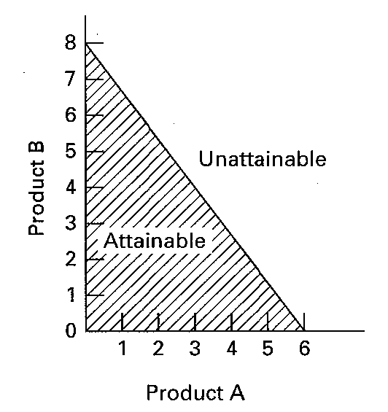
27. Suppose a consumer has a daily income of $48 and purchases just two goods, A and B. The price of A is $8 and the price of B is $6. In the graph below, draw the budget line for the consumer. Indicate the area of the below graph that is attainable given the income and the area that is unattainable.

28. Below is the budget line for George. Answer the following questions based on his monthly budget constraint.

(a) Suppose the price of lattes is $4.00. What is George’s monthly income?
(b) Based on the income found in Part A. What is the price of donuts?
(c) Suppose the price of lattes increased to $5.00. Draw in new budget line.
(d) Assume George’s monthly income changes to $60 (Keep the price of lattes at $4.00). Draw the new budget line.
(a) George has a monthly income of $120.00. When George spends all his income on lattes we know he can purchase 30 of them. Remember: Income / Price = Quantity Purchased. Rearranging this equation we can solve for monthly income by multiply the price of lattes by quantity of lattes (30 * $4.00 = $120.00).
(b) We found that George has a monthly income of $120. If he spends all that income on donuts he can purchase 60 donuts. Remember: Income / Price = Quantity Purchased. Rearraning this equation to solve for price we find the price of donuts is $2.00 ($120 / 60 = $2.00).
(c) If the price of lattes increases to $5.00 the number of lattes we can purchase in a month falls. This can be seen by a pivot in the budget constraint.
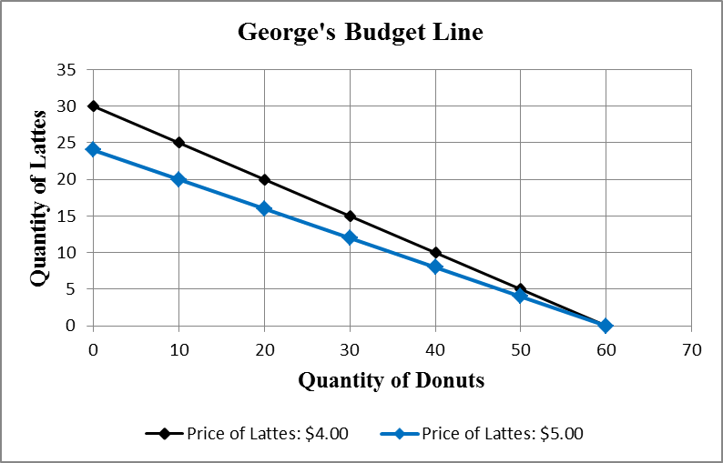

(d) A decrease in George’s monthly income from $120 to $60 means he can purchase fewer lattes and donuts, shifting the budget line toward the orgin.
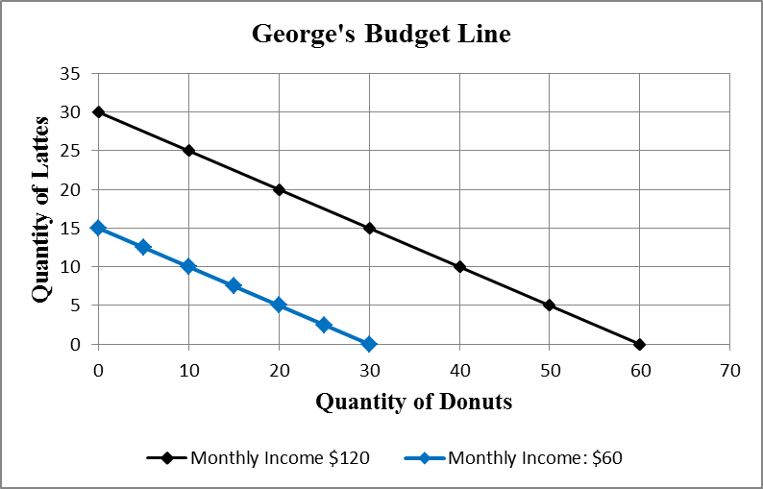

29. How will an increase in income affect the budget line for two goods, all other things equal?

A budget line is defined by the intercepts for the two goods in a two-quadrant graph. These intercept values are calculated by dividing money income by the price of the product. If money income increases and prices stay the same, then the intercept values will increase and the budget line will shift outward from the origin.

30. Explain: “It is in the nature of all economic problems that absolute solutions are denied us.”

The key to the explanation is that solutions to economic problems involve choices among alternatives. The nature of economic problems involves scarcity of resources relative to our wants. Therefore, there is always an opportunity cost in making the “best choice.” That is, another solution is forgone.

31. Comment on the statement from an opportunity cost perspective: “The major cost of going to college is the $15,000 per year in tuition.” Assume that a person could have earned $30,000 a year if the person did not go to college.

Tuition is only one part of the cost of going to college. The major cost of going to college for most people is the forgone income that could have been earned working full-time. Let’s say a person had a choice of going to college with a yearly tuition of $15,000 or working full-time at a job that paid $30,000 a year. In this case, the opportunity cost of going to college would be $45,000 ($15,000 in tuition paid plus the $30,000 in forgone income).

32. (Consider This) Why might it be a good economic decision for a person such as Ryan Seacrest or Mark Zuckerberg to drop out of college? Give an economic justification for such a decision.

The economic decision should be based on weighing the costs of going to college with the expected benefit of doing something else with the time. If the opportunity costs of going to college are high because there is a better alternative that would yield more expected benefits, then it would make sense to drop out of college. This situation was true for both Ryan Seacrest and Mark Zuckerberg. Both had compelling alternatives in entertainment and business outside of college that were likely to produce much greater lifetime earnings and benefits. Staying in college would mean that these potential benefits would be lost.

33. What is meant by the “economizing problem”?

The economizing problem stems from two related facts. Economic wants are unlimited because they cannot be completely satisfied with the existing limited supply of resources available for production. Resources are said to be scarce relative to these unlimited economic wants. For this reason, people must make choices and economize on resource use.

34. List the four resource categories and give a brief description of each.

(a) Land: natural resources including land, forests, water and minerals.
(b) Capital: investment goods or those manufactured items used in production of other goods. Factories, tools, machinery, transportation facilities, and equipment are examples. Money is not a capital good.
(c) Labor: a broad term used to describe the physical and mental talents of men and women available to be used in producing goods and services.
(d) Entrepreneurial ability: a type of human resource, but unique from productive labor in that it refers to the person who is the driving force behind production decisions, innovation, and the one who is willing to bear the risk of starting and running a business.

35. What four basic functions does the entrepreneur perform for the economy?

First, the entrepreneur takes the initiative in combining resources to produce a product. In this way the entrepreneur is a catalyst for production in the economy. Second, the entrepreneur makes basic business policy decisions that set the course for the business enterprise. Third, the entrepreneur will introduce new or improved products to the market place or develop new forms of business organization. In this role, the entrepreneur serves as an innovator for the economy. Fourth, the entrepreneur bears the risk in terms of time, effort, and invested funds. A market economy has no guarantee of profits for the entrepreneurs, but it is the expectation of profit that gives incentives to the entrepreneur to bear risk.

36. What do economists mean when they say that economic resources or factors of production are scarce or limited in supply?

They mean that resources are not so abundant that they may be used freely for everything everyone wants. There are not enough resources available to meet all of society’s unlimited economic wants.

37. Explain and evaluate: “If resources were infinitely abundant in relation to the demand for them, the economizing problem would dissolve in a sea of affluence.”

If this were true, people would not have to make choices and there would be no need for economic systems to distribute the goods and services produced. In a world of abundance, people could simply help themselves to whatever they wanted.

38. “The relative scarcity of resources makes the operation of any economy a matter of choosing between alternatives.” Explain.

The fact that people cannot have as much as they want of everything requires them to make choices. There has to be some system for making these choices. For example, it may be “first come, first serve,” or a system based on power with the strongest controlling the resources, or it may be a market-based system where the primary motivation is the profit incentive.

39. “The two cornerstones of economics are the scarcity of resources and the multiplicity of wants. True economy consists of deriving maximum want satisfaction from available resources.” Explain.

The first statement refers to the basic economic problem: that society’s wants are unlimited relative to the limited supply of productive resources. The second part refers to the concept of efficiency, both allocative and productive. Since resources are scarce, it is desirable to achieve the most output from those available. Otherwise we waste resources and will not satisfy as many wants as we could from the resources that we have available, which would mean not achieving productive efficiency. Allocative efficiency means the maximum satisfaction of wants with these resources.

40. The production possibilities curve below show the hypothetical relationship between the production of food and clothing in an economy.
Combination | Food | Clothing
A | 0 | 4
B | 7 | 3
C | 13 | 2
D | 18 | 1
E | 22 | 0

(a) What is the marginal opportunity cost of producing the second unit of clothing?
(b) What is the total opportunity cost of producing the second unit of clothing?
(c) What is the marginal opportunity cost of producing the third unit of clothing?
(d) What is the total opportunity cost of producing the third unit of clothing?

- 5 units of food (18 − 13 = 5); (b) 9 units of food (22 − 13 = 9); (c) 6 units of food (13 − 7 = 6);
(d) 15 units of food (22 − 7 = 15).

41. The production possibilities curve below shows the hypothetical relationship between the production of guns (national defense) and butter (social goods) in an economy.
Combination | Guns | Butter
A | 0 | 4
B | 14 | 3
C | 26 | 2
D | 36 | 1
E | 44 | 0

(a) What is the marginal opportunity cost of producing the second unit of butter?
(b) What is the total opportunity cost of producing the second unit of butter?
(c) What is the marginal opportunity cost of producing the third unit of butter?
(d) What is the total opportunity cost of producing the third unit of butter?

(a) 10 units of guns (36 − 26 = 10); (b) 18 units of guns (44 − 26 = 18); (c) 12 units of guns (26 − 14 = 12); (d) 30 units of guns (44 − 14 = 30).

42. A production possibilities table for two products, grain and airplanes, is found below. Usual assumptions regarding production possibilities are implied. Grain is measured in metric tons and airplanes are measured in units of 1,000.
Combination | Grain  (metric tons) | Airplanes  (1,000s)
A | 0 | 7
B | 14 | 6
C | 26 | 5
D | 36 | 4
E | 44 | 3
F | 50 | 2
G | 54 | 1
H | 56 | 0

(a) Using the below graph construct a production possibilities curve from this information placing grain on the vertical axis and airplanes on the horizontal axis.
(b) What is the opportunity cost of producing the first unit of airplanes? The marginal opportunity cost of producing the fourth unit of airplanes?
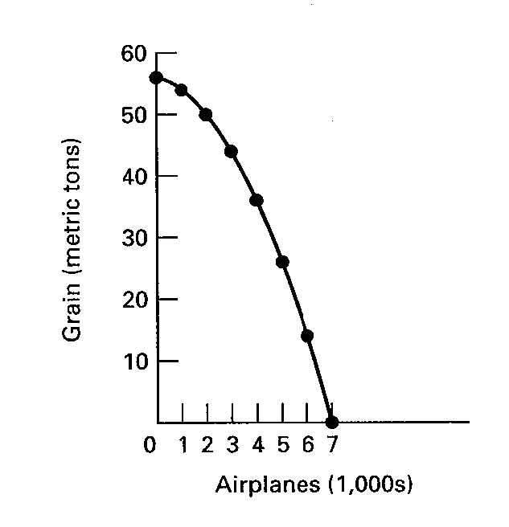
(a) See graph.
(b) Two units of grain (56 − 54) are sacrificed if one unit of planes is produced. When the fourth unit of planes is produced the marginal opportunity cost is eight units of grain (44 − 36).

43. A production possibilities table for two products, corn and paper, is found below. Usual assumptions regarding production possibilities are implied. Corn is measured in tons, and paper is measured per unit.
Combination | Corn | Paper
A | 0 | 6
B | 18 | 5
C | 33 | 4
D | 45 | 3
E | 54 | 2
F | 60 | 1
G | 63 | 0

(a) Using the following graph construct a production possibilities curve from this information placing corn on the vertical axis and paper on the horizontal axis.
(b) What is the marginal opportunity cost of producing the first unit of paper? The marginal opportunity cost of producing the fourth unit of paper?

(a) See graph.
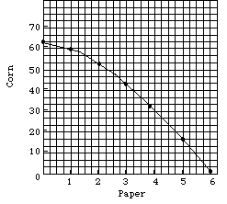
(b) Three units of corn are sacrificed if 1 unit of paper is produced. When the fourth unit of paper is produced the opportunity cost is 12 units of corn (44 − 36).

44. How are tradeoffs illustrated by the production possibilities curve? Consider the case of Federal government spending on national defense and spending on social programs.

In the production possibilities model, an increase in government spending on national defense will come at the expense of government spending on social programs. If the nation wants to be more secure then it will have to give up the opportunities to use its scarce budget resources for social programs. Conversely, if there is more spending on social programs, there will have to be cuts to national defense, assuming that there is a fixed budget constraint. Moving in either direction on the production possibilities curve will involve trading off one desirable public good for another.

45. What is the economic rationale for the law of increasing opportunity costs?

Economic resources are not completely adaptable to alternative uses. In a two-product (A and B) economy, an increase in the production of product A will cause a reduction in the quantity of product B that can be produced because resources are being reallocated from the production of B to A. That reallocation of resources is not constant and becomes increasingly costly in terms of the lost production of B. As more resources shift from the production of B to A, these resources are less and less adaptable or suitable for the production of A. The production of more and more of A entails increasing opportunity costs in the form of less and less production of B.

46. Explain how increasing opportunity costs are reflected graphically in the production possibilities curve. How would the curve appear if opportunity costs were constant? (Answer verbally or illustrate your response with diagrams.)

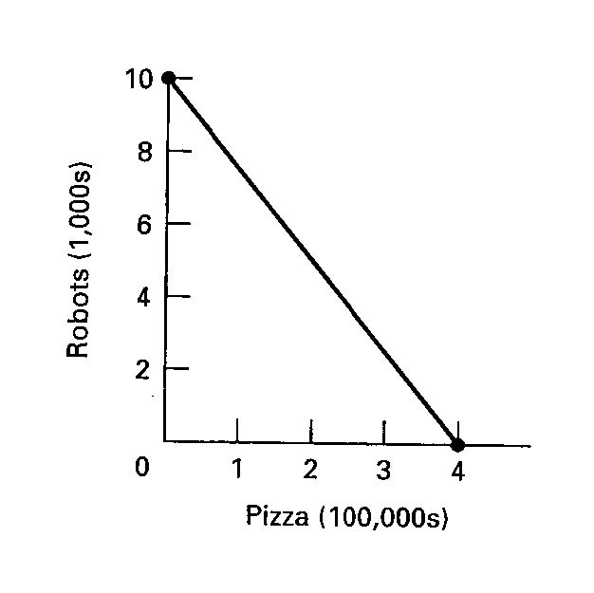
The production possibilities curve illustrates the concept of increasing opportunity costs with its changing slope. This causes the curve to be concave toward the origin. It occurs because when society produces more and more of one product, it must give up increasing amounts of alternative products due to the fact that resources are specialized. If resources could be used equally efficiently to produce all things, opportunity costs would be constant and the production possibilities curve would be a straight line graph showing alternative production possibilities. The example from the text of pizza and robots would be reflected as shown in the following graph.

47. How is the most-valued or optimal point on the production possibilities curve determined?

Full employment and productive efficiency allows a society to achieve any point on the production possibilities curve. What point on the curve, however, is optimal? Answering this question focuses on the attainment of allocative efficiency. Any economic activity should be increased so long as the marginal benefit exceeds the marginal cost. Conversely, any economic activity should be decreased so long as the marginal cost exceeds the marginal benefits. Resources are efficiently allocated to an economic activity when the marginal cost equals the marginal benefit.

48. In the following graph, explain the relationship between marginal cost and marginal benefit at 1 million units of output, 2 million units of output, and 3 million units of output for the production of computers. In your explanation discuss the overallocation of resources, underallocation of resources, and optimal allocation of resources for the production of computers.
At 1 million units of output, the marginal cost is $4 and the marginal benefit is $12. There is underallocation of resources to computer production. For each additional computer produced up to 2 million, the marginal benefits are greater than the marginal costs. At 2 million units of output, the marginal cost is $8 and the marginal benefit is $8. This point represents allocative efficiency and would be the optimal level of output. The benefits of an additional unit of output just equal the additional cost at this level of production. At 3 million units of output, the marginal cost is $12 and the marginal benefit is $4. There is an overallocation of resources to computer production at this level of output. Society would be better off if there was less output. In fact, production of each unit after 2 million has a marginal cost that is greater than the marginal benefit.

49. Suppose the United States can produce cattle or corn with a given amount of resources. Below is a graph depicting the production possibility frontier for the United States and the marginal benefit and cost of a bushel of corn. Discuss the relationship between the marginal cost and marginal benefit of corn and the production of both corn and cattle.
(a) Discuss the overallocation of resources, underallocation of resources, and optimal allocation of resources.
(b) When operating at the optimal level of corn production, what is the optimal level of cattle production? Why is this the optimal amount (why not more or less cattle)?

(a) At 10 billion bushels of corn the marginal cost is $3 and the marginal benefit is $9. There is an underallocation of resources to corn, the benefit of an additional unit of corn outweighs the cost. For each additional bushel of corn produced up to 15 billion, the marginal benefits are greater than the marginal costs and production should be expanded. At 15 billion bushels the marginal benefit is equal to the marginal cost, this level of production represents the optimal allocation of corn. At 20 billion bushels of corn there is an overallocation of resources. The marginal cost ($9) is greater than the marginal benefit ($3). Society would be better off if there were less output. This is true for any allocation greater than the optimal 15 billion bushels.
(b) Based on the marginal benefit and marginal cost of corn the optimal allocation of corn is 15 billion bushels. When the economy is producing 15 billion bushels of corn, the maximum amount of cattle that can be produced is 30 billion pounds. Any cattle production that is less than 30 billion pounds would under employ society’s resources. Any level of production beyond 30 billion pounds is unattainable without trade or economic growth. Based on the information given above the optimal allocation of resources is 15 billion bushels of corn and 30 billion pounds of cattle.

50. Comment: “We could do a better job of solving the economizing problem by setting our consumption goals lower rather than by setting our production goals higher.”

In part this statement is saying that one way to satisfy our wants is to be more conservative in what we consume. Through conservation we may be able to satisfy as many wants without being wasteful of resources. For example, by driving more fuel-efficient cars, Americans can increase travel without increasing gasoline consumption. Other examples can be found to show that we can maintain or increase satisfaction by using existing resources more efficiently. On the other hand, conservation cannot be the entire solution to the economizing problem as population wants expand relative to scarce resources.

51. (Consider This) Explain what happened to Iraq’s production possibilities curve as a result of: (a) the war with the United States in 2003; and (b) the rebuilding of the nation after the war.

(a) Iraq’s production possibilities curve shifted inward because of the destruction of the nation’s infrastructure (roads, bridges, housing, buildings). A great deal of productive capacity was lost during the war.
(b) With the conclusion of hostilities, the nation’s infrastructure and businesses are being rebuilt. This work will help shift the production possibilities curve outward as the nation’s economy grows.

52. What changes must occur for the potential total output of the economy to grow?

For the economy to grow there must be either an expansion of resources or an improvement in productive efficiency so that more can be produced with the existing level of resources. Both of these changes would be most desirable for rapid growth.

53. Look at the following production possibilities curve illustrating the possibilities in Sluggerville for producing bats and/or peanuts with the existing level of resources and technology.
(a) Show a point U that would indicate unemployed resources in Sluggerville.
(b) Draw a new curve B that illustrates the results of improved technology in the production of bats, but no change in the production efficiency of peanuts.
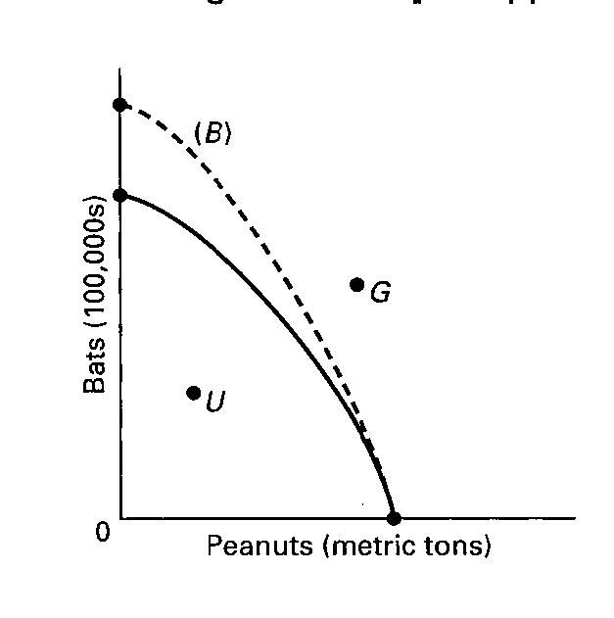
(c) Show a point G that would indicate a point that is currently unattainable in the production of peanuts and bats in Sluggerville.

(a) Point U should be anywhere inside the curve.
(b) B should be extended beyond the original curve on the “bat” axis; every point on B should reflect more bats at each level of peanuts. At zero bats, the curve should be at the original point on the peanut axis.
(c) G could be any point outside the original curve.

54. Cattletown Steakhouse is a restaurant known for its steak meal and hamburger basket.
(a) Using the below graph draw a production possibility frontier exhibiting increasing opportunity costs.
(b) On the graph label the areas that are attainable and unattainable.
(c) On the graph label a point where resources are fully employed and one where they are underemployed.
(d) Suppose the patty machine (used to produce hamburgers) breaks down, increasing the time it takes to produce a hamburger basket. Depict this situation on the production possibility frontier.
(a) See graph below. Increasing opportunity costs reflects the bowed shape of the production possibilities frontier. This line is depicted by PP.
(b) See graph below. Any points on or inside the production possibility frontier is attainable. Any point beyond the production possibility frontier is unattainable.
(c) See graph below. Points A, B, and C represent points where resources are fully employed. Points D, E, and F represent points where resources are underemployed, the Steakhouse could produce more of one good without giving up any of the other.
(d) When the patty machine breaks the Steakhouse can make fewer Hamburger Basket with a given amount of resources. The number of Steak Meals does not change. This leads to a pivot inward of the production possibilities frontier. The frontier pivots from line PP to PP’.
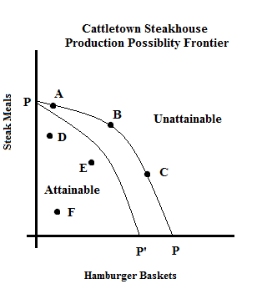

55. Economic growth is the result of what two factors?

Economic growth is the result of increases in supplies of resources and technological advances. Economic growth at full employment leads to an economy with greater output of both consumer and capital goods.

56. What do economists mean when they state that investment is spending on “goods for the future”?

It is easiest to explain this statement by realizing that consumption is spending on goods and services for the present. The resources that are not used for consumption can be devoted to goods or services that can be used in future production. For example, investment in education, machinery, factories, equipment, and tools are types of spending that will be used in expanding production of consumer goods and services in the future.

57. One application of the production possibilities concept has been to explain the difference in growth patterns of a nation with a high level of investment (Alta) and an equivalent nation with a low level of investment (Zorn). Use the concept to explain why Alta’s economic growth would be greater than that of Zorn over time.

The application suggests the tradeoff illustrated by a production possibilities curve with consumption spending on one axis and investment spending on the other axis. In Alta the combination of consumption and investment spending is heavily weighted toward investment. In Zorn investment spending is a smaller percentage of domestic output. If investment were measured on the vertical axis and consumption on the horizontal axis, Alta’s optimal selection would be much higher on its production possibilities curve than would be the selection in Zorn. As a result of this larger proportion of income spent on investment goods, Alta’s capital resource base and its economy grow more rapidly, which means its production possibilities curve shifts outward at a more rapid pace over time.

58. The production possibilities curve suggests that a nation cannot live beyond its means or production potential. Explain why international trade would cause this statement to be modified.

International trade allows for greater specialization and production. This activity has the effect of increasing the quantity and quality of resources, using resources more efficiently or improving output through the use of new production techniques. Thus, the gains from international trade and specialization are the equivalent of economic growth.

59. Explain how each event affects production possibilities.
(a) The population becomes more educated over time as the number of high school dropouts falls and the number of college graduates rises.
(b) The unemployment rate declines from 7.3 to 4.5 percent of the labor force.
(c) Businesses and government are unable to solve a major computer problem, thus reducing economic efficiency and national output.
(d) Advances in telecommunications and new technology significantly contribute to economic growth over time.
(e) The Congress and the President decide to allocate more resources to national defense.
(f) A nation participates in increased international trade with other nations of the world.

(a) Improvements in the basic education of the labor force typically contribute to an increase in productivity. The production possibilities curve should move outward.
(b) Unemployment means that there is inefficient use of existing resources. Production moves from a point inside the production possibilities curve toward the frontier.
(c) The most likely answer is that the production possibilities curve shifts inward. It would also be possible that there is movement from the frontier of the production possibilities curve to an interior point. Both answers indicate that there is less economic inefficiency in the economy.
(d) Advances in telecommunications and new technology significantly contribute to economic growth over time.
(e) There will be movement along the existing production possibilities curve toward more defense goods at one axis from all other goods at the other axis.
(f) Specialization and international trade enable a nation to produce more goods and services at less sacrifice of other goods and service. The nation can use its increased production to trade for the other goods it wants. The production possibilities curve will shift outward.

60. Describe the adjustments in the production possibilities curves in each of the following situations for the U.S. economy.
(a) the economy moves from full employment into a deep recession
(b) the economy makes great strides in eliminating discrimination
(c) the end of the cold war leads to cuts in military spending
(d) Congress significantly increases government spending for health and education

(a) The economy begins at a point on the curve but with recession there is unemployment and the economy now operates at a point in the area inside the curve, indicating that production is less than that which is possible because some resources are not being used.
(b) Eliminating discrimination would move the economy from a point inside its production possibilities curve toward a point on the curve.
(c) If the curve is illustrating the tradeoff between private spending and government spending (or between military and consumer goods), then this should mean a movement along the curve in the direction of more private or consumer production and less military production. Government spending in general could decrease, but if that were not the case, then the government might simply shift some funds from the military to other types of government spending and the point would not necessarily move at all on a curve depicting the tradeoff between government and private spending.
(d) Movement depends on where the money is coming from. If the money comes from increased taxes or borrowing, then there is a movement along the curve away from private spending and toward public spending. If the money comes from other government programs and the curve is illustrating government versus private spending, the amount of total government production would not necessarily change, so the point could remain at the same spot on the curve.

61. (Last Word) List and give examples of the five pitfalls to economic thinking.

First, bias and preconceptions can cloud economic thinking. An example would be the belief that “the only reason people are unemployed is that they are too lazy to work.” Second, economic terminology in the popular press can be slanted or emotionally loaded. Examples of loaded or slanted terms are “corporate welfare,” “gouging the consumer,” and “exorbitant salaries.” Third, there is the problem of definition of terms. For example, the term “capital” may refer either to “capital goods” or “financial capital.” Fourth, you make a mistake when you assume that what is true for the individual or part of a group is also true for the group as a whole. For example, if an individual stands up to see better at a football game, the individual is better off, but if all the fans stand up to see better, the group is not better off. Fifth, there are two causation fallacies. You might conclude that one event causes the other simply because one preceded the other (the after this, therefore because of this causation): “I washed my car, therefore it rained.” You might also confuse correlation with causation: “incomes rose and the crime rate fell, thus higher incomes reduce the crime rate.”

62. (Last Word) Below are four statements. Each of them is an example of one of the pitfalls often encountered in the study of economics. Indicate following each statement the type of pitfall involved.
(a) “July is the month with the most ice cream sales and also the month with the most drownings. Therefore, the more ice cream people eat, the more likely they are to drown.”
(b) “Dry weather in the county where Farmer Brown lives decreased his income because his crop was so poor. Therefore, when there is dry weather in the nation as a whole all farm incomes will suffer.”
(c) “I have to live within my income. Therefore, governments should not be allowed to borrow money.”
(d) “National health insurance plans are socialistic.”

(a) Causation is confused with correlation. (“Post hoc” fallacy.)
(b) This is the fallacy of composition. What is bad for one farmer is not necessarily bad for all farmers if prices rise to offset the decline in crop yields. However, dry weather in only one county would not cause an increase in agricultural prices, so Farmer Brown would suffer if his were the only dry area.
(c) This illustrates two pitfalls. The fallacy of composition may be a factor behind this statement since governments are a collection of individuals, but the fallacy is that governments do not have limited life spans and additionally have the power to tax. This statement also illustrates biased thinking since it assumes that all borrowing is bad.
(d) This is an example of loaded terminology to influence one’s view of national health insurance plans.

63. (Last Word) What is the fallacy of composition? Give an economic and a non-economic example.

It is the incorrect reasoning that what is true for an individual (or part of a group) is necessarily true for the whole group. Or, what is true at the micro level of analysis may not be true at the macro level of analysis. Economic example: when an individual farmer produces a large crop, then the farmer should have an increased income because he or she has more output to sell. If, however, all farmers produce more output, then the increase in output may decrease prices and reduce farm income. Non-economic example: If a spectator at a packed basketball arena stands up, then he or she will likely see the game better. If, however, all spectators at the game stand up, then the group of spectators as a whole will not be able to see the game better.

64. (Last Word) Explain the economic fallacy in the statement: “If the Jones family would just cut up their credit cards and live within their means, they’d be better off. And if consumers in this nation cut up their credit cards and lived within their means, the nation would be better off.”

This is an example of the fallacy of composition. Cutting up credit cards may be good for the Jones family depending on their circumstances. If they have taken on too much debt and are in financial trouble, then cutting up credit cards would reduce their impulses to spend money. But if all consumers cut up their credit cards this action would reduce consumer spending in the economy because there would be fewer transactions and it would make the economy less efficient. Economic growth would decline because of the reduced consumer spending.

65. (Last Word) Explain what the post hoc fallacy is. Give an example.

It means “after this, therefore because of this.” It is the mistaken belief that when one event precedes another, the first event is the cause of the second. An example: I washed my car today; therefore it will rain tomorrow.

66. (Last Word) Explain the difference between correlation and causation and give an example.

Correlation refers to a systematic association between two sets of data (two outcomes). Causation implies that there is a cause-effect relationship between two events. Correlation does not imply causation. Just because two events are related in a predictable manner does not necessarily mean that one causes the other. More must be known about the cause-effect relationship before conclusions about causation can be drawn.
For example, one could discover a positive correlation between ice-cream sales and the number of drownings. However, this does not mean that eating ice cream causes drowning, nor does it mean that more drownings cause people to buy ice cream!

67. (Last Word) Suppose the following were facts relating years of education to average annual income of individuals. Can you conclude that years of education cause income to increase?
Years of education | Income
0–10 | $ 8,000
11–12 | 15,000
13–15 | 22,000
16–18 | 30,000
19–21 | 35,000
22 and over | 52,000

The data suggest that average incomes rise as years of education increase. This result is a correlation, indicating that education and income are related in a systematic and dependable way. The data cannot prove causation because there may be other factors that explain the relationship. And the causation can run the other way: higher incomes lead to more education.
C. Appendix Questions

68. Why do economists use graphs in their work?

69. In a two-dimensional graph showing the relationship between income and consumption in the economy, what is shown on the vertical axis and what is shown on the horizontal axis?

70. Define what is meant by a positive or direct relationship between two variables and describe the line graph depicting such a relationship.

71. Define what is meant by an inverse relationship between two variables and describe the line graph depicting such a relationship.

72. Show graphically the relationships that you would expect to find between (a) student IQs and grade point averages (GPAs); (b) the price of a product and the amount consumers will purchase; (c) the temperature and the number of people at the swimming pool. Which of these are direct relationships and which are inverse? What considerations might change the expected relationships?

73. Differentiate between the independent and dependent variables in an economic relationship.

74. Show graphically on the below graph the expected relationship between investment spending and interest rates. Put investment expenditures on the horizontal axis and the rate of interest on the vertical axis; connect the points and label the curve “Investment demand.” Describe this relationship between the rate of interest and investment expenditures. Describe the slope of the investment curve.

75. State the definition for the slope of a straight line graph.

76. Use the following table to answer the next three questions.
Consumption | Income
$15,000 | $ 20,000
30,000 | 40,000
45,000 | 60,000
60,000 | 80,000
75,000 | 100,000

(a) What would be the slope of the line if you graphed the relationship between consumption and income? (Consumption would be on the vertical axis and income on the horizontal axis.) Explain how the slope is calculated.
(b) How does the slope of this line reflect marginal changes? Give a numerical explanation.

77. A graph shows the quantity for Product A on the vertical axis and the quantity for Product B on the horizontal axis. What is the proper interpretation of a vertical line at a particular quantity for Product B that is parallel to the vertical axis of the graph? What is the slope of the vertical line?

78. A graph shows the quantity of corn on the vertical axis and the quantity of steel on the horizontal axis. What is the proper interpretation of a horizontal line at a particular quantity for corn that is parallel to the horizontal axis of the graph? What is the slope of the horizontal line?

79. There are two sets of x, y points on a straight line in a two-variable graph with y on the vertical axis and x on the horizontal axis. What would be the linear equation for the line if one set of points was (0, 9) and the other set was (13, 61)?

80. The value of the vertical intercept is $150 and the slope is −25 in a linear equation for price and quantity demanded. If price is $5.00, what is the quantity demanded? State the linear equation and show how you found the answer.

81. How do you determine the slope of a nonlinear curve? Will the slope be the same along the curve? Explain.

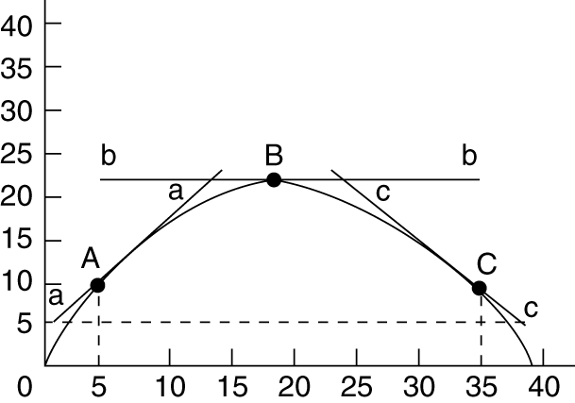
82. Using the below graph give the slopes of the straight lines tangent to the curve at points A, B, and C.

D. Answers to Appendix Questions

68. Why do economists use graphs in their work?

Economists use graphs to illustrate the relationship between economic variables in a visual format which often is more efficient than explaining the relationship in words. By seeing the relationship in graphical format, the reader (viewer) is able to readily describe the relationship.

69. In a two-dimensional graph showing the relationship between income and consumption in the economy, what is shown on the vertical axis and what is shown on the horizontal axis?

In the typical two-dimensional graph, the vertical axis measures the dependent variable, which in this case would be consumption. The horizontal axis measures the independent variable, which in this case would be income.

70. Define what is meant by a positive or direct relationship between two variables and describe the line graph depicting such a relationship.

A positive or direct relationship between two variables describes a situation where the two variables change in the same direction. If the first variable increases, the second variable increases; if the first decreases, the second decreases. An example would be individual income and spending. Generally, high spending is associated with high incomes and lower spending is associated with lower incomes. The line graph of a direct, positive relationship is upsloping from left to right.

71. Define what is meant by an inverse relationship between two variables and describe the line graph depicting such a relationship.

An inverse relationship describes a situation where the two variables change in opposite directions. When the first variable increases, the second variable decreases and vice versa. An example would be product price and quantity demanded of the product. Other things being equal, the higher the product price, the less will be purchased. The line graph of an inverse relationship has a negative slope; that is, it is downsloping from left to right.

72. Show graphically the relationships that you would expect to find between (a) student IQs and grade point averages (GPAs); (b) the price of a product and the amount consumers will purchase; (c) the temperature and the number of people at the swimming pool. Which of these are direct relationships and which are inverse? What considerations might change the expected relationships?

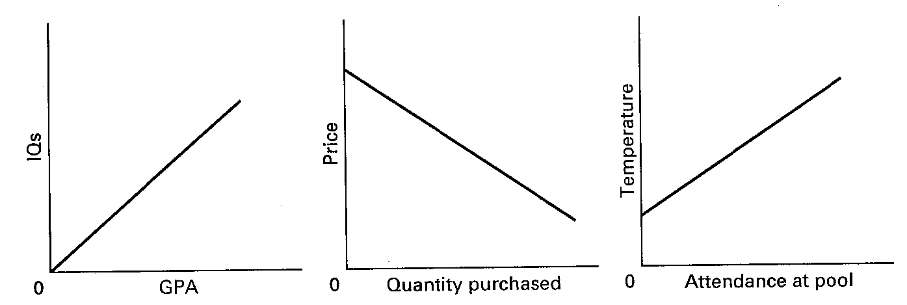
The direct relationships expected are (a) IQs and grade point averages, and (c) the temperature and the number of people at the pool. The inverse relationship expected is between price and quantity purchased.

These relationships could change if external conditions were changed to affect these relationships. For example, in (a) if high IQ students were forced to take the most difficult classes, the direct relationship might disappear; in (b) if high-priced products became very fashionable and were of far superior quality, people might actually buy more when prices rose; in (c) if the number of people in the pool was limited to a low number or if air pollution alerts accompanied high temperatures, the direct relationship between temperature and pool attendance might change.

73. Differentiate between the independent and dependent variables in an economic relationship.

The dependent variable changes as a consequence of the change in the independent variable. By specifying one variable as the dependent variable, a causal relationship is implied with changes in the independent variable causing changes in the dependent variable. The dependent variable is the “effect” or outcome.

74. Show graphically on the below graph the expected relationship between investment spending and interest rates. Put investment expenditures on the horizontal axis and the rate of interest on the vertical axis; connect the points and label the curve “Investment demand.” Describe this relationship between the rate of interest and investment expenditures. Describe the slope of the investment curve.

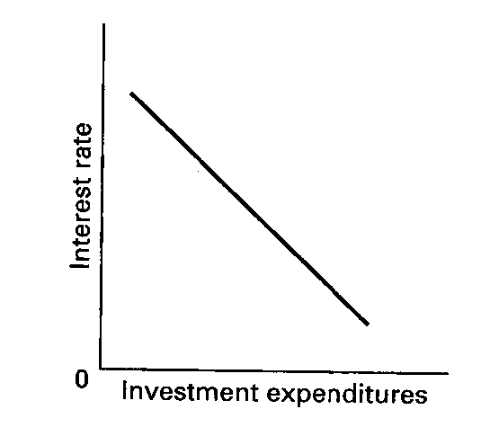
The relationship between the interest rate and investment expenditures is inverse. The slope of the investment curve is downsloping or negative.
Investment demand

75. State the definition for the slope of a straight line graph.

The ratio of the vertical change (the rise or fall) to the horizontal change (the run) in moving between two points on the line is called the slope of the line. The slope of an upsloping line is positive, reflecting a direct relationship between two variables; the slope of a downsloping line is negative, reflecting an inverse relationship.

76. Use the following table to answer the next three questions.
Consumption | Income
$15,000 | $ 20,000
30,000 | 40,000
45,000 | 60,000
60,000 | 80,000
75,000 | 100,000

(a) What would be the slope of the line if you graphed the relationship between consumption and income? (Consumption would be on the vertical axis and income on the horizontal axis.) Explain how the slope is calculated.
(b) How does the slope of this line reflect marginal changes? Give a numerical explanation.

(a) The line is linear. The slope of the line would be .75. From one point to another, the vertical change in the 15,000 and the horizontal change is 20,000, so 15,000/20,000 =.75.
(b) For every increase in income of $20,000, there is a marginal or extra increase in consumption of $15,000. So a change of $1 in income is associated with a marginal change of $0.75 in consumption.

77. A graph shows the quantity for Product A on the vertical axis and the quantity for Product B on the horizontal axis. What is the proper interpretation of a vertical line at a particular quantity for Product B that is parallel to the vertical axis of the graph? What is the slope of the vertical line?

The vertical line indicates that the two products are unrelated. There is no change in Product A for a given quantity of Product B. The slope of a vertical line is infinite.

78. A graph shows the quantity of corn on the vertical axis and the quantity of steel on the horizontal axis. What is the proper interpretation of a horizontal line at a particular quantity for corn that is parallel to the horizontal axis of the graph? What is the slope of the horizontal line?

The horizontal line indicates that the two products are unrelated. There is no change in the quantity of steel for a given quantity of corn. The slope of a horizontal line is zero.

79. There are two sets of x, y points on a straight line in a two-variable graph with y on the vertical axis and x on the horizontal axis. What would be the linear equation for the line if one set of points was (0, 9) and the other set was (13, 61)?

The linear equation is y = 9 + 4x.

80. The value of the vertical intercept is $150 and the slope is −25 in a linear equation for price and quantity demanded. If price is $5.00, what is the quantity demanded? State the linear equation and show how you found the answer.

The linear equation is quantity demanded = $150 − 25(price). Therefore: 25 = $100 − 15 ($5.00).

81. How do you determine the slope of a nonlinear curve? Will the slope be the same along the curve? Explain.

The slope of a curve at any point is determined by calculating the slope of a straight line tangent to the curve at that point. The slope will change as you move along the curve. The curve has a different slope at each point.

82. Using the below graph give the slopes of the straight lines tangent to the curve at points A, B, and C.

The slope at point A is 5/5 = 1, at B it is zero, at C it is −5/5 = −1. To find these slopes divide the vertical distance of the tangent by the horizontal distance. At point C the line slopes down, so the vertical distance is negative when the horizontal direction is positive.

