Test Bank
to accompany
Life: The Science of Biology, Eleventh Edition
Sadava • Hillis • Heller • Hacker

Chapter 1: Studying Life

TEST BANK QUESTIONS

Multiple Choice

1. The basic structural and physiological unit of most living organisms is the
a. aggregate.
b. organelle.
c. genome.
d. membrane.
e. cell.
Answer: e
Learning Outcome: 1.1.1.a Describe characteristics shared by all living things.
Bloom’s Level: 2. Understanding

2. Unmanned space probes are searching for signs of life on Mars. Which of the following would provide the best evidence for the presence of living organisms on Mars?
a. Carbon dioxide in the atmosphere
b. Different nucleic acids and amino acids from those found on Earth
c. Fatty acid molecules
d. Complex molecules containing genetic information
e. Simple organic molecules
Answer: d
Learning Outcome: 1.1.1.a Describe characteristics shared by all living things.
Bloom’s Level: 5. Evaluating

3. The seed of a desert plant may be dormant for many years without growing, but it is still considered to be alive because it
a. is always converting molecules.
b. contains a genome and is capable of growing into a fully functional organism.
c. is always regulating its internal environment.
d. is reproducing.
e. is extracting energy from its environment.
Answer: b
Learning Outcome: 1.1.1.a Describe characteristics shared by all living things.
Bloom’s Level: 2. Understanding

4. Which of the following statements about viruses is true?
a. They do not mutate or evolve.
b. They do not contain genetic information.
c. They carry out physiological functions on their own.
d. They depend on cellular organisms to reproduce.
e. They are composed of cells.
Answer: d
Learning Outcome: 1.1.1.a Describe characteristics shared by all living things.
Bloom’s Level: 4. Analyzing

5. Which is not a characteristic of most living organisms?
a. Regulation of internal environment
b. One or more cells
c. Ability to produce biological molecules
d. Ability to extract energy from the environment
e. Ability to change traits according to need
Answer: e
Learning Outcome: 1.1.1.a Describe characteristics shared by all living things.
Bloom’s Level: 2. Understanding

6. Earth is approximately _______ years old.
a. 5.5 million
b. 40–50 million
c. 4.5 billion
d. 5 trillion
e. 40 trillion
Answer: c
Learning Outcome: 1.1.2.a Describe current scientific thinking about the origin of life on Earth.
Bloom’s Level: 1. Remembering

7. There has been life on Earth for approximately _______ years.
a. 10,000
b. 4 million
c. 100 million
d. 1 billion
e. 4 billion
Answer: e
Learning Outcome: 1.1.2.a Describe current scientific thinking about the origin of life on Earth.
Bloom’s Level: 1. Remembering

8. The oldest rocks on Earth are approximately _______ years old.
a. 4,000‒5,000
b. 400,000‒500,000
c. 2–3 million
d. 4–4.5 billion
e. 8 billion
Answer: d
Learning Outcome: 1.1.2.a Describe current scientific thinking about the origin of life on Earth.
Bloom’s Level: 2. Understanding

9. The critical step for the evolution of life was the
a. formation of fatty acids.
b. formation of simple molecules.
c. appearance of proteins that could replicate themselves.
d. appearance of nucleic acids that could replicate themselves.
e. synthesis of proteins.
Answer: d
Learning Outcome: 1.1.2.a Describe current scientific thinking about the origin of life on Earth.
Bloom’s Level: 2. Understanding

10. Cells are characterized by
a. an aggregation of proteins.
b. the synthesis of proteins with stable shapes.
c. the enclosure of biological molecules by a membrane.
d. complex proteins being dissolved in water.
e. the formation of reactants and products.
Answer: c
Learning Outcome: 1.1.2.a Describe current scientific thinking about the origin of life on Earth.
Bloom’s Level: 2. Understanding

11. Refer to the figure below showing life’s “timeline.”

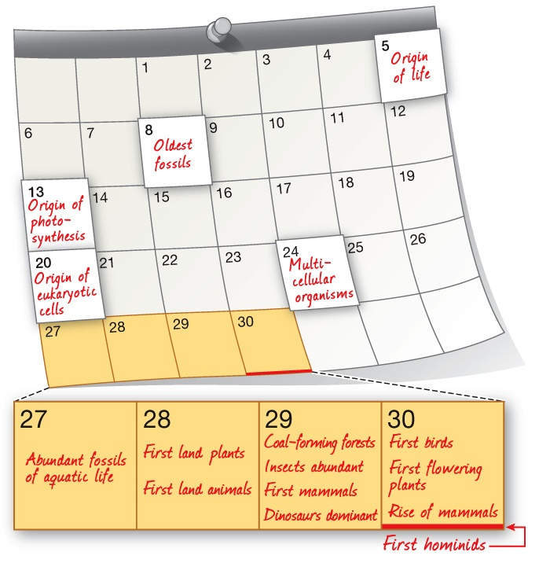

Based on the timeline, which statement is true?
a. The oldest fossils include photosynthesizers.
b. The first photosynthesizers were prokaryotic.
c. Multicellularity arose before the evolution of eukaryotic cells.
d. The oldest fossils include multicellular organisms.
e. The first photosynthesizers were multicellular.
Answer: b
Learning Outcome: 1.1.2.b Describe the earliest forms of life.
Bloom’s Level: 4. Analyzing

12. An abundance of O₂ led to the evolution of
a. photosynthetic eukaryotes.
b. aerobic eukaryotes.
c. anaerobic prokaryotes.
d. photosynthetic prokaryotes.
e. anaerobic eukaryotes.
Answer: b
Learning Outcome: 1.1.2.c Explain how photosynthesis influenced the history of life on Earth.
Bloom’s Level: 4. Analyzing

13. O₂ is critical for terrestrial life on Earth because it
a. allows for anaerobic metabolism.
b. blocks UV radiation.
c. provides energy to some basic forms of life.
d. provided food for early prokaryotes.
e. once led to production of ozone in the upper atmosphere.
Answer: e
Learning Outcome: 1.1.2.c Explain how photosynthesis influenced the history of life on Earth.
Bloom’s Level: 2. Understanding

14. The accumulation of _______ allowed organisms to grow larger.
a. O₂ in the atmosphere
b. CO₂ in the atmosphere
c. CO₂ in the water
d. O₃ in the atmosphere
e. O₃ in the water
Answer: a
Learning Outcome: 1.1.2.c Explain how photosynthesis influenced the history of life on Earth.
Bloom’s Level: 1. Remembering

15. Which statement about aerobic metabolism is false?
a. It is more efficient than anaerobic metabolism.
b. It can occur in O₂-rich environments.
c. It allows organisms to grow.
d. It is used by the majority of organisms on Earth today.
e. It provides protection from UV radiation.
Answer: e
Learning Outcome: 1.1.2.c Explain how photosynthesis influenced the history of life on Earth.
Bloom’s Level: 2. Understanding

16. Which event was most directly responsible for increasing oxygen in Earth’s atmosphere?
a. The cooling of the planet
b. The emergence of eukaryotes
c. The development of multicellularity
d. The evolution of photosynthesis
e. The rise of prokaryotes
Answer: d
Learning Outcome: 1.1.2.c Explain how photosynthesis influenced the history of life on Earth.
Bloom’s Level: 1. Remembering

17. Photosynthesis was a major evolutionary milestone for several reasons. One reason is that
a. photosynthetic organisms contributed ozone to the environment, which led to the evolution of aerobic organisms.
b. photosynthesis led to conditions that allowed life to arise on land.
c. photosynthesis is the only metabolic process that consumes oxygen.
d. photosynthesis provides oxygen for anaerobic organisms.
e. photosynthesis changed the levels of carbon dioxide in Earth’s atmosphere.
Answer: b
Learning Outcome: 1.1.2.c Explain how photosynthesis influenced the history of life on Earth.
Bloom’s Level: 2. Understanding

18. Refer to the figure below.

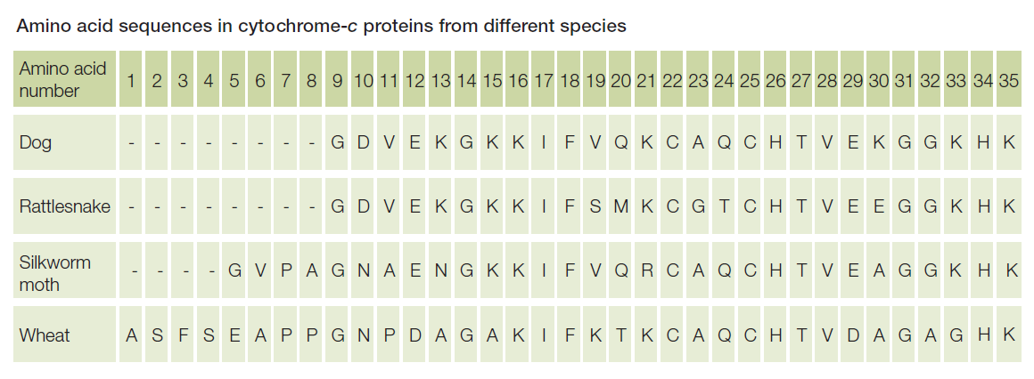

The figure compares data from four different organisms. The data include the first 35 amino acids that make up the protein cytochrome c, which functions in cellular respiration. Each capital letter represents a different amino acid. What do these data indicate about relationships among these four organisms?
a. The four organisms are unrelated because each has a unique sequence of amino acids that make up the cytochrome c protein.
b. All four organisms have a common origin because the same protein is found in all four with only small differences in structure among the four.
c. All four organisms have a common origin because cells in all four contain large and complex biomolecules that carry out metabolic reactions that sustain life.
d. Only rattlesnake and dog have a common origin because only their cytochrome c sequences are similar.
e. Only wheat is unrelated to the other three, as shown by differences in cytochrome c structures, because wheat is a plant and the others are animals.
Answer: b
Learning Outcome: 1.1.3.a Describe evidence that supports the common origin of all life on Earth.
Bloom’s Level: 4. Analyzing

19. Bacterial cells and human cells share many similar features. Which feature can be used as support for the claim that humans and bacteria have a common origin?
a. Both extract energy from their environment.
b. Both undergo cell division.
c. Both use chemical reactions to maintain the living state.
d. They contain proteins with similar compositions.
e. They have similar percentages of water.
Answer: d
Learning Outcome: 1.1.3.a Describe evidence that supports the common origin of all life on Earth.
Bloom’s Level: 3. Applying

20. Suppose a space probe is successful in discovering a living organism on a distant planet. Which would be the best approach to collect data that would show whether this organism shares a common origin with Earth organisms?
a. Observe the organism’s reproduction rate.
b. Test the organism’s ability to adapt to an Earth environment.
c. Analyze the chemical makeup of the organism’s genome.
d. Determine whether the organism can use oxygen in its metabolism.
e. Investigate whether a population of that type of organism is able to undergo evolutionary change.
Answer: c
Learning Outcome: 1.1.3.a Describe evidence that supports the common origin of all life on Earth.
Bloom’s Level: 5. Evaluating

21. Refer to the figure below showing DNA as life’s “blueprint.”

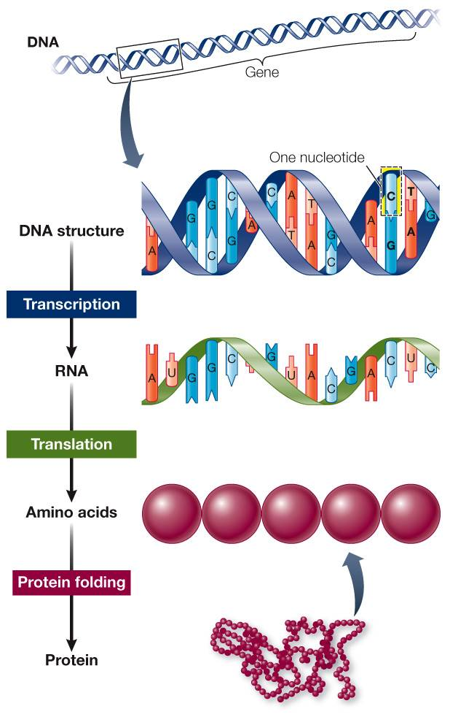

Which statement is not supported by evidence presented in the figure?
a. Genes are composed of DNA.
b. Information in DNA is used to construct proteins.
c. Nucleotides contain genetic information.
d. DNA is composed of nucleotides.
e. Proteins are composed of genes.
Answer: e
Learning Outcome: 1.1.3.b Explain the biological importance of the genetic code.
Bloom’s Level: 2. Understanding

22. The exposure of DNA to excessive levels of ultraviolet radiation produces dimers of thymine (a nucleotide); if unrepaired, these can lead to production of skin cancer. This mutation would
a. have no effect on genes.
b. have no effect on proteins.
c. affect both genes and proteins.
d. affect only proteins.
e. affect only genes.
Answer: c
Learning Outcome: 1.1.3.b Explain the biological importance of the genetic code.
Bloom’s Level: 3. Applying

23. The information needed to produce proteins is contained in
a. nutrients.
b. tissues.
c. evolution.
d. organs.
e. genes.
Answer: e
Learning Outcome: 1.1.3.b Explain the biological importance of the genetic code.
Bloom’s Level: 2. Understanding

24. The ultimate source of new genetic variation is
a. perfect replication of the genome.
b. mating.
c. artificial selection.
d. mutations in the genome.
e. structural adaptations.
Answer: d
Learning Outcome: 1.1.4.a Explain how natural selection can produce evolutionary change.
Bloom’s Level: 2. Understanding

25. Natural selection functions
a. by causing mutations in the genome.
b. by producing structural and functional changes within organisms.
c. through differential probabilities of survival and reproductive success.
d. through sexual selection and genetic drift.
e. by allowing unlimited growth of populations.
Answer: c
Learning Outcome: 1.1.4.a Explain how natural selection can produce evolutionary change.
Bloom’s Level: 2. Understanding

26. Change in the genetic makeup of populations over time is known as
a. evolution.
b. speciation.
c. growth.
d. ecological change.
e. global change.
Answer: a
Learning Outcome: 1.1.4.a Explain how natural selection can produce evolutionary change.
Bloom’s Level: 2. Understanding

27. The thorns on cacti are modified leaves and represent an example of a(n) _______
a. evolution.
b. binomial.
c. expressed gene.
d. genome.
e. adaptation.
Answer: e
Learning Outcome: 1.1.4.a Explain how natural selection can produce evolutionary change.
Bloom’s Level: 3. Applying

28. The toe pads of arboreal (tree) frogs and the webbed feet of aquatic frogs are examples of
a. genetic drift.
b. structural adaptations.
c. sexual selection.
d. artificial selection.
e. cooperation.
Answer: b
Learning Outcome: 1.1.4.a Explain how natural selection can produce evolutionary change.
Bloom’s Level: 3. Applying

29. Which is the feature or component of organisms that allows for their success in such a wide variety of environments on Earth?
a. Prokaryotic cells
b. Eukaryotic cells
c. Homeostasis
d. Adaptation
e. Model systems
Answer: d
Learning Outcome: 1.1.4.a Explain how natural selection can produce evolutionary change.
Bloom’s Level: 2. Understanding

30. Which does not contribute to adaptation in the wild?
a. Artificial selection
b. Genetic drift
c. Natural selection
d. Sexual selection
e. Environmental conditions
Answer: a
Learning Outcome: 1.1.4.a Explain how natural selection can produce evolutionary change.
Bloom’s Level: 2. Understanding

31. Which of the following is not true of life?
a. Life has a common ancestry.
b. Life is made up of living organisms.
c. Living organisms are all descended from a common origin.
d. Life has multiple origins.
e. Life has striking similarities across gene sequences.
Answer: d
Learning Outcome: 1.1.4.b Explain how scientists classify organisms according to evolutionary relationships.
Bloom’s Level: 2. Understanding

32. A species consists of
a. all the populations of different organisms that live together in a particular area.
b. all the populations found in a community.
c. a group of individuals of the same type of organism that share a common genome.
d. all the populations found in an ecosystem.
e. a group of individual organisms in an area that do not interact.
Answer: c
Learning Outcome: 1.1.4.b Explain how scientists classify organisms according to evolutionary relationships.
Bloom’s Level: 2. Understanding

33. The same DNA code is used by Archaea, Bacteria, and Eukarya. However, when the sequences of genes encoding proteins of similar function are compared, certain groups of genes in Eukarya are more similar to those in Archaea than to those in Bacteria, while other groups of genes in Eukarya are more similar to those in Bacteria than to those in Archaea. Which statement is consistent with these findings?
a. The origins of Archaea, Bacteria, and Eukarya are all different and unique from one another.
b. Archaea and Bacteria have the same common ancestor that differs from the one each shares with Eukarya.
c. Eukarya and Bacteria have the same common ancestor, and Eukarya and Archaea have the same common ancestor, but Archaea and Bacteria do not share a common ancestor.
d. Archaea, Bacteria, and Eukarya represent lineages that came from a single common ancestor.
e. Eukarya and Archaea have the same common ancestor that differs from the one each shares with Bacteria.
Answer: d
Learning Outcome: 1.1.4.b Explain how scientists classify organisms according to evolutionary relationships.
Bloom’s Level: 4. Analyzing

34. A node on a phylogenetic tree represents
a. an extinction event.
b. a hybridization event between two variants of a species.
c. a common ancestor of two lineages.
d. a die-off of a population.
e. a new generation.
Answer: c
Learning Outcome: 1.1.4.b Explain how scientists classify organisms according to evolutionary relationships.
Bloom’s Level: 1. Remembering

35. Species are given a distinctive scientific name formed from two Latin names called a
a. minimal.
b. biannual.
c. normal.
d. binomial.
e. polynomial.
Answer: d
Learning Outcome: 1.1.4.b Explain how scientists classify organisms according to evolutionary relationships.
Bloom’s Level: 1. Remembering

36. Which scientific name is written incorrectly?
a. Homo sapiens
b. Branta Canadensis
c. Acer saccharum
d. H. neanderthalensis
e. Canis lupus
Answer: b
Learning Outcome: 1.1.4.b Explain how scientists classify organisms according to evolutionary relationships.
Bloom’s Level: 3. Applying

37. A phylogenetic tree
a. classifies all plant species based on their habitats.
b. diagrams the evolutionary history of a particular group of organisms.
c. is based on binomial nomenclature.
d. only catalogues fossil plants.
e. only uses genome sequencing data.
Answer: b
Learning Outcome: 1.1.4.b Explain how scientists classify organisms according to evolutionary relationships.
Bloom’s Level: 2. Understanding

38. Once a phylogenetic tree has been constructed,
a. it cannot be changed.
b. it cannot be consolidated into any other phylogenetic tree.
c. it can be modified only using genetic data.
d. it can be modified only as organisms continue to evolve.
e. it can be modified or enlarged as new evidence warrants.
Answer: e
Learning Outcome: 1.1.4.b Explain how scientists classify organisms according to evolutionary relationships.
Bloom’s Level: 2. Understanding

39. Scientists’ ability to reconstruct evolutionary history has been most enhanced in recent decades by
a. new fossil-hunting techniques.
b. advances in anatomical dissection.
c. improved microscopic technologies.
d. accurate genetic sequencing techniques.
e. an increase in research in animal developmental biology.
Answer: d
Learning Outcome: 1.1.4.b Explain how scientists classify organisms according to evolutionary relationships.
Bloom’s Level: 1. Remembering

40. Evolutionary relationships among living organisms can be determined by comparing
a. their genomes.
b. their physiological states.
c. their life stages.
d. their genders.
e. their ages.
Answer: a
Learning Outcome: 1.1.4.b Explain how scientists classify organisms according to evolutionary relationships.
Bloom’s Level: 2. Understanding

41. You propose a set of experiments to test whether present-day chloroplasts originated from a single or multiple endosymbiotic events. Which experimental approach would provide the most detailed test of these hypotheses?
a. Testing whether different groups of photosynthetic organisms have similar pigments in their chloroplasts
b. Testing whether the chloroplasts of different groups of photosynthetic organisms have the same structure
c. Performing an instrumental test to determine whether the wavelengths of light absorption by chloroplast pigments are the same in different groups of photosynthetic organisms
d. Using structural chemistry to test whether the light-absorbing pigments in different groups of photosynthetic organisms are the same
e. Comparing the genomes of chloroplasts found in different groups of photosynthetic organisms to determine their evolutionary relationship to one another as well as to free-living species
Answer: e
Learning Outcome: 1.1.4.b Explain how scientists classify organisms according to evolutionary relationships.
Bloom’s Level: 5. Evaluating

42. Plants, fungi, and animals are most closely related to different groups of
a. protists.
b. endosymbiotic bacteria.
c. Archaea.
d. cyanobacteria.
e. inorganic molecules.
Answer: a
Learning Outcome: 1.1.4.b Explain how scientists classify organisms according to evolutionary relationships.
Bloom’s Level: 1. Remembering

43. Plants are
a. eukaryotic unicellular aerobes.
b. eukaryotic multicellular aerobes.
c. eukaryotic multicellular anaerobes.
d. prokaryotic unicellular anaerobes.
e. prokaryotic multicellular aerobes.
Answer: b
Learning Outcome: 1.1.4.b Explain how scientists classify organisms according to evolutionary relationships.
Bloom’s Level: 2. Understanding

44. Which group is most distantly related to protists?
a. Plants
b. Archaea
c. Birds
d. Fungi
e. Mammals
Answer: b
Learning Outcome: 1.1.4.b Explain how scientists classify organisms according to evolutionary relationships.
Bloom’s Level: 1. Remembering

45. A scientist has isolated the same gene from ten different species. Once these ten pieces of DNA have been sequenced, the scientist will line up the sequences to compare them. She should be able to draw conclusions about the evolutionary relationships among these ten species by using the following as a guide: The _______ the _______ in gene sequences for two species, the _______ the time span since these species diverged from a common ancestor during their evolution.
a. greater; similarities; shorter
b. fewer; similarities; shorter
c. greater; similarities; longer
d. fewer; differences; longer
e. greater; differences; shorter
Answer: a
Learning Outcome: 1.1.4.b Explain how scientists classify organisms according to evolutionary relationships.
Bloom’s Level: 2. Understanding

46. Refer to the diagram below showing the evolutionary tree of life.

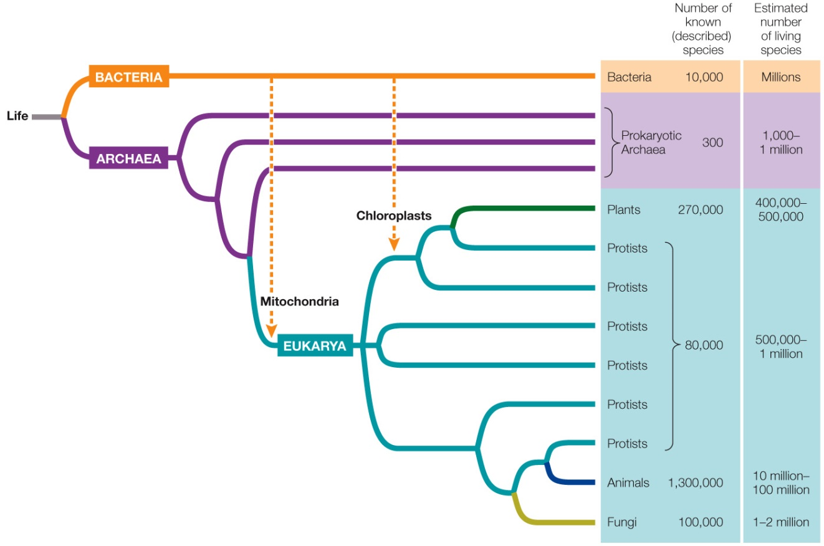

According to the relationships indicated by this phylogeny, which statement is true?
a. Animals are equally related to plants and fungi.
b. Animals are more closely related to fungi than they are to plants or any protists.
c. Fungi evolved more recently than did plants.
d. Most eukaryotes are protists.
e. Plants evolved more recently than did archaea.
Answer: c
Learning Outcome: 1.1.4.b Explain how scientists classify organisms according to evolutionary relationships.
Bloom’s Level: 4. Analyzing

47. Refer to the diagram below showing the evolutionary tree of life.

Which statement is supported by this diagram?
a. Plants contain chloroplasts but not mitochondria.
b. No members of Eukarya contain both mitochondria and chloroplasts.
c. Chloroplasts are found in bacteria.
d. Mitochondria evolved before chloroplasts.
e. Mitochondria are found in bacteria.
Answer: d
Learning Outcome: 1.1.4.b Explain how scientists classify organisms according to evolutionary relationships.
Bloom’s Level: 4. Analyzing

48. In the names of organisms, the _______ is placed first and the _______ is placed second.
a. species; genus
b. genus; domain
c. domain; genus
d. genus; species
e. domain; species
Answer: d
Learning Outcome: 1.1.4.b Explain how scientists classify organisms according to evolutionary relationships.
Bloom’s Level: 1. Remembering

49. Which factors are taken into consideration in the biological classification of organisms?
a. Physical characteristics only
b. Molecular characteristics only
c. Physical characteristics and fossil records only
d. Physical characteristics and molecular characteristics only
e. Physical characteristics, fossil records, and molecular characteristics
Answer: e
Learning Outcome: 1.1.4.b Explain how scientists classify organisms according to evolutionary relationships.
Bloom’s Level: 1. Remembering

50. Some plants have a vascular system composed of a type of tissue called vascular tissue. Plant vascular tissue functions to carry water, minerals, and nutrients to cells throughout the plant. In an analogous way, some animals have a vascular system, which is composed of several types of tissues that function collectively to move water, minerals, and nutrients to cells throughout the animal’s body. Which statement makes an accurate comparison of plant and animal vascular systems?
a. Because both systems have the same basic function, they are composed of cells that are structurally similar.
b. Both plant and animal vascular systems evolved from a common origin, because they share the same biological function.
c. Animals are more complex than plants, implying that the vascular systems in animals are more complex than the vascular systems in plants.
d. The vascular systems in plants are not true vascular systems like those in animals, because plants do not have hearts.
e. Both systems evolved as the result of cell differentiation that took different paths in plants and animals but resulted in similar functions.
Answer: e
Learning Outcome: 1.1.4.c Describe cellular differentiation and its significance to the range of living things observed today.
Bloom’s Level: 3. Applying

51. Refer to the figure below showing changes in the diversity of vertebrate life forms inhabiting Earth over its history.

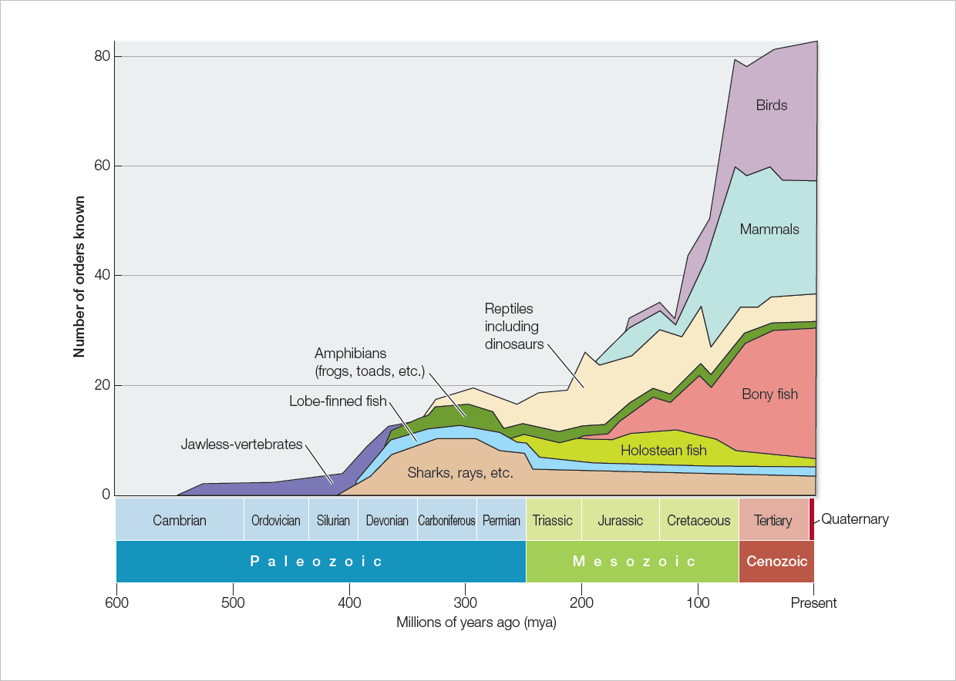

Which statement is accurate and also describes factors that most contributed to the trend depicted in the figure?
a. The range of animal body forms increased tremendously over the history of life on Earth because cell differentiation opened up new structural possibilities.
b. Over time, animals have experienced increasing survival rates because evolution moves in the direction of improving on past forms.
c. Simple vertebrates slowly evolved into more complex vertebrates, because the more complex forms are more highly evolved.
d. Biologists are less able to document the variety of life forms that inhabited Earth the farther back in time they search for clues.
e. The environment on Earth has changed: it was least hospitable to life in its earliest stages but has grown more and more hospitable to life over its long history.
Answer: a
Learning Outcome: 1.1.4.c Describe cellular differentiation and its significance to the range of living things observed today.
Bloom’s Level: 5. Evaluating

52. Which feature is the same in muscle cells and gut cells?
a. Cell function
b. Local cell environment
c. Expressed genes
d. Genome
e. Proteins formed
Answer: d
Learning Outcome: 1.1.4.c Describe cellular differentiation and its significance to the range of living things observed today.
Bloom’s Level: 2. Understanding

53. Which provides evidence of the ability of cells to become specialized?
a. Replacing the nucleus in a sheep’s cell with the nucleus from a mouse cell results in a cell with characteristics of a mouse cell.
b. Cells removed from a multicellular animal can undergo cell division in culture dishes indefinitely when provided a continued source of nutrients.
c. Cells from a mouse embryo can be isolated and used to repair an injury in the central nervous system of an adult mouse.
d. A virus can infect a human cell and insert some of its DNA into a human chromosome, where it will be replicated and carried along during division of the human cell.
e. Mouse cells grown in culture dishes undergo cell division at a slower rate at temperatures colder than 37°C.
Answer: c
Learning Outcome: 1.1.4.d Use evidence to explain the ability of cells to become specialized and to contribute a unique function to the organism.
Bloom’s Level: 3. Applying

54. A group of cells that work together to carry out a similar function is known as a(n)
a. tissue.
b. organ system.
c. unicellular organism.
d. protein.
e. gene.
Answer: a
Learning Outcome: 1.1.4.d Use evidence to explain the ability of cells to become specialized and to contribute a unique function to the organism.
Bloom’s Level: 1. Remembering

55. Refer to the figure below.

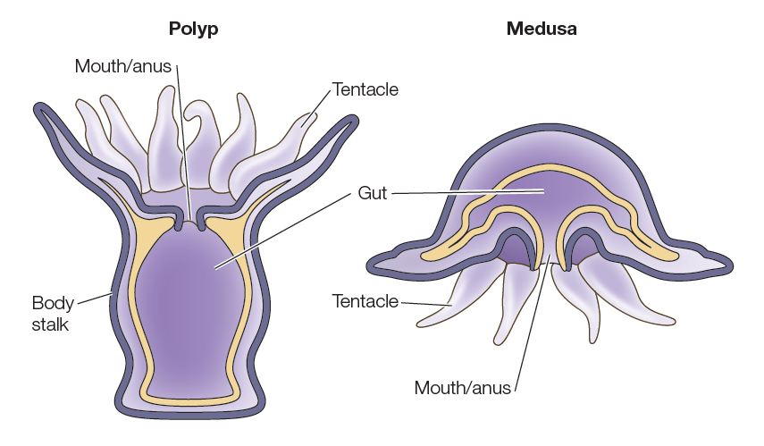

The Cnidaria are simple marine animals that have either of the two basic body plans shown in the figure. You may be familiar with sea anemones, which have the body plan shown on the left, and you are likely familiar with jellyfish, which have the body plan shown on the right. What feature shared by both of these cnidarians could have been important in providing the conditions that enabled the rise of multicellularity on Earth?
a. Marine habitat
b. Tentacles
c. Shared mouth and anus
d. Separate internal and external layers
e. Symmetrical body shape
Answer: d
Learning Outcome: 1.1.4.e Describe how the rise of multicellular life required an internal environment in which the needs of body cells could be served by specialized cells.
Bloom’s Level: 3. Applying

56. Scientists hypothesize that multicellularity evolved when groups of cells exposed to an internal environment specialized to perform tasks needed by groups of cells exposed to the external environment, and vice versa. Which biological structures existing today could be used as examples to explain this concept?
a. The blood cells moving in a fish’s circulatory system and the fish’s lung tissue
b. The lining of a snake’s intestine and the snake’s skin
c. The bark on an oak tree and the waxy cuticle on an oak leaf
d. The trachea (airway) in a blackbird’s neck and the heart in the blackbird’s chest
e. The whiskers on a cat’s face and the fur on the cat’s tail
Answer: b
Learning Outcome: 1.1.4.e Describe how the rise of multicellular life required an internal environment in which the needs of body cells could be served by specialized cells.
Bloom’s Level: 3. Applying

57. Of the following, which is the smallest biological entity that maintains homeostasis?
a. Molecule
b. Cell
c. Tissue
d. Organ
e. Organism
Answer: b
Learning Outcome: 1.1.4.f Explain why cell activities and organs have to be regulated in order to maintain homeostasis.
Bloom’s Level: 2. Understanding

58. Homeostasis is
a. the mechanism by which organisms acquire nutrients from the environment.
b. the maintenance of a narrow range of internal conditions.
c. the sensory system of an organism.
d. the mechanical movement of molecules from one cellular location to another.
e. the maintenance of extracellular fluids.
Answer: b
Learning Outcome: 1.1.4.f Explain why cell activities and organs have to be regulated in order to maintain homeostasis.
Bloom’s Level: 1. Remembering

59. Which is not an attribute of homeostasis in a multicellular organism?
a. Maintaining a stable internal environment
b. Maintaining the extracellular fluid within a range of physical conditions
c. Maintaining a stable external environment
d. Physiological systems that can change in response to regulatory signals
e. Physiological systems that work cooperatively
Answer: c
Learning Outcome: 1.1.4.f Explain why cell activities and organs have to be regulated in order to maintain homeostasis.
Bloom’s Level: 2. Understanding

60. Which represents the correct order of the levels of complexity at which life is studied, from most inclusive to least inclusive?
a. Cell, tissue, organ, organism, population, community
b. Community, population, organ, organism, tissue, cell
c. Community, population, organism, organ, tissue, cell
d. Community, organism, population, organ, tissue, cell
e. Community, organism, population, cell, organ, tissue
Answer: c
Learning Outcome: 1.1.4.g Describe the hierarchy of the biological world.
Bloom’s Level: 2. Understanding

61. Refer to the image below.
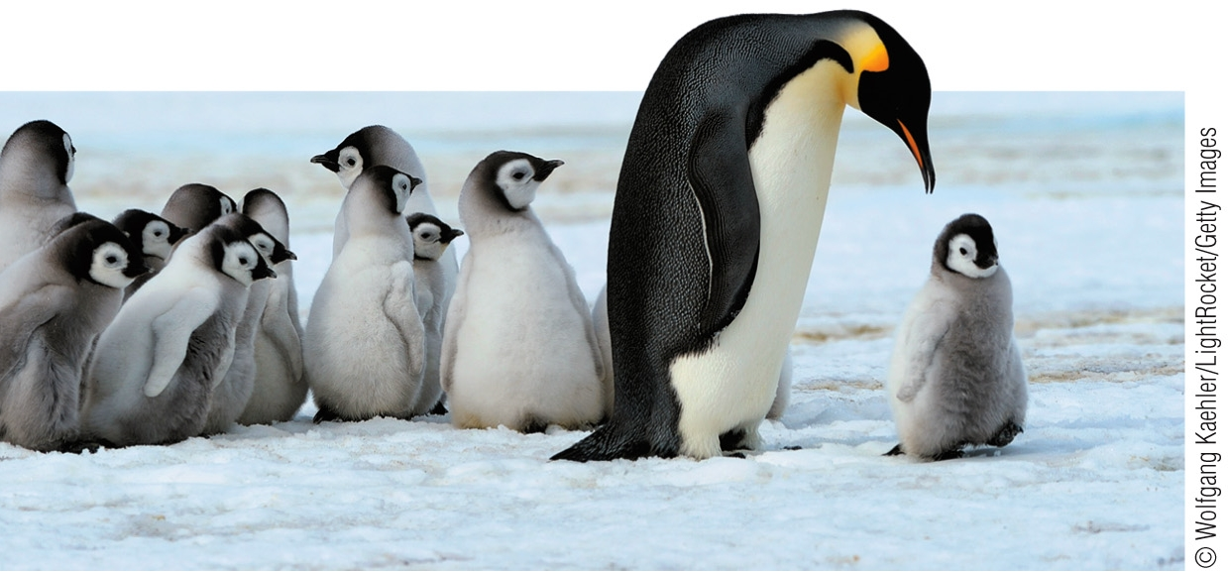

Which is the smallest (lowest) level of biological organization that is visible and easily distinguished?
a. Community
b. Organism
c. Molecule
d. Cell
e. Population
Answer: b
Learning Outcome: 1.1.4.g Describe the hierarchy of the biological world.
Bloom’s Level: 3. Applying

62. Which usually results from a scientific investigation?
a. Proof of the hypothesis
b. Refinement of the experimental design to produce qualitative data
c. Formulation of new questions that result in additional experimentation
d. Repetition of statistical tests to verify results
e. Development of additional technologies to meet the needs of scientists
Answer: c
Learning Outcome: 1.2.1.b Explain the roles of inductive logic and deductive logic in scientific inquiry.
Bloom’s Level: 4. Analyzing

63. Which is not one of the major steps in the approach that uses a hypothesis and then a prediction?
a. Stating an opinion
b. Forming a hypothesis
c. Making an observation
d. Asking a question
e. Testing a prediction
Answer: a
Learning Outcome: 1.2.1.b Explain the roles of inductive logic and deductive logic in scientific inquiry.
Bloom’s Level: 2. Understanding

64. After observing that fish live in clean water but not in polluted water, researchers state that “polluted water kills fish.” Scientifically, this statement is an example of a(n)
a. fact.
b. observation.
c. opinion.
d. theory.
e. hypothesis.
Answer: e
Learning Outcome: 1.2.1.b Explain the roles of inductive logic and deductive logic in scientific inquiry.
Bloom’s Level: 3. Applying

65. A biologist listens to frogs singing at a local pond and hypothesizes that the sounds are mating calls. What would be the next step in the hypothesis-and-prediction method?
a. Controlling an environment
b. Making an observation
c. Forming a hypothesis
d. Making a prediction
e. Testing a prediction
Answer: d
Learning Outcome: 1.2.1.b Explain the roles of inductive logic and deductive logic in scientific inquiry.
Bloom’s Level: 3. Applying

66. A biologist hypothesizes that the sounds made by lions at night in the Serengeti are territoriality calls and predicts that two lions inhabiting the same territory will roar even louder. She selects an area inhabited by one lion, records its calls, and plays them back in the same area. She records her observations and notes that the lion does indeed roar more often as a result of this experiment. What would be the next step in the hypothesis-and-prediction method?
a. Asking new questions
b. Making an observation
c. Forming a hypothesis
d. Making a prediction
e. Testing a prediction
Answer: a
Learning Outcome: 1.2.1.b Explain the roles of inductive logic and deductive logic in scientific inquiry.
Bloom’s Level: 3. Applying

67. The main purpose of any single experiment is to
a. obtain accurate quantitative measurements.
b. prove unambiguously that a particular hypothesis is correct.
c. avoid a merely comparative analysis.
d. answer as many key questions as possible.
e. test a prediction that is based on a hypothesis.
Answer: e
Learning Outcome: 1.2.1.b Explain the roles of inductive logic and deductive logic in scientific inquiry.
Bloom’s Level: 2. Understanding

68. A rapid decline of amphibian populations has been observed worldwide. Which could not be one of the proposed hypotheses related to this decline?
a. A fungal disease is the cause.
b. Increased exposure to ultraviolet radiation is the cause.
c. Exposure to agricultural chemicals is the cause.
d. Exposure to an oil spill is the cause.
e. Frogs die naturally.
Answer: e
Learning Outcome: 1.2.1.b Explain the roles of inductive logic and deductive logic in scientific inquiry.
Bloom’s Level: 3. Applying

69. Which question cannot be answered by means of the hypothesis-and-prediction approach?
a. Are eastern meadowlark populations declining faster than western meadowlark populations?
b. Is the song of the western meadowlark prettier than that of the eastern meadowlark?
c. Do eastern and western meadowlarks interbreed?
d. Do meadowlarks benefit from prairie habitat restoration?
e. Have the migration paths of western meadowlarks been affected by climate change?
Answer: b
Learning Outcome: 1.2.1.b Explain the roles of inductive logic and deductive logic in scientific inquiry.
Bloom’s Level: 3. Applying

70. Refer to the diagram below showing the steps in the scientific method.

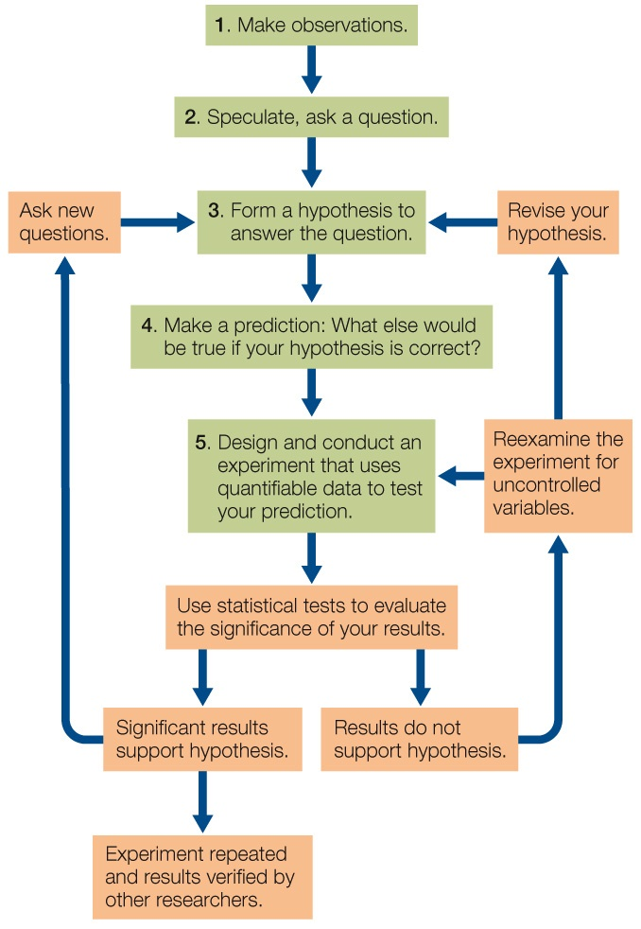

Which step in the diagram best illustrates the use of inductive logic?
a. 1
b. 2
c. 3
d. 4
e. 5
Answer: c
Learning Outcome: 1.2.1.b Explain the roles of inductive logic and deductive logic in scientific inquiry.
Bloom’s Level: 2. Understanding

71. Refer to the graph below showing the results of a study that exposed male frogs to atrazine, a chemical used in killing weeds in agricultural areas.
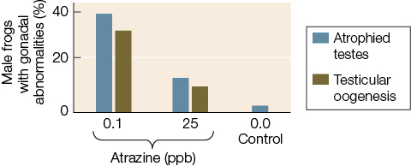

According to the data in the graph, higher atrazine concentrations do not result in a higher rate of gonadal abnormality. Which conclusion can be drawn from these results?
a. Low levels of atrazine are not as dangerous to amphibians as high levels of atrazine.
b. A dosage of 15 ppb would cause a rate of abnormality between the one caused by the 0.1 ppb dosage and the one caused by the 25 ppb dosage.
c. The effect of the atrazine exposure is not proportional to the level of exposure.
d. Atrazine is only hazardous in a natural ecosystem, where it is naturally diluted in the waterways.
e. Atrazine usage should be banned.
Answer: c
Learning Outcome: 1.2.1.b Explain the roles of inductive logic and deductive logic in scientific inquiry.
Bloom’s Level: 4. Analyzing

72. Which is not a step in the scientific method?
a. Observing
b. Recording quantitative data
c. Discarding data that disprove a hypothesis
d. Formulating a hypothesis
e. Asking questions
Answer: c
Learning Outcome: 1.2.1.b Explain the roles of inductive logic and deductive logic in scientific inquiry.
Bloom’s Level: 2. Understanding

73. The advantage of controlled scientific experiments is that
a. all variables except one are held constant.
b. the hypothesis can be proven correct.
c. patterns can be predicted.
d. investigations can be carried out in the field.
e. a massive amount of data can be synthesized.
Answer: a
Learning Outcome: 1.2.1.c Describe how a controlled experiment is designed.
Bloom’s Level: 5. Evaluating

74. Which is a characteristic of a comparative experiment?
a. It has only independent variables.
b. It has only one dependent variable.
c. It compares one independent variable with one dependent variable.
d. It starts with groups or samples that are as similar as possible.
e. It starts with the prediction that there will be a difference between groups or samples.
Answer: e
Learning Outcome: 1.2.1.d Differentiate between controlled experiments and comparative experiments.
Bloom’s Level: 2. Understanding

75. A researcher collected frog and water samples from eight widely separated sites across the United States and studied the incidence of abnormalities in frogs exposed to different levels of the herbicide atrazine. This was a(n) _______ experiment.
a. comparative
b. controlled
c. inductive
d. logic
e. deductive
Answer: a
Learning Outcome: 1.2.1.d Differentiate between controlled experiments and comparative experiments.
Bloom’s Level: 2. Understanding

76. A statistical test starts with
a. a null hypothesis.
b. deductive logic.
c. inductive logic.
d. a hypothesis.
e. a model system.
Answer: a
Learning Outcome: 1.2.1.e Explain how statistics are used in biological investigations.
Bloom’s Level: 2. Understanding

77. Refer to the table below.

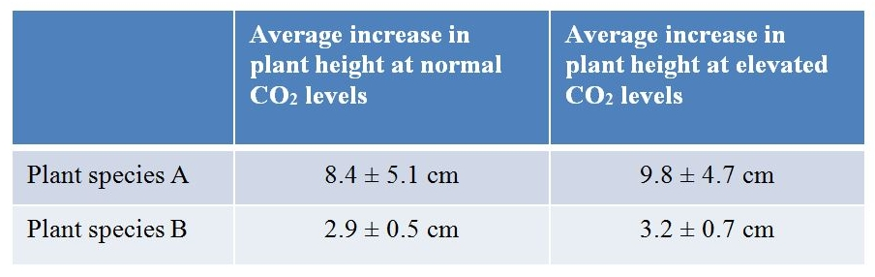
A biologist studied plant growth using two plant species grown over a 2-week period. For each species, 20 plants were used, randomly split into control and experimental groups. Except for CO₂ exposure, conditions were identical for all plants. The table summarizes results as average height increase, along with a plus/minus value indicating the range of individual plant heights measured. Which is the null hypothesis that would be developed when using statistics to analyze these results?
a. The growth rates of certain species of plants are more influenced by CO₂ levels than others.
b. Differences in growth rate at the different CO₂ levels could be due to random variations in the samples of both species.
c. All plants show variation in growth rate when environmental variables are changed.
d. Carbon dioxide is one of many variables that can influence plant growth rate.
e. The effect of CO₂ on plant growth rate depends on the species of plant being investigated.
Answer: b
Learning Outcome: 1.2.1.e Explain how statistics are used in biological investigations.
Bloom’s Level: 3. Applying

78. Bacteria can be used as a model system to study chemical reactions in cells. These reactions can be related to similar processes in humans because bacteria and humans
a. share a genetic code.
b. are both prokaryotes.
c. have exactly the same genome.
d. have the same number of chromosomes.
e. share the same habitat.
Answer: a
Learning Outcome: 1.2.1.f Explain why model organisms are used in biological research.
Bloom’s Level: 2. Understanding

79. Much of what we know about the biochemistry of photosynthesis was discovered in experiments with
a. fruit flies.
b. zebrafish.
c. roundworms.
d. Arabidopsis.
e. Chlorella.
Answer: e
Learning Outcome: 1.2.1.f Explain why model organisms are used in biological research.
Bloom’s Level: 1. Remembering

80. Scientific explanations for a natural phenomenon
a. can be tested only in the laboratory.
b. are always based on an ethical point of view.
c. are based on reproducible and quantifiable observations.
d. are based on untested hypotheses.
e. cannot be rejected.
Answer: c
Learning Outcome: 1.2.1.g Explain the difference between science and non-science.
Bloom’s Level: 2. Understanding

81. Which statement represents a scientific point of view?
a. Earth was created by a supernatural force.
b. The positions of the sun, moon, and stars provide guidance for making decisions.
c. Inner strength comes from the beauty in nature.
d. Meditation helps to solve health problems.
e. Testing the effect of antibiotics on E. coli can help prevent deaths from food poisoning.
Answer: e
Learning Outcome: 1.2.1.g Explain the difference between science and non-science.
Bloom’s Level: 3. Applying

82. Many possible applications of scientific knowledge raise ethical issues for some people. Which application, however, would be rejected by all responsible scientists?
a. Selecting the sex of one’s children
b. Using stem cells as part of medical treatments
c. Modifying the human genome
d. Using scientific knowledge to dictate how the world ought to be
e. Moving genes from one organism to another
Answer: d
Learning Outcome: 1.2.1.g Explain the difference between science and non-science.
Bloom’s Level: 5. Evaluating

83. In which organisms have modern agricultural practices been used to develop new breeds or strains?
a. Animals
b. Plants
c. Fungi and plants
d. Animals and plants
e. Animals, plants, and fungi
Answer: e
Learning Outcome: 1.3.1.a Explain the relevance of biology to people’s daily lives.
Bloom’s Level: 1. Remembering

84. Which scientific field is providing us with knowledge that will help in the control of possible future tuberculosis epidemics?
a. Fungal bioinformatics
b. Agricultural biology
c. Plant genomics
d. Marine ecology
e. Molecular biology
Answer: e
Learning Outcome: 1.3.1.a Explain the relevance of biology to people’s daily lives.
Bloom’s Level: 1. Remembering

85. New vaccines to protect against the influenza virus are developed every year because of the virus’s
a. high rate of infection.
b. high rate of evolution.
c. long generation time.
d. low mutation rate.
e. short life span.
Answer: b
Learning Outcome: 1.3.1.a Explain the relevance of biology to people’s daily lives.
Bloom’s Level: 2. Understanding

86. Which problem is directly related to global climate change?
a. Development of antibiotic-resistant bacteria
b. Overfishing of bluefin tuna
c. Engineering of drought-resistant crops
d. Consumption of fossil fuels
e. Genetic diseases
Answer: d
Learning Outcome: 1.3.1.a Explain the relevance of biology to people’s daily lives.
Bloom’s Level: 3. Applying

87. Overfishing in the Atlantic bluefin tuna breeding ground has resulted in a serious decline in the tuna’s population. In response, an international commission drew a line down the middle of the Atlantic Ocean with the intent of allowing western populations of bluefin tuna to recover by restricting fishing quotas in that hemisphere. Why did this policy fail to achieve the desired result?
a. Tracking data showed that the tuna’s breeding ground is identical to its feeding ground.
b. Tracking data showed that western bluefin tuna feed all across the Atlantic Ocean.
c. Tracking data showed that eastern and western bluefin tuna populations are geographically isolated in terms of their feeding grounds.
d. No tuna caught on the eastern side of the line were from the western breeding population.
e. All tuna caught on the western side of the line were from the eastern breeding population.
Answer: b
Learning Outcome: 1.3.1.a Explain the relevance of biology to people’s daily lives.
Bloom’s Level: 4. Analyzing

88. Which is not a direct concern for biologists?
a. The origin of the universe
b. The extraction and consumption of fossil fuels
c. The rate of change in the world’s ecosystems
d. The increase in anthropogenic carbon dioxide in the atmosphere
e. The rapid rate of climate warming
Answer: a
Learning Outcome: 1.3.1.a Explain the relevance of biology to people’s daily lives.
Bloom’s Level: 2. Understanding

89. The term “anthropogenic” refers to
a. human-caused fires.
b. the study of insects.
c. human-generated effects upon the environment.
d. the study of human biology.
e. the study of agriculture.
Answer: c
Learning Outcome: 1.3.1.a Explain the relevance of biology to people’s daily lives.
Bloom’s Level: 1. Remembering

90. A young child becomes very ill and is taken for medical evaluation. The analysis reveals a genetic disorder, and he is sent home with medication to alleviate his symptoms. Other members of the family are concerned about how the child’s illness can affect them. Which statement provides reasonable advice to these family members?
a. Isolate the sick child as much as possible to prevent any other family members from contracting the illness.
b. Have only adult family members come into contact with the sick child, and keep younger members of the family away from the child and any of his things.
c. Allow family members to interact with the child as long as they avoid contact with his body fluids and wash their hands immediately after interactions with him.
d. Give everyone in the family the same medication as the child to prevent their contracting the illness from the child.
e. Assure all family members that the illness is not contagious and that the best course of action is to make the child as comfortable as possible and stick to the prescribed dosage and timing when administering his medication.
Answer: e
Learning Outcome: 1.3.1.b Apply biological knowledge to answer a question that pertains to everyday life.
Bloom’s Level: 5. Evaluating

Fill in the Blank

91. _______ are the basic structural and physiological units of living organisms.
Answer: Cells
Learning Outcome: 1.1.1.a Describe characteristics shared by all living things.
Bloom’s Level: 1. Remembering

92. In the course of evolution, fatty acids were the critical ingredient in the enclosure of biological molecules in membranous films because these molecules are not _______ in water.
Answer: soluble
Learning Outcome: 1.1.2.a Describe current scientific thinking about the origin of life on Earth.
Bloom’s Level: 1. Remembering

93. The two membrane-enclosed compartments within cells that are thought to have arisen from prokaryotes engulfing other prokaryotes are mitochondria and _______.
Answer: chloroplasts
Learning Outcome: 1.1.2.a Describe current scientific thinking about the origin of life on Earth.
Bloom’s Level: 2. Understanding

94. Single-celled organisms that lack discrete intracellular compartments belong to the groups Archaea and _______.
Answer: Bacteria
Learning Outcome: 1.1.2.b Describe the earliest forms of life.
Bloom’s Level: 1. Remembering

95. In contrast to eukaryotic cells, prokaryotes lack intracellular compartments referred to as _______.
Answer: organelles
Learning Outcome: 1.1.2.b Describe the earliest forms of life.
Bloom’s Level: 1. Remembering

96. The use of energy from sunlight to synthesize complex molecules is known as _______.
Answer: photosynthesis
Learning Outcome: 1.1.2.c Explain how photosynthesis influenced the history of life on Earth.
Bloom’s Level: 1. Remembering

97. The sum total of all the chemical transformations and other work done in a living organism is called its _______.
Answer: metabolism
Learning Outcome: 1.1.2.c Explain how photosynthesis influenced the history of life on Earth.
Bloom’s Level: 1. Remembering

98. Scientists have been able to show that organisms as different as fruit flies and dogs share a majority of their genes. In these investigations, scientists compare the DNA of two or more organisms by looking for similarities in nucleotide _______.
Answer: sequences
Learning Outcome: 1.1.3.a Describe evidence that supports the common origin of all life on Earth.
Bloom’s Level: 3. Applying

99. The total of all the information encoded by an organism’s genes constitutes its _______.
Answer: genome
Learning Outcome: 1.1.3.b Explain the biological importance of the genetic code.
Bloom’s Level: 1. Remembering

100. The change in genetic makeup of biological populations through time is called _______.
Answer: evolution
Learning Outcome: 1.1.4.a Explain how natural selection can produce evolutionary change.
Bloom’s Level: 1. Remembering

101. Charles Darwin called the differential survival and reproduction among individuals in a population _______.
Answer: natural selection
Learning Outcome: 1.1.4.a Explain how natural selection can produce evolutionary change.
Bloom’s Level: 1. Remembering

102. _______ are structural, physiological, or behavioral traits that enhance an organism’s chance of survival and reproduction in its environment.
Answer: Adaptations
Learning Outcome: 1.1.4.a Explain how natural selection can produce evolutionary change.
Bloom’s Level: 1. Remembering

103. A Pacific tree frog has the scientific nomenclature Hyla regilla. This particular tree frog belongs to the genus _______.
Answer: Hyla
Learning Outcome: 1.1.4.b Explain how scientists classify organisms according to evolutionary relationships.
Bloom’s Level: 3. Applying

104. The three major groups of multicellular eukaryotes are the plants, animals, and fungi. They evolved independently from different groups of unicellular eukaryotes generally known as _______.
Answer: protists
Learning Outcome: 1.1.4.b Explain how scientists classify organisms according to evolutionary relationships.
Bloom’s Level: 1. Remembering

105. Genome sequencing and other molecular techniques have allowed biologists to study the evolution and classification of life’s diverse organisms. By examining the fossil record and by identifying similarities and differences among living species, they have been able to construct _______ trees to diagram evolutionary relationships.
Answer: phylogenetic
Learning Outcome: 1.1.4.b Explain how scientists classify organisms according to evolutionary relationships.
Bloom’s Level: 1. Remembering

106. A group of individuals of the same species that interact is called a population, a group of populations of different species that live and interact in the same area make up a community, and communities together with the nonliving environment constitute a(n) _______.
Answer: ecosystem
Learning Outcome: 1.1.4.g Describe the hierarchy of the biological world.
Bloom’s Level: 3. Applying

107. A claim has been made that populations of songbirds in a forest ecosystem will decline as the result of proposed increases in human activity in a nearby area. One means of testing this claim would be to collect quantifiable _______ on the bird populations before the human activity begins and at various times after.
Answer: data
Learning Outcome: 1.2.1.a Explain the role of observation in scientific inquiry.
Bloom’s Level: 3. Applying

108. Refer to the diagram below showing the steps in the scientific method.

Step 4 illustrates the use of _______ logic.
Answer: deductive
Learning Outcome: 1.2.1.b Explain the roles of inductive logic and deductive logic in scientific inquiry.
Bloom’s Level: 2. Understanding

109. After observing new data, scientists apply _______ logic in order to propose a possible explanation, which is called a hypothesis.
Answer: inductive
Learning Outcome: 1.2.1.b Explain the roles of inductive logic and deductive logic in scientific inquiry.
Bloom’s Level: 3. Applying

110. A scientist is designing an experiment to test a bacterium’s ability to use carbon sources other than glucose for nourishment. She inoculates four different flasks with samples of the bacterium and observes whether the bacteria grow. All of the flasks contain minimal media plus a carbon source. The carbon source is glucose in flask A, arabinose in flask B, galactose in flask C, and lactose in flask D. Flask A is a _______ in this experiment.
Answer: control
Learning Outcome: 1.2.1.c Describe how a controlled experiment is designed.
Bloom’s Level: 3. Applying

111. Frogs are amphibians and spend time both on land and in water. Female frogs are vulnerable to predation by fish when they enter the water to lay eggs. A hypothesis has been proposed that frogs rely on chemical detection of predators in addition to visual detection. In other words, frogs detect the presence of predator fish by chemicals released by fish into the water. In designing an experiment to test this hypothesis, a scientist constructed two test ponds that were identical except for the presence of compounds released by fish. This condition was the only _______ that differed in the two setups used in the experiment.
Answer: variable
Learning Outcome: 1.2.1.c Describe how a controlled experiment is designed.
Bloom’s Level: 3. Applying

112. Platelets are cell fragments that are critical for blood clotting, a process that involves the release of proteins from platelet storage granules. Platelet granules contain approximately 300 different proteins. One hypothesis about the packaging of proteins into these granules is that each protein is delivered in precisely measured amounts to each granule. An alternative hypothesis is that each protein is targeted to the individual storage granules randomly. The second hypothesis is an example of a(n) _______ hypothesis.
Answer: null
Learning Outcome: 1.2.1.e Explain how statistics are used in biological investigations.
Bloom’s Level: 3. Applying

113. Because of the similarities shared by many life forms, scientific knowledge gained about one type of organism can often be generalized to other organisms. Biologists studying photosynthesis, for example, have experimented with the Chlorella alga, knowing that they could extend their findings to plants. In this case, photosynthesis in the alga was considered a _______ system.
Answer: model
Learning Outcome: 1.2.1.f Explain why model organisms are used in biological research.
Bloom’s Level: 2. Understanding

114. The study of cellular metabolism in the bacterium Escherichia coli has allowed scientists to understand many cellular reactions that take place in human cells as well. This is an example of how biologists use model systems to extend their findings to many different types of _______.
Answer: organisms
Learning Outcome: 1.2.1.f Explain why model organisms are used in biological research.
Bloom’s Level: 2. Understanding

115. Changes in the global climate, leading to the extinctions of large numbers of species and the spread of new and old diseases, are caused largely by the activities of _______.
Answer: humans
Learning Outcome: 1.3.1.a Explain the relevance of biology to people’s daily lives.
Bloom’s Level: 2. Understanding

Short Answer/Essay

116. What hypothesis has been proposed to explain the emergence of eukaryotic cells?
Answer: Eukaryotic cells contain a number of membrane-bound organelles. It is hypothesized that organelles such as mitochondria and chloroplasts evolved from engulfed prokaryotic organisms that were not digested but instead began a mutual relationship with the host cell that engulfed them.
Learning Outcome: 1.1.2.a Describe current scientific thinking about the origin of life on Earth.
Bloom’s Level: 2. Understanding

117. Cellular life is divided into three major lineages. What are these three lineages, and what are their key similarities and differences?
Answer: The three major lineages of life are Bacteria, Archaea, and Eukarya. Both Bacteria and Archaea are composed of prokaryotes—unicellular organisms that have an outer membrane but lack membrane-bound organelles. Members of Eukarya are defined by having their DNA contained within a nuclear membrane and by containing other membrane-bound organelles, including mitochondria and, within some members, chloroplasts. The Eukarya domain includes unicellular eukaryotic cells (e.g., yeasts), protists, and all multicellular organisms (plants, animals, and fungi).
Learning Outcome: 1.1.2.b Describe the earliest forms of life.
Bloom’s Level: 1. Remembering

118. What is the significance of the fact that mitochondria and chloroplasts contain the DNA that instructs their form and function?
Answer: The independent DNA found in mitochondria and chloroplasts is evidence of their ancient origins as bacteria that became incorporated into eukaryotic cells. Since the ancestors of these organelles once existed as independent organisms, they have their own genomes.
Learning Outcome: 1.1.2.b Describe the earliest forms of life.
Bloom’s Level: 2. Understanding

119. Biologists can now isolate genes from organisms and decode their DNA. When the nucleotide sequences from the same gene in different species are compared, differences are discovered. How could you use those data to deduce the evolutionary relationships among the organisms in your comparison?
Answer: If two species share particular changes in the gene being compared and those changes are not shared by other species being examined, we would expect the two species with the common changes to be more closely related to one another. By comparing many such changes in many genes, we can group species based on their relative evolutionary divergence from one another. For example, humans share more changes in our genes with chimpanzees than we do with gorillas. From this, we can deduce that humans and chimpanzees share a more recent common ancestor than humans and gorillas do.
Learning Outcome: 1.1.4.b Explain how scientists classify organisms according to evolutionary relationships.
Bloom’s Level: 3. Applying

120. Refer to the figure below.

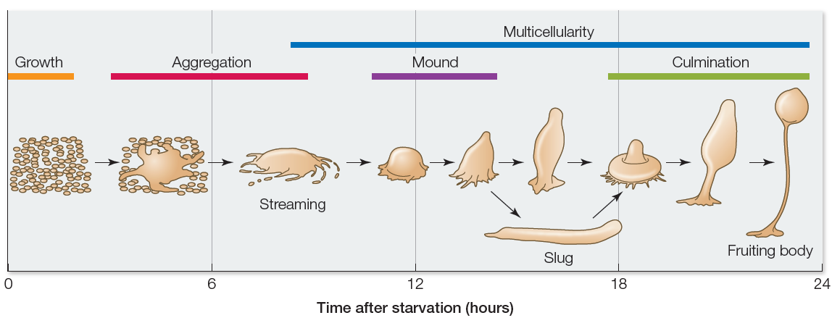

The diagram depicts the life cycle of an organism known as a slime mold, which can be found in temperate forest ecosystems. A slime mold begins as a group of single cells that function independently when nutrients are readily available. However, these cells begin aggregating to form a multicellular slug and then a fruiting body when starved. The fruiting body produces spores and dies after releasing the spores. Provided that they land in a nutrient-rich environment, spores then develop into individual cells that can begin the process over again. Using this information, explain how cell specialization contributes to the biological success of slime molds.
Answer: The diagram and text indicate that cell specialization occurs as the multicellular slug forms the fruiting body. This structure has different parts with different functions. The bottom holds the structure to the ground, the stalk allows the top to be raised above the ground so that the spores produced by the top of the fruiting body can be in a position to be carried by wind to a distant location. This gives the slime mold a greater chance at survival, because its present location has run out of nutrients. Cell specialization in this case provides the organism an additional chance at survival by making a means for dispersing itself throughout a wide range.
Learning Outcome: 1.1.4.d Use evidence to explain the ability of cells to become specialized and to contribute a unique function to the organism.
Bloom’s Level: 3. Applying

121. Refer to the figure below.

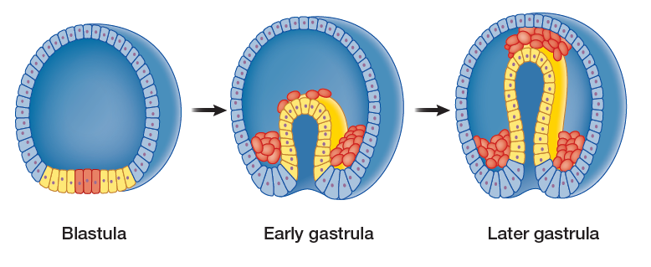
The figure shows early steps in the embryonic development of a simple vertebrate animal. Each figure represents a cross-sectional view of a developing embryo. The blastula can be described as a ball of cells. These cells formed from a fertilized egg that underwent several rounds of cell division. The blastula then undergoes invagination to form the gastrula as shown in the diagram. During invagination, some cells are pushed up into the center of the ball, creating a cell-lined pocket on the inside of the gastrula. This pocket later becomes the digestive tract of the developing animal. All vertebrate animals follow this pattern of development. Analyze the diagram to explain why the process of gastrulation provides the opportunity for the evolution of cell specialization and multicellularity in animals.
Answer: The diagram shows that the cells in the blastula stage are all basically equal in their exposure to the exterior environment. But once the blastula undergoes invagination, some cells move into the interior of the ball of cells and others remain on the exterior. The interior cells in the gastrula experience a different environment than the exterior cells. This new condition allows the exterior cells to become specialized in protection tasks and the interior cells to become specialized at digestion and transport of digested materials to outer parts of the structure. The different environments that interior and exterior cells experience have been critical to enabling them to differentiate in different ways.
Learning Outcome: 1.1.4.e Describe how the rise of multicellular life required an internal environment in which the needs of body cells could be served by specialized cells.
Bloom’s Level: 4. Analyzing

122. Multicellular organisms must regulate their internal environment. Explain the concept of homeostasis, why it is necessary, and how organisms maintain homeostasis.
Answer: Homeostasis is the state of maintaining an organism’s internal environment within a narrow range of conditions. To survive in environments that are unfavorable to cellular processes, multicellular organisms require the ability to maintain homeostasis. To do so, organisms have developed regulatory systems that can sense the conditions of the internal and external environments on a continuous basis. These regulatory systems integrate this information about the internal and external environments and modulate the internal physiological systems to maintain homeostasis.
Learning Outcome: 1.1.4.f Explain why cell activities and organs have to be regulated in order to maintain homeostasis.
Bloom’s Level: 2. Understanding

123. The study of biology can be organized from the most basic unit, the molecule, up to the biosphere. Describe how each level is connected with the level below it.
Answer: The cell is composed of many different types of molecules. Cells with the same function and coordination are grouped together to form tissues. Several tissue types work together to form a functioning organ. A complex multicellular organism is composed of organs and organ systems. Many organisms of the same species living together make up a population. A community encompasses all of the populations within a given area. An ecosystem includes many communities in the same geographical area. All of the ecosystems on Earth make up the biosphere.
Learning Outcome: 1.1.4.g Describe the hierarchy of the biological world.
Bloom’s Level: 2. Understanding

124. Refer to the image below, which shows a group of organisms.

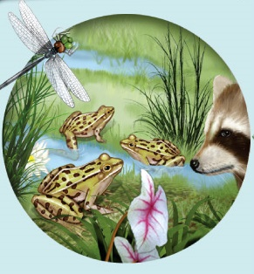

According to the hierarchy of biological systems, what level is represented by this group of organisms? Explain your reasoning. If nonliving components such as soil, oxygen, carbon dioxide, and water are included with these organisms, what level is represented? Explain.
Answer: The group of organisms represents a community because they are of different species all interacting with one another in the same location. When the nonliving components associated with this community are added, the system represents an ecosystem. An ecosystem is composed of both the living and nonliving elements that are interdependent and occupy the same location. A community is just the populations of living organisms in this same location.
Learning Outcome: 1.1.4.g Describe the hierarchy of the biological world.
Bloom’s Level: 3. Applying

125. Refer to the graph below.

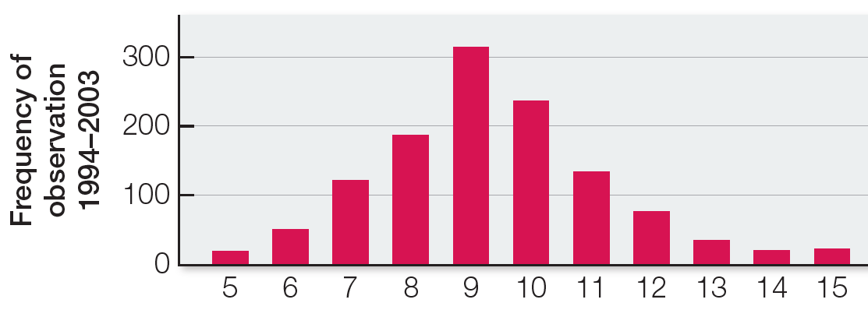

The graph shows data collected between 1993 and 2003 relating to a population of birds. Suppose that in 2003 another biologist observed a sudden decrease in the population of an insect that was the major component of the diet of this bird species. Explain how both sets of observations would have provided a basis for developing a testable hypothesis.
Answer: The observation that the insect population was decreasing dramatically would have prompted someone to realize that this could affect the amount of energy available to the bird population. A hypothesis could have been that the bird’s clutch size would decrease as its main dietary component decreased in availability, because the birds would not have as much energy to put toward reproduction. The observations about the insects suggest that the birds would lose an important source of energy, and the observations about clutch size provide the basis for analyzing the effects of this loss of energy.
Learning Outcome: 1.2.1.a Explain the role of observation in scientific inquiry.
Bloom’s Level: 3. Applying

126. Refer to the figure below.

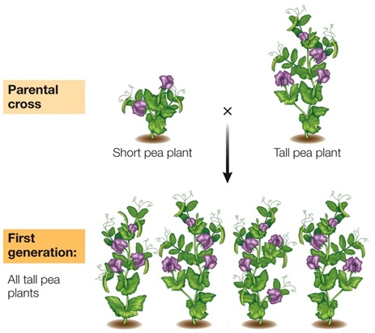

Gregor Mendel observed that some crosses between short and tall pea plants yielded the results shown in the figure. Explain why this observation did not fit with what someone of Mendel’s time might have expected, and how this relates to the scientific investigations that Mendel pursued.
Answer: Someone of Mendel’s time would probably have predicted that a cross between a short pea plant and a tall pea plant would yield half short and half tall pea plant progeny. That’s because the simple prediction would be that the progeny would resemble the parents. Because all of the progeny have the characteristics of one parent, this prompted Mendel to propose that the tall characteristic was dominant over the short characteristic. He then ran experiments to test this hypothesis.
Learning Outcome: 1.2.1.a Explain the role of observation in scientific inquiry.
Bloom’s Level: 3. Applying

127. Why is it important in science to design and perform experiments that are capable of falsifying a hypothesis?
Answer: Answer: In science, we formulate hypotheses about how the world works, then try to test those hypotheses with experiments. An experiment must be designed such that it can uncover problems with the hypothesis. If an experiment produces the type of information that could reject a hypothesis, then the experiments is a good test of that hypothesis.
Learning Outcome: 1.2.1.b Explain the roles of inductive logic and deductive logic in scientific inquiry.
Bloom’s Level: 2. Understanding

128. Discuss how the process of scientific inquiry is different from other forms of inquiry. Include in your discussion a description of the hypothesis-and-prediction approach.
Answer: The process of scientific inquiry is unique in that a hypothesis must be testable, and it must be possible to reject it. The hypothesis-and-prediction approach begins with observations that lead to questions. From the questions, hypotheses are formed that are probable explanations for the observed phenomena. Predictions are formed from the hypotheses and tested. Conclusions are drawn from the test results. These conclusions may, in turn, lead to additional hypotheses.
Learning Outcome: 1.2.1.b Explain the roles of inductive logic and deductive logic in scientific inquiry.
Bloom’s Level: 2. Understanding

129. Scientists interested in human biology typically perform experiments with other model systems. Why do scientists use model systems in this way?
Answer: Model systems are useful in the study of biology because all organisms have evolved from a common ancestor. Therefore, cellular pathways in, for example, bacteria and fruit flies are very similar to those found in humans. Model systems are valuable because in many cases they can be manipulated experimentally.
Learning Outcome: 1.2.1.f Explain why model organisms are used in biological research.
Bloom’s Level: 2. Understanding

130. Modern biological scientific research has greatly increased the cure rate for many diseases. How has biological research improved the development of disease treatments?
Answer: Biological research has assisted the development of medical treatments by providing basic understandings of the causes of diseases, such as the roles of genetics and environmental factors in their development. This knowledge enables the development of treatments that are more efficacious and have fewer side effects than treatments that are discovered through trial and error and with no understanding of how the treatments work against the disease.
Learning Outcome: 1.3.1.b Apply biological knowledge to answer a question that pertains to everyday life.
Bloom’s Level: 2. Understanding

LEARNINGCURVE QUESTIONS

Multiple Choice

1. Imagine that NASA’s next probe to one of Jupiter’s moons takes a sample from one of its methane lakes. Pictures taken under a microscope reveal a cell-like structure remarkably similar to that of a simple prokaryotic organism. NASA calls it a “Xenop.” Based on the textbook’s discussion of the common aspects of living organisms on Earth, which of the following pieces of information about the Xenop is paired with its logical conclusion?
a. The Xenop is the same size and shape as some prokaryotes and, therefore, is or was a living organism.
b. The Xenop contains different nucleic acids and amino acids from organisms on Earth and, therefore, is not and never was a living organism.
c. The Xenop can go many years without extracting energy from its environment and, therefore, is not and never was a living organism.
d. The Xenop does not contain genetic information or reproduce and, therefore, is not and never was a living organism.
e. The Xenop contains complex molecules and, therefore, is or was a living organism.
Answer: d
Hint: Which characteristic of Xenop is essential to life?
Learning Outcome: 1.1.1.a Describe characteristics shared by all living things.
Bloom’s Level: 4. Analyzing
Difficulty Level: Difficult

2. All living organisms acquire _______ from their environment.
a. sunlight
b. nutrients
c. carbon dioxide for photosynthesis
d. cues for forming different tissue types
e. oxygen
Answer: b
Hint: Are some of these items things that some living organisms can survive without?
Learning Outcome: 1.1.1.a Describe characteristics shared by all living things.
Bloom’s Level: 1. Remembering
Difficulty Level: Easy

3. Nutrients acquired by animals
a. are all synthesized by the cells of other organisms.
b. are all broken down outside of cells.
c. are a source of matter but not energy for the animals.
d. are broken down to produce usable energy for cellular processes.
e. do not play a role in the synthesis of complex molecules.
Answer: d
Hint: Think about how an animal’s cells use nutrient molecules such as glucose as a source of energy and materials for repair and growth.
Learning Outcome: 1.1.1.a Describe characteristics shared by all living things.
Bloom’s Level: 2. Understanding
Difficulty Level: Moderate

4. Viruses
a. can mutate.
b. can extract energy from their environment.
c. can synthesize DNA or RNA on their own.
d. can reproduce on their own.
e. are cellular.
Answer: a
Hint: Remember that viruses have a special type of life form because they do not show all of the characteristics of life all the time.
Learning Outcome: 1.1.1.a Describe characteristics shared by all living things.
Bloom’s Level: 2. Understanding
Difficulty Level: Moderate

5. If samples were brought back from a distant planet, which would be the first evidence of life in them, assuming their evolution followed the same path as on Earth?
a. Presence of nucleic acids
b. Multicellular life forms
c. Presence of oxygen
d. Cell membranes
e. Presence of fatty acids
Answer: a
Hint: What characteristic of living things enables them to replicate crucial molecules that make up their cells?
Learning Outcome: 1.1.2.a Describe current scientific thinking about the origin of life on Earth.
Bloom’s Level: 3. Applying
Difficulty Level: Difficult

6. Scientists postulate that the enclosure of complex proteins and other biological molecules by membranes resulted in the first cells with the ability to
a. reproduce.
b. photosynthesize.
c. carry out aerobic respiration.
d. live in nonaqueous environments.
e. differentiate.
Answer: a
Hint: What function ensures that future generations will be enabled?
Learning Outcome: 1.1.2.a Describe current scientific thinking about the origin of life on Earth.
Bloom’s Level: 2. Understanding
Difficulty Level: Moderate

7. Life arose on Earth approximately _______ years ago.
a. 4,000
b. 400,000
c. 4 million
d. 1.5 billion
e. 4 billion
Answer: e
Hint: Consider that it took 600 million years for life to arise after Earth formed.
Learning Outcome: 1.1.2.a Describe current scientific thinking about the origin of life on Earth.
Bloom’s Level: 1. Remembering
Difficulty Level: Easy

8. Which correctly lists the order of important first events in the history of life?
a. First archaea, chemical evolution, first chloroplasts, first nucleus, first cyanobacteria
b. Chemical evolution, first archaea, first cyanobacteria, first nucleus, first chloroplasts
c. Chemical evolution, first cyanobacteria, first archaea, first chloroplasts, first nucleus
d. First cyanobacteria, first nucleus, first archaea, first chloroplasts, chemical evolution
e. First cyanobacteria, chemical evolution, first archaea, first nucleus, first chloroplasts
Answer: b
Hint: Remember that organelles evolved after prokaryotes had been present on Earth for a long period of time.
Learning Outcome: 1.1.2.b Describe the earliest forms of life.
Bloom’s Level: 2. Understanding
Difficulty Level: Difficult

9. Scientists estimate that for more than _______ years after cells originated, all organisms consisted of one cell.
a. 2,500
b. 250,000
c. 2 million
d. 2 billion
e. 2 trillion
Answer: d
Hint: Consider that the Eukarya emerged about 2 billion years ago.
Learning Outcome: 1.1.2.b Describe the earliest forms of life.
Bloom’s Level: 1. Remembering
Difficulty Level: Easy

10. A cell
a. always contains a nucleus.
b. is found only in plants and animals.
c. is the fundamental unit of life.
d. is never an entire organism.
e. is always prokaryotic.
Answer: c
Hint: What can be said about all cells?
Learning Outcome: 1.1.2.b Describe the earliest forms of life.
Bloom’s Level: 2. Understanding
Difficulty Level: Moderate

11. All chemical transformations and other work done in an organism contribute to its
a. mechanical work.
b. synthesis.
c. breakdown.
d. metabolism.
e. electrical work.
Answer: d
Hint: How did the earliest cells evolve the means to supply their energy needs?
Learning Outcome: 1.1.2.b Describe the earliest forms of life.
Bloom’s Level: 2. Understanding
Difficulty Level: Moderate

12. Metabolism is
a. the consumption of energy.
b. the release of energy.
c. all chemical transformations in a cell or organism.
d. the production of heat by chemical reactions.
e. the exchange of nutrients and waste products with the environment.
Answer: c
Hint: Remember that metabolism is carried out by the molecules present in the interior of a cell.
Learning Outcome: 1.1.2.b Describe the earliest forms of life.
Bloom’s Level: 1. Remembering
Difficulty Level: Moderate

13. Eukaryotic cells differ from prokaryotic cells in that a eukaryotic cell has
a. genes.
b. proteins.
c. a membrane-bound nucleus.
d. membranes.
e. nucleic acids.
Answer: c
Hint: Remember that biologists hypothesize that eukaryotic cells may have arisen as prokaryotes engulfed one another.
Learning Outcome: 1.1.2.b Describe the earliest forms of life.
Bloom’s Level: 2. Understanding
Difficulty Level: Easy

14. The early organisms that produced the first oxygen gas in Earth’s atmosphere were
a. aerobic eukaryotes.
b. anaerobic eukaryotes.
c. photosynthetic prokaryotes.
d. aerobic prokaryotes.
e. completely unlike modern organisms.
Answer: c
Hint: Remember that aerobic organisms use oxygen and do not produce it.
Learning Outcome: 1.1.2.c Explain how photosynthesis influenced the history of life on Earth.
Bloom’s Level: 2. Understanding
Difficulty Level: Moderate

15. The initial accumulation of oxygen in the atmosphere was the result of photosynthesis from an organism most like modern
a. algae.
b. mosses.
c. kelp.
d. eukaryotes.
e. cyanobacteria.
Answer: e
Hint: What are the simplest organisms that are able to carry out photosynthesis?
Learning Outcome: 1.1.2.c Explain how photosynthesis influenced the history of life on Earth.
Bloom’s Level: 1. Remembering
Difficulty Level: Easy

16. Photosynthesis was a major evolutionary milestone because
a. photosynthetic organisms contributed oxygen to the environment, which led to the evolution of aerobic organisms.
b. photosynthesis led to conditions that allowed unicellular organisms to thrive in marine environments.
c. photosynthesis is the only metabolic process that can convert the chemical energy stored in chemical bonds into biological work.
d. photosynthesis reduces the harmful effects of ultraviolet light.
e. photosynthetic organisms provided a way for the elements carbon, oxygen, and hydrogen to be recycled from the biosphere back into the physical environment.
Answer: a
Hint: Consider that the evolution of photosynthesis substantially changed the atmosphere on Earth.
Learning Outcome: 1.1.2.c Explain how photosynthesis influenced the history of life on Earth.
Bloom’s Level: 2. Understanding
Difficulty Level: Difficult

17. The emergence of which of the following is hypothesized to have led to changes in Earth’s atmosphere that in turn led to totally new avenues of evolution?
a. Sexual reproduction
b. Eukarya
c. Photosynthesis
d. Multicellularity
e. Aerobic metabolism
Answer: c
Hint: Remember that cyanobacteria are prokaryotes that developed the ability to capture energy from the sun.
Learning Outcome: 1.1.2.c Explain how photosynthesis influenced the history of life on Earth.
Bloom’s Level: 1. Remembering
Difficulty Level: Difficult

18. The organisms that produced oxygen gas in Earth’s atmosphere paved the way for the type of metabolism used by larger organisms, called _______ metabolism.
a. anaerobic
b. photosynthetic
c. aerobic
d. homeostatic
e. heterotrophic
Answer: c
Hint: What name is given to organisms that use oxygen as a reactant in their metabolism?
Learning Outcome: 1.1.2.c Explain how photosynthesis influenced the history of life on Earth.
Bloom’s Level: 2. Understanding
Difficulty Level: Easy

19. Ozone is important to life on Earth because it
a. is toxic to all forms of life.
b. can be used in place of oxygen.
c. blocks much ultraviolet radiation.
d. provides energy to some basic forms of life.
e. acts as a disinfectant.
Answer: c
Hint: Consider that ozone is both hazardous and beneficial to life.
Learning Outcome: 1.1.2.c Explain how photosynthesis influenced the history of life on Earth.
Bloom’s Level: 1. Remembering
Difficulty Level: Easy

20. A final prerequisite for the survival of life on land was the accumulation of a protective layer of
a. O₂ in the atmosphere.
b. CO₂ in the atmosphere.
c. water vapor in the atmosphere.
d. O₃ in the atmosphere.
e. bacteria in the soil.
Answer: d
Hint: What compound developed as a by-product of photosynthesis that accumulated as a shield against ultraviolet radiation from the sun?
Learning Outcome: 1.1.2.c Explain how photosynthesis influenced the history of life on Earth.
Bloom’s Level: 1. Remembering
Difficulty Level: Moderate

21. Refer to the table below.

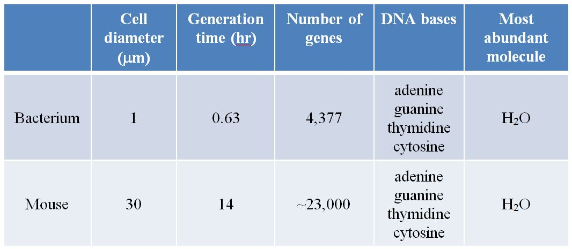

Which data provide evidence that these two organisms have a common origin?
a. Cell sizes
b. Time for one cell division cycle
c. Number of genes
d. DNA base identities
e. Identity of most prevalent molecule in a cell
Answer: d
Hint: Consider that if the bacterium and mouse have a common origin, they may share certain characteristics of their common ancestor.
Learning Outcome: 1.1.3.a Describe evidence that supports the common origin of all life on Earth.
Bloom’s Level: 4. Analyzing
Difficulty Level: Moderate

22. Suppose that a microorganism is discovered on a distant planet. Which investigation could be expected to yield information that could either support or refute the hypothesis that life originated only once in the universe?
a. Study of the organism’s ability to synthesize new molecules
b. Investigation into the ability of the organism to reproduce itself
c. Identification of the molecule(s) that encode the organism’s biological information
d. Evaluation of the organism’s rate of nutrient intake
e. Analysis of the organism’s cell surface area-to-volume ratio
Answer: c
Hint: What information would be most helpful in determining whether this organism has any historical link to organisms on Earth?
Learning Outcome: 1.1.3.a Describe evidence that supports the common origin of all life on Earth.
Bloom’s Level: 3. Applying
Difficulty Level: Moderate

23. In the human body you can find a variety of cells, including skin cells, blood cells, bone cells, nerve cells, and muscle cells. You can find the same variety of cells in a frog. Which statement is true about these cells?
a. As a result of descent from a common ancestor, similar genes are expressed in similar types of cells in frog and human.
b. A common ancestor of frog and human lost similar genetic components that led to cell specialization.
c. Different ancestors of frog and human were exposed to similar environmental pressures that led to cell specialization.
d. Cell specialization was an evolutionary event that occurred after the human and frog lineages split apart from their common ancestor.
e. To express the same types of cells, humans and frogs have identical genetic components.
Answer: a
Hint: Think about how any organism begins its life as a single cell.
Learning Outcome: 1.1.3.a Describe evidence that supports the common origin of all life on Earth.
Bloom’s Level: 3. Applying
Difficulty Level: Difficult

24. A genome is
a. not subject to change.
b. usually made of RNA.
c. made of proteins.
d. the sum of all genetic information in a cell.
e. only found in an animal or plant cell.
Answer: d
Hint: Remember that each species has a distinct genome.
Learning Outcome: 1.1.3.b Explain the biological importance of the genetic code.
Bloom’s Level: 1. Remembering
Difficulty Level: Easy

25. All cells in a complicated multicellular organism
a. contain a subset of the genome.
b. have the same function.
c. express the same parts of the genome at the same time during development.
d. have controlled expression of their genome.
e. randomly express parts of the genome.
Answer: d
Hint: How does the DNA present in a muscle cell compare with the DNA present in a skin cell?
Learning Outcome: 1.1.3.b Explain the biological importance of the genetic code.
Bloom’s Level: 2. Understanding
Difficulty Level: Moderate

26. Which of the following statements about mutations is incorrect?
a. All mutations are harmful.
b. Mutations occur spontaneously.
c. Mutations can be induced by outside environmental factors.
d. Mutations occur each time the genome is replicated.
e. A mutation can improve the functioning of an organism.
Answer: a
Hint: Consider that bacteria develop resistance to antibiotics through mutation.
Learning Outcome: 1.1.3.b Explain the biological importance of the genetic code.
Bloom’s Level: 2. Understanding
Difficulty Level: Easy

27. Which statement is correct?
a. All cells from a single complex organism express the same genes.
b. Mutations are always caused by chemicals or radiation.
c. Mutations can occur spontaneously.
d. Most mutations are harmful, so evolution proceeds more rapidly when no mutations occur.
e. Mutations affect proteins but not the DNA.
Answer: c
Hint: Remember that mutations tend to be random events.
Learning Outcome: 1.1.3.b Explain the biological importance of the genetic code.
Bloom’s Level: 1. Remembering
Difficulty Level: Moderate

28. The information needed to produce proteins is contained in
a. nutrients.
b. tissues.
c. evolution.
d. organs.
e. genes.
Answer: e
Hint: What cellular structure carries the biological information necessary for directing the functions in a cell?
Learning Outcome: 1.1.3.b Explain the biological importance of the genetic code.
Bloom’s Level: 1. Remembering
Difficulty Level: Easy

29. Which is required for natural selection to occur?
a. Organisms in a population must have the same traits.
b. A trait must be heritable so that it is capable of being passed on to future generations.
c. A trait must decrease survival.
d. A trait must decrease reproductive success.
e. A trait must be capable of change within a single individual.
Answer: b
Hint: Go through each condition listed and ask if this is required for natural selection to occur.
Learning Outcome: 1.1.4.a Explain how natural selection can produce evolutionary change.
Bloom’s Level: 4. Analyzing
Difficulty Level: Difficult

30. Populations of organisms have been able to inhabit a wide variety of environments on Earth because they
a. have a genome.
b. contain organelles.
c. carry out photosynthesis.
d. adapt through evolution.
e. are similar to model organisms.
Answer: d
Hint: What allows a species of organism to survive in a hostile environment?
Learning Outcome: 1.1.4.a Explain how natural selection can produce evolutionary change.
Bloom’s Level: 2. Understanding
Difficulty Level: Easy

31. Darwin referred to the differential reproductive success of individuals with particular variations as
a. evolution.
b. artificial selection.
c. the cell theory.
d. natural selection.
e. inheritance of acquired characteristics.
Answer: d
Hint: What process results from only some individuals passing on their traits to the next generation because of environmental factors?
Learning Outcome: 1.1.4.a Explain how natural selection can produce evolutionary change.
Bloom’s Level: 1. Remembering
Difficulty Level: Easy

32. A key point in Darwin’s explanation of evolution is that
a. the biological structures most likely to be inherited are those that have become best suited to the environment through constant use.
b. all mutations that occur are those that will help future generations fit more successfully into their environments.
c. any trait that confers even a small increase in the probability that its possessor will survive and reproduce will be favored and will spread through the population.
d. genes change to help organisms cope with problems encountered within their environments.
e. extinction is nature’s way of weeding out undeserving organisms.
Answer: c
Hint: Consider that both favorable and unfavorable characteristics occur in populations and that environmental factors influence the survival of individuals according to the presence and absence of these characteristics.
Learning Outcome: 1.1.4.a Explain how natural selection can produce evolutionary change.
Bloom’s Level: 2. Understanding
Difficulty Level: Difficult

33. Which statement is true?
a. The diversity of life has depended on similar environments and ecological communities around the globe.
b. Sexual selection and genetic drift contribute to the diversity of life.
c. Earth has existed and changed over a few thousand years, at most.
d. All ancestral forms of life were very similar to organisms that currently exist.
e. All organisms are closely related genetically.
Answer: b
Hint: Think about ways that could have contributed to the huge diversity of life forms that exist today.
Learning Outcome: 1.1.4.a Explain how natural selection can produce evolutionary change.
Bloom’s Level: 4. Analyzing
Difficulty Level: Difficult

34. Evolution is
a. only relevant to the study of biology.
b. the change in the genetic makeup of a population through time.
c. the change in protein expression of an individual organism through time.
d. not influenced by natural selection.
e. always improving a species.
Answer: b
Hint: Remember that evolution is a process that occurs over many generations.
Learning Outcome: 1.1.4.a Explain how natural selection can produce evolutionary change.
Bloom’s Level: 2. Understanding
Difficulty Level: Easy

35. Relationships between living organisms can best be gleaned by comparing
a. the fossil record.
b. the genomes of living organisms.
c. the patterns of embryological development of living organisms.
d. anatomical features of living organisms.
e. anatomical features of fossils.
Answer: b
Hint: Consider that DNA sequences can be analyzed with great precision.
Learning Outcome: 1.1.4.b Explain how scientists classify organisms according to evolutionary relationships.
Bloom’s Level: 5. Evaluating
Difficulty Level: Moderate

36. A phylogenetic tree
a. shows ecological relationships among different organisms.
b. relies on evidence from controlled experiments.
c. helps us predict the future challenges facing living organisms.
d. shows the order in which populations split and evolved into new species.
e. is not subject to change once it has been constructed.
Answer: d
Hint: Go through each statement listed and ask, Does this describe the basis or function of a phylogenetic tree?
Learning Outcome: 1.1.4.b Explain how scientists classify organisms according to evolutionary relationships.
Bloom’s Level: 2. Understanding
Difficulty Level: Moderate

37. The Eukarya include all of the following except
a. archaea.
b. plants.
c. fungi.
d. animals.
e. protists.
Answer: a
Hint: Remember that the Eukarya evolved from a lineage of prokaryotes that incorporated membrane-bound organelles in their cell interiors.
Learning Outcome: 1.1.4.b Explain how scientists classify organisms according to evolutionary relationships.
Bloom’s Level: 1. Remembering
Difficulty Level: Moderate

38. Refer to the figure below.

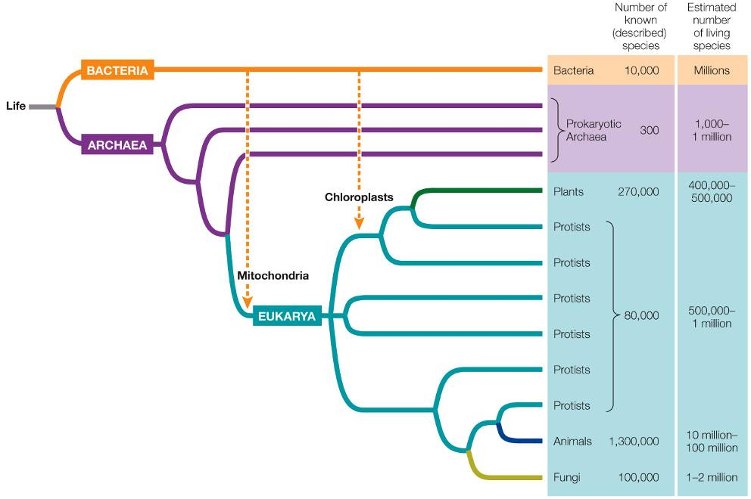

Which is demonstrated in this diagram of the tree of life?
a. There are three groups of Eukarya.
b. Protists and bacteria have no common ancestor.
c. Plants and fungi have a more recent common ancestor than plants and animals do.
d. Plants, fungi, and animals are descendants of a common eukaryotic ancestor.
e. Archaea is the most ancient group in terms of the evolutionary history of all organisms on Earth.
Answer: d
Hint: Remember that a node connecting organisms on the right of the tree represents the last common ancestor of those organisms.
Learning Outcome: 1.1.4.b Explain how scientists classify organisms according to evolutionary relationships.
Bloom’s Level: 4. Analyzing
Difficulty Level: Difficult

39. A group of differentiated cells that work together to carry out a similar function is known as a(n)
a. tissue.
b. organ system.
c. unicellular organism.
d. protein.
e. gene.
Answer: a
Hint: Considering a cell, what is the next higher level of complexity in an organism?
Learning Outcome: 1.1.4.c Describe cellular differentiation and its significance to the range of living things observed today.
Bloom’s Level: 1. Remembering
Difficulty Level: Moderate

40. Suppose that multicellular life had never evolved on Earth. Which characteristic would be absent in the life forms observed today in that case?
a. The ability to carry out photosynthesis
b. The ability to move about
c. The ability to prey on other organisms
d. The ability to digest food molecules
e. Nervous systems
Answer: e
Hint: Which of these characteristics can only be accomplished with specialized cell functions?
Learning Outcome: 1.1.4.c Describe cellular differentiation and its significance to the range of living things observed today.
Bloom’s Level: 3. Applying
Difficulty Level: Difficult

41. Refer to the figure below showing the steps carried out in a laboratory using cells obtained from a mouse embryo.

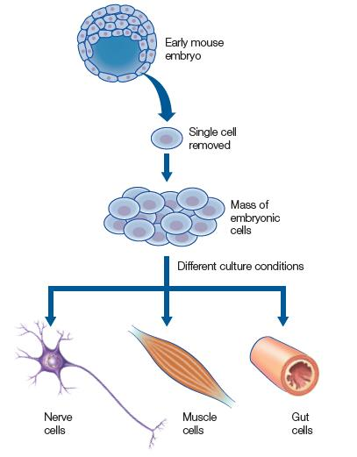

What statement is true based on the experiment depicted in the figure?
a. The processes involved in a developing multicellular organism are too complex to study in the lab.
b. External factors are unimportant in determining the path of specialization of cells in a developing embryo.
c. Specialization of each cell in a multicellular organism relies solely on which genetic factors are present in the cell.
d. A multicellular organism develops from a group of identical cells into nonidentical specialized cells that perform different functions.
e. Cells become specialized as a mouse embryo develops, but their specialized identities can be changed to different identities at times along the way.
Answer: d
Hint: Think about the factors influencing the fates of the cells shown in the figure.
Learning Outcome: 1.1.4.d Use evidence to explain the ability of cells to become specialized and to contribute a unique function to the organism.
Bloom’s Level: 4. Analyzing
Difficulty Level: Moderate

42. Suppose that you are working in a research lab investigating the nature of multicellularity. Which evidence could you gather from two different types of cells obtained from an adult multicellular animal to show that they are specialized?
a. Presence of cell machinery needed to synthesize proteins
b. Ability to take in nutrients
c. Differences in genes being expressed
d. Changes to the total amount of DNA present
e. Responses of cells to waste buildup
Answer: c
Hint: Consider skin cells and muscle cells of a mouse. Which of the processes listed could be used to distinguish these two sets of cells?
Learning Outcome: 1.1.4.d Use evidence to explain the ability of cells to become specialized and to contribute a unique function to the organism.
Bloom’s Level: 3. Applying
Difficulty Level: Difficult

43. Which is evidence that an organ system provides a level of function not possible with individual organs operating independently?
a. Bears grow thick fur on their bodies.
b. Blood circulates to all tissues of a horse’s body.
c. Humans produce antibodies that bind to invading pathogens.
d. Bones in mammals are composed of living cells.
e. The dog stomach produces digestive enzymes.
Answer: b
Hint: In each case, body parts are mentioned, but in only one does the description cover a function that relies on an organ system and not just one organ or tissue.
Learning Outcome: 1.1.4.d Use evidence to explain the ability of cells to become specialized and to contribute a unique function to the organism.
Bloom’s Level: 3. Applying
Difficulty Level: Easy

44. Refer to the figure below.

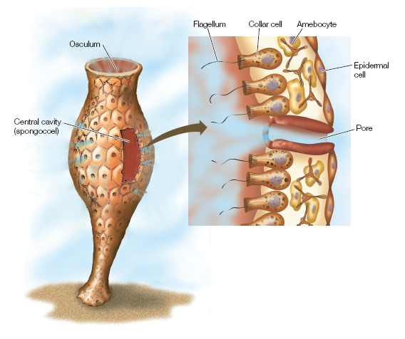

The figure shows a simple sponge that lives attached to the ocean floor. The sponge consists of an outer layer of epidermal cells, an inner layer of collar cells and amebocytes, and pore cells that allow water to move from the outside to the inside. The water is propelled by the beating of flagella attached to the collar cells on the inside cavity. Collar cells trap food particles that are digested by the amebocytes. A student claims that a simple sponge could be a model organism used to study how multicellular organisms evolved. Which statement best evaluates this student’s claim?
a. The student’s statement is correct because the sponge lives attached to the ocean floor and would therefore be a model for multicellular plant evolution.
b. The student’s statement is correct because the sponge demonstrates a simple structure made up of cells that have specialized to serve different functions.
c. The student’s statement is incorrect because the sponge does not have any recognizable organs or organ systems.
d. The student’s statement is incorrect because the sponge has only four different types of cells while other multicellular organisms have many more.
e. The student’s statement cannot be evaluated, because there is not enough information to support or refute the claim.
Answer: b
Hint: Think about what is accomplished in a multicellular organism that has several different types of cells in its structure.
Learning Outcome: 1.1.4.e Describe how the rise of multicellular life required an internal environment in which the needs of body cells could be served by specialized cells.
Bloom’s Level: 5. Evaluating
Difficulty Level: Difficult

45. Sea squirts are marine organisms that have a simple bag-like body structure. The sea squirt draws water through slits in its body into the body interior. It filters food from the moving water and squirts the water along with waste materials through an opening in its body. What is likely true about the sea squirt’s body cells?
a. The body cells are all identical in structure and function, so each cell has the ability to conduct every task needed for survival.
b. The body cells are all identical in structure but have different functions depending on location in the animal’s body.
c. The body cells on the inside have evolved to rely on the cells on the outside for a function they cannot carry out, and vice versa.
d. The body cells on the inside and outside have evolved to perform every function, giving the best chance of survival if environmental conditions change.
e. The body cells on the outside must be dead, since they are not in contact with the food source and only provide a protective role.
Answer: c
Hint: How does the body structure of the sea squirt allow the internal body cells to experience a different set of conditions than the external body cells? Why might this change the pattern of evolutionary change in these two sets of cells?
Learning Outcome: 1.1.4.e Describe how the rise of multicellular life required an internal environment in which the needs of body cells could be served by specialized cells.
Bloom’s Level: 3. Applying
Difficulty Level: Difficult

46. Refer to the table below.

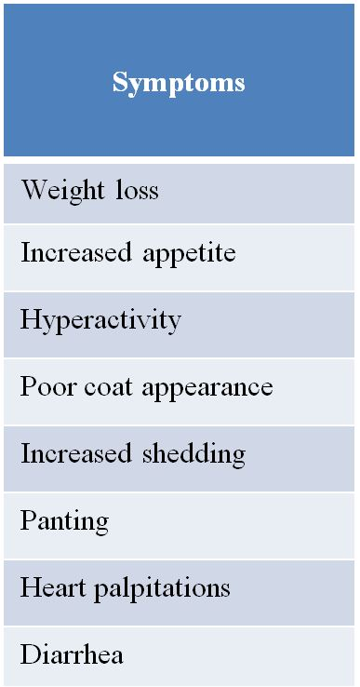

The table shows a list of symptoms observed in an older domestic cat. The veterinarian observing these symptoms suspects a problem involving the thyroid gland. This gland produces and secretes thyroid hormone. Thyroid hormone is involved in controlling cell metabolism and its use of energy. It also is involved in controlling heart rate, breathing rate, and other organ functions. Should this be a concern to the cat’s owner?
a. Yes, because the cat’s internal body systems are not in balance and will continue to be out of balance until thyroid hormone levels are restored to the normal range.
b. Yes, because the cat could infect the owner with the disorder during cleanup of waste resulting from the cat’s diarrhea.
c. No, because the symptoms are not debilitating and the cat is not likely to die from the disorder.
d. No, because this is likely to be a temporary problem that the cat will eventually recover from on its own.
e. There is not enough information to make a judgment.
Answer: a
Hint: Think about the symptoms and the likely cause of these symptoms. Is this a disorder that needs medical intervention?
Learning Outcome: 1.1.4.f Explain why cell activities and organs have to be regulated in order to maintain homeostasis.
Bloom’s Level: 3. Applying
Difficulty Level: Moderate

47. Gaucher disease is a genetic disorder in which the cells do not produce an enzyme necessary for breaking down fatty substances. Persons afflicted with Gaucher disease experience severe problems, including swelling, bruising, anemia, neurological problems, and bone abnormalities. Some patients die of the disease. Which statement explains why the lack of an enzyme leads to the problems observed in patients with Gaucher disease?
a. Fatty substances accumulate and block normal cell functions.
b. Cells are forced to use fatty substances as a nutrient source.
c. DNA mutates at a greater rate upon exposure to fatty substances.
d. Fatty substances break down proteins and DNA in cells.
e. Enzymes other than the missing one catalyze their reactions at accelerated rates.
Answer: a
Hint: What is the most likely outcome resulting from lack of breakdown of fatty substances in a cell?
Learning Outcome: 1.1.4.f Explain why cell activities and organs have to be regulated in order to maintain homeostasis.
Bloom’s Level: 3. Applying
Difficulty Level: Difficult

48. Homeostasis involves the maintenance of a
a. variable internal environment.
b. constant external environment.
c. constant internal environment.
d. constant rate of natural selection.
e. variable rate of natural selection.
Answer: c
Hint: The root word “homeo” means “same” or “similar,” and the root word “stasis” means “standing still” or “stable.”
Learning Outcome: 1.1.4.f Explain why cell activities and organs have to be regulated in order to maintain homeostasis.
Bloom’s Level: 1. Remembering
Difficulty Level: Easy

49. In terms of increasing complexity, the order of parts of a multicellular animal is
a. cell, macromolecule, tissue, organ, organ system.
b. molecule, cell, tissue, organ, organ system.
c. tissue, cell, molecule, organ system, organ.
d. molecule, tissue, cell, organ, organ system.
e. tissue, molecule, cell, organ, organ system.
Answer: b
Learning Outcome: 1.1.4.g Describe the hierarchy of the biological world.
Difficulty Level: Difficult
Bloom’s Level: 1. Remembering
Hint: Consider how a Russian doll is a nested set of objects in which each object fits inside the next larger one. This is similar to how a multicellular animal is composed of parts, each of which goes to make up the next larger structure.

50. Which represents a correct ordering of the levels of complexity at which life is studied, from most simple to most complex?
a. Community, population, organism, organ, tissue, cell
b. Cell, organ, tissue, organism, population, community
c. Cell, tissue, organ, organism, population, community
d. Cell, tissue, organ, population, organism, community
e. Tissue, organ, cell, population, organism, community
Answer: c
Hint: Think about each category and how it compares in size and makeup to the other categories.
Learning Outcome: 1.1.4.g Describe the hierarchy of the biological world.
Bloom’s Level: 2. Understanding
Difficulty Level: Difficult

51. Which sequence gives the correct ordering of levels from smallest to largest?
a. Population, organism, ecosystem, community
b. Organism, population, community, ecosystem
c. Community, ecosystem, organism, population
d. Ecosystem, community, population, organism
e. Organism, community, population, ecosystem
Answer: b
Hint: Remember that a population contains a group of organisms of the same species.
Learning Outcome: 1.1.4.g Describe the hierarchy of the biological world.
Bloom’s Level: 1. Remembering
Difficulty Level: Difficult

52. Suppose fish caught at one location in a bay are tagged with simple, numbered, plastic tags. Which kind of information can a scientist gain if she catches one of these fish in another bay distant from the first?
a. How deep it swam
b. The route it took before it was caught
c. How far it can swim
d. Exactly how far it swam
e. Whether it was chased by a predator fish
Answer: c
Hint: Think about how a scientist tags a fish, releases it, and then catches it at a later time and at a distant location. Which type of information can be gained from such a process?
Learning Outcome: 1.2.1.a Explain the role of observation in scientific inquiry.
Bloom’s Level: 4. Analyzing
Difficulty Level: Difficult

53. A biologist plans to investigate whether different species of mammals have different ranges of body temperature. Evaluate the following information collection procedures, and determine which will be the best to use during this investigation.
a. One measurement will need to be taken from 20 different species, using an instrument that can be read to 1°C.
b. Multiple measurements will need to be taken from 2 different species, using an instrument that can be read to 1°C.
c. One measurement will need to be taken from 2 different species, using an instrument that can be read to 0.1°C.
d. Multiple measurements will need to be taken from 20 different species, using an instrument that can be read to 0.1°C.
e. Multiple measurements will need to be taken from 2 different species, using an instrument that can be read to 0.01°C.
Answer: d
Hint: What sort of data will provide the best information for testing the hypothesis that different species of mammals have different ranges of body temperature?
Learning Outcome: 1.2.1.a Explain the role of observation in scientific inquiry.
Bloom’s Level: 5. Evaluating
Difficulty Level: Moderate

54. A fungus species is observed to undergo asexual reproduction at some times and sexual reproduction at other times. A researcher hypothesizes that the nutrient levels available to the fungus may be responsible for this effect. Which data could be used to test this hypothesis?
a. Compare the genome of a mutant that is not able to switch from asexual to sexual reproduction to the genome of the normal fungus.
b. Observe the sexual behavior of the fungus grown in a laboratory under various conditions such as pH, temperature, and water availability.
c. Find samples of the fungus growing in the wild, record their reproductive behavior, and collect samples of the substrate they are growing on for chemical analysis.
d. Collect information from cells about which genes are being expressed under the two types of reproductive behaviors.
e. Grow fungi on high levels of nutrients in the lab, and observe reproductive behavior before and after adding additional nutrients.
Answer: c
Hint: To test the hypothesis, you need two sets of information: nutrient levels in the substrate and how those levels correlate to reproductive behavior in the fungus growing on the substrate. Which scenario meets these requirements?
Learning Outcome: 1.2.1.a Explain the role of observation in scientific inquiry.
Bloom’s Level: 5. Evaluating
Difficulty Level: Difficult

55. In the scientific method, a hypothesis
a. is a final answer to a question.
b. is tested by polling many scientists’ opinions.
c. is never proven wrong, but only proven right.
d. is the basis for making predictions.
e. is proven to be correct when evidence is found to support it.
Answer: d
Hint: Remember that a hypothesis is a statement that explains an observation and that can be used to design additional investigations to try to either support or refute the hypothesis.
Learning Outcome: 1.2.1.b Explain the roles of inductive logic and deductive logic in scientific inquiry.
Bloom’s Level: 2. Understanding
Difficulty Level: Moderate

56. Which statement about the scientific method is true?
a. After forming a hypothesis, scientists apply deductive logic to make predictions from the hypothesis.
b. The most informative experiments are those that have the greatest probability of supporting the hypothesis.
c. In a comparative experiment, a scientist compares groups that differ in a variable that has been manipulated in one of the groups and left unaltered in the other group.
d. Controlled experiments are valuable when we do not know or cannot control the critical variables.
e. A statistical test of a hypothesis starts with the premise that a significant difference exists between the groups in the study.
Answer: a
Hint: Consider that scientists take care to plan experiments that they think will best test their ideas.
Learning Outcome: 1.2.1.b Explain the roles of inductive logic and deductive logic in scientific inquiry.
Bloom’s Level: 2. Understanding
Difficulty Level: Difficult

57. After observing that frogs live in clean water but not in polluted water, researchers state that “polluted water kills frogs.” This simple statement is an example of
a. scientific inquiry.
b. biological evolution.
c. a prediction.
d. a hypothesis.
e. a fact.
Answer: d
Hint: What type of statement do scientists pose to explain observations that they have made?
Learning Outcome: 1.2.1.b Explain the roles of inductive logic and deductive logic in scientific inquiry.
Bloom’s Level: 3. Applying
Difficulty Level: Easy

58. Which question cannot be answered by means of the method that uses a hypothesis and then a prediction?
a. Are bees more attracted to red roses than to yellow roses?
b. Are red roses more beautiful than yellow roses?
c. Why are red roses red?
d. Do red roses bloom earlier than yellow roses?
e. Are red roses more susceptible to mildew than yellow roses?
Answer: b
Hint: Which question is not testable through scientific inquiry?
Learning Outcome: 1.2.1.b Explain the roles of inductive logic and deductive logic in scientific inquiry.
Bloom’s Level: 3. Applying
Difficulty Level: Moderate

59. Which of the following is not a feature of scientific hypotheses?
a. They cannot be falsified.
b. They make predictions.
c. They are based on observations.
d. They can be tested by experimentation.
e. They can be tested by observational analysis.
Answer: a
Hint: Remember that scientific hypotheses are statements that may or may not be true.
Learning Outcome: 1.2.1.c Describe how a controlled experiment is designed.
Bloom’s Level: 2. Understanding
Difficulty Level: Moderate

60. Comparative experiments are designed to answer questions that require
a. experimental groups and control groups.
b. little or no data collection.
c. a final, definitive answer.
d. the collection of qualitative data.
e. observation and comparison rather than controlled variables.
Answer: e
Hint: Remember that the two major types of experiments are comparative and controlled.
Learning Outcome: 1.2.1.d Differentiate between controlled experiments and comparative experiments.
Bloom’s Level: 2. Understanding
Difficulty Level: Easy

61. In an experiment, researchers subjected frogs to various levels of the herbicide atrazine while keeping all other variables constant. This is an example of a _______ experiment.
a. controlled
b. repeated
c. laboratory
d. comparative
e. biased
Answer: a
Hint: Remember that a comparative experiment involves observing and comparing groups, whereas a controlled experiment involves studying the effects of changing one variable in a single system.
Learning Outcome: 1.2.1.d Differentiate between controlled experiments and comparative experiments.
Bloom’s Level: 3. Applying
Difficulty Level: Easy

62. Refer to the figure below.

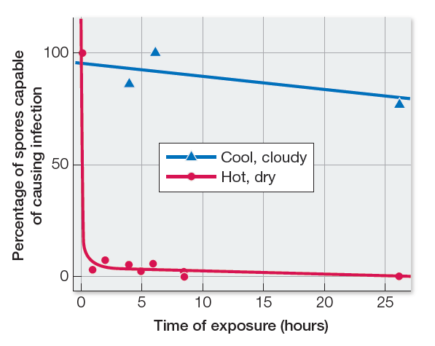

The graph shows results from a study on a pathogen that infects and destroys grape plants. The pathogen reproduces asexually to form spores. These spores are easily transported by wind to new plant hosts to begin a new round of infection. In this study, scientists infected grape vine plants with viable spores and placed the plants in a vineyard. The scientists then collected spores that were produced from this infection. They collected some spores at various times on hot, dry days and collected other spores at various times on cool, cloudy days. Then they tested both sets of spores to see how well they caused infection in a new round of host plants. Which statement can be made about this study?
a. This was a comparative experiment because it was conducted using living plants in a field study.
b. This was a controlled experiment because only one variable differed between the two sets of spores.
c. This was a comparative experiment because the viabilities of two sets of spores were being compared.
d. This was a controlled experiment because the plants being studied were limited to a certain number.
e. This was both a comparative and a controlled experiment because it was conducted in a field while specific variables were kept constant.
Answer: b
Hint: Remember that a controlled experiment is designed so that only one variable is manipulated, whereas a comparative experiment is carried out without such stringent control of all variables.
Learning Outcome: 1.2.1.d Differentiate between controlled experiments and comparative experiments.
Bloom’s Level: 4. Analyzing
Difficulty Level: Difficult

63. A research group collected fossilized snails of a particular species from various locations and brought them into the lab for study. They used electron microscopy to study the physical features of the shells as well as chemical methods for analyzing their chemical makeup. They also used analytical lab techniques to date the fossils. The results of this work enabled the researchers to draw conclusions about evolutionary changes in the snails. Which statement can be made about this study?
a. This was a comparative experiment because the subjects of the study were collected from field locations.
b. This was a controlled experiment because all of the analyses were conducted in a laboratory where conditions could be controlled.
c. This was a comparative experiment because the characteristics of different samples collected from different locations were compared.
d. This was a controlled experiment because the samples being studied were limited to one species of snail.
e. This was both a comparative and a controlled experiment because it involved comparisons of field samples carried out in a laboratory setting.
Answer: c
Hint: Remember that a comparative experiment involves comparison of data collected from subjects that may be influenced by many unknown variables, whereas a controlled experiment is designed so that groups being compared are influenced in the same way by all variables except one.
Learning Outcome: 1.2.1.d Differentiate between controlled experiments and comparative experiments.
Bloom’s Level: 4. Analyzing
Difficulty Level: Difficult

64. Which does not result from a scientific investigation?
a. Refinement of the experimental design
b. Formulation of new questions that result in additional experimentation
c. Use of statistical tests to evaluate the significance of the results
d. Experiments repeated and verified by others
e. A conclusion based on the investigator’s opinion
Answer: e
Hint: Consider that one scientific investigation can produce data and observations that lead to much evaluation and discussion among scientists.
Learning Outcome: 1.2.1.e Explain how statistics are used in biological investigations.
Bloom’s Level: 2. Understanding
Difficulty Level: Easy

65. Refer to the table below.

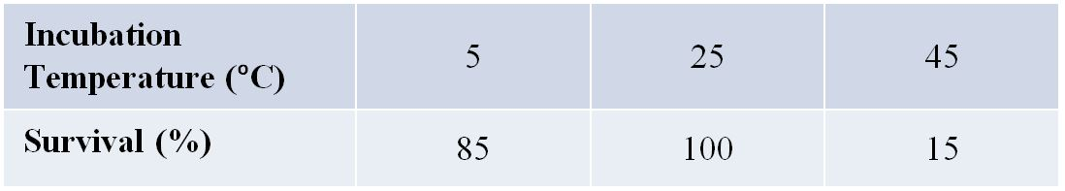

Groups of 50 house flies were kept in three chambers under the same conditions except for temperature. After 4 hours, the number of surviving flies in each chamber was counted and expressed as a percentage of the initial 50 flies. Which is the null hypothesis that would be developed when using statistics to analyze these results?
a. No fly can survive equally well at all temperatures.
b. Differences in genetic makeup can explain differences between individual flies in their ability to survive at extreme temperatures.
c. Temperature is not the only variable that can affect fly survival rate.
d. Some flies are more able to survive extremes in temperature than other flies.
e. Differences in percent survival at the different temperatures could be due to random variations in the samples.
Answer: e
Hint: Remember that the null hypothesis states that there is no real difference between two randomly selected groups taken from the same population.
Learning Outcome: 1.2.1.e Explain how statistics are used in biological investigations.
Bloom’s Level: 3. Applying
Difficulty Level: Difficult

66. Which statement about statistical analysis in science is false?
a. Statistical methods are applied to data to definitively prove a hypothesis.
b. Statistical tests analyze variation and calculate the probability that observed differences in an experiment could be due to random variation.
c. Statistical tests can be used to evaluate both comparative and controlled experiments.
d. Scientists generally conclude that the differences they measure are significant if the statistical tests show that the probability of error is 5 percent or lower.
e. Statistical analyses often begin with stating the null hypothesis, which states that the data can be explained by random variation alone.
Answer: a
Hint: Remember that statistical tests are used to help determine what conclusions can be drawn from data, but not as a means to prove a preexisting bias toward a certain conclusion.
Learning Outcome: 1.2.1.e Explain how statistics are used in biological investigations.
Bloom’s Level: 4. Analyzing
Difficulty Level: Difficult

67. Which statement about model systems is false?
a. The results of a study of a model system might be extended to humans.
b. Much of what we know about the genes that control animal development has come from work on Arabidopsis thaliana.
c. Basic understanding of chemical reactions in cells came from research on bacteria.
d. The biochemistry of photosynthesis was worked out from experiments on Chlorella.
e. Knowledge of how animals develop has come from work on sea urchins.
Answer: b
Hint: Scientists have used a species of mustard plant as a model to study plant development.
Learning Outcome: 1.2.1.f Explain why model organisms are used in biological research.
Bloom’s Level: 2. Understanding
Difficulty Level: Difficult

68. Much of what we know about the genes that control plant development was discovered in experiments with
a. fruit flies.
b. zebrafish.
c. roundworms.
d. Arabidopsis thaliana.
e. Chlorella.
Answer: d
Hint: Would scientists have used an animal model to study plant development?
Learning Outcome: 1.2.1.f Explain why model organisms are used in biological research.
Bloom’s Level: 1. Remembering
Difficulty Level: Moderate

69. Analyze the following question to determine whether it is a scientific question or a non-scientific question, and explain why: What causes cancer?
a. This is a non-scientific question because today’s scientists do not have all of the tools they would need to answer it.
b. This is a scientific question because it deals with a medical topic and medicine is a branch of science.
c. This is a non-scientific question because scientists have been working to try to answer it for decades and still cannot answer it completely.
d. This is a scientific question because scientists can gather data through experimentation that provide support for answers to this question.
e. This question does not qualify as either a scientific or non-scientific question because it is too broad to classify.
Answer: d
Hint: Remember that a scientific question can be answered through scientific investigation.
Learning Outcome: 1.2.1.g Explain the difference between science and non-science.
Bloom’s Level: 4. Analyzing
Difficulty Level: Moderate

70. Which claim has a scientific basis and why?
a. Animals can understand the meanings of words, because it has been shown that they respond to specific oral commands.
b. Psychological factors improve some health conditions, because people taking pills containing no medication have shown health improvements.
c. A huge aquatic creature inhabits the extremely deep lake in Loch Ness, Scotland, because parts of it have been observed by many people over many decades.
d. Life must exist on other planets, because there are so many other planets that it would be impossible for all of them to be devoid of life.
e. Extrasensory perception has been claimed to be a real phenomenon, because so many people have experiences that have no other explanation.
Answer: b
Hint: Remember that a scientific claim is supported by evidence obtained using scientific methods of investigation that specifically test that claim.
Learning Outcome: 1.2.1.g Explain the difference between science and non-science.
Bloom’s Level: 3. Applying
Difficulty Level: Moderate

71. Which is an example of science?
a. An article in a national news magazine about using astrology to buy stocks
b. A book about a woman overcoming cancer with dietary changes
c. A religious text stating predictions about future events
d. An almanac with 40 years of daily temperature and precipitation data used as a farmer’s planting guide
e. A report on the comprehensive effects of an oil spill covering the time immediately after the spill
Answer: d
Hint: Which of these written documents applies a scientific method to reach a conclusion or achieve a goal?
Learning Outcome: 1.2.1.g Explain the difference between science and non-science.
Bloom’s Level: 5. Evaluating
Difficulty Level: Difficult

72. For a hypothesis to be scientifically valid, it must be _______, and it should be possible to _______ it.
a. testable; prove
b. testable; reject
c. controlled; prove
d. controlled; reject
e. testable; control
Answer: b
Hint: Remember that a hypothesis is only a possible explanation awaiting evidence to support or refute it.
Learning Outcome: 1.2.1.g Explain the difference between science and non-science.
Bloom’s Level: 1. Remembering
Difficulty Level: Moderate

73. Which is the oldest example of a human application of biological principles?
a. Vaccinations
b. Stem cell therapies
c. Molecular genetic technologies
d. Plant breeding techniques
e. Antibiotic production
Answer: d
Hint: Think about how people long ago began to cultivate food crops.
Learning Outcome: 1.3.1.a Explain the relevance of biology to people’s daily lives.
Bloom’s Level: 2. Understanding
Difficulty Level: Easy

74. Which of the following predates modern-day medical practice and knowledge of biology?
a. Knowing that infections can be passed from one person to another
b. Understanding how living organisms work
c. Knowing that many diseases are genetic
d. Understanding the origin, basis, and effects of disease
e. Knowing that bacteria evolve
Answer: a
Hint: Think about which idea has been around for several hundred years while the others are much more recent.
Learning Outcome: 1.3.1.a Explain the relevance of biology to people’s daily lives.
Bloom’s Level: 1. Remembering
Difficulty Level: Easy

75. Many of the microbial organisms that are periodically epidemic in human populations have
a. short generation times and low mutation rates.
b. short generation times and high mutation rates.
c. long generation times and low mutation rates.
d. long generation times and high mutation rates.
e. long generation times and no mutations.
Answer: b
Hint: Which set of conditions gives microbes the greatest opportunity to undergo change and become highly pathogenic?
Learning Outcome: 1.3.1.a Explain the relevance of biology to people’s daily lives.
Bloom’s Level: 2. Understanding
Difficulty Level: Moderate

76. Scientists develop new vaccines for flu every year because of the
a. high rate of infection by the influenza virus in humans.
b. long incubation time of the influenza virus in the human body.
c. high rate of mutation of the influenza virus.
d. long generation time of the influenza virus.
e. low rate of transmission of influenza virus from person to person.
Answer: c
Hint: Think about the various conditions that will allow a virus to undergo such rapid change.
Learning Outcome: 1.3.1.a Explain the relevance of biology to people’s daily lives.
Bloom’s Level: 4. Analyzing
Difficulty Level: Moderate

77. Which of the following should not derive from the study of biology?
a. Modern agriculture
b. Public policy
c. Understanding ecosystems
d. Medical practice
e. Political influence
Answer: e
Hint: Consider all of the ways that biology impacts the daily lives of people everywhere.
Learning Outcome: 1.3.1.a Explain the relevance of biology to people’s daily lives.
Bloom’s Level: 3. Applying
Difficulty Level: Moderate

78. When applying biology to public policy,
a. the recommendations of scientists are always followed.
b. the economic issues of a policy are not considered.
c. several countries may be involved.
d. there are no ethical issues involved.
e. the correct course of action is always evident.
Answer: c
Hint: Remember that developing public policies tends to involve many different groups and ideas.
Learning Outcome: 1.3.1.a Explain the relevance of biology to people’s daily lives.
Bloom’s Level: 2. Understanding
Difficulty Level: Easy

79. An international commission drew a line down the middle of the Atlantic Ocean with the intent of allowing western populations of bluefin tuna to recover from ocean fishing. Which statement is false?
a. The policy had little effect on bluefin populations, as the eastern and western Atlantic populations freely mix.
b. Tracking data revealed that bluefin tuna feed across the Atlantic Ocean.
c. Bluefin tuna populations recovered in the western Atlantic Ocean.
d. Bluefin fishing was restricted in the western Atlantic Ocean but not in the eastern Atlantic Ocean.
e. It was initially assumed that bluefin tuna populations had geographically separated feeding grounds.
Answer: c
Hint: Remember that tracking data indicated that eastern and western bluefin tuna populations mixed in the middle of the Atlantic Ocean.
Learning Outcome: 1.3.1.a Explain the relevance of biology to people’s daily lives.
Bloom’s Level: 4. Analyzing
Difficulty Level: Difficult

80. Which is not something that a governmental institute should consider in crafting public policy?
a. Harmful effects of a herbicide on wild species
b. Potential farming income losses due to a ban on an insecticide
c. Special handling procedures required to safely use a substance
d. Stock holdings by a government official in a chemical company
e. Widespread utility of a drug versus detrimental side effects
Answer: d
Hint: Remember that public policy development should involve consideration of any circumstance that harms or interferes with the health of biological systems.
Learning Outcome: 1.3.1.a Explain the relevance of biology to people’s daily lives.
Bloom’s Level: 3. Applying
Difficulty Level: Difficult

81. Which is not an effect of a vastly increasing human population on the environment?
a. Changing global climate
b. Evolution of antibiotic-resistant bacteria
c. Extinctions of a great number of species
d. Spreading of disease
e. Influencing the frequency of volcanic eruptions around the world
Answer: e
Hint: Consider how the rise of the human population indirectly causes a lot of problems.
Learning Outcome: 1.3.1.a Explain the relevance of biology to people’s daily lives.
Bloom’s Level: 2. Understanding
Difficulty Level: Moderate

82. Which human activities do not rely on biodiversity?
a. Bird-watching
b. Gardening
c. Farming
d. Hunting
e. Fishing
Answer: c
Hint: One of these activities concerns large quantities of the same biological material, not a diverse array of biological materials.
Learning Outcome: 1.3.1.a Explain the relevance of biology to people’s daily lives.
Bloom’s Level: 4. Analyzing
Difficulty Level: Difficult

83. Which statement is true?
a. Biologists have discovered almost all of the species that inhabit Earth.
b. Biologists have discovered about three-quarters of the species that inhabit Earth.
c. Biologists have discovered about half of the species that inhabit Earth.
d. Biologists have discovered only a small percentage of the species that inhabit Earth.
e. Biologists have discovered a small percentage of the species that inhabit Mars.
Answer: d
Hint: Remember that Earth is very large and humans have not even explored the vast majority of regions on Earth where organisms may be found.
Learning Outcome: 1.3.1.a Explain the relevance of biology to people’s daily lives.
Bloom’s Level: 1. Remembering
Difficulty Level: Moderate

84. Pesticides are not used in organic farming, and so agricultural pests must be managed using other methods. Biologists have determined that the organism that causes potato blight, Phytophthora infestans, is an obligate parasite of the potato plant and several other host plants. That means that this unicellular organism can only survive in stems, leaves, tubers, or spores of its hosts. Knowing this information, which practice is an organic farmer likely to carry out?
a. Plant all potato crops in the same or adjacent fields.
b. Plow under potato plants after a harvest to serve as fertilizer for the next crop.
c. Allow plants to grow from seeds that blow by chance onto a field.
d. Rotate crops so that potato plants fully decompose before another potato crop is started.
e. Burn the soil and all plant waste in every field after every harvest.
Answer: d
Hint: Think about each option in light of what is known about the pest that causes potato blight. Which option would best reduce the ability of this pest to survive and reproduce while still maintaining healthy soil?
Learning Outcome: 1.3.1.b Apply biological knowledge to answer a question that pertains to everyday life.
Bloom’s Level: 5. Evaluating
Difficulty Level: Difficult

85. Tsetse flies are parasites that live off fresh blood they obtain by biting their hosts in hot, humid areas in Africa. Their natural hosts are wild pig and bushbuck, a type of antelope, but they have a broad host range. A second parasite, Trypanosoma brucei, is a unicellular organism that spends part of its life cycle in the tsetse fly. This microorganism causes African sleeping sickness in humans and is transmitted into human blood through the bite of a tsetse fly. Humans are increasingly moving into regions where the tsetse fly lives. This has increased deforestation of the natural habitats of pigs and bushbucks, which has caused declines in their populations. Listed below are several possible outcomes of these changes. Evaluate the likelihood of each of the outcomes listed, and select the most likely outcome.
a. Tsetse fly populations will decline, causing a decline in Trypanosoma brucei infections in humans.
b. The symptoms of African sleeping sickness in humans will decrease in intensity and duration.
c. African sleeping sickness incidence in humans and livestock will increase.
d. The tsetse fly will lose its ability to transmit Trypanosoma brucei to humans.
e. Trypanosoma brucei will move to a new host other than the tsetse fly.
Answer: c
Hint: How do the broad host possibilities for the tsetse fly influence this situation?
Learning Outcome: 1.3.1.b Apply biological knowledge to answer a question that pertains to everyday life.
Bloom’s Level: 5. Evaluating
Difficulty Level: Difficult

86. For many years, scientists have been debating whether to totally eradicate mosquitoes from the planet. The main reason for eliminating all mosquitoes is that they carry pathogens that cause diseases such as malaria, yellow fever, dengue fever, and Zika virus disease. Listed below are characteristics of mosquitoes. Which could be argued as a reason for not totally eradicating these insects?
a. Mosquitoes consume as much as 300 mL of blood per day from a single large animal in some areas of the world.
b. Mosquitoes pass through a larval stage and a pupal stage, both of which are aquatic.
c. Both male and female adult mosquitoes feed on plant nectar, but only females also feed on blood.
d. Mosquitoes are the primary pollinators of some tropical crops such as cacao.
e. Mosquitoes inhabit regions that are warm, temperate, or cold, including the Arctic.
Answer: d
Hint: Which of these characteristics is an example of how mosquitoes provide a service to an ecosystem?
Learning Outcome: 1.3.1.b Apply biological knowledge to answer a question that pertains to everyday life.
Bloom’s Level: 3. Applying
Difficulty Level: Easy

Fill in the Blank

87. During development, cells in a human embryo divide and take on varying shapes and functions. For example, some embryonic cells divide and become osteoclasts while others become osteoblasts, two types of cells that make up bone. This process is called _______.
Answer: differentiation
Hint: What process allows cells to become specialized?
Learning Outcome: 1.1.4.c Describe cellular differentiation and its significance to the range of living things observed today.
Bloom’s Level: 3. Applying
Difficulty Level: Easy

88. Peeling skin syndrome is a disease in which outer skin tissue peels off in large sheets in affected individuals. This disease has a genetic basis. Research has identified that patients with this disease produce a nonfunctional protein. This protein normally becomes embedded in skin cell membranes and functions in adhesion between cells to hold them together to stabilize skin tissue. Continued investigation into this disease would likely focus on locating the _______ in the gene encoding the nonfunctioning adhesion protein in these patients.
Answer: mutation
Hint: If you were looking for an error in a gene, what would you be looking for?
Learning Outcome: 1.1.4.d Use evidence to explain the ability of cells to become specialized and to contribute a unique function to the organism.
Bloom’s Level: 3. Applying
Difficulty Level: Easy

89. Diabetes type 1 is a disease in which the hormone insulin is not produced. Insulin promotes the uptake of glucose by cells, so when insulin is absent, cells do not take up glucose from the blood. This causes elevated blood glucose levels and leaves cells starved for an energy source. Injecting insulin as needed by these patients is a solution that allows their bodies to maintain a state of _______.
Answer: homeostasis
Hint: What is the condition of balance in the body called?
Learning Outcome: 1.1.4.f Explain why cell activities and organs have to be regulated in order to maintain homeostasis.
Bloom’s Level: 3. Applying
Difficulty Level: Easy

90. A researcher conducting a field study records the number of eggs laid by female wood ducks in a region over several breeding seasons. The researcher also records observations of wood duck mating and nesting behavior. The measurements of egg numbers are called _______ because they can be subjected to mathematical and statistical methods of analysis.
Answer: data
Hint: What term is used when referring to quantitative measurements collected during an investigation?
Learning Outcome: 1.2.1.a Explain the role of observation in scientific inquiry.
Bloom’s Level: 3. Applying
Difficulty Level: Easy

91. Refer to the following table.

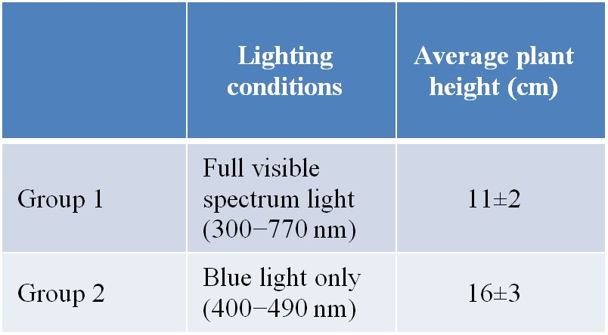

The table summarizes data collected by a student during an investigation to determine the effects of blue light on plant growth. Group 1 represents the _______ group in this investigation.
Answer: control
Hint: What information does group 1 provide in this investigation?
Learning Outcome: 1.2.1.c Describe how a controlled experiment is designed.
Bloom’s Level: 4. Analyzing
Difficulty Level: Easy

92. Refer to the table below.

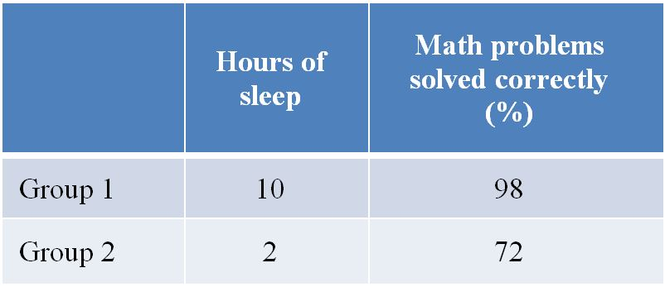

The table summarizes data collected during an investigation to determine the effects of lack of sleep on human problem-solving ability. Group 2 represents the _______ group in this investigation.
Answer: experimental
Hint: What is the difference between group 2 and group 1?
Learning Outcome: 1.2.1.c Describe how a controlled experiment is designed.
Bloom’s Level: 4. Analyzing
Difficulty Level: Easy

93. An agricultural researcher is interested in finding the minimal amount of a chemical fertilizer that, when applied to a corn crop, will support a certain yield of corn. The researcher sets up an experiment in which groups of corn plants are divided into fields and given different quantities of fertilizer. The fertilizer represents the _______ in this investigation.
Answer: controlled variable
Hint: What is the term used to describe factors or conditions that can be manipulated or changed in order to investigate their effects on a system?
Learning Outcome: 1.2.1.c Describe how a controlled experiment is designed.
Bloom’s Level: 3. Applying
Difficulty Level: Easy

94. Medical researchers interested in finding effective treatments for human diseases often use mice or rats in their work. The reason for this is that it is unethical to do certain kinds of experiments on humans, and so another animal that has characteristics similar to those of humans is used as a _______ system.
Answer: model
Hint: What term is used when referring to a species that will be investigated and whose results will be generalized to another species?
Learning Outcome: 1.2.1.f Explain why model organisms are used in biological research.
Bloom’s Level: 3. Applying
Difficulty Level: Easy

95. Some folk medicines have been found to have a scientific basis. For example, the practice of chewing on willow bark to relieve pain was shown to have merit when it was discovered that willow bark contained the compound salicylic acid. A modified form of this compound, acetylsalicylic acid, is now used as the active ingredient in aspirin. If willow bark were put to the test, experiment after experiment would show that this folk medicine was effective at relieving pain. This is an example of the concept that to be scientific, observations that support a hypothesis must be _______.
Answer: repeatable
Hint: If another folk medicine appeared to work sometimes but not always, would its use be considered an example of science or non-science?
Learning Outcome: 1.2.1.g Explain the difference between science and non-science.
Bloom’s Level: 3. Applying
Difficulty Level: Moderate

96. A region of Amazon rainforest has been targeted for deforestation so that the land can be used for growing a single crop—a species of palm that will be harvested for its palm oil. What harm could this cause? A biologist might be expected to give the following answer: Because this land will go from harboring many hundreds of thousands of species to having just one species, it is an example of land that will undergo extreme loss of _______.
Answer: biodiversity
Hint: What term is used to describe the number and variety of living species in a region?
Learning Outcome: 1.3.1.b Apply biological knowledge to answer a question that pertains to everyday life.
Bloom’s Level: 3. Applying
Difficulty Level: Easy

SUMMATIVE QUIZ QUESTIONS

1. An organism
a. always contains more than one cell.
b. can evolve.
c. cannot do biological work.
d. can be generated from nonliving materials.
e. must reproduce to ensure survival of its kind.
Answer: e
Learning Outcome: 1.1.1.a Describe characteristics shared by all living things.
Bloom’s Level: 2. Understanding

2. According to current thinking about the rise of life on Earth, what two critical types of molecules evolved in what order before the first primordial cells formed?
a. Carbohydrates followed by lipids
b. Nucleic acids followed by proteins
c. Enzymes followed by DNA
d. Photosynthetic pigments followed by amino acids
e. Oxygen followed by ozone
Answer: b
Learning Outcome: 1.1.2.a Describe current scientific thinking about the origin of life on Earth.
Bloom’s Level: 1. Remembering

3. Which are the two main lineages of prokaryotes that diverged early in life’s history?
a. Bacteria and Eukarya
b. Protista and Bacteria
c. Eukarya and Protista
d. Bacteria and Archaea
e. Archaea and Eukarya
Answer: d
Learning Outcome: 1.1.2.b Describe the earliest forms of life.
Bloom’s Level: 1. Remembering

4. The organisms that produced the oxygen gas in Earth’s early atmosphere were
a. anaerobic eukaryotes.
b. aerobic eukaryotes.
c. photosynthetic prokaryotes.
d. aerobic prokaryotes.
e. completely unlike modern organisms.
Answer: c
Learning Outcome: 1.1.2.c Explain how photosynthesis influenced the history of life on Earth.
Bloom’s Level: 2. Understanding

5. Evidence from which type of data supports the common origin of all life on Earth?
a. DNA structure
b. Atmospheric oxygen levels
c. Age of oldest fossil
d. Mitochondrial function
e. Cellular specialization
Answer: a
Learning Outcome: 1.1.3.a Describe evidence that supports the common origin of all life on Earth.
Bloom’s Level: 2. Understanding

6. Genetic information
a. is identical for all living cells.
b. continues unchanging from one generation to the next.
c. originates in the proteins in a cell.
d. can be passed on to offspring.
e. is only found in animal and plant cells.
Answer: d
Learning Outcome: 1.1.3.b Explain the biological importance of the genetic code.
Bloom’s Level: 1. Remembering

7. Prior to the industrial revolution in the mid-1800s, a species of moth had light-colored wings speckled with small black spots. This coloration camouflaged the moths resting on the birch trees growing in their native habitat, since birch bark has similar coloring. In the early 1900s, this changed as dark soot produced by industrial pollution coated birch trees such that the trees lost their speckled coloring. Years later, it was observed that the moths of this species had changed from being light and speckled to being solid black. Which is the most plausible reason for this change?
a. The moths changed their coloration to match their habitat as a response to increases in birds that preyed on the moths.
b. Black moths migrated into the habitat while speckled moths migrated out to decrease their chances of becoming prey for birds.
c. Birds evolved to become better predators of the speckled moths since there were more of them available as a food source.
d. Both birds and moths evolved to become better able to survive since evolution always causes change in the direction of improving any species.
e. Speckled moths declined and darker variants rose in numbers, as birds could more easily prey on speckled moths and less easily prey on black moths.
Answer: e
Learning Outcome: 1.1.4.a Explain how natural selection can produce evolutionary change.
Bloom’s Level: 3. Applying

8. Refer to the figure below showing the tree of life.

Based on this figure, which statement is true?
a. Most of the species that were ever present on Earth have already been discovered.
b. The diversity of organisms on Earth has increased since life arose.
c. Protists are prokaryotes.
d. Plants and bacteria do not share a common ancestor.
e. Fungi are more closely related to plants than to animals.
Answer: b
Learning Outcome: 1.1.4.b Explain how scientists classify organisms according to evolutionary relationships.
Bloom’s Level: 4. Analyzing

9. Which evolutionary development paved the way for the tremendous diversity of life forms observed on Earth today?
a. Predation
b. Cellular differentiation
c. Flight
d. Cell division
e. Anaerobic metabolism
Answer: b
Learning Outcome: 1.1.4.c Describe cellular differentiation and its significance to the range of living things observed today.
Bloom’s Level: 1. Remembering

10. Which set of outcomes is most likely if cell processes become unregulated and homeostasis is lost?
a. Mutation and genetic change
b. Metabolic readjustment and healing
c. Malfunction and disease
d. Adaptation and survival
e. Differentiation and cell specialization
Answer: c
Learning Outcome: 1.1.4.f Explain why cell activities and organs have to be regulated in order to maintain homeostasis.
Bloom’s Level: 1. Remembering

11. A population differs from a community in that a community
a. consists of just one species.
b. includes the abiotic environment.
c. includes many species.
d. is synonymous with an ecosystem.
e. is individuals of the same species that interact with each other.
Answer: c
Learning Outcome: 1.1.4.g Describe the hierarchy of the biological world.
Bloom’s Level: 2. Understanding

12. A researcher poses the hypothesis that plants grow tallest under a full spectrum of visible light. The researcher runs an experiment in which she plants seeds of the same plant species in pots and places different groups of pots under different lighting conditions. Group 1 receives the full spectrum of visible light, while groups 2 through 6 receive narrow ranges of visible wavelengths of light. All lighting conditions are at the same intensity. The researcher observes that the plants growing tallest are those exposed to blue light. After making these observations, which step is she most likely to carry out next?
a. Discard her original hypothesis and formulate a new one.
b. Repeat the experiment at a different level of light intensity.
c. Discard her question that asks what factors influence plant growth and why.
d. Design a follow-up experiment to change soil type and water conditions simultaneously as tests of these variables on plant growth.
e. Run a control trial to be sure that a valid conclusion can be made based on the results.
Answer: a
Learning Outcome: 1.2.1.a Explain the role of observation in scientific inquiry.
Bloom’s Level: 4. Analyzing

13. In the scientific method, a hypothesis is
a. a final answer to a question.
b. formulated by statistical analysis of data.
c. an alternative to an experiment.
d. the basis for making predictions.
e. formulated solely by speculation.
Answer: d
Learning Outcome: 1.2.1.b Explain the roles of inductive logic and deductive logic in scientific inquiry.
Bloom’s Level: 2. Understanding

14. A biologist hypothesizes that keeping mice on a restricted diet with minimal calories will increase their aggression. The biologist designs an experiment in which 100 mice are to be housed in individual cages under similar conditions and diets. He then plans to place pairs of mice together in the same cage to observe their interactions. What is true about this study design?
a. The study is well designed since it uses a large sample of mice.
b. The study is not controlled.
c. The study includes too many variables.
d. The study is flawed because the hypothesis is not testable.
e. The study is unnecessary because the results are obvious.
Answer: b
Learning Outcome: 1.2.1.c Describe how a controlled experiment is designed.
Bloom’s Level: 5. Evaluating

15. A research group hypothesizes that diet influences the distribution of bacterial species inhabiting the human digestive system. The researchers define two populations with very different diets—one in England and another in Africa—for sample collection. They take fecal samples from each group and measure the percentage of each species of bacteria present in the samples. How is this investigation classified and why?
a. This investigation is a controlled investigation because it was carried out using defined study populations.
b. This investigation is a controlled investigation because controlled methods were used for the collection and analysis of fecal samples.
c. This investigation is a comparative study because it compares a characteristic of two different groups that could be influenced by many variables.
d. This investigation is a comparative study because it tests a hypothesis that was formulated by comparing the diets of two populations.
e. This investigation is both a controlled and comparative study because it controls all but one variable influencing two study groups and then compares how that variable differs.
Answer: c
Learning Outcome: 1.2.1.d Differentiate between controlled experiments and comparative experiments.
Bloom’s Level: 4. Analyzing

16. Which is a reason to use statistics to evaluate data?
a. It provides a way for proving that your hypothesis is correct.
b. It facilitates the exclusion of data that do not fit your hypothesis.
c. It makes it possible to avoid having to consider the null hypothesis.
d. It enables you to predict experimental results.
e. It accounts for variation in scientific measurements.
Answer: e
Learning Outcome: 1.2.1.e Explain how statistics are used in biological investigations.
Bloom’s Level: 2. Understanding

17. Refer to the table below.

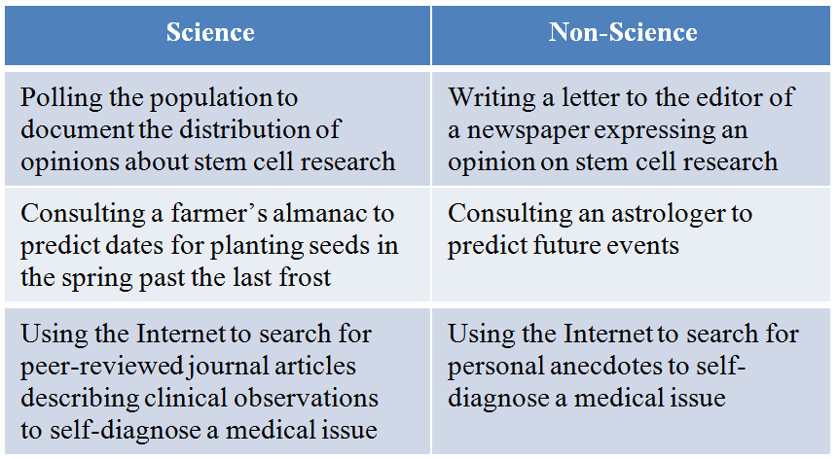

A student created the table to categorize various scenarios as representing science or non-science. Which statement best evaluates the student’s table?
a. The table is accurate as written and requires no changes.
b. Polling is not scientific, so the scenario regarding polling the population should be moved to the non-science section of the table.
c. Consulting a farmer’s almanac is not scientific, so this statement should be moved to the non-science section of the table.
d. Using the Internet is scientific since the searching process is unbiased, so both statements regarding Internet use should appear on the science section of the table.
e. Self-diagnosing a medical issue is not scientific, so both statements regarding this scenario should be moved to the non-science section of the table.
Answer: a
Learning Outcome: 1.2.1.g Explain the difference between science and non-science.
Bloom’s Level: 5. Evaluating

18. In 1928, British bacteriologist Alexander Fleming made an accidental discovery. He noticed that a fungus had contaminated one of the agar plates he had streaked with a bacterial species to be studied. The fungus prevented the bacteria from growing in the immediate area surrounding the fungus. Upon further investigation, Fleming found that the fungus produced a substance that was the agent responsible for killing the bacteria. He called this substance penicillin. Given this information, which statement best explains why Fleming’s discovery is relevant to the general public today?
a. Fleming’s work revealed the ability of bacteria to mutate, which necessitates the constant search for new antibiotics.
b. Fleming’s discovery enabled the development of chemical substances as antibiotics to treat deadly bacterial infections.
c. Fleming’s research spawned new questions about the ecological interactions between fungi and bacteria.
d. Fleming’s attention to detail diverted his efforts to investigate bacteria and likely robbed humanity of important discoveries that he would have otherwise made.
e. Fleming’s sloppiness in the lab serves as a reminder to all researchers that sterile technique is critical to preventing unwanted fungal growth on bacterial plates.
Answer: b
Learning Outcome: 1.3.1.a Explain the relevance of biology to people’s daily lives.
Bloom’s Level: 3. Applying

19. Biologists have discovered through research on bacteria that they can use enzymes from these organisms to make specific changes of their choosing in the DNA of living bacterial cells. Are these discoveries relevant to people in their everyday lives? Why or why not?
a. No, because changes made to the DNA of bacteria are unrelated to anything that would affect the average person.
b. No, because work carried out in a laboratory setting would not be applicable to events that occur in the natural world.
c. No, because human cells are eukaryotic and bacterial cells are prokaryotic, so cellular processes in the two cells differ in too many ways.
d. Yes, because all organisms on Earth use the same genetic code, so techniques developed using bacterial DNA are applicable to human DNA.
e. Yes, because all cells use the same enzymes to carry out metabolic reactions, so human cells will have the same enzymes discovered in bacterial cells.
Answer: d
Learning Outcome: 1.3.1.a Explain the relevance of biology to people’s daily lives.
Bloom’s Level: 3. Applying

20. A couple of recent movies depict terrifying scenarios in which pathogenic bacteria or viruses kill most of the people they infect. Which statement best answers whether it is possible for such a scenario to occur in real life and explains why?
a. It is not possible, because modern medicine has developed vaccines that protect us from harmful pathogens.
b. It is not possible, because even if someone does become infected, the medical community has so much knowledge and capability that it can effectively suppress any pathogen.
c. It is not possible, because bacteria and viruses found today are much less dangerous than they were many years ago when they caused so many human deaths.
d. It is possible because the more pathogenic the microbe, the easier it is for that microbe to infect someone.
e. It is possible because bacteria and viruses have such short life spans and large populations, they can quickly evolve new and very harmful characteristics.
Answer: e
Learning Outcome: 1.3.1.b Apply biological knowledge to answer a question that pertains to everyday life.
Bloom’s Level: 3. Applying

