Klein, Organic Chemistry 3e
Chapter 1

1. Chemical reactions occur as a result of __________

A. the attraction between opposite charges.
B. the nucleus–nucleus interactions.
C. the motion of electrons.
D. like atoms interacting.
E. combining two chemicals.

Answer: C
Learning Objective: 1.1 Compare and contrast organic and inorganic compounds
Difficulty: Easy

2. From the following, identify the item which does not contain organic compounds.

A. medicine
B. socks
C. a plant
D. a coin
E. a plastic cup

Answer: D
Learning Objective: 1.1 Compare and contrast organic and inorganic compounds
Difficulty: Easy

3. What is the difference between inorganic and organic compounds?

A. organic compounds do not contain carbon
B. organic compounds contain carbon
C. organic compounds are without pesticides
D. inorganic compounds contain carbon
E. inorganic compounds are composed exclusively of transition metal elements

Answer: B
Learning Objective: 1.1 Compare and contrast organic and inorganic compounds
Difficulty: Easy

4. Constitutional isomers do not differ in ____________.

A. physical properties
B. atomic connectivity
C. molecular formula
D. name
E. constitution

Answer: C
Learning Objective: 1.2 Describe structural theory of matter, molecular formula and structural formula
Difficulty: Easy

5. What is the relationship between the following compounds?

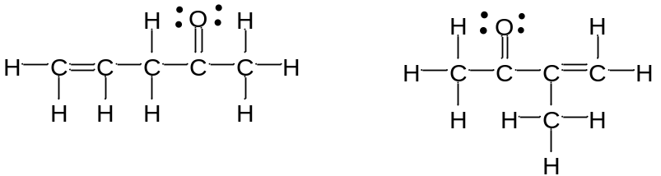

A. isotopes
B. constitutional isomers
C. the same structure
D. composed of different elements
E. no relationship

Answer: B
Learning Objective: 1.2 Describe structural theory of matter, molecular formula and structural formula
Difficulty: Easy

6. What is the relationship between the following compounds?

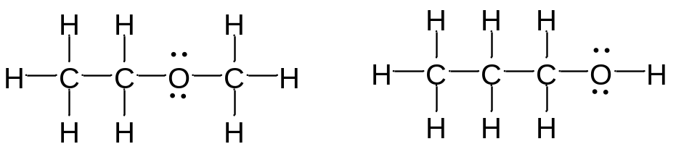

A. resonance isomers
B. constitutional isomers
C. empirical isomers
D. There is no relationship

Answer: B
Learning Objective: 1.2 Describe structural theory of matter, molecular formula and structural formula
Difficulty: Easy

7. Carbon is considered to be _______.

A. tetravalent
B. divalent
C. trivalent
D. monovalent
E. pentavalent

Answer: A
Learning Objective: 1.2 Describe structural theory of matter, molecular formula and structural formula
Difficulty: Easy

8. Which of the following compounds are constitutional isomers of each other?

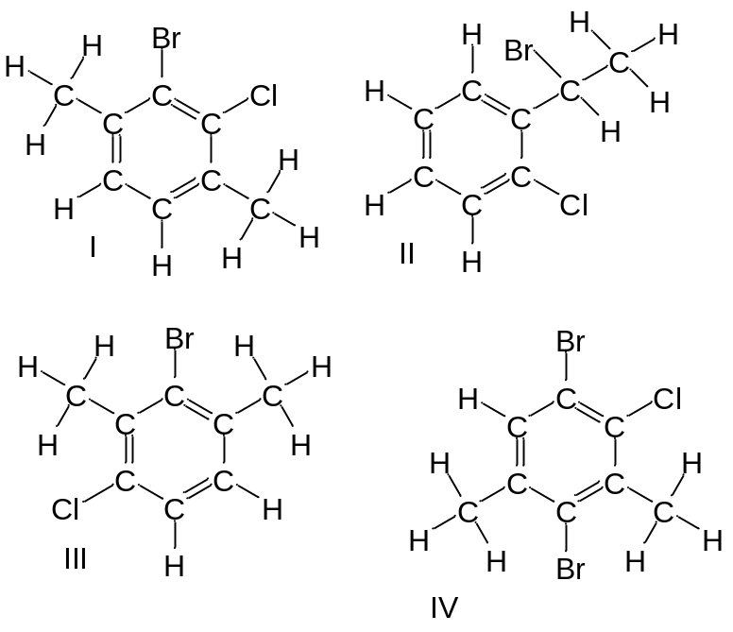

A. I and II
B. III and IV
C. I, II and IV
D. II, III and IV
E. I, II, and III

Answer: E

Learning Objective: 1.2 Describe structural theory of matter, molecular formula and structural formula
Difficulty: Medium

9. Which of the following compounds are constitutional isomers of each other?

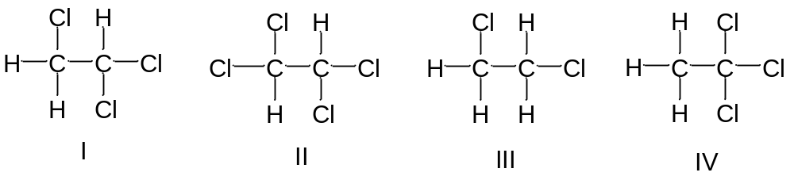

A. I and II
B. III and IV
C. II and III
D. I and IV
E. All of these

Answer: D
Learning Objective: 1.2 Describe structural theory of matter, molecular formula and structural formula
Difficulty: Medium

10. Draw three constitutional isomers that have molecular formula C₄H₈BrCl

Answer:

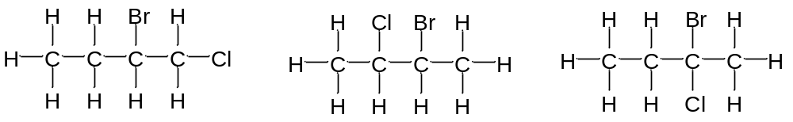

There are additional correct answers.

Learning Objective: 1.2 Describe structural theory of matter, molecular formula and structural formula
Difficulty: Medium

11. Draw three constitutional isomers that have molecular formula C₄H₈O.

Answer:

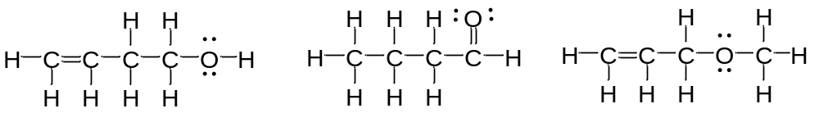

There are additional correct answers

Learning Objective: 1.2 Describe structural theory of matter, molecular formula and structural formula
Difficulty: Hard

12. What force is NOT taken into account in the formation of a covalent bond?

A. repulsion between two positively charged nuclei
B. force of attraction between positively charged nuclei and negatively charged electrons
C. repulsion between two negatively charged nuclei
D. repulsion between positively charged nuclei and negatively charged electrons

Answer: D
Learning Objective: 1.3 Define covalent bond, valence electrons, octet rule, and lone pair
Difficulty: Easy

13. What is the correct Lewis dot structure for S?

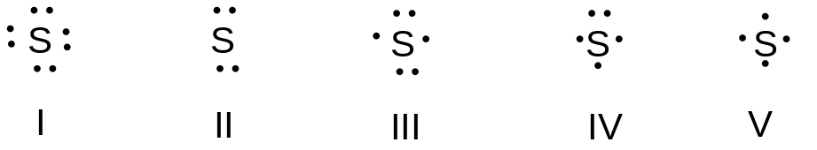

A. I
B. II
C. III
D. IV
E. V

Answer: C
Learning Objective: 1.3 Define covalent bond, valence electrons, octet rule, and lone pair
Difficulty: Easy

14. What is the correct Lewis dot structure for C?

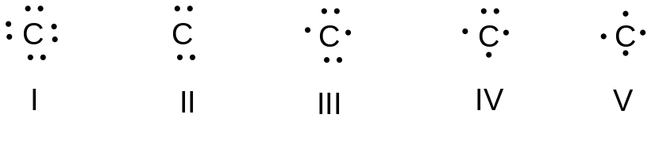

A. I
B. II
C. III
D. IV
E. V

Answer: E
Learning Objective: 1.3 Define covalent bond, valence electrons, octet rule, and lone pair
Difficulty: Easy

15. What is the correct Lewis structure for PH₃?

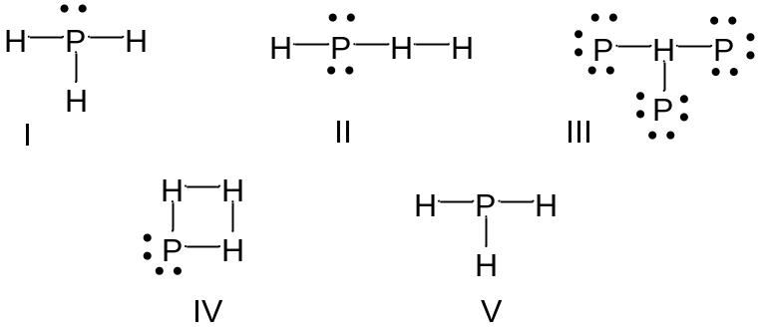

A. I
B. II
C. III
D. IV
E. V

Answer: A
Learning Objective: 1.3 Define covalent bond, valence electrons, octet rule, and lone pair
Difficulty: Easy

16. What is the correct Lewis structure for COCl₂?

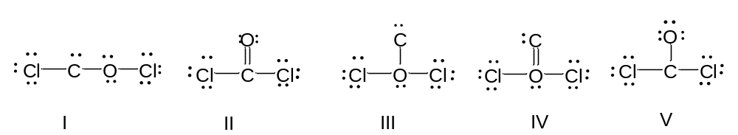

A. I
B. II
C. III
D. IV
E. V

Answer: B
Learning Objective: 1.3 Define covalent bond, valence electrons, octet rule, and lone pair
Difficulty: Hard

17. What is the correct Lewis structure for CH₃CO₂H?

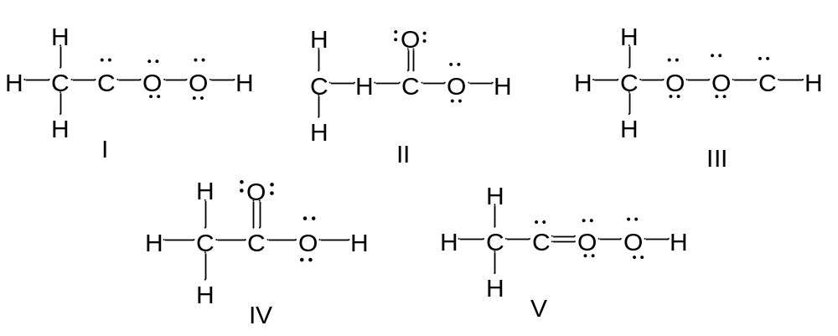

A. I
B. II
C. III
D. IV
E. V

Answer: D
Learning Objective: 1.3 Define covalent bond, valence electrons, octet rule, and lone pair
Difficulty: Hard

18. Which of the following compounds has two lone pairs on the central atom?

A. CO₂
B. SCl₂
C. NF₃
D. CS₂
E. SO₃

Answer: B
Learning Objective: 1.3 Define covalent bond, valence electrons, octet rule, and lone pair
Difficulty: Medium

19. What is the formal charge on oxygen in the following structure?

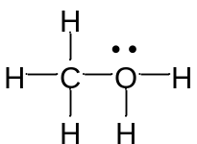

A. 2-
B. 1-
C. 2+
D. 1+
E. 0

Answer: D
Learning Objective: 1.4 Define formal charge and describe how formal charge is calculated
Difficulty: Easy

20. What is the formal charge on nitrogen in the following structure?

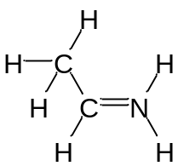

A. 2-
B. 1-
C. 2+
D. 1+
E. 0

Answer: D
Learning Objective: 1.4 Define formal charge and describe how formal charge is calculated
Difficulty: Easy

21. What is the formal charge on oxygen in the following structure?

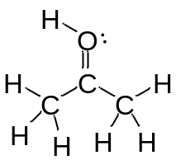

A. 0
B. 1+
C. 2+
D. 1-
E. 2-

Answer: B
Learning Objective: 1.4 Define formal charge and describe how formal charge is calculated
Difficulty: Easy

22. What is the formal charge on oxygen in the following structure?

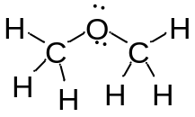

A. 2+
B. 2-
C. 1+
D. 1-
E. 0

Answer: E
Learning Objective: 1.4 Define formal charge and describe how formal charge is calculated
Difficulty: Easy

23. Which of the following structures have a zero formal charge on the carbon atom?

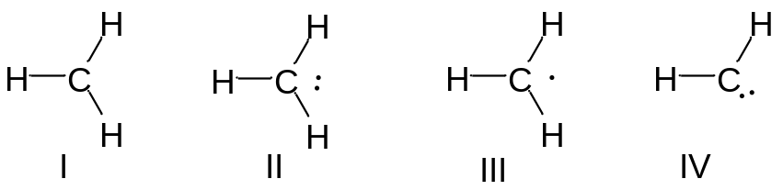

A. I and III
B. II and III
C. III and IV
D. I and IV
E. II and IV

Answer: C
Learning Objective: 1.4 Define formal charge and describe how formal charge is calculated
Difficulty: Medium

24. Which of the following structures have a 1- formal charge on the sulfur atom?

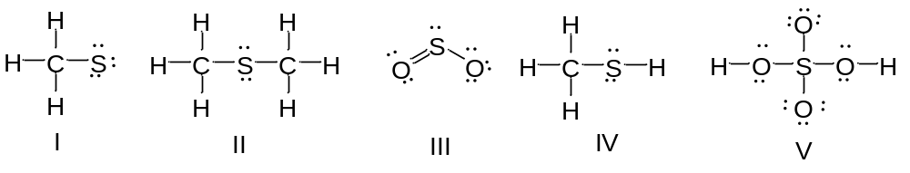
A. I
B. II
C. III
D. IV
E. V

Answer: A
Learning Objective: 1.4 Define formal charge and describe how formal charge is calculated
Difficulty: Easy

25. Which of the following structures have a 1+ formal charge on the sulfur atom?

A. I
B. II
C. III
D. IV
E. V

Answer: C
Learning Objective: 1.4 Define formal charge and describe how formal charge is calculated
Difficulty: Easy

26. What are the formal charges on boron and fluorine in the following structure?

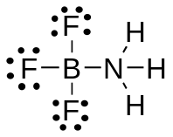

A. B = 1+, N = 1+
B. B = 1+, N = 1-
C. B = 1-, N = 1-
D. B = 1-, N = 1+
E. B = 1-, N = 0

Answer: D
Learning Objective: 1.4 Define formal charge and describe how formal charge is calculated
Difficulty: Medium

27. What are the formal charges on boron and oxygen in the following structure?

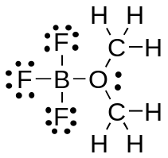

A. B = 1-, O = 1-
B. B = 1-, O = 1+
C. B = 1+, O = 1+
D. B = 1+, O = 1-
E. B = 1-, O = 0

Answer: B
Learning Objective: 1.4 Define formal charge and describe how formal charge is calculated
Difficulty: Medium

28. Which of the following structures have 1+ formal charge on the central atom?

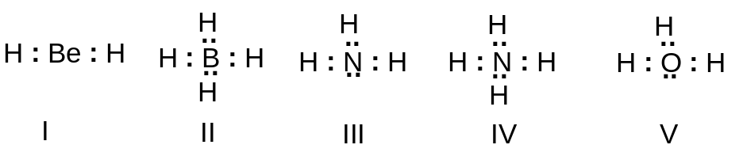

A. I
B. II
C. III
D. III and V
E. IV and V

Answer: E
Learning Objective: 1.4 Define formal charge and describe how formal charge is calculated
Difficulty: Medium

29. Which of the following structures have a formal charge on at least one atom?

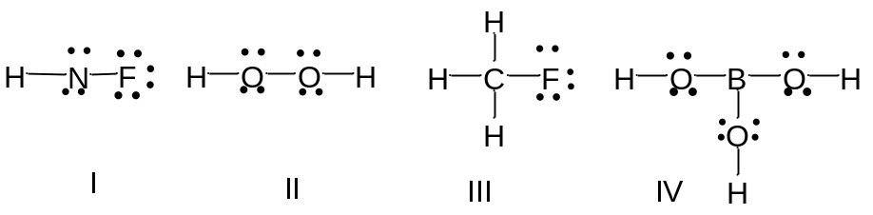

A. I
B. II
C. III
D. IV
E. None of these

Answer: A
Learning Objective: 1.4 Define formal charge and describe how formal charge is calculated
Difficulty: Medium

30. Which of the following structures have a 1- formal charge on the nitrogen atom?

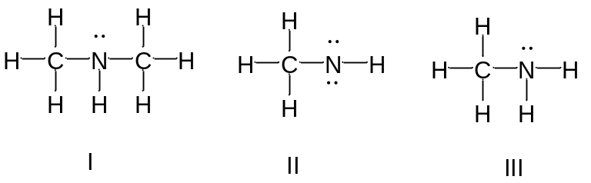

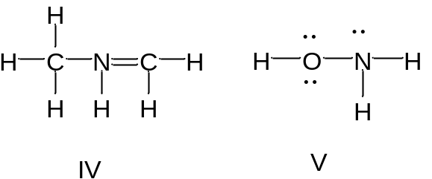

A. I
B. II
C. III
D. IV
E. V

Answer: B
Learning Objective: 1.4 Define formal charge and describe how formal charge is calculated
Difficulty: Medium

31. The bonding pattern of oxygen with a formal charge of –1 could be described as _____.

A. one lone pair of electrons and three single bonds
B. two lone pairs of electrons and two single bonds
C. three lone pairs of electrons, and one single bond
D. one lone pair of electrons, one single, and one double bond
E. zero lone pairs, and two single and one double bond

Answer: C
Learning Objective: 1.4 Define formal charge and describe how formal charge is calculated
Difficulty: Medium

32. In an ammonium ion, nitrogen has a valence of 4, and zero nonbonding electrons. What is the correct formal charge of nitrogen with 4 covalent bonds?

A. 2-
B. 2+
C. 1-
D. 1+
E. 0

Answer: D
Learning Objective: 1.4 Define formal charge and describe how formal charge is calculated
Difficulty: Medium

33. What is the correct Lewis structure for nitric acid, HNO₃, including the formal charges?

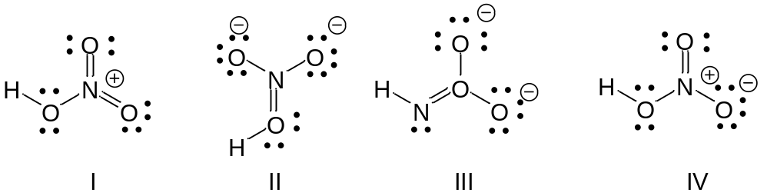

A. I
B. II
C. III
D. IV
E. None of these

Answer: D
Learning Objective: 1.4 Define formal charge and describe how formal charge is calculated
Difficulty: Medium

34. What is the correct Lewis structure for hydrocyanic acid, HCN, including the formal charges, if any?

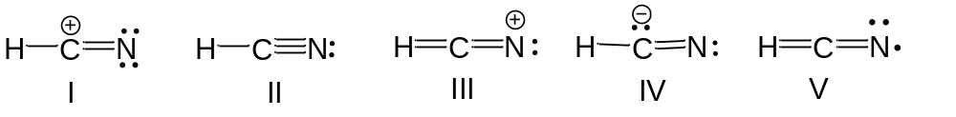

A. I
B. II
C. III
D. IV
E. V

Answer: B
Learning Objective: 1.4 Define formal charge and describe how formal charge is calculated
Difficulty: Hard

35. What is the correct Lewis structure for SCN— including the formal charges, if any?

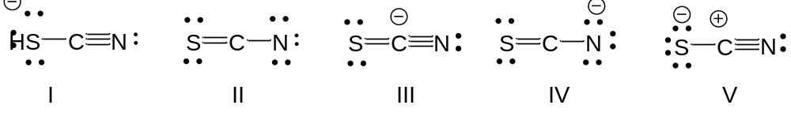

A. I
B. II
C. III
D. IV
E. V

Answer: A
Learning Objective: 1.4 Define formal charge and describe how formal charge is calculated
Difficulty: Hard

36. What is the correct Lewis structure for N₂O including the formal charges, if any?

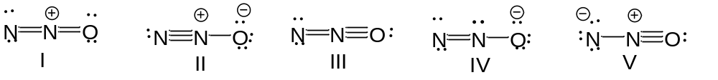

A. I
B. II
C. III
D. IV
E. V

Answer: B
Learning Objective: 1.4 Define formal charge and describe how formal charge is calculated
Difficulty: Hard

37. What is the correct Lewis structure for hydrazoic acid, HN₃, including the formal charges, if any?

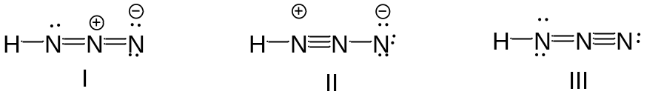

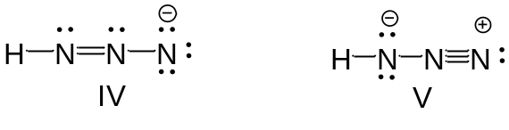

A. I
B. II
C. III
D. IV
E. V

Answer: A
Learning Objective: 1.4 Define formal charge and describe how formal charge is calculated
Difficulty: Hard

38. Draw the Lewis structure for NH₂CN including formal charges, if any?

Answer:

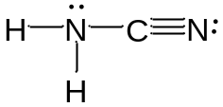

Learning Objective: 1.4 Define formal charge and describe how formal charge is calculated
Difficulty: Medium

39. Draw the Lewis structure for –CH₂CN including formal charges?

Answer:

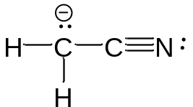

Learning Objective: 1.4 Define formal charge and describe how formal charge is calculated
Difficulty: Medium

40. Draw the Lewis structure for ozone, O_{3,} including formal charges, if any?

Answer:

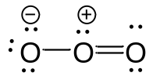

Learning Objective: 1.4 Define formal charge and describe how formal charge is calculated
Difficulty: Medium

41. The electronegativity of elements on the periodic table tends to increase_______.

A. from left to right, top to bottom
B. from right to left, bottom to top
C. from left to right, bottom to top
D. from right to left, top to bottom
E. from upper right to lower left

Answer: C
Learning Objective: 1.5 Describe the relationship between electronegativity and covalent, polar covalent, and ionic bonds
Difficulty: Easy

42. Which of the following is the least electronegative element?

A. B
B. C
C. N
D. O
E. F

Answer: A
Learning Objective: 1.5 Describe the relationship between electronegativity and covalent, polar covalent, and ionic bonds
Difficulty: Easy

43. Which of the following is the most electronegative element?

A. B
B. C
C. N
D. O
E. H

Answer: D
Learning Objective: 1.5 Describe the relationship between electronegativity and covalent, polar covalent, and ionic bonds
Difficulty: Easy

44. Which of the following is the least electronegative element?

A. P
B. N
C. Mg
D. Si
E. K

Answer: E
Learning Objective: 1.5 Describe the relationship between electronegativity and covalent, polar covalent, and ionic bonds
Difficulty: Easy

45. Which of the following is the most electronegative element?

A. P
B. N
C. S
D. O
E. F

Answer: E
Learning Objective: 1.5 Describe the relationship between electronegativity and covalent, polar covalent, and ionic bonds
Difficulty: Easy

46. What is the correct order of increasing electronegativity for Rb, F and O?

A. Rb < F < O
B. Rb < O < F
C. O < F < Rb
D. F < Rb < O
E. None of these

Answer: B
Learning Objective: 1.5 Describe the relationship between electronegativity and covalent, polar covalent, and ionic bonds
Difficulty: Easy

47. Which of the following series has the correct order of elements in increasing electronegativity?

A. C < N < B < Br
B. P < N < As < F
C. Li < B < N < F
D. Cl < Cs < C < Co
E. Be < B < Ba < Br

Answer: C
Learning Objective: 1.5 Describe the relationship between electronegativity and covalent, polar covalent, and ionic bonds
Difficulty: Easy

48. The Cl—Cl bond is best described as___________.

A. nonpolar covalent
B. polar covalent
C. ionic
D. coordinate covalent
E. None of these.

Answer: A
Learning Objective: 1.5 Describe the relationship between electronegativity and covalent, polar covalent, and ionic bonds
Difficulty: Easy

49. The C—Cl bond is best described as___________.

A. nonpolar covalent
B. polar covalent
C. ionic
D. coordinate covalent
E. None of these.

Answer: B
Learning Objective: 1.5 Describe the relationship between electronegativity and covalent, polar covalent, and ionic bonds
Difficulty: Easy

50. The bond between potassium and oxygen is best described as___________.

A. nonpolar covalent
B. polar covalent
C. ionic
D. coordinate covalent
E. None of these.

Answer: C
Learning Objective: 1.5 Describe the relationship between electronegativity and covalent, polar covalent, and ionic bonds
Difficulty: Easy

51. The bond between carbon and hydrogen is best described as ___________.

A. nonpolar covalent
B. polar covalent
C. ionic
D. coordinate covalent
E. None of these.

Answer: A
Learning Objective: 1.5 Describe the relationship between electronegativity and covalent, polar covalent, and ionic bonds
Difficulty: Easy

52. Which of the following is the correct depiction of induction for a C—F bond?

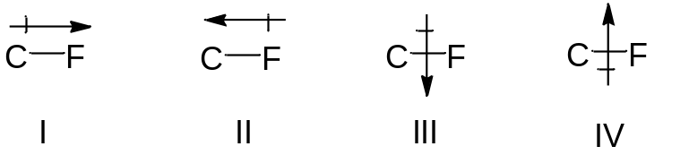

A. I
B. II
C. III
D. IV
E. None of these.

Answer: A
Learning Objective: 1.5 Describe the relationship between electronegativity and covalent, polar covalent, and ionic bonds
Difficulty: Easy

53. Which of the following is the correct representation of the dipole for a P—Cl bond?

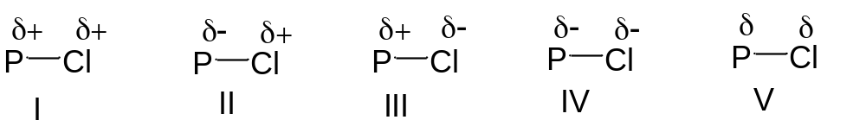

A. I
B. II
C. III
D. IV
E. V

Answer: C
Learning Objective: 1.5 Describe the relationship between electronegativity and covalent, polar covalent, and ionic bonds
Difficulty: Easy

54. Which of the following is the correct representation of partial charges at the indicated atoms?

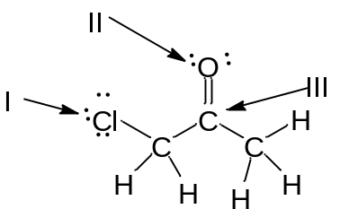

A. I = δ+; II = δ+; III = δ+
B. I = δ–; II = δ–; III = δ–
C. I = δ+; II = δ+; III = δ–
D. I = δ–; II = δ–; III = δ+
E. I = δ+; II = δ–; III = δ+

Answer: D
Learning Objective: 1.5 Describe the relationship between electronegativity and covalent, polar covalent, and ionic bonds
Difficulty: Medium

55. Which atom has the most δ+ in the following compound?

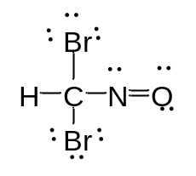

A. N
B. O
C. Br
D. H
E. C

Answer: E
Learning Objective: 1.5 Describe the relationship between electronegativity and covalent, polar covalent, and ionic bonds
Difficulty: Medium

56. Which of the following statements best describes the C—Cl bond in the following compound?

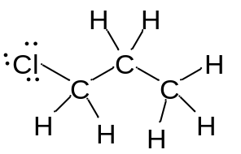

A. nonpolar; no dipole
B. polar; δ+ at carbon and δ– at chlorine
C. polar; δ– at carbon and δ+ at chlorine
D. ionic
E. None of these.

Answer: B
Learning Objective: 1.5 Describe the relationship between electronegativity and covalent, polar covalent, and ionic bonds
Difficulty: Medium

57. Which of the following compounds have both polar covalent and ionic bonds?

A. NH₄Br
B. H₂O₂
C. HCN
D. H₂S
E. None of these.

Answer: A
Learning Objective: 1.5 Describe the relationship between electronegativity and covalent, polar covalent, and ionic bonds
Difficulty: Medium

58. For the following compound identify the polar covalent bonds and indicate the partial charges by using δ+ and δ-.

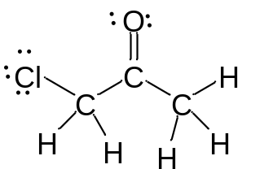

Answer:

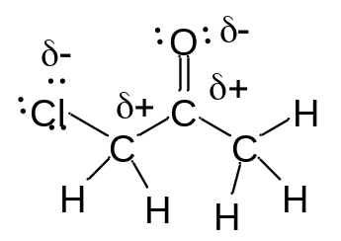

Learning Objective: 1.5 Describe the relationship between electronegativity and covalent, polar covalent, and ionic bonds
Difficulty: Medium

59. For the following compound identify the polar covalent bonds and indicate the partial charges by using δ+ and δ-.

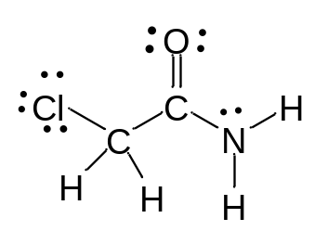

Answer:

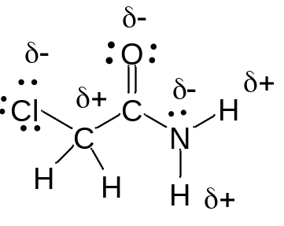

Learning Objective: 1.5 Describe the relationship between electronegativity and covalent, polar covalent, and ionic bonds
Difficulty: Medium

60. For NaSCH₃, identify each bond as polar covalent, nonpolar covalent or ionic.

Answer:
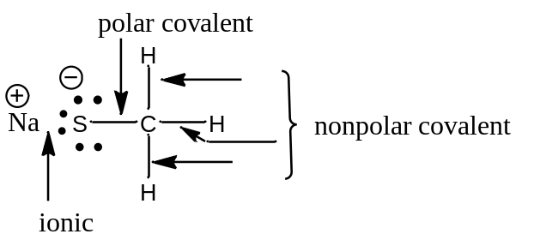

Learning Objective: 1.5 Describe the relationship between electronegativity and covalent, polar covalent, and ionic bonds
Difficulty: Medium

61. For the following compound, identify each bond as polar covalent, nonpolar covalent or ionic and place a δ+ on the most electropositive carbon.

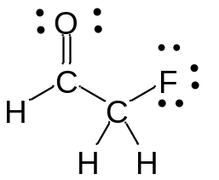

Answer:

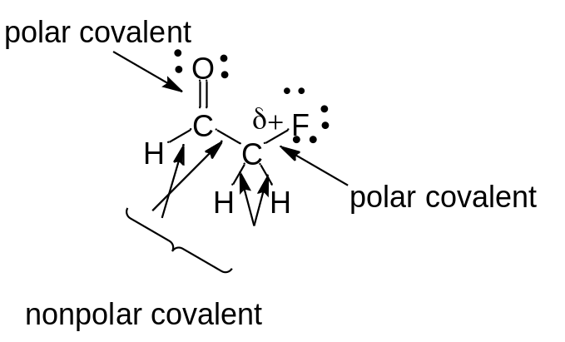

Learning Objective: 1.5 Describe the relationship between electronegativity and covalent, polar covalent, and ionic bonds
Difficulty: Medium

62. Orbitals with the same energy are called ___________.

A. quantum orbitals
B. atomic orbitals
C. antibonding orbitals
D. bonding orbitals
E. degenerate orbitals

Answer: E
Learning Objective: 1.6 Describe the shape and phase of s and p atomic orbitals and the process of filling orbitals with electrons
Difficulty: Easy

63. What is the letter designation for the following atomic orbital?



A. s
B. p
C. d
D. f
E. g

Answer: B
Learning Objective: 1.6 Describe the shape and phase of s and p atomic orbitals and the process of filling orbitals with electrons
Difficulty: Easy

64. What is the letter designation for the following atomic orbital?



A. s
B. p
C. d
D. f
E. g

Answer: C
Learning Objective: 1.6 Describe the shape and phase of s and p atomic orbitals and the process of filling orbitals with electrons
Difficulty: Easy

65. In quantum mechanics a node (nodal surface or plane) is ________ .

A. location where ψ is negative
B. location where ψ is positive
C. location where ψ² is positive
D. location where ψ² is negative
E. location where ψ is zero

Answer: E
Learning Objective: 1.6 Describe the shape and phase of s and p atomic orbitals and the process of filling orbitals with electrons
Difficulty: Easy

66. Which of the following principle states that “Each orbital can accommodate a maximum of two electrons with opposite spin”?

A. Aufbau principle
B. Pauli exclusion principle
C. Hund’s Rule
D. Heizenberg Uncertainty principle
E. Le Chatelier’s principle

Answer: B
Learning Objective: 1.6 Describe the shape and phase of s and p atomic orbitals and the process of filling orbitals with electrons
Difficulty: Easy

67. Which of the following principle states “When orbitals of equal energy are available, every orbital gets one electron before any gets two electrons”?

A. Aufbau principle
B. Pauli exclusion principle
C. Hund’s Rule
D. Heizenberg Uncertainty principle
E. Le Chatelier’s principle

Answer: C
Learning Objective: 1.6 Describe the shape and phase of s and p atomic orbitals and the process of filling orbitals with electrons
Difficulty: Easy

68. Which of the following represents the ground state electron configuration for phosphorous?

A. 1s² 2s² 2p⁶ 3s¹ 3p⁴
B. 1s² 2s² 2p⁶ 3s² 3p⁴
C. 1s² 2s² 2p⁶ 3s² 3p³
D. 1s² 2s² 2p⁶ 3s² 3p²
E. 1s² 2s² 2p⁶ 3s² 3p⁵

Answer: C
Learning Objective: 1.6 Describe the shape and phase of s and p atomic orbitals and the process of filling orbitals with electrons
Difficulty: Medium

69. The atomic number for nitrogen is 7. Which of the following represents the ground state electron configuration for nitrogen?

A. 1s² 2s¹ 2p⁴
B. 1s² 2p⁵
C. 2s² 2p⁵
D. 1s² 2s² 2p³
E. 1s² 2s² 3s³

Answer: D
Learning Objective: 1.6 Describe the shape and phase of s and p atomic orbitals and the process of filling orbitals with electrons
Difficulty: Medium

70. Which element has the electron configuration 1s² 2s² 2p⁶ 3s² 3p⁵?

A. oxygen
B. fluorine
C. sulfur
D. chlorine
E. bromine

Answer: D
Learning Objective: 1.6 Describe the shape and phase of s and p atomic orbitals and the process of filling orbitals with electrons
Difficulty: Medium

71. Which element has the electron configuration 1s² 2s² 2p⁶ 3s² 3p³?

A. Cl
B. S
C. P
D. Al
E. N

Answer: C
Learning Objective: 1.6 Describe the shape and phase of s and p atomic orbitals and the process of filling orbitals with electrons
Difficulty: Medium

72. What is the electronic configuration for the nitride ion?

A. 1s² 2s² 2p⁰
B. 1s² 2s² 2p²
C. 1s² 2s²2p³
D. 1s² 2s²2p⁴
E. 1s² 2s² 2p⁶

Answer: E
Learning Objective: 1.6 Describe the shape and phase of s and p atomic orbitals and the process of filling orbitals with electrons
Difficulty: Medium

73. What is the electronic configuration for the magnesium ion?

A. 1s² 2s² 2p⁶3s²
B. 1s² 2s² 2p⁶
C. 1s² 2s²2p⁴
D. 1s² 2s²2p⁶3s¹
E. 1s² 2s² 2p⁶3s²2p²

Answer: B
Learning Objective: 1.6 Describe the shape and phase of s and p atomic orbitals and the process of filling orbitals with electrons
Difficulty: Medium

74. What is the electronic configuration for the oxide ion?

A. 1s² 2s² 2p⁶
B. 1s² 2s² 2p²
C. 1s² 2s²2p⁴
D. 1s² 2s⁰2p⁶
E. 1s² 2s² 2p⁶3s²2p²

Answer: A
Learning Objective: 1.6 Describe the shape and phase of s and p atomic orbitals and the process of filling orbitals with electrons
Difficulty: Medium

75. Which element has the following electronic configuration?

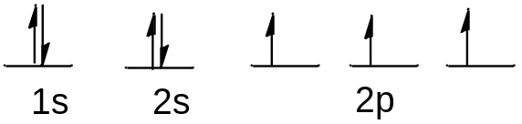

A. boron
B. carbon
C. silicon
D. nitrogen
E. fluorine

Answer: D
Learning Objective: 1.6 Describe the shape and phase of s and p atomic orbitals and the process of filling orbitals with electrons
Difficulty: Medium

76. Which element has the following electronic configuration?

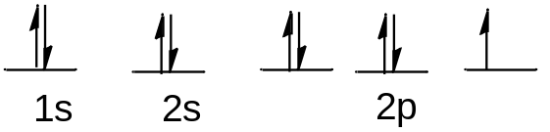

A. boron
B. carbon
C. silicon
D. nitrogen
E. fluorine

Answer: E
Learning Objective: 1.6 Describe the shape and phase of s and p atomic orbitals and the process of filling orbitals with electrons
Difficulty: Medium

77. The following ground state electron configuration violates ___.

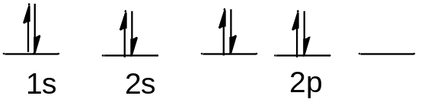

A. the Aufbau principle
B. the Pauli Exclusion principle
C. Hund’s Rule
D. Heisenberg’s Uncertainty principle
E. None of these.

Answer: C
Learning Objective: 1.6 Describe the shape and phase of s and p atomic orbitals and the process of filling orbitals with electrons
Difficulty: Easy

78. The following ground state electron configuration violates ____.

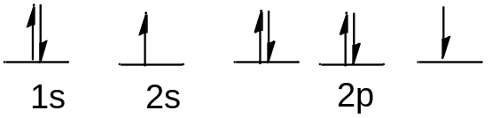

A. the Aufbau principle
B. the Pauli Exclusion principle
C. Hund’s Rule
D. Heisenberg’s Uncertainty principle
E. None of these.

Answer: A
Learning Objective: 1.6 Describe the shape and phase of s and p atomic orbitals and the process of filling orbitals with electrons
Difficulty: Easy

79. The following ground state electron configuration violates ____.

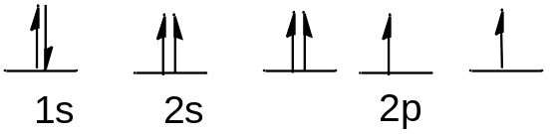

A. the Aufbau principle
B. the Pauli Exclusion principle
C. Hund’s Rule
D. Heisenberg’s Uncertainty principle
E. None of these.

Answer: B
Learning Objective: 1.6 Describe the shape and phase of s and p atomic orbitals and the process of filling orbitals with electrons
Difficulty: Easy

80. Ar, K⁺, and Cl– have equal numbers of electrons, and are considered isoelectronic. Provide the ground state electron configuration for them.

Answer: 1s² 2s² 2p⁶ 3s² 3p⁶
Learning Objective: 1.6 Describe the shape and phase of s and p atomic orbitals and the process of filling orbitals with electrons
Difficulty: Medium

81. Constructive interference of waves results in_______.

A. a wave with smaller amplitude
B. a wave with larger amplitude
C. cancellation of both waves
D. formation of a node
E. Both C and D

Answer: B
Learning Objective: 1.7 Define a bond in terms of valence bond theory
Difficulty: Easy

82. Destructive interference of waves results in_______.

A. a wave with smaller amplitude
B. a wave with larger amplitude
C. cancellation of both waves
D. formation of a node
E. Both C and D

Answer: E
Learning Objective: 1.7 Define a bond in terms of valence bond theory
Difficulty: Easy

83. All single bonds can be classified as _______.

A. nonpolar covalent
B. polar covalent
C. ionic
D. sigma bonds
E. pi bonds

Answer: D
Learning Objective: 1.7 Define a bond in terms of valence bond theory
Difficulty: Easy

84. Which of the bonding type has circular symmetry with respect to the bond axis?

A. sigma bond
B. pi bond
C. delta bond
D. covalent bond
E. ionic bond

Answer: A

Learning Objective: 1.7 Define a bond in terms of valence bond theory
Difficulty: Medium

85. The difference between valence bond theory and molecular orbital (MO) theory is _____.

A. valence bond theory requires the linear combination of atomic orbitals
B. MO theory requires the linear combination of atomic orbitals
C. valence bond theory considers only individual atomic orbitals
D. Both A and B
E. Both B and C

Answer: E
Learning Objective: 1.8 Compare and contrast molecular orbital theory and valence bond theory, molecular orbitals and atomic orbitals, and bonding MOs and antibonding MOs
Difficulty: Medium

86. How many molecular orbitals are formed, when the 1s orbitals of two hydrogen atoms combine to form a hydrogen molecule?

A. 1
B. 2
C. 3
D. 4
E. 5

Answer: B
Learning Objective: 1.8 Compare and contrast molecular orbital theory and valence bond theory, molecular orbitals and atomic orbitals, and bonding MOs and antibonding MOs
Difficulty: Medium

87. Which molecular orbitals are formed, when the 1s orbitals of two hydrogen atoms combine to form a hydrogen molecule?

A. two bonding molecular orbitals
B. only one bonding molecular orbital
C. one bonding and one antibonding molecular orbital
D. two antibonding molecular orbitals
E. only one antibonding orbital

Answer: C
Learning Objective: 1.8 Compare and contrast molecular orbital theory and valence bond theory, molecular orbitals and atomic orbitals, and bonding MOs and antibonding MOs
Difficulty: Medium

88. How are electrons distributed in the molecular orbitals, when the 1s orbitals of two hydrogen atoms combine to form a hydrogen molecule?

A. two electrons in the bonding molecular orbital
B. one electron in the bonding molecular orbital, one electron in the non–bonding molecular orbital
C. one electron in the bonding molecular orbital, one electron in the antibonding molecular orbital
D. two electrons in the antibonding molecular orbital
E. two electrons in the non–bonding molecular orbital

Answer: A
Learning Objective: 1.8 Compare and contrast molecular orbital theory and valence bond theory, molecular orbitals and atomic orbitals, and bonding MOs and antibonding MOs
Difficulty: Medium

89. According to molecular orbital theory, the constructive interference of two atomic orbitals results in a(n) _______.

Answer: bonding molecular orbital
Learning Objective: 1.8 Compare and contrast molecular orbital theory and valence bond theory, molecular orbitals and atomic orbitals, and bonding MOs and antibonding MOs
Difficulty: Medium

90. According to molecular orbital theory, the destructive interference of two atomic orbitals results in a(n) _______.

Answer: antibonding molecular orbital
Learning Objective: 1.8 Compare and contrast molecular orbital theory and valence bond theory, molecular orbitals and atomic orbitals, and bonding MOs and antibonding MOs
Difficulty: Medium

91. According to molecular orbital theory the highest energy molecular orbital that is occupied with an electron is referred to as _____.

A. degenerate
B. antibonding
C. the LCAO
D. the LUMO
E. the HOMO

Answer: E
Learning Objective: 1.8 Compare and contrast molecular orbital theory and valence bond theory, molecular orbitals and atomic orbitals, and bonding MOs and antibonding MOs
Difficulty: Easy

92. According to molecular orbital theory the lowest energy molecular orbital that is unoccupied with an electron is referred to as _______.

A. degenerate
B. antibonding
C. the LCAO
D. the LUMO
E. the HOMO

Answer: D
Learning Objective: 1.8 Compare and contrast molecular orbital theory and valence bond theory, molecular orbitals and atomic orbitals, and bonding MOs and antibonding MOs
Difficulty: Easy

93. Which of the following statement is incorrect, when the 1s atomic orbitals of two hydrogen atoms results in constructive interference?

A. a sigma bonding molecular orbital is formed
B. the bonding molecular orbital formed is lower in energy than the 1s atomic orbital
C. the bonding molecular orbital formed has a node between the atoms
D. the bonding molecular orbital formed has circular symmetry
E. a maximum of two electrons may occupy the bonding molecular orbital

Answer: C
Learning Objective: 1.8 Compare and contrast molecular orbital theory and valence bond theory, molecular orbitals and atomic orbitals, and bonding MOs and antibonding MOs
Difficulty: Hard

94. Describe what happens to create a sp³ hybridized orbital.

A. two s electrons are promoted to a p orbital
B. three p electrons are promoted to a s orbital
C. two p electrons are promoted to a s orbital
D. an s electron is promoted to a p orbital
E. a p electron is promoted to a s orbital

Answer: D
Answer: sigma bonding molecular orbital
Learning Objective: 1.9 Explain how pi bonds and sp³, sp², and sp hybrid orbital sets are formed
Difficulty: Medium

95. Interaction of the following two atomic orbitals results in what kind of molecular orbital, in the orientation shown?

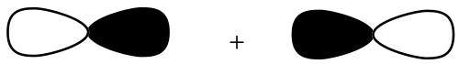

Answer: sigma bonding molecular orbital
Learning Objective: 1.9 Explain how pi bonds and sp³, sp², and sp hybrid orbital sets are formed
Difficulty: Medium

96. Interaction of the following two atomic orbitals results in what kind of molecular orbital, in the orientation shown?

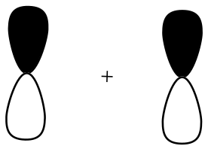

Answer: pi bonding molecular orbital
Learning Objective: 1.9 Explain how pi bonds and sp³, sp², and sp hybrid orbital sets are formed
Difficulty: Medium

97. Interaction of the following two atomic orbitals results in what kind of molecular orbital, in the orientation shown?

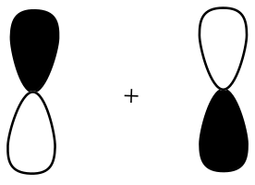

Answer: pi antibonding molecular orbital
Learning Objective: 1.9 Explain how pi bonds and sp³, sp², and sp hybrid orbital sets are formed
Difficulty: Medium

98. What is the hybridization state of the oxygen atom in the following compound?

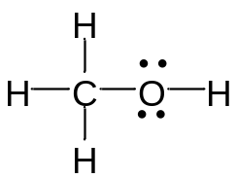

A. sp
B. sp²
C. sp³
D. sp³d
E. s²p

Answer: C
Learning Objective: 1.9 Explain how pi bonds and sp³, sp², and sp hybrid orbital sets are formed
Difficulty: Easy

99. What is the hybridization state of the carbon in CO₂?

A. sp
B. sp²
C. sp³
D. sp³d
E. s²p

Answer: A
Learning Objective: 1.9 Explain how pi bonds and sp³, sp², and sp hybrid orbital sets are formed
Difficulty: Easy

100. What is the hybridization state of the nitrogen atom in the following compound?

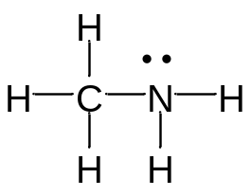

A. sp
B. sp²
C. sp³
D. sp³d
E. s²p

Answer: C
Learning Objective: 1.9 Explain how pi bonds and sp³, sp², and sp hybrid orbital sets are formed
Difficulty: Easy

101. What is the hybridization state of the boron atom in the following compound?

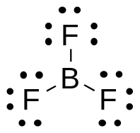

A. sp
B. sp²
C. sp³
D. sp³d
E. s²p

Answer: B
Learning Objective: 1.9 Explain how pi bonds and sp³, sp², and sp hybrid orbital sets are formed
Difficulty: Easy

102. What is the hybridization state of the carbon (I) atom in the following compound?

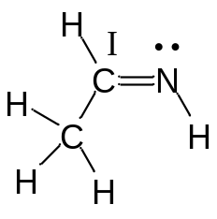

A. sp
B. sp²
C. sp³
D. sp³d
E. sp³d²

Answer: B
Learning Objective: 1.9 Explain how pi bonds and sp³, sp², and sp hybrid orbital sets are formed
Difficulty: Easy

103. What is the hybridization state of the nitrogen atom in the following compound?

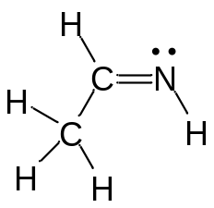

A. sp
B. sp²
C. sp³
D. sp⁴
E. s²p

Answer: B
Learning Objective: 1.9 Explain how pi bonds and sp³, sp², and sp hybrid orbital sets are formed
Difficulty: Easy

104. The lone pairs of electrons of the nitrogen atom are located in which orbitals?

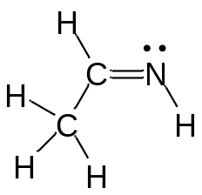

A. sp²
B. sp³
C. sp
D. s
E. p

Answer: A
Learning Objective: 1.9 Explain how pi bonds and sp³, sp², and sp hybrid orbital sets are formed
Difficulty: Medium

105. Which of the following structures have carbon with sp² hybridization state?

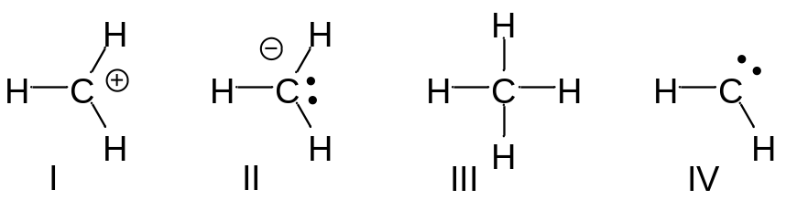

A. I and II
B. III and IV
C. I and III
D. II and IV
E. I and IV

Answer: E
Learning Objective: 1.9 Explain how pi bonds and sp³, sp², and sp hybrid orbital sets are formed
Difficulty: Medium

106. Which of the indicated carbon atoms have sp² hybridization state in the following compound?

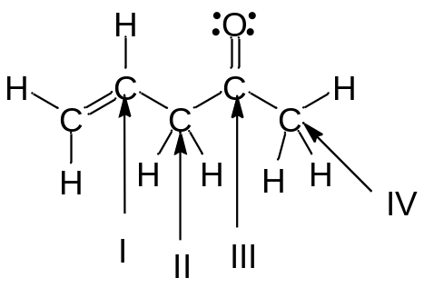

A. I and II
B. III and IV
C. II and III
D. I and III
E. II and IV

Answer: D
Learning Objective: 1.9 Explain how pi bonds and sp³, sp², and sp hybrid orbital sets are formed
Difficulty: Medium

107. What is the correct order of hybridization state for the numbered carbon atoms in the following compound?

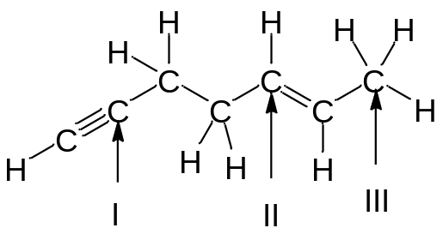

A. I = sp³, II = sp², III = sp
B. I = sp², II = sp, III = sp²
C. I = sp, II = sp², III = sp³
D. I = sp, II = sp², III = sp
E. I = sp², II = sp³, III = sp²

Answer: C
Learning Objective: 1.9 Explain how pi bonds and sp³, sp², and sp hybrid orbital sets are formed
Difficulty: Medium

108. How many s—sp² sigma bonds are in the following compound?

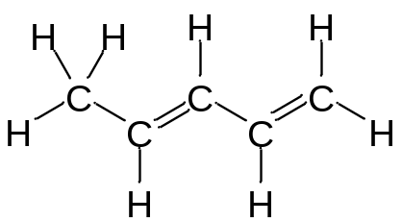

A. 2
B. 3
C. 4
D. 5
E. 6

Answer: D
Learning Objective: 1.9 Explain how pi bonds and sp³, sp², and sp hybrid orbital sets are formed
Difficulty: Medium

109. The C₂—C₃ bond in the following compound results from the overlap of which orbitals?

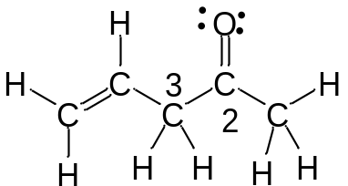

A. sp–sp²
B. sp–sp³
C. sp²–sp²
D. sp²–sp³
E. sp³–sp²

Answer: D
Learning Objective: 1.9 Explain how pi bonds and sp³, sp², and sp hybrid orbital sets are formed
Difficulty: Medium

110. The sigma bond that is part of C=C in the following compound results from the overlap of which orbitals?

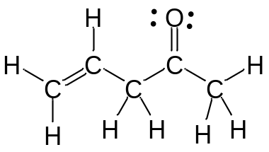

A. sp–sp²
B. sp–sp³
C. sp²–sp²
D. sp²–sp³
E. sp³–sp²

Answer: C
Learning Objective: 1.9 Explain how pi bonds and sp³, sp², and sp hybrid orbital sets are formed
Difficulty: Easy

111. The C—C sigma bond in ethyne (H—C≡C—H) results from the overlap of which orbitals?

A. sp–sp
B. sp–sp³
C. sp²–sp²
D. sp–s
E. p–p

Answer: A
Learning Objective: 1.9 Explain how pi bonds and sp³, sp², and sp hybrid orbital sets are formed
Difficulty: Easy

112. How many pi bonds are present in the following compound?

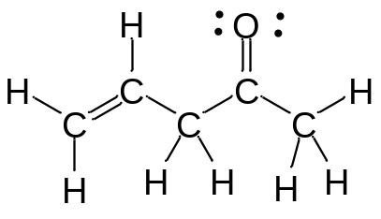

A. one
B. two
C. three
D. four
E. five

Answer: B
Learning Objective: 1.9 Explain how pi bonds and sp³, sp², and sp hybrid orbital sets are formed
Difficulty: Easy

113. How many pi bonds are present in the following compound?

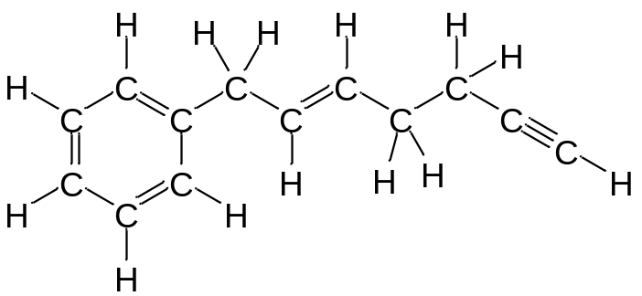

A. two
B. three
C. four
D. five
E. six

Answer: E
Learning Objective: 1.9 Explain how pi bonds and sp³, sp², and sp hybrid orbital sets are formed
Difficulty: Easy

114. How many sigma bonds are present in the following compound?

A. 20
B. 22
C. 24
D. 25
E. 27

Answer: E
Learning Objective: 1.9 Explain how pi bonds and sp³, sp², and sp hybrid orbital sets are formed
Difficulty: Easy

115. The sigma bond that is part of C=N in the following compound results from the overlap of which orbitals?

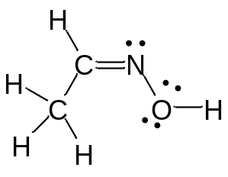

A. sp²–sp²
B. sp–sp
C. sp²–sp³
D. sp³–sp³
E. sp³–sp²

Answer: A
Learning Objective: 1.9 Explain how pi bonds and sp³, sp², and sp hybrid orbital sets are formed
Difficulty: Medium

116. The bonds indicated by the arrow in the following compound results from the overlap of which orbitals?

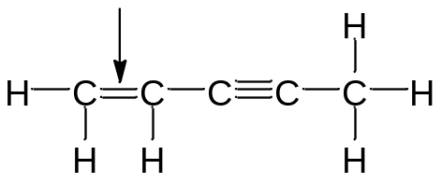

A. sp²–sp²
B. sp³–sp³
C. p–p
D. Both A and B
E. Both A and C

Answer: E
Learning Objective: 1.9 Explain how pi bonds and sp³, sp², and sp hybrid orbital sets are formed
Difficulty: Medium

117. Which orbitals are involved in the C—O, sigma bond in acetone, shown below?

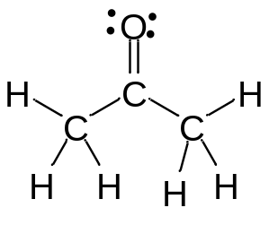

A. C_{sp}²—O_{sp}²
B. C_{sp}³—O_{sp}³
C. C_{sp}—O_{sp}
D. C_{p}—O_{p}
E. C_{sp}—O_{p}

Answer: A
Learning Objective: 1.9 Explain how pi bonds and sp³, sp², and sp hybrid orbital sets are formed
Difficulty: Medium

118. Which of the following best describes the orbitals involved in the formation of the C=O bond in acetone, shown below?

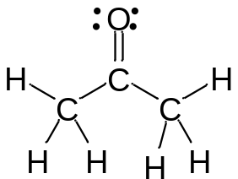

A.
B.
C.
D.
E.

Answer: B
Learning Objective: 1.9 Explain how pi bonds and sp³, sp², and sp hybrid orbital sets are formed
Difficulty: Medium

119. The C—H bond in the methyl cation, CH₃⁺, results from the overlap of which orbitals?

A. sp³–sp²
B. sp³–sp³
C. sp²–s
D. sp³–p
E. p–s

Answer: C
Learning Objective: 1.9 Explain how pi bonds and sp³, sp², and sp hybrid orbital sets are formed
Difficulty: Medium

120. The lone pair of electrons in the methyl anion, CH₃—, resides in which orbital?

A. s²
B. p
C. sp
D. sp³
E. sp²

Answer: D
Learning Objective: 1.9 Explain how pi bonds and sp³, sp², and sp hybrid orbital sets are formed
Difficulty: medium

121. What is the hybridization state of the indicated atoms in the following compound?

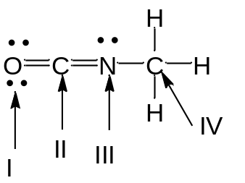

A. I – sp ; II – sp² ; III – sp³ ; IV – sp²
B. I – sp² ; II – sp ; III – sp² ; IV – sp³
C. I – sp³ ; II – sp² ; III – sp ; IV – sp²
D. I – sp² ; II – sp³ ; III – sp² ; IV – sp
E. I – sp² ; II – sp² ; III – sp² ; IV – sp³

Answer: B
Learning Objective: 1.9 Explain how pi bonds an sp³, sp², and sp hybrid orbital sets are formed
Difficulty: Hard

122. The carbon and oxygen atoms in carbon monoxide are connected by which type of bond(s)?

A. a sigma (σ) bond
B. two sigma (σ) bonds
C. a pi (π) bond
D. two pi (π) bonds
E. both A and D

Answer: E
Learning Objective: 1.9 Explain how pi bonds and sp³, sp², and sp hybrid orbital sets are formed
Difficulty: Medium

123. The N—H bond in the following compound is a _____ and is formed from the _____.

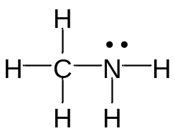

A. σ bond; sp² – s orbital overlap
B. σ bond; sp³ – s orbital overlap
C. π bond; sp³ – s orbital overlap
D. π bond; sp² – p orbital overlap
E. π bond; p – p orbital overlap

Answer: B
Learning Objective: 1.9 Explain how pi bonds and sp³, sp², and sp hybrid orbital sets are formed
Difficulty: Easy

124. Which is the shortest bond in the following compound?

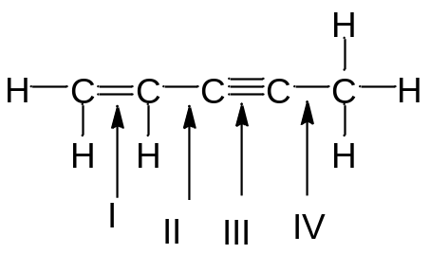

A. I
B. II
C. III
D. IV
E. I and III have the same length

Answer: C
Learning Objective: 1.9 Explain how pi bonds and sp³, sp², and sp hybrid orbital sets are formed
Difficulty: Easy

125. Which of the following compounds contains the shortest carbon–carbon bond?

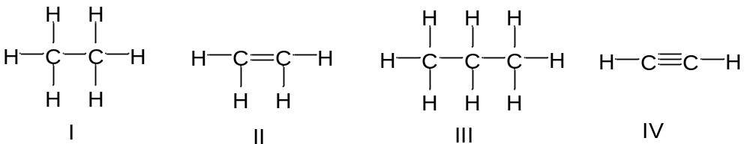

A. I
B. II
C. III
D. IV
E. All of these

Answer: D
Learning Objective: 1.9 Explain how pi bonds and sp³, sp², and sp hybrid orbital sets are formed
Difficulty: Medium

126. Compare the bond length and strength for the following compounds.

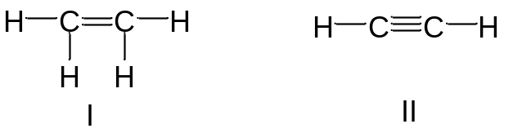

A. the shortest and strongest bond is found in compound I
B. the shortest and strongest bond is found in compound II
C. the shortest and weakest bond is found in compound I
D. the shortest and weakest bond is found in compound II
E. the bonds are of identical length and strength

Answer: B
Learning Objective: 1.9 Explain how pi bonds and sp³, sp², and sp hybrid orbital sets are formed
Difficulty: Medium

127. Which is the longest C—C bond in the following compound?

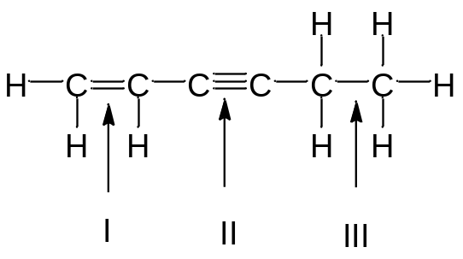

A. I
B. II
C. III
D. I and III
E. All of these

Answer: C
Learning Objective: 1.9 Explain how pi bonds and sp³, sp², and sp hybrid orbital sets are formed
Difficulty: Medium

128. Rank the indicated C—C bonds in increasing order of bond length.

A. I < II < III
B. II < III < I
C. III < I< II
D. II < I< III
E. I < III< II

Answer: D
Learning Objective: 1.9 Explain how pi bonds and sp³, sp², and sp hybrid orbital sets are formed
Difficulty: Medium

129. Identify the compound with the strongest carbon – nitrogen bond.

A. CH₃CH₂CH=NH
B. CH₃CH₂NH₂
C. CH₃CH₂C≡N
D. The length of the carbon-nitrogen bonds are the same

Answer: C
Learning Objective: 1.9 Explain how pi bonds and sp³, sp², and sp hybrid orbital sets are formed
Difficulty: Easy

130. Identify the compound with the longest carbon – nitrogen bond.

A. CH₃CH₂CH=NH
B. CH₃CH₂NH₂
C. CH₃CH₂C≡N
D. The length of the carbon-nitrogen bonds are the same

Answer: B
Learning Objective: 1.9 Explain how pi bonds and sp³, sp², and sp hybrid orbital sets are formed
Difficulty: Easy

131. The molecular geometry of carbon tetrachloride, CCl₄, is _________ .

A. tetrahedral
B. trigonal planar
C. trigonal pyramidal
D. square planar
E. linear

Answer: A
Learning Objective: 1.10 Describe VSEPR theory
Difficulty: Easy

132. Which of the following compounds have trigonal planar molecular geometry?

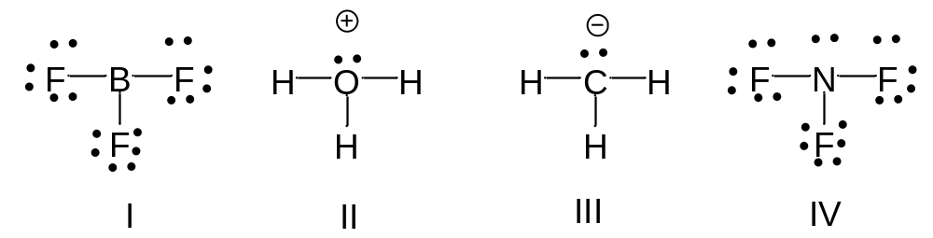

A. I
B. II
C. III
D. IV
E. I and IV

Answer: A
Learning Objective: 1.10 Describe VSEPR Theory
Difficulty: Easy

133. Which of the following compounds have trigonal pyramidal molecular geometry?

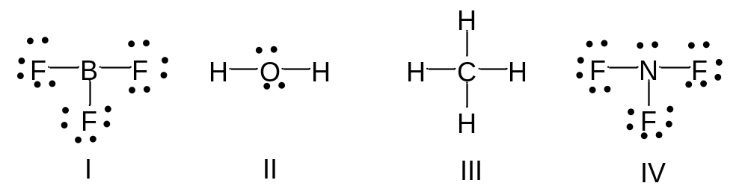

A. I
B. II
C. III
D. IV
E. I and IV

Answer: D
Learning Objective: 1.10 Describe VSEPR Theory
Difficulty: Easy

134. Which of the following compounds have bent molecular geometry?

A. I
B. II
C. III
D. IV
E. I and IV

Answer: B
Learning Objective: 1.10 Describe VSEPR Theory
Difficulty: Medium

135. Which of the following compounds have trigonal planar molecular geometry?

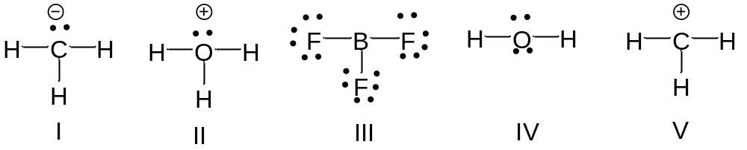
A. I, II and III
B. II and III
C. III and V
D. V only
E. All of these

Answer: C
Learning Objective: 1.10 Describe VSEPR Theory
Difficulty: Medium

136. Which of the following compounds have tetrahedral electron geometry?

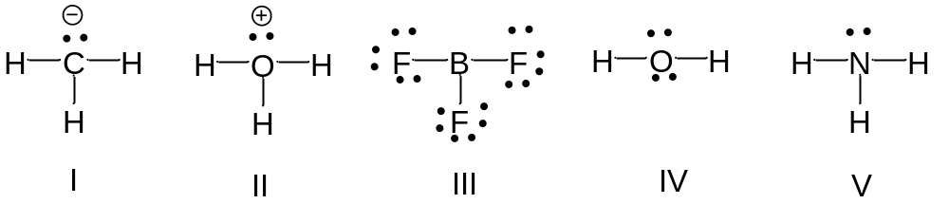

A. I, II and III
B. I, II, IV and V
C. III and IV and V
D. IV and V
E. All of these

Answer: B
Learning Objective: 1.10 Describe VSEPR Theory
Difficulty: Medium

137. Which of the following compounds have trigonal planar electron geometry?

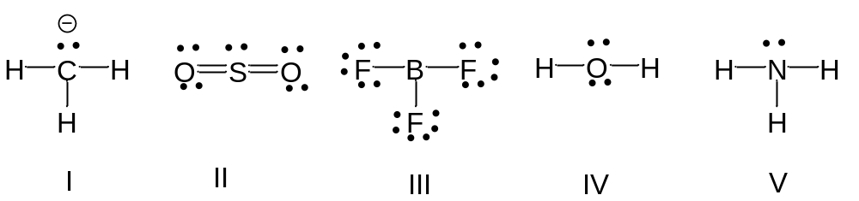

A. I, II and III
B. I, II, IV and V
C. III and IV and V
D. II and III
E. All of these

Answer: D
Learning Objective: 1.10 Describe VSEPR Theory
Difficulty: Medium

138. What is the molecular geometry at the central atom in CH₂Br₂?

A. trigonal planar
B. trigonal pyramidal
C. square planar
D. tetrahedral
E. None of these

Answer: D
Learning Objective: 1.10 Describe VSEPR Theory
Difficulty: Medium

139. What is the molecular geometry at the central atom in Cl₂CO?

A. trigonal planar
B. trigonal pyramidal
C. square planar
D. tetrahedral
E. bent

Answer: A
Learning Objective: 1.10 Describe VSEPR Theory
Difficulty: Medium

140. What is the molecular geometry at the nitrogen atom in the following compound?

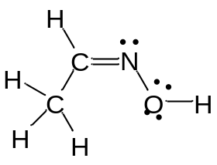

A. trigonal planar
B. trigonal pyramidal
C. linear
D. tetrahedral
E. bent

Answer: E
Learning Objective: 1.10 Describe VSEPR Theory
Difficulty: Medium

141. Which compound does not have a linear molecular geometry?

A. CO₂
B. H₂O
C. BeCl₂
D. HCN
E. C₂H₂

Answer: B
Learning Objective: 1.10 Describe VSEPR Theory
Difficulty: Medium

142. What is the approximate bond angle around the indicated carbon atom?

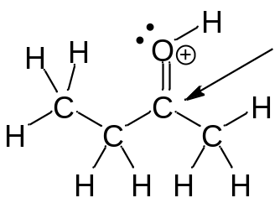

A. 60⁰
B. 90⁰
C. 109.5⁰
D. 120⁰
E. 180⁰

Answer: D
Learning Objective: 1.10 Describe VSEPR Theory
Difficulty: Easy

143. What is the approximate bond angle around the indicated carbon atom?

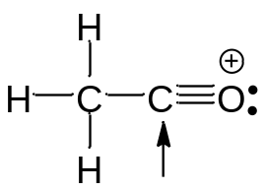

A. 60⁰
B. 90⁰
C. 109.5⁰
D. 120⁰
E. 180⁰

Answer: E
Learning Objective: 1.10 Describe VSEPR Theory
Difficulty: Easy

144. What is the approximate bond angle around the nitrogen atom?

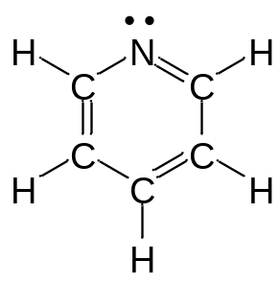

A. 90⁰
B. 109.5⁰
C. 120⁰
D. 180⁰
E. 100⁰

Answer: C
Learning Objective: 1.10 Describe VSEPR Theory
Difficulty: Medium

145. What is the approximate bond angle around sulfur atom in Cl₂CO?

A. 90⁰
B. 109.5⁰
C. 105⁰
D. 120⁰
E. 180⁰

Answer: D
Learning Objective: 1.10 Describe VSEPR Theory
Difficulty: Medium

146. What is the hybridization state and approximate bond angle around the carbon atom in HCN?

A. sp², 120⁰
B. sp, 180⁰
C. sp³, 109.5⁰
D. sp³, 120⁰
E. sp, 120⁰

Answer: B
Learning Objective: 1.10 Describe VSEPR Theory
Difficulty: Medium

147. What is the hybridization state and approximate bond angle around nitrogen in the following compound?

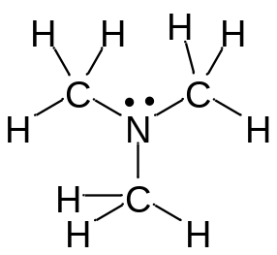

A. sp², 109.5°
B. sp², 107°
C. sp³, 109.5°
D. sp³, 107⁰
E. sp², 120⁰

Answer: D
Learning Objective: 1.10 Describe VSEPR Theory
Difficulty: Medium

148. What is the hybridization state and approximate bond angle around sulfur in the following compound?

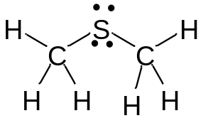

A. sp², 109.5°
B. sp³, 109.5°
C. sp³, 107°
D. sp³, 105⁰
E. sp², 105⁰

Answer: D
Learning Objective: 1.10 Describe VSEPR Theory
Difficulty: Hard

149. What is the hybridization state and molecular geometry around the sulfur atom in SO₃?

A. sp², tetrahedral
B. sp², trigonal planar
C. sp³, tetrahedral
D. sp³, trigonal pyramidal
E. sp², trigonal pyramidal

Answer: B
Learning Objective: 1.10 Describe VSEPR Theory
Difficulty: Hard

150. What is the hybridization state and molecular geometry around the carbon atom in CO₂?

A. sp, linear
B. sp², trigonal planar
C. sp³, tetrahedral
D. sp³, trigonal pyramidal
E. sp², trigonal pyramidal

Answer: A
Learning Objective: 1.10 Describe VSEPR Theory
Difficulty: Medium

151. What are the hybridization state, molecular geometry and approximate bond angle for the methyl cation, CH₃⁺?

A. sp², tetrahedral, 109⁰
B. sp², trigonal planar, 120⁰
C. sp³, tetrahedral, 109.5⁰
D. sp³, trigonal pyramidal, 120⁰
E. sp², trigonal pyramidal, 180⁰

Answer: B
Learning Objective: 1.10 Describe VSEPR Theory
Difficulty: Medium

152. What are the hybridization state, molecular geometry and approximate bond angle for the methyl anion, CH₃—?

A. sp², tetrahedral, 109⁰
B. sp², trigonal planar, 120⁰
C. sp³, tetrahedral, 109.5⁰
D. sp³, trigonal pyramidal, <109.5⁰
E. sp², trigonal pyramidal, 180⁰

Answer: D
Learning Objective: 1.10 Describe VSEPR Theory
Difficulty: Medium

153. Draw the Lewis structure for SOCl₂ and predict the hybridization state, molecular geometry and approximate bond angle around the central atom.

Answer:

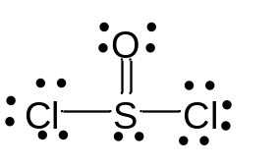

sp³, trigonal pyramidal, 107⁰
Learning Objective: 1.10 Describe VSEPR Theory
Difficulty: Hard

154. Draw the Lewis structure for HCOOH and predict the hybridization state, molecular geometry and approximate bond angle around the central atom.

Answer:

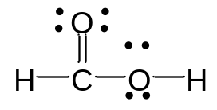

sp², trigonal planar, 120⁰
Learning Objective: 1.10 Describe VSEPR Theory
Difficulty: Hard

155. Following is the structure for Propranolol, and antihypertensive drug. What are the hybridization state, molecular geometry and approximate bond angle at the indicated nitrogen and oxygen atom in Propranolol?

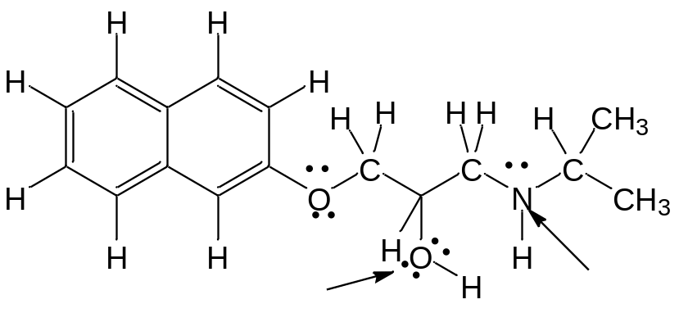

Answer:
N: sp³, trigonal pyramidal, 107⁰
O: sp³, bent, 105⁰
Learning Objective: 1.10 Describe VSEPR Theory
Difficulty: Hard

156. What are the hybridization state, molecular geometry and approximate bond angle at each nitrogen atom in the following compound?
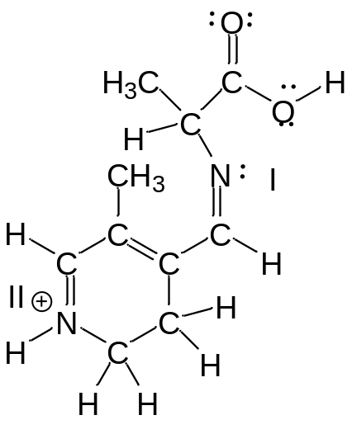

Answer:
N(I): sp², bent, 120⁰
N(II): sp², trigonal planar, 120⁰
Learning Objective: 1.10 Describe VSEPR Theory
Difficulty: Hard

157. Tryptophan is an essential amino acid important in the synthesis of the neurotransmitter serotonin in the body. What are the hybridization state, molecular geometry and approximate bond angle at the indicated carbon and nitrogen atoms?

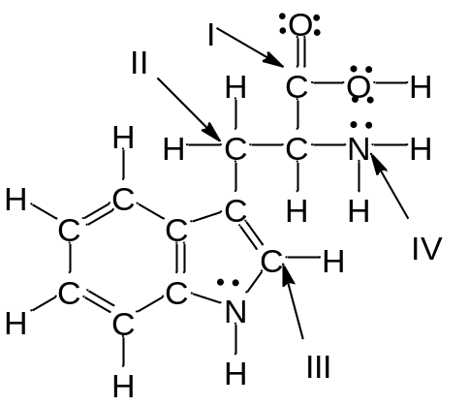

Answer:
C(I): sp², trigonal planar, 120⁰
C(II): sp³, tetrahedral, 109.5⁰
C(III): sp², trigonal planar, 120⁰
N(IV): sp³, trigonal pyramidal, 107⁰

Learning Objective: 1.10 Describe VSEPR Theory
Difficulty: Hard

158. Which of the following covalent bonds has the largest dipole moment?

A. C—C
B. C—H
C. C—O
D. N—H
E. H—F

Answer: E
Learning Objective: 1.11 Describe how dipole moment is used in calculating the ionic character of a bond
Difficulty: Easy

159. Which of the following compounds has no dipole moment?

A. CH₄
B. NH₃
C. HF
D. HCl
E. HBr

Answer: A
Learning Objective: 1.11 Describe how dipole moment is used in calculating the ionic character of a bond
Difficulty: Easy

160. Which of the following compounds has polar covalent bonds?

A. NH₃
B. Na₂O
C. H₂
D. KF
E. Both A and C

Answer: A
Learning Objective: 1.11 Describe how dipole moment is used in calculating the ionic character of a bond
Difficulty: Easy

161. Which of the following compounds have a net dipole moment?

A. CBr₄
B. CO₂
C. CH₄
D. H₂O
E. C₂H₄

Answer: D
Learning Objective: 1.11 Describe how dipole moment is used in calculating the ionic character of a bond
Difficulty: Medium

162. Which of the following compounds does not have dipole moment?

A. HCl
B. NCl₃
C. CO
D. BF₃
E. All have dipole moment

Answer: D
Learning Objective: 1.11 Describe how dipole moment is used in calculating the ionic character of a bond
Difficulty: Medium

163. Which of the following compounds has a net dipole moment of zero?

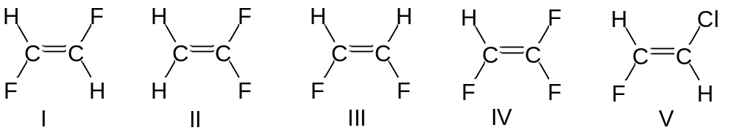

A. I
B. II
C. III
D. IV
E. V

Answer: A
Learning Objective: 1.11 Describe how dipole moment is used in calculating the ionic character of a bond
Difficulty: Medium

164. Which of the following compounds have a dipole moment?

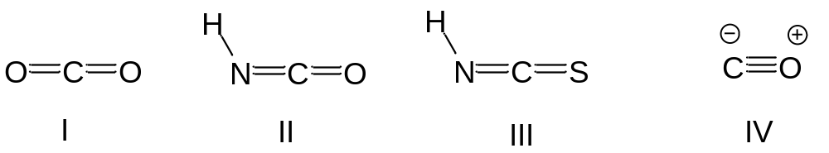

A. II
B. III
C. II and III
D. I, II and III
E. II, III and IV

Answer: E
Learning Objective: 1.11 Describe how dipole moment is used in calculating the ionic character of a bond
Difficulty: Medium

165. Rank the following compounds in order of decreasing dipole moment.

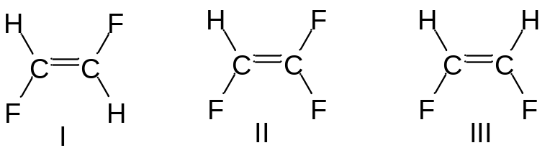

A. I > II > III
B. II > III > I
C. I > III > II
D. III > II > I
E. II > I > III

Answer: D
Learning Objective: 1.11 Describe how dipole moment is used in calculating the ionic character of a bond
Difficulty: Hard

166. Rank the following compounds in order of decreasing dipole moment.

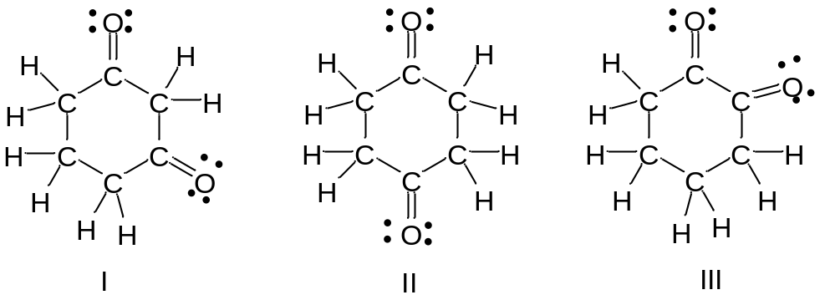

A. I > II > III
B. II >III > I
C. I > III > II
D. III > I > II
E. II > I > III

Answer: D
Learning Objective: 1.11 Describe how dipole moment is used in calculating the ionic character of a bond
Difficulty: Medium

167. Which of the following compounds has a dipole moment? Indicate the direction of the dipole moment.

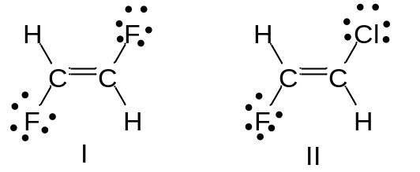

Answer: Compound I has no dipole moment. Compound II has a dipole moment.

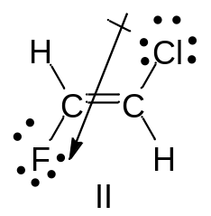

Learning Objective: 1.11 Describe how dipole moment is used in calculating the ionic character of a bond
Difficulty: Medium

168. Which of the following compounds has a dipole moment? Indicate the direction of the dipole moment.

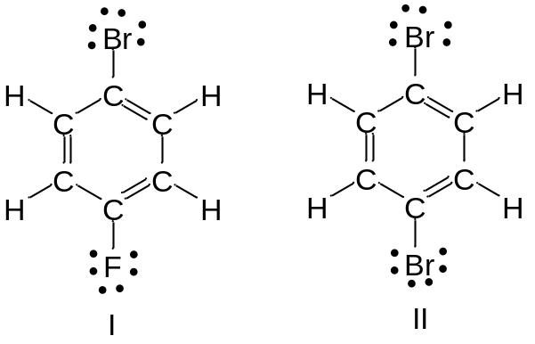

Answer: Compound II has no dipole moment. Compound I has a dipole moment.

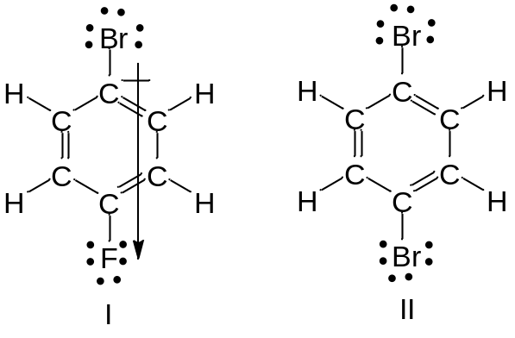

Learning Objective: 1.11 Describe how dipole moment is used in calculating the ionic character of a bond
Difficulty: Medium

169. BF₃ has a no dipole moment. Draw the Lewis structure for BF₃, showing all nonbonding electrons. Indicate the polarity of every atom in the structure using δ+ and δ– notation. Explain why the molecule has no net dipole.

Answer:

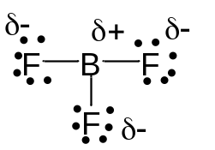

The trigonal planar geometry of BF₃ results in the cancellation of individual bond dipoles, producing a net molecular dipole of zero.

Learning Objective: 1.11 Describe how dipole moment is used in calculating the ionic character of a bond
Difficulty: Easy

170. Which of the intermolecular forces listed below is generally considered the strongest?

A. London dispersion forces
B. fleeting dipole-dipole interactions
C. dipole-dipole interactions
D. hydrogen bonding
E. the vital force

Answer: D
Learning Objective: 1.12 Describe the basic nature of all intermolecular forces
Difficulty: Easy

171. Which intermolecular force is generally considered the weakest?

A. ion-dipole interactions
B. London dispersion forces
C. dipole-dipole interactions
D. hydrogen bonding
E. covalent bonding

Answer: B
Learning Objective: 1.12 Describe the basic nature of all intermolecular forces
Difficulty: Easy

172. Which intermolecular force is primarily responsible for base pairing, and stability, of the double helix in DNA?

A. ion-dipole interactions
B. London dispersion forces
C. dipole-dipole interactions
D. hydrogen bonding
E. covalent bonding

Answer: D
Learning Objective: 1.12 Describe the basic nature of all intermolecular forces
Difficulty: Easy

173. What is the strongest intermolecular force present in the following compound?

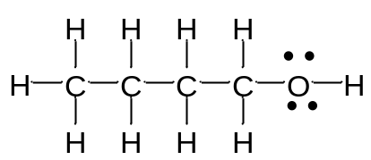

A. ion-dipole interactions
B. London dispersion forces
C. dipole-dipole interactions
D. hydrogen bonding
E. covalent bonding

Answer: D
Learning Objective: 1.12 Describe the basic nature of all intermolecular forces
Difficulty: Easy

174. What is the strongest intermolecular force present in the following compound?

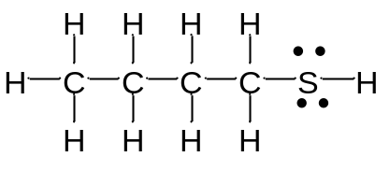

A. ion-dipole interactions
B. London dispersion forces
C. dipole-dipole interactions
D. hydrogen bonding
E. covalent bonding

Answer: C
Learning Objective: 1.12 Describe the basic nature of all intermolecular forces
Difficulty: Medium

175. Which of the following statements best explains the observation that hydrogen fluoride has the highest boiling point of all the hydrogen halides?

A. The fluorine in HF is the smallest atom for all of the halogens
B. Fluorine is the most electronegative of the atoms
C. Hydrogen fluoride can participate in hydrogen bonding
D. HF is very reactive and can react and dissolve glass
E. HF is a weak acid, and doesn’t completely dissociate

Answer: C
Learning Objective: 1.12 Describe the basic nature of all intermolecular forces
Difficulty: Medium

176. Which of the following compounds have the greatest fleeting dipole interactions between like molecules?

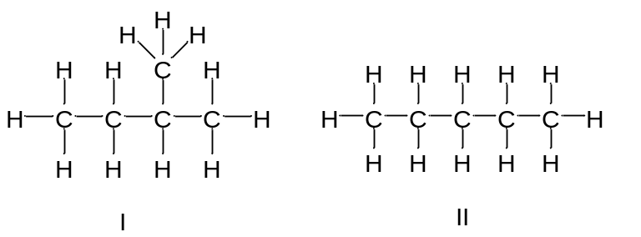

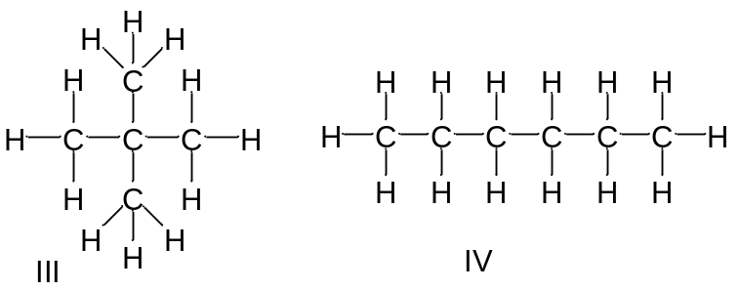

A. I
B. II
C. III
D. IV
E. I, III and IV

Answer: D
Learning Objective: 1.12 Describe the basic nature of all intermolecular forces
Difficulty: Easy

177. Which of the following compounds have the highest boiling point?

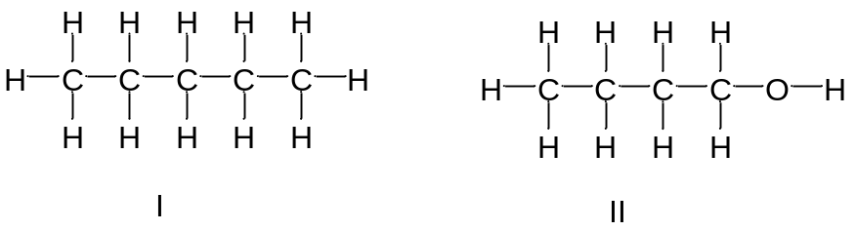

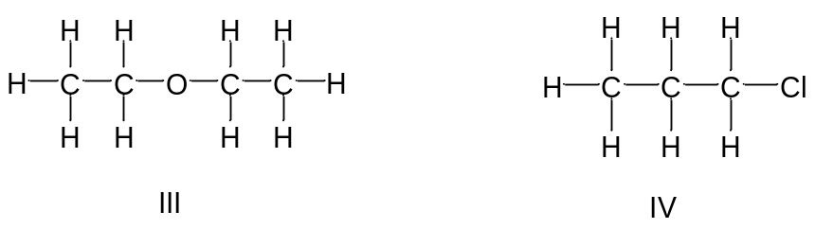

A. I
B. II
C. III
D. IV
E. II and IV

Answer: B
Learning Objective: 1.12 Describe the basic nature of all intermolecular forces
Difficulty: Easy

178. Which of the following compounds have the lowest boiling point?

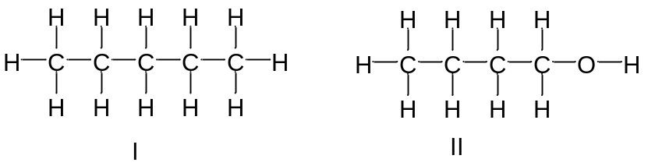

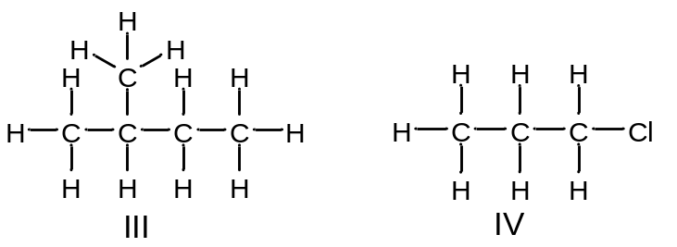

A. I
B. II
C. III
D. IV
E. II and IV

Answer: C
Learning Objective: 1.12 Describe the basic nature of all intermolecular forces
Difficulty: Easy

179. Which of the following compounds have the lowest boiling point?

A. CH₃Cl
B. CH₂Cl₂
C. CH₄
D. CHCl₃
E. CCl₄

Answer: C
Learning Objective: 1.12 Describe the basic nature of all intermolecular forces
Difficulty: Easy

180. Which of the following compounds have the lowest boiling point?

A. I
B. II
C. III
D. IV
E. I and III

Answer: C
Learning Objective: 1.12 Describe the basic nature of all intermolecular forces
Difficulty: Medium

181. Rank the following compounds in decreasing order of boiling point.

A. III > I > IV > II
B. II > I > IV > III
C. III > I > II > IV
D. IV > II > I > III
E. I > III > II > IV

Answer: D
Learning Objective: 1.12 Describe the basic nature of all intermolecular forces
Difficulty: Medium

182. Rank the following compounds in decreasing order of boiling point.

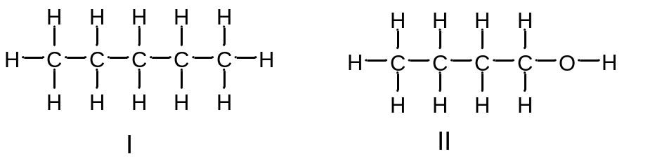

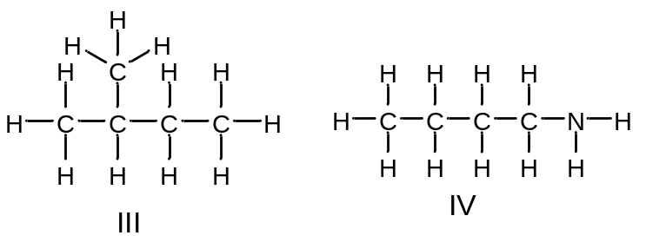

A. III > I > IV > II
B. II > IV > I > III
C. III > I > II > IV
D. IV > II > I > III
E. I > III > II > IV

Answer: B
Learning Objective: 1.12 Describe the basic nature of all intermolecular forces
Difficulty: Hard

183. Rank the following compounds in decreasing order of boiling point.

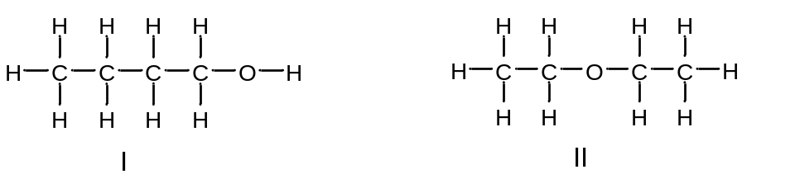

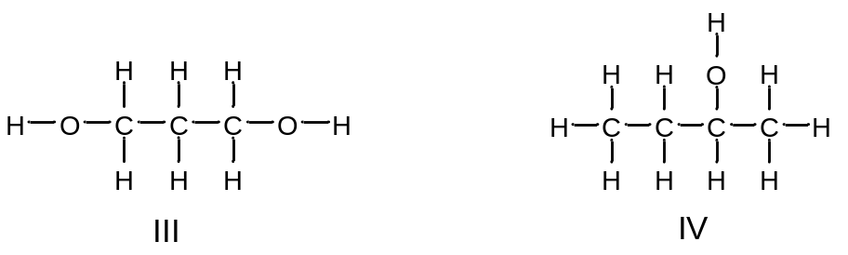

A. III > I > IV > II
B. II > IV > III > I
C. III > I > II > IV
D. IV > II > I > III
E. I > III > II > IV

Answer: A
Learning Objective: 1.12 Describe the basic nature of all intermolecular forces
Difficulty: Medium

184. Which of the following compounds has a higher boiling point? Explain why.

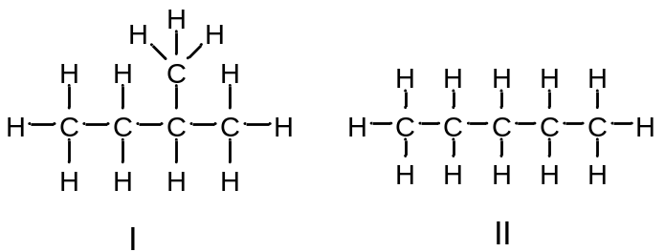

Answer: Compound II has a higher boiling point than compound I. Compound II has larger surface area that allows for stronger fleeting dipole-dipole interactions between molecules.

Learning Objective: 1.12 Describe the basic nature of all intermolecular forces
Difficulty: Medium

185. Which of the following compounds has a higher boiling point? Explain why.

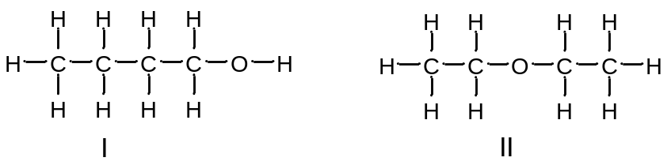

Answer: Compound I has a higher boiling point than compound II. Compound I has hydrogen bonding interactions between molecules. Compound II has dipole-dipole interactions that are weaker than hydrogen bonding interactions.

Learning Objective: 1.12 Describe the basic nature of all intermolecular forces
Difficulty: Easy

186. Which of the following compounds is most soluble in water?

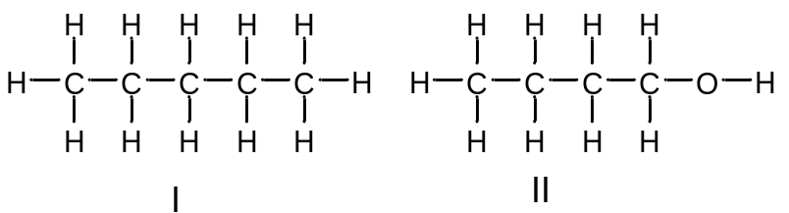

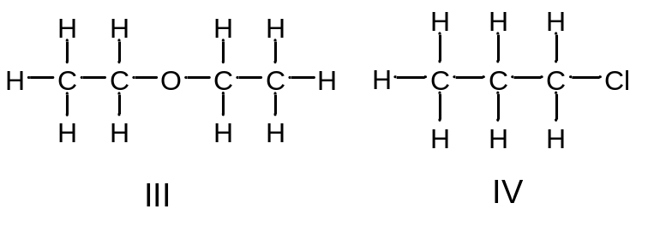

A. I
B. II
C. III
D. IV
E. II and III

Answer: B
Learning Objective: 1.13 Compare the actions of soap and dry cleaning in removing oil or grease from clothing, including a statement of the basic principle involved in solubility
Difficulty: Easy

187. Which of the following compounds is most soluble in butane, CH₃CH₂CH₂CH₃?

A. I
B. II
C. III
D. IV
E. II and III

Answer: A
Learning Objective: 1.13 Compare the actions of soap and dry cleaning in removing oil or grease from clothing, including a statement of the basic principle involved in solubility
Difficulty: Medium

188. For soap to remove and dissolve oil in water, what molecular features are needed?

A. one end of the molecule must be polar
B. the compound must contain oxygen atoms
C. one end of the molecule must be nonpolar
D. Both A and C
E. All A, B and C

Answer: D
Learning Objective: 1.13 Compare the actions of soap and dry cleaning in removing oil or grease from clothing, including a statement of the basic principle involved in solubility
Difficulty: Medium

189. Amino acids are the building blocks of proteins. Which statement best describes the physical properties of the following amino acid?

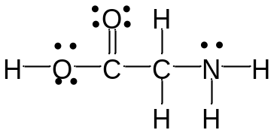

A. high melting points and low solubility in water
B. large dipole moments and no hydrogen bonding
C. high melting points and large dipole moments
D. low solubility in water and small dipole moments
E. small dipole moments and are hydrophobic

Answer: C
Learning Objective: 1.13 Compare the actions of soap and dry cleaning in removing oil or grease from clothing, including a statement of the basic principle involved in solubility
Difficulty: Medium

190. Sugars, an example of which is shown below, tend to be very soluble in water. Explain why.

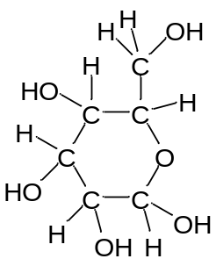

Answer: Favorable hydrogen bonding between the sugar and water readily occurs as both contain O–H groups capable of hydrogen bonding.

Learning Objective: 1.13 Compare the actions of soap and dry cleaning in removing oil or grease from clothing, including a statement of the basic principle involved in solubility
Difficulty: Medium

191. Describe how soaps function as cleaning agents.

Answer: Soaps form clusters called micelles. The polar groups of the soaps form the surface of the micelle and hydrogen bond to the surrounding water. The interior of the micelle is composed of the nonpolar, hydrophobic portions of the soap molecules. Grease and dirt are nonpolar and have limited solubility in water. In soapy water however, grease and dirt will dissolve in the nonpolar interior of the soap micelles, which in turn are soluble in the water.

Learning Objective: 1.13 Compare the actions of soap and dry cleaning in removing oil or grease from clothing, including a statement of the basic principle involved in solubility
Difficulty: Medium

