1. Decide whether the following problem can be solved using precalculus, or whether calculus is required. If the problem can be solved using precalculus, solve it. If the problem seems to require calculus, use a graphical or numerical approach to estimate the solution.
​
Find the distance traveled in 2 seconds by an object traveling at a constant velocity of 11 feet per second.
​
 | a. | calculus, 22 ft
 | b. | calculus, 42 ft
 | c. | precalculus, 22 ft
 | d. | calculus, 44 ft
 | e. | precalculus, 44 ft

ANSWER: | c
POINTS: | 1
DIFFICULTY: | Easy
REFERENCES: | 2.1.1
QUESTION TYPE: | Multiple Choice
HAS VARIABLES: | True
LEARNING OBJECTIVES: | CETF.LAED.11.72 - Recognize problems requiring precalculus and find the solution
OTHER: | Skill
NOTES: | Section 2.1
DATE CREATED: | 7/11/2017 8:25 AM
DATE MODIFIED: | 7/11/2017 8:25 AM

2. Decide whether the following problem can be solved using precalculus, or whether calculus is required. If the problem can be solved using precalculus, solve it. If the problem seems to require calculus, use a graphical or numerical approach to estimate the solution.
​
Find the distance traveled in 14 seconds by an object moving with a velocity of feet per second.
​
 | a. | calculus, 154.8204 ft
 | b. | precalculus, 156.1704 ft
 | c. | calculus, 159.9436 ft
 | d. | precalculus, 159.9436 ft
 | e. | precalculus, 154.8204 ft

ANSWER: | c
POINTS: | 1
DIFFICULTY: | Medium
REFERENCES: | 2.1.2
QUESTION TYPE: | Multiple Choice
HAS VARIABLES: | True
LEARNING OBJECTIVES: | CETF.LAED.11.73 - Recognize problems requiring calculus and estimate solutions
OTHER: | Skill
NOTES: | Section 2.1
DATE CREATED: | 7/11/2017 8:25 AM
DATE MODIFIED: | 7/11/2017 8:25 AM

3. Decide whether the following problem can be solved using precalculus, or whether calculus is required. If the problem can be solved using precalculus, solve it. If the problem seems to require calculus, use a graphical or numerical approach to estimate the solution.
​
A cyclist is riding on a path whose elevation is modeled by the function where x and are measured in miles. Find the rate of change of elevation when .
​
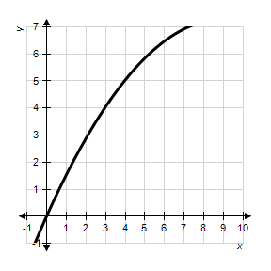
​
 | a. | precalculus, 0.09
 | b. | calculus, 0.21
 | c. | calculus, 0.81
 | d. | calculus, 0.09
 | e. | precalculus, 0.21

ANSWER: | c
POINTS: | 1
DIFFICULTY: | Medium
REFERENCES: | 2.1.3
QUESTION TYPE: | Multiple Choice
HAS VARIABLES: | True
LEARNING OBJECTIVES: | CETF.LAED.11.73 - Recognize problems requiring calculus and estimate solutions
OTHER: | Skill
NOTES: | Section 2.1
DATE CREATED: | 7/11/2017 8:25 AM
DATE MODIFIED: | 7/11/2017 8:25 AM

4. Decide whether the following problem can be solved using precalculus, or whether calculus is required. If the problem can be solved using precalculus, solve it. If the problem seems to require calculus, use a graphical or numerical approach to estimate the solution.
​
A cyclist is riding on a path whose elevation is modeled by the function where x and are measured in miles. Find the rate of change of elevation when .
​
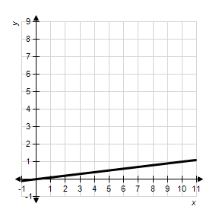
​
 | a. | calculus, 0.5
 | b. | precalculus, 0.1
 | c. | calculus, 0.1
 | d. | precalculus, 0.5
 | e. | precalculus, 0.35

ANSWER: | b
POINTS: | 1
DIFFICULTY: | Easy
REFERENCES: | 2.1.4
QUESTION TYPE: | Multiple Choice
HAS VARIABLES: | True
LEARNING OBJECTIVES: | CETF.LAED.11.72 - Recognize problems requiring precalculus and find the solution
OTHER: | Skill
NOTES: | Section 2.1
DATE CREATED: | 7/11/2017 8:25 AM
DATE MODIFIED: | 7/11/2017 8:25 AM

5. Decide whether the following problem can be solved using precalculus, or whether calculus is required. If the problem can be solved using precalculus, solve it. If the problem seems to require calculus, use a graphical or numerical approach to estimate the solution.
​
Find the area of the shaded region bounded by the triangle with vertices , , .
​
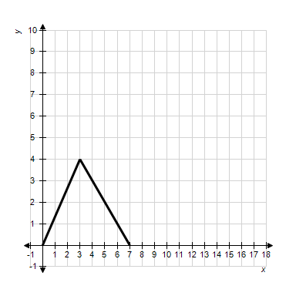
​
 | a. | precalculus, 28
 | b. | calculus, 42
 | c. | precalculus, 14
 | d. | precalculus, 42
 | e. | calculus, 28

ANSWER: | c
POINTS: | 1
DIFFICULTY: | Easy
REFERENCES: | 2.1.5a
QUESTION TYPE: | Multiple Choice
HAS VARIABLES: | True
LEARNING OBJECTIVES: | CETF.LAED.11.72 - Recognize problems requiring precalculus and find the solution
OTHER: | Skill
NOTES: | Section 2.1
DATE CREATED: | 7/11/2017 8:25 AM
DATE MODIFIED: | 7/11/2017 8:25 AM

6. Decide whether the following problem can be solved using precalculus, or whether calculus is required. If the problem can be solved using precalculus, solve it. If the problem seems to require calculus, use a graphical or numerical approach to estimate the solution.
​
Find the area of the shaded region.
​
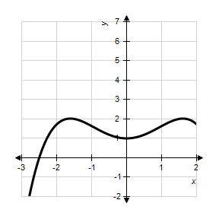
​
 | a. | calculus, 5
 | b. | precalculus, 5
 | c. | precalculus, 6
 | d. | calculus, 7
 | e. | precalculus, 7

ANSWER: | a
POINTS: | 1
DIFFICULTY: | Medium
REFERENCES: | 2.1.5b
QUESTION TYPE: | Multiple Choice
HAS VARIABLES: | True
LEARNING OBJECTIVES: | CETF.LAED.11.74 - Recognize problems requiring calculus and estimate solution
OTHER: | Skill
NOTES: | Section 2.1
DATE CREATED: | 7/11/2017 8:25 AM
DATE MODIFIED: | 7/11/2017 8:25 AM

7. Consider the function and the point on the graph of f. Graph f and the secant line passing through and for .
​
 | a. | ​ | b. | ​
 | c. | ​ | d. | ​
 | e. | ​

ANSWER: | d
POINTS: | 1
DIFFICULTY: | Easy
REFERENCES: | 2.1.6a
QUESTION TYPE: | Multiple Choice
HAS VARIABLES: | True
LEARNING OBJECTIVES: | CETF.LAED.11.75 - Graph a function and the secant line passing through given points
OTHER: | Skill
NOTES: | Section 2.1
DATE CREATED: | 7/11/2017 8:25 AM
DATE MODIFIED: | 7/11/2017 8:25 AM

8. Consider the function and the point on the graph of f. Find the slope of the secant line passing through and for . Round your answer to four decimal places.
​
a.
b.
c.
d.
e.

ANSWER: | a
POINTS: | 1
DIFFICULTY: | Easy
REFERENCES: | 2.1.6b
QUESTION TYPE: | Multiple Choice
HAS VARIABLES: | True
LEARNING OBJECTIVES: | CETF.LAED.11.76 - Calculate the slope of a secant line passing through given points
OTHER: | Skill
NOTES: | Section 2.1
DATE CREATED: | 7/11/2017 8:25 AM
DATE MODIFIED: | 7/11/2017 8:25 AM

9. Consider the function and the point on the graph of f. Estimate the slope m of the tangent line of f at . Round your answer to four decimal places.
​
a.
b.
c.
d.
e.

ANSWER: | a
POINTS: | 1
DIFFICULTY: | Medium
REFERENCES: | 2.1.6c
QUESTION TYPE: | Multiple Choice
HAS VARIABLES: | True
LEARNING OBJECTIVES: | CETF.LAED.11.77 - Estimate the slope of a tangent line
OTHER: | Skill
NOTES: | Section 2.1
DATE CREATED: | 7/11/2017 8:25 AM
DATE MODIFIED: | 7/11/2017 8:25 AM

10. Consider the function and the point on the graph of f. Graph f and the secant line passing through and for .
​
 | a. | ​ | b. | ​
 | c. | ​ | d. | ​
 | e. | ​

ANSWER: | d
POINTS: | 1
DIFFICULTY: | Easy
REFERENCES: | 2.1.7a
QUESTION TYPE: | Multiple Choice
HAS VARIABLES: | True
LEARNING OBJECTIVES: | CETF.LAED.11.75 - Graph a function and the secant line passing through given points
OTHER: | Skill
NOTES: | Section 2.1
DATE CREATED: | 7/11/2017 8:25 AM
DATE MODIFIED: | 7/11/2017 8:25 AM

11. Consider the function and the point on the graph of f. Find the slope of the secant line passing through and for . Round your answer to one decimal place.
​
 | a. | 4.5
 | b. | 3.0
 | c. | 3.0
 | d. | 4.5
 | e. | 4.0

ANSWER: | b
POINTS: | 1
DIFFICULTY: | Easy
REFERENCES: | 2.1.7b
QUESTION TYPE: | Multiple Choice
HAS VARIABLES: | True
LEARNING OBJECTIVES: | CETF.LAED.11.76 - Calculate the slope of a secant line passing through given points
OTHER: | Skill
NOTES: | Section 2.1
DATE CREATED: | 7/11/2017 8:25 AM
DATE MODIFIED: | 7/11/2017 8:25 AM

12. Consider the function and the point on the graph of f. Estimate the slope of the tangent line of f at .
​
 | a. | 11
 | b. | 6
 | c. | 9
 | d. | 5
 | e. | 10

ANSWER: | d
POINTS: | 1
DIFFICULTY: | Medium
REFERENCES: | 2.1.7c
QUESTION TYPE: | Multiple Choice
HAS VARIABLES: | True
LEARNING OBJECTIVES: | CETF.LAED.11.78 - Calculate the slope of secant line passing through the given points
OTHER: | Skill
NOTES: | Section 2.1
DATE CREATED: | 7/11/2017 8:25 AM
DATE MODIFIED: | 7/11/2017 8:25 AM

13. Use the rectangles in the following graph to approximate the area of the region bounded by , , 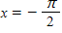, and 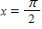.
​
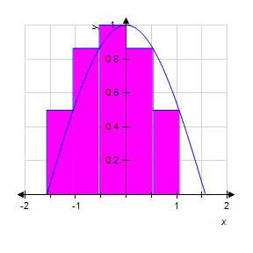
​
 | a. | 3.9082
 | b. | 2.6055
 | c. | 1.9541
 | d. | 1.4656
 | e. | 0.9770

ANSWER: | c
POINTS: | 1
DIFFICULTY: | Medium
REFERENCES: | 2.1.8a
QUESTION TYPE: | Multiple Choice
HAS VARIABLES: | True
LEARNING OBJECTIVES: | CETF.LAED.11.79 - Estimate the area of a region using rectangles
OTHER: | Skill
NOTES: | Section 2.1
DATE CREATED: | 7/11/2017 8:25 AM
DATE MODIFIED: | 7/11/2017 8:25 AM

14. Use the rectangles in the following graph to approximate the area of the region bounded by , , , and .
​
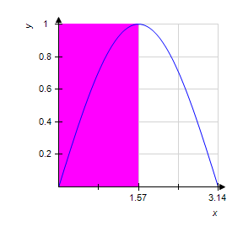
​
 | a. | 0.7850
 | b. | 1.5700
 | c. | 3.1400
 | d. | 1.1775
 | e. | 1.0519

ANSWER: | b
POINTS: | 1
DIFFICULTY: | Medium
REFERENCES: | 2.1.8b
QUESTION TYPE: | Multiple Choice
HAS VARIABLES: | True
LEARNING OBJECTIVES: | CETF.LAED.11.79 - Estimate the area of a region using rectangles
OTHER: | Skill
NOTES: | Section 2.1
DATE CREATED: | 7/11/2017 8:25 AM
DATE MODIFIED: | 7/11/2017 8:25 AM

15. Use the rectangles in the graph given below to approximate the area of the region bounded by 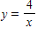, , , and . Round your answer to three decimal places.
​
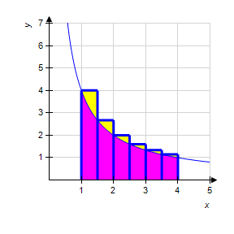
​
 | a. | 2.481 units²
 | b. | 6.371 units²
 | c. | 3.585 units²
 | d. | 6.872 units²
 | e. | 6.903 units²

ANSWER: | b
POINTS: | 1
DIFFICULTY: | Medium
REFERENCES: | 2.1.9a
QUESTION TYPE: | Multiple Choice
HAS VARIABLES: | True
LEARNING OBJECTIVES: | CETF.LAED.11.79 - Estimate the area of a region using rectangles
OTHER: | Skill
NOTES: | Section 2.1
DATE CREATED: | 7/11/2017 8:25 AM
DATE MODIFIED: | 7/11/2017 8:25 AM

16. Consider the length of the graph of 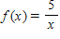from to . Approximate the length of the curve by finding the sum of the lengths of four line segments, as shown in following figure. Round your answer to two decimal places.
​
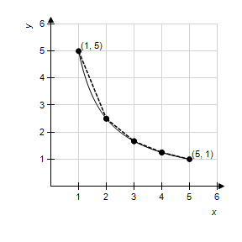
​
 | a. | 6.11
 | b. | 8.12
 | c. | 5.66
 | d. | 8.49
 | e. | 7.11

ANSWER: | a
POINTS: | 1
DIFFICULTY: | Medium
REFERENCES: | 2.1.11b
QUESTION TYPE: | Multiple Choice
HAS VARIABLES: | True
LEARNING OBJECTIVES: | CETF.LAED.11.80 - Estimate the length of the curve using a piecewise linear function
OTHER: | Skill
NOTES: | Section 2.1
DATE CREATED: | 7/11/2017 8:25 AM
DATE MODIFIED: | 7/11/2017 8:25 AM

17. Consider the length of the graph of 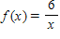from to . Approximate the length of the curve by finding the sum of the lengths of five line segments, as shown in following figure. Round your answer to two decimal places.
​
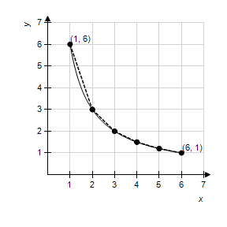
​
 | a. | 7.76
 | b. | 9.77
 | c. | 7.07
 | d. | 9.9
 | e. | 8.76

ANSWER: | a
POINTS: | 1
DIFFICULTY: | Medium
REFERENCES: | 2.1.11b
QUESTION TYPE: | Multiple Choice
HAS VARIABLES: | True
LEARNING OBJECTIVES: | CETF.LAED.11.80 - Estimate the length of the curve using a piecewise linear function
OTHER: | Skill
NOTES: | Section 2.1
DATE CREATED: | 7/11/2017 8:25 AM
DATE MODIFIED: | 7/11/2017 8:25 AM

18. Consider the length of the graph of 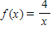from to . Approximate the length of the curve by finding the sum of the lengths of three line segments, as shown in following figure. Round your answer to two decimal places.
​
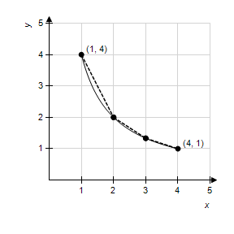
​
 | a. | 4.49
 | b. | 6.52
 | c. | 4.24
 | d. | 7.07
 | e. | 5.51

ANSWER: | a
POINTS: | 1
DIFFICULTY: | Medium
REFERENCES: | 2.1.11b
QUESTION TYPE: | Multiple Choice
HAS VARIABLES: | True
LEARNING OBJECTIVES: | CETF.LAED.11.80 - Estimate the length of the curve using a piecewise linear function
OTHER: | Skill
NOTES: | Section 2.1
DATE CREATED: | 7/11/2017 8:25 AM
DATE MODIFIED: | 7/11/2017 8:25 AM

