Chapter 1
An Introduction to Money and the Financial System

Problems

- List the financial transactions you have engaged in over the past week. How might each one have been carried out 50 years ago? (LO1)

Answer: Commercial purchases that you made likely used credit cards and debit cards. Fifty years ago they would have all used cash. Payment of utilities (if you do it) might have been done by electronic transfer, rather than a check (which would have been the method 50 years ago).

- How were you, or your family or your friends affected by the recent failure of the financial system to function normally during the financial crisis of 2007-2009? (LO1)

Answer: It is likely that you or someone you know had an account with one of the many financial institutions that folded during the crisis, or that someone you know was refused a business loan or a mortgage or had a bank foreclose on their house.

- List three items you used to buy with cash but you now purchase with a debit card. (LO1)

Answer: Among the possibilities: purchases of cappuccino at the local coffee shop, gasoline for your car, and groceries for the week.

- Various financial instruments usually serve one of two distinct purposes: to store value or to transfer risk. Name a financial instrument used for each purpose. (LO1)

Answer: Financial instruments used to store value include bank accounts, stocks and bonds. Instruments used to transfer risk include car insurance and life insurance.

- Financial innovation has reduced individuals’ need to carry cash. Explain how. (LO1)

Answer: Everyone has a number of alternative methods of payment. Electronic forms, like credit and debit cards, are the primary ones that have reduced need to carry cash.

- * Many people believe that, despite ongoing financial innovations, cash will always be with us to some degree as a form of money. What core principle could justify this view? (LO2)

Answer: Core Principle 3 – information is the basis for decisions. When cash is used to settle a transaction, it is a final payment, not some form of a promise to pay. No information is needed about the payer once cash has been handed over to settle a transaction. This has obvious advantages to the recipient, as the information costs are negligible. In some circumstances, one or both parties to a transaction may wish to preserve their anonymity, and cash allows this.

- When you apply for a loan, you are required to answer lots of questions. Why? Why is the set of questions you must answer standardized? (LO2)

Answer: The questions are aimed at figuring out how likely you are to repay the loan. They are standardized to reduce the cost of making the loan.

- Name two distinct financial markets and describe the kind of asset traded in each. (LO1)

Answer: Among the best-known financial markets are those for stocks and for bonds. In the stock markets, equities or ownership shares in companies are bought and sold. In the bond market, debt issues of government units or companies are traded.

- * Why do you think the financial system has become more globally integrated over time? Can you think of any downside to this increased integration? (LO1)

Answer: Technological progress is one obvious reason. According to Core Principle 3, information is the basis for decisions. Improvements in technology have allowed for huge volumes of information to be collected and disseminated quickly and cheaply on a global basis, facilitating long distance financial transactions. Increased integration allows for problems that arise in the financial system of one country to spread more quickly and easily to other countries, as we saw during the financial crisis of 2007-2009.

- The government is heavily involved in the financial system. Explain why. (LO1)

Answer: For markets to work there have to be rules. And the rules need to be enforced. The government both makes the rules and enforces them so that we all trust the markets to work as they should. Without the government to monitor the financial system, ensuring that people behave themselves, the system would collapse.

- If offered the choice of receiving $1,000 today or $1,000 in one year’s time, which option would you choose, and why? (LO2)

Answer: Core Principle 1 states that time has value, so you should choose option 1. By receiving the $1,000 today, you can immediately put the money to use. Perhaps you buy a new computer or put the money in the bank to earn interest. Regardless of what you do with the money, waiting a year to receive the money involves an opportunity cost.

- If time has value, why are financial institutions often willing to extend you a 30-year mortgage at a lower annual interest rate than they would charge for a one-year loan? (LO2)

Answer: With a mortgage, the house you purchase acts as collateral for the loan. In the event you default, the bank can sell the house and recoup its funds. The existence of collateral reduces the risk associated with the loan and so reduces the compensation the bank requires.

- Using Core Principle 2, under what circumstances would you expect a job applicant to accept an offer of a low base salary and an opportunity to earn commission over one with a higher base salary and no commission potential? (LO2)

Answer: The applicant would have to expect to earn a higher total salary working for a low base and commission, as they require compensation for the risk they assume due to the uncertainty about the level of commission earnings.

- Suppose medical research confirms earlier speculation that red wine is good for you. Why would banks be willing to lend to vineyards that produce red wine at a lower interest rate than before? (LO2)

Answer: The future prospects for the vineyards have improved, reducing the risk involved in lending to them. The banks require less compensation than before.

- * If the U.S. Securities and Exchange Commission eliminated its requirement for public companies to disclose information about their finances, what would you expect to happen to the stock prices for these companies? (LO2)

Answer: You should expect the stock prices to fall. Gathering sufficient information upon which to make an informed investment decision would become much more costly for investors, reducing the demand for the stock at a given price.

- If 2 percent growth is your break-even point for an investment project, under which outlook for the economy would you be more inclined to go ahead with the investment: (1) A forecast for economic growth that ranges from 0 to 4 percent, or (2) a forecast of 2 percent growth for sure, assuming the forecasts are equally reliable? What core principle does this illustrate? (LO2)

Answer: You would be more inclined to invest in the project if you knew for sure that growth would be 2%. Uncertainty about the future makes investment less attractive, as you run the risk of losing out if the lower end of the forecast is realized. This illustrates core principle 5 – stability improves welfare.

- * Why are large, publicly listed companies much more likely than small businesses to sell financial instruments such as bonds directly to the market, while small businesses get their financing from financial institutions such as banks? (LO2)

Answer: Information costs associated with small businesses are higher than those for large, publicly listed companies—costs that bond market investors are unlikely to be willing to incur. Banks are skilled at gathering information about borrowers and evaluating the risks associated with loans. Therefore, they are more likely to be willing to lend to smaller businesses.

- * During the financial crisis of 2007-2009, some financial instruments that received high ratings in terms of their safety turned out to be much riskier than those ratings indicated. Explain why markets for other financial instruments might have been adversely affected by that development. (LO2)

Answer: Core Principle 3 states that information is the basis for decisions. Ratings are an important source of information for investors in assessing many financial instruments, and so when confidence in that information is undermined, they are more reluctant to lend.

- Suppose financial institutions didn’t exist but you urgently needed a loan. Where would you most likely get this loan? Using Core Principles, identify an advantage and a disadvantage this arrangement might have over borrowing from a financial institution. (LO2)

Answer: In the absence of financial institutions, you are most likely to borrow from a family member or a friend. An advantage of this arrangement, under Core Principle 3, would be that your family and friends naturally have more information about you than a bank and know, without having you fill in copious forms, that you can be relied upon to pay them back. A disadvantage would be the necessity of finding a family member or friend who happened to have funds available to lend to you at that particular point in time. Financial institutions help bring potential borrowers and lenders in the financial market together to allocate available resources (Core principle 4).
- In broad terms, explain how a central bank tries to maintain economic and financial stability and encourage economic growth. (LO1)

Answer: Central banks can moderate business cycle fluctuations by adjusting interest rates. They also have powerful tools to steady fragile financial systems and to support dysfunctional markets. By helping to reduce the volatility associated with business cycles and financial instability, they reduce the risks that individuals can’t eliminate on their own, allowing to invest in the future. That promotes economic growth.

- The Dodd-Frank Act, enacted in the United States in the aftermath of the 2007-2009 financial crisis, includes provisions aimed at enhancing the coordination of various regulatory agencies. Which two core principles might best explain these reforms? (LO2)

Answer:
Core Principle 3 - Information is the basis for decisions. Coordination should improve the flow of information among regulatory agencies, enabling better decision making.

Core Principle 5 - Stability improves welfare. Improved regulation as a result of greater coordination should bring greater stability to the financial system and so improve welfare.

- In December 2015, the Federal Reserve increased its policy interest rate target. This was the first increase since cutting the target to close to zero in December 2008 to combat the economy weakness associated with the financial crisis. If central banks use interest rates to moderate business cycle swings in the economy, what might you infer from this decision about the Fed’s view of the economy? (LO2)

Answer: The Federal Reserve’s decision to begin raising the target for the policy interest rate from its historic low level reflected its view at that time that the economic recovery was on a solid footing.

Data Exploration

- Go to the FRED database at the Federal Reserve Bank of St. Louis website (http://fred.stlouisfed.org). Register to set up your own account. Doing so will allow you to save and update graphs, alter them for submitting assignments and making presentations, and receive a notice whenever the data is updated.

Answer: Sign up as indicated.

- To begin using FRED, plot the consumer price index (FRED code: CPIAUCSL) and find the date and level of the latest monthly observation. Then plot the inflation rate as measured by the percent change from a year ago of this index.

Answer: As of June, 2016, the value of the index was 239.927; note that tis value is subject to revision. The plot for CPI (adjusting for any data revisions) is:

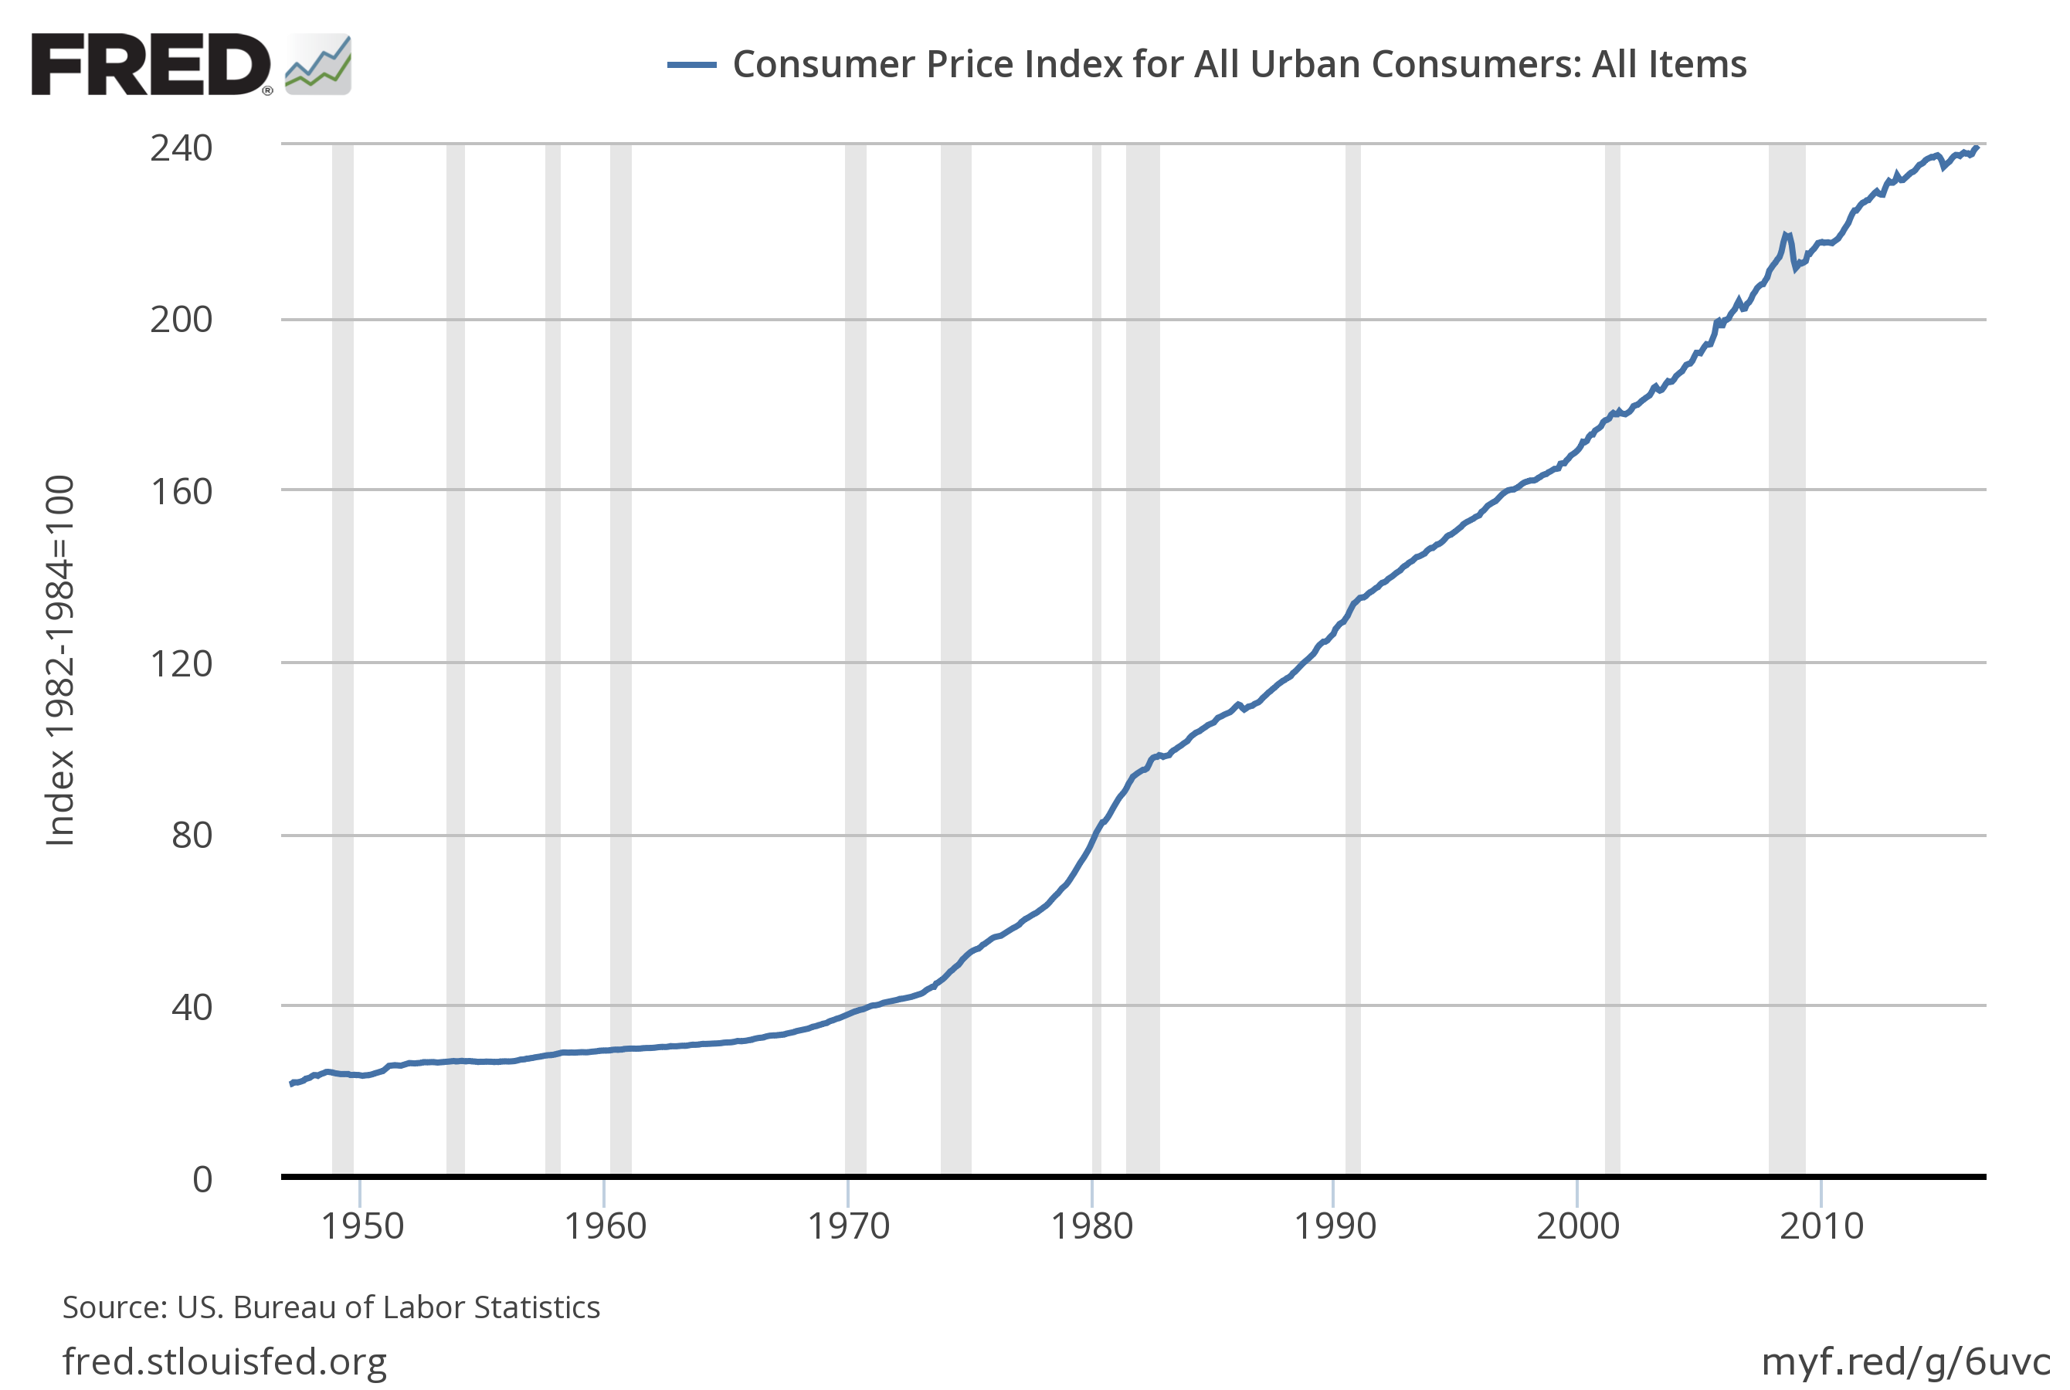
Recessions are depicted by vertical shaded bars.

- Plot the level of real GDP (FRED code: GDPC1). Then plot the rate of economic growth as the percent change from a year ago of this index. Describe how real GDP behaves in recessions, which are denoted in the FRED graph by vertical shaded bars. If you registered on FRED (as in Data Exploration Problem 1), save the graph so that you can recall and update the graph easily when new observations become available.

Answer: The graph for the level of real GDP is:
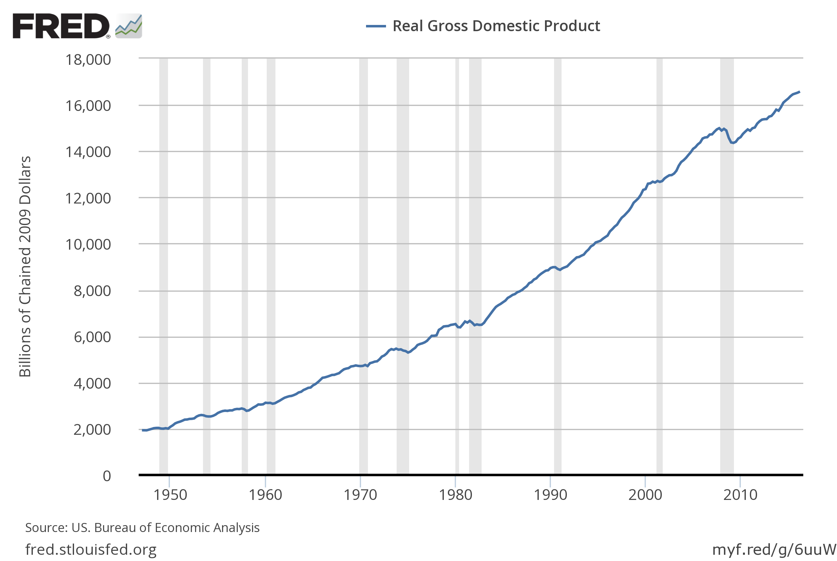

The plot of the rate of economic growth, expressed as the percentage change from a year ago, is:

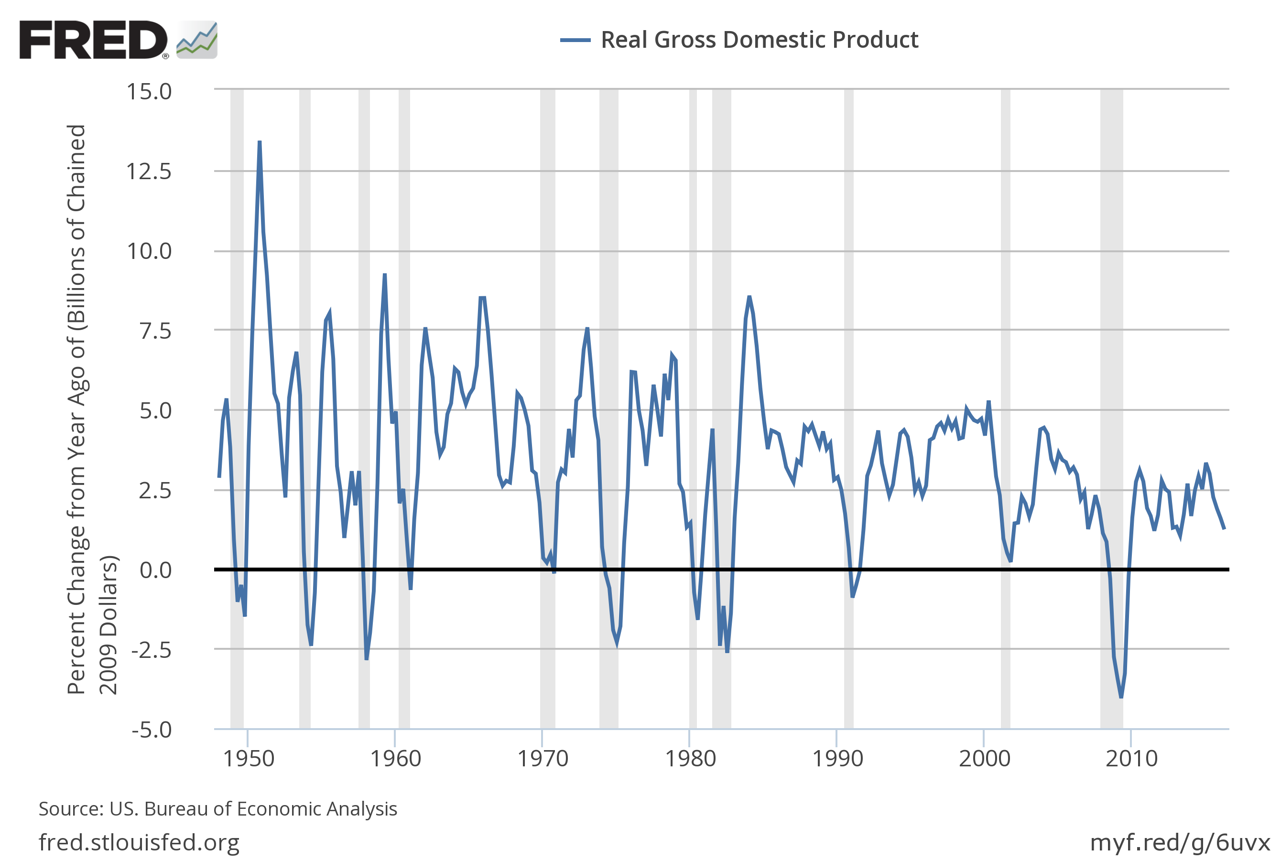
Real GDP usually declines in recessions and rebounds afterwards. In the 2007-2009 episode, the percentage declines of nominal and real GDP were the largest since Great Depression. In that episode, nominal GDP fell below year-ago levels for the first time in nearly five decades.

- Examine nominal GDP (FRED code: GDP) based on a figure showing percent change from a year ago. What was special about the behavior of nominal GDP during the financial crisis of 2007-2009 compared to previous decades?

Answer: The plot appears below. Unlike other recessions since 1960, nominal GDP fell noticeably during the 2007-2009 financial crisis.

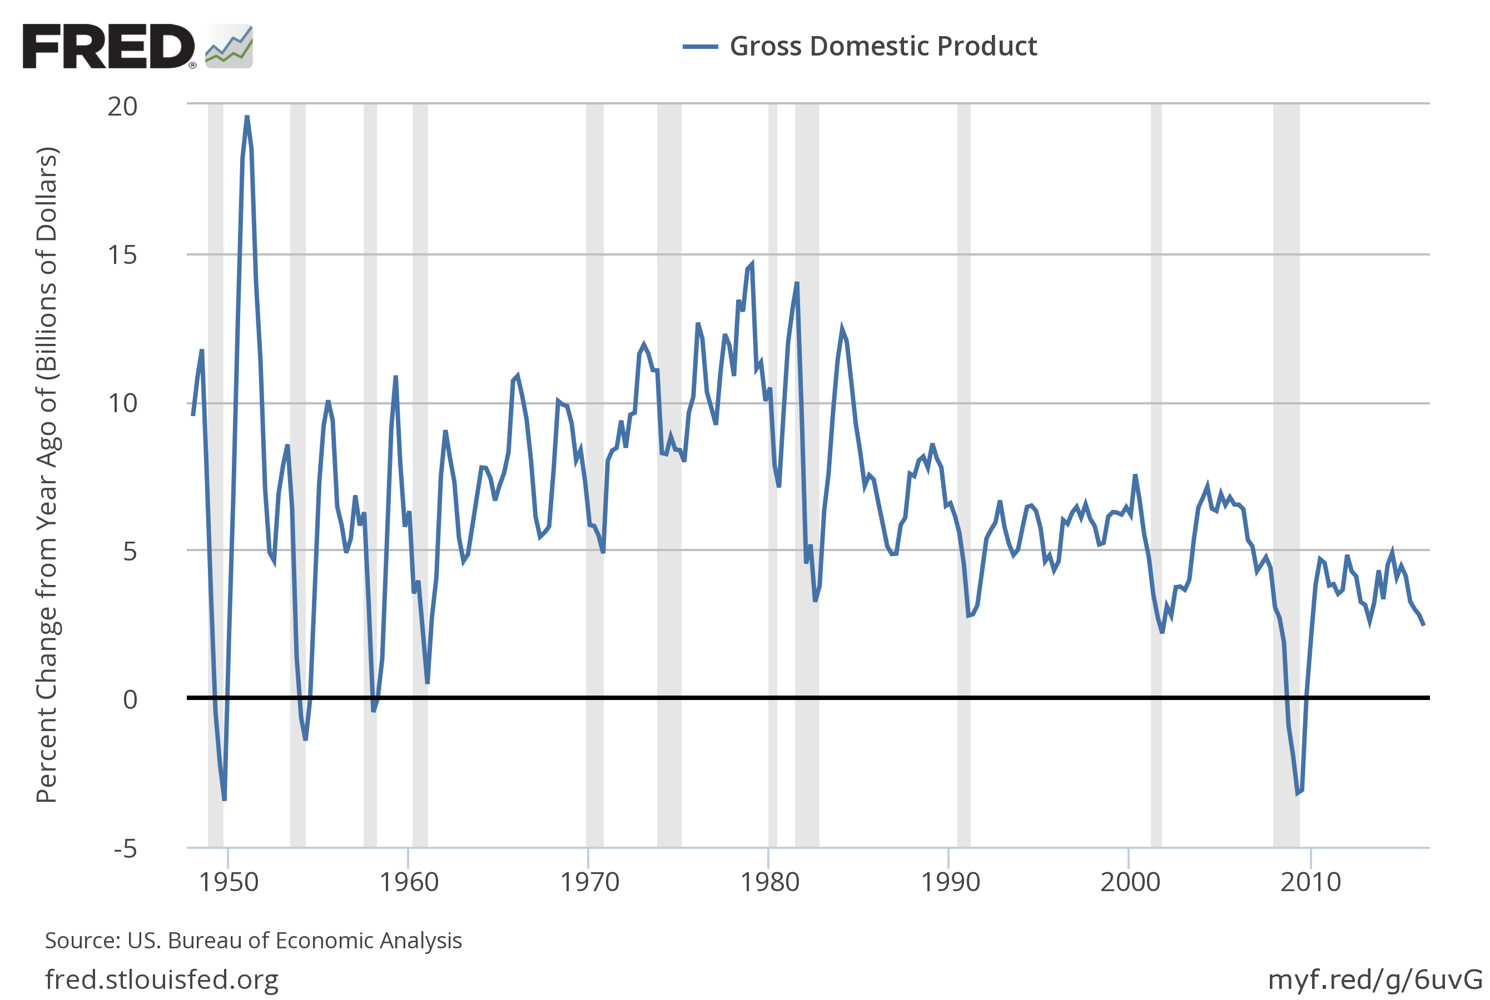

- Plot on one figure the percent change from a year ago of both the GDP deflator (FRED code: GDPDEF) and real GDP (FRED code: GDPC1). How does the GDP deflator link nominal and real GDP? Since the mid-1980s, does it fluctuate more or less than real GDP?

Answer: The data plots with real GDP and the GDP deflator is given below:

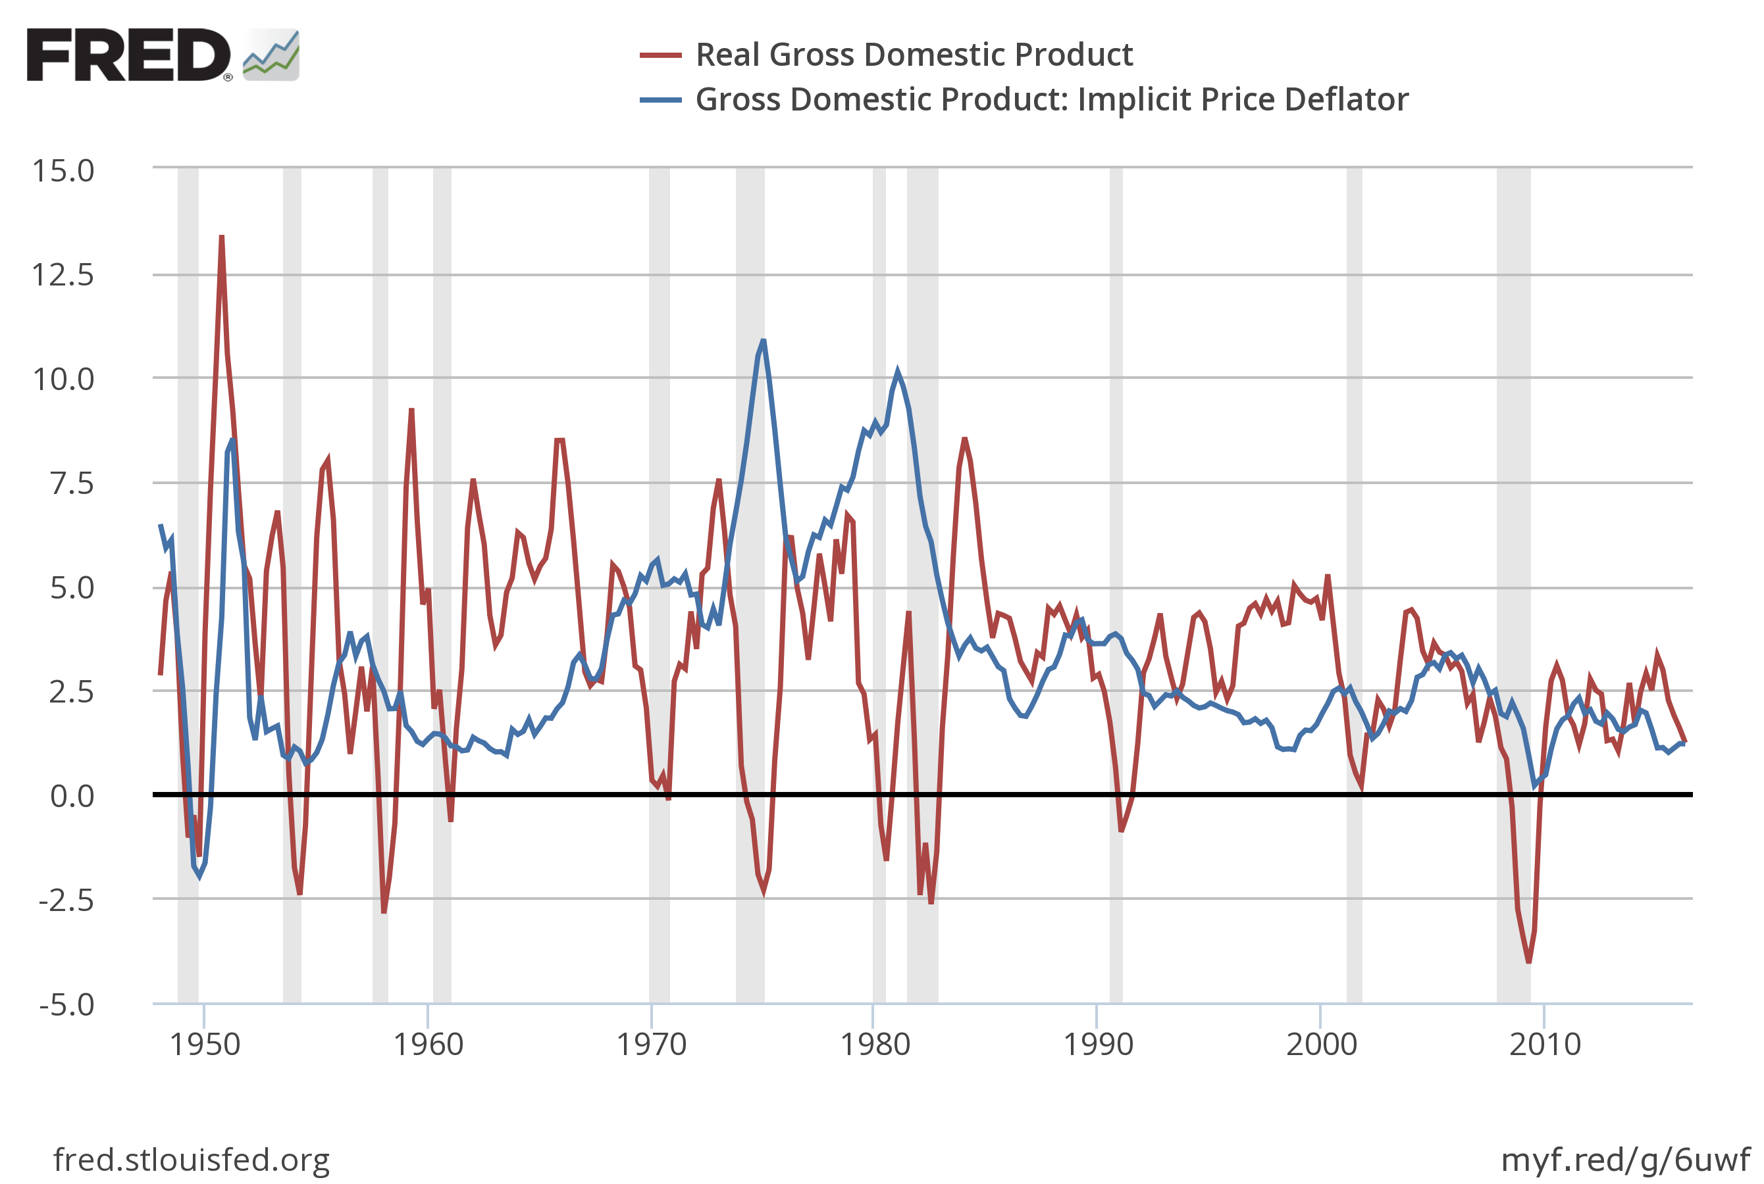

Nominal GDP is the product of real GDP and the GDP deflator. Alternatively, real GDP is nominal GDP divided by the deflator. In simple terms, if Y is nominal GDP, P is the deflator, and Q is real GDP, then Y = PQ or equivalently Q = Y / P. Compared with earlier periods, the GDP deflator appears to have become less variable since the mid-1980s. Furthermore, it appears less volatile than real GDP.

* indicates more difficult problems

