Microsoft Access 2013 Chapter 1 – Lab Test A
Creating an Electronic Accessories Database

Purpose: To demonstrate the ability to create a database, queries, a form, and a report.

Problem: An electronics store wants to keep track of its sales representatives for its various outlets. The database it will use consists of two tables. The Outlets table contains data on the particular outlet store. The Sales Rep table contains pertinent data about the electronics store’s sales representatives.

Instructions: The structure for the Outlets table is shown in Table A1A – 1 and the data is shown in Table A1A – 2. The structure for the Sales Rep table is shown in Table A1A – 3 and the data is shown in Table A1A – 4.

1. Create a new database to store the two tables related to the electronics store. Call the database, GetItNow Electronics.
2. Create the sales representatives table using the structure shown in Table A1A – 1. Make the Sales Rep ID the primary key. Use the name, Sales Rep, for the table.
3. Add the data shown in Table A1A – 2 to the Sales Rep table.
4. Save the Sales Rep table and print it.
5. Create the Outlets table using the structure shown in Table A1A – 3. Make the Outlet ID the primary key. Use the name, Outlets, for the table.
6. Add the data shown in Table A1A – 4.
7. Save the Outlets table and print it.
8. Create a query using the Simple Query Wizard for the Sales Rep table. Include the Sales Rep ID, Full Name, Outlet ID, Quota, and YTD Sales in the query. Save the query as Sales Rep Query.
9. Open the Sales Rep Query and add a criterion to limit retrieval to those sales representatives located in outlet GINE 11. Save the query as Sales Rep – GINE 11 Query.
10. Create a simple form for the Sales Rep table. Use the name, Sales Rep Form, for the form.
11. Create the report shown in Figure A1A – 1 for the Sales Rep table. Add totals for the Quota and YTD Sales.
12. Change the database properties, as specified by your instructor. Submit the database in the format specified by your instructor.

Structure of the Sales Rep table
Field Name | Data Type | Field Size | Primary Key? | Description
Sales Rep ID | Short Text | 3 | Yes | Sales Representative ID (Primary Key)
Full Name | Short Text | 30
Gender | Short Text | 1 |  | Gender (M or F)
Age | Number
Hire Date | Date/Time
Outlet ID | Short Text | 7 |  | Outlet ID
Quota | Currency
YTD Sales | Currency |  |  | Year to date sales amount

Table A1A – 1

Data for the Sales Rep table
Sales Rep ID | Name | Gender | Age | Hire Date | Store ID | Quota | YTD Sales
321 | Moeller, Pierre | M | 24 | 3/12/2001 | GINE 11 | 3,656,640 | 3,336,300
101 | Battistini, Jorge | M | 26 | 7/2/2001 | GINE 15 | 3,371,092 | 1,960,932
205 | Lambert, Paul | M | 35 | 3/16/2002 | GINE 11 | 1,768,442 | 1,525,237
613 | Brunell, Candace | F | 36 | 6/1/2002 | GINE 17 | 3,000,264 | 2,078,386
475 | Dunn, Alan | M | 39 | 6/6/2002 | GINE 26 | 1,652,836 | 1,432,701
125 | Lyon, Jody | F | 27 | 8/3/2002 | GINE 15 | 2,280,900 | 1,548,311
324 | Bulger, Gloria | F | 25 | 12/23/2002 | GINE 15 | 2,651,270 | 2,451,454
140 | Lopez, Maria | F | 25 | 6/3/2004 | GINE 17 | 1,837,213 | 1,563,140
285 | Dillig, Henry | M | 42 | 11/21/2006 | GINE 11 | 3,899,402 | 1,916,753
512 | Kahn, Ramesh | M | 44 | 4/6/2007 | GINE 26 | 3,426,535 | 3,292,270
678 | Chiu, Leslie | F | 36 | 7/15/2007 | GINE 26 | 3,218,514 | 2,514,181
287 | Wochos, Lisa | F | 30 | 10/21/2007 | GINE 15 | 2,648,883 | 2,188,106
465 | Cataldo, Lydia | F | 25 | 11/15/2007 | GINE 11 | 3,668,028 | 2,846,910

Table A1A – 2

Structure of the Outlets table
Field Name | Data Type | Field Size | Primary Key? | Description
Outlet ID | Short Text | 7 | Yes | Outlet ID (Primary Key)
Address | Short Text | 30 |  | Outlet Address
City | Short Text | 20
State | Short Text | 2
Zip | Short Text | 5

Table A1A – 3

Data for the Outlets table
Outlet ID | Address | City | State | Zip
GINE 11 | 1298 Western Court | Bedlam | CA | 34896
GINE 15 | 25 Parkington Palace | Southtown | CA | 39746
GINE 17 | 1212 Mocking Bird | Ambervson | CA | 38957
GINE 26 | 774 Oakland | Parkville | CA | 38974

Table A1A – 4

GINE 11 | 1298 Western Court | Bedlam | CA | 34896
GINE 15 | 25 Parkington Palace | Southtown | CA | 39746
GINE 17 | 1212 Mocking Bird | Ambervson | CA | 38957
GINE 26 | 774 Oakland | Parkville | CA | 38974

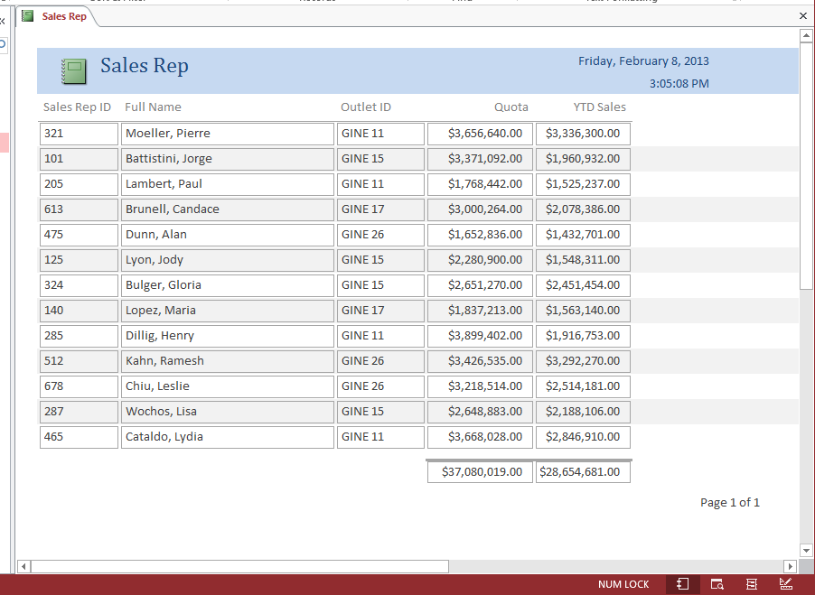

Figure A1A – 1

