1  © jsnyderdesign / iStockphoto  CHAPTER | Accounting as a Tool for Management

Unit Summaries

Unit 1.1 – What is Managerial Accounting?
This unit provides an introduction to the field of managerial accounting by comparing it to financial accounting and discussing the four functions of managers within an organization.

Unit 1.2 – Different Strategies, Different Information
This unit discusses how an organization’s strategy determines the information needed to support decision making within the organization. Common systems for managing and monitoring the organization’s progress toward strategic goals – Balanced Scorecard, Supply Chain Management, Just-in-Time Inventory, and ERP systems – are introduced on a simple level.

Unit 1.3 – Ethical Considerations in Managerial Accounting
This unit provides a basic discussion of the need for ethical behavior within the organization and provides guidance for creating a code of corporate conduct. Results from recent National Business Ethics Surveys are presented. The IMA Statement of Ethical Professional Practice is introduced to serve as the guide for making ethical decisions within the managerial accounting context.

Assignment Classification by Learning Objective

Learning Objective | Exercises | Problems | Cases
- Define managerial accounting. (Unit 1.1) | 1 | 8
- Describe the differences between managerial and financial accounting. (Unit 1.1) | 2
- List and describe the four functions of managers. (Unit 1.1) | 3 | 8 | 10
- Explain how the selection of a particular business strategy determines the information that managers need to run an organization effectively. (Unit 1.2) | 4, 5, 6 | 8 | 10
- Discuss the importance of ethical behavior in managerial accounting. (Unit 1.3) | 7 | 9 | 11

Assignment Characteristics

Item | Description | L. O. | Difficulty Level | Minutes to Complete | Bloom’s Taxonomy | AACSB | AICPA FN | AICPA PC | IMA | Ethics  Coverage
1-1 | Use managerial accounting information | 1 | M | 12 | AP | A | DM | PS | DA
1-2 | Discriminate between managerial and financial accounting | 2 | D | 10-15 | AP | C | R | C | R
1-3 | Classify managerial functions | 3 | D | 10-12 | C | A | R | C | DA
1-4 | Identify managers’ need for information | 4 | M | 12 | AP | A | M | PS | SP
1-5 | Identify supply chain links | 4 | D | 15-20 | S, AN | A | DM | PS | DA,SP
1-6 | Identify balanced scorecard perspectives | 4 | M | 10-15 | C | C | R | C | PM
1-7 | Apply the IMA Statement of Professional Practice | 5 | D | 20 | AP, AN | A, E | R | C | BA
1-8 | Use managerial accounting information | 1, 3, 4 | M | 15-20 | AP, AN | A | DM | PS | DA, SP
1-9 | Evaluate corporate codes of conduct | 5 | M | 15-20 | C, AN | E | R | C | BA
1-10 | Identify supply chain trading partners | 3, 4 | M | 15-20 | S, AN | A | DM | PS | DA, SP
1-11 | Apply a corporate code of conduct to make ethical decisions | 5 | D | 15-20 | AN, E | A, E | R | C | BA

Difficulty: E = Easy, M = Moderate, D = Difficult
Bloom: K = Knowledge, C = Comprehension, AP = Application, AN = Analysis, S = Synthesis, E = Evaluation
AACSB: A = Analytic, C = Communication, E = Ethics
AICPA FN: DM = Decision modeling, RA = Risk Analysis, M = Measurement, R = Reporting, RS = Research, T = Technology
AICPA PC: C = Communication, I = Interaction, L = Leadership, P = Professional demeanor, PM = Project Management,
PS = Problem Solving and Decision Making, T = Technology
IMA: BA = Business applications, BP = Budget Preparation, CM = Cost Management, DA = Decision Analysis,
PM = Performance Measurement, R = Reporting, SP = Strategic Planning

Chapter Summary

Unit 1.1

LO 1 Define managerial accounting.
There are several formal definitions of managerial accounting. A simple one is “the generation of relevant information to support management’s decision-making activities.”

LO 2 Describe the differences between managerial and financial accounting.
Managerial accounting’s primary users are managers and decision makers within an organization, whereas financial accounting is aimed primarily at external users. Unlike GAAP that guides financial accounting, there are no mandated rules in managerial accounting. Managerial accounting reports focus on operating segments, while financial accounting statements report results for the organization as a whole. Managerial accounting is concerned more with projecting future results than reporting past results. Managerial accounting information is prepared to allow managers to take advantage of an opportunity, even if some accuracy must be sacrificed. Financial accounting information is balanced to the penny and is delivered after the end of the accounting period.

LO 3 List and describe the four functions of managers.
Planning means setting a direction for the organization. Long-term, or strategic planning provides direction for a five- to ten-year period. Short-term, or operational planning provides more detailed guidance for the coming year; it translates the company’s strategy into action steps. Controlling is the monitoring of day-to-day operations to identify any problems that require corrective action. Evaluating is the process of comparing a particular period’s actual results to planned results for the purpose of assessing managerial performance. Decision making means choosing between alternative courses of action.

Unit 1.2

LO 4 Explain how the selection of a particular business strategy determines the information that managers need to run an organization effectively. (Unit 1.2)
To run a business effectively, managers need information that shows how well operations are meeting the organization’s strategic goals. For instance, if the organization’s strategy is to be a low-cost producer, information about product costs and cost variances will be more useful to managers than information about research and development.

Unit 1.3

LO 5 Discuss the importance of ethical behavior in managerial accounting.
Ethical behavior means knowing right from wrong and then doing the right thing. Many companies and most professional organizations have codes of conduct to guide employees’ actions. Acting unethically can lead to illegal activity and ultimately to the destruction of the firm. Furthermore, research has shown that a public commitment to ethical behavior can lead to superior financial performance.

Related Reading

Management Accounting

Kristine Brands and Mark Holtzblatt. “Business Analytics: Transforming the Role of Management Accountants,” Management Accounting Quarterly, Spring 2015, vol. 16, no. 3.
This article discusses how management accountants can apply business analytics in several settings.

B. Douglas Clinton and Larry R. White. “The Roles of the Management Accountant: 2003 – 2012,” Management Accounting Quarterly, Fall 2012, 40 – 74.
This study reports results from a new survey of IMA members and compares those results to a 2003 survey to determine how management accounting has change over the past decade.

Delwyn D. DeVries and Tanya Lee, “Making Information Work for You,” Strategic Finance, February 2012, 37-41.
Management accountants play an important role in providing information to support managers’ decision making. This survey of manufacturing firm managers provides insights into how to improve decision making results through acquiring the appropriate information.

David Hurtt, Michael Robinson, and Marty Stuebs, “The Gatekeepers’ Tools,” Strategic Finance, January 2010, 37-43.
This article examines the management accountant’s role as information gatekeepers, with a particular emphasis on the need for professional and personal ethics. IMA members may download a pdf version from the IMA web site at www.imanet.org.

James W. Damitio and Raymond S. Schmidgall, “What Accounting Skills Do Managers Value?,” Strategic Finance, October 2007, 52-53.
This short article will be helpful in motivating non-accounting students to understand that the concepts covered in this course are important to managers in all areas of business. IMA members may download a pdf version from the IMA web site at www.imanet.org.

Peter Brewer, “Redefining Management Accounting,” Strategic Finance, March 2008, 27-34.
Brewer presents a new framework for management accounting based on four pillars of leadership, strategic management, operational alignment, and continuous learning and improvement. Tables 1, 2, 3, and 4 provide questions that you may want to consider as you develop your course. Available online at http://www.imanet.org/PDFs/Public/SF/2008_03/03_08_brewer.pdf.

Ethics

Ethics Resource Center, http://www.ethics.org/.
This web site has a number of excellent resources on ethics. You can obtain results of the latest National Business Ethics Survey here. Also of note is the set of ethics tools provided at http://ethics.org/research/free-toolkit .

Manuel Velasquez, Claire Andre, Thomas Shanks, S.J., and Michael J. Meyer, “Thinking Ethically: A Framework for Moral Decision Making”.
This web site provides a short description of various ethical decision making approaches. Available online at http://www.scu.edu/ethics/practicing/decision/thinking.html.

Anne M. Wilkins, Robert Colvard,and John Lipinski, “Does Your Company Have This Document?,” Strategic Finance, July 2014, 35-39.
This article discusses the need for having a corporate code of conduct and identifies seven steps to follow in creating a code of conduct.

Curtis C. Verschoor, “New Survey of Workplace Ethics Shows Surprising Results,” Strategic Finance, April 2012, 12-15.
Results of the 2011 National Business Ethics Survey are discussed.

Amy Fredin, “The Unexpected Cost of Staying Silent,” Strategic Finance, April 2012, 53-59.
It’s easier to not blow the whistle when you observe unethical behavior, yet there is a price to pay when you choose to remain silent.

Kasthuri Henry, “Leading with Your Soul,” Strategic Finance, February 2009, 44-51.
Henry presents The Corporate Ethical Leadership Model ™ and discusses six ethical leadership traits.

Supply Chains

The following articles illustrate the impacts of supplier issues within a global supply chain and the production delays that can result.
- Thomas Black and Susanna Ray, “Downsides of Just-in-Time Inventory,” Bloomberg Businessweek, March 28 – April 3, 2011, 17-18.
- Bruce Einhorn, Tim Culpan, and Alan Ohnsman, “Now, a Weak Link in The Global Supply Chain,” Bloomberg Businessweek, March 21-27, 2011, 18-19.
- Anna Maril van der Meulen and Christina Zander, “Saab Production Restart Delayed,” The Wall Street Journal, July 8, 2011
- Juro Osawa, “Sharp’s iPad Panels Delayed,” The Wall Street Journal, March 15, 2012
- Mike Ramsey, Honda Struggles with Supply,” The Wall Street Journal, August 17, 2011
- Shara Tibken, “Thai Floods Jolt PC Supply Chain,” The Wall Street Journal, October 18, 2011

Phred Dvorak, “Clarity is Missing Link in Supply Chain,” The Wall Street Journal,” May 18, 2009, A1.
This article provides an interesting look at the supply chain for chips used in consumer electronics. Of particular interest is the discussion of how just-in-time inventory affects different links in the supply chain. A supply chain diagram is included that shows the international nature of this particular supply chain. The article can be the basis of discussing how the actions of one supply chain trading partner can have potentially disastrous consequences for other supply chain trading partners. The discussion of the lead times for Best Buy’s purchase of DVD players and the DVD manufacturer’s time required to produce the DVDs also shows potential timing issues within the supply chain.

Pietra Rivoli, The Travels of a T-shirt in the Global Economy, Hoboken, NJ: John Wiley & Sons, 2005.
This book recounts how a $6 t-shirt begins in the cotton fields of West Texas, makes it way to a Chinese factory, and eventually ends up in a used clothing market in Africa. It also provides some insight into the apparel industry, which is used in the C&C Sports running case throughout the textbook. A video of the author discussing the book is available at http://www.youtube.com/watch?v=9yYQqKxz8Tg.

Click Fraud Resources

These articles provide additional information on click fraud that can supplement the discussion of this slide in the PowerPoint deck.
- Brian Grow and Ben Elgin, with Moira Herbst “Click Fraud: The dark side of advertising,” BusinessWeek, October 2, 2006; available online at http://www.bloomberg.com/news/articles/2006-10-01/click-fraud .
- Stefanie Olsen, “Click fraud roils search advertisers,” CNET News, March 4, 2005; available online at http://news.cnet.com/Click-fraud-roils-search-advertisers/2100-1024_3-5600300.html
- Rhys Blakely, “Click fraud fears grow for online advertising,” TimesOnline, February 6, 2006.

Additional Cases

Norman T. Sheehan and Joseph A. Schmidt, “Preparing Accounting Students for Ethical Decision Making: Developing Individual Codes of Conduct Based on Personal Values,” Journal of Accounting Education, September 2015 (vol. 33, no. 3), 183-197
This exercise challenges students to identify their core values and then use those core values to create a personal code of conduct.

Keely Byrne and Jim Deter, “Business Cycles and Employment Practices in a Domestic Garment Company: Part A,” Business Roundtable Institute for Corporate Ethics Case BRI-1002A
This case is set in the apparel industry. While many of the company facts appear similar to those of C&C Sports in the text, the case is not related. In the case, company managers are facing a seasonal reduction in product demand and must decide how to decrease production. No detailed knowledge of production costs is needed, making this case appropriate for discussion early in the course. Available online at http://www.corporate-ethics.org/pdf/BRI-1002A.pdf.

Jason C. Porter and Darryl J. Woolley, “The BBDE Health Center: A Case Study of Business Ethics,” IMA Educational Case Journal, September 2012 (Vol. 5, No. 3, Art. 3)
This case presents an ethical dilemma facing the controller of a behavioral health center. After identifying the ethical issues and available courses of action, students are asked to look for guidance in the IMA Statement of Professional Practice. IMA members may download a pdf version from the IMA web site at www.imanet.org.

Critical Thinking Exercises

Read Eva Dou, “Apple Shifts Supply Chain Away From Foxconn to Pegatron,” The Wall Street Journal,” May 29, 2013

Questions
- Why did Apple CEO Tim Cook add Pegatron Corp. as a manufacturing supplier rather than relying solely on Foxconn?

Cook’s move to add Pegatron Corp. as a supplier appears to be a strategic one related to risk diversification. Reliance on one supplier creates the risk that the supplier cannot meet its obligations, resulting in missed opportunities for the company. In particular, Foxconn had manufacturing issues with the iPhone 5. With Apple expanding its product lines, it seems prudent to expand the supply chain as well.

- What risks does Apple face by outsourcing manufacturing to another company?

As Apple has begun to experience in its partnership with Foxconn, outsourcing brings a risk from lack of control, as Foxconn may make decisions on key components without notifying Apple of the changes. Apple also faces a risk of product shortages is its outsourced manufacturing partner experiences and production issues. And with tech companies such as Apple, there is the risk that trade secrets may be shared with competitors, since many producers such as Foxconn and Pegatron also provide contract manufacturing services to competitors.

- How do the labor practices of supply chain partners affect Apple and other companies?
Labor practices of supply chain partners impact the quality of products manufactured. Work conditions at the partner’s facilities may be attributed to the other partners as well, with shareholders and activists often calling for improved conditions.

Read Russ Banham, “Supply Chains and Demand,” CFO.com, September 1, 2009 (available online at http://www.cfo.com/printable/article.cfm/14290335) and Phred Dvorak, “Clarity is Missing Link in Supply Chain,” The Wall Street Journal,” May 18, 2009, A1

Questions
- How did Best Buy suffer in the first quarter of 2009 because of decisions made by other trading partners in its supply chain?
Best Buy was not able to obtain as much inventory as it could have sold during the period because suppliers did not produce adequate inventory to meet its needs. These suppliers were reluctant to produce more goods because of signs of decreased demand. Therefore, Best Buy was unable to meet its customers’ demand for electronics, resulting in lower sales revenue and likely lower profits than could have been achieved with adequate inventory.

- Why are companies interested in the financial health of their vendors, that is, those companies that represent early links in the supply chain?
If a trading partner’s financial health is weak, there is potential that the trading partner will go out of business. This leaves all subsequent links in the supply chain scrambling to find alternative suppliers for that product.

- What are the links in the supply chain that produced your managerial accounting textbook? Create a supply chain diagram that shows the order of these links.
Logging Company
Student
Bookstore
Printer
Paper Company
Transportation Company
Tree farm

Read Vanessa O’Connell, “Diamond Industry Makeover Sends Fifth Avenue to Africa,” The Wall Street Journal, October 26, 2009 (available online at http://online.wsj.com/article/SB125650986946206903.html)

Questions
- What changes have occurred in the diamond supply chain?
Retailers such as Tiffany & Co. have move backward in the supply chain into sourcing, cutting, and polishing diamonds, activities that retailers have typically avoided. Diamond miners have moved forward in the supply chain to operate retail stores.

- Such moves within the supply chain are known as “vertical integration.” What risks do these companies face as they attempt vertical integration?
Companies attempting to vertically integrate often lack the specialized knowledge required to operate in another position in the supply chain. Tiffany & Co. has already divested its interests in diamond mining operations and is having to train novice workers to polish diamonds that meet the company’s high quality standards.

PowerPoint Slide Notes

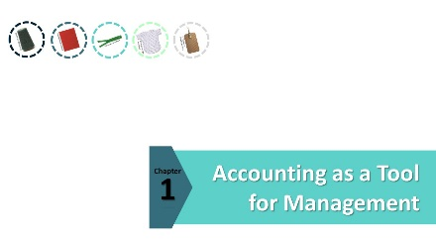
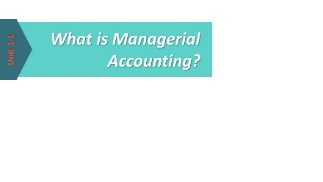
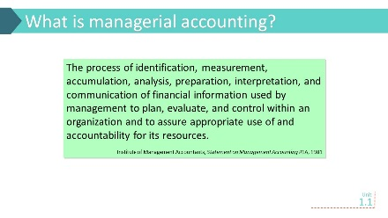 | Ask students to provide their definition of managerial accounting before you show this definition. Write their descriptors on the board for later review. When you have heard from several students, or when answers stop flowing, show this slide and read the definition to the class. Take a big breath in the middle to emphasize the length of the definition.  An interesting assignment would be to ask the students to write down their definitions and turn them in. At the end of the course, you can return the definitions and ask students to comment on how their own definition of managerial accounting has changed as a result of the course.
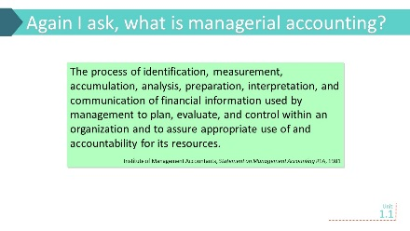 | Read this definition to the students. Explain that the IMA’s definition has evolved over time as the role of managerial accountants has evolved. However, this definition is still a bit abstract for students at the introductory level to understand on the first day of class. Encourage students to continue refining their own definition of managerial accounting throughout the course.
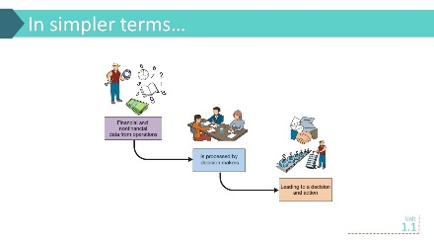 | This is a simple definition of managerial accounting that students should be able to understand early in the course. Relate the descriptors you wrote on the board from before the first slide to the components of this definition.
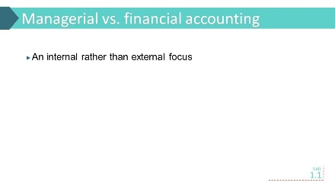 | Since most students will have completed a financial accounting course, comparing and contrasting managerial accounting to financial accounting will help them develop an understanding of managerial accounting. Point out that managerial accounting focuses on the internal operations of the organization, and that managerial accounting information is provided to users (managers) within the organization. Financial accounting, on the other hand, provides information to external parties such as creditors and investors.
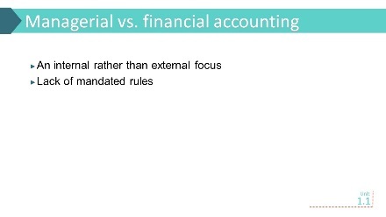 | Reinforce that unlike financial accounting that has GAAP (or IFRS) to guide how to account for transactions, managerial accounting is not bound by a set of reporting standards. You may want to mention that the IMA does publish its views regarding managerial accounting and financial management in its Statements on Management Accounting (online at http://imanet.org/publications_statements.asp), but companies are not required to implement these recommendations.
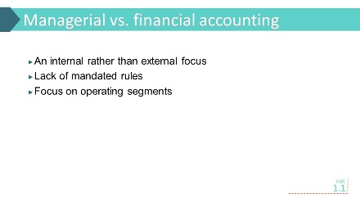 | Managerial accounting exists to facilitate and support decision making within the organization. Since many of these decisions affect smaller segments of the organization, these smaller units or segments become the focus of much of the managerial accounting effort. External financial statements are prepared only at the organization level. Pick a well-known company and ask students to identify some of the segments that might exist within the organization and then identify some decisions that those segments might need managerial accounting information for.
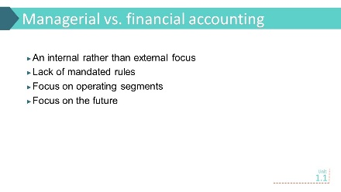 | Remind students that published financial statements are always reporting what has happened in the past, while the decisions that managerial accounting information is supporting are about the future. But this doesn’t mean historical financial accounting information is useless for decision making. Ask students to think about their resumé, which reports their past achievements. Is this historical record useless to a potential employer? No. It provides useful information for predicting future performance.
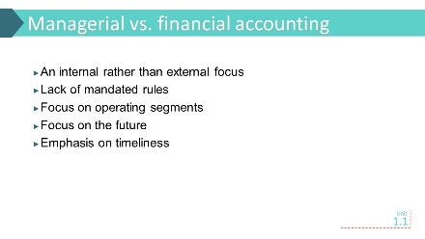 | Managerial accounting information must be received within the decision window, and sometimes that means getting the numbers “close enough”. Getting a more accurate number after the decision deadline has passed is worthless. This is a good time to talk about the concept of materiality.
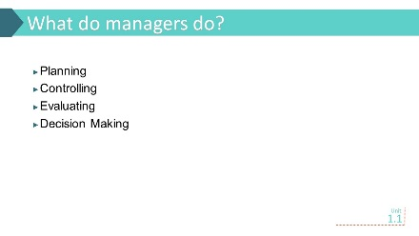 | If managerial accounting’s role is to support managerial decision making, then students need a basic understanding of what role managers play within an organization.
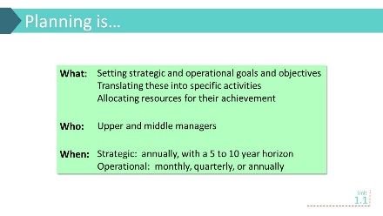 | Students should be somewhat familiar with the concept of planning. Ask them to discuss how they do planning in their personal lives. This discussion could focus on the use of a personal budget. Talk about the difference in operational and strategic planning. If you use the personal budget example, you can emphasize this by looking at a budget for the coming month versus a budget for the next five to ten years.
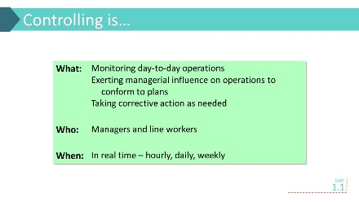 | Controlling often has a negative connotation. Help the students understand that controlling is primarily about moving operations in the desired direction. Relate controlling back to the planning discussion. Using the personal budget example, talk about how that budget affects spending decisions.
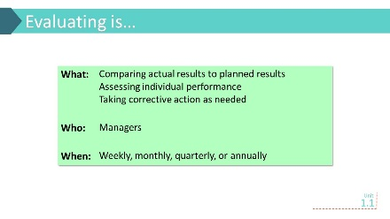 | Evaluating is comparing actual results to planned results. Using the personal budget example, talk about comparing actual spending to the budget at the end of the month to see how well you stayed within the budget. If some areas were overspent, corrective action will be needed in the following month to bring spending back in line with the budget.
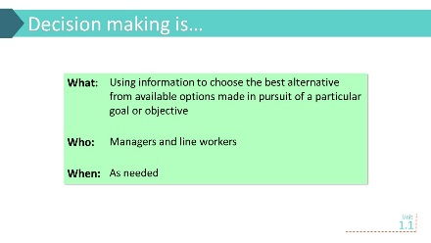 | Ask students to talk about decisions they have made and the information they have used to support those decisions. This can be related back to the personal budget example.
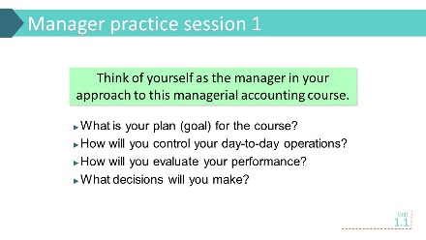 | Typical answers include  Plan (goal): an A in the course  Control: do homework, attend class  Evaluate: self-assessment of understanding (using end of unit reviews), grades, professor feedback  Decisions: study more, do more sample problems, meet with professor, get a tutor
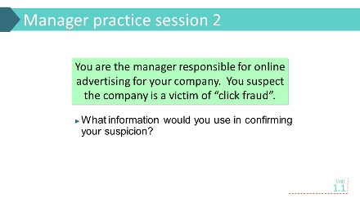 | Provide a short description of click fraud. It may help to pull up a Google, Bing or similar search on a product such as cameras and show the click ads on the right side of the results. The following information would help investigate the presence of click fraud:  - Actual # of click throughs vs. budgeted #  - Actual advertising charge vs. budget  - # of click through customers that make a purchase  - Average length of visit
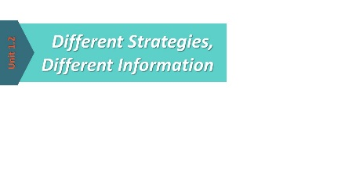
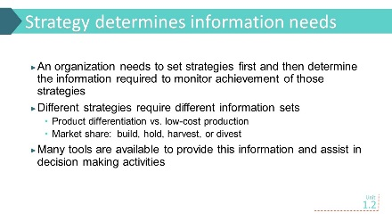 | Students need to understand that information is provided for a purpose. If there is no need for the information, it is useless to spend time and money generating it. Different strategies will require different information to support decision making activities. Talk about the strategies and information needs discussed in the text for product differentiation and market share.
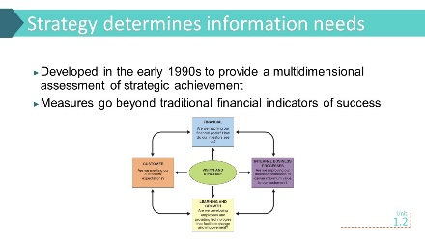 | This is just a brief introduction to the balanced scorecard. A more complete discussion is found in Chapter 11. Focus on how strategy determines what measures are included in the balanced scorecard.
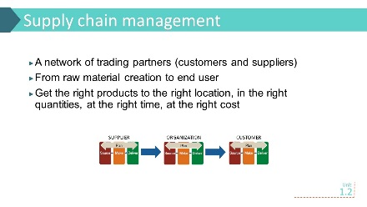 | Students must understand that today’s organization operates within a complex supply chain, where decisions made by one trading partner can have dramatic ripple effects throughout the supply chain.
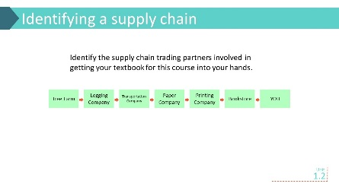 | Once you have identified the supply chain for the textbook as suggested in the critical thinking exercise on pp. 1-4 and 1-5 of these teaching notes, ask students to think about what would happen if the lumber company decided to reduce production of trees. With less supply of lumber, the paper company would have less raw material to make paper, and prices would likely rise to offset the reduced supply. That would lead to increased prices to the publisher and ultimately to the student. It might also bring a faster move toward e-books, which would completely alter the industry’s supply chain.
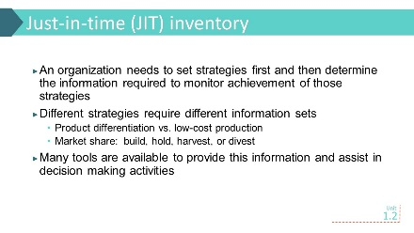 | Inventory management is critical to an organization’s success. Too much inventory and you tie up needed resources. Too little, and you lose sales that will not be made up in the future. There are lots of examples of companies that use JIT. Use the Phred Dvorak article listed under Related Readings or the Allen Edmonds article in footnote 14 of the text chapter to guide discussion.
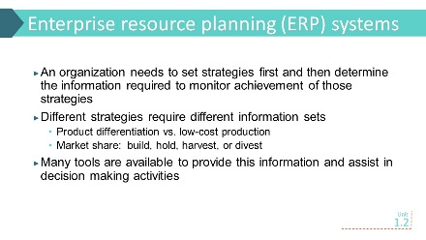 | To get information a company has to have data about its operations. Many organizations now use ERP systems to collect that data throughout the organization and make it available to managers when they need it. This type of information system is superior to the old legacy systems that divided data across many different systems, often resulting in data duplication that sometimes was inaccurate. SAP is probably the most well-known ERP system.
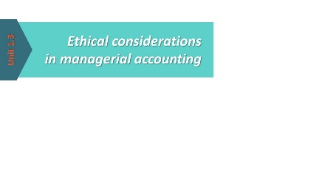
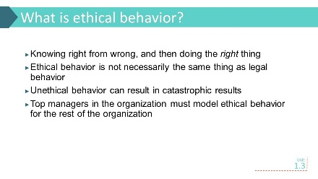 | Ethics are a critical component of good business practice. Talk with the students about what ethical decision making is and is not. Point out that all publicly-traded companies are required to have a corporate code of conduct. Ask students what “ethical behavior” means for this course or in a university setting.
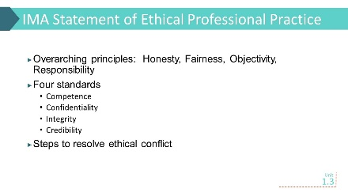 | Professional organizations also have codes of conduct. The IMA Statement of Ethical Professional Practice included in Exhibit 1-8 is one such code. As this code is referred to throughout the text and problems, it will be useful to discuss the main components at this time. Strategic Finance, the IMA’s monthly publication, contains an ethics column each month. It may be helpful to bring in one of these and apply the four ethics standards.
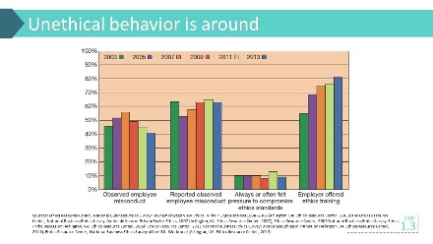 | Despite corporate and professional codes of conduct, unethical behavior still appears. The National Business Ethics Survey gives a glimpse into unethical behavior. While Exhibit 1-9 was the most recent data available at the time the book was written, you may want to check the Ethics Resource Center for the latest survey results.

