Chapter 01
Limits, Alternatives, and Choices

Multiple Choice Questions
1. | Economics can best be described as the study of:  A. how to increase the level of productive resources so there is maximum output in society.  B. how to use productive resources to maximize income level.  C. how people, institutions, and society make choices under conditions of scarcity.  D. how business structures influence the allocation of income among firms.

2. | The primary goal of economic activities is to:  A. expand the production of goods and services.  B. equalize the distribution of consumer income and wealth.  C. make the most efficient use of scarce productive resources.  D. reallocate resources from consumption to production in the economy.

3. | Among competing issues, the most important concern of economics is with the:  A. degree of competition in stock and bond markets in the economy.  B. efficient use of limited productive resources to satisfy economic wants.  C. issue of equality in the distribution of income and wealth among households.  D. budget deficits in the domestic economy and trade deficits in the international economy.

4. | Which of the following is not a central focus of the "economic perspective"?  A. Scarcity and choice  B. The scientific method  C. Purposeful behavior  D. Marginal analysis

5. | The term "scarcity" in economics can refer to the fact that:  A. economic wants are limited and resources are abused.  B. even in the richest country some people go hungry.  C. no country can produce enough products to satisfy everybody's economic wants.  D. it is impossible to produce too much of any particular good or service in a market economy.

6. | The basic economic problem is essentially one of deciding how to make the best use of:  A. limited resources to satisfy limited economic wants.  B. limited resources to satisfy unlimited economic wants.  C. unlimited resources to satisfy unlimited economic wants.  D. unlimited resources to satisfy limited economic wants.

7. | The key concept that serves as the basis for the study of economics is:  A. opportunity cost.  B. unemployment.  C. money.  D. scarcity.

8. | As a student of economics, when you speak of scarcity, you are referring to the ability of society to:  A. employ all of its resources.  B. consume all that is produced.  C. satisfy economic wants given limited resources.  D. continually make technological breakthroughs and increase production.

9. | As a consequence of the condition of scarcity:  A. there is never enough of anything.  B. production has to be centrally planned.  C. things that are plentiful have relatively high prices.  D. individuals and communities have to make choices from among alternatives.

10. | What is the economic meaning of the expression that "there is no such thing as a free lunch"?  A. It refers to "free-riders," who do not pay for the cost of a product but who receive the benefit from it.  B. It means that economic freedom is limited by the amount of income available to the consumer.  C. It means there is an opportunity cost when resources are used to provide "free" products.  D. It indicates that products only have value because people are willing to pay for them.

11. | According to the Gates, Winfrey, and Rodriguez illustration:  A. Gates, Winfrey, and Rodriguez made a mistake by not attending college.  B. Gates, Winfrey, and Rodriguez did not weigh marginal benefits against marginal costs when making decisions.  C. Opportunity costs vary greatly between individuals and matter in decision making.  D. Attending college has little effect on lifetime earnings.

12. | One major feature of the economic perspective is:  A. that scarcity is more important than choice.  B. that costs are more important than benefits.  C. the assumption of purposeful behavior by individuals.  D. the idea that the economy has unproductive resources.

13. | The satisfaction or pleasure one gets from consuming a good or service is called:  A. price.  B. utility.  C. consumption.  D. preferences.

14. | The utility of a specific product:  A. is determined by consumer income.  B. is determined by the price of the product.  C. varies from person to person using the product.  D. is constant from person to person using the product.

15. | Which expression is another way of saying "marginal cost"?  A. total cost  B. additional cost  C. average cost  D. scarcity

16. | Henry wants to buy a book. The economic perspective suggests that Henry will buy the book if:  A. the book will give him utility.  B. his income is high.  C. the marginal cost of the book is greater than its marginal benefit.  D. the marginal benefit of the book is greater than its marginal cost.

17. | From an economic perspective, when a consumer decides to buy more life insurance, the consumer has most likely concluded that the:  A. marginal costs of more insurance coverage have increased.  B. marginal benefits of more insurance coverage have decreased.  C. marginal benefits of more insurance coverage are greater than the marginal costs.  D. opportunity costs of more insurance coverage are greater than the payment for more insurance coverage.

18. | From an economic perspective, when a student decides to attend another year of college, the student has concluded that the marginal:  A. costs of attending college have increased that year.  B. benefits of attending college have decreased that year.  C. benefits of attending college are greater than the marginal costs.  D. costs of attending college will be subsidized by someone else such as parents or the government.

19. | When an economist says that there is "too much of a good thing," the economist is suggesting that:  A. scarcity is not a problem.  B. wants are limited.  C. the marginal cost of the thing is less than the marginal benefit.  D. the marginal benefit of the thing is less than the marginal cost.

20. | Are the goods that businesses offer for "free" to consumers also free to society?  A. Yes, because the individual consumer does not have to pay for them.  B. Yes, because the marginal benefit is greater than the marginal cost.  C. No, because scarce resources were used to produce the free goods.  D. No, because society does not assign a value to free goods.

21. | When producers maximize their profits from the production of a good or service, they are:  A. testing a hypothesis.  B. exhibiting purposeful behavior.  C. assuming that all other things are equal.  D. making a trade-off between economic efficiency and economic freedom.

22. | How is the economic perspective reflected in lines for fast food?  A. Customers select the shortest line because they have perfect information.  B. Customers select the shortest line because they believe it will reduce their time cost of obtaining food.  C. Lines will typically be of unequal length because of the inefficiencies in counter service.  D. The set of food choices is often too complex for customers and thus creates long lines.

23. | From an economic perspective, when consumers leave a fast food restaurant because the lines to be served are too long, they have concluded the:  A. marginal cost of waiting is less than the marginal benefit of being served.  B. marginal cost of waiting is greater than the marginal benefit of being served.  C. management is exhibiting irrational behavior by not maximizing profits.  D. management is making an assumption that other things are equal.

24. | The process of developing hypotheses, testing them against facts, and using the results to construct theories is called:  A. opportunity cost calculation.  B. the scientific method.  C. marginal analysis.  D. microeconomics.

25. | The statement that "the unemployment rate will increase as the economy moves into a recession" is an example of:  A. a normative statement.  B. a microeconomic statement.  C. marginal analysis.  D. a generalization.

26. | An economic model is:  A. a value judgment.  B. a fact.  C. built using theory.  D. built on policies.

27. | Economic models do not reflect the full complexity of reality and instead are based on:  A. trade-offs.  B. purposeful simplifications.  C. value judgments.  D. the fallacy of composition.

28. | The role of an assumption in an economic theory is to:  A. add realism.  B. prove the theory.  C. increase the scope of application.  D. simplify the theory.

29. | The purpose of the ceteris paribus assumption used in economic analysis is to:  A. make sure that all relevant factors are considered.  B. avoid making normative statements.  C. avoid making positive statements.  D. restrict the analysis to the effect of a single economic factor.

30. | A basic assumption used in most economic theories is that:  A. what is true for a part of the whole must also be true for the whole.  B. as price decreases, quantity demanded will decrease.  C. whatever goes up must come down.  D. all other things remain the same.

31. | One reason economists have difficulty applying the scientific method is because:  A. economic conditions are constant.  B. controlled laboratory experiments are often infeasible and sometimes impossible.  C. people are involved, and their behavior is entirely unpredictable.  D. the scientific method does not apply to economics.

32. | Which is an illustration of a microeconomic question?  A. What is the current national rate of unemployment?  B. Is the economy experiencing a declining rate of inflation?  C. Will a new type of television set increase the number of buyers?  D. Is the production of goods and services in the economy greater this year than last year?

33. | Which question is an example of a microeconomic question?  A. What should the federal government do to reduce the trade deficit with Japan?  B. Will the merger of two airlines likely result in higher airline ticket prices?  C. What factors are contributing to the rise of unemployment in the economy?  D. Will the inflation rate remain relatively stable this year?

34. | Microeconomics focuses on:  A. the workings of the whole economy or large sectors of it.  B. the individual units that make up the whole of the economy.  C. issues such as unemployment and inflation.  D. total output and the general level of prices.

35. | Macroeconomics focuses on:  A. the individual units that make up the whole of the economy.  B. studies of how individual markets and industries are organized.  C. total output and the general level of prices in the economy.  D. how a business determines how much output to produce.

36. | The study of how a single business firm sets its prices would fall under the study of:  A. macroeconomics.  B. microeconomics.  C. income distribution.  D. economic growth.

37. | The branch of economics that focuses primarily on aggregates is:  A. macroeconomics.  B. microeconomics.  C. scientific economics.  D. consumer economics.

38. | An "aggregate":  A. treats a collection of specific units as one unit.  B. treats a single unit as if it were a collection of specific units.  C. is the primary unit of analysis in microeconomics.  D. is too large to analyze using standard macroeconomic theories.

39. | Which would be considered a macroeconomic study? A study of the effect of:  A. a decrease in the price of automobiles on automobile sales.  B. changing government spending to increase employment.  C. a new tax on the profits of a business.  D. lower interest rates on a firm's investment.

40. | Which question is an illustration of a microeconomic question?  A. Is the quantity of wine purchased in one year dependent upon the price of wine?  B. Does government spending influence the total level of employment in the economy?  C. Is the purchasing power of the dollar higher or lower today than it was in 2005?  D. Is capitalism superior to socialism?

41. | Which question is an illustration of a macroeconomic question?  A. Is a business unresponsive to the demands of consumers?  B. Is a consumer boycott an effective means of reducing product prices?  C. Is the level of employment in the economy sensitive to the level of consumer spending?  D. Are oil companies engaging in a rip-off of consumers by charging exorbitantly high prices for gasoline?

42. | The macroeconomist would most likely study:  A. the effects of changing beer prices on the market for pretzels.  B. the effects of an increased income tax on a typical household's purchase of goods.  C. the effects of a reduction in income tax rates on the nation's total output.  D. how consumers in Gary, Indiana, respond to lower gasoline prices.

43. | Macroeconomics is the study of economics from the standpoint of:  A. individual economic units.  B. a typical firm.  C. a typical household.  D. the overall economy.

44. | The alternative combinations of two goods that a consumer can purchase with a given money income is:  A. a production possibilities curve.  B. a demand curve.  C. consumer equilibrium.  D. a budget line.

45. | When modeling consumer choice, the price ratio of the two products is the:  A. equilibrium exchange rate.  B. slope of the budget line.  C. point of tangency for equilibrium.  D. demand for the two products.

46. | Decreases in product prices causes the consumer's:  A. production possibilities curves to shift outward from the origin.  B. production possibilities curves to shift inward to the origin.  C. budget line to shift outward from the origin.  D. budget line to shift inward to the origin.

47. | If a product's price falls and the consumer buys 4 units, as they did before the price change, then the:  A. budget line will be unaffected.  B. budget line must shift inward to the origin.  C. budget line may shift either outward from or inward to the origin.  D. consumer will no longer be in equilibrium.

48. | Suppose a consumer has an income of $16, the price of A is $2, and the price of B is $1. Which combination is on the consumer's budget line?  A. 4A and 9B  B. 5A and 6B  C. 6A and 6B  D. 8A and 8B

49. | If a consumer has an income of $200, the price of X is $5, and the price of Y is $10, the maximum quantity of X the consumer is able to purchase is:  A. 5.  B. 10.  C. 20.  D. 40.

50. | Assume that a consumer purchases two products and the consumer's money income increases. All other things equal, the most likely effect is:  A. an outward shift in the production possibilities curve because the consumer can now satisfy more wants.  B. an inward shift in the budget line because the consumer can now purchase less of both products.  C. an outward shift in the budget line because the consumer can now purchase more of both products.  D. no change in the consumer's buying pattern.

51. | 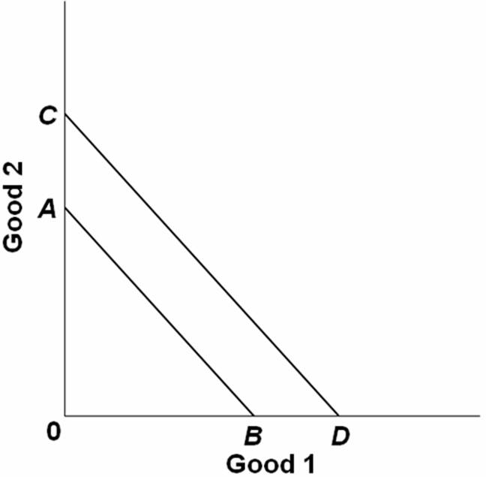  Refer to the above graph. The shift of the budget line from AB to CD is consistent with:  A. a decrease in money income.  B. an increase in money income.  C. an increase in the price of Good 1 and no change in the price of Good 2.  D. a decrease in the price of Good 2 and no change in the price of Good 1.

52. | 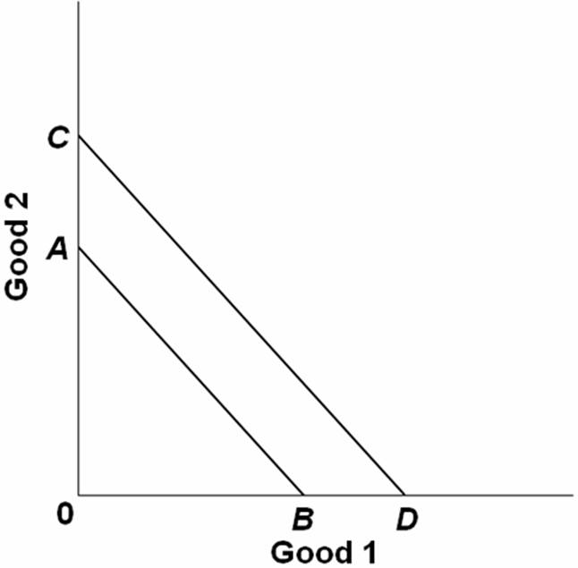  Refer to the above graph. The shift of the budget line from CD to AB is consistent with:  A. a decrease in money income.  B. an increase in money income.  C. an increase in the price of Good 1 and no change in the price of Good 2.  D. a decrease in the price of Good 2 and no change in the price of Good 1.

53. | 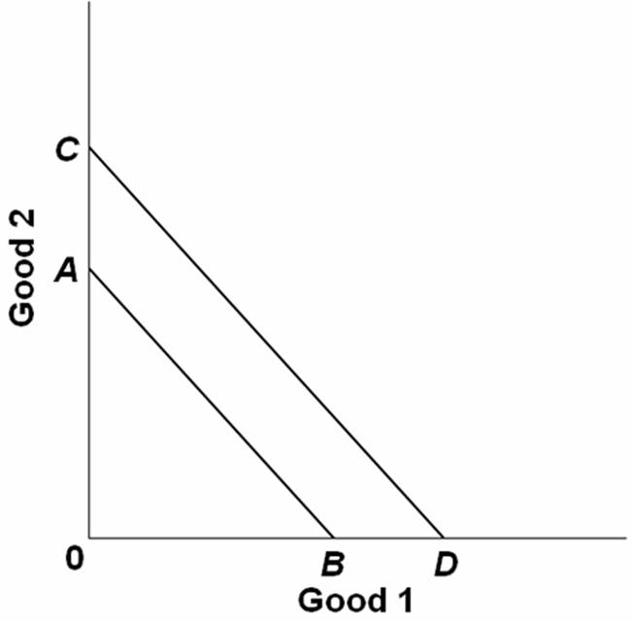  In the diagram above, Cheri's budget line shifts outward from AB to CD. Which statement below is consistent with this shift?  A. Both prices double; her income doubles.  B. Her income is reduced; no change in either price.  C. Both prices are reduced by 50 percent; her income is reduced by less than 50 percent.  D. Both the price of good 1 and Cheri's income increase; there is no change in the price of good 2.

54. | 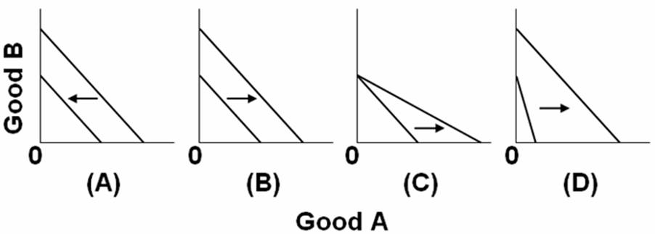  Refer to the above graphs. Which pairs of budget constraints represent only an increase in income but no change in the prices of goods A and B?  A. Graph A  B. Graph B  C. Graph C  D. Graph D

55. | 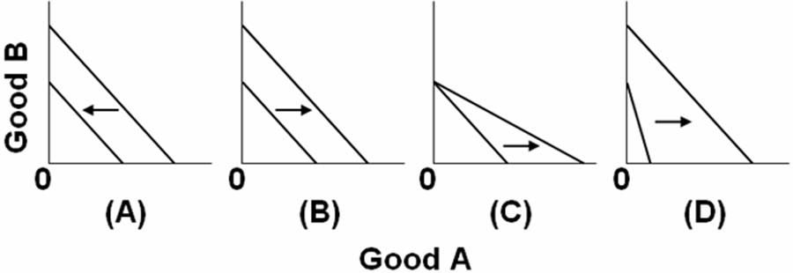  Refer to the above graphs. Which pairs of budget constraints represent only a decrease in the price of good A, but no change in income?  A. Graph A  B. Graph B  C. Graph C  D. Graph D

56. | 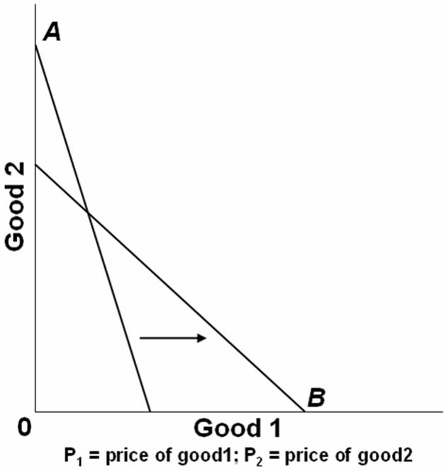  In the graph above, A is the initial budget line and B is the new budget line. Which of the following changes might have occurred?  A. P₁ was unchanged, P₂ increased, income decreased.  B. P₁ decreased, P₂ increased, income was unchanged.  C. P₁ increased, P₂ decreased, income was unchanged.  D. P₁ decreased, P₂ was unchanged, income increased.

57. | 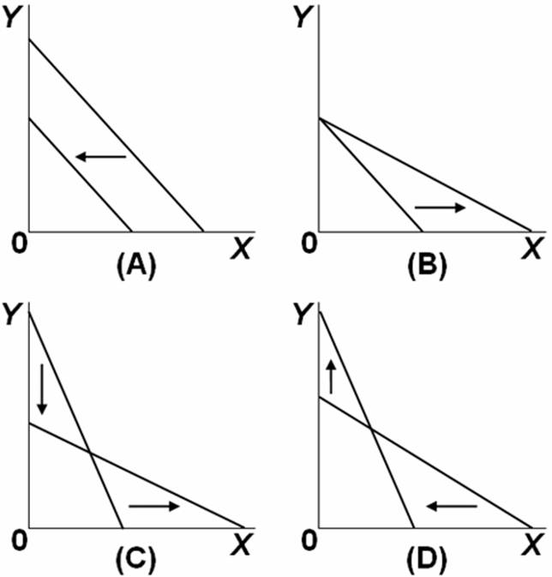  Refer to the above graphs. Which pairs of budget constraints represent only a decrease in income, but no change in the price of X and Y?  A. Graph A  B. Graph B  C. Graph C  D. Graph D

58. | 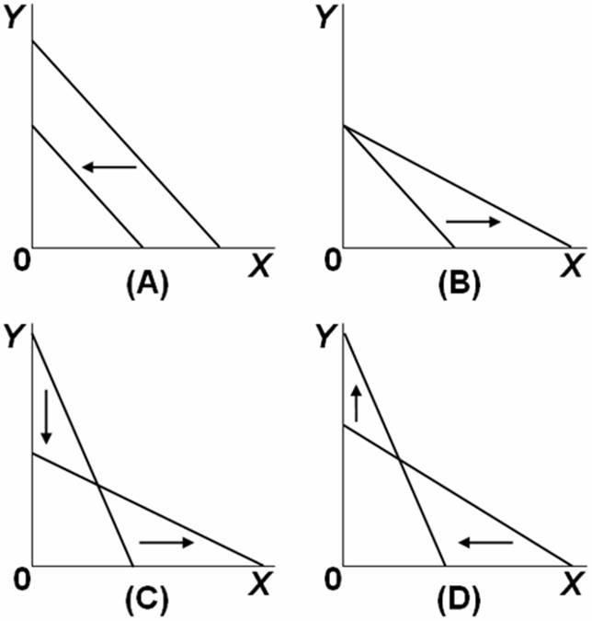  Refer to the above graphs. Which pairs of budget constraints represent only a decrease in the price of X, but no change in income and no change in the price of Y?  A. Graph A  B. Graph B  C. Graph C  D. Graph D

59. | 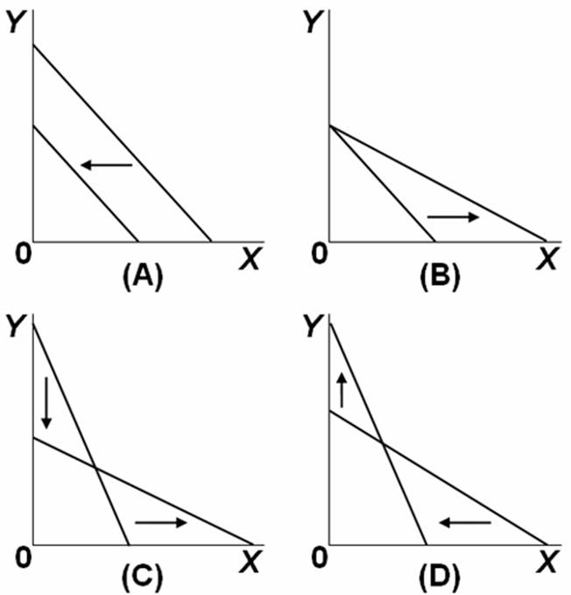  Refer to the above graphs. Which of the above pairs of budget constraint lines illustrates a decrease in the price of good X and an increase in the price of good Y?  A. Graph A  B. Graph B  C. Graph C  D. Graph D

60. | 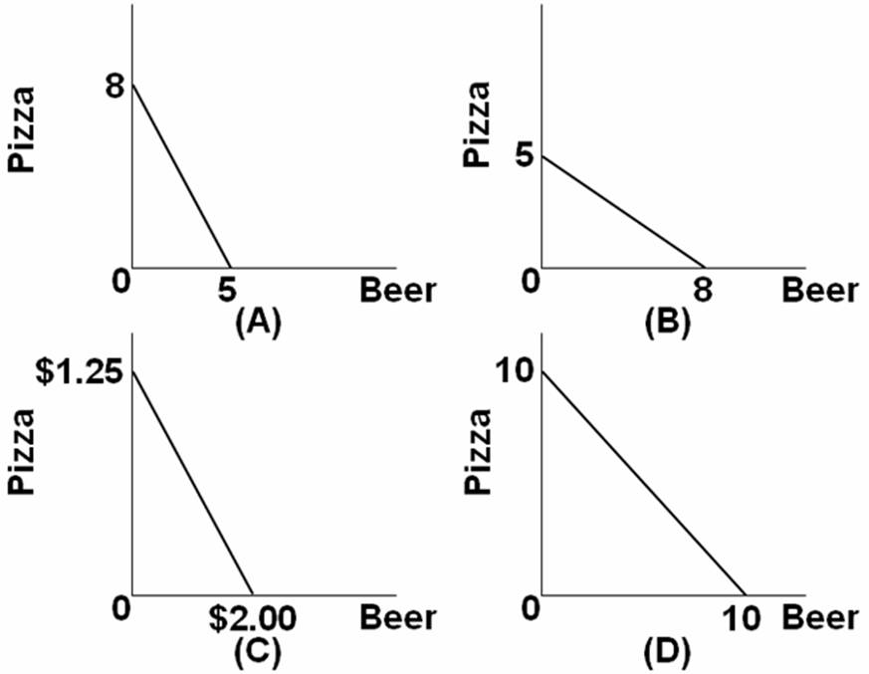  Refer to the above graphs. Pizza and beer are the only two goods Jon consumes. The price of beer is $2.00 per pitcher and pizza is $1.25 per slice. If Jon has only $10 to spend for the evening, which graph represents the set of possible combinations of beer and pizza he can consume?  A. Graph A  B. Graph B  C. Graph C  D. Graph D

61. | The individual who brings together economic resources and assumes the risk in a capitalist economy is called the:  A. manager.  B. entrepreneur.  C. stockbroker.  D. banker.

62. | Which would not be considered as capital by an economist?  A. A share of corporate stock issued by General Motors  B. An automobile used by a salesperson at General Electric  C. A crane used by a building contractor  D. A razor used by a barber

63. | Which is not considered to be an economic resource?  A. Land (or other natural resources)  B. Money  C. Labor  D. Tools and machinery

64. | Economic resources in the capitalist system are brought together by:  A. government units.  B. entrepreneurs.  C. labor unions.  D. the managerial elite.

65. | Money is not considered to be an economic resource because:  A. as such it is not productive.  B. money is not a free gift of nature.  C. the terms of trade can be determined in nonmonetary terms.  D. idle money balances do not earn interest income.

66. | Which is a factor of production?  A. Money  B. Interest  C. Rent  D. Capital

67. | Which is considered to be an economic resource by economists?  A. Rent  B. Money  C. Labor  D. Wages

68. | Society wants to use its scarce resources efficiently. To achieve this economic goal it must:  A. have full employment and full production.  B. have a fixed resource base and fixed technology.  C. expand the use of capital goods and reduce the use of labor.  D. increase the rental, interest, wage, and profit payments to the factors of production.

69. | When an economy is at full employment and full production, more of any one product:  A. cannot be produced because there is full production.  B. can be produced only if there is a general decrease in prices.  C. can be produced only if there is less production of some other products.  D. cannot be produced unless private enterprise does so rather than government.

70. | The production possibilities curve represents which of the following?  A. The amount of goods attainable with variable resources  B. The maximum amount of goods attainable with variable resources  C. The maximum combinations of goods attainable with fixed resources  D. The amount of goods attainable if prices decline

71. | On a production possibilities curve, the optimal or best combination of output for any society:  A. is at a point near the top of the curve.  B. is at the precise midpoint of the curve.  C. is at a point near the bottom of the curve.  D. depends upon the preferences of society.

72. | The following economy produces two products.  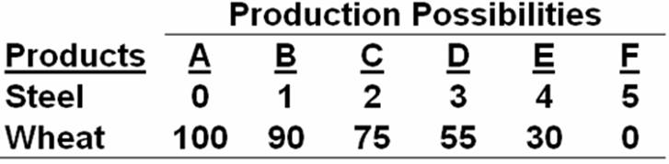  Refer to the above table. The total opportunity cost of the three units of steel is:  A. 15 units of wheat.  B. 20 units of wheat.  C. 45 units of wheat.  D. 55 units of wheat.

73. | The following economy produces two products.  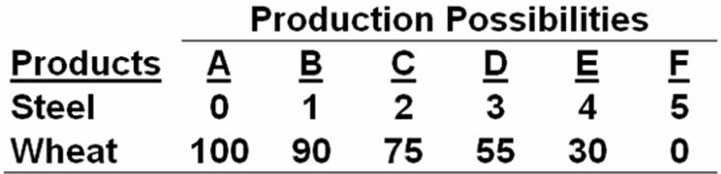  Refer to the above table. The marginal opportunity cost of the third unit of steel is:  A. 10 units of wheat.  B. 15 units of wheat.  C. 20 units of wheat.  D. 30 units of wheat.

74. | The following economy produces two products.  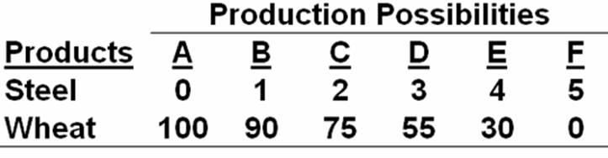  Refer to the above table. A change from possibility C to B means that:  A. 1 unit of steel is given up to get 75 units of wheat.  B. 2 units of steel are given up to get 75 units of wheat.  C. 1 unit of steel is given up to get 15 more units of wheat.  D. 2 units of steel are given up to get 15 more units of wheat.

75. | The following economy produces two products.  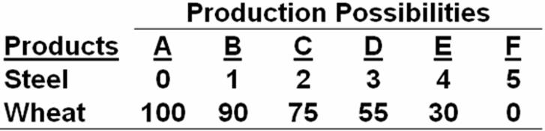  Refer to the above table. In moving from possibility A to F, the cost of a unit of steel in terms of a unit of wheat:  A. increases.  B. decreases.  C. remains constant.  D. increases from A to B, and decreases from B to F.

76. | The following economy produces two products.  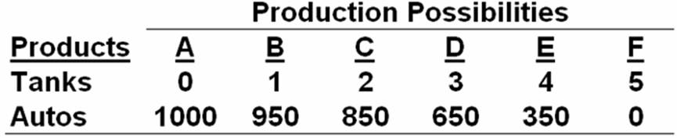  Refer to the above table. The total opportunity cost of the three units of tanks is:  A. 200 units of autos.  B. 350 units of autos.  C. 650 units of autos.  D. 1000 units of autos.

77. | The following economy produces two products.  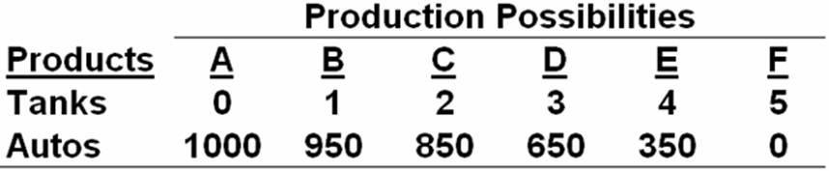  Refer to the above table. The marginal opportunity cost of the fourth unit of tanks is:  A. 200.  B. 300.  C. 350.  D. 650.

78. | The following economy produces two products.  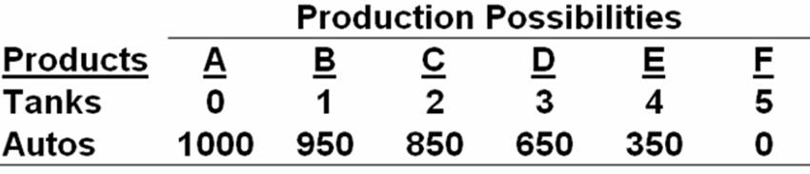  Refer to the above table. The opportunity cost of each additional tank in terms of autos:  A. remains constant.  B. falls as more tanks are produced.  C. increases as more tanks are produced.  D. cannot be measured because there is no currency.

79. | The following economy produces two products.  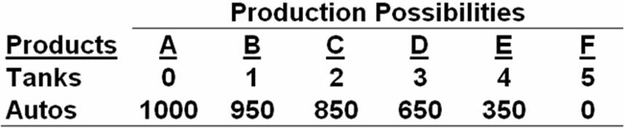  Refer to the above table. According to the production possibilities schedule, a combination of four tanks and 650 autos is:  A. attainable and involves an efficient use of society's resources.  B. attainable, but would not be in the best interests of a strong national defense.  C. not attainable because it is not listed in the schedule.  D. not attainable because society does not have sufficient resources to produce this combination.

80. | The following economy produces two products.  Given the production possibilities schedule above, a combination of three tanks and 350 autos:  A. illustrates the trade-off between tanks and autos.  B. is attainable but involves the unemployment or inefficient use of some of society's resources.  C. cannot be produced by society, given its current level of resources and production technology.  D. is not attainable because this combination is not listed in the schedule.

81. | 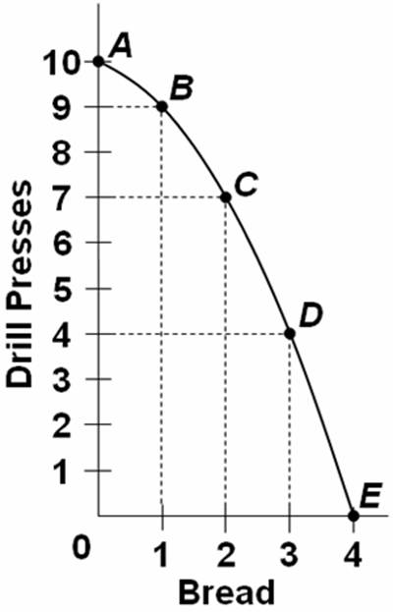  Refer to the above graph. The total opportunity cost of nine drill presses is:  A. 1 unit of bread.  B. 2 units of bread.  C. 3 units of bread.  D. 4 units of bread.

82. | 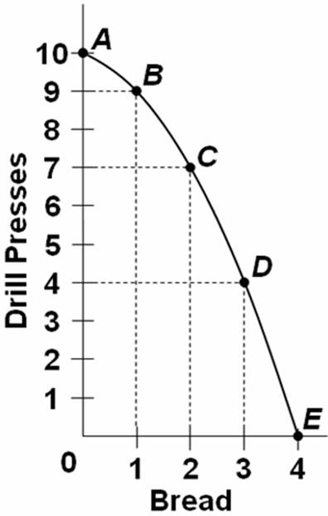  Refer to the above graph. The marginal opportunity cost of the fourth unit of bread is:  A. 1 unit of drill presses.  B. 2 units of drill presses.  C. 3 units of drill presses.  D. 4 units of drill presses.

83. | A point inside the production possibilities curve is:  A. attainable and the economy is efficient.  B. attainable, but the economy is inefficient.  C. unattainable and the economy is inefficient.  D. unattainable, but the economy is efficient.

84. | A point on the frontier of the production possibilities curve is:  A. attainable and the economy is efficient.  B. attainable, but the economy is inefficient.  C. unattainable and the economy is inefficient.  D. unattainable, but the economy is efficient.

85. | The production possibility curve:  A. is convex to the origin.  B. is based on the law of diminishing returns.  C. is the boundary between attainable and unattainable outputs.  D. reflects the mixed economy found with most economic systems.

86. | A movement along the production possibilities curve would imply that:  A. the labor force has grown.  B. productivity has increased.  C. productivity has declined.  D. society has chosen a different set of outputs.

87. | If an economy is producing at a point inside a production possibilities curve:  A. the economy is efficient.  B. there is economic growth.  C. resources are unemployed.  D. resources are fully employed.

88. | 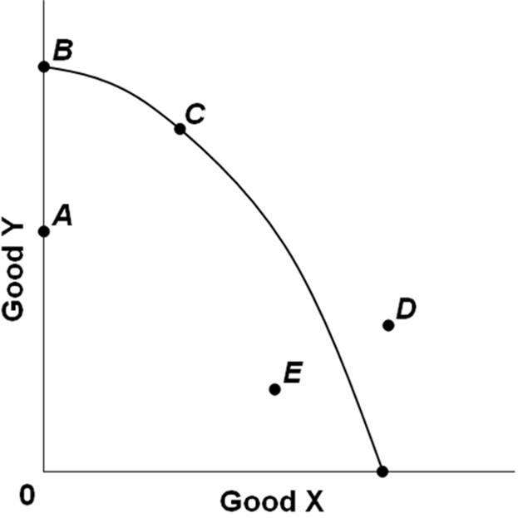  The graph above shows the production possibilities curve for an economy producing two goods, X and Y. Which of the points on the graph indicate unemployed resources?  A. D only  B. E only  C. E and A only  D. B and C only

89. | If an economy that produces capital and consumer goods is operating at a point on its production possibilities curve:  A. it is achieving full employment but not full production.  B. it is achieving full production but not full employment.  C. more capital goods can be produced only at the cost of some consumer goods.  D. the economy is incapable of achieving significant economic growth.

90. | Consider a society that is producing inside its production possibilities frontier. This society could best achieve efficiency in its production of output by:  A. distributing incomes more equally.  B. fully employing all available resources.  C. increasing the levels of wages and prices.  D. producing relatively more capital goods and relatively fewer consumer goods.

91. | A reduction in the level of unemployment would have which effect with respect to the nation's production possibilities curve?  A. It would shift the curve to the right.  B. It would shift the curve to the left.  C. It would not shift the curve; it would be represented by moving from a point inside the curve toward the curve.  D. It would not shift the curve; it would be represented by moving from a point on the curve to a point outside the curve.

92. | 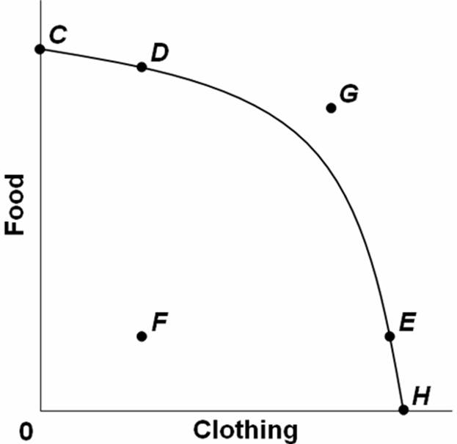  Points C, D, E, and H on the above graph show:  A. an inefficient allocation of society's scarce resources.  B. a constant trade-off between food and clothing.  C. possible combinations of food and clothing.  D. unattainable combinations of food and clothing.

93. | 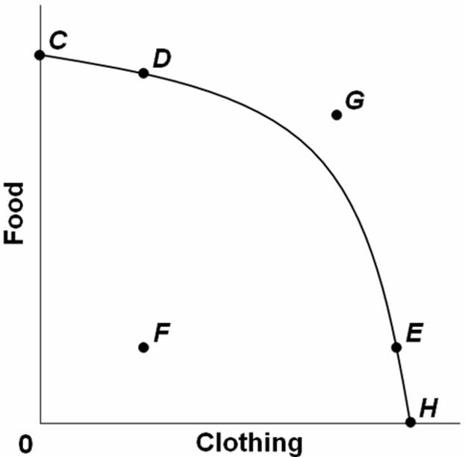  The combination of food and clothing shown by point G on the above graph:  A. is not attainable, given society's available resources and technology.  B. can be attained only if some of society's resources are unemployed.  C. suggests that the law of increasing relative costs is not operating in this case.  D. results only because society allocates its resources inefficiently.

94. | Along a production possibilities curve, an increase in the production of one type of good can be accomplished only by:  A. decreasing the production of the other type of good.  B. increasing the production of the other type of good.  C. holding constant the production of the other type of good.  D. decreasing the price of the other type of good.

95. | Assume that for Indy, one hour of study time in economics is perfectly substitutable for an hour of study time in calculus. Indy has exams in both subjects tomorrow and he determines that if spends all of his time studying economics, he will receive scores of 96 on his economics exam and 45 on his calculus exam. If he studies only calculus, his econ score will be 81 and his calculus score 90. Based on this information and assuming that Indy has no better alternative use of his time, what is the opportunity cost of improving his econ score by one (1) point?  A. 1 point on his calculus exam.  B. 1/3 point on his calculus exam.  C. 3 points on his calculus exam.  D. The opportunity cost cannot be determined with the information given.

96. | If a production possibilities boundary is a curve concave to the origin and not a straight line, then:  A. resources are equally suited to producing alternative products.  B. resources are not equally suited to producing alternative products.  C. resources are perfectly interchangeable to alternative uses.  D. there are unemployed resources.

97. | The production possibilities curve bows outward from the origin because:  A. opportunity costs decrease as the production of a good increases.  B. opportunity costs increase as the production of a good increases.  C. more production of one good results in more production of the other good.  D. resources are not of uniform quality.

98. | The law of increasing opportunity costs indicates that:  A. resources are perfectly mobile except for transportation costs.  B. the sum of all costs cannot rise above the market price of a product.  C. to produce more of one good, society must sacrifice larger and larger amounts of alternative goods.  D. if the prices of all the resources involved in the production of goods increase, the cost of producing those goods will increase at the same rate.

99. | The production possibilities table below shows the hypothetical relationship between the production of capital goods and consumer goods in an economy.  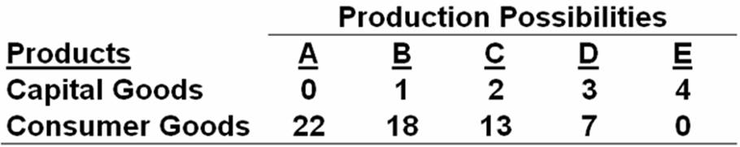  Refer to the table above. What is the opportunity cost of producing the third unit of capital goods?  A. 4 units of consumer goods  B. 5 units of consumer goods  C. 6 units of consumer goods  D. 7 units of consumer goods

100. | The production possibilities table below shows the hypothetical relationship between the production of capital goods and consumer goods in an economy.  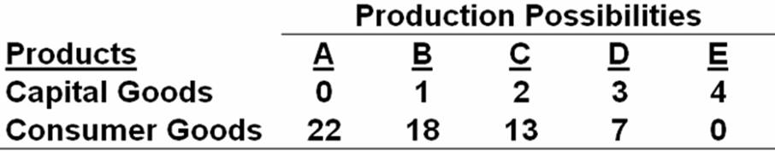  Refer to the table above. What is the opportunity cost of producing the first two units of capital goods?  A. 4 units of consumer goods  B. 5 units of consumer goods  C. 9 units of consumer goods  D. 13 units of consumer goods

101. | The production possibilities table below shows the hypothetical relationship between the production of capital goods and consumer goods in an economy.  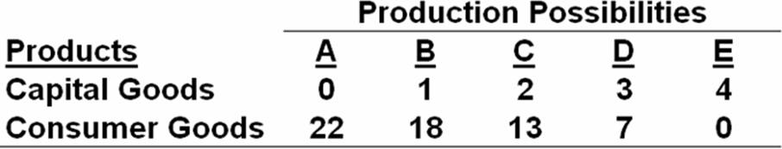  Refer to the table above. What is the opportunity cost of producing the first three units of capital goods?  A. 6 units of consumer goods  B. 7 units of consumer goods  C. 15 units of consumer goods  D. 22 units of consumer goods

102. | The law of increasing opportunity cost explains why the shape of the production possibilities curve is:  A. a straight line parallel to the horizontal axis.  B. a straight line from one axis to the other.  C. bowed out (concave) from the origin of the graph.  D. bowed inward (convex) to the origin of the graph.

103. | Which statement is an economic rationale for the law of increasing opportunity cost?  A. The economy is employing all of its available resources.  B. Many economic resources are better at producing one product than another.  C. In any economy, the state of technology is changing and resources are variable.  D. The economy is achieving productive efficiency by producing goods and services at the least cost.

104. | Opportunity cost is best defined as:  A. marginal cost minus marginal benefit.  B. the value of the best forgone alternative.  C. the time spent on an economic activity.  D. the money cost of an economic decision.

105. | Tammie makes $150 a day as a bank clerk. She takes off two days of work without pay to fly to another city to attend the concert of her favorite music group. The cost of transportation for the trip is $250. The cost of the concert ticket is $50. The opportunity cost of Tammie's trip to the concert is:  A. $300.  B. $450.  C. $500.  D. $600.

106. | When a state government chooses to build more roads, the required resources are no longer available for spending on public education. This dilemma illustrates the concept of:  A. marginal analysis.  B. full employment.  C. full production.  D. opportunity cost.

107. | The opportunity cost of a new national park is the:  A. alternative uses for the land and funding for the park.  B. cost of constructing park buildings and highways to get to it.  C. cost of hiring staff and park rangers to provide services for visitors.  D. increased pollution to the wildlife habitat at the park.

108. | After graduating from high school, Ron Willis plans to go to college. The college tuition is $15,000 a year. But, instead of going to college, Ron could take a full-time job paying $20,000. If Ron decides to go to college, what is his opportunity cost for attending for one year?  A. $5,000  B. $15,000  C. $20,000  D. $35,000

109. | In a production possibilities table, the most-valued or optimal point for society is determined by:  A. a combination of products at the midpoint of the table.  B. a combination of products at the ends of the table.  C. the equality of marginal benefits and marginal costs.  D. the maximization of opportunity costs.

110. | The overallocation of resources by society to a product means that the:  A. marginal benefit is greater than the marginal cost.  B. marginal cost is greater than the marginal benefit.  C. entrepreneurs are making too much profit in the economy.  D. workers are not being paid adequate wages and salaries.

111. | When society overallocates resources to a product it means that the:  A. investment in the product is declining.  B. opportunity cost of the product is decreasing.  C. marginal benefit is greater than the marginal cost.  D. marginal benefit is less than the marginal cost.

112. | The "war on terror" waged by the United States:  A. shifted the production possibilities curve to the right.  B. shifted the production possibilities curve inward.  C. caused the United States to shift from "defense goods" to "civilian goods."  D. caused the perceived marginal benefit curve for "defense goods" to shift out.

113. | Scaling back the U.S. "war on terror" would:  A. shift U.S. production from "defense goods" to "civilian goods."  B. shift U.S. production from "civilian goods" to "defense goods."  C. shift the production possibilities curve inward.  D. suggest that the United States is allocating less than the optimal amount of resources to the war on terror.

114. | Economic growth may be represented by a:  A. rightward shift of the production possibilities curve.  B. leftward shift of the production possibilities curve.  C. production possibilities curve that remains fixed.  D. point outside (to the right) of the production possibilities curve.

115. | Increases in resources or improvements in technology will tend to cause a society's production possibilities curve to:  A. shift inward or to the left.  B. shift outward or to the right.  C. become horizontal.  D. become vertical.

116. | A nation that devotes more of its resources to capital investment is likely to:  A. shift outward its production possibilities curve.  B. shift inward its production possibilities curve.  C. increase the slope of its production possibilities curve.  D. decrease the slope of its production possibilities curve.

117. | All of the following would affect the position of a country's production possibilities curve, except:  A. the quantity of labor.  B. the level of unemployment.  C. the amount of the capital stock.  D. technological progress.

118. | 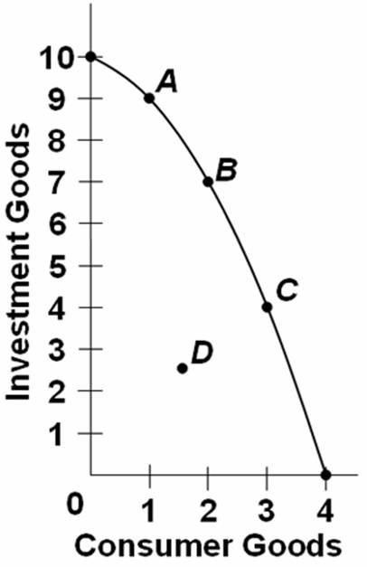  Refer to the above graph. Which point on the production possibilities curve would indicate that there is unemployment in this economy?  A. A  B. B  C. C  D. D

119. | 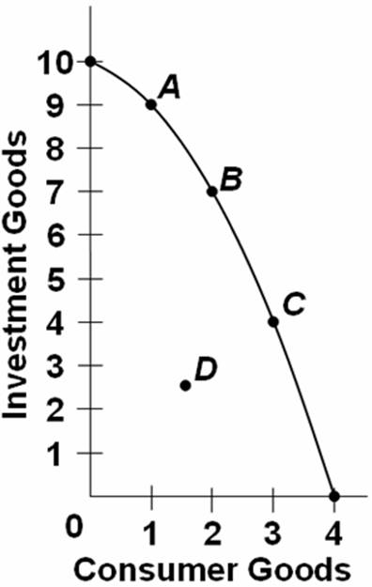  Refer to the above graph. The selection of which point on the production possibilities curve is most like to result in the largest increase in economic growth over time?  A. A  B. B  C. C  D. D

120. | 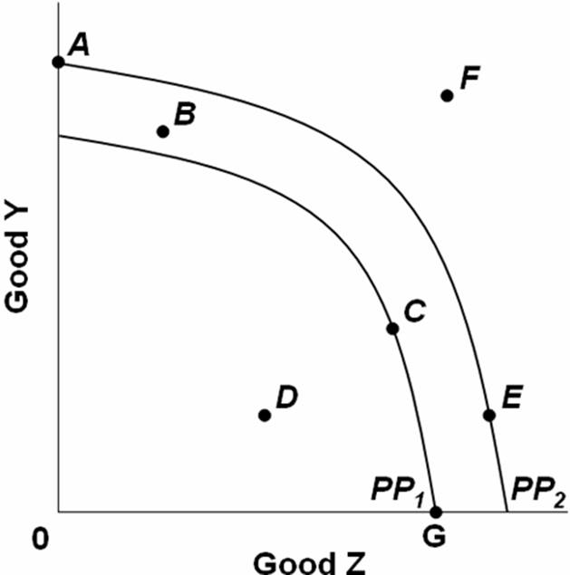  The graph above shows two production possibilities curves for a nation that produces two goods, Y and Z. PP₁ and PP₂ show the production possibilities for years 1 and 2. The nation's total production then decreased after year 2. This change could be represented by a move from:  A. F to A.  B. A to E.  C. F to B.  D. E to D.

121. | 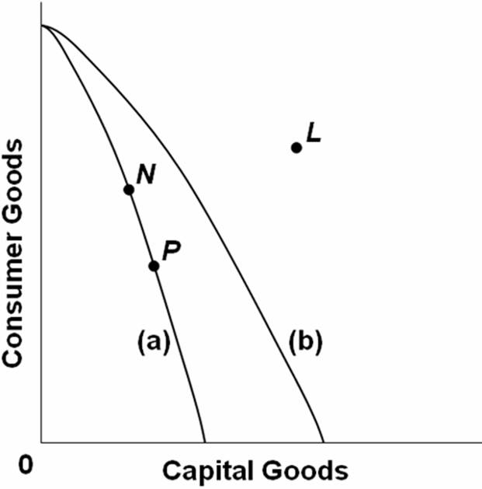  Refer to the above production possibilities curves. Curve (a) is the current curve for the economy. Given production possibilities curve (a), point N suggests that the economy is:  A. attaining full employment but not full production.  B. attaining full production but not full employment.  C. using its available resources inefficiently.  D. attaining both full employment and full production.

122. | 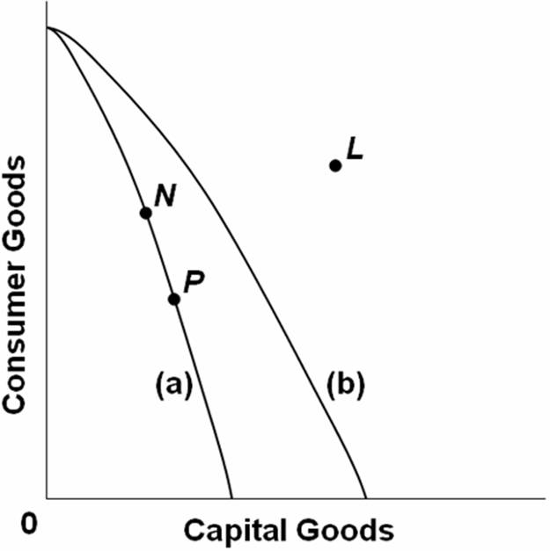  Refer to the above production possibilities curves. Curve (a) is the current curve for the economy. The movement from curve (a) to curve (b) suggests:  A. a movement from unemployment to full employment.  B. an improvement in capital goods technology but not in consumer goods technology.  C. an improvement in consumer goods technology but not in capital goods technology.  D. a decline in the total output of this society.

123. | 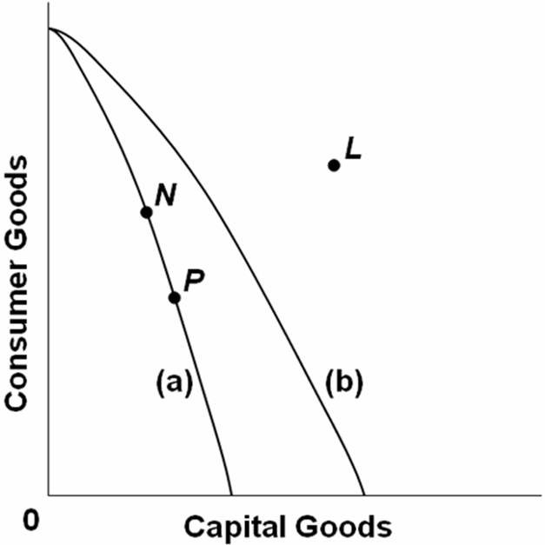  Refer to the above production possibilities curves. Curve (a) is the current curve for the economy. Other things being equal, society's current choice of point P on curve (a) will:  A. allow it to achieve more rapid economic growth than would the choice of point N.  B. entail a slower rate of economic growth than would the choice of point N.  C. entail the same rate of growth as would the choice of point N.  D. be unobtainable because it exceeds the productive capacity of the economy.

124. | Which situation would most likely shift the production possibilities curve for a nation in an outward direction?  A. A decrease in the quality of products  B. An increase in the supply of resources  C. A decrease in the state of technology  D. An increase in the amount of discrimination

125. | Suppose there are two economies, Alpha and Beta, which have the same production possibilities curves and are on the same point on each curve. If Beta then devotes more resources to investment goods than consumer goods when compared to Alpha, then in the future:  A. Alpha will experience greater economic growth than Beta.  B. Beta will experience greater economic growth than Alpha.  C. Alpha will not be able to achieve full employment or productive efficiency.  D. Beta will not be able to achieve full employment or productive efficiency

126. | Cuba is a command economy that suffered decline in economic growth because of a cut in support from the former Soviet Union when it collapsed. As a consequence, Cuba:  A. experienced a shift outward in its production possibilities curve.  B. experienced a shift inward in its production possibilities curve.  C. moved along its existing production possibilities curve.  D. went to a point inside its production possibilities curve.

127. | Which situation would most likely cause a nation's production possibilities curve to shift inward?  A. The construction of more capital goods  B. An increase in foreign trade  C. An increase in the number of skilled immigrant workers  D. The destruction from bombing and warfare in a losing military conflict

128. | A nation can increase its production possibilities by:  A. shifting resources from investment good production to consumer good production.  B. shifting resources from private goods to public goods.  C. improving labor productivity.  D. reducing international trade.

129. | 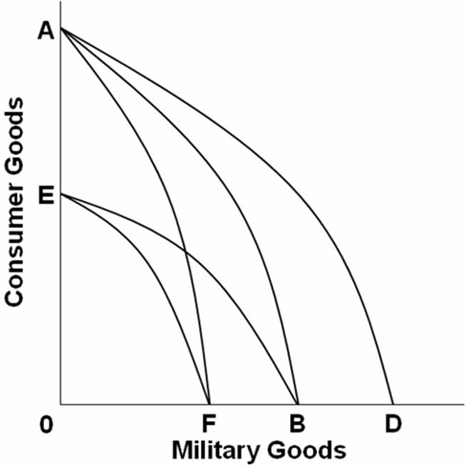  Refer to the above graph. Assume that before the Persian Gulf War, Iraq's production possibilities were represented by AB. Which line on the above graph would represent the change in Iraq's production possibilities after the war?  A. AB to BE  B. AB to AF  C. AB to AD  D. AB to EF

True / False Questions
130. | Economics is the study of the efficient use of scarce resources to achieve maximum satisfaction of economic wants.  True False

131. | Marginal analysis is the comparison of additional benefits with the additional costs.  True False

132. | From the "economic perspective," people make purposeful decisions based on hypotheses.  True False

133. | By using the same ceteris paribus assumptions, economic principles are just as certain and precise as those of the laboratory sciences.  True False

134. | Macroeconomics is concerned with the whole economy or its major sectors.  True False

135. | The economizing problem arises from the conflict between having relatively unlimited resources and relatively limited wants.  True False

136. | The fundamental economic problem is that productive resources are scarce in relation to the demand for them.  True False

137. | The four factors of production are land, labor, capital, and government services.  True False

138. | A point inside the production possibilities curve illustrates that resources are not being used as efficiently as possible.  True False

139. | The concave, or bowed-out, shape of the production possibilities curve illustrates the law of increasing opportunity costs.  True False

140. | If the marginal benefits are greater than the marginal cost of an activity, then society is overallocating resources to this activity.  True False

141. | The marginal cost curve for a product slopes upward as more units are produced because of the law of increasing costs.  True False

142. | If the marginal benefits of the output from resources devoted to the production of a product are greater than the marginal costs, then there has been an overallocation of resources to the production of that product.  True False

143. | Economic growth is shown by a shift of the production possibilities curve outward and to the right.  True False

144. | If a nation is incurring a trade deficit (it is buying more from abroad—importing, than it is selling abroad—exporting), then it is most likely producing beyond the frontier of its production possibilities curve.  True False

145. | The implied production possibilities curve between work time and grades suggests that more hours spent working will mean more income, but also less study time and a lower grade average.  True False

Chapter 01 Limits, Alternatives, and Choices Answer Key

Multiple Choice Questions
1. | Economics can best be described as the study of:  A. how to increase the level of productive resources so there is maximum output in society.  B. how to use productive resources to maximize income level.  C. how people, institutions, and society make choices under conditions of scarcity.  D. how business structures influence the allocation of income among firms.

AACSB: Analytic
Blooms: Remember
Difficulty: 1 Easy
Learning Objective: 01-01 Define economics and the features of the economic perspective.
Topic: Economic perspectives
Topic: Economics

2. | The primary goal of economic activities is to:  A. expand the production of goods and services.  B. equalize the distribution of consumer income and wealth.  C. make the most efficient use of scarce productive resources.  D. reallocate resources from consumption to production in the economy.

AACSB: Analytic
Blooms: Remember
Difficulty: 1 Easy
Learning Objective: 01-01 Define economics and the features of the economic perspective.
Topic: Economic perspectives
Topic: Economics

3. | Among competing issues, the most important concern of economics is with the:  A. degree of competition in stock and bond markets in the economy.  B. efficient use of limited productive resources to satisfy economic wants.  C. issue of equality in the distribution of income and wealth among households.  D. budget deficits in the domestic economy and trade deficits in the international economy.

AACSB: Analytic
Blooms: Remember
Difficulty: 1 Easy
Learning Objective: 01-01 Define economics and the features of the economic perspective.
Topic: Economic perspectives
Topic: Economics

4. | Which of the following is not a central focus of the "economic perspective"?  A. Scarcity and choice  B. The scientific method  C. Purposeful behavior  D. Marginal analysis

AACSB: Analytic
Blooms: Remember
Difficulty: 2 Medium
Learning Objective: 01-01 Define economics and the features of the economic perspective.
Topic: Economic perspectives
Topic: Economics

5. | The term "scarcity" in economics can refer to the fact that:  A. economic wants are limited and resources are abused.  B. even in the richest country some people go hungry.  C. no country can produce enough products to satisfy everybody's economic wants.  D. it is impossible to produce too much of any particular good or service in a market economy.

AACSB: Analytic
Blooms: Remember
Difficulty: 1 Easy
Learning Objective: 01-01 Define economics and the features of the economic perspective.
Topic: Economic perspectives
Topic: Economics

6. | The basic economic problem is essentially one of deciding how to make the best use of:  A. limited resources to satisfy limited economic wants.  B. limited resources to satisfy unlimited economic wants.  C. unlimited resources to satisfy unlimited economic wants.  D. unlimited resources to satisfy limited economic wants.

AACSB: Analytic
Blooms: Remember
Difficulty: 1 Easy
Learning Objective: 01-01 Define economics and the features of the economic perspective.
Topic: Economic perspectives
Topic: Economics

7. | The key concept that serves as the basis for the study of economics is:  A. opportunity cost.  B. unemployment.  C. money.  D. scarcity.

AACSB: Analytic
Blooms: Remember
Difficulty: 2 Medium
Learning Objective: 01-01 Define economics and the features of the economic perspective.
Topic: Economic perspectives
Topic: Economics

8. | As a student of economics, when you speak of scarcity, you are referring to the ability of society to:  A. employ all of its resources.  B. consume all that is produced.  C. satisfy economic wants given limited resources.  D. continually make technological breakthroughs and increase production.

AACSB: Analytic
Blooms: Remember
Difficulty: 2 Medium
Learning Objective: 01-01 Define economics and the features of the economic perspective.
Topic: Economic perspectives
Topic: Economics

9. | As a consequence of the condition of scarcity:  A. there is never enough of anything.  B. production has to be centrally planned.  C. things that are plentiful have relatively high prices.  D. individuals and communities have to make choices from among alternatives.

AACSB: Analytic
Blooms: Remember
Difficulty: 1 Easy
Learning Objective: 01-01 Define economics and the features of the economic perspective.
Topic: Economic perspectives
Topic: Economics

10. | What is the economic meaning of the expression that "there is no such thing as a free lunch"?  A. It refers to "free-riders," who do not pay for the cost of a product but who receive the benefit from it.  B. It means that economic freedom is limited by the amount of income available to the consumer.  C. It means there is an opportunity cost when resources are used to provide "free" products.  D. It indicates that products only have value because people are willing to pay for them.

AACSB: Reflective Thinking
Blooms: Apply
Difficulty: 2 Medium
Learning Objective: 01-01 Define economics and the features of the economic perspective.
Topic: Economic perspectives
Topic: Economics

11. | According to the Gates, Winfrey, and Rodriguez illustration:  A. Gates, Winfrey, and Rodriguez made a mistake by not attending college.  B. Gates, Winfrey, and Rodriguez did not weigh marginal benefits against marginal costs when making decisions.  C. Opportunity costs vary greatly between individuals and matter in decision making.  D. Attending college has little effect on lifetime earnings.

AACSB: Analytic
Blooms: Remember
Difficulty: 1 Easy
Learning Objective: 01-01 Define economics and the features of the economic perspective.
Topic: Economic perspectives
Topic: Economics

12. | One major feature of the economic perspective is:  A. that scarcity is more important than choice.  B. that costs are more important than benefits.  C. the assumption of purposeful behavior by individuals.  D. the idea that the economy has unproductive resources.

AACSB: Analytic
Blooms: Remember
Difficulty: 1 Easy
Learning Objective: 01-01 Define economics and the features of the economic perspective.
Topic: Economic perspectives
Topic: Economics

13. | The satisfaction or pleasure one gets from consuming a good or service is called:  A. price.  B. utility.  C. consumption.  D. preferences.

AACSB: Analytic
Blooms: Remember
Difficulty: 1 Easy
Learning Objective: 01-01 Define economics and the features of the economic perspective.
Topic: Economic perspectives
Topic: Economics

14. | The utility of a specific product:  A. is determined by consumer income.  B. is determined by the price of the product.  C. varies from person to person using the product.  D. is constant from person to person using the product.

AACSB: Analytic
Blooms: Remember
Difficulty: 2 Medium
Learning Objective: 01-01 Define economics and the features of the economic perspective.
Topic: Economic perspectives
Topic: Economics

15. | Which expression is another way of saying "marginal cost"?  A. total cost  B. additional cost  C. average cost  D. scarcity

AACSB: Analytic
Blooms: Remember
Difficulty: 1 Easy
Learning Objective: 01-01 Define economics and the features of the economic perspective.
Topic: Economic perspectives
Topic: Economics

16. | Henry wants to buy a book. The economic perspective suggests that Henry will buy the book if:  A. the book will give him utility.  B. his income is high.  C. the marginal cost of the book is greater than its marginal benefit.  D. the marginal benefit of the book is greater than its marginal cost.

AACSB: Analytic
Blooms: Understand
Difficulty: 2 Medium
Learning Objective: 01-01 Define economics and the features of the economic perspective.
Topic: Economic perspectives
Topic: Economics

17. | From an economic perspective, when a consumer decides to buy more life insurance, the consumer has most likely concluded that the:  A. marginal costs of more insurance coverage have increased.  B. marginal benefits of more insurance coverage have decreased.  C. marginal benefits of more insurance coverage are greater than the marginal costs.  D. opportunity costs of more insurance coverage are greater than the payment for more insurance coverage.

AACSB: Analytic
Blooms: Understand
Difficulty: 2 Medium
Learning Objective: 01-01 Define economics and the features of the economic perspective.
Topic: Economic perspectives
Topic: Economics

18. | From an economic perspective, when a student decides to attend another year of college, the student has concluded that the marginal:  A. costs of attending college have increased that year.  B. benefits of attending college have decreased that year.  C. benefits of attending college are greater than the marginal costs.  D. costs of attending college will be subsidized by someone else such as parents or the government.

AACSB: Analytic
Blooms: Understand
Difficulty: 2 Medium
Learning Objective: 01-01 Define economics and the features of the economic perspective.
Topic: Economic perspectives
Topic: Economics

19. | When an economist says that there is "too much of a good thing," the economist is suggesting that:  A. scarcity is not a problem.  B. wants are limited.  C. the marginal cost of the thing is less than the marginal benefit.  D. the marginal benefit of the thing is less than the marginal cost.

AACSB: Analytic
Blooms: Understand
Difficulty: 2 Medium
Learning Objective: 01-01 Define economics and the features of the economic perspective.
Topic: Economic perspectives
Topic: Economics

20. | Are the goods that businesses offer for "free" to consumers also free to society?  A. Yes, because the individual consumer does not have to pay for them.  B. Yes, because the marginal benefit is greater than the marginal cost.  C. No, because scarce resources were used to produce the free goods.  D. No, because society does not assign a value to free goods.

AACSB: Analytic
Blooms: Understand
Difficulty: 2 Medium
Learning Objective: 01-01 Define economics and the features of the economic perspective.
Topic: Economic perspectives
Topic: Economics

21. | When producers maximize their profits from the production of a good or service, they are:  A. testing a hypothesis.  B. exhibiting purposeful behavior.  C. assuming that all other things are equal.  D. making a trade-off between economic efficiency and economic freedom.

AACSB: Analytic
Blooms: Remember
Difficulty: 1 Easy
Learning Objective: 01-01 Define economics and the features of the economic perspective.
Topic: Economic perspectives
Topic: Economics

22. | How is the economic perspective reflected in lines for fast food?  A. Customers select the shortest line because they have perfect information.  B. Customers select the shortest line because they believe it will reduce their time cost of obtaining food.  C. Lines will typically be of unequal length because of the inefficiencies in counter service.  D. The set of food choices is often too complex for customers and thus creates long lines.

AACSB: Analytic
Blooms: Understand
Difficulty: 2 Medium
Learning Objective: 01-01 Define economics and the features of the economic perspective.
Topic: Economic perspectives
Topic: Economics

23. | From an economic perspective, when consumers leave a fast food restaurant because the lines to be served are too long, they have concluded the:  A. marginal cost of waiting is less than the marginal benefit of being served.  B. marginal cost of waiting is greater than the marginal benefit of being served.  C. management is exhibiting irrational behavior by not maximizing profits.  D. management is making an assumption that other things are equal.

AACSB: Analytic
Blooms: Understand
Difficulty: 2 Medium
Learning Objective: 01-01 Define economics and the features of the economic perspective.
Topic: Economic perspectives
Topic: Economics

24. | The process of developing hypotheses, testing them against facts, and using the results to construct theories is called:  A. opportunity cost calculation.  B. the scientific method.  C. marginal analysis.  D. microeconomics.

AACSB: Analytic
Blooms: Remember
Difficulty: 1 Easy
Learning Objective: 01-02 Describe the role of economic theory in economics.
Topic: Theories, principles, and models

25. | The statement that "the unemployment rate will increase as the economy moves into a recession" is an example of:  A. a normative statement.  B. a microeconomic statement.  C. marginal analysis.  D. a generalization.

AACSB: Analytic
Blooms: Understand
Difficulty: 1 Easy
Learning Objective: 01-02 Describe the role of economic theory in economics.
Topic: Theories, principles, and models

26. | An economic model is:  A. a value judgment.  B. a fact.  C. built using theory.  D. built on policies.

AACSB: Analytic
Blooms: Remember
Difficulty: 1 Easy
Learning Objective: 01-02 Describe the role of economic theory in economics.
Topic: Theories, principles, and models

27. | Economic models do not reflect the full complexity of reality and instead are based on:  A. trade-offs.  B. purposeful simplifications.  C. value judgments.  D. the fallacy of composition.

AACSB: Analytic
Blooms: Remember
Difficulty: 1 Easy
Learning Objective: 01-02 Describe the role of economic theory in economics.
Topic: Theories, principles, and models

28. | The role of an assumption in an economic theory is to:  A. add realism.  B. prove the theory.  C. increase the scope of application.  D. simplify the theory.

AACSB: Analytic
Blooms: Remember
Difficulty: 1 Easy
Learning Objective: 01-02 Describe the role of economic theory in economics.
Topic: Theories, principles, and models

29. | The purpose of the ceteris paribus assumption used in economic analysis is to:  A. make sure that all relevant factors are considered.  B. avoid making normative statements.  C. avoid making positive statements.  D. restrict the analysis to the effect of a single economic factor.

AACSB: Analytic
Blooms: Remember
Difficulty: 1 Easy
Learning Objective: 01-02 Describe the role of economic theory in economics.
Topic: Theories, principles, and models

30. | A basic assumption used in most economic theories is that:  A. what is true for a part of the whole must also be true for the whole.  B. as price decreases, quantity demanded will decrease.  C. whatever goes up must come down.  D. all other things remain the same.

AACSB: Analytic
Blooms: Remember
Difficulty: 1 Easy
Learning Objective: 01-02 Describe the role of economic theory in economics.
Topic: Theories, principles, and models

31. | One reason economists have difficulty applying the scientific method is because:  A. economic conditions are constant.  B. controlled laboratory experiments are often infeasible and sometimes impossible.  C. people are involved, and their behavior is entirely unpredictable.  D. the scientific method does not apply to economics.

AACSB: Analytic
Blooms: Remember
Difficulty: 1 Easy
Learning Objective: 01-02 Describe the role of economic theory in economics.
Topic: Theories, principles, and models

32. | Which is an illustration of a microeconomic question?  A. What is the current national rate of unemployment?  B. Is the economy experiencing a declining rate of inflation?  C. Will a new type of television set increase the number of buyers?  D. Is the production of goods and services in the economy greater this year than last year?

AACSB: Analytic
Blooms: Understand
Difficulty: 1 Easy
Learning Objective: 01-03 Distinguish microeconomics from macroeconomics.
Topic: Macroeconomics and microeconomics

33. | Which question is an example of a microeconomic question?  A. What should the federal government do to reduce the trade deficit with Japan?  B. Will the merger of two airlines likely result in higher airline ticket prices?  C. What factors are contributing to the rise of unemployment in the economy?  D. Will the inflation rate remain relatively stable this year?

AACSB: Analytic
Blooms: Apply
Difficulty: 2 Medium
Learning Objective: 01-03 Distinguish microeconomics from macroeconomics.
Topic: Macroeconomics and microeconomics

34. | Microeconomics focuses on:  A. the workings of the whole economy or large sectors of it.  B. the individual units that make up the whole of the economy.  C. issues such as unemployment and inflation.  D. total output and the general level of prices.

AACSB: Analytic
Blooms: Remember
Difficulty: 1 Easy
Learning Objective: 01-03 Distinguish microeconomics from macroeconomics.
Topic: Macroeconomics and microeconomics

35. | Macroeconomics focuses on:  A. the individual units that make up the whole of the economy.  B. studies of how individual markets and industries are organized.  C. total output and the general level of prices in the economy.  D. how a business determines how much output to produce.

AACSB: Analytic
Blooms: Remember
Difficulty: 1 Easy
Learning Objective: 01-03 Distinguish microeconomics from macroeconomics.
Topic: Macroeconomics and microeconomics

36. | The study of how a single business firm sets its prices would fall under the study of:  A. macroeconomics.  B. microeconomics.  C. income distribution.  D. economic growth.

AACSB: Analytic
Blooms: Remember
Difficulty: 1 Easy
Learning Objective: 01-03 Distinguish microeconomics from macroeconomics.
Topic: Macroeconomics and microeconomics

37. | The branch of economics that focuses primarily on aggregates is:  A. macroeconomics.  B. microeconomics.  C. scientific economics.  D. consumer economics.

AACSB: Analytic
Blooms: Remember
Difficulty: 1 Easy
Learning Objective: 01-03 Distinguish microeconomics from macroeconomics.
Topic: Macroeconomics and microeconomics

38. | An "aggregate":  A. treats a collection of specific units as one unit.  B. treats a single unit as if it were a collection of specific units.  C. is the primary unit of analysis in microeconomics.  D. is too large to analyze using standard macroeconomic theories.

AACSB: Analytic
Blooms: Remember
Difficulty: 1 Easy
Learning Objective: 01-03 Distinguish microeconomics from macroeconomics.
Topic: Macroeconomics and microeconomics

39. | Which would be considered a macroeconomic study? A study of the effect of:  A. a decrease in the price of automobiles on automobile sales.  B. changing government spending to increase employment.  C. a new tax on the profits of a business.  D. lower interest rates on a firm's investment.

AACSB: Analytic
Blooms: Understand
Difficulty: 2 Medium
Learning Objective: 01-03 Distinguish microeconomics from macroeconomics.
Topic: Macroeconomics and microeconomics

40. | Which question is an illustration of a microeconomic question?  A. Is the quantity of wine purchased in one year dependent upon the price of wine?  B. Does government spending influence the total level of employment in the economy?  C. Is the purchasing power of the dollar higher or lower today than it was in 2005?  D. Is capitalism superior to socialism?

AACSB: Analytic
Blooms: Understand
Difficulty: 3 Hard
Learning Objective: 01-03 Distinguish microeconomics from macroeconomics.
Topic: Macroeconomics and microeconomics

41. | Which question is an illustration of a macroeconomic question?  A. Is a business unresponsive to the demands of consumers?  B. Is a consumer boycott an effective means of reducing product prices?  C. Is the level of employment in the economy sensitive to the level of consumer spending?  D. Are oil companies engaging in a rip-off of consumers by charging exorbitantly high prices for gasoline?

AACSB: Analytic
Blooms: Understand
Difficulty: 3 Hard
Learning Objective: 01-03 Distinguish microeconomics from macroeconomics.
Topic: Macroeconomics and microeconomics

42. | The macroeconomist would most likely study:  A. the effects of changing beer prices on the market for pretzels.  B. the effects of an increased income tax on a typical household's purchase of goods.  C. the effects of a reduction in income tax rates on the nation's total output.  D. how consumers in Gary, Indiana, respond to lower gasoline prices.

AACSB: Analytic
Blooms: Understand
Difficulty: 2 Medium
Learning Objective: 01-03 Distinguish microeconomics from macroeconomics.
Topic: Macroeconomics and microeconomics

43. | Macroeconomics is the study of economics from the standpoint of:  A. individual economic units.  B. a typical firm.  C. a typical household.  D. the overall economy.

AACSB: Analytic
Blooms: Remember
Difficulty: 1 Easy
Learning Objective: 01-03 Distinguish microeconomics from macroeconomics.
Topic: Macroeconomics and microeconomics

44. | The alternative combinations of two goods that a consumer can purchase with a given money income is:  A. a production possibilities curve.  B. a demand curve.  C. consumer equilibrium.  D. a budget line.

AACSB: Analytic
Blooms: Remember
Difficulty: 2 Medium
Learning Objective: 01-04 List the categories of scarce resources and delineate the nature of the economizing problem.
Topic: Individual's economic problem

45. | When modeling consumer choice, the price ratio of the two products is the:  A. equilibrium exchange rate.  B. slope of the budget line.  C. point of tangency for equilibrium.  D. demand for the two products.

AACSB: Analytic
Blooms: Remember
Difficulty: 2 Medium
Learning Objective: 01-04 List the categories of scarce resources and delineate the nature of the economizing problem.
Topic: Individual's economic problem

46. | Decreases in product prices causes the consumer's:  A. production possibilities curves to shift outward from the origin.  B. production possibilities curves to shift inward to the origin.  C. budget line to shift outward from the origin.  D. budget line to shift inward to the origin.

AACSB: Analytic
Blooms: Remember
Difficulty: 1 Easy
Learning Objective: 01-04 List the categories of scarce resources and delineate the nature of the economizing problem.
Topic: Individual's economic problem

47. | If a product's price falls and the consumer buys 4 units, as they did before the price change, then the:  A. budget line will be unaffected.  B. budget line must shift inward to the origin.  C. budget line may shift either outward from or inward to the origin.  D. consumer will no longer be in equilibrium.

AACSB: Analytic
Blooms: Understand
Difficulty: 2 Medium
Learning Objective: 01-04 List the categories of scarce resources and delineate the nature of the economizing problem.
Topic: Individual's economic problem

48. | Suppose a consumer has an income of $16, the price of A is $2, and the price of B is $1. Which combination is on the consumer's budget line?  A. 4A and 9B  B. 5A and 6B  C. 6A and 6B  D. 8A and 8B  The consumer can buy 5A for $10 and 6B for $6, which exhausts the budget constraint of $16.

AACSB: Analytic
Blooms: Apply
Difficulty: 2 Medium
Learning Objective: 01-04 List the categories of scarce resources and delineate the nature of the economizing problem.
Topic: Individual's economic problem

49. | If a consumer has an income of $200, the price of X is $5, and the price of Y is $10, the maximum quantity of X the consumer is able to purchase is:  A. 5.  B. 10.  C. 20.  D. 40.  If the consumer spends all his or her income on X, then 40 units can be bought ($200/$5 = 40).

AACSB: Analytic
Blooms: Apply
Difficulty: 2 Medium
Learning Objective: 01-04 List the categories of scarce resources and delineate the nature of the economizing problem.
Topic: Individual's economic problem

50. | Assume that a consumer purchases two products and the consumer's money income increases. All other things equal, the most likely effect is:  A. an outward shift in the production possibilities curve because the consumer can now satisfy more wants.  B. an inward shift in the budget line because the consumer can now purchase less of both products.  C. an outward shift in the budget line because the consumer can now purchase more of both products.  D. no change in the consumer's buying pattern.

AACSB: Analytic
Blooms: Apply
Difficulty: 2 Medium
Learning Objective: 01-04 List the categories of scarce resources and delineate the nature of the economizing problem.
Topic: Individual's economic problem

51. | Refer to the above graph. The shift of the budget line from AB to CD is consistent with:  A. a decrease in money income.  B. an increase in money income.  C. an increase in the price of Good 1 and no change in the price of Good 2.  D. a decrease in the price of Good 2 and no change in the price of Good 1.

AACSB: Analytic
Blooms: Understand
Difficulty: 2 Medium
Learning Objective: 01-04 List the categories of scarce resources and delineate the nature of the economizing problem.
Topic: Individual's economic problem

52. | Refer to the above graph. The shift of the budget line from CD to AB is consistent with:  A. a decrease in money income.  B. an increase in money income.  C. an increase in the price of Good 1 and no change in the price of Good 2.  D. a decrease in the price of Good 2 and no change in the price of Good 1.

AACSB: Analytic
Blooms: Understand
Difficulty: 2 Medium
Learning Objective: 01-04 List the categories of scarce resources and delineate the nature of the economizing problem.
Topic: Individual's economic problem

53. | In the diagram above, Cheri's budget line shifts outward from AB to CD. Which statement below is consistent with this shift?  A. Both prices double; her income doubles.  B. Her income is reduced; no change in either price.  C. Both prices are reduced by 50 percent; her income is reduced by less than 50 percent.  D. Both the price of good 1 and Cheri's income increase; there is no change in the price of good 2.

AACSB: Analytic
Blooms: Understand
Difficulty: 2 Medium
Learning Objective: 01-04 List the categories of scarce resources and delineate the nature of the economizing problem.
Topic: Individual's economic problem

54. | Refer to the above graphs. Which pairs of budget constraints represent only an increase in income but no change in the prices of goods A and B?  A. Graph A  B. Graph B  C. Graph C  D. Graph D

AACSB: Analytic
Blooms: Understand
Difficulty: 2 Medium
Learning Objective: 01-04 List the categories of scarce resources and delineate the nature of the economizing problem.
Topic: Individual's economic problem

55. | Refer to the above graphs. Which pairs of budget constraints represent only a decrease in the price of good A, but no change in income?  A. Graph A  B. Graph B  C. Graph C  D. Graph D

AACSB: Analytic
Blooms: Understand
Difficulty: 2 Medium
Learning Objective: 01-04 List the categories of scarce resources and delineate the nature of the economizing problem.
Topic: Individual's economic problem

56. | In the graph above, A is the initial budget line and B is the new budget line. Which of the following changes might have occurred?  A. P₁ was unchanged, P₂ increased, income decreased.  B. P₁ decreased, P₂ increased, income was unchanged.  C. P₁ increased, P₂ decreased, income was unchanged.  D. P₁ decreased, P₂ was unchanged, income increased.

AACSB: Reflective Thinking
Blooms: Apply
Difficulty: 3 Hard
Learning Objective: 01-04 List the categories of scarce resources and delineate the nature of the economizing problem.
Topic: Individual's economic problem

57. | Refer to the above graphs. Which pairs of budget constraints represent only a decrease in income, but no change in the price of X and Y?  A. Graph A  B. Graph B  C. Graph C  D. Graph D

AACSB: Analytic
Blooms: Understand
Difficulty: 2 Medium
Learning Objective: 01-04 List the categories of scarce resources and delineate the nature of the economizing problem.
Topic: Individual's economic problem

58. | Refer to the above graphs. Which pairs of budget constraints represent only a decrease in the price of X, but no change in income and no change in the price of Y?  A. Graph A  B. Graph B  C. Graph C  D. Graph D

AACSB: Analytic
Blooms: Understand
Difficulty: 2 Medium
Learning Objective: 01-04 List the categories of scarce resources and delineate the nature of the economizing problem.
Topic: Individual's economic problem

59. | Refer to the above graphs. Which of the above pairs of budget constraint lines illustrates a decrease in the price of good X and an increase in the price of good Y?  A. Graph A  B. Graph B  C. Graph C  D. Graph D

AACSB: Analytic
Blooms: Understand
Difficulty: 2 Medium
Learning Objective: 01-04 List the categories of scarce resources and delineate the nature of the economizing problem.
Topic: Individual's economic problem

60. | Refer to the above graphs. Pizza and beer are the only two goods Jon consumes. The price of beer is $2.00 per pitcher and pizza is $1.25 per slice. If Jon has only $10 to spend for the evening, which graph represents the set of possible combinations of beer and pizza he can consume?  A. Graph A  B. Graph B  C. Graph C  D. Graph D  If Jon exhausts all his income on beer, he will purchase 5 pitchers. If he exhausts all his income on pizza, he will purchase 8 slices. These are the endpoints of graph A.

AACSB: Analytic
Blooms: Apply
Difficulty: 2 Medium
Learning Objective: 01-04 List the categories of scarce resources and delineate the nature of the economizing problem.
Topic: Individual's economic problem

61. | The individual who brings together economic resources and assumes the risk in a capitalist economy is called the:  A. manager.  B. entrepreneur.  C. stockbroker.  D. banker.

AACSB: Analytic
Blooms: Remember
Difficulty: 1 Easy
Learning Objective: 01-04 List the categories of scarce resources and delineate the nature of the economizing problem.
Topic: Society's economic problem

62. | Which would not be considered as capital by an economist?  A. A share of corporate stock issued by General Motors  B. An automobile used by a salesperson at General Electric  C. A crane used by a building contractor  D. A razor used by a barber

AACSB: Analytic
Blooms: Remember
Difficulty: 2 Medium
Learning Objective: 01-04 List the categories of scarce resources and delineate the nature of the economizing problem.
Topic: Society's economic problem

63. | Which is not considered to be an economic resource?  A. Land (or other natural resources)  B. Money  C. Labor  D. Tools and machinery

AACSB: Analytic
Blooms: Remember
Difficulty: 1 Easy
Learning Objective: 01-04 List the categories of scarce resources and delineate the nature of the economizing problem.
Topic: Society's economic problem

64. | Economic resources in the capitalist system are brought together by:  A. government units.  B. entrepreneurs.  C. labor unions.  D. the managerial elite.

AACSB: Analytic
Blooms: Remember
Difficulty: 1 Easy
Learning Objective: 01-04 List the categories of scarce resources and delineate the nature of the economizing problem.
Topic: Society's economic problem

65. | Money is not considered to be an economic resource because:  A. as such it is not productive.  B. money is not a free gift of nature.  C. the terms of trade can be determined in nonmonetary terms.  D. idle money balances do not earn interest income.

AACSB: Analytic
Blooms: Remember
Difficulty: 2 Medium
Learning Objective: 01-04 List the categories of scarce resources and delineate the nature of the economizing problem.
Topic: Society's economic problem

66. | Which is a factor of production?  A. Money  B. Interest  C. Rent  D. Capital

AACSB: Analytic
Blooms: Remember
Difficulty: 1 Easy
Learning Objective: 01-04 List the categories of scarce resources and delineate the nature of the economizing problem.
Topic: Society's economic problem

67. | Which is considered to be an economic resource by economists?  A. Rent  B. Money  C. Labor  D. Wages

AACSB: Analytic
Blooms: Remember
Difficulty: 1 Easy
Learning Objective: 01-04 List the categories of scarce resources and delineate the nature of the economizing problem.
Topic: Society's economic problem

68. | Society wants to use its scarce resources efficiently. To achieve this economic goal it must:  A. have full employment and full production.  B. have a fixed resource base and fixed technology.  C. expand the use of capital goods and reduce the use of labor.  D. increase the rental, interest, wage, and profit payments to the factors of production.

AACSB: Analytic
Blooms: Remember
Difficulty: 2 Medium
Learning Objective: 01-05 Apply production possibilities analysis; increasing opportunity costs; and economic growth.
Topic: Production possibilities model

69. | When an economy is at full employment and full production, more of any one product:  A. cannot be produced because there is full production.  B. can be produced only if there is a general decrease in prices.  C. can be produced only if there is less production of some other products.  D. cannot be produced unless private enterprise does so rather than government.

AACSB: Analytic
Blooms: Remember
Difficulty: 2 Medium
Learning Objective: 01-05 Apply production possibilities analysis; increasing opportunity costs; and economic growth.
Topic: Production possibilities model

70. | The production possibilities curve represents which of the following?  A. The amount of goods attainable with variable resources  B. The maximum amount of goods attainable with variable resources  C. The maximum combinations of goods attainable with fixed resources  D. The amount of goods attainable if prices decline

AACSB: Analytic
Blooms: Remember
Difficulty: 3 Hard
Learning Objective: 01-05 Apply production possibilities analysis; increasing opportunity costs; and economic growth.
Topic: Production possibilities model

71. | On a production possibilities curve, the optimal or best combination of output for any society:  A. is at a point near the top of the curve.  B. is at the precise midpoint of the curve.  C. is at a point near the bottom of the curve.  D. depends upon the preferences of society.

AACSB: Analytic
Blooms: Remember
Difficulty: 1 Easy
Learning Objective: 01-05 Apply production possibilities analysis; increasing opportunity costs; and economic growth.
Topic: Production possibilities model

72. | The following economy produces two products.  Refer to the above table. The total opportunity cost of the three units of steel is:  A. 15 units of wheat.  B. 20 units of wheat.  C. 45 units of wheat.  D. 55 units of wheat.  If this economy decides to produce three units of steel, it must give up 45 units of wheat (100 - 55 = 45).

AACSB: Analytic
Blooms: Understand
Difficulty: 2 Medium
Learning Objective: 01-05 Apply production possibilities analysis; increasing opportunity costs; and economic growth.
Topic: Production possibilities model

73. | The following economy produces two products.  Refer to the above table. The marginal opportunity cost of the third unit of steel is:  A. 10 units of wheat.  B. 15 units of wheat.  C. 20 units of wheat.  D. 30 units of wheat.  If this economy goes from 2 units of steel to 3, then it must give up 20 units of wheat.

AACSB: Analytic
Blooms: Understand
Difficulty: 2 Medium
Learning Objective: 01-05 Apply production possibilities analysis; increasing opportunity costs; and economic growth.
Topic: Production possibilities model

74. | The following economy produces two products.  Refer to the above table. A change from possibility C to B means that:  A. 1 unit of steel is given up to get 75 units of wheat.  B. 2 units of steel are given up to get 75 units of wheat.  C. 1 unit of steel is given up to get 15 more units of wheat.  D. 2 units of steel are given up to get 15 more units of wheat.

AACSB: Analytic
Blooms: Understand
Difficulty: 2 Medium
Learning Objective: 01-05 Apply production possibilities analysis; increasing opportunity costs; and economic growth.
Topic: Production possibilities model

75. | The following economy produces two products.  Refer to the above table. In moving from possibility A to F, the cost of a unit of steel in terms of a unit of wheat:  A. increases.  B. decreases.  C. remains constant.  D. increases from A to B, and decreases from B to F.

AACSB: Analytic
Blooms: Understand
Difficulty: 2 Medium
Learning Objective: 01-05 Apply production possibilities analysis; increasing opportunity costs; and economic growth.
Topic: Production possibilities model

76. | The following economy produces two products.  Refer to the above table. The total opportunity cost of the three units of tanks is:  A. 200 units of autos.  B. 350 units of autos.  C. 650 units of autos.  D. 1000 units of autos.  To get 3 units of tanks, this economy had to give up 350 (1,000 - 650 = 350) autos.

AACSB: Analytic
Blooms: Understand
Difficulty: 2 Medium
Learning Objective: 01-05 Apply production possibilities analysis; increasing opportunity costs; and economic growth.
Topic: Production possibilities model

77. | The following economy produces two products.  Refer to the above table. The marginal opportunity cost of the fourth unit of tanks is:  A. 200.  B. 300.  C. 350.  D. 650.  To go from 3 tanks to 4 tanks, the cost was 300 autos.

AACSB: Analytic
Blooms: Understand
Difficulty: 2 Medium
Learning Objective: 01-05 Apply production possibilities analysis; increasing opportunity costs; and economic growth.
Topic: Production possibilities model

78. | The following economy produces two products.  Refer to the above table. The opportunity cost of each additional tank in terms of autos:  A. remains constant.  B. falls as more tanks are produced.  C. increases as more tanks are produced.  D. cannot be measured because there is no currency.

AACSB: Analytic
Blooms: Understand
Difficulty: 2 Medium
Learning Objective: 01-05 Apply production possibilities analysis; increasing opportunity costs; and economic growth.
Topic: Production possibilities model

79. | The following economy produces two products.  Refer to the above table. According to the production possibilities schedule, a combination of four tanks and 650 autos is:  A. attainable and involves an efficient use of society's resources.  B. attainable, but would not be in the best interests of a strong national defense.  C. not attainable because it is not listed in the schedule.  D. not attainable because society does not have sufficient resources to produce this combination.

AACSB: Analytic
Blooms: Understand
Difficulty: 2 Medium
Learning Objective: 01-05 Apply production possibilities analysis; increasing opportunity costs; and economic growth.
Topic: Production possibilities model

80. | The following economy produces two products.  Given the production possibilities schedule above, a combination of three tanks and 350 autos:  A. illustrates the trade-off between tanks and autos.  B. is attainable but involves the unemployment or inefficient use of some of society's resources.  C. cannot be produced by society, given its current level of resources and production technology.  D. is not attainable because this combination is not listed in the schedule.

AACSB: Analytic
Blooms: Understand
Difficulty: 2 Medium
Learning Objective: 01-05 Apply production possibilities analysis; increasing opportunity costs; and economic growth.
Topic: Production possibilities model

81. | Refer to the above graph. The total opportunity cost of nine drill presses is:  A. 1 unit of bread.  B. 2 units of bread.  C. 3 units of bread.  D. 4 units of bread.  To get 9 drill presses, this economy must give up 3 (4 - 1 = 3) units of bread.

AACSB: Analytic
Blooms: Understand
Difficulty: 2 Medium
Learning Objective: 01-05 Apply production possibilities analysis; increasing opportunity costs; and economic growth.
Topic: Production possibilities model

82. | Refer to the above graph. The marginal opportunity cost of the fourth unit of bread is:  A. 1 unit of drill presses.  B. 2 units of drill presses.  C. 3 units of drill presses.  D. 4 units of drill presses.

AACSB: Analytic
Blooms: Understand
Difficulty: 2 Medium
Learning Objective: 01-05 Apply production possibilities analysis; increasing opportunity costs; and economic growth.
Topic: Production possibilities model

83. | A point inside the production possibilities curve is:  A. attainable and the economy is efficient.  B. attainable, but the economy is inefficient.  C. unattainable and the economy is inefficient.  D. unattainable, but the economy is efficient.

AACSB: Analytic
Blooms: Remember
Difficulty: 2 Medium
Learning Objective: 01-05 Apply production possibilities analysis; increasing opportunity costs; and economic growth.
Topic: Production possibilities model

84. | A point on the frontier of the production possibilities curve is:  A. attainable and the economy is efficient.  B. attainable, but the economy is inefficient.  C. unattainable and the economy is inefficient.  D. unattainable, but the economy is efficient.

AACSB: Analytic
Blooms: Remember
Difficulty: 2 Medium
Learning Objective: 01-05 Apply production possibilities analysis; increasing opportunity costs; and economic growth.
Topic: Production possibilities model

85. | The production possibility curve:  A. is convex to the origin.  B. is based on the law of diminishing returns.  C. is the boundary between attainable and unattainable outputs.  D. reflects the mixed economy found with most economic systems.

AACSB: Analytic
Blooms: Remember
Difficulty: 2 Medium
Learning Objective: 01-05 Apply production possibilities analysis; increasing opportunity costs; and economic growth.
Topic: Production possibilities model

86. | A movement along the production possibilities curve would imply that:  A. the labor force has grown.  B. productivity has increased.  C. productivity has declined.  D. society has chosen a different set of outputs.

AACSB: Analytic
Blooms: Remember
Difficulty: 1 Easy
Learning Objective: 01-05 Apply production possibilities analysis; increasing opportunity costs; and economic growth.
Topic: Production possibilities model

87. | If an economy is producing at a point inside a production possibilities curve:  A. the economy is efficient.  B. there is economic growth.  C. resources are unemployed.  D. resources are fully employed.

AACSB: Analytic
Blooms: Remember
Difficulty: 2 Medium
Learning Objective: 01-05 Apply production possibilities analysis; increasing opportunity costs; and economic growth.
Topic: Production possibilities model

88. | The graph above shows the production possibilities curve for an economy producing two goods, X and Y. Which of the points on the graph indicate unemployed resources?  A. D only  B. E only  C. E and A only  D. B and C only

AACSB: Analytic
Blooms: Understand
Difficulty: 1 Easy
Learning Objective: 01-05 Apply production possibilities analysis; increasing opportunity costs; and economic growth.
Topic: Production possibilities model

89. | If an economy that produces capital and consumer goods is operating at a point on its production possibilities curve:  A. it is achieving full employment but not full production.  B. it is achieving full production but not full employment.  C. more capital goods can be produced only at the cost of some consumer goods.  D. the economy is incapable of achieving significant economic growth.

AACSB: Analytic
Blooms: Remember
Difficulty: 2 Medium
Learning Objective: 01-05 Apply production possibilities analysis; increasing opportunity costs; and economic growth.
Topic: Production possibilities model

90. | Consider a society that is producing inside its production possibilities frontier. This society could best achieve efficiency in its production of output by:  A. distributing incomes more equally.  B. fully employing all available resources.  C. increasing the levels of wages and prices.  D. producing relatively more capital goods and relatively fewer consumer goods.

AACSB: Analytic
Blooms: Remember
Difficulty: 2 Medium
Learning Objective: 01-05 Apply production possibilities analysis; increasing opportunity costs; and economic growth.
Topic: Production possibilities model

91. | A reduction in the level of unemployment would have which effect with respect to the nation's production possibilities curve?  A. It would shift the curve to the right.  B. It would shift the curve to the left.  C. It would not shift the curve; it would be represented by moving from a point inside the curve toward the curve.  D. It would not shift the curve; it would be represented by moving from a point on the curve to a point outside the curve.

AACSB: Analytic
Blooms: Understand
Difficulty: 3 Hard
Learning Objective: 01-05 Apply production possibilities analysis; increasing opportunity costs; and economic growth.
Topic: Production possibilities model

92. | Points C, D, E, and H on the above graph show:  A. an inefficient allocation of society's scarce resources.  B. a constant trade-off between food and clothing.  C. possible combinations of food and clothing.  D. unattainable combinations of food and clothing.

AACSB: Analytic
Blooms: Understand
Difficulty: 1 Easy
Learning Objective: 01-05 Apply production possibilities analysis; increasing opportunity costs; and economic growth.
Topic: Production possibilities model

93. | The combination of food and clothing shown by point G on the above graph:  A. is not attainable, given society's available resources and technology.  B. can be attained only if some of society's resources are unemployed.  C. suggests that the law of increasing relative costs is not operating in this case.  D. results only because society allocates its resources inefficiently.

AACSB: Analytic
Blooms: Understand
Difficulty: 2 Medium
Learning Objective: 01-05 Apply production possibilities analysis; increasing opportunity costs; and economic growth.
Topic: Production possibilities model

94. | Along a production possibilities curve, an increase in the production of one type of good can be accomplished only by:  A. decreasing the production of the other type of good.  B. increasing the production of the other type of good.  C. holding constant the production of the other type of good.  D. decreasing the price of the other type of good.

AACSB: Analytic
Blooms: Remember
Difficulty: 1 Easy
Learning Objective: 01-05 Apply production possibilities analysis; increasing opportunity costs; and economic growth.
Topic: Production possibilities model

95. | Assume that for Indy, one hour of study time in economics is perfectly substitutable for an hour of study time in calculus. Indy has exams in both subjects tomorrow and he determines that if spends all of his time studying economics, he will receive scores of 96 on his economics exam and 45 on his calculus exam. If he studies only calculus, his econ score will be 81 and his calculus score 90. Based on this information and assuming that Indy has no better alternative use of his time, what is the opportunity cost of improving his econ score by one (1) point?  A. 1 point on his calculus exam.  B. 1/3 point on his calculus exam.  C. 3 points on his calculus exam.  D. The opportunity cost cannot be determined with the information given.

AACSB: Analytic
Blooms: Apply
Difficulty: 2 Medium
Learning Objective: 01-05 Apply production possibilities analysis; increasing opportunity costs; and economic growth.
Topic: Production possibilities model

96. | If a production possibilities boundary is a curve concave to the origin and not a straight line, then:  A. resources are equally suited to producing alternative products.  B. resources are not equally suited to producing alternative products.  C. resources are perfectly interchangeable to alternative uses.  D. there are unemployed resources.

AACSB: Analytic
Blooms: Remember
Difficulty: 2 Medium
Learning Objective: 01-05 Apply production possibilities analysis; increasing opportunity costs; and economic growth.
Topic: Production possibilities model

97. | The production possibilities curve bows outward from the origin because:  A. opportunity costs decrease as the production of a good increases.  B. opportunity costs increase as the production of a good increases.  C. more production of one good results in more production of the other good.  D. resources are not of uniform quality.

AACSB: Analytic
Blooms: Remember
Difficulty: 2 Medium
Learning Objective: 01-05 Apply production possibilities analysis; increasing opportunity costs; and economic growth.
Topic: Production possibilities model

98. | The law of increasing opportunity costs indicates that:  A. resources are perfectly mobile except for transportation costs.  B. the sum of all costs cannot rise above the market price of a product.  C. to produce more of one good, society must sacrifice larger and larger amounts of alternative goods.  D. if the prices of all the resources involved in the production of goods increase, the cost of producing those goods will increase at the same rate.

AACSB: Analytic
Blooms: Remember
Difficulty: 2 Medium
Learning Objective: 01-05 Apply production possibilities analysis; increasing opportunity costs; and economic growth.
Topic: Production possibilities model

99. | The production possibilities table below shows the hypothetical relationship between the production of capital goods and consumer goods in an economy.  Refer to the table above. What is the opportunity cost of producing the third unit of capital goods?  A. 4 units of consumer goods  B. 5 units of consumer goods  C. 6 units of consumer goods  D. 7 units of consumer goods  Going from C to D is a one-unit increase in capital goods and it costs 6 units of consumer goods (from 13 down to 7).

AACSB: Analytic
Blooms: Understand
Difficulty: 1 Easy
Learning Objective: 01-05 Apply production possibilities analysis; increasing opportunity costs; and economic growth.
Topic: Production possibilities model

100. | The production possibilities table below shows the hypothetical relationship between the production of capital goods and consumer goods in an economy.  Refer to the table above. What is the opportunity cost of producing the first two units of capital goods?  A. 4 units of consumer goods  B. 5 units of consumer goods  C. 9 units of consumer goods  D. 13 units of consumer goods  Increasing capital goods from Point A to C requires giving up 9 (22 - 13 = 9) consumer goods.

AACSB: Analytic
Blooms: Understand
Difficulty: 2 Medium
Learning Objective: 01-05 Apply production possibilities analysis; increasing opportunity costs; and economic growth.
Topic: Production possibilities model

101. | The production possibilities table below shows the hypothetical relationship between the production of capital goods and consumer goods in an economy.  Refer to the table above. What is the opportunity cost of producing the first three units of capital goods?  A. 6 units of consumer goods  B. 7 units of consumer goods  C. 15 units of consumer goods  D. 22 units of consumer goods  Producing the first three capital goods requires giving up 15 (22 - 7 = 15) consumer goods.

AACSB: Analytic
Blooms: Understand
Difficulty: 2 Medium
Learning Objective: 01-05 Apply production possibilities analysis; increasing opportunity costs; and economic growth.
Topic: Production possibilities model

102. | The law of increasing opportunity cost explains why the shape of the production possibilities curve is:  A. a straight line parallel to the horizontal axis.  B. a straight line from one axis to the other.  C. bowed out (concave) from the origin of the graph.  D. bowed inward (convex) to the origin of the graph.

AACSB: Analytic
Blooms: Remember
Difficulty: 2 Medium
Learning Objective: 01-05 Apply production possibilities analysis; increasing opportunity costs; and economic growth.
Topic: Production possibilities model

103. | Which statement is an economic rationale for the law of increasing opportunity cost?  A. The economy is employing all of its available resources.  B. Many economic resources are better at producing one product than another.  C. In any economy, the state of technology is changing and resources are variable.  D. The economy is achieving productive efficiency by producing goods and services at the least cost.

AACSB: Analytic
Blooms: Remember
Difficulty: 2 Medium
Learning Objective: 01-05 Apply production possibilities analysis; increasing opportunity costs; and economic growth.
Topic: Production possibilities model

104. | Opportunity cost is best defined as:  A. marginal cost minus marginal benefit.  B. the value of the best forgone alternative.  C. the time spent on an economic activity.  D. the money cost of an economic decision.

AACSB: Analytic
Blooms: Remember
Difficulty: 1 Easy
Learning Objective: 01-05 Apply production possibilities analysis; increasing opportunity costs; and economic growth.
Topic: Production possibilities model

105. | Tammie makes $150 a day as a bank clerk. She takes off two days of work without pay to fly to another city to attend the concert of her favorite music group. The cost of transportation for the trip is $250. The cost of the concert ticket is $50. The opportunity cost of Tammie's trip to the concert is:  A. $300.  B. $450.  C. $500.  D. $600.  Tammie gave up two days of work ($300) plus $250 + $50. Her opportunity cost was the sum of this, or $600.

AACSB: Analytic
Blooms: Apply
Difficulty: 3 Hard
Learning Objective: 01-05 Apply production possibilities analysis; increasing opportunity costs; and economic growth.
Topic: Production possibilities model

106. | When a state government chooses to build more roads, the required resources are no longer available for spending on public education. This dilemma illustrates the concept of:  A. marginal analysis.  B. full employment.  C. full production.  D. opportunity cost.

AACSB: Analytic
Blooms: Remember
Difficulty: 2 Medium
Learning Objective: 01-05 Apply production possibilities analysis; increasing opportunity costs; and economic growth.
Topic: Production possibilities model

107. | The opportunity cost of a new national park is the:  A. alternative uses for the land and funding for the park.  B. cost of constructing park buildings and highways to get to it.  C. cost of hiring staff and park rangers to provide services for visitors.  D. increased pollution to the wildlife habitat at the park.

AACSB: Analytic
Blooms: Understand
Difficulty: 1 Easy
Learning Objective: 01-05 Apply production possibilities analysis; increasing opportunity costs; and economic growth.
Topic: Production possibilities model

108. | After graduating from high school, Ron Willis plans to go to college. The college tuition is $15,000 a year. But, instead of going to college, Ron could take a full-time job paying $20,000. If Ron decides to go to college, what is his opportunity cost for attending for one year?  A. $5,000  B. $15,000  C. $20,000  D. $35,000

AACSB: Analytic
Blooms: Apply
Difficulty: 2 Medium
Learning Objective: 01-05 Apply production possibilities analysis; increasing opportunity costs; and economic growth.
Topic: Production possibilities model

109. | In a production possibilities table, the most-valued or optimal point for society is determined by:  A. a combination of products at the midpoint of the table.  B. a combination of products at the ends of the table.  C. the equality of marginal benefits and marginal costs.  D. the maximization of opportunity costs.

AACSB: Analytic
Blooms: Remember
Difficulty: 3 Hard
Learning Objective: 01-05 Apply production possibilities analysis; increasing opportunity costs; and economic growth.
Topic: Production possibilities model

110. | The overallocation of resources by society to a product means that the:  A. marginal benefit is greater than the marginal cost.  B. marginal cost is greater than the marginal benefit.  C. entrepreneurs are making too much profit in the economy.  D. workers are not being paid adequate wages and salaries.

AACSB: Analytic
Blooms: Remember
Difficulty: 2 Medium
Learning Objective: 01-05 Apply production possibilities analysis; increasing opportunity costs; and economic growth.
Topic: Production possibilities model

111. | When society overallocates resources to a product it means that the:  A. investment in the product is declining.  B. opportunity cost of the product is decreasing.  C. marginal benefit is greater than the marginal cost.  D. marginal benefit is less than the marginal cost.

AACSB: Analytic
Blooms: Remember
Difficulty: 2 Medium
Learning Objective: 01-05 Apply production possibilities analysis; increasing opportunity costs; and economic growth.
Topic: Production possibilities model

112. | The "war on terror" waged by the United States:  A. shifted the production possibilities curve to the right.  B. shifted the production possibilities curve inward.  C. caused the United States to shift from "defense goods" to "civilian goods."  D. caused the perceived marginal benefit curve for "defense goods" to shift out.

AACSB: Analytic
Blooms: Remember
Difficulty: 2 Medium
Learning Objective: 01-05 Apply production possibilities analysis; increasing opportunity costs; and economic growth.
Topic: Economic perspectives
Topic: Economics

113. | Scaling back the U.S. "war on terror" would:  A. shift U.S. production from "defense goods" to "civilian goods."  B. shift U.S. production from "civilian goods" to "defense goods."  C. shift the production possibilities curve inward.  D. suggest that the United States is allocating less than the optimal amount of resources to the war on terror.

AACSB: Analytic
Blooms: Remember
Difficulty: 2 Medium
Learning Objective: 01-05 Apply production possibilities analysis; increasing opportunity costs; and economic growth.
Topic: Economic perspectives
Topic: Economics

114. | Economic growth may be represented by a:  A. rightward shift of the production possibilities curve.  B. leftward shift of the production possibilities curve.  C. production possibilities curve that remains fixed.  D. point outside (to the right) of the production possibilities curve.

AACSB: Analytic
Blooms: Remember
Difficulty: 1 Easy
Learning Objective: 01-05 Apply production possibilities analysis; increasing opportunity costs; and economic growth.
Topic: Unemployment, growth, and the future

115. | Increases in resources or improvements in technology will tend to cause a society's production possibilities curve to:  A. shift inward or to the left.  B. shift outward or to the right.  C. become horizontal.  D. become vertical.

AACSB: Analytic
Blooms: Remember
Difficulty: 1 Easy
Learning Objective: 01-05 Apply production possibilities analysis; increasing opportunity costs; and economic growth.
Topic: Unemployment, growth, and the future

116. | A nation that devotes more of its resources to capital investment is likely to:  A. shift outward its production possibilities curve.  B. shift inward its production possibilities curve.  C. increase the slope of its production possibilities curve.  D. decrease the slope of its production possibilities curve.

AACSB: Analytic
Blooms: Remember
Difficulty: 1 Easy
Learning Objective: 01-05 Apply production possibilities analysis; increasing opportunity costs; and economic growth.
Topic: Unemployment, growth, and the future

117. | All of the following would affect the position of a country's production possibilities curve, except:  A. the quantity of labor.  B. the level of unemployment.  C. the amount of the capital stock.  D. technological progress.

AACSB: Analytic
Blooms: Remember
Difficulty: 3 Hard
Learning Objective: 01-05 Apply production possibilities analysis; increasing opportunity costs; and economic growth.
Topic: Unemployment, growth, and the future

118. | Refer to the above graph. Which point on the production possibilities curve would indicate that there is unemployment in this economy?  A. A  B. B  C. C  D. D

AACSB: Analytic
Blooms: Understand
Difficulty: 1 Easy
Learning Objective: 01-05 Apply production possibilities analysis; increasing opportunity costs; and economic growth.
Topic: Unemployment, growth, and the future

119. | Refer to the above graph. The selection of which point on the production possibilities curve is most like to result in the largest increase in economic growth over time?  A. A  B. B  C. C  D. D

AACSB: Analytic
Blooms: Understand
Difficulty: 2 Medium
Learning Objective: 01-05 Apply production possibilities analysis; increasing opportunity costs; and economic growth.
Topic: Unemployment, growth, and the future

120. | The graph above shows two production possibilities curves for a nation that produces two goods, Y and Z. PP₁ and PP₂ show the production possibilities for years 1 and 2. The nation's total production then decreased after year 2. This change could be represented by a move from:  A. F to A.  B. A to E.  C. F to B.  D. E to D.

AACSB: Analytic
Blooms: Understand
Difficulty: 1 Easy
Learning Objective: 01-05 Apply production possibilities analysis; increasing opportunity costs; and economic growth.
Topic: Unemployment, growth, and the future

121. | Refer to the above production possibilities curves. Curve (a) is the current curve for the economy. Given production possibilities curve (a), point N suggests that the economy is:  A. attaining full employment but not full production.  B. attaining full production but not full employment.  C. using its available resources inefficiently.  D. attaining both full employment and full production.

AACSB: Analytic
Blooms: Understand
Difficulty: 1 Easy
Learning Objective: 01-05 Apply production possibilities analysis; increasing opportunity costs; and economic growth.
Topic: Unemployment, growth, and the future

122. | Refer to the above production possibilities curves. Curve (a) is the current curve for the economy. The movement from curve (a) to curve (b) suggests:  A. a movement from unemployment to full employment.  B. an improvement in capital goods technology but not in consumer goods technology.  C. an improvement in consumer goods technology but not in capital goods technology.  D. a decline in the total output of this society.

AACSB: Analytic
Blooms: Understand
Difficulty: 2 Medium
Learning Objective: 01-05 Apply production possibilities analysis; increasing opportunity costs; and economic growth.
Topic: Unemployment, growth, and the future

123. | Refer to the above production possibilities curves. Curve (a) is the current curve for the economy. Other things being equal, society's current choice of point P on curve (a) will:  A. allow it to achieve more rapid economic growth than would the choice of point N.  B. entail a slower rate of economic growth than would the choice of point N.  C. entail the same rate of growth as would the choice of point N.  D. be unobtainable because it exceeds the productive capacity of the economy.

AACSB: Analytic
Blooms: Understand
Difficulty: 3 Hard
Learning Objective: 01-05 Apply production possibilities analysis; increasing opportunity costs; and economic growth.
Topic: Unemployment, growth, and the future

124. | Which situation would most likely shift the production possibilities curve for a nation in an outward direction?  A. A decrease in the quality of products  B. An increase in the supply of resources  C. A decrease in the state of technology  D. An increase in the amount of discrimination

AACSB: Analytic
Blooms: Understand
Difficulty: 2 Medium
Learning Objective: 01-05 Apply production possibilities analysis; increasing opportunity costs; and economic growth.
Topic: Unemployment, growth, and the future

125. | Suppose there are two economies, Alpha and Beta, which have the same production possibilities curves and are on the same point on each curve. If Beta then devotes more resources to investment goods than consumer goods when compared to Alpha, then in the future:  A. Alpha will experience greater economic growth than Beta.  B. Beta will experience greater economic growth than Alpha.  C. Alpha will not be able to achieve full employment or productive efficiency.  D. Beta will not be able to achieve full employment or productive efficiency

AACSB: Analytic
Blooms: Understand
Difficulty: 2 Medium
Learning Objective: 01-05 Apply production possibilities analysis; increasing opportunity costs; and economic growth.
Topic: Unemployment, growth, and the future

126. | Cuba is a command economy that suffered decline in economic growth because of a cut in support from the former Soviet Union when it collapsed. As a consequence, Cuba:  A. experienced a shift outward in its production possibilities curve.  B. experienced a shift inward in its production possibilities curve.  C. moved along its existing production possibilities curve.  D. went to a point inside its production possibilities curve.

AACSB: Analytic
Blooms: Understand
Difficulty: 2 Medium
Learning Objective: 01-05 Apply production possibilities analysis; increasing opportunity costs; and economic growth.
Topic: Unemployment, growth, and the future

127. | Which situation would most likely cause a nation's production possibilities curve to shift inward?  A. The construction of more capital goods  B. An increase in foreign trade  C. An increase in the number of skilled immigrant workers  D. The destruction from bombing and warfare in a losing military conflict

AACSB: Analytic
Blooms: Remember
Difficulty: 1 Easy
Learning Objective: 01-05 Apply production possibilities analysis; increasing opportunity costs; and economic growth.
Topic: Unemployment, growth, and the future

128. | A nation can increase its production possibilities by:  A. shifting resources from investment good production to consumer good production.  B. shifting resources from private goods to public goods.  C. improving labor productivity.  D. reducing international trade.

AACSB: Analytic
Blooms: Remember
Difficulty: 2 Medium
Learning Objective: 01-05 Apply production possibilities analysis; increasing opportunity costs; and economic growth.
Topic: Unemployment, growth, and the future

129. | Refer to the above graph. Assume that before the Persian Gulf War, Iraq's production possibilities were represented by AB. Which line on the above graph would represent the change in Iraq's production possibilities after the war?  A. AB to BE  B. AB to AF  C. AB to AD  D. AB to EF

AACSB: Analytic
Blooms: Understand
Difficulty: 3 Hard
Learning Objective: 01-05 Apply production possibilities analysis; increasing opportunity costs; and economic growth.
Topic: Unemployment, growth, and the future

True / False Questions
130. | Economics is the study of the efficient use of scarce resources to achieve maximum satisfaction of economic wants.  TRUE

AACSB: Analytic
Blooms: Remember
Difficulty: 1 Easy
Learning Objective: 01-01 Define economics and the features of the economic perspective.
Topic: Economic perspectives
Topic: Economics

131. | Marginal analysis is the comparison of additional benefits with the additional costs.  TRUE

AACSB: Analytic
Blooms: Remember
Difficulty: 1 Easy
Learning Objective: 01-01 Define economics and the features of the economic perspective.
Topic: Economic perspectives
Topic: Economics

132. | From the "economic perspective," people make purposeful decisions based on hypotheses.  FALSE

AACSB: Analytic
Blooms: Remember
Difficulty: 3 Hard
Learning Objective: 01-01 Define economics and the features of the economic perspective.
Topic: Economic perspectives
Topic: Economics

133. | By using the same ceteris paribus assumptions, economic principles are just as certain and precise as those of the laboratory sciences.  FALSE

AACSB: Analytic
Blooms: Remember
Difficulty: 2 Medium
Learning Objective: 01-02 Describe the role of economic theory in economics.
Topic: Theories, principles, and models

134. | Macroeconomics is concerned with the whole economy or its major sectors.  TRUE

AACSB: Analytic
Blooms: Remember
Difficulty: 1 Easy
Learning Objective: 01-03 Distinguish microeconomics from macroeconomics.
Topic: Macroeconomics and microeconomics

135. | The economizing problem arises from the conflict between having relatively unlimited resources and relatively limited wants.  FALSE

AACSB: Analytic
Blooms: Remember
Difficulty: 1 Easy
Learning Objective: 01-04 List the categories of scarce resources and delineate the nature of the economizing problem.
Topic: Society's economic problem

136. | The fundamental economic problem is that productive resources are scarce in relation to the demand for them.  TRUE

AACSB: Analytic
Blooms: Remember
Difficulty: 2 Medium
Learning Objective: 01-04 List the categories of scarce resources and delineate the nature of the economizing problem.
Topic: Society's economic problem

137. | The four factors of production are land, labor, capital, and government services.  FALSE

AACSB: Analytic
Blooms: Remember
Difficulty: 1 Easy
Learning Objective: 01-04 List the categories of scarce resources and delineate the nature of the economizing problem.
Topic: Society's economic problem

138. | A point inside the production possibilities curve illustrates that resources are not being used as efficiently as possible.  TRUE

AACSB: Analytic
Blooms: Remember
Difficulty: 1 Easy
Learning Objective: 01-04 List the categories of scarce resources and delineate the nature of the economizing problem.
Topic: Production possibilities model

139. | The concave, or bowed-out, shape of the production possibilities curve illustrates the law of increasing opportunity costs.  TRUE

AACSB: Analytic
Blooms: Remember
Difficulty: 3 Hard
Learning Objective: 01-04 List the categories of scarce resources and delineate the nature of the economizing problem.
Topic: Production possibilities model

140. | If the marginal benefits are greater than the marginal cost of an activity, then society is overallocating resources to this activity.  FALSE

AACSB: Analytic
Blooms: Remember
Difficulty: 2 Medium
Learning Objective: 01-04 List the categories of scarce resources and delineate the nature of the economizing problem.
Topic: Production possibilities model

141. | The marginal cost curve for a product slopes upward as more units are produced because of the law of increasing costs.  TRUE

AACSB: Analytic
Blooms: Remember
Difficulty: 3 Hard
Learning Objective: 01-04 List the categories of scarce resources and delineate the nature of the economizing problem.
Topic: Production possibilities model

142. | If the marginal benefits of the output from resources devoted to the production of a product are greater than the marginal costs, then there has been an overallocation of resources to the production of that product.  FALSE

AACSB: Analytic
Blooms: Remember
Difficulty: 2 Medium
Learning Objective: 01-04 List the categories of scarce resources and delineate the nature of the economizing problem.
Topic: Production possibilities model

143. | Economic growth is shown by a shift of the production possibilities curve outward and to the right.  TRUE

AACSB: Analytic
Blooms: Remember
Difficulty: 1 Easy
Learning Objective: 01-05 Apply production possibilities analysis; increasing opportunity costs; and economic growth.
Topic: Unemployment, growth, and the future

144. | If a nation is incurring a trade deficit (it is buying more from abroad—importing, than it is selling abroad—exporting), then it is most likely producing beyond the frontier of its production possibilities curve.  FALSE

AACSB: Analytic
Blooms: Remember
Difficulty: 3 Hard
Learning Objective: 01-05 Apply production possibilities analysis; increasing opportunity costs; and economic growth.
Topic: Unemployment, growth, and the future

145. | The implied production possibilities curve between work time and grades suggests that more hours spent working will mean more income, but also less study time and a lower grade average.  TRUE

AACSB: Analytic
Blooms: Understand
Difficulty: 2 Medium
Learning Objective: 01-05 Apply production possibilities analysis; increasing opportunity costs; and economic growth.
Topic: Unemployment, growth, and the future

