Box 1.1
Discoveries of new oil and gas reserves drop to 20-year low
Preliminary figures suggest the volume of oil and gas found last year, excluding shale and other reserves onshore in North America, was the lowest since at least 1995, according to previously unpublished data from IHS, the research company. Depending on later revisions, 2014 may turn out to have been the worst year for finding oil and gas since 1952.
The slowdown in discoveries has been particularly pronounced for oil, suggesting that production from shales in the US and elsewhere, and from Opec, will play an increasingly important role in meeting growing global demand in the next decade.
Because new oilfields generally take many years to develop, recent discoveries make no immediate difference to the crude market, but give an indication of supply potential in the 2020s. Peter Jackson of IHS said: ‘The number of discoveries and the size of the discoveries has been declining at quite an alarming rate … you look at supply in 2020–25, it might make the outlook more challenging.’ So far there has not been a single new ‘giant’ field – one with reserves of more than 500 million barrels of oil equivalent – reported to have been found last year, although subsequent revisions may change that.
Last year, the number of exploration and appraisal wells drilled worldwide was only 1 per cent lower than in 2013. This year, exploration budgets are being cut back across the industry and the number of wells drilled is likely to fall further.
New discoveries are not the only sources of future oil supply. Companies can also add to their production potential with extensions of existing fields, and there are large known reserves – both ‘unconventional’, including shale in North America and heavy oil in Canada and Venezuela, and ‘conventional’ in countries including Saudi Arabia, Iran, Iraq and the United Arab Emirates.
The weakness of new discoveries increases the need for production from those sources to rise if, as expected, global demand for oil continues to increase.
The shale boom has transformed the outlook for oil in the US, and played a critical role in creating the oversupply that led to the collapse in prices, but it is still relatively small on a global scale, Mr Jackson said, accounting for about 5 per cent of world oil production. There are also very large shale oil reserves in countries including Russia, China, Argentina and Libya, but the industries there are still in their infancy.
Shale is also a relatively high cost source of oil compared with reserves in the Middle East, and requires higher crude prices to be commercially viable. Mr Jackson said that with crude prices around their present levels, it would be ‘very difficult’ to start up new shale production projects.
From the Financial Times. 15 February 2015. ‘Discoveries of new oil and gas reserves drop to 20-year low’. Ed Crooks. © The Financial Times Limited 2015. All Rights Reserved.

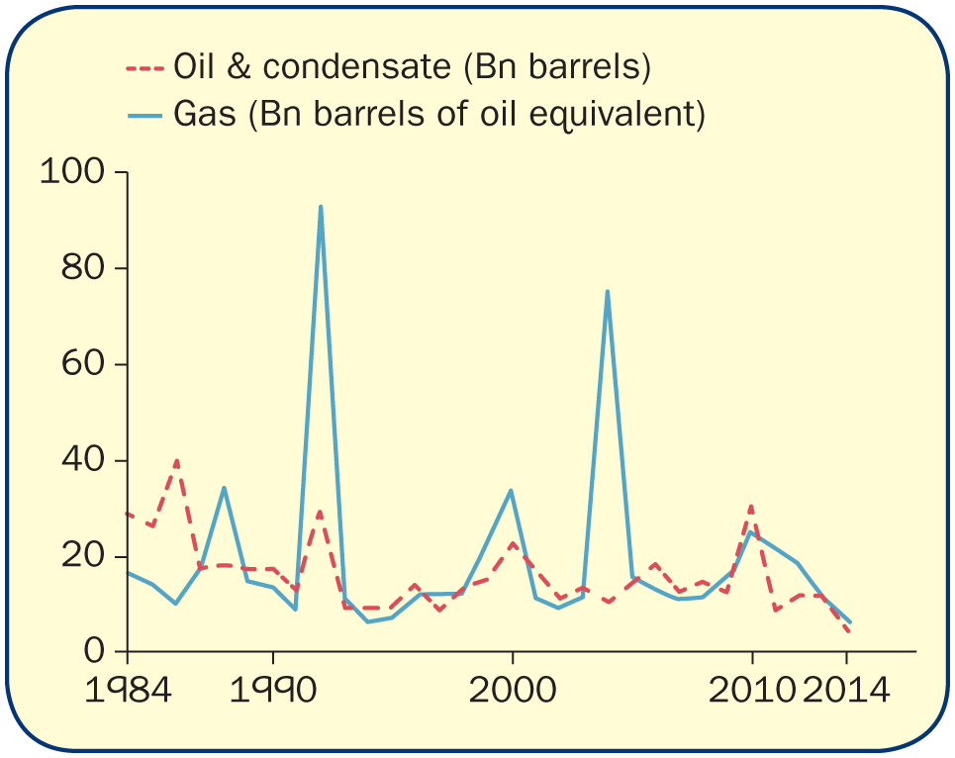
Multiple Choice Questions 1

- Which of the following correctly defines the central problem with which economics as a subject is concerned?
- Deciding what is a fair price that goods should be sold for
- How societies can live on the same income as before with fewer resources
- The problem of scarcity resulting from unlimited wants and a finite amount of resources
- How incomes can be distributed more equally
Feedback: Scarcity of resources relative to the infinite wants of society is the central problem of economics. Although economics is concerned with how prices are determined, it is not primarily about whether or not the price for any good is ‘fair’. Likewise, how income is to be distributed is not the central problem of economics. Economists are also not able to say whether or not income is fairly distributed as this is a value judgement. All households have to make individual decisions about living on the income they have, but incomes are in most cases rising and most resources are increasing over time. Economics is concerned with the decisions that society has to make given the problem of scarcity and not those of individual households.

- Which one of the following resources used in the extraction and distribution of oil and gas is limited in supply in the long run?
  - Managers
  - Oil platforms
  - Oil and gas reserves
  - Oil tankers
Feedback: At any given time, there is a certain amount of known oil and gas reserves in the world. In the long run this may increase as a result of oil exploration, but there is clearly a limit to how much remains to be discovered and how much it is profitable for companies to continue drilling for. The others can be increased – managers can be trained and recruited, oil platforms can be made and oil tankers constructed.

- The problem of the scarcity of oil can be overcome by which of the following?
  - A fall in oil prices
  - An increase in the volume of shale oil
  - A reduction in the number and size of new oil discoveries
  - Higher taxes on oil companies
Feedback: Only an increase in the volume of shale oil will resolve the problem of the scarcity of oil. If oil is scarce, oil prices need to rise not fall to reflect this. Lower oil prices will increase global demand by encouraging consumers and firms to use more oil and by making it less profitable for oil companies to undertake more oil exploration. A reduction in the number of new oil discoveries will obviously decrease supply. Higher taxes on oil companies will make it less profitable to drill for more oil. An increase in unconventional forms of oil such as shale will increase future oil supply.

- The problem of scarcity means that society must make all of the following decisions except:
  - Which of society’s material wants must be satisfied and which not?
  - How much of a society’s scarce resources should be allocated to alternative uses?
  - What is the most efficient method of producing the goods and services that consumers want?
  - All of the above
Feedback: The problem of scarcity creates a problem of choice. Given that not all wants can be met, someone somehow has to decide which ones will be met. This can be done through the market or by state planning. Having decided which wants are to be satisfied, society must decide how to allocate labour, capital and land to different alternative uses so that production can take place. Again, there is the alternative of the state or the market. Finally, producers must make choices of about how to produce these goods – e.g. whether to use a lot of labour and not much capital or vice-versa. All are decisions which society must make depending on the economic system it adopts.

- Which of the following factors best explains the collapse in world oil prices between 2014 and 2015?
  - Rising global demand
  - Political turmoil in the Middle East
  - The shale boom
  - The cut back in exploration budgets by oil companies

Feedback: Shale is an unconventional form of oil the discovery of which did much to boost production in the USA and to contribute to the fall in crude oil and gas prices. Were it not for shale, political turmoil in the Middle East might have driven up oil prices. Global demand has also been rising, but not as fast as production. This however would lead to a rise not a fall in oil prices. Likewise the cutback in exploration budgets by oil companies has been a factor leading to a fall in supply which might otherwise be expected to lead to a rise in oil prices.

