Chapter 01
Interpreting Financial Statements

True / False Questions
1. | Current liabilities are defined as liabilities with a maturity of less than a year.  True False

2. | A decline in the Net fixed assets account between year-end 2013 and year-end 2014 is a clear indication that fixed assets were sold during 2014.  True False

3. | When reporting financial performance for tax purposes, U.S. companies prefer to use accelerated depreciation methods over the straight-line method.  True False

4. | Accounting rules require U.S. companies to depreciate research and development (R&D) expenditures using the straight-line method.  True False

5. | You can construct a sources and uses statement for 2014 if you have a company's year-end balance sheets for 2014 and 2015.  True False

6. | A reduction in long-term debt is a use of cash.  True False

7. | The accrual principle requires that revenue not be recognized until payment from a sale is received.  True False

Multiple Choice Questions
8. | Which of the following statements concerning the cash flow-production cycle is true?  A. The profits reported in a given time period equal the cash flows generated.  B. A company's operations and finances are independent of each other.  C. Financial statements have nothing to do with reality.  D. The movement of cash to inventory, to accounts receivable, and back to cash is known as the firm's working capital cycle.  E. A profitable company will always have sufficient cash to meet its obligations.

9. | Which of the following statements concerning a firm's cash flows and profits is false?  A. Managers must be at least as concerned with cash flows as with profits.  B. A company that sells merchandise at a profit will generate cash soon enough to replenish cash flows required for continued production.  C. The cash flows generated in a given time period can differ from the profits reported.  D. Profits are no assurance that cash flow will be sufficient to maintain solvency.  E. Due to required cash investments in current assets, fast-growing and profitable companies can literally "grow broke".

10. | Which of the following is NOT a typical reason for differences between profits and cash flow?  A. Goodwill  B. Depreciation expense  C. Changes in accounts receivable  D. Accrual accounting practices

11. | Which one of the following is the financial statement that shows a financial snapshot, taken at a point in time, of all the assets the company owns and all the claims against those assets?  A. income statement  B. creditor's statement  C. balance sheet  D. cash flow statement  E. sources and uses statement

12. | A balance sheet reports the value of a firm's assets, liabilities, and equity:  A. over an annual period.  B. over any period of time.  C. at any point in time.  D. at the end of the year.

13. | A company sells used equipment with a book value of $100,000 for $250,000 cash. How would this transaction affect the company's balance sheet?  A. Equity rises $250,000; net plant and equipment falls $250,000.  B. Cash rises $250,000; net plant and equipment falls $100,000; equity rises $150,000.  C. Cash rises $250,000; accounts receivable falls $100,000; goodwill rises $150,000.  D. Cash rises $250,000; net plant and equipment falls $250,000.

14. | A company purchases a new $10 million building, financed half with cash and half with a bank loan. How would this transaction affect the company's balance sheet?  A. Net plant and equipment rises $10 million; cash falls $10 million; bank debt rises $5 million.  B. Net plant and equipment rises $5 million; cash falls $10 million; bank debt rises $5 million.  C. Net plant and equipment rises $5 million; cash falls $5 million; bank debt rises $5 million.  D. Net plant and equipment rises $10 million; cash falls $5 million; bank debt rises $5 million.

15. | Which one of the following is the financial statement that summarizes a firm's revenue and expenses over a period of time?  A. income statement  B. balance sheet  C. cash flow statement  D. sources and uses statement  E. market value statement

16. | The sources and uses of cash over a stated period of time are reflected on the:  A. income statement.  B. balance sheet.  C. shareholders' equity statement.  D. cash flow statement.  E. statement of operating position.

17. | Which one of the following is a source of cash?  A. increase in accounts receivable  B. decrease in notes payable  C. decrease in common stock  D. increase in inventory  E. increase in accounts payable

18. | Which one of the following is a use of cash?  A. increase in notes payable  B. increase in inventory  C. increase in long-term debt  D. decrease in accounts receivable  E. increase in common stock

19. | Which one of the following is a source of cash?  A. decrease in accounts receivable  B. decrease in common stock  C. decrease in long-term debt  D. decrease in accounts payable  E. increase in inventory

20. | Which of the following would NOT be considered a use of cash?  A. Dividends paid  B. A decrease in accounts payable  C. Depreciation  D. An increase in the cash and marketable securities account

21. | Which one of the following is the financial statement that summarizes changes in the company's cash balance over a period of time?  A. income statement  B. balance sheet  C. cash flow statement  D. shareholders' equity statement  E. market value statement

22. | Which of the following is NOT a major category on the cash flow statement?  A. Cash flows from selling activities  B. Cash flows from operating activities  C. Cash flows from financing activities  D. Cash flows from investing activities

23. | The book value of a firm is:  A. equivalent to the firm's market value provided that the firm has some fixed assets.  B. based on historical cost.  C. generally greater than the market value when fixed assets are included.  D. more of a financial than an accounting valuation.  E. adjusted to the market value whenever the market value exceeds the stated book value.

24. | Which of the following is a reason why a company's market value of equity differs from its book value of equity?  A. Shareholders are keenly aware of book values, but have little interest in market values.  B. Accountants' charges for the cost of equity are often higher than they should be.  C. Fair value accounting is becoming more widely used.  D. Values of assets on the balance sheet typically reflect historical cost, adjusted for appropriate depreciation.

25. | Depreciation expense:  A. reduces both taxes and net income.  B. increases net fixed assets as shown on the balance sheet.  C. is a noncash item that increases net income.  D. decreases current assets, net income, and operating cash flows.

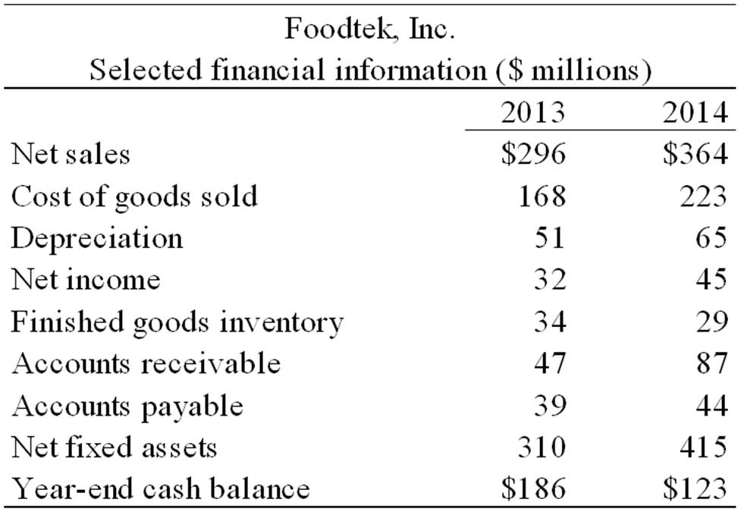

26. | Please refer to the financial information for Foodtek, Inc. above. During 2014, how much cash (in $ millions) did Foodtek collect from sales?  A. 364  B. 277  C. 404  D. 324  E. 451  F. None of the above.

27. | Please refer to the financial information for Foodtek, Inc. above. During 2014, what was the cost of merchandise (in $ millions) produced by Foodtek?  A. 223  B. 194  C. 252  D. 228  E. 218  F. None of the above.

28. | Please refer to the financial information for Foodtek, Inc. above. Assuming the company neither sold nor salvaged any assets during the year, what were Foodtek's capital expenditures (in $ millions) during 2014?  A. 415  B. 105  C. 310  D. 40  E. 170  F. None of the above.

29. | Please refer to the financial information for Foodtek, Inc. above. Assuming that there were no financing cash flows during 2014 and basing your answer solely on the information provided, what were Foodtek's cash flows from operations (in $ millions) for 2014?  A. 45  B. 110  C. 70  D. 80  E. 35  F. None of the above.

30. | Suppose an acquiring firm pays $100 million for a target firm and the target's assets have a book value of $70 million and an estimated replacement value of $80 million. What amount would be allocated to the acquiring firm's goodwill account?  A. $0 million  B. $20 million  C. $30 million  D. $70 million  E. $80 million  F. None of the above.

31. | JM Case Inc. has a market value of $5 million with 500,000 shares outstanding. The book value of its equity is $1,750,000. What is JM Case's price per share?  A. $3.50  B. $5  C. $10  D. $25  E. $50  F. None of the above.

32. | JM Case Inc. has a market value of $5 million with 500,000 shares outstanding. The book value of its equity is $1,750,000. What is JM Case's book value per share?  A. $3.50  B. $5  C. $10  D. $25  E. $50  F. None of the above.

33. | JM Case Inc. has a market value of $5 million with 500,000 shares outstanding. The book value of its equity is $1,750,000. If the company repurchases 20 percent of its shares in the stock market, what will be the book value of equity if all else remains the same?  A. $750,000  B. $1,250,000  C. $1,000,000  D. $1,400,000  E. $4,000,000  F. None of the above.

34. | JM Case Inc. has a market value of $5 million with 500,000 shares outstanding. The book value of its equity is $1,750,000. If the company repurchases 20 percent of its shares in the stock market and there are no taxes or transactions costs and all else remains the same, what should the market value of the firm be after the repurchase?  A. $1,000,000  B. $1,750,000  C. $3,250,000  D. $4,000,000  E. $5,000,000  F. None of the above.

35. | ZZZ Corporation's income statement shows a provision for income taxes of $65 million in 2014. At the end of 2013, ZZZ's balance sheet reported income taxes payable of $12 million and deferred taxes of $18 million. At the end of 2014 their balance sheet shows income taxes payable of $15 million and deferred taxes of $17 million. What were ZZZ's taxes paid in 2014?  A. $61 million  B. $63 million  C. $65 million  D. $67 million  E. $69 million

Short Answer Questions
36. | The book value of Little Statistic's total assets is $400,000. Suppose Number Crunching Inc. acquires Little Statistic's assets for $1 million and finances the purchase by selling $600,000 in new stock, $300,000 in new debt, and reducing cash by $100,000. Describe how the acquisition affects Number Crunching's balance sheet.

37. | Playdough Products earned net income of $500,000 in 2011. The firm increased its accounts receivable during the year by $220,000. The book value of its assets declined by the year's depreciation charge, which was $140,000, and the market value of its assets increased by $50,000. Based only on this information, how much cash did Playdough Products generate during the year? Please ignore taxes for this problem.

38. | During 2011, Lele Design earned net income of $250,000. The firm neither bought nor sold any capital assets. The book value of its assets declined by the year's depreciation charge of $200,000. The firm's operating cash flow for the year was $450,000. The market value of its assets increased by $300,000. Based only on this information, what was Lele Design's economic income for the year? Why is this figure different from its accounting income? Please ignore taxes for this problem.

39. | Identify the sources and uses of cash for Blackhurst Corporation for 2014 based on the following year-end balance sheets.  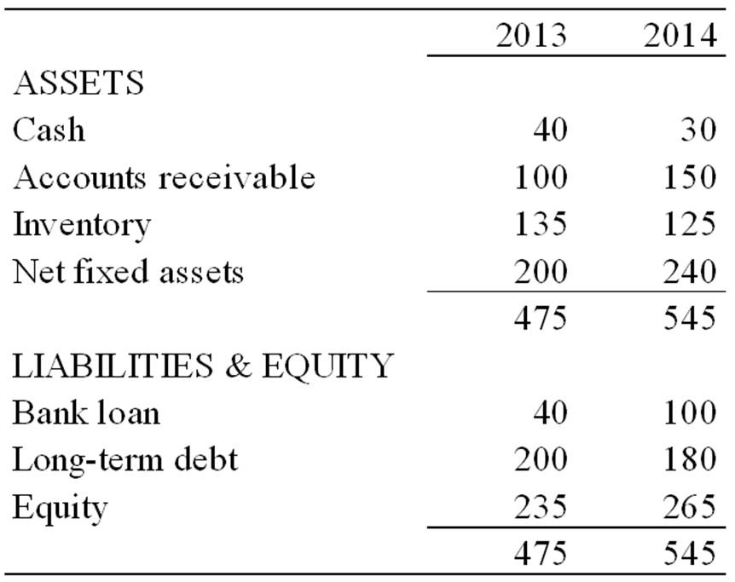

Chapter 01 Interpreting Financial Statements Answer Key
True / False Questions
1. | Current liabilities are defined as liabilities with a maturity of less than a year.  TRUE

Accessibility: Keyboard Navigation
Difficulty: 1 Easy

2. | A decline in the Net fixed assets account between year-end 2013 and year-end 2014 is a clear indication that fixed assets were sold during 2014.  FALSE

Accessibility: Keyboard Navigation
Difficulty: 2 Medium

3. | When reporting financial performance for tax purposes, U.S. companies prefer to use accelerated depreciation methods over the straight-line method.  TRUE

Accessibility: Keyboard Navigation
Difficulty: 2 Medium

4. | Accounting rules require U.S. companies to depreciate research and development (R&D) expenditures using the straight-line method.  FALSE

Accessibility: Keyboard Navigation
Difficulty: 1 Easy

5. | You can construct a sources and uses statement for 2014 if you have a company's year-end balance sheets for 2014 and 2015.  FALSE

Accessibility: Keyboard Navigation
Difficulty: 1 Easy

6. | A reduction in long-term debt is a use of cash.  TRUE

Accessibility: Keyboard Navigation
Difficulty: 1 Easy

7. | The accrual principle requires that revenue not be recognized until payment from a sale is received.  FALSE

Accessibility: Keyboard Navigation
Difficulty: 1 Easy

Multiple Choice Questions
8. | Which of the following statements concerning the cash flow-production cycle is true?  A. The profits reported in a given time period equal the cash flows generated.  B. A company's operations and finances are independent of each other.  C. Financial statements have nothing to do with reality.  D. The movement of cash to inventory, to accounts receivable, and back to cash is known as the firm's working capital cycle.  E. A profitable company will always have sufficient cash to meet its obligations.

Accessibility: Keyboard Navigation
Difficulty: 2 Medium

9. | Which of the following statements concerning a firm's cash flows and profits is false?  A. Managers must be at least as concerned with cash flows as with profits.  B. A company that sells merchandise at a profit will generate cash soon enough to replenish cash flows required for continued production.  C. The cash flows generated in a given time period can differ from the profits reported.  D. Profits are no assurance that cash flow will be sufficient to maintain solvency.  E. Due to required cash investments in current assets, fast-growing and profitable companies can literally "grow broke".

Accessibility: Keyboard Navigation
Difficulty: 2 Medium

10. | Which of the following is NOT a typical reason for differences between profits and cash flow?  A. Goodwill  B. Depreciation expense  C. Changes in accounts receivable  D. Accrual accounting practices

Accessibility: Keyboard Navigation
Difficulty: 2 Medium

11. | Which one of the following is the financial statement that shows a financial snapshot, taken at a point in time, of all the assets the company owns and all the claims against those assets?  A. income statement  B. creditor's statement  C. balance sheet  D. cash flow statement  E. sources and uses statement

Accessibility: Keyboard Navigation
Difficulty: 1 Easy

12. | A balance sheet reports the value of a firm's assets, liabilities, and equity:  A. over an annual period.  B. over any period of time.  C. at any point in time.  D. at the end of the year.

Accessibility: Keyboard Navigation
Difficulty: 1 Easy

13. | A company sells used equipment with a book value of $100,000 for $250,000 cash. How would this transaction affect the company's balance sheet?  A. Equity rises $250,000; net plant and equipment falls $250,000.  B. Cash rises $250,000; net plant and equipment falls $100,000; equity rises $150,000.  C. Cash rises $250,000; accounts receivable falls $100,000; goodwill rises $150,000.  D. Cash rises $250,000; net plant and equipment falls $250,000.

Accessibility: Keyboard Navigation
Difficulty: 2 Medium

14. | A company purchases a new $10 million building, financed half with cash and half with a bank loan. How would this transaction affect the company's balance sheet?  A. Net plant and equipment rises $10 million; cash falls $10 million; bank debt rises $5 million.  B. Net plant and equipment rises $5 million; cash falls $10 million; bank debt rises $5 million.  C. Net plant and equipment rises $5 million; cash falls $5 million; bank debt rises $5 million.  D. Net plant and equipment rises $10 million; cash falls $5 million; bank debt rises $5 million.

Accessibility: Keyboard Navigation
Difficulty: 2 Medium

15. | Which one of the following is the financial statement that summarizes a firm's revenue and expenses over a period of time?  A. income statement  B. balance sheet  C. cash flow statement  D. sources and uses statement  E. market value statement

Accessibility: Keyboard Navigation
Difficulty: 1 Easy

16. | The sources and uses of cash over a stated period of time are reflected on the:  A. income statement.  B. balance sheet.  C. shareholders' equity statement.  D. cash flow statement.  E. statement of operating position.

Accessibility: Keyboard Navigation
Difficulty: 1 Easy

17. | Which one of the following is a source of cash?  A. increase in accounts receivable  B. decrease in notes payable  C. decrease in common stock  D. increase in inventory  E. increase in accounts payable

Accessibility: Keyboard Navigation
Difficulty: 1 Easy

18. | Which one of the following is a use of cash?  A. increase in notes payable  B. increase in inventory  C. increase in long-term debt  D. decrease in accounts receivable  E. increase in common stock

Accessibility: Keyboard Navigation
Difficulty: 1 Easy

19. | Which one of the following is a source of cash?  A. decrease in accounts receivable  B. decrease in common stock  C. decrease in long-term debt  D. decrease in accounts payable  E. increase in inventory

Accessibility: Keyboard Navigation
Difficulty: 1 Easy

20. | Which of the following would NOT be considered a use of cash?  A. Dividends paid  B. A decrease in accounts payable  C. Depreciation  D. An increase in the cash and marketable securities account

Accessibility: Keyboard Navigation
Difficulty: 2 Medium

21. | Which one of the following is the financial statement that summarizes changes in the company's cash balance over a period of time?  A. income statement  B. balance sheet  C. cash flow statement  D. shareholders' equity statement  E. market value statement

Accessibility: Keyboard Navigation
Difficulty: 1 Easy

22. | Which of the following is NOT a major category on the cash flow statement?  A. Cash flows from selling activities  B. Cash flows from operating activities  C. Cash flows from financing activities  D. Cash flows from investing activities

Accessibility: Keyboard Navigation
Difficulty: 1 Easy

23. | The book value of a firm is:  A. equivalent to the firm's market value provided that the firm has some fixed assets.  B. based on historical cost.  C. generally greater than the market value when fixed assets are included.  D. more of a financial than an accounting valuation.  E. adjusted to the market value whenever the market value exceeds the stated book value.

Accessibility: Keyboard Navigation
Difficulty: 1 Easy

24. | Which of the following is a reason why a company's market value of equity differs from its book value of equity?  A. Shareholders are keenly aware of book values, but have little interest in market values.  B. Accountants' charges for the cost of equity are often higher than they should be.  C. Fair value accounting is becoming more widely used.  D. Values of assets on the balance sheet typically reflect historical cost, adjusted for appropriate depreciation.

Accessibility: Keyboard Navigation
Difficulty: 1 Easy

25. | Depreciation expense:  A. reduces both taxes and net income.  B. increases net fixed assets as shown on the balance sheet.  C. is a noncash item that increases net income.  D. decreases current assets, net income, and operating cash flows.

Accessibility: Keyboard Navigation
Difficulty: 1 Easy

26. | Please refer to the financial information for Foodtek, Inc. above. During 2014, how much cash (in $ millions) did Foodtek collect from sales?  A. 364  B. 277  C. 404  D. 324  E. 451  F. None of the above.  In 2014, sales were $364 million, but account receivable rose $40 million, indicating that the company only received $324 million in cash. (This ignores possible changes in bad debt reserves.) Letting bop stand for beginning of period, and eop for end of period, the equation is (where AR = accounts receivable)  AR_{eop} = AR_{bop} + Sales - Collections  Collections = Sales - Change in AR  $324 = $364 - $40

Difficulty: 2 Medium

27. | Please refer to the financial information for Foodtek, Inc. above. During 2014, what was the cost of merchandise (in $ millions) produced by Foodtek?  A. 223  B. 194  C. 252  D. 228  E. 218  F. None of the above.  During 2014, the company sold $223 million of merchandise at cost, but finished goods inventory fell $5 million, indicating that the company only produced $218 million of merchandise. Letting bop stand for beginning of period, and eop for end of period, the equation is  Inventory_{eop} = Inventory_{bop} + Production - Cost of sales  Production = Cost of sales + Change in Inventory  $218 = $223 - $5

Difficulty: 2 Medium

28. | Please refer to the financial information for Foodtek, Inc. above. Assuming the company neither sold nor salvaged any assets during the year, what were Foodtek's capital expenditures (in $ millions) during 2014?  A. 415  B. 105  C. 310  D. 40  E. 170  F. None of the above.  Net fixed assets rose $105 million, depreciation reduced net fixed assets by $65 million, so capital expenditures must have been $170 million (ignoring asset sales or write-offs). Letting bop stand for beginning of period, and eop for end of period, the equation is  Net fixed assets_{eop} = Net fixed assets_{bop} + Capital Expenditures + Depreciation  Capital Expenditures = Change in net fixed assets + Depreciation  $170 = $105 + $65

Difficulty: 2 Medium

29. | Please refer to the financial information for Foodtek, Inc. above. Assuming that there were no financing cash flows during 2014 and basing your answer solely on the information provided, what were Foodtek's cash flows from operations (in $ millions) for 2014?  A. 45  B. 110  C. 70  D. 80  E. 35  F. None of the above.  Cash flow from operations can be calculated directly from items in the table. Start with net income, remove any noncash items (such as depreciation), and add any cash transactions that are not captured by the income statement (such as changes to working capital accounts).  CF from operations = Net income - increase in acct. receivable - increase in inventory + increase in acct. payable + depreciation  CF from operations = 45 - 40 + 5 + 5 + 65 = $80 million

Difficulty: 3 Hard

30. | Suppose an acquiring firm pays $100 million for a target firm and the target's assets have a book value of $70 million and an estimated replacement value of $80 million. What amount would be allocated to the acquiring firm's goodwill account?  A. $0 million  B. $20 million  C. $30 million  D. $70 million  E. $80 million  F. None of the above.

Accessibility: Keyboard Navigation
Difficulty: 1 Easy

31. | JM Case Inc. has a market value of $5 million with 500,000 shares outstanding. The book value of its equity is $1,750,000. What is JM Case's price per share?  A. $3.50  B. $5  C. $10  D. $25  E. $50  F. None of the above.  Stock price per share = $5 million/500,000 shares = $10 per share

Accessibility: Keyboard Navigation
Difficulty: 1 Easy

32. | JM Case Inc. has a market value of $5 million with 500,000 shares outstanding. The book value of its equity is $1,750,000. What is JM Case's book value per share?  A. $3.50  B. $5  C. $10  D. $25  E. $50  F. None of the above.  Book value per share = $1,750,000/500,000 shares = $3.50 per share

Accessibility: Keyboard Navigation
Difficulty: 1 Easy

33. | JM Case Inc. has a market value of $5 million with 500,000 shares outstanding. The book value of its equity is $1,750,000. If the company repurchases 20 percent of its shares in the stock market, what will be the book value of equity if all else remains the same?  A. $750,000  B. $1,250,000  C. $1,000,000  D. $1,400,000  E. $4,000,000  F. None of the above.  JM Case will pay $10 per share for the 100,000 shares (= 0.20 × 500,000) it repurchases. This reduces the book value by $1 million. Assuming all else remains the same, the new book value should be $750,000.

Accessibility: Keyboard Navigation
Difficulty: 2 Medium

34. | JM Case Inc. has a market value of $5 million with 500,000 shares outstanding. The book value of its equity is $1,750,000. If the company repurchases 20 percent of its shares in the stock market and there are no taxes or transactions costs and all else remains the same, what should the market value of the firm be after the repurchase?  A. $1,000,000  B. $1,750,000  C. $3,250,000  D. $4,000,000  E. $5,000,000  F. None of the above.  Since nothing else has changed, the market value should fall by exactly the amount of the cash paid in the transaction. The new market value will be $4 million. Another way to think about this is to note that repurchase of the shares will reduce cash by $1 million (or increase liabilities by the same amount if financed with debt), and thus the firm is worth $1 million less to the owners after the repurchase, or $4 million. After repurchasing 100,000 shares (= 0.20 × 500,000), 400,000 shares will be outstanding, and the price per share remains $10 ($4 million/400,000).

Accessibility: Keyboard Navigation
Difficulty: 2 Medium

35. | ZZZ Corporation's income statement shows a provision for income taxes of $65 million in 2014. At the end of 2013, ZZZ's balance sheet reported income taxes payable of $12 million and deferred taxes of $18 million. At the end of 2014 their balance sheet shows income taxes payable of $15 million and deferred taxes of $17 million. What were ZZZ's taxes paid in 2014?  A. $61 million  B. $63 million  C. $65 million  D. $67 million  E. $69 million  Taxes paid = Provision for income taxes - Increase in taxes payable - Increase in deferred taxes = 65 - 3 + 1 = $63 million

Accessibility: Keyboard Navigation
Difficulty: 2 Medium

Short Answer Questions
36. | The book value of Little Statistic's total assets is $400,000. Suppose Number Crunching Inc. acquires Little Statistic's assets for $1 million and finances the purchase by selling $600,000 in new stock, $300,000 in new debt, and reducing cash by $100,000. Describe how the acquisition affects Number Crunching's balance sheet.  First, let us account for Number Crunching's $1 million expenditure. Cash will fall $100,000, liabilities will rise $300,000, and owners' equity will rise $600,000. Next, let us account for the assets acquired. The accountants will write up the value of fixed assets and possibly inventory to their estimated replacement value; they will then add the difference between the acquisition price and the replacement value of the assets acquired to a goodwill account appearing in the long-term assets section of Number Crunching's balance sheet; and lastly, they will consolidate the two companies' balance sheets by adding like accounts together.

Difficulty: 2 Medium

37. | Playdough Products earned net income of $500,000 in 2011. The firm increased its accounts receivable during the year by $220,000. The book value of its assets declined by the year's depreciation charge, which was $140,000, and the market value of its assets increased by $50,000. Based only on this information, how much cash did Playdough Products generate during the year? Please ignore taxes for this problem.  Playdough Products generated $420,000 of cash during the year. The $500,000 net income ignores the fact that accounts receivable rose $220,000, a use of cash. It also treats $140,000 depreciation as an expense, whereas it is a noncash charge. The $50,000 increase in market value of assets adds to the value of the business, but is not a cash flow. Summary:  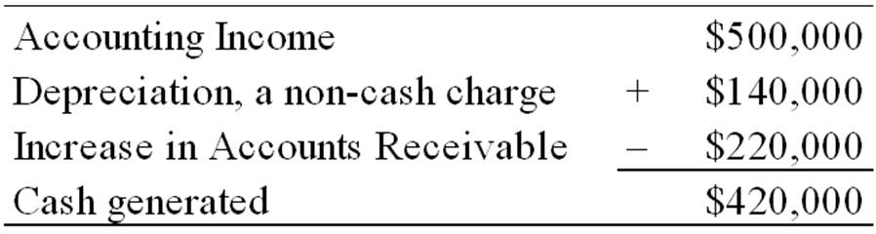

Difficulty: 2 Medium

38. | During 2011, Lele Design earned net income of $250,000. The firm neither bought nor sold any capital assets. The book value of its assets declined by the year's depreciation charge of $200,000. The firm's operating cash flow for the year was $450,000. The market value of its assets increased by $300,000. Based only on this information, what was Lele Design's economic income for the year? Why is this figure different from its accounting income? Please ignore taxes for this problem.  Lele Design generated economic income equal to $750,000, comprised of $450,000 in operating cash flow ($250,000 net income plus $200,000 depreciation) plus a $300,000 increase in the market value of its assets. The $500,000 difference between economic income and accounting income consists of the $200,000 noncash charge of depreciation, and the $300,000 appreciation in the market value of assets, which accounting income does not include.

Difficulty: 2 Medium

39. | Identify the sources and uses of cash for Blackhurst Corporation for 2014 based on the following year-end balance sheets.  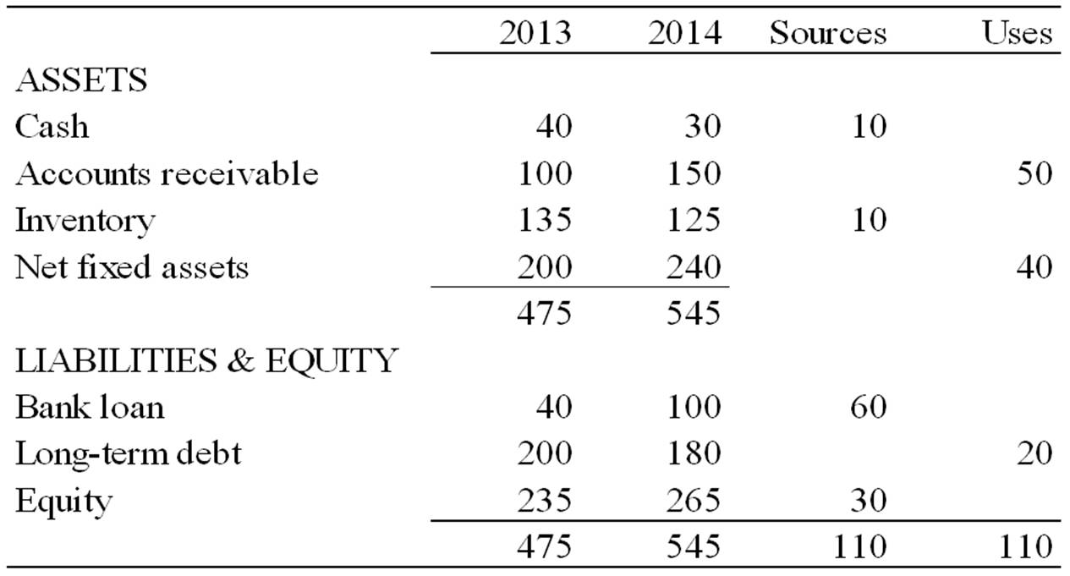

Difficulty: 2 Medium

