Human Anatomy & Physiology, (Amerman)
Chapter 1 Introduction to Anatomy and Physiology

1) Which learner thrives in an environment with a practical-based laboratory or hands-on activities?
A) visual/verbal
B) tactile/kinesthetic
C) visual/nonverbal
D) auditory/verbal
Answer: B
Bloom's Taxonomy: 1) Knowledge
Learning Outcome: 1.1.1

2) Sierra says she learns more from reading the textbook for class than from sitting in lecture. She must be a(n):
A) visual/verbal learner.
B) tactile/kinesthetic learner.
C) visual/nonverbal learner.
D) auditory/verbal learner.
Answer: A
Bloom's Taxonomy: 2) Comprehension
Learning Outcome: 1.1.1

3) Jesse felt comfortable using the microscope after listening to directions from his lab professor. His learning style preference must be:
A) visual/verbal learner.
B) tactile/kinesthetic learner.
C) visual/nonverbal learner.
D) auditory/verbal learner.
Answer: D
Bloom's Taxonomy: 2) Comprehension
Learning Outcome: 1.1.1

4) What does the SQ3R method stand for?
A) search, quiet, research, read, and remember
B) share, quiz, query, question, and read
C) survey, question, read, recite, and review
D) sort, query, read, recite, and review
Answer: C
Bloom's Taxonomy: 1) Knowledge
Learning Outcome: 1.1.1

5) Why should a student use the SQ3R method?
A) The SQ3R method provides a student with a strategy for improving test taking skills.
B) The SQ3R method provides a plan for a student to improve textbook reading skills.
C) The SQ3R method provides a student with a strategy for taking notes during lecture class.
D) The SQ3R method provides a student with ways to improve time management skills.
Answer: B
Bloom's Taxonomy: 1) Knowledge
Learning Outcome: 1.1.1
6) What is a good way to manage time in preparation for your anatomy and physiology class?
A) I should delay studying until the day or two before the test to best remember the material.
B) I should stay up all night the night before the test to maximize what is stored in short-term memory.
C) I study only on the weekends when I have many hours of free time.
D) I make a schedule and budget my time.
Answer: D
Bloom's Taxonomy: 1) Knowledge
Learning Outcome: 1.1.1

7) What type of learner performs best with study groups?
A) tactile/kinesthetic learner
B) visual/verbal learner
C) visual/nonverbal learner
D) any type of visual learner
Answer: A
Bloom's Taxonomy: 1) Knowledge
Learning Outcome: 1.1.1

8) What is a good strategy for class or laboratory preparation?
A) Read and prepare notes before attending your class or laboratory.
B) Avoid reading before class as you may get confused.
C) Only read after you have attended class or laboratory.
D) Focus on reading your materials on the weekends when you have hours to spend.
Answer: A
Bloom's Taxonomy: 1) Knowledge
Learning Outcome: 1.1.2

9) How could you use the Learning Outcomes in this book to help you study?
A) Rewrite each Learning Outcome in your notes.
B) Recite the Learning Outcomes until you have them memorized.
C) Read through the Learning Outcomes after you have completed a section.
D) Write down the answers to the Learning Outcomes.
Answer: D
Bloom's Taxonomy: 2) Comprehension
Learning Outcome: 1.1.3

10) What characteristic of life involves the removal of waste products that result from metabolic processes?
A) growth
B) reproduction
C) excretion
D) irritability
Answer: C
Bloom's Taxonomy: 1) Knowledge
Learning Outcome: 1.2.1
11) What is the smallest level of structural organization in the human body?
A) organ level
B) chemical level
C) tissue level
D) cellular level
Answer: B
Bloom's Taxonomy: 2) Comprehension
Learning Outcome: 1.2.2

12) Which of the following is the most complex structural level of organization?
A) cellular level
B) tissue level
C) organ level
D) chemical level
Answer: C
Bloom's Taxonomy: 2) Comprehension
Learning Outcome: 1.2.2

13) Which of the following is the correct sequence, from simplest to most complex, in the levels of structural organization of the human body?
A) chemical level, cellular level, tissue level, organ level, organ system level, organismal level
B) chemical level, tissue level, cellular level, organ system level, organ level, organismal level
C) cellular level, chemical level, tissue level, organ level, organ system level, organismal level
D) cellular level, tissue level, chemical level, organ level, organ system level, organismal level
Answer: A
Bloom's Taxonomy: 2) Comprehension
Learning Outcome: 1.2.2

14) In laboratory, you will study the overall structure and shape of the femur bone without the aid of a microscope. This is a study known as:
A) regional anatomy.
B) microscopic anatomy.
C) systemic anatomy.
D) gross anatomy.
Answer: D
Bloom's Taxonomy: 1) Knowledge
Learning Outcome: 1.2.3

15) In laboratory, you will study tissues. This area of study is known as:
A) gross anatomy.
B) physiology.
C) histology.
D) cytology.
Answer: C
Bloom's Taxonomy: 1) Knowledge
Learning Outcome: 1.2.3
16) Which organ system produces movement and generates heat?
A) muscular system
B) endocrine system
C) skeletal system
D) digestive system
Answer: A
Bloom's Taxonomy: 1) Knowledge
Learning Outcome: 1.2.5

17) Which organ system includes blood vessels and the heart?
A) cardiovascular system
B) endocrine system
C) respiratory system
D) lymphatic system
Answer: A
Bloom's Taxonomy: 1) Knowledge
Learning Outcome: 1.2.4

18) Which two organ systems include the pancreas as a component?
A) digestive and urinary systems
B) endocrine and lymphatic systems
C) digestive and endocrine systems
D) respiratory and cardiovascular systems
Answer: C
Bloom's Taxonomy: 1) Knowledge
Learning Outcome: 1.2.4

19) What is a major function of the respiratory system?
A) return excess tissue fluid to the cardiovascular system
B) deliver oxygen to the blood and remove carbon dioxide from the body
C) produce vitamin D and retain water
D) digest food and absorb nutrients into the blood
Answer: B
Bloom's Taxonomy: 1) Knowledge
Learning Outcome: 1.2.5

20) When we imagine a person exhibiting anatomical position, the palms of the hands are assumed to be facing:
A) forward.
B) backward.
C) to the side.
D) down.
Answer: A
Bloom's Taxonomy: 1) Knowledge
Learning Outcome: 1.3.1
21) A person who is standing facing forward with hands at the sides, palms facing forward, is in the:
A) supine position.
B) anatomical position.
C) frontal position.
D) sagittal position.
Answer: B
Bloom's Taxonomy: 1) Knowledge
Learning Outcome: 1.3.1

22) A person in anatomical position is visualized to be:
A) laying down on his or her back.
B) standing upright.
C) sitting down.
D) laying down on the stomach.
Answer: B
Bloom's Taxonomy: 1) Knowledge
Learning Outcome: 1.3.1

23) Which directional term indicates the front side of the body?
A) medial
B) anterior (ventral)
C) posterior (dorsal)
D) superior (cranial)
Answer: B
Bloom's Taxonomy: 1) Knowledge
Learning Outcome: 1.3.2

24) A directional term that means the same as posterior is:
A) dorsal.
B) anterior.
C) ventral.
D) sagittal.
Answer: A
Bloom's Taxonomy: 1) Knowledge
Learning Outcome: 1.5.2

25) What best describes the directional term proximal?
A) toward the head
B) toward the front
C) closer to the point of origin
D) closer to the midline of the body
Answer: C
Bloom's Taxonomy: 1) Knowledge
Learning Outcome: 1.3.2
26) Select the appropriate directional term to complete this sentence: The mouth is ________ to the nose.
A) posterior (dorsal)
B) inferior (caudal)
C) superior (cranial)
D) distal
Answer: B
Bloom's Taxonomy: 1) Knowledge
Learning Outcome: 1.3.3

27) Select the appropriate directional term to complete this sentence: The elbow is ________ to the wrist.
A) inferior (caudal)
B) proximal
C) distal
D) superficial
Answer: B
Bloom's Taxonomy: 1) Knowledge
Learning Outcome: 1.3.3

28) In anatomical position, the palms are on the:
A) anterior (ventral) surface.
B) posterior (dorsal) surface.
C) lateral surface.
D) superior (cranial) surface.
Answer: A
Bloom's Taxonomy: 1) Knowledge
Learning Outcome: 1.3.3

29) The shoulder is also known as the:
A) acromial region.
B) digital region.
C) antebrachial region.
D) brachial region.
Answer: A
Bloom's Taxonomy: 1) Knowledge
Learning Outcome: 1.3.4

30) On which body surface is the sural region?
A) anterior (ventral)
B) posterior (dorsal)
C) superficial
D) medial
Answer: B
Bloom's Taxonomy: 1) Knowledge
Learning Outcome: 1.3.3, 1.3.4
31) The vertebral region is superior to the:
A) sacral region.
B) cervical region.
C) occipital region.
D) cephalic region.
Answer: A
Bloom's Taxonomy: 2) Comprehension
Learning Outcome: 1.3.3, 1.3.4

32) The hand is also known as the:
A) plantar region.
B) pedal region.
C) manual region.
D) acromial region.
Answer: C
Bloom's Taxonomy: 1) Knowledge
Learning Outcome: 1.3.4

33) A plane that divides the body into superior and inferior parts is known as a:
A) sagittal plane.
B) midsagittal (median) plane.
C) transverse (horizontal) plane.
D) frontal (coronal) plane.
Answer: C
Bloom's Taxonomy: 1) Knowledge
Learning Outcome: 1.3.6

34) Dr. Mitchell performs open heart surgery. The incision he makes through the sternal region of his patient divides the thoracic cavity into equal left and right parts. This incision must be made along a:
A) sagittal plane.
B) midsagittal (median) plane.
C) transverse (horizontal) plane.
D) frontal (coronal) plane.
Answer: B
Bloom's Taxonomy: 2) Comprehension
Learning Outcome: 1.3.6

35) What are the two subcavities of the dorsal body cavity?
A) cranial and vertebral (spinal) cavities
B) thoracic and abdominopelvic cavities
C) abdominal and pelvic cavities
D) pleural and pericardial cavities
Answer: A
Bloom's Taxonomy: 1) Knowledge
Learning Outcome: 1.4.1
36) What major organs are housed in the thoracic cavity?
A) lungs, heart, esophagus, trachea
B) stomach, intestines, liver, pancreas
C) urinary bladder, reproductive organs
D) brain and spinal cord
Answer: A
Bloom's Taxonomy: 1) Knowledge
Learning Outcome: 1.4.1

37) What separates the thoracic cavity from the abdominopelvic cavity?
A) pericardium
B) pleura
C) diaphragm
D) mediastinum
Answer: C
Bloom's Taxonomy: 1) Knowledge
Learning Outcome: 1.4.1

38) The thoracic cavity is situated superior to the abdominopelvic cavity and separated by the diaphragm. Therefore, the diaphragm creates a:
A) transverse (horizontal) plane or cross section.
B) midsagittal (median) plane.
C) parasagittal plane.
D) frontal (coronal) plane.
Answer: A
Bloom's Taxonomy: 2) Comprehension
Learning Outcome: 1.4.1, 1.3.3

39) What smaller cavity within the thoracic cavity houses the heart, great blood vessels, esophagus, and trachea?
A) mediastinum
B) diaphragm
C) peritoneal cavity
D) abdominal cavity
Answer: A
Bloom's Taxonomy: 1) Knowledge
Learning Outcome: 1.4.1

40) Which regions of the abdominopelvic cavity are situated medially?
A) right and left hypochondriac regions, and the epigastric region
B) right hypochondriac, right lumbar, and right iliac (inguinal) regions
C) right and left lumbar regions and the umbilical region
D) epigastric, umbilical, hypogastric regions
Answer: D
Bloom's Taxonomy: 2) Comprehension
Learning Outcome: 1.4.2
41) Select the letter that represents the left iliac (inguinal) region.
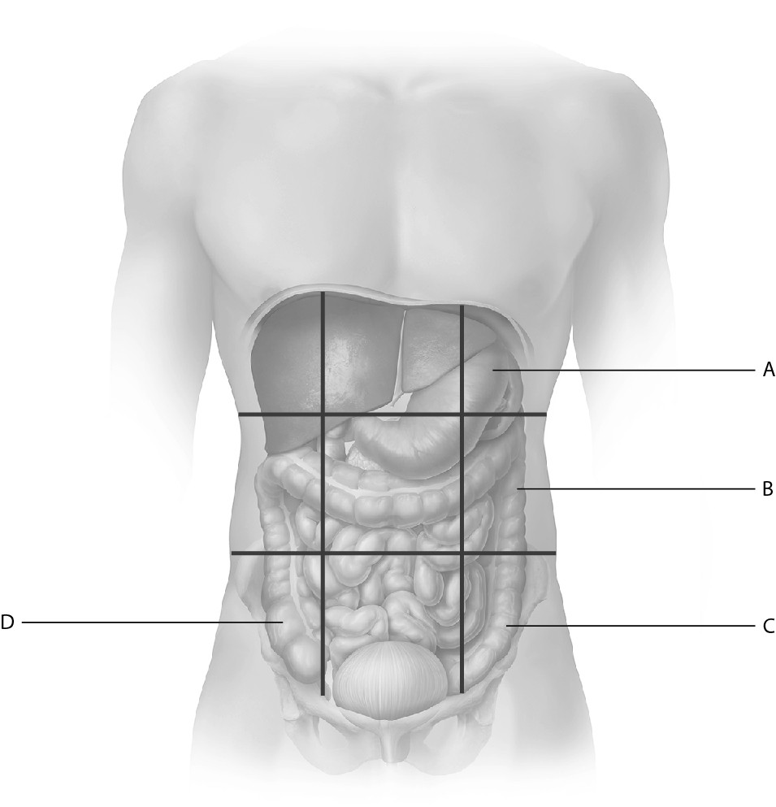
A) A
B) B
C) C
D) D
Answer: C
Bloom's Taxonomy: 1) Knowledge
Learning Outcome: 1.4.2

42) Which region of the abdominopelvic cavity lies between the right and left lumbar regions?
A) hypogastric region
B) right lumbar region
C) epigastric region
D) umbilical region
Answer: D
Bloom's Taxonomy: 1) Knowledge
Learning Outcome: 1.4.2

43) Serous membranes line certain cavities within the:
A) ventral cavities.
B) cranial cavity.
C) dorsal cavities.
D) vertebral (spinal) cavity.
Answer: A
Bloom's Taxonomy: 1) Knowledge
Learning Outcome: 1.4.3
44) The innermost serous membrane attached to the heart muscle is called the:
A) visceral peritoneum.
B) visceral pleura.
C) visceral pericardium.
D) parietal pericardium.
Answer: C
Bloom's Taxonomy: 1) Knowledge
Learning Outcome: 1.4.3

45) What would a needle travel through as it enters the right lung?
A) parietal pleura, serous fluid, visceral pleura, right lung
B) parietal pleura, serous fluid, right lung, visceral pleura
C) visceral pleura, serous fluid, parietal pleura, right lung
D) visceral pericardium, serous fluid, parietal pericardium, right lung
Answer: A
Bloom's Taxonomy: 3) Analysis
Learning Outcome: 1.4.3

46) Which serous membrane covers the abdominal organs?
A) pleura
B) mediastinum
C) peritoneum
D) pericardium
Answer: C
Bloom's Taxonomy: 1) Knowledge
Learning Outcome: 1.4.3

47) The maintenance of a relatively constant internal environment is termed:
A) homeostasis.
B) integration.
C) effector control.
D) positive feedback.
Answer: A
Bloom's Taxonomy: 1) Knowledge
Learning Outcome: 1.5.1

48) What part of a feedback loop causes physiological responses to return the variable to the normal homeostatic range?
A) receptor (sensor)
B) stimulus
C) effector
D) control center
Answer: C
Bloom's Taxonomy: 1) Knowledge
Learning Outcome: 1.5.2
49) A cell or organ that responds to the directions of the control center in a negative feedback loop is termed a(n):
A) stimulus.
B) effector.
C) receptor.
D) regulator.
Answer: B
Bloom's Taxonomy: 1) Knowledge
Learning Outcome: 1.5.2

50) When you go outside on a hot summer day, your body temperature heats up above the normal range. Receptors in your brain detect the change in body temperature. The brain activates nerve cells that send messages to sweat glands, causing the body temperature to fall as the sweat evaporates from the skin. What part of this feedback loop is the stimulus?
A) increased body temperature
B) brain
C) nerve cells
D) sweat glands
Answer: A
Bloom's Taxonomy: 3) Application
Learning Outcome: 1.5.2

51) When you go outside on a hot summer day, your body temperature heats up above the normal range. Receptors in your brain detect the change in body temperature. The brain activates nerve cells that send messages to sweat glands, causing the body temperature to fall as the sweat evaporates from the skin. What part of this feedback loop is the effector?
A) increased body temperature
B) brain
C) nerve cells
D) sweat glands
Answer: D
Bloom's Taxonomy: 3) Application
Learning Outcome: 1.5.2

52) How does the effector restore homeostasis in a negative feedback loop?
A) The effector opposes the initial stimulus and shuts off when conditions return to the normal range.
B) The effector amplifies the response, but does not continue indefinitely.
C) The effector increases and reinforces the initial stimulus.
D) The effector causes a rapid change in a variable.
Answer: A
Bloom's Taxonomy: 2) Comprehension
Learning Outcome: 1.5.3
53) A mother breastfeeds her infant. As long as the baby suckles his mother's breast, the mother's mammary glands produce milk. Suckling, the stimulus, increases milk production, the response. This scenario is best described as:
A) anatomical position.
B) principle of complementarity of structure and function.
C) a negative feedback loop.
D) a positive feedback loop.
Answer: D
Bloom's Taxonomy: 3) Application
Learning Outcome: 1.5.3

54) The type of feedback that increases or enhances the effects of the variable is:
A) neutral.
B) negative.
C) positive.
D) responsive.
Answer: C
Bloom's Taxonomy: 1) Knowledge
Learning Outcome: 1.5.3

55) What of the following best summarizes the principle of complementarity of structure and function?
A) maintenance of a stable internal environment
B) structure drives function
C) function follows structure
D) form follows function
Answer: D
Bloom's Taxonomy: 2) Comprehension
Learning Outcome: 1.5.4

56) What is a gradient?
A) equilibrium or balance between two unconnected areas
B) more of something exists in one area than another and the two areas are connected
C) maintenance of a relatively stable internal environment
D) equal amounts of something exist in areas that are connected
Answer: B
Bloom's Taxonomy: 1) Knowledge
Learning Outcome: 1.5.5

57) Blood pressure in arteries is higher than the blood pressure in capillaries. Blood flows from arteries to capillaries due to the presence of a:
A) negative feedback loop.
B) gradient.
C) homeostatic imbalance.
D) positive feedback loop.
Answer: B
Bloom's Taxonomy: 2) Comprehension
Learning Outcome: 1.5.5
58) What are the two major methods by which cells communicate to coordinate their functions?
A) effectors and responses
B) temperature gradients and pressure gradients
C) chemical messengers and/or electrical signals
D) positive feedback loops and negative feedback loops
Answer: C
Bloom's Taxonomy: 1) Knowledge
Learning Outcome: 1.5.6

59) A nerve cell releases chemical messengers to trigger changes in a nearby muscle cell. This is example of a core principle known as:
A) feedback loops.
B) cell-cell communication.
C) principle of complementarity of structure and function.
D) gradients.
Answer: B
Bloom's Taxonomy: 2) Comprehension
Learning Outcome: 1.5.6

60) What is NOT one of the four core principles related to homeostasis?
A) metabolism
B) cell-cell communication
C) feedback loops
D) gradients
Answer: A
Bloom's Taxonomy: 1) Knowledge
Learning Outcome: 1.5.1, 1.5.4, 1.5.5, 1.5.6

61) When studying, you should actively read the textbook by taking notes and making diagrams.
Answer: TRUE
Bloom's Taxonomy: 1) Knowledge
Learning Outcome: 1.1.1

62) You should wait to read the textbook until you have heard the material presented in lecture or laboratory.
Answer: FALSE
Bloom's Taxonomy: 1) Knowledge
Learning Outcome: 1.1.2

63) The simplest level of organization in the human body is the cellular level.
Answer: FALSE
Bloom's Taxonomy: 2) Comprehension
Learning Outcome: 1.2.2

64) The thymus is a component of both the endocrine and lymphatic systems.
Answer: TRUE
Bloom's Taxonomy: 1) Knowledge
Learning Outcome: 1.2.4
65) Patients are always examined while they are standing in anatomical position.
Answer: FALSE
Bloom's Taxonomy: 2) Comprehension
Learning Outcome: 1.3.1

66) The popliteal region is posterior (dorsal) to the patellar region.
Answer: TRUE
Bloom's Taxonomy: 1) Knowledge
Learning Outcome: 1.3.3, 1.3.4

67) The transverse (horizontal plane or cross section) plane divides the body into anterior and posterior parts.
Answer: FALSE
Bloom's Taxonomy: 1) Knowledge
Learning Outcome: 1.3.6

68) Serous fluid lubricates around organs and reduces friction as the organ moves against adjacent structures.
Answer: TRUE
Bloom's Taxonomy: 1) Knowledge
Learning Outcome: 1.4.3

69) Negative feedback loops produce responses in the opposite direction of the initial stimulus while positive feedback loops produce responses in the same direction of the initial stimulus.
Answer: TRUE
Bloom's Taxonomy: 2) Comprehension
Learning Outcome: 1.5.3

70) According to the principle of complementarity of structure and function, structure and function are related only at the cellular level.
Answer: FALSE
Bloom's Taxonomy: 1) Knowledge
Learning Outcome: 1.5.4
Match the following with the correct regional anatomical term.

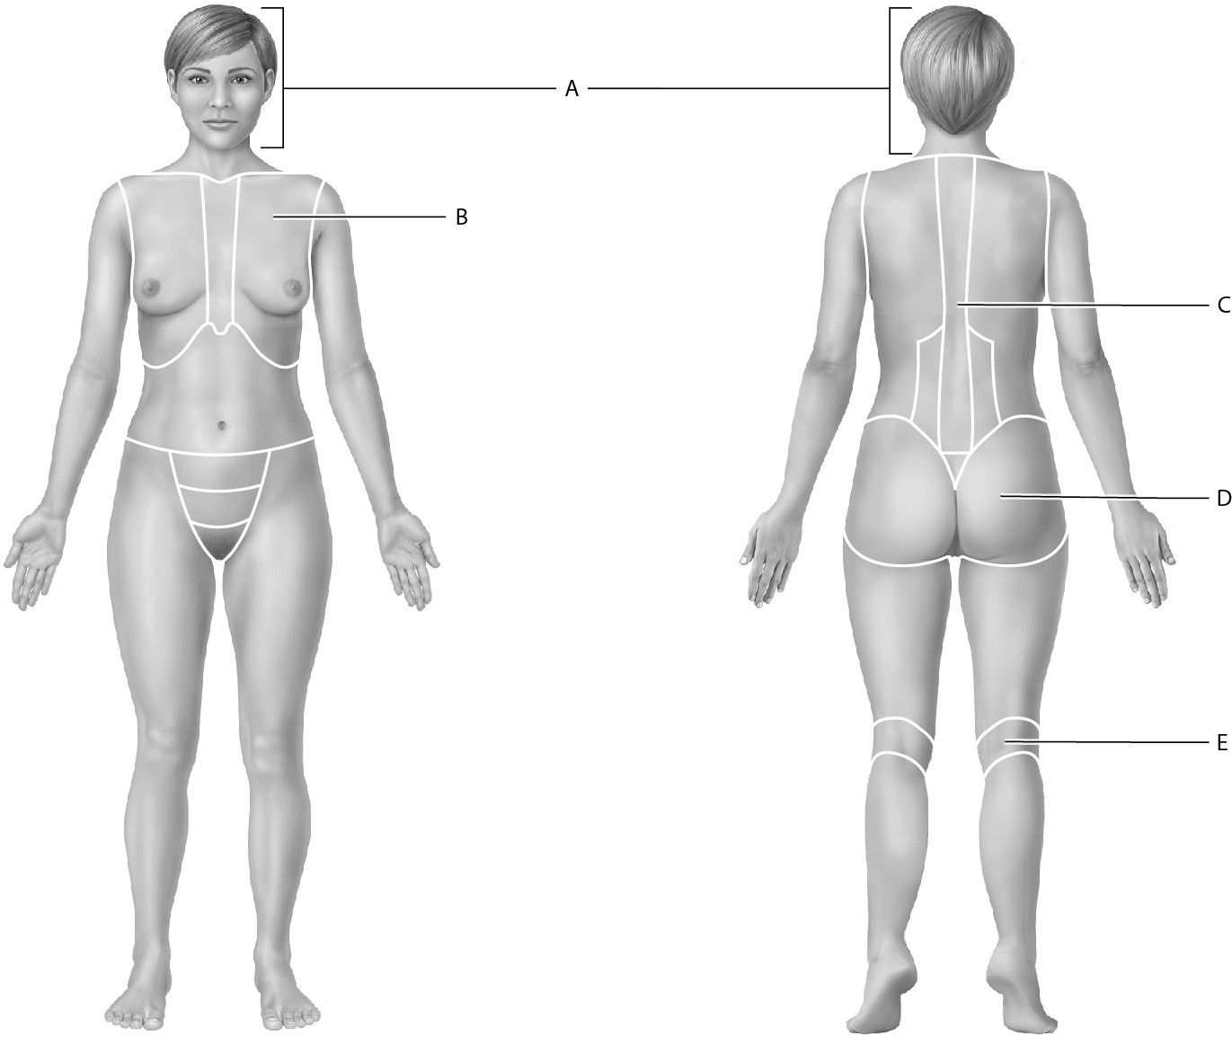
71) Identify the thoracic region.
Answer: B
Bloom's Taxonomy: 1) Knowledge
Learning Outcome: 1.3.5

72) Identify the vertebral region.
Answer: C
Bloom's Taxonomy: 1) Knowledge
Learning Outcome: 1.3.5

73) Identify the cephalic region.
Answer: A
Bloom's Taxonomy: 1) Knowledge
Learning Outcome: 1.3.5

74) Identify the popliteal region.
Answer: E
Bloom's Taxonomy: 1) Knowledge
Learning Outcome: 1.3.5
75) Identify the gluteal region.
Answer: D
Bloom's Taxonomy: 1) Knowledge
Learning Outcome: 1.3.5

Match the following with the correct body cavity or subdivision.

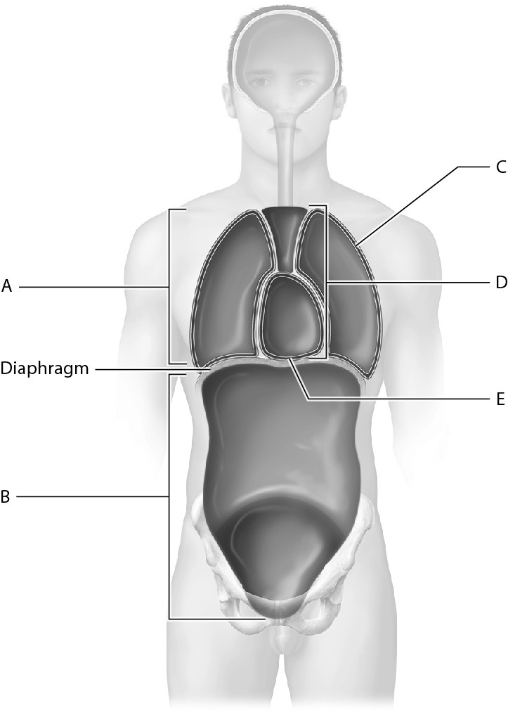

76) Identify the thoracic cavity.
Answer: A
Bloom's Taxonomy: 1) Knowledge
Learning Outcome: 1.4.1

77) Identify the abdominopelvic cavity.
Answer: B
Bloom's Taxonomy: 1) Knowledge
Learning Outcome: 1.4.1

78) Identify the cavity where the left lung is housed.
Answer: C
Bloom's Taxonomy: 1) Knowledge
Learning Outcome: 1.4.1

79) Identify the mediastinum.
Answer: D
Bloom's Taxonomy: 1) Knowledge
Learning Outcome: 1.4.1
80) Identify the cavity that houses the heart.
Answer: E
Bloom's Taxonomy: 1) Knowledge
Learning Outcome: 1.4.1

81) Gillian prefers to study alone. She mostly draws diagrams from the textbook or makes charts and tables to organize her thoughts as she reads. Determine and discuss her learning style.
Answer: Gillian prefers a visual/nonverbal learning style. A visual/nonverbal learner usually best understands concepts through the use of diagrams, illustrations, and other visual media without text. Visual/nonverbal learners may experience more success in studying alone than in study groups.
Bloom's Taxonomy: 3) Application
Learning Outcome: 1.1.1

82) Describe the SQ3R method for reading a textbook.
Answer: The SQ3R method stands for survey, questions, read, recite, and review. First, you should survey the chapter by skimming the material and figures. Next, form questions about the content in the chapter that you can answer as you read. Actively read by taking notes and drawing diagrams. As you read, recite the material by speaking aloud. The final step is to review what you have read. You may choose to answer questions in the book, write summaries, or discuss topics aloud with study partners.
Bloom's Taxonomy: 2) Comprehension
Learning Outcome: 1.1.1

83) Define metabolism.
Answer: Metabolism includes the wide range of chemical processes carried out by living organisms. Metabolism includes both "building" processes in which smaller chemicals are combined to form larger ones, and "breaking down" processes in which larger chemicals are broken down into smaller ones.
Bloom's Taxonomy: 1) Knowledge
Learning Outcome: 1.2.1

84) Explain how gross anatomy and microscopic anatomy differ.
Answer: The field of gross anatomy examines structures, including organs and organ systems that can be seen with the unaided eye. The field of microscopic anatomy examines structures that require a microscope to be seen.
Bloom's Taxonomy: 2) Comprehension
Learning Outcome: 1.2.3

85) Describe anatomical position.
Answer: In anatomical position, the body is standing upright, feet are shoulder width apart, upper limbs are at the sides of the trunk, and the head and palms are facing forward.
Bloom's Taxonomy: 2) Comprehension
Learning Outcome: 1.3.1
86) Instead of using the directional terms superior and inferior to describe positions on the upper and lower limbs, what directional terms are used? Define these terms.
Answer: Instead of using superior and inferior for the limbs, the terms proximal and distal are used. Proximal refers to something being closer to the point of origin (the trunk) while distal refers to something being farther away from the point of origin. Structures nearer the trunk are proximal while structures farther away are distal.
Bloom's Taxonomy: 2) Comprehension
Learning Outcome: 1.3.2

87) Peggy is having surgery on the right carpal region. A 3 cm incision will be made deep to the skin and muscle, but will be superficial to the bone. Explain to her where her surgery will occur.
Answer: Peggy will have surgery on the wrist, or carpal, region of her right hand. The 3 cm incision will penetrate through the skin and muscle, but will not go as deep into her wrist as the bone.
Bloom's Taxonomy: 2) Comprehension
Learning Outcome: 1.3.3, 1.3.5

88) Explain how a midsagittal (median) plane differs from a parasagittal plane.
Answer: A midsagittal (median) plane divides the body into equal left and right parts while a parasagittal plane divides the body into unequal left and right parts.
Bloom's Taxonomy: 1) Knowledge
Learning Outcome: 1.3.6

89) A female patient presents at the emergency room with pain in the right lower quadrant. Which organs might be involved?
Answer: The appendix, the right ovary, the first part of the large intestine, or the last part of the small intestine may be the source of pain in this female patient.
Bloom's Taxonomy: 1) Knowledge
Learning Outcome: 1.4.2

90) List the four quadrants and nine regions of the abdominopelvic cavity.
Answer: The four quadrants are the right upper quadrant, right lower quadrant, left upper quadrant, and left lower quadrant. The nine regions are the right hypochondriac region, epigastric region, left hypochondriac region, right lumbar region, umbilical region, left lumbar region, right iliac (inguinal) region, hypogastric region, and left iliac (inguinal) region.
Bloom's Taxonomy: 1) Knowledge
Learning Outcome: 1.4.2

91) Explain where the pericardial cavity is situated in relation to the pericardial membranes.
Answer: The pericardial cavity is situated between the visceral pericardium (attached to the heart muscle) and the outer parietal pericardium.
Bloom's Taxonomy: 2) Comprehension
Learning Outcome: 1.4.3

92) Define homeostasis and homeostatic imbalance.
Answer: Homeostasis is maintenance of the body's internal environment. Disturbances in homeostasis, known as homeostatic imbalances, can result in disease or death if uncorrected.
Bloom's Taxonomy: 1) Knowledge
Learning Outcome: 1.5.1
93) List and describe the components of a feedback loop.
Answer: The components of a feedback loop are the stimulus, receptor (sensor), control center, and effector/response. A stimulus is a regulated variable outside its normal range. A receptor (sensor) is a cellular structure that picks up information and sends it to a control center. The control center is often cells in the brain or an endocrine organ (gland). The control center compares the current value to its set point and determines that it's out of range. The control center sends signals to effectors. Effectors are cells or organs that cause physiological responses that return the variable to the normal homeostatic range.
Bloom's Taxonomy: 2) Comprehension
Learning Outcome: 1.5.2

94) Discuss the role of effector in both the negative and positive feedback loops.
Answer: In a negative feedback loop, the effector activity opposes the initial stimulus and shuts off when conditions return to the normal range. However, in a positive feedback loop, the effector's activity actually increases–positive feedback reinforces the initial stimulus using a loop of increasing output that amplifies the response. A positive feedback loop therefore causes a rapid change in a variable.
Bloom's Taxonomy: 2) Comprehension
Learning Outcome: 1.5.3

95) List the four core principles that relate to homeostasis.
Answer: The four core principles that relate to homeostasis are:
1) feedback loops
2) the relationship of structure and function
3) gradients
4) cell-cell communication
Bloom's Taxonomy: 1) Knowledge
Learning Outcome: 1.5.1, 1.5.4, 1.5.5, 1.5.6

96) Summarize the principle of complementarity of structure and function.
Answer: The principle of complementarity can be summarized as form follows function. In other words, the form of a structure is always such that it best suits its function.
Bloom's Taxonomy: 2) Comprehension
Learning Outcome: 1.5.4

97) Discuss why anatomical position is used.
Answer: Anatomical position provides accurate communication among scientists and health care professionals since it prevents experimental and medical errors. Anatomical position also provides a common frame of reference from which all body parts and regions are described.
Bloom's Taxonomy: 2) Comprehension
Learning Outcome: 1.3.1

98) Explain how the popliteal and patellar regions differ.
Answer: The popliteal region refers to the posterior (dorsal) side of the knee while the patellar region refers to the anterior (ventral) side of the knee. We may say that the popliteal region is posterior to the patellar region.
Bloom's Taxonomy: 2) Comprehension
Learning Outcome: 1.3.3, 1.3.4
99) Jose is having back surgery. Discuss the specific type of section the surgeon should use to make a cut along his vertebral region.
Answer: The vertebral region is situated along the body's midline. To operate on this region, the surgeon should make a cut along the midsagittal, or medial, plane on Jose's posterior (dorsal) body surface. The midsagittal plane divides the body into equal left and right parts.
Bloom's Taxonomy: 2) Comprehension
Learning Outcome: 1.3.6

100) Pleurisy is the inflammation of the serous membranes surrounding the lungs. With pleurisy, the inflamed membranes may secrete more serous fluid than normal. Predict the effects of excess serous fluid on serous membrane function.
Answer: Serous fluid is an extremely thin, slippery, watery layer situated between the visceral and parietal pleura. This fluid is produced by the cells of the membrane to lubricate around the organs and reduce friction as the lungs move against adjacent structures. Excess fluid around the lungs puts pressure on the lungs and can impair the lubricating function of the serous membranes, making it harder for these membranes to reduce friction.
Bloom's Taxonomy: 3) Application
Learning Outcome: 1.4.3

101) Explain how scratching a chaffing label on a shirt is an example of a negative feedback loop.
Answer: An irritation to the skin from a chaffing shirt label is a stimulus detected by a receptor (or sensor). The receptor sends this information to a control center, the brain, where it is determined that the skin irritation is out of normal range. The control center sends signals to effectors that cause physiological responses to return the variable to normal homeostatic range. Scratching, the response, stops the chaffing by moving the label off the skin, and thus removes the stimulus.
Bloom's Taxonomy: 2) Comprehension
Learning Outcome: 1.5.3

