Type your name
Independent Challenge 1
Help Lawrence Media solve a problem. Complete the following steps.
You Try It
1. Save this file with a new name
Click the File tab, click Save As, add your name to the end of the filename, then click Save.
For example, save this file as PS1-IC1 Sharon Rodriguez.docx.

2. Get ready
During a recent meeting with Ken Lawrence, the founder of Lawrence Media, and his project managers, he said Lawrence Media had a major problem retaining good salespeople.
Review the statements and facts in Figure 1-16, duplicated below:
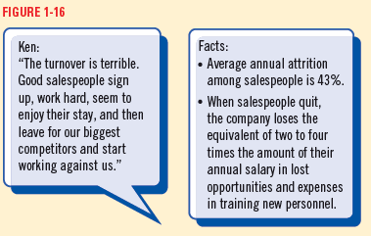

3. Now you try it
In the following space, outline the steps Lawrence Media can take to analyze and solve their sales staff problem. First, write a problem analysis.

Problem analysis:
- Lawrence Media is not retaining salespeople. This problem is typical among salespeople since 43% leave their position each year.
- When salespeople quit, Lawrence Media no longer has to pay their salary.
- However, they have to have additional expenses because they have to train new salespeople. They also lose money because they lose opportunities the salespeople might have developed.
- In addition, salespeople often leave Lawrence Media to work for their competitors.

Next, list the steps to solve the problem.

Steps to solve the problem:
- Identify the problem – Lawrence Media is not retaining salespeople and turnover is high.
- Gather information - Find out why salespeople switch jobs in general. Do they like the challenge of a new job? Do they want less supervision? Do they earn higher salaries or commissions when they switch?
Find out why salespeople leave Lawrence Media in particular—do they want to make more money? Do they think the quality of the products are low? Are the working conditions difficult or inflexible? Do they want more variety in their activities?
Learn whether competitors handle salespeople differently from Lawrence Media.
- Clarify the problem – Is the problem special to Lawrence Media? Or is it a problem throughout their industry? With most salespeople?
- Consider possible solutions - For example, if salespeople want to make more money, can Lawrence Media offer or increase the commissions on each sale? Could salespeople receive bonuses if they meet goals such as time with Lawrence Media, amount of sales or number of new customers?
- Select the best option – If salespeople want to earn more money, the best solution might be to increase commissions. That way, if salespeople sell more products, both they and the company earn more. Salespeople are also more likely to stay, which saves the company money.
- Make a decision and monitor the solution – After deciding to increase commissions, for example, track employee turnover and conduct job satisfaction surveys.

Submit the document to your instructor as requested.

