1
Student:

- The entirely new food category Chobani launched in 2005 was
  - Italian-style ragù sauce.
  - Turkish-style cottage cheese.
  - French-style yogurt.
  - Greek-style yogurt.
  - Oriental-style teriyaki sauce.
- From its inception, where did Hamdi Ulukaya, the creator of Chobani, Inc., want to place Chobani yogurt?
  - the organic foods section of major grocery store chains
  - in warehouse club stores like Sam's Club or Costco
  - the dairy case of major grocery store chains
  - in mass merchandise stores like Target
  - in both independent organic cooperatives, farmer's markets, and major organic grocery stores like Whole Foods or Sprouts
- All of the following are marketing mix strategies that Chobani has used to sell its yogurt EXCEPT:
  - develop a new yogurt product line for kids.
  - price the Chobani yogurt line below its major competitors (Yoplait and Dannon) to increase sales and market share.
  - use Facebook, YouTube, and other social media to promote Chobani yogurt.
  - rely on "word-of-mouth" to reach new customers.
  - employ a spokesperson to open a yogurt bar.
- Which of the following statements about marketing is MOST ACCURATE?
  - Unless you take a marketing class, you will never truly know anything about marketing.
  - Marketing is nothing more than common sense.
  - Marketing requires an innate sense of creativity; you either have it or you don't.
  - You can call yourself a marketing expert only if you have sold something.
  - You are already a marketing expert because as a consumer, you have already been involved in marketing decisions.
- Mark Zuckerberg is a co-founder of the social networking website called .
  - Pinterest
  - Groupon
  - LinkedIn
  - Facebook
  - Twitter
- Initially, Facebook targeted which consumer market segment?
  - grade school children ages 6 to 12 years old
  - high school students
  - college students
  - adults with professional occupations
  - senior adults 55 years and older

- Mark Zuckerberg encountered unimaginable success with his launch of "TheFacebook.com" website from his college dorm room. By the end of the second week, it had almost members.
A. 100
B. 300
C. 500
D. 1,000
E. 5,000
- of all new businesses fail within five years of their launch.
  - Only 5 percent
  - Only 10 percent
  - Only 25 percent
  - About 40 percent
  - Over 50 percent
- More than half of all new businesses fail within years of their launch.
  - two
  - three
  - four
  - five
  - ten
- Mark Zuckerberg's launch of "TheFacebook.com" website became a huge success. Yet, more than half of all new businesses fail within years of their launch.
  - two
  - three
  - four
  - five
  - ten
- Marketing refers to
  - the production of products or services that will generate the highest return on investment.
  - the strategies used in the advertising and promotion of products and services to customers around the globe.
  - the process of identifying target market segments for a product or service.
  - the activity involved in getting a product or service from the manufacturer to ultimate consumers and organizational buyers.
Ethe activity for creating, communicating, delivering, and exchanging offerings that benefit its
. customers, the organization, its stakeholders, and society at large.

- The activity for creating, communicating, delivering, and exchanging offerings that benefit its customers, the organization, its stakeholders, and society at large is referred to as .
  - manufacturing
  - advertising
  - marketing
  - selling
  - promotion

- The combined American Marketing Association's 2004 and 2007 definitions of marketing used in the textbook define marketing as
A the activity for creating, communicating, delivering, and exchanging offerings solely for the benefit of
. the organization's stockholders.
Bthe activity for creating, communicating, delivering, and exchanging offerings that benefit its
. customers, the organization, its stakeholders, and society at large.
- the activity for creating, communicating, delivering, and exchanging solely for the benefit of the organization's employees.
- the activity for selling a product or service at the highest possible price.
- the activities of advertising, promoting, and selling products to the greatest number of profitable customers.
- All of the following are true about marketing EXCEPT:
  - Marketing is a broader activity than advertising.
  - Marketing stresses the importance of delivering genuine benefits in the offerings of goods, services, and ideas sold to customers.
  - Marketing persuades people to buy the "wrong" things.
  - When an organization engages in marketing, all stakeholders should benefit.
  - Marketing is a broader activity than personal selling.
- An organization's stockholders, its suppliers, its employees, its customers, and society at large all share what in common with regard to an organization?
  - All are stakeholders and should benefit from the marketing of an organization's offering.
  - Everyone has a say in the ultimate design of a product.
  - Everyone is legally culpable if something goes wrong with a product.
  - All have to make some type of direct financial investment in the organization so it can profitably sell its products.
  - All use the products and/or services marketed by the organization.
- Which of the following statements about stakeholders is MOST ACCURATE?
  - Ultimately, the only relevant stakeholder is the ultimate consumer.
BThe suppliers, shareholders, employees, and customers are all stakeholders of an organization and all
. should benefit from the organization's marketing activities.
- Employees can be stakeholders only if they own shares in their company.
- Suppliers are the most important stakeholders because without them, products could never be produced.
- The only way to be a stakeholder is to have a financial investment in an organization's product, service, or idea.
- Mizuno designs and sells high quality baseball gloves. Who does NOT benefit from the firm's marketing activities for its gloves?
  - a baseball or softball player who purchases a new Mizuno glove
  - the Sports Authority salesperson who sells a customer a Mizuno glove
  - the supplier who provided the leather to Mizuno
  - the shareholder of Mizuno that designs and manufactures the gloves
  - all stakeholders should be benefit from Mizuno's marketing efforts, even society at large
- To serve both buyers and sellers, marketing seeks to and satisfy the needs and wants of prospective customers.
  - change
  - create
  - manipulate
  - discover
  - measure

- To serve both buyers and sellers, marketing seeks to discover and the needs and wants of prospective customers.
  - change
  - satisfy
  - create
  - manipulate
  - preserve
- Whether an individual is buying for personal or household use, or an organization is buying for its own use or for resale, the individual or organization would be considered
  - a prospective customer.
  - a dual-purpose marketing decision maker.
  - a potential distributor.
  - an informed buyer.
  - an end-user.
- A student wants to buy a smartphone so she can share pictures with her friends. An insurance claims adjuster wants to buy a smartphone to document accidents (take pictures, write a report, etc.). If they both purchase the same model smartphone, such as an Apple iPhone, which statement is MOST ACCURATE?
AThe adjuster is a prospective customer because the smartphone will be used for work; the student is
. only a secondary user since the purpose of the smartphone is just for entertainment.
B.Both the adjuster and the student are potential customers because in their own way, they both benefit from the smartphone.
CNeither the adjuster nor the student is a prospective customer since the company will pay for the
. adjuster's smartphone and the student's parents will pay for hers.
DThe student is the prospective customer since there are more students buying smartphones for personal
. use than there are insurance adjusters buying smartphones for business use.
EOnly a person who has bought a smartphone previously is a prospective customer because only
. previous owners of smartphones benefit from buying new ones.

22.

The Terrafugia Transition (see the photo above) is a 19-foot, two-seater road-drivable, light-sport aircraft with an anticipated price of $279,000. The MOST LIKELY prospective customers for this flying car would include
- students who attend college at least 500 miles away from home.
- retired seniors receiving social security.
- executives for whom time is extremely important.
- teens who like to try new things.
- families in need of a second vehicle.
- In marketing, the idea of exchange refers to
  - the negotiation phase between the manufacturer and the seller.
  - the financial remuneration (monetary payment) for a product or service.
  - the trade of things of value between buyer and seller so that each is better off after the trade.
  - the bartering of products and services between non-governmental organizations or individuals.
  - the practice of swapping products and services for other products and services rather than for money.
- Marketing seeks to discover the needs and wants of prospective customers and satisfy them. Essential to this process is the idea of exchange, which refers to
  - the trade of things of value between buyer and seller so that each is better off after the trade.
  - the negotiation phase between the manufacturer and the seller.
  - the financial remuneration (monetary payment) for a product or service.
  - the transport of tangible goods to new owners.
  - the practice of swapping products and services for other products and services rather than for money.
- The trade of things of value between buyer and seller so that each is better off after the trade is referred to as .
  - financial remuneration
  - exchange
  - countertrade
  - barter
  - marketing

- The American Red Cross created a series of advertisements to encourage people to donate blood. After viewing an ad, Amanda went to the local Red Cross office and donated a pint of her blood. Amanda returned home feeling happy that she had performed a good deed. Did an exchange occur in a marketing sense?
  - Yes, because the blood was donated to the Red Cross based on an advertisement, a marketing activity.
  - Yes, because the donated blood was exchanged for a feeling of satisfaction.
  - No, because the Red Cross is nonprofit organization.
  - No, because no money changed hands.
  - No, because the Red Cross, a service organization, did not provide Amanda with a product.
- A church put advertisements in its weekly bulletins to encourage its members to participate in the services by telling a brief, positive story about how fellow members have helped them during times of need. Jack volunteered and shared his story during a service. Afterwards, he felt joyous. Was this an exchange in a marketing sense?
  - Yes, because the church ran an advertisement, a marketing activity.
B. No, because the church is nonprofit organization and these actions are expected without any expectation of "exchange."
- No, because no money was exchanged.
- Yes, because sharing his story at a service was exchanged for a feeling of joy.
- No, because the church did not provide Jack with a tangible product or service.
- A local college of business offers an outstanding graduate business school education program. Marissa pays the tuition to attend and earns her MBA with a concentration in marketing management. Upon graduating, she is offered a high paying, fulfilling position. Was this a marketing exchange?
  - No, because the university earned a profit from Marissa's tuition.
B No, because money was exchanged in the form of tuition and Marissa's income will come from her
. employer, not the graduate school.
- No, because the school did not provide Marissa with a tangible product, only the potential of an education.
- Yes, because the university promised Marissa she would graduate on time, and she did.
E. Yes, because paying tuition was exchanged for knowledge that directly led to Marissa's high paying, fulfilling new job.

29.

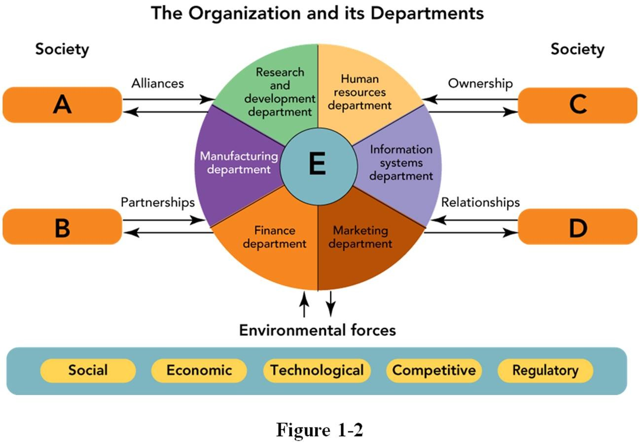30.

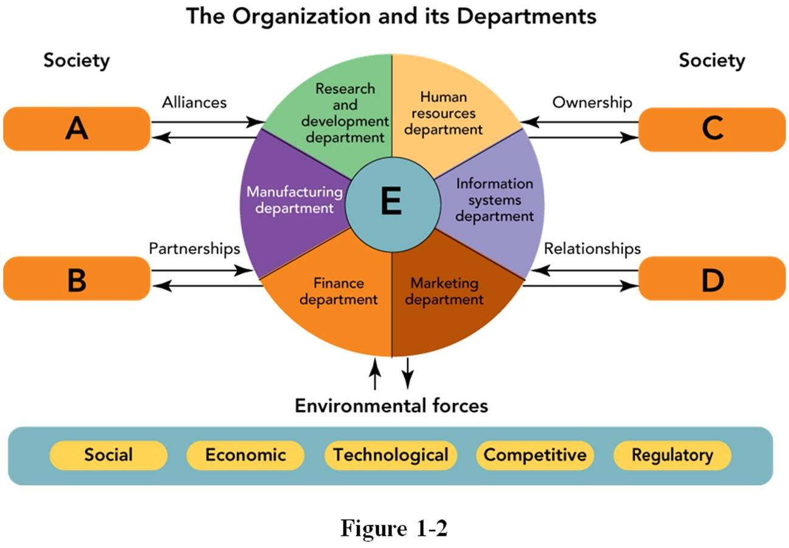
In Figure 1-2 above, "A" represents an organization's alliances with
- suppliers.
- customers.
- shareholders.
- other departments.
- other organizations.

31.

32.

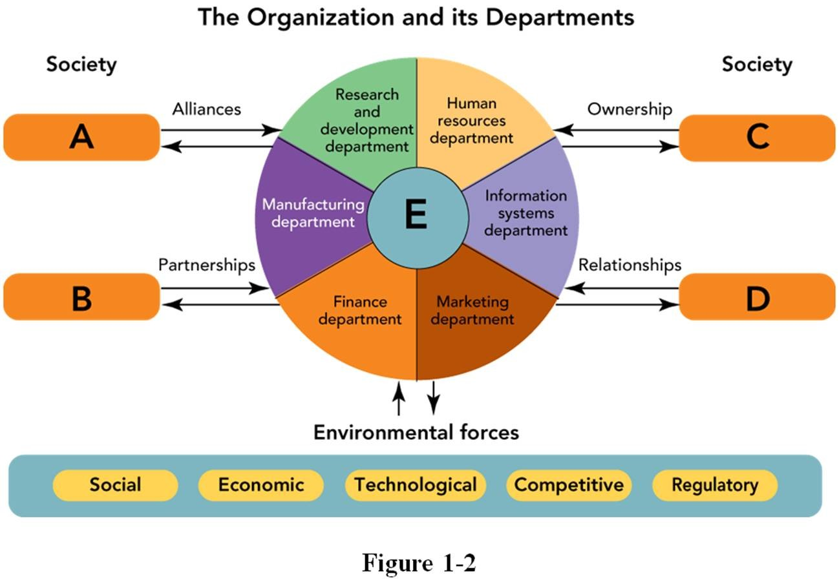
In Figure 1-2 above, "C" represents an organization's ownership with
- other organizations.
- suppliers.
- customers.
- other departments.
- shareholders.

33.

In Figure 1-2 above, the center ring "E" in an organization consists of , which oversees the departments surrounding it.
  - marketing
  - manufacturing
  - human resources
  - senior management
  - finance
- Which of the following statements about marketing activities is MOST ACCURATE?
  - Marketing is affected by society but rarely, if ever, affects society as a whole.
B The marketing department works closely with other departments and employees to implement an
. organization's marketing activities.
CMarketing activities are the sole responsibility of the marketing department; other departments are
. involved only if there is an emergency (such as a product recall).
D Environmental forces do not affect marketing activities as long as a firm closely monitors its
. environment through rigorous market research.
E.Marketing is essentially developing the right product and convincing potential customers that they "need" it, not just "want" it.
- All of the following are departments in a typical organization EXCEPT:
  - finance.
  - manufacturing.
  - information systems.
  - human resources.
  - suppliers.
- The department of an organization is responsible for facilitating relationships, partnerships, and alliances with the organization's customers, shareholders, suppliers, and other organizations.
  - purchasing
  - marketing
  - human resources
  - accounting
  - information systems

- The marketing department of an organization is responsible for facilitating .
  - relationships, partnerships, and alliances with the organization's customers, shareholders, suppliers, and other organizations
  - healthy competition with other product manufacturers
  - financial contracts with banks and other lending institutions
  - alliances with firms with non-competitive products that target similar markets
  - the coordination between the various departments within the entire firm
- Which of the following statements about marketing departments is MOST ACCURATE?
  - The marketing department should work solely with people within its own department.
B The marketing department should suggest where a firm should invest its money based on its knowledge
. of the market and environmental forces.
C. The marketing department is only responsible for the 4 Ps, not the 7 Ps.
D.The marketing department is only responsible for market research, supervision of product development, and product promotion.
EThe marketing department must work closely with a network of other departments and employees to
. help provide the customer-satisfying products required for the organization to survive and prosper.
- All of the following are environmental forces that affect an organization EXCEPT:
  - economic
  - geographical
  - social
  - regulatory
  - technological
- Which of the following is NOT an environmental force?
  - economic
  - regulatory
  - social
  - commercial
  - technological
- Which of the following statements about marketing activities is MOST ACCURATE?
  - Marketing is affected by society but rarely, if ever, affects society as a whole.
  - The marketing department works closely with other departments and employees to implement marketing activities.
CMarketing activities are the sole responsibility of the marketing department; other departments are
. involved only if there is an emergency (such as a product recall).
D Environmental forces do not affect marketing activities as long as a firm closely monitors its
. environment through rigorous market research.
E Marketing, after all is said and done, is essentially developing the right product and convincing
. potential customers that they "need" it, not just "want it."

- All of the following are factors required for marketing to occur EXCEPT:
  - a desire and ability on the part of two or more parties (individuals or organizations) to be satisfied.
  - something to exchange between two or more parties (individuals or organizations).
  - two or more parties (individuals or organizations) with the same wants.
  - two or more parties (individuals or organizations) with unsatisfied needs.
  - a way for the parties (individuals or organizations) to communicate.
- Four factors are required for marketing to occur: (1) ; (2) a desire and ability of parties to be satisfied; (3) a way for the parties to communicate; and (4) something to exchange.
  - a healthy competitive environment
  - an affordable and actionable advertising campaign
  - a sense of social responsibility
  - an ability to see hidden potential within an environmental force
  - two or more parties (individuals or organizations) with unsatisfied needs

- Four factors are required for marketing to occur: (1) two or more parties (individuals or organizations) with unsatisfied needs; (2) ; (3) a way for the parties to communicate; and (4) something to exchange.
  - a healthy competitive environment
  - government approval
  - an affordable and actionable advertising campaign
  - a desire and ability on their part to be satisfied
  - an ability to see hidden potential within an environmental force
- Four factors are required for marketing to occur: (1) two or more parties (individuals or organizations) with unsatisfied needs; (2) a desire and ability on their part to be satisfied; (3) ; and (4) something to exchange.
  - a way for the parties to communicate
  - a healthy competitive environment
  - an affordable and actionable advertising campaign
  - a sense of social responsibility
  - an ability to see hidden potential within an environmental force
- Four factors are required for marketing to occur: (1) two or more parties (individuals or organizations) with unsatisfied needs; (2) a desire and ability on their part to be satisfied; (3) a way for the parties to communicate; and (4) .
  - an affordable and actionable advertising campaign
  - something to exchange
  - a healthy competitive environment
  - government approval
  - an ability to see hidden potential within an environmental force
- Which of the following conditions are necessary for marketing to occur?
  - two or more people, a method of assessing needs, a way to communicate, and an exchange
  - two or more people, a product, a reasonable price, and a place to make an exchange
  - a quality product, a fair price, a clever method of promotion, and a place where a customer can buy the product
D two or more parties with unsatisfied needs, a desire and an ability to satisfy them, a way to
. communicate, and something to exchange
E.an ability to see a hidden trend within an environmental force, a product, and an affordable and actionable advertising campaign
- A business student is preparing for the Graduate Management Admission Test (GMAT) so he can get into a good graduate business school. He knows that any money he spends on a tutor will be well worth it if he can improve his scores. He's heard that there is a great tutor in his local community but has no idea who she is. To ensure that marketing occurs with her, he should
  - buy a GMAT study guide at his college bookstore.
  - find out what the minimum score he needs to get into the graduate business school of his choice. Cattempt to find the tutor by conducting a Google search for her website, looking for flyers in the
. students' business lounge, obtaining copies of the college newspaper and looking for her ad, or asking his friends whether they know of her and her tutoring services.
D consider alternatives to graduate school in case the scores he receives by taking the test without any
. help are not sufficient admission.
E. apply for delayed admission if he can't find this tutor.

- For marketing to occur, there must be two or more parties with unsatisfied needs. Dr. Pepper Snapple Group distributes Country Time lemonade in cans through supermarkets at a price comparable to that of soft drinks. The most likely "second" party needed for marketing to occur would be
  - people who are nostalgic about childhood lemonade stands they had during hot summers.
  - people with a desire for a beverage other than soda or water.
  - product demonstrators who offer samples of Country Time lemonade to shoppers at local supermarkets.
  - a local distributor of alcoholic beverages.
  - a nutritionist promoting the benefits of fresh fruit in people's diets.
- A student would like to buy cross-over SUV from a local dealer, but she thinks the payments will be too high. Marketing does not occur in this situation because
  - two or more parties have unsatisfied needs.
  - there is no desire on the part of either party to satisfy its needs.
  - one of the involved parties does not have the ability to satisfy its needs.
  - there is no way for each party to communicate with one another.
  - there has been no assessment of consumer wants and needs.
- A college student is taking a full course load, working 20 hours per week, and still has to take out a student loan to cover tuition. One day, he sees a classmate driving a new Lexus LFA sports coupe (price:
$375,000) and feels he just has to have one for himself. What factor is MOST LIKELY to prevent a successful marketing exchange between the student and the local Lexus dealer located in an affluent suburb about 20 miles from his university?
  - The local Lexus dealer only has one Lexus LFA sports coupe in stock—red, which is the color he wants.
  - The student does not have the resources to qualify for a $375,000 auto loan.
  - Although the Lexus LFA sports coupe is a great car, there may be other cars with better gas mileage and resale value.
  - He's afraid that if someone at school sees him with the car, he might lose his student loan.
  - His girlfriend wants him to drive a Kia Soul.
- A local candidate running for office would very much like to have your vote. She promises that she will "make the country better." Because all candidates for public office say this, you decide not to vote for her. Marketing will not occur in this situation because .
  - marketing doesn't apply to the voting process
  - the desire and ability to satisfy needs is missing
  - there is no direct way for the parties to communicate
  - something to exchange is missing
  - there is only one party involved in this situation
- The Arizona Biltmore in Phoenix is a resort hotel located less than a mile away from the Biltmore Fashion Park, a large upscale shopping mall. The hotel wants to promote its proximity to the shopping center as well as its many other amenities to convention-goers from other states. Which of the following marketing actions would MOST LIKELY help The Arizona Biltmore communicate with potential convention attendees?
  - Place an ad in the in-flight magazines of all the major airlines targeting business/first class flyers.
  - Send a mass mailing to all local businesses.
  - Set up information kiosks at several locations within the Biltmore Fashion Park.
  - Offer free made-to-order breakfasts for guests staying at the hotel on business.
  - Offer special discount rates to guests coming from the East Coast.

- A farmhand would like to buy a moped scooter to commute to his job at a nearby ranch. He doesn't know how to find a dealer though, and doesn't have Internet access. Which of the following reasons explain why marketing fails to occur here?
  - There are not two or more parties with unsatisfied needs.
  - A desire to satisfy a need is missing.
  - No assessments of consumer wants and needs have been made.
  - There is no way for the parties involved to communicate.
  - The ability to satisfy a need is missing.

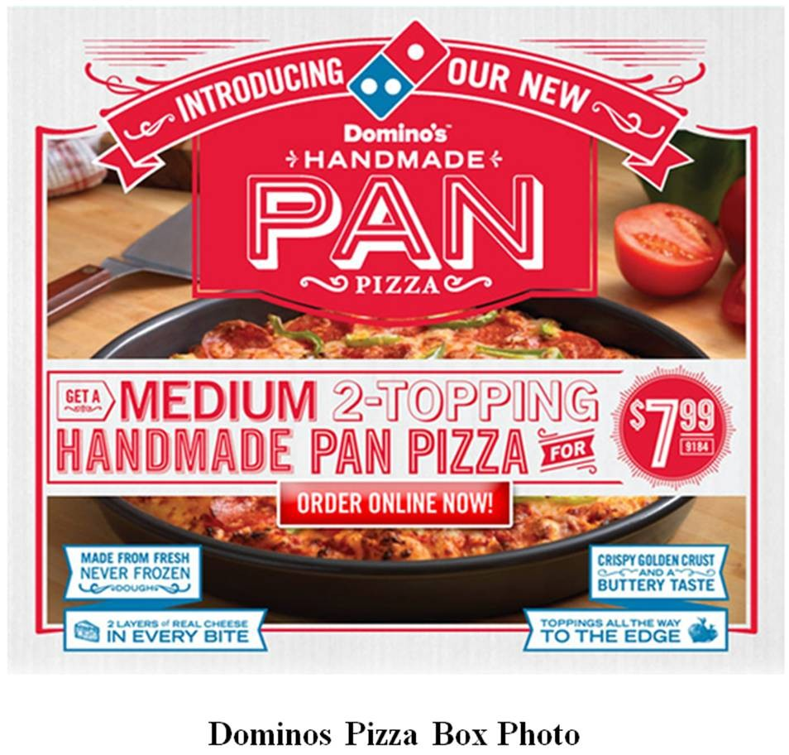55.

Suppose you want a snack after taking this exam—a Pan Pizza from Dominos, which is located across the street from your College of Business classroom. Unfortunately, you forgot your wallet in the haste of getting to class on time to take the test. Therefore, you have no means to pay for the pizza. Which of the following reasons explain why marketing fails to occur here between you and Dominos?
- There are not two or more parties with unsatisfied needs.
- The ability to satisfy a need is missing.
- A desire to satisfy a need is missing.
- No assessments of consumer wants and needs have been made.
- There is no way for the parties involved to communicate.
- The two central concerns of marketing are .
  - increasing market share and making profits
  - holding down costs while increasing profits
  - developing products and finding suppliers
  - discovering and satisfying consumer needs
  - practicing ethics and sustainability
- The first objective in marketing is to discover consumers' .
  - diversity of opinion to create advertising messages
  - income to determine the most lucrative price point for a product
  - lifetime value of an offering to the organization
  - characteristics that would be useful to segment markets
  - needs to create products that could satisfy them

- Marketing discovers consumer needs by
  - implementing a marketing program.
  - conducting effective marketing research.
  - balancing the marketing mix elements—the 4 Ps of the marketing program.
  - advertising to diverse groups of prospective buyers.
  - copying the products and services of competitors.
- New-product experts generally estimate that up to percent of the more than 40,000 new consumable products introduced in the United States annually "don't succeed in the long run."
  - 33
  - 50
  - 67
  - 75
  - 94
- To avoid new-product failure, new-product expert Robert M. McMath suggests
  - implementing a regional rather than a nationwide rollout of a new product.
  - building a hierarchical organizational structure so that more people have a chance to spot product problems.
  - focusing on customer benefits and learning from the past.
  - increasing the marketing budget, since "success comes to those who can outspend the competition."
  - releasing several different versions of a new product at the same time to see which one is most successful.
- If you followed the suggestions of Robert M. McMath, which of the following provides the best advice for a marketer, such as Colgate, when launching a new consumer product, such as toothpaste?
A.Anticipate the future five years out in terms of product form, ingredients, and packaging—to invent the "toothpaste of tomorrow!"
- Give the product a mysterious name that is unrelated the product's benefits but provokes consumer curiosity.
- Initiate a Facebook campaign against beverages sweetened with high fructose corn syrup, which can contribute to tooth decay.
- Create unusual packaging that has special shelving requirements.
- Study past toothpaste product failures and learn from them.
- A factor that might doom a product in the marketplace is referred to as a(n) .
  - albatross
  - land mine
  - pit fall
  - showstopper
  - wild card
- Showstoppers refer to
  - creative or innovative members of a marketing team.
  - unexpected alternative uses for a product that result in a sudden increase in sales.
  - factors that might doom a product in the marketplace.
  - a sudden loss of financial backing even though the item is in production.
  - a situation when a competitor's product suddenly beats a firm's new product to the marketplace.
- Which of the following products mentioned in Chapter 1 of the textbook failed in the marketplace?
  - Terrafugia Transition
  - Pepsi Next
  - Bell bicycle helmet
  - 3M Post-it Flag+ Highlighter
  - Dr. Care toothpaste

65.

The Terrafugia Transition (see the photo above) is a flying car with an anticipated price of $279,000. A potential showstopper for this product is likely to be
- concern about damage caused in a small on-road fender bender might make it dangerous to fly.
- a lack of marketing towards retired seniors.
- the efficiency of commuting for corporate executives.
- the availability of flight instruction for licensed drivers.
- a very poor product warranty.

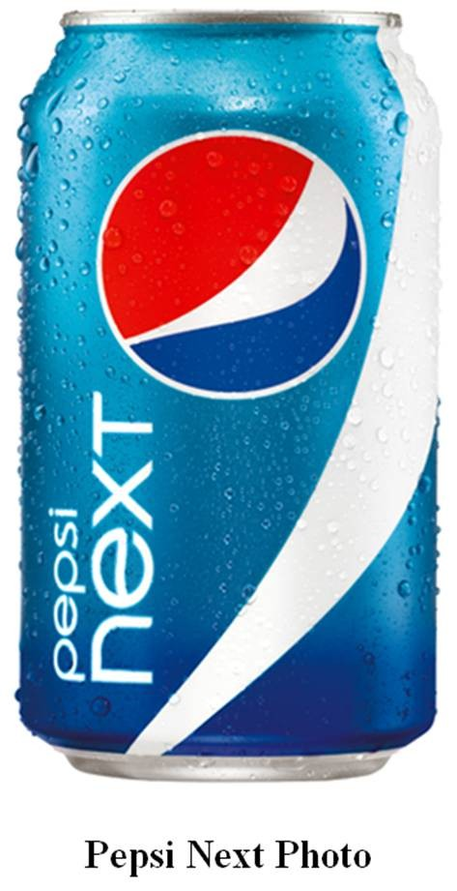66.

Pepsi Next (see the photo above) is a mid-calorie soft drink targeted at consumers who want both taste and low calories. A potential showstopper for this product is likely to be its
  - lack of advertising on television.
  - association with similar mid-/low-calorie soft drinks that have failed in the recent past, such as Pepsi Edge and Coca Cola C2.
  - lower profit margin due the added costs of three artificial sweetener ingredients.
  - cannibalization of Diet Pepsi, which has a much larger market share.
  - use of sucrose instead of high fructose corn sugar, which tastes more like sugar.
- A occurs when a person feels deprived of basic necessities such as food, clothing, and shelter.
  - desire
  - need
  - utility
  - want
  - craving
- A need refers to
  - a sense of personal inadequacy based upon observations by others around you.
  - a sense of urgency, which causes a person to take action.
  - a feeling that is shaped by a person's knowledge, culture, or personality.
  - a feeling of being deprived of something, but not fully understanding what it may be.
  - a situation when a person feels deprived of basic necessities such as food, clothing, and shelter.
- All of the following are examples of products or services that satisfy a consumer need EXCEPT:
  - a pair of jeans.
  - an apple.
  - a student dormitory.
  - a sports car.
  - a jacket.
- A is a need that is shaped by a person's knowledge, culture, and personality.
  - desire
  - feeling
  - utility
  - want
  - craving

- A want refers to
  - a sense of personal inadequacy based upon observations by others around you.
  - a powerful desire that causes a person to take action.
  - a need that is shaped by a person's knowledge, culture, or personality.
  - a feeling of being deprived of something, but not fully understanding what it may be.
  - a situation when a person feels deprived of basic necessities such as food, clothing, and shelter.
- Which of the following statements best distinguishes between consumer needs and wants?
  - Needs are far more influential than wants with respect to marketing decision making.
B Wants affect marketing decisions primarily for planned purchases while needs affect marketing
. decisions primarily for impulse purchases.
CWants occur when a person feels deprived of basic necessities such as food, clothing, and shelter while
. needs are determined by a person's knowledge, culture, or personality.
DNeeds occur when a person feels deprived of basic necessities such as food, clothing, and shelter while
. wants are determined by a person's knowledge, culture, or personality.

73.
E. Needs and wants are psychologically the same.

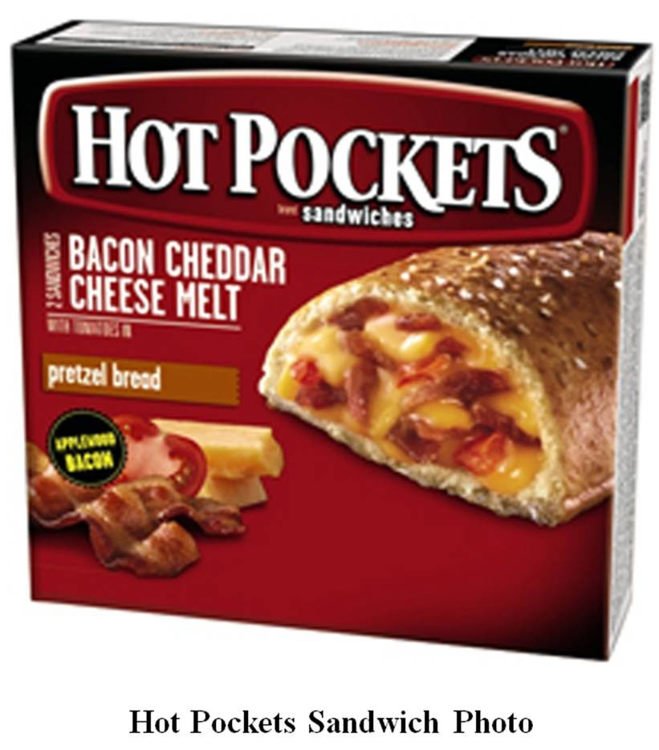
A television advertisement shows several teenagers searching through the refrigerator for something to satisfy their hunger. The refrigerator offers the teenagers many alternatives—celery, bologna, cottage cheese, and box of Hot Pockets Bacon Cheddar Cheese Melt sandwiches (see the photo above). The ad, which shows the teens happily selecting the Hot Pockets sandwiches, appeals to the consumers'
for sustenance to satisfy their hunger and attempts to shape their for the advertised product.
- needs; wants
- wants; needs
- wants; cravings
- cravings; needs
- needs; preferences

74.

75.

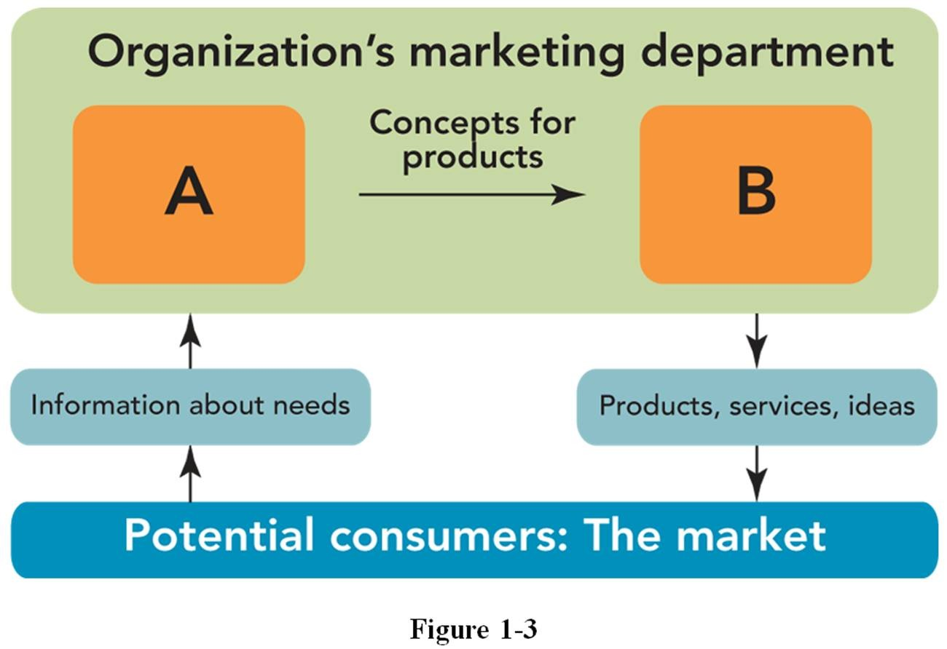
In Figure 1-3 above, "A" represents and "B" represents .
- decisions by management; purchases by customers
- employees efforts; stakeholder rewards
- sales department; manufacturing department
- suppliers; distributors
- discovering consumer needs; satisfying consumer needs

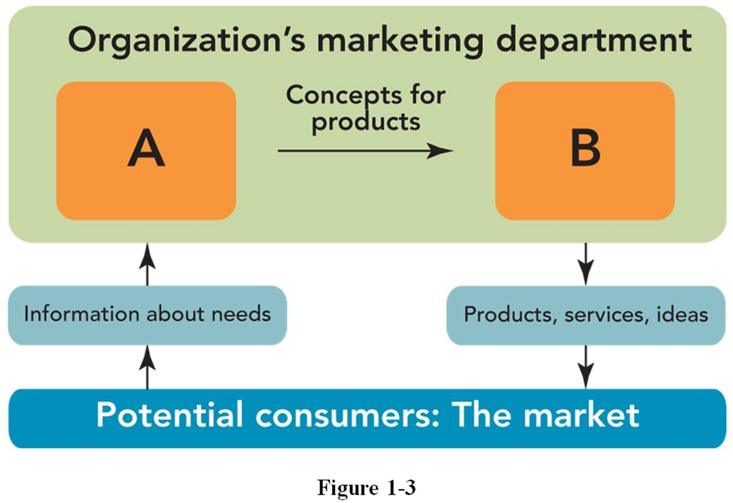
In Figure 1-3 above, "B" is accomplished by .
- designing a marketing program
- conducting marketing research
- discovering consumer needs
- developing a distribution strategy
- identifying target markets

- People with both the desire and ability to buy a specific offering are referred to as [a(n)] .
  - shoppers
  - customer base
  - market
  - bazaar
  - emporium
- In a marketing context, a market refers to
  - people with a similar want for a particular product or service.
  - people with both the desire and ability to buy a specific offering.
  - the central location for all buying and selling of products and services.
  - an open space or covered building where vendors convene to sell their offerings.
  - the free the operation of supply and demand.
- All markets ultimately are composed of .
  - people
  - brands
  - products
  - organizations
  - governments
- The most likely market for cosmetic dentistry, where costs can be as much as $15,000 for teeth straightening and whitening, is
  - toddlers with crooked baby teeth, when crooked teeth run in the family.
  - all former smokers who have been smoke free for at least one year.
  - anyone who has the time, the money, and the desire to undergo the procedures.
  - anyone who has dental insurance.
  - adults who want to make a good first impression for a job interview.
- A target market refers to
  - people who could purchase a product regardless of who ultimately uses it.
  - one or more specific groups of potential consumers toward which an organization directs its marketing program.
  - former customers who now use competitors' products.
  - the cluster of benefits that an organization develops to satisfy consumers' needs.
  - people with both the desire and the ability to buy a specific offering.
- A target market refers to
  - customers who have already purchased a firm's product at least once, have been satisfied, and are likely to be repeat purchasers.
Bboth existing and potential customers who have used a competitor's product, are dissatisfied, and who
. now seek a different product or service to satisfy their needs.
- a specific group of current consumers toward which an organization directs its advertising.
- one or more specific groups of potential consumers who are seeking a product for which there are no current substitutes.
- one or more specific groups of potential consumers toward which an organization directs its marketing program.
- One or more specific groups of potential consumers toward which an organization directs its marketing program is referred to as a
  - mass market.
  - tangential market.
  - potential market.
  - target market.
  - promotional market.

- Kraft produces Lunchables, a prepackaged meal usually consisting of several crackers, small slices of meat, and small slices of cheese. Other items in the product line contain small bottles of Chiquita Strawberry Banana Fruit smoothie, Capri-Sun juice, or Kool-Aid. The box is bright yellow and
the quantity of food contained within it is small. The target market for Kraft Lunchables is MOST LIKELY:
  - moms with school-age children who pack a simple healthy lunch for them.
  - business people looking for a fulfilling breakfast at the office.
  - business travelers on the run.
  - teenagers who are hungry for an after-school snack.
  - baby boomers who are trying to lose weight.
- Which of the following people would MOST LIKELY be the best target market for tickets to the home games of the Indianapolis Colts professional football team?
  - all people with an interest in professional football
  - all people in the Midwest who have an interest in sports
  - all men who played on a varsity football team in high school
  - all people in the Indianapolis and surrounding areas interested in football
  - all people in Indiana who watch football on TV
- Which of the following groups would be the LEAST LIKELY target market for a company producing canned food in single serving sizes?
  - single adults
  - school kitchens
  - campers
  - senior citizens
  - vending machine owners
- TUMI brand briefcases are very expensive, high-end briefcases that are generally sold in specialty luggage shops. Which of the following groups of people would be the MOST LIKELY target market for TUMI brand briefcases?
  - police officers
  - executives
  - construction workers
  - postal workers
  - students
- The United States Army recently has been both praised and criticized for its use of a popular video game, America's Army, which is designed to reach potential recruits. The game's creator, Colonel Casey Wardynski, wanted to provide a sense of the training and teamwork one could find in the Army's military environment. The game is designed for "boys 14 years or older," which represent the Army's
.
  - mass market
  - actual recruits
  - restricted market
  - target market
  - untapped market
- A local university offers business courses for a specific target market composed of people who currently work and want to take refresher courses to obtain certification in their chosen business field (marketing, accounting, etc.). Which of the following would be the most effective way to communicate with the target market, bearing in mind that communication must be both effective and economical?
  - put announcements on campus bulletin boards
  - distribute promotional materials during classes
  - advertise on national television
  - advertise on local hip-hop radio shows
  - advertise in the local newspaper

- The four Ps are commonly known as
  - the environmental or uncontrollable forces.
  - the environmental or controllable factors.
  - the marketing mix or controllable factors.
  - the marketing mix or uncontrollable forces.
  - predict, produce, package, and persuade.
- The marketing manager's controllable factors—product, price, promotion, and place—that can be used to solve a marketing problem are referred to as (the) .
  - marketing concept
  - marketing mix
  - marketing program
  - environmental forces
  - marketing toolbox
- The marketing mix refers to
A the selection of product benefits and attributes that are to be added to or subtracted from a given
. product to create variations within a product line.
B. the specific ratio within a budget that divides resources between advertising, sales promotion, and personal selling.
C the marketing manager's controllable factors—product, price, promotion, and place—that can be used
. to solve a marketing problem.
D. the allocation of resources within a firm towards individual marketing programs.
Ethe environmental forces—social, economic, technological, competitive, and regulatory—that impact
. the marketing decisions for a particular product at any given time.

- The marketing mix refers to
  - the multiple sales and advertising strategies that can be used to promote a product.
B the controllable forces—social, economic, technological, competitive, and regulatory—to which a
. marketing manager must constantly adapt.
Cthe blending of different communication and delivery channels that are mutually reinforcing in
. attracting, retaining, and building relationships with consumers who shop and buy in traditional intermediaries and online.
- the marketing manager's controllable factors that can be used to solve marketing problems.
- a set of complementary products that when sold together generate more sales than when sold separately.
- Which of the following would a marketer use as a synonym for controllable marketing mix factors?
  - the four Ps of marketing
  - environmental forces
  - macromarketing forces
  - marketing management factors
  - micromarketing factors
- The four Ps of the marketing mix are
  - priorities, personnel, placement, and profits.
  - prediction, production, pricing, and promotion.
  - product, price, production, and place.
  - product, price, promotion, and place.
  - predict, produce, package, and persuade.
- All of the following constitute the "4 Ps" of the marketing mix EXCEPT:
  - promotion.
  - profitability.
  - price.
  - place.
  - product.

- The four Ps are commonly known as
  - the environmental or uncontrollable forces.
  - the environmental or controllable factors.
  - the marketing mix or controllable factors.
  - the marketing mix or uncontrollable forces.
  - predict, produce, package, and persuade.
- The marketing mix elements are called because they are the responsibility of the marketing department in an organization.
  - uncontrollable forces
  - profitability factors
  - stakeholder value generators
  - target market segments
  - controllable factors
- Jakubowski Farms Gourmet Bread Base is the brand name for a mix designed for use in bread making machines. The mixes are sold in 2-pound canisters for $14.99 plus postage. The products are only available through the mail. People learn about the product through word-of-mouth and bread machine demonstrations the company's founder gives to groups in Wisconsin where she lives. This is a description of the company's
  - action plan.
  - market segmentation strategy.
  - mission statement.
  - marketing mix.
  - target market.
- The element of the marketing mix that describes a good, service, or idea to satisfy consumers' needs is known as
  - a product.
  - the price.
  - promotion.
  - the place or distribution.
  - a market segment.
- The owners of Old School Brand Authentic Antique Foods researched Civil War records to come up with recipes used in the old-fashioned cookies the company produces and markets. This statement deals with which part of the marketing mix?
  - process
  - price
  - product
  - place
  - people
- The element of the marketing mix that describes what is exchanged for a product is known as
  - a product.
  - the price.
  - promotion.
  - the place or distribution.
  - productivity.
- Which element of the marketing mix is demonstrated when Mars, Inc. has a sale on M&MS® brand candies?
  - product
  - price
  - promotion
  - place
  - production

- The element of the marketing mix demonstrated when an art gallery suggests a $2.00 donation at the door is .
  - philanthropy
  - place
  - product
  - promotion
  - price
- To attend a winter concert presented by the community chorus, every person had to donate one unwrapped toy at the concert hall door. This statement is most closely related to the element of the marketing mix.
  - product
  - philanthropy
  - price
  - place
  - promotion
- The element of the marketing mix that describes a means of communication between the seller and buyer is known as
  - a product.
  - promotion.
  - the price.
  - the place or distribution.
  - advertising.
- The owners of Old School Brand Authentic Antique Foods researched Civil War records to come up with recipes for the old-fashioned products they market. Concern about the element of the marketing mix would make them eager to be featured in an upcoming edition of Taste of Home magazine.
  - product
  - price
  - production
  - promotion
  - place
- The element of the marketing mix is demonstrated when a company places an ad in the Yellow Pages.
  - product
  - price
  - promotion
  - place
  - process
- When a company places an ad on Google, the action is a tactic of the element of the marketing mix.
  - product
  - price
  - promotion
  - place
  - process
- The element of the marketing mix that describes a means of getting the product to the consumer is known as
  - a product.
  - the price.
  - promotion.
  - the place or distribution.
  - transportation.

- The element of the marketing mix is demonstrated when a newspaper carrier throws a paper on the customer's front porch.
  - place
  - product
  - price
  - promotion
  - procurement
- The ability to buy a soda from a vending machine demonstrates which element of the marketing mix?
  - product
  - price
  - promotion
  - place
  - process
- The cluster of benefits that an organization promises customers to satisfy their needs is referred to as a(n)
.
  - core benefit proposal
  - product protocol
  - marketing program
  - marketing mix
  - customer value proposition
- A customer value proposition is
Athe unique combination of benefits received by targeted buyers that includes quality, convenience, on-
. time delivery, and both before-sale and after-sale service at a specific price.
Ba statement that, before product development begins, identifies (1) a well-defined target market; (2)
. specific customers' needs, wants, and preferences; and (3) what the product will be and do to satisfy consumers.
C. a unique strength relative to competitors that provides superior returns, often based on quality, time, cost, or innovation.
- the characteristics of a product that make it superior to competitive substitutes.
- the cluster of benefits that an organization promises customers to satisfy their needs.
- Michelin's can be summed up as "providing safety-conscious parents greater security in tires at a premium price."
  - customer value proposition
  - protocol
  - mission statement
  - core values
  - marketing program
- The uncontrollable forces in a marketing decision involving social, economic, technological, competitive, and regulatory forces are referred to as .
  - the 5 Fs of marketing
  - environmental forces
  - business conditions
  - a marketing ecosystem
  - a business sphere
- Which of the following is NOT an environmental force?
  - technological
  - regulatory
  - ecological
  - competitive
  - economic

- Environmental forces refer to
  - the internal strengths of a company that enable the firm to remain competitive.
B the marketing manager's uncontrollable factors—product, price, promotion, and place—that can be
. used to solve marketing problems.
C. the unpredictable or uncontrollable availability of natural resources that can enhance or restrain a company's growth.
D the marketing manager's uncontrollable forces in a marketing decision involving social, economic,
. technological, competitive, and regulatory forces.
E the marketing manager's controllable forces in a marketing decision involving social, economic,
. technological, competitive, and regulatory forces.

- The five major environmental forces in a marketing decision are
  - climate change, natural resources, pollution, natural disasters, and global conflict (war).
  - social, technological, economic, competitive, and regulatory.
  - corporate ownership, internal management, supplier partnerships, strategic alliances, and customer relationships.
  - product, price, promotion, place, and people.
  - ethics, sustainability, cultural awareness, diversity, and values.
- Which of the following statements about environmental forces is MOST ACCURATE?
  - Environmental forces are almost always controllable if the marketing department correctly scans them. B An organization that incorporates the marketing concept can exert just as much influence on
. environmental forces as they can exert on that organization.
- Environmental forces consistently result in negative outcomes for an organization.
- Some environmental forces can actually enhance a firm's marketing opportunities.
- Environmental forces can almost always be predicted.
- Which of the following statements describes an environmental force?
A. Several states have legislation that requires people transporting children to use age- and height- appropriate car seats.
- Tupperware has more than 200,000 independent dealers who market its entire product line.
- A car battery comes with a lifetime guarantee.
- An automobile dealer offers a $500 rebate during the month of July.
- A major bottler offers a 10-cent refund on returnable bottles.
- Local newspaper readership has declined significantly in recent years. Not only are traditional newspapers losing subscribers, they are also losing advertisers. To combat these trends, many newspaper publishers now offer online versions of their printed newspapers. This is MOST LIKELY a response to which environmental force?
  - economic, since few can afford a newspaper today
  - competitive, resulting from new, smaller local newspapers that are flourishing
  - technological, since high-speed printing presses have become more easy to use
  - social, resulting from changing consumer preferences for information delivered online
  - regulatory, since the government provides tax incentives for paper-based products
- A growing trend to "Buy American" has caused U.S. automakers to increase political pressure on Washington to pass legislation for more restrictive quotas on Japanese car imports. In addition, a decline in the value of the U.S. dollar would be instrumental in Toyota's decision to build a manufacturing
plant in the United States instead of continuing to export cars from Japan. If Toyota builds the plant, its decision would reflect
  - a reactive strategy that would impact the competitive environmental force.
  - a proactive maneuver to manipulate and impact the social environmental force.
  - a positive result from regulatory and economic environmental forces.
  - a positive response to a technological environmental force.
  - a negative impact as a result of adverse competitive, regulatory, and technological environmental forces.

- Many large consulting firms are beginning to sponsor "women-only" networking events. The purpose of these events is to offer an opportunity for women in management to network with other businesswomen, either as clients, mentors, or protégés. This is an example of which environmental force?
  - social
  - economic
  - technological
  - competitive
  - regulatory
- With today's smartphones, one can watch the news, shoot videos, browse the Internet, take pictures, and listen to music. Improved new features are added with each smartphone introduced by Apple, Samsung, BlackBerry, and the like. As a result, existing customers often want to replace their existing smartphones with new models or brands every two years when their contracts expire. This increase in demand is due mostly to changes in , an environmental force.
  - competition
  - social culture
  - technology
  - regulations
  - the economy
- Pending federal legislation will require all online retailers to collect state sales taxes from customers.
This would affect online sellers such as Virtual Vineyards, which now only collects state sales taxes from customers who reside in California—its home state. This pending legislation would be an example of which environmental force?
  - social
  - economic
  - technological
  - competitive
  - regulatory
- The unique combination of benefits received by targeted buyers that includes quality, convenience, on- time delivery, and both before-sale and after-sale service at a specific price is called
  - customer value.
  - target marketing.
  - benefit proposition.
  - value-based marketing.
  - a customer value proposition.
- Customer value refers to
  - the need of a customer to receive the highest quality product at the lowest possible price.
  - the least expensive product that will provide it with most of the basic benefits.
Ca statement that, before product development begins, identifies (1) a well-defined target market; (2)
. specific customers' needs, wants, and preferences; and (3) what the product will be and do to satisfy consumers.
Dthe unique combination of benefits received by targeted buyers that includes quality, convenience, on-
. time delivery, and both before-sale and after-sale service at a specific price.
E. the cluster of benefits that an organization promises customers to satisfy their needs.
- Which of the following statements about customer value is MOST ACCURATE?
A Target customers assess customer value in terms of the combination of benefits (quality, convenience,
. etc.), regardless of the price.
B.Loyal customers are less profitable to firms in the long run since they expect lower prices over time in order to remain loyal.
- Research suggests that firms can be most successful by being all things to all consumers.
- It is impossible to place a dollar value on a loyal, satisfied customer.
- To create value for targeted buyers, firms must build long-term relationships with them.

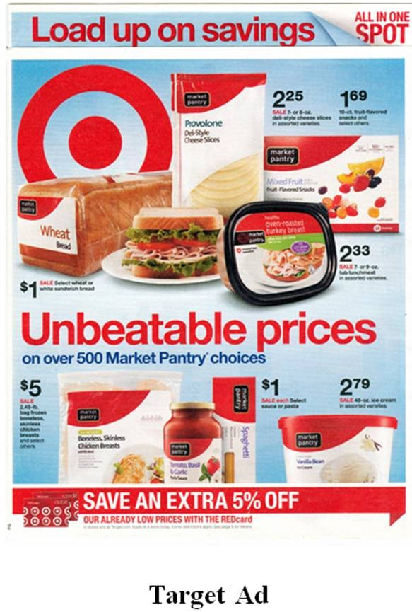129.

As shown in the ad above, Target has been successful by offering consumers the best
- experience.
- products/services.
- customer service.
- availability.
- price.
- According to the textbook, Starbucks provides its customers with the best
  - branding.
  - products/services.
  - price.
  - customer service.
  - availability.

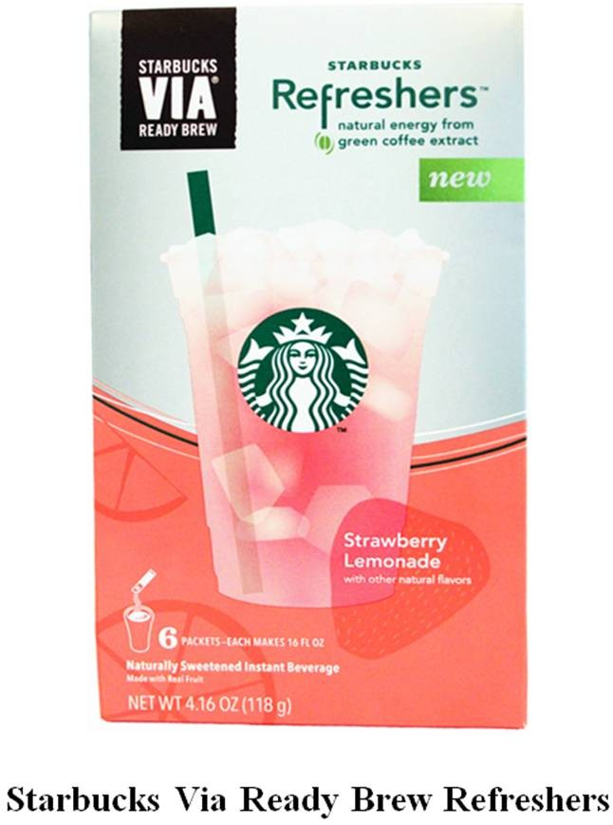131.

What customer value strategy does Starbucks Coffee Company deliver to its customers when it offers them its Starbucks Via Ready Brew Refreshers?
- best product/service
- best customer service
- best value
- best assortment
- best price
- According to the textbook, U.S. Bank delivers customer value by providing its customers with the best
  - assortment.
  - products/services.
  - price.
  - customer service.
  - availability.

133.

As shown in the ad above, U.S. Bank delivers customer value by providing its customers with the best
- assortment.
- products/services.
- price.
- customer service.
- availability.
- Those who have flown on Singapore Air have experienced firsthand the great food that is served during the flight, the friendliness of the flight attendants, and the comfortable seating. Singapore Air creates customer value by providing its customers with
  - the best airport experience.
  - the most convenient flight schedules.
  - the best price for the distance traveled.
  - the best in-flight service.
  - the greatest sense of personal safety.
- Relationship marketing refers to
A the selection and the assignment of a firm's personnel for a specific product or product line to a group
. of current or prospective customers.
B. the belief that it is easier and less expensive to find new customers than to retain old ones.
C the linking of the organization to its individual customers, employees, suppliers, and other partners for
. their mutual long-term benefits.
Dthe process of identifying prospective buyers, understanding them intimately, and developing favorable
. long-term perceptions of the organization and its offerings so that buyers will choose them in the marketplace.
E.exclusive legally binding contractual agreements between retailers and customers in order to create enhanced value for each party.
- The linking of the organization to its individual customers, employees, suppliers, and other partners for their mutual long-term benefit is referred to as
  - relationship marketing.
  - exclusive dealing.
  - loyalty marketing.
  - customer relationship management.
  - symbiotic marketing.

- Which of the following statements about relationship marketing is MOST ACCURATE?
  - Relationship marketing has a short-term focus: increasing profits for the firm.
  - Relationship marketing begins before and ends after the sale.
C.Relationship marketing occurs when there is a personal, ongoing relationship between an organization and its customers.
- Very few companies today are engaged in relationship marketing.
- The Internet has allowed marketers to establish more personal relationships with customers.
- In the nonprofit world of the performing arts, box office technology has essentially remained the same since the 1980s. A company called Tessitura is trying to change that. Tessitura is able to track every transaction with its patrons in one database. The information collected includes ticket purchases, fund- raising, volunteering, and gift shop purchases that will help symphonies, operas, and theaters develop customer profiles in order to tailor their sales messages to specific individuals. In other words, Tessitura will allow arts groups to engage in
  - market aggregation.
  - relationship marketing.
  - societal marketing.
  - market mining.
  - mainstream marketing.
- Publix Supermarkets and The Little Clinic signed an exclusive agreement, placing small walk-in health clinics inside selected stores. Publix customers can have simple medical needs addressed in a convenient and familiar environment seven days a week and pick up their prescriptions from the pharmacy without leaving the store. This is an example of
  - supplier management.
  - customer valuation.
  - societal marketing.
  - market aggregation.
  - relationship marketing.
- A business traveler joined the Starwood Preferred Guest Program in order to earn points each time he stayed overnight in a Westin or Sheraton hotel. Once he has accumulated enough points, he can trade his points in for a free night's stay. As a member of this program, the traveler receives periodic updates on new hotels and learns of ways to earn additional points. The marketing term that best describes this scenario is
  - relationship marketing.
  - customer satisfaction promotion.
  - customer relationship management.
  - customer valuation.
  - supplier-consumer partnership.
- A marketing program refers to
  - a plan that integrates the marketing mix to provide a good, service, or idea to prospective buyers.
B the selection of product benefits and attributes that are added to or subtracted from a given product to
. create variations within a product line.
C the marketing manager's controllable factors—product, price, promotion, and place—that can be used
. to solve a marketing problem.
- the specific ratio within a marketing budget that divides resources between advertising, promotions, and personal selling.
- the allocation of resources within a firm towards individual marketing mix elements.
- A is a plan that integrates the marketing mix to provide a good, service, or idea to prospective buyers.
  - marketing strategy
  - marketing program
  - macromarketing tactic
  - micromarketing tactic
  - customer relationship management

- After an assessment of needs, a marketing manager must translate ideas from consumers into concepts for products that a firm may develop. The concepts must then be converted into a tangible
  - marketing strategy.
  - macromarketing agenda.
  - micromarketing agenda.
  - marketing program.
  - marketing concept.
- Market segments refer to
  - the relatively heterogeneous groups of prospective buyers that result from the market segmentation process.
Ball buyers of a product or service who have previously purchased a particular firm's products or services
. and who intend to repeat that purchase sometime in the future.
C. the smallest number of buyers that have similar needs but do not react similarly in a buying situation. D the relatively homogeneous groups of prospective buyers that (1) have common needs and (2) will
. respond similarly to a marketing action.
E.all potential buyers of a product or service who intend to purchase a firm's products or services but who have not yet done so.
- The relatively homogeneous groups of prospective buyers that (1) have common needs and (2) will respond similarly to a marketing action is referred to as a(n) .
  - market segment
  - target market
  - customer base
  - ultimate consumer
  - preferred customer
- The phrase "relatively homogeneous collections of prospective buyers" is most descriptive of
  - demographic clusters.
  - organizational buyers.
  - ultimate consumers.
  - market segments.
  - qualified prospects.
- In marketing, each consists of people who are relatively similar to each other in terms of their consumption behavior.
  - market segment
  - demographic cluster
  - organizational buyer group
  - ultimate consumer group
  - qualified prospect group
- An inventor for 3M, David Windorski questioned dozens of students about how they study. They told him
  - that Scotch tape had outgrown its usefulness to students.
  - to make new products that have higher quality.
  - that the average backpack was already too heavy.
  - that it would be reasonable to put Post-it® Flags together with a highlighter.
  - to determine the ratio of 3M products to study aid products of other competitors.
- The purpose of the introduction of 3M Post-it® Flag Highlighters was to
  - stay ahead of trends and focus its marketing program on only one segment.
  - stay ahead of trends and focus its marketing program on two mutually inclusive segments. C.increase production economies of scale by reducing manufacturing and marketing costs for Post-it®
Flags and Post-it® Notes.
- preempt a competitive move by Sanford's Sharpie to introduce a similar product.
- help college students with their studying.

- Which of the following statements about 3M's marketing program for Post-it® Flag Highlighters is

MOST ACCURATE?
A In his first attempt, David Windorski, a 3M inventor, designed the Post-it® Flag Highlighter in exactly
. the right way to appeal to its target market.
- Paralegals were initially the intended target market for the Post-it® Flag Highlighter.
- David Windorski, a 3M inventor, also developed the Post-it® Flag Pen for the office worker segment.
- The Post-it® Flag Highlighter was not successful and was deleted from the Post-it® Flag product line. EIn his development of the Post-it® Flag Highlighter, David Windorski examined similar products of
. 3M's major competitors and simply made changes that would provide the "WOW" factor.
  - icing strategy for its Post-it® Flag Highlighters was as follows:
    - match its principal competitors' highlighters' prices.
    - charge a price that would give a reasonable bookstore price to students and an acceptable profit to distributors and 3M.
    - set an initially low price with the intent of bringing down the price even further later if sales were less than anticipated.
    - make the product easier to purchase by placing the Post-it® Flag Highlighter in discount office supply
retailers.
    - use the same pricing strategy as its 3M's Post-it® Flag and Post-it® Note offerings.
  - Post-it® Flag Highlighter and Pen marketing programs were designed for what primary objective?
    - the initial introduction of two new 3M products
    - specific promotions to be used for long-range strategies
    - segmenting the market into twelve specific target market segments
    - marketing 3M products to foreign markets
    - positioning the products relative to major competitors
  - ace strategy in its marketing program made it convenient for to buy Post-it® Flag Highlighters and Post-it® Flag Pens.
    - external salespeople only
    - college students only
    - office workers only
    - college students and office workers
    - teachers only
- Based on the marketing program 3M developed for its Post-it® Flag Highlighters and Post-it® Flag Pens, one can conclude that
  - the market segments for Post-it® Flag Highlighters and Post-it® Flag Pens are identical.
  - the target market segments for Post-it® Flag Highlighters and Post-it® Flag Pens are not realistic.
  - the Post-it® Flag Highlighters and Post-it® Flag Pens are priced unfairly for its target markets.
  - the prices for 3M's Post-it® Flag Highlighters and Post-it® Flag Pens are set to maximize 3M's profits,
not its distributors' profits.
  - the promotion strategy is designed to increase awareness among potential users.
- All of the following statements about the overall marketing program for 3M's Post-it® Flag Highlighters are true EXCEPT:
ADavid Windorski, a 3M inventor, designed the second generation of Post-it® Flag Highlighters and
. Pens without the rotating cover to make it easier to insert replacement flags.
B. Office workers were initially the intended target market for the Post-it® Flag Highlighter.
C In his first attempt, David Windorski, a 3M inventor, designed the Post-it® Flag Highlighter in exactly
. the right way to appeal to its target market.
DDavid Windorski, the designer of the Post-it® Flag Highlighter, appeared on The Oprah Winfrey show
. so she could thank him in person for "his most incredible invention."
E Recently, 3M introduced additions to the Post-it® Flag+ Highlighter line: a Post-it® Flag+ Gel Pen and
. a Post-it® Flag+ Permanent Marker.

- With respect to the history of American business, the era covered the early years of the United States up until the 1920s.
  - production
  - sales
  - marketing concept
  - customer relationship
  - market orientation
- If you wanted a new pair of shoes during the Civil War, you traced the outline of your foot on a piece of paper and gave it to a shoemaker. There was no distinction between the right and left foot because you wanted your shoes as quickly as possible, and the shoemaker knew that you would buy them even if they just "sort of" fit. This is an example of a transaction that would have occurred during the era in U.S. business history.
  - marketing concept
  - sales
  - production
  - societal marketing concept
  - market orientation
- With respect to the history of American business, the era covered the years from the 1920s to the 1960s.
  - production
  - sales
  - marketing concept
  - customer relationship
  - market orientation
- The period of American business history when firms could produce more goods than they could sell and the focus was on hiring more salespeople to seek out new markets and customers is referred to as the
era.
  - sales
  - marketing concept
  - production
  - goods
  - market orientation
- In the 19th century, the belief was that production creates its own demand. By the early 20th century, American companies began to produce more goods than buyers could consume. At the same time, competition became more significant. The usual solution was to hire more salespeople to find new buyers. This describes the era.
  - goods
  - production
  - sales
  - marketing concept
  - market orientation
- Shortly after World War II, Sam Jackson developed an idea for a biodegradable lubricant that was superior to anything currently on the market. He was excited about his new idea and persuaded a number of his friends to help produce samples. While demand kept up with production at first, he soon found that he had to hire a sales force to sell excess product to manufacturing companies in the area. He decided this was primarily because his company had several strong competitors that had recently come into the industry. This is an example of marketing behavior that would occur during the era of U.S. business history.
  - marketing concept
  - production
  - goods
  - sales
  - societal marketing concept

- In the movie Tin Men, two rival salesmen engaged in a variety of dishonest and unethical practices in order to sell aluminum siding to homeowners in 1963. Their job was difficult, in part, because the supply of aluminum siding surpassed the demand for the product and competition was intense. This situation is indicative of the era of U.S. business history.
  - goods
  - sales
  - production
  - market orientation
  - societal marketing
- Imagine a confectionary company has introduced a new nutty candy bar during the 1930s (the sales era in U.S. business history). Which of the following statements would you MOST LIKELY expect management to make if sales of this new candy bar were much lower than expected?
  - "We'd better do some market testing to determine why people are dissatisfied."
  - "Perhaps we should make candy bars with raisins."
  - "Let's put more aggressive salespeople in the field."
  - "Let's lower the price and change the name."
E "Don't worry about it; we're the largest candy manufacturer in the area. Sooner or later they'll get
. hungry enough that they'll come to us."

- In U.S. business history, the marketing concept era began in .
  - the early years of the Civil War
  - the 1920s
  - the late 1950s
  - the mid-1980s
  - the first few years of the 21st century
- With respect to the history of American business, the era began in the late 1950s when marketing became the motivating force among many firms.
  - production
  - sales
  - customer relationship
  - market orientation
  - marketing concept
- The American business period that strove to satisfy consumer needs while achieving an organization's goals is called the era.
  - marketing concept
  - sales
  - production
  - societal marketing concept
  - customer relationship
- With respect to the history of American business, the era immediately followed the sales era.
  - production
  - promotion
  - customer relationship
  - market orientation
  - marketing concept
- Which era of U.S. business history does the following statement best describe? "We are in the business of satisfying the needs and wants of consumers while achieving our own goals."
  - the production era
  - the sales era
  - the marketing concept era
  - the marketing orientation era
  - the societal marketing era

- Insisting upon a market orientation within one's firm first occurred during which era in U.S. business history?
  - the production era
  - the sales era
  - the reduction era
  - the marketing concept era
  - the societal marketing era
- Which of the following statements about the marketing concept era is MOST ACCURATE?
  - The marketing concept era can trace its roots to early Greek culture.
B. During the marketing concept era, companies tried to satisfy the needs of consumers while also achieving their goals.
C. During the marketing concept era, companies began to implement the idea of a marketing program. D During the marketing concept era, companies believed you could produce as much as you wanted
. because the product would sell itself.
E. All U.S. firms are now operating with a marketing concept era philosophy.
- Which of the following terms best describes the marketing concept era?
  - consumer-oriented
  - production-oriented
  - sales-oriented
  - society-oriented
  - competition-oriented
- The idea that an organization should (1) strive to satisfy the needs of consumers (2) while also trying to achieve the organization's goals reflects the
  - concept of synergy.
  - marketing concept.
  - principle of customer relationship management.
  - societal marketing concept.
  - consumerism concept.
- The marketing concept refers to
Athe activity for creating, communicating, delivering, and exchanging offerings that benefit its
. customers, the organization, its stakeholders, and society at large.
Bthe belief that an organization should focus its efforts on (1) continuously collecting information about
. customers' needs, (2) sharing this information across departments, and (3) using it to create customer value.
C. the view that organizations should satisfy the needs of consumers in a way that provides for society's well being.
Dthe process of identifying prospective buyers, understanding them intimately, and developing favorable
. long-term perceptions of the organization and its offerings so that buyers will choose them in the marketplace.
E the idea that an organization should (1) strive to satisfy the needs of consumers (2) while also trying to
. achieve the organization's goals.

- In 1952, General Electric's annual report stated, "The concept introduces…marketing…at the beginning rather than the end of the production cycle and integrates marketing into each phase of the business." This is a brief statement of what has come to be known as the
  - sustainability perspective.
  - age of consumerism.
  - sales concept.
  - marketing concept.
  - customer relationship management concept.

- Firms such as General Electric, Marriott, and Facebook have achieved great success by putting a huge effort into implementing the marketing concept, giving their firms a
  - production orientation.
  - sales orientation.
  - customer relationship orientation.
  - service orientation.
  - market orientation.
- Many companies subscribe to being "green" because they feel that consumers value this. Yet, in many of these same firms, office computers are left on 24 hours a day and office paper is not recycled. This example indicates it is not always easy for firms to act in accordance with the
  - marketing concept.
  - customer relationship management concept.
  - consumerism.
  - social entrepreneurship.
  - cause marketing.
- A market orientation refers to
Athe orientation of an organization that focuses its efforts on: (1) continuously collecting information
. about the environment; (2) keeping abreast of the actions of its competitors; and (3) using this information to create customer value.
Bthe orientation of an organization that focuses its efforts on: (1) continuously collecting information
. about customers' needs; (2) sharing this information across departments; and (3) using it to create customer value.
Cthe belief that the buying environment for any given industry is volatile and therefore all marketing
. decisions should be short-term and easily adaptable to change.
Dthe belief that the buying environment for any given industry is relatively stable and therefore all
. marketing decisions should be long-term to prevent loss of focus.
Ethe point of view that holds that there is always someone who needs or can benefit from your product,
. and if one segment fails, there is an even better one somewhere in the "market."
- An organization with a market orientation
Afocuses its efforts on: (1) continuously collecting information about the environment; (2) keeping
. abreast of the actions of its competitors; and (3) using this information to create customer value. Bidentifies prospective buyers, understands them intimately, and develops favorable long-term
. perceptions of the organization and its offerings so that they will choose it in the marketplace.
- strives to satisfy the needs of consumers while also trying to achieve its goals.
- satisfies the needs of consumers in a way that provides for society's well being.
Efocuses its efforts on: (1) continuously collecting information about customers' needs; (2) sharing this
. information across departments; and (3) using it to create customer value.
- An organization that focuses its efforts on (1) continuously collecting information about customers' needs; (2) sharing this information across departments; and (3) using it to create customer value is said to have a
  - product orientation.
  - customer orientation.
  - market orientation.
  - industry orientation.
  - societal orientation.
- An organization that focuses its efforts on (1) continuously collecting information about customers' needs; (2) sharing this information across departments; and (3) using it to create customer value is said to have a
  - societal marketing concept.
  - focus on macromarketing.
  - nonprofit orientation.
  - market orientation.
  - profit maximization orientation.

- With respect to the history of American business, the era is when today's firms continuously seek to satisfy the high expectations of customers.
  - production
  - sales
  - marketing concept
  - customer relationship
  - societal marketing

182.

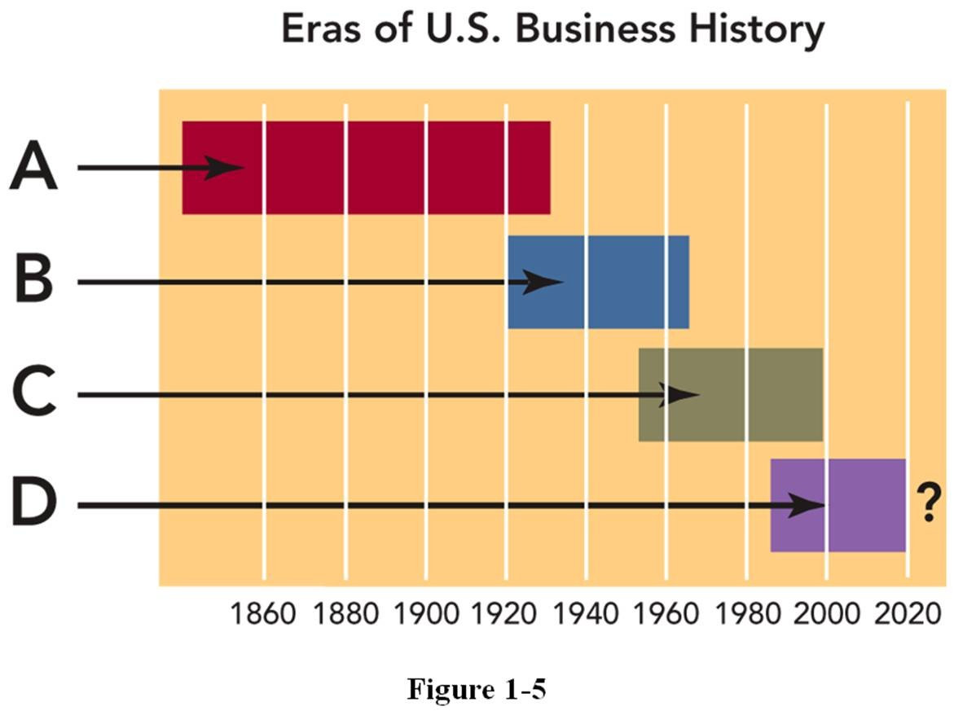
In Figure 1-5 above, "A" represents which era in U.S. business history?
- sales era
- production era
- age of consumerism
- marketing concept era
- customer relationship era

183.

184.

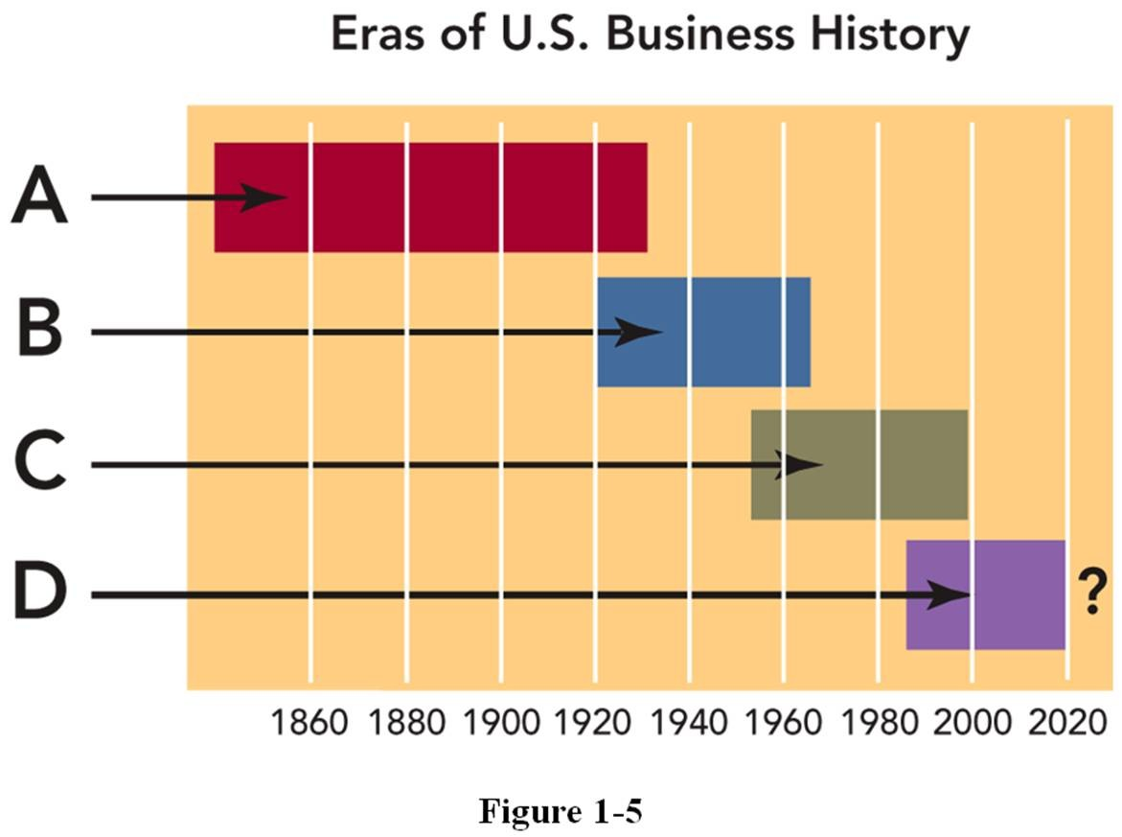
In Figure 1-5 above, letter "B" represents which era in U.S. business history?
- sales era
- production era
- age of consumerism
- marketing concept era
- customer relationship era

In Figure 1-5 above, letter "C" represents which era in U.S. business history?
- sales era
- production era
- age of consumerism
- marketing concept era
- customer relationship era

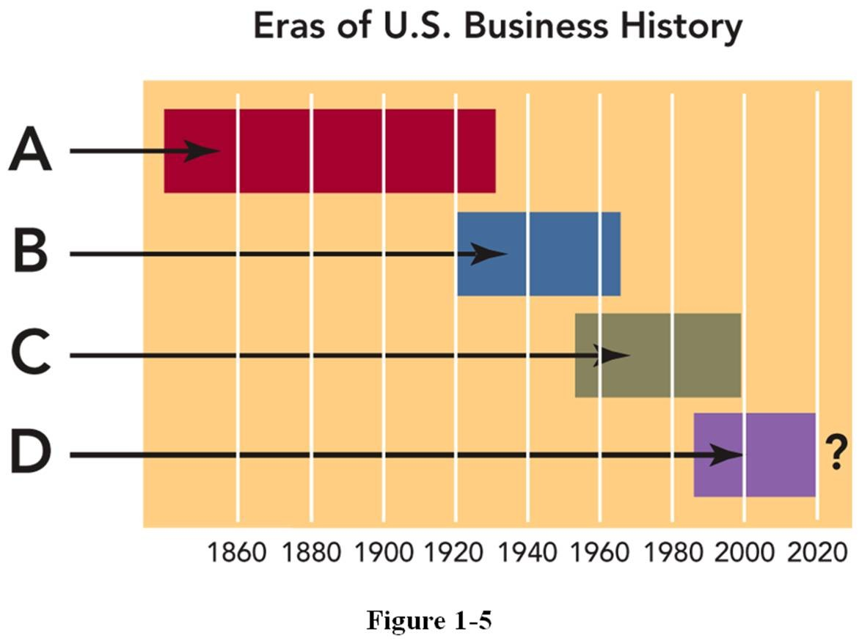185.

In Figure 1-5 above, letter "D" represents which era in U.S. business history?
  - sales era
  - production era
  - age of consumerism
  - marketing concept era
  - customer relationship era
- Customer relationship management refers to
  - the view that organizations should satisfy the needs of consumers in a way that provides for society's well being.
Bthe process of identifying prospective buyers, understanding them intimately, and developing favorable
. long-term perceptions of the organization and its offerings so that buyers will choose them in the marketplace.
C the idea that an organization should (1) strive to satisfy the needs of consumers (2) while also trying to
. achieve the organization's goals.
D the links an organization has to its individual customers, employees, suppliers, and other partners for
. their mutual long-term benefit.
E. the cluster of benefits that an organization promises customers to satisfy their needs.
- Customer relationship management (CRM) is most closely related to the era in U.S. business history.
  - customer relationship
  - production
  - sales
  - marketing concept
  - societal marketing
- The United Way of Greater Toronto (UWGT), like many charities, was sitting on a gold mine of donor data. Unfortunately, UWGT was not certain how to use that information to its greatest advantage. UWGT could blanket past donors with generic mailings, but it could not offer donors information that would convince them to donate to UWGT over other charities. Which of the following tools would be most useful for the nonprofit organization to use?
  - a flexible marketing system
  - a database warehouse
  - a customer relationship management plan
  - a competitive intelligence framework
  - a customer-oriented marketing program

- Customer experience refers to
  - the practice of building ties to customers based on a salesperson's attention and commitment to customer needs over time.
  - the links an organization has to its customers for their mutual long-term benefits.
Cthe process of identifying prospective buyers, understanding them intimately, and developing favorable
. long-term perceptions of the organization and its offerings so that buyers will choose them in the marketplace.
- the internal response that customers have to all aspects of an organization and its offerings.
- the activities in which a firm will participate in order to create a positive buying experience for the customer.
- The internal response that customers have to all aspects of an organization and its offerings is referred to as .
  - customer experience
  - relationship marketing
  - internal customer audit
  - internal marketing
  - customer relationship management
- Recently, Fortune magazine named Trader Joe's "America's hottest retailer" for its outstanding
, including personal attention from employees in the store.
  - customer value proposition
  - relationship marketing
  - customer experience
  - internal marketing
  - customer relationship management
- All of the following are aspects of Trader Joe's customer experience EXCEPT:
  - it has a large and expensive research and development facility.
  - it offers unusual food products not available from other retailers.
  - it stocks yuppie-friendly staples on its shelves.
  - it sets low prices by offering its own brands, not national ones.
  - it provides rare employee "engagement" to help customers.
- Today, the standards of marketing practice have shifted from the interests of producers to the interests of
.
  - nonprofit organizations
  - government
  - suppliers
  - resellers
  - consumers
- Social responsibility is
  - the view that organizations should satisfy the needs of consumers in a way that provides for society's well being.
  - the fundamental, passionate, and enduring principles of an organization that guide its conduct over time.
C the idea that an organization should (1) strive to satisfy the needs of consumers (2) while also trying to
. achieve the organization's goals.
D. the idea that individuals and organizations are accountable to a larger society.
Ethe recognition of the need for organizations to improve the state of people, the planet, and profit
. simultaneously if they are to achieve sustainable, long-term growth.

- The idea that individuals and organizations are accountable to a larger society is known as
  - the societal marketing concept.
  - social responsibility.
  - consumerism.
  - sustainable development.
  - capitalism.
- As organizations have changed their orientation, society's expectations of marketers have also changed.
Today, the emphasis of marketing practice has shifted from the interests of to the interests of consumers.
  - society at large
  - government
  - suppliers
  - resellers
  - producers
- You change the oil in your car yourself and dump the used oil down the sewer drain that ultimately flows into the local river. Oil manufacturers know this in not an isolated occurrence, so should they be concerned?
  - No, you paid for the oil and you can dispose of it as you like.
  - No, the oil company will someday add a premium to the price to pay for oil cleanup in the environment.
  - Yes, this is the type of situation that can get "Big Oil" a lot of bad press.
  - Yes, this is an issue of social responsibility because the polluted water affects others in the society at large.
  - No, this is an issue solely between you and your neighbors.
- Which of the following most directly explains why pharmaceutical giant Pfizer offered low-income senior citizens many of its most widely used prescriptions for $15 each per month?
  - the profit motive since aging baby boomers are a large, profitable market
  - the social responsibility concept
  - the necessity of matching competitors' actions
  - new regulatory Medicare mandates as a result of the Affordable Care Act legislation
  - the mandate by its industry's code of ethics
- The societal marketing concept
  - is the moral principles and values that govern the actions and decisions of an organization.
  - is the idea that organizations are part of a larger society and are accountable to that society for their actions.
  - actively tries to understand customer needs and satisfying them while satisfying the firm's goals.
  - involves conducting business in a way that protects the natural environment while making economic progress.
  - is the view that an organization should satisfy the needs of consumers in a way that provides for society's well being.
- The view that holds an organization should satisfy the needs of consumers in a way that also provides for society's well being is known as
  - the societal marketing concept.
  - the marketing concept.
  - consumerism.
  - social responsibility.
  - capitalism.

- Innovators at 3M developed Scotch-Brite® Never Rust Wool Soap Pads from recycled plastic bottles. Even though these soap pads are more expensive than competitive brands (Brillo and SOS), customers are willing to pay the premium price. Customers appreciate the value of a superior product (they
don't rust or scratch) and appreciate the fact that their purchase is environmentally responsible. This demonstrates that
  - an organization can be environmentally conscious while still satisfying its customers and remaining competitive in the market.
  - an organization can use a customer's sense of social responsibility to its own advantage even though the effects are minimal.
  - if a company uses recycled materials, it can always charge more than what a product is actually worth.
  - it is more important to act in a socially responsible manner than to consider the profits and goals of the organization.
  - the first brand that creates a new product gets to charge the highest price and make the greatest profits.
- What kinds of organizations engage in marketing?
  - only those that can afford to advertise
  - only very large and established for profit organizations
  - only Fortune 5,000 companies
  - every organization regardless of the kind
  - only the organization that wants to make a profit
- Which of the following organizations engage in marketing?
  - the Chicago Cubs
  - the San Francisco Opera
  - the City of Denver
  - the President of the United States
  - Every organization or individual can engage in marketing to some extent.
- Which of the following statements best describes a good?
  - Goods are physical objects.
  - Goods are the only currency that can be used in an exchange.
  - Goods are intangible concepts and thoughts about ideas or causes.
  - Goods are the benefits organizations receive for selling products and services.
  - Goods can be either tangible or intangible.
- Which of the following statements best describes a service?
  - Services are physical objects.
  - Services are intangible items.
  - Services are thoughts about concepts, actions, or causes.
  - Services are the benefits organizations receive in exchange for selling products.
  - Services comprise the subset of tangible features of products.
- Organizations such as American Airlines, U.S. Bank, and the Red Cross provide customers with products that are typically called a(n) .
  - utility
  - performance
  - service
  - value
  - idea
- A live theatre performance cannot be touched like a physical object, but is still considered a product. To a marketer, this is an example of a(n) .
  - utility
  - production
  - value
  - service
  - idea

- In marketing, thoughts about concepts, actions, or causes are referred to as
  - utilities.
  - experiences.
  - values.
  - ideas.
  - services.
- A product
  - consists of the benefits or customer value received by its sellers.
  - is the cluster of benefits that an organization promises customers to satisfy their needs.
Cis a good, service, or idea consisting of a bundle of tangible and intangible attributes that satisfy
. consumers' needs and is received in exchange for money or something else of value.
D. consists of items that the consumer purchases frequently, conveniently, and with a minimum of shopping effort.
E is the set of intangible activities or benefits that an organization provides to satisfy consumers' needs in
. exchange for money or something else of value.

- A good, service, or idea consisting of a bundle of tangible and intangible attributes that satisfies consumers' needs and is received in exchange for money or something else of value is known as a(n)
  - utility.
  - item.
  - service.
  - marketing program.
  - product.
- Which answer reflects (in order) a good, a service, and an idea that can be marketed?
  - a candy bar, a wastepaper basket, and a vending machine
  - a CD, a concert, and a souvenir T-shirt
  - a political candidate, democracy, and freedom
  - an iPod, an iPhone, and an iPad
  - a toothbrush, laser teeth whitening, and dental hygiene
- The Hermitage, a famous Russian art museum, was suffering financial difficulties as the result of lost funding and a decline in tourists. The decrease in visitors was blamed on a lack of awareness of the treasures contained in the museum. The Hermitage's director used a strategic alliance with IBM to create a website where people view some of the wonders of the Hermitage in an online virtual tour. The hope is that this sampling of paintings, sculptures, artifacts, etc. will encourage visitors to make a trip to the
Hermitage and spend enough money there to cover operational costs. The Hermitage is a(n) that uses online virtual tours to market itself worldwide.
  - good
  - idea
  - service
  - assembly
  - charity
- All of the following are examples of ideas EXCEPT:
A.State governments in Arizona and Florida marketing the notion of taking a warm, sunny winter vacations in their states.
- Apple using a TV ad to explain the features of an iPad mini (camera, screen resolution, user interface, etc.).
- the Nature Conservancy marketing the cause of protecting the environment.
- conservative politicians who attempt to persuade voters of the need to slash government spending to reduce the $17 trillion debt.
E Charities like the Red Cross marketing the idea that it's worthwhile for you to donate your time or
. money to their causes to benefit society.

- Ultimate consumers refer to
  - the people who use the products and services purchased for a household.
  - people who have already purchased a firm's product at least once, have been satisfied, and are likely to make repeat purchases.
Cpeople or organizations that have used a competitor's product and who have been dissatisfied, and who
. are still seeking a product or service to satisfy their needs.
- those manufacturers, wholesalers, retailers, and government agencies that buy goods and services for their own use or for resale.
- one or more specific groups of potential customers toward whom an organization directs its marketing program.
- The people who use the products and services purchased for a household are called
  - organizational buyers.
  - household prospects.
  - ultimate consumers.
  - a target market.
  - sellers.
- What is the marketing term for people, whether they are 80 years or 8 months old, who use products and services purchased for a household?
  - ultimate consumers
  - situational buyers
  - primary buyers
  - a target market
  - household prospects
- Time Inc. has published a new magazine, All You, which is distributed only in Walmart stores. Who is the ultimate consumer for this magazine?
  - the person who buys the magazine to read at home
  - the person who stocks the magazine rack at Walmart
  - the person who browses the magazine in the store but does not buy it
  - the salesperson for Time Inc. who sold the magazine to Walmart
  - All people, from the writer, to the seller, to the reader at home, are the ultimate consumers.
- Which of the following is an example of an ultimate consumer?
  - a newspaper reporter who receives a plane ticket to Washington, D.C. to cover the presidential inauguration
  - a school teacher who bought a ticket to the Summer Olympics opening ceremonies
  - an office receptionist who renews the magazines that are found in the office waiting room
  - a retailer who buys poster board to make signs for an upcoming store sale
  - a landscaping firm employee who buys a new wheelbarrow to use to haul mulch
- Entities such as manufacturers, retailers, and government agencies that buy goods and services for their own use or for resale are referred to as
  - intermediate buyers.
  - selling agents.
  - organizational buyers.
  - manufacturing agents.
  - brokers.
- Organizational buyers are described as
  - only purchasers of raw materials and natural resources.
  - employees who purchase household items for their personal use.
  - any individual or group making a purchase worth over $100,000.
  - manufacturers, retailers, or government agencies that buy products for their own use or for resale.
  - any man, woman, or child who uses products purchased for a household.

- Which of the following is the best example of an organizational buyer?
  - a mother buying milk for her young son
  - a store owner buying hand-painted slate signs to sell in her store
  - a computer programmer buying the latest game for his Xbox
  - a botanist buying a rose bush for his home garden
  - a parent buying a softball glove for a daughter
- Effective marketing benefits society because it
  - reduces competition, making the playing field more even.
  - improves the quality of products and services regardless of the cost.
  - allows companies to charge whatever price they want, regardless of product quality.
  - makes countries more competitive in world markets while simultaneously reducing competition in their home markets.
  - enhances competition, which improves the quality of products and services and lowers their prices.
- Utility refers to
  - the number of alternative uses or benefits that can be provided by a single product or service.
  - the adaptability of a marketing program to adjust to changes in the marketing environment.
  - the benefits or customer value received by users of the product.
  - the fixed costs associated with the production of a single unit of a product within a product line.
  - the variable costs associated with the production of a single unit of a product within a product line.
- The benefits or customer value received by users of a product is called .
  - utility
  - synergy
  - consumerism
  - cost-benefit ratio
  - customer lifetime value
- The four utilities marketing creates are
  - product, price, promotion, and place.
  - form, function, value, and people.
  - monopoly, monopolistic competition, pure competition, and oligopoly.
  - form, place, time, and possession.
  - natural gas, fossil fuel, electricity, and water.
- The value to consumers that comes from the production or alteration of a product or service constitutes
utility.
  - time
  - place
  - possession
  - market
  - form
- Which of the following is an example of form utility?
  - an iPhone with a "multitouch" user interface for easy navigation
  - stamp vending machines that are located in drug stores
  - a service station that has a 24-hour ice machine available for use when the station is closed
  - a mobile phone company that offers six-month financing, same as cash
  - a gourmet candy store that offers a home delivery service
- FreshCase packaging is the first-ever vacuum package for red meat that maintains the meat's appetizing color, reducing both food and plastic waste. This is an example of creating utility in the case-ready meat category.
  - time
  - place
  - form
  - possession
  - market

- The process of taking wool off sheep and using it to make soft sweaters shows how manufacturing can create utility.
  - time
  - form
  - place
  - possession
  - market
- The process of turning corn into ethanol shows how BioFuel Energy, a Minnesota ethanol producer, can create utility.
  - time
  - place
  - possession
  - market
  - form
- The value to consumers that comes from having the offering available where consumers need it constitutes utility.
  - time
  - place
  - possession
  - market
  - form
- Which of the following statements is an example of place utility?
  - airlines that allow you to print your own boarding pass at home
  - a service station that adds a diesel fuel pump to its three unleaded gasoline pumps
  - a mobile phone company that offers six-month financing, same as cash
  - cold cut packages that can be zipped close for reuse
  - an iPhone with a "multitouch" user interface for easy navigation
- The value to consumers that comes from having the offering available when they need it constitutes
utility.
  - place
  - possession
  - market
  - time
  - form
- What utility does UPS provide when it delivers new DVD releases to Best Buy stores before the Tuesday national release day?
  - time utility
  - place utility
  - possession utility
  - market utility
  - form utility
- Dick's Sporting Goods carries baseballs all year around. The same is true for footballs and tennis equipment. With this all-year-around strategy, Dick's Sporting Goods offers utility for these products.
  - time
  - place
  - possession
  - market
  - form

- Which of the following is an example of time utility?
  - an iPhone with a "multitouch" user interface for easy navigation
  - Goodwill that has a 24-hour drop off box for clothing donations
  - a dry cleaners that is located inside a supermarket
  - a mobile phone company that offers six-month financing, same as cash
  - a new herbal supplement that offers a 30-day free trial
- Redbox places vending machines at local convenience and grocery stores that allow customers to rent and return popular DVDs 24 hours a day. This creates both and utilities.
  - form and place
  - form and time
  - place and time
  - time and possession
  - form and possession
- The value to consumers that comes from making an item easy to purchase through the provision of credit cards and financial arrangements constitutes utility.
  - time
  - place
  - market
  - possession
  - form
- Which of the following is an example of possession utility?
  - an iPhone with a large selection of new "apps"
  - the local dairy that offers to deliver bottles of milk to a customer's doorstep
  - disposable diapers that come equipped with resealable tabs
  - a gourmet food store that carries a line of ready-made salads
  - a mobile phone company that offers six-month financing, same as cash
- Robert was running low on cash and could not buy his Marketing textbook by the first day of class if the bookstore did not accept his credit card. Luckily, the bookstore accepted his VISA card, so the bookstore created utility for Robert.
  - form
  - time
  - price
  - possession
  - place
- The founder of Chobani Greek Yogurt, who won the 2013 Ernst & Young World Entrepreneur of the Year award, is
  - Mark Zuckerberg.
  - "Trader" Joe Demapolis.
  - Hamdi Ulukaya.
  - Robert M. McMath.
  - David Windorski.
- The difference between "Greek" yogurt and "American" yogurt is that the latter
  - has a thick texture.
  - is too thin.
  - is not sweet enough for health-conscience palettes.
  - is only sold in health or natural food stores.
  - has high protein content.

- All of the following are points of difference for Chobani Greek Yogurt EXCEPT:
  - a shorter, wider cup that was more visible on retailers' shelves.
  - preservative-free.
  - a bit lower in protein than regular yogurt.
  - proprietary animal-based thickener to make its "Greek-style" yogurts.
  - a straining process that removes excess liquid whey.
- All of the following current or prospective distribution channels for Chobani Greek Yogurt

EXCEPT:
  - convenience stores.
  - drug stores.
  - mass merchandisers.
  - supermarkets.
  - vending machines.
- Chobani used all of the following tactics to promote its Chobani Greek Yogurt EXCEPT:
  - sponsored the Food Network's Rachel vs. Guy Kids Kick-Off TV show with its Chobani Champions®
Tubes.
  - created a website to provide consumers with recipes that use Chobani Greek Yogurt.
  - sponsored the 2012 U.S. Olympic Team.
  - used its CHOmobile to offer samples of its Greek Yogurt to first-time customers.
  - relied on word-of-mouth in its early years.
- Describe the marketing mix actions mentioned in the textbook that Chobani has taken since its founding in 2005.

- Why are you, as a student, already somewhat of a marketing expert before taking this course? Provide a specific example from your own personal experience and relate it to something you just "formally" learned about marketing.

- What is the abridged American Marketing Association definition of marketing according to the textbook?
How does this differ from your previous notion of marketing before beginning this course?

- What are the two key objectives of marketing? Define "exchange" and explain how it supports these objectives.

- Some people may assume that for a marketer, the only thing of value for which he or she
would "exchange" would be monetary (check, credit/debit, currency, and/or coin transactions). But what else can be exchanged? Provide an example of a nonmonetary transaction that still fits the criteria of exchange.

- In addition to consumers, what other people, groups, and environmental forces interact to influence an organization's marketing activities?

- What four factors are required for marketing to occur?

- In China, many people are removing their money from the state banks and lending it out themselves.
The interest rate earned in a state bank account is about one-half the rate of inflation. On the other hand, loaning money to friends, relatives, and even unrelated entrepreneurs can often earn the investor a rate at least double the inflation rate. The gray market, an underground network of investors and private businesses, moves the cash from lenders to businesses. Did marketing occur here? Explain your answer.

- Add your own personal experience and creativity to what you have just learned about marketing.
Formulate a plan to assess the needs of either (1) students who have too many textbooks to carry to and from class or (2) executives who are too busy to keep up with the latest information in their field.

- Define needs and wants. Can marketing shape a person's wants? Explain your answer.

- What are the three components of a person's ability to buy an offering?

- Explain the difference between a market and a target market. Provide a specific example of each.

- Describe two different target markets for two different products or services you, your friends, or your family have recently purchased or used.

- An inventor designs a scissors that has interchangeable blades that allow the user to switch from straight cuts to decorative cuts. Identify two possible target markets and explain your answer.

- Marketing managers used a combination of four tools in order to develop a complete marketing program to reach consumers. Briefly define these four tools.

- Imagine you have the sole marketing rights to a new herbal shampoo that stops hair loss and actually causes new hair growth. You plan to sell your product on an Internet website, which you will advertise on late night television. You are also hoping to obtain free publicity to place stories in men's fashion magazines. You are planning to sell online a 15-ounce bottle for $24.99 plus $7.99 shipping and handling. Using the information provided, identify each element of your marketing mix.

- List the five environmental forces in a marketing decision that generally are outside the control of marketing managers.

- Why do some marketers feel that environmental forces are NOT entirely outside their influence?

- Do college students have a choice in which classes they take to earn a degree? Use what you have learned about the controllable and uncontrollable aspects of marketing in terms of how they might relate to course selection decision-making. Incorporate marketing terms in your response.

265.

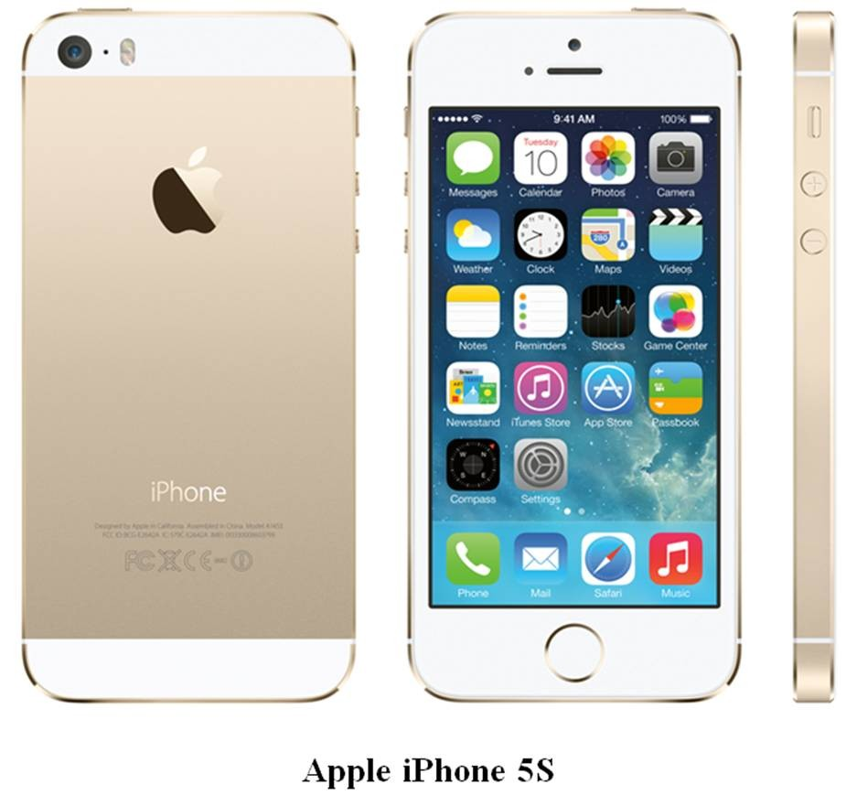
The Apple iPhone 5S (shown above) is rated by Consumer Reports as being one of the best smartphones in the industry. Define customer value. In what ways do you think the Apple iPhone 5S provides value for its customers?

- Assume you are a salesperson for a direct marketing firm that does "in-home" jewelry parties. If most of your hosts or hostesses hold only one party a year, what strategies could you use to build strong customer relationships? If you are creating your own business for this example, make sure to describe your product(s) in your introductory sentence.

- During October, kiosk or "pop-up" stores often appear in many malls for the holiday season. Typically, these kiosks sell gift boxes of cheese, jewelry, and other items people think are appropriate seasonal gifts. In January, these "pop-up" retailers vanish. Is it possible for such a retailer to use relationship marketing? Explain your answer.

- Twitter is a website that offers a social networking service, enabling its users to send and read other users' messages or conversations called tweets, which are text-based posts of up to 140 characters displayed
on the user's profile page. Connected to each "tweet" is a rich details pane that provides additional information, deeper context, and embedded media. Companies are just beginning to use Twitter as a tool in their relationship marketing programs. In what ways could Twitter be used to benefit both the customer and the organization?

- Explain the marketing program that 3M used to reach the student target market for the Post-it® Flag Highlighter and the rationale used for each element of the marketing mix.

- Explain the marketing program 3M used to reach the office worker segment with its Post-it® Flag Pen.

- Many market-oriented, older manufacturing organizations have experienced four distinct stages in the life of their firms. Beginning with the 1860s, list and define each of the four eras of U.S. business history.

- Define the marketing concept.

- It is said that goods, services, and ideas are marketed. Define goods, services, and ideas and give at least one example of each.

- What are the primary differences between an ultimate consumer and an organizational buyer? Select one product and explain the differences in either its use or purchase, depending on whether it was purchased by an ultimate consumer or an organizational buyer.

- In our free-enterprise society, which three specific groups benefit from effective marketing?

- Explain what is meant by the concept of marketing utility. Identify and describe the four utilities created by marketing.

- At the BMW website, BMW.com, you can design your own BMW with the exact features you desire. If you choose to use this method to purchase a car, what type of utility(ies) has(have) been created?

- Explain Chobani's product strategy that makes Chobani Greek Yogurt different from its principal competitors.

- Describe Chobani's distribution (place) strategy.

1. (p. 2) D

2. (p. 2) C

3. (p. 2-4) B

4. (p. 4) E

5. (p. 5) D

6. (p. 5) C

7. (p. 5) E

8. (p. 5) E

9. (p. 5) D

10. (p. 5) D

11. (p. 5) E

12. (p. 5) C

13. (p. 5) B

14. (p. 5-7) C

15. (p. 5) A

16. (p. 5) B

17. (p. 5) E

18. (p. 5) D

19. (p. 5) B

20. (p. 5) A

21. (p. 5) B

22. (p. 5) C

23. (p. 5) C

24. (p. 5) A

25. (p. 5) B

26. (p. 5) B

27. (p. 5) D

28. (p. 5) E

29. (p. 6) E

30. (p. 6) B

31. (p. 6) E

32. (p. 6) D

33. (p. 6) D

34. (p. 6) B

35. (p. 6) E

36. (p. 6) B

1 Key

37. (p. 6) A

38. (p. 6) E

39. (p. 6) B

40. (p. 6) D

41. (p. 6) B

42. (p. 6-7) C

43. (p. 6-7) E

44. (p. 6-7) D

45. (p. 6-7) A

46. (p. 6-7) B

47. (p. 6-7) D

48. (p. 6-7) C

49. (p. 6-7) B

50. (p. 6-7) C

51. (p. 6-7) B

52. (p. 6-7) D

53. (p. 6-7) A

54. (p. 6-7) D

55. (p. 6-7) B

56. (p. 7) D

57. (p. 7) E

58. (p. 8) B

59. (p. 8) E

60. (p. 8) C

61. (p. 8) E

62. (p. 8) D

63. (p. 8) C

64. (p. 8-9) E

65. (p. 8-9) A

66. (p. 8-9) B

67. (p. 9) B

68. (p. 9) E

69. (p. 9) D

70. (p. 9) D

71. (p. 9) C

72. (p. 9) D

73. (p. 9) A

74. (p. 9-10) E

75. (p. 9-10) A

76. (p. 9) C

77. (p. 9) B

78. (p. 9) A

79. (p. 9) C

80. (p. 10) B

81. (p. 10) E

82. (p. 10) D

83. (p. 10) A

84. (p. 10) D

85. (p. 10) B

86. (p. 10) B

87. (p. 10) D

88. (p. 10) E

89. (p. 10) C

90. (p. 10) B

91. (p. 10) C

92. (p. 10) D

93. (p. 10) A

94. (p. 10) D

95. (p. 10) B

96. (p. 10) C

97. (p. 10) E

98. (p. 10) D

99. (p. 10) A

100. (p. 10) C

101. (p. 10) B

102. (p. 10) B

103. (p. 10) E

104. (p. 10) C

105. (p. 10) B

106. (p. 10) D

107. (p. 10) C

108. (p. 10) C

109. (p. 10) D

110. (p. 10) A

111. (p. 10) D

112. (p. 10) E

113. (p. 10) E

114. (p. 10) A

115. (p. 11) B

116. (p. 11) C

117. (p. 11) D

118. (p. 11) B

119. (p. 11) D

120. (p. 11) A

121. (p. 11) D

122. (p. 11) C

123. (p. 11) A

124. (p. 11) C

125. (p. 11) E

126. (p. 11) A

127. (p. 11) D

128. (p. 11-12) E

129. (p. 11-12) E

130. (p. 11-12) B

131. (p. 11-12) A

132. (p. 11-12) D

133. (p. 11-12) D

134. (p. 11-12) D

135. (p. 12) C

136. (p. 12) A

137. (p. 12) C

138. (p. 12) B

139. (p. 12) E

140. (p. 12) A

141. (p. 12) A

142. (p. 12) B

143. (p. 12) D

144. (p. 12) D

145. (p. 12) A

146. (p. 12) D

147. (p. 12) A

148. (p. 13) D

149. (p. 13) E

150. (p. 13-14) C

151. (p. 13-14) B

152. (p. 13-14) A

153. (p. 13-14) D

154. (p. 13-14) E

155. (p. 13-14) C

156. (p. 15) A

157. (p. 15) C

158. (p. 15) B

159. (p. 15) A

160. (p. 15) C

161. (p. 15) D

162. (p. 15) B

163. (p. 15) C

164. (p. 15) C

165. (p. 15) E

166. (p. 15) A

167. (p. 15) E

168. (p. 15) C

169. (p. 15) D

170. (p. 15) B

171. (p. 15) A

172. (p. 15) B

173. (p. 15) E

174. (p. 15) D

175. (p. 15) E

176. (p. 15) A

177. (p. 15) B

178. (p. 15) E

179. (p. 15) C

180. (p. 15) D

181. (p. 15) D

182. (p. 15) B

183. (p. 15) A

184. (p. 15) D

185. (p. 15) E

186. (p. 15) B

187. (p. 15) A

188. (p. 15) C

189. (p. 16) D

190. (p. 16) A

191. (p. 16) C

192. (p. 16) A

193. (p. 17) E

194. (p. 17) D

195. (p. 17) B

196. (p. 17) E

197. (p. 17) D

198. (p. 17) B

199. (p. 17) E

200. (p. 17) A

201. (p. 17) A

202. (p. 17-18) D

203. (p. 17-18) E

204. (p. 18) A

205. (p. 18) B

206. (p. 18) C

207. (p. 18) D

208. (p. 18) D

209. (p. 18) C

210. (p. 18) E

211. (p. 18) E

212. (p. 18) C

213. (p. 18) B

214. (p. 18) A

215. (p. 18) C

216. (p. 18) A

217. (p. 18) A

218. (p. 18) B

219. (p. 18) C

220. (p. 18) D

221. (p. 18) B

222. (p. 19) E

223. (p. 19) C

224. (p. 19) A

225. (p. 19) D

226. (p. 19) E

227. (p. 19) A

228. (p. 19) C

229. (p. 19) B

230. (p. 19) E

231. (p. 19) B

232. (p. 19) A

233. (p. 19) D

234. (p. 19) A

235. (p. 19) A

236. (p. 19) B

237. (p. 19) C

238. (p. 19) D

239. (p. 19) E

240. (p. 19) D

241. (p. 21) C

242. (p. 21) B

243. (p. 21-22) D

244. (p. 22) E

245. (p. 22-23) A

- (p. 2-4, 21-23) Product actions. (1) In 2005, Turkish immigrant Hamdi Ulukaya developed Chobani yogurt, a strained yogurt that is a little bit sour, like sour cream, has much more protein, fewer calories, and more calcium than the traditional American yogurts. (2) In 2011, Chobani introduced its Champion Tubes Greek yogurt line for kids. (3) In 2013, Chobani expanded its main product line by adding more flavors like Coconut, Banana, and Key Lime that were suggested by customers. Price actions. The text does not describe any pricing action that Chobani took. Promotion actions. (1) Initially, Chobani had little money for traditional advertising, so it relied on positive "word-of-mouth"—one happy
customer telling another about this new Chobani Greek yogurt. (2) In 2010, Chobani used its "CHOmobile" to hand out free samples to encourage consumers to try Greek Yogurt for the first time. (3) In 2012, Chobani sponsored the London Olympics and Paralympic Games. (4) Chobani also aired a TV ad called "Proudly with You" during these Olympics. (5) Chobani uses social media such as Facebook, YouTube (which feature "Just as Good" recipes to show customers how to use its tasty products in meals and desserts), Pinterest, Instagram, Twitter, and other social media sites. (6) In 2011, Chobani hired former 2-time Olympian women's softball pitcher Jennie Finch as spokesperson to promote the Champions brand. Place (distribution) actions. (1) Initially, Chobani wanted to distribute its Greek yogurt in the main dairy cases of major grocery chains, not in the niche or organic sections of these chains nor in natural foods or specialty stores. (2) By 2009, Chobani could be found in the main dairy cases of chains like Stop & Shop, BJ's, and Costco. (3) In 2010, Chobani used its "CHOmobile." (4) In 2013, Chobani Greek Yogurt was sold in the U.S., Canada, and Australia. (5) In 2012, Chobani opened its first "yogurt bar," called Chobani SoHo, in New York City—a store that will feature "a collection of non-frozen, yogurt-based creations."

- (p. 4) Students are, in a sense, marketing experts because they engage in many marketing activities every day. Experience in shopping for products gives students great insights into the world of marketing. As consumers, students have been involved in thousands of marketing decisions, but mostly on the buying and not the selling side. For example, right before class a student may have bought lunch in the school cafeteria—as a buyer in a marketing activity.

- (p. 5) The American Marketing Association represents marketing professionals. Combining its 2004 and 2007 definitions, "Marketing is the activity for creating, communicating, delivering, and exchanging offerings that benefit its customers, the organization, its stakeholders, and
society at large." This definition shows marketing to be a far broader activity than simply advertising or personal selling. It stresses the importance of delivering genuine benefits in the offerings of products, services, and ideas marketed to customers. Also, note that the organization doing the marketing, the stakeholders affected (such as customers, employees, suppliers, and shareholders), and society should all benefit.

- (p. 5) To serve both buyers and sellers, marketing seeks (1) to discover the needs and wants of prospective customers and (2) to satisfy them. The key to achieving these two objectives is the idea of exchange, which is the trade of things of value between buyer and seller so that each is better off after the trade. If an exchange takes place, then marketers will have been successful in achieving these two objectives, since each party must be better off after the trade.

- (p. 5) Exchange is the trade of things of value between buyer and seller so that each is better off after the trade. This could include exchange of votes for political leadership, donations of time in exchange for feelings of generosity, etc. It would also include barter, the practice of exchanging products and services for other products and services rather than for money in both domestic and global markets.

- (p. 6) Foremost is the organization itself, whose mission and objectives determine what business it is in and what goals it seeks. Within the organization, management is responsible for establishing these goals. The marketing department works closely with a network of other
departments and employees to help provide the customer-satisfying products required for the organization to survive and prosper. The marketing department is responsible for facilitating relationships, partnerships, and alliances with the organization's customers, its shareholders (or often representatives of groups served by a nonprofit organization), its suppliers, and other organizations. Environmental forces such as social, economic, technological, competitive, and regulatory forces also shape an organization's marketing activities. Finally, an organization's marketing decisions are affected by and, in turn, often have an important impact on society as a whole. The organization must strike an acceptable balance among all these influences. See Figure 1-2 in the textbook.

- (p. 6-7) For marketing to occur, four factors are required: (1) two or more parties (individuals or organizations) with unsatisfied needs; (2) a desire and ability on their parts to satisfy these needs; (3) a way for the parties to communicate; and (4) something to exchange.

- (p. 6-7) To answer this question, students will need to know the four factors that are required for marketing to occur. (1) There must be two or more parties with unsatisfied needs. The lenders want to receive a higher interest rate on their funds and the businesses need short-term loans. (2) There must be a desire and an ability to satisfy those needs. The lenders want to receive a higher interest rate on their funds and the
businesses need short-term loans. The money is available since the lenders removed it from the state banks. (3) There must be a way for the parties to communicate. Word-of-mouth from the gray market, an underground network, allows communication between the lenders and businesses. (4) There must be something to exchange. Cash was exchanged in the form of loans, repaid with interest. Students should be able to see that marketing did indeed occur.

- (p. 7-8) A quality answer will include multiple techniques. Even though this is not the "market research" chapter, there are textbook examples of observation, questioning, involvement of stakeholders in the research process, discussions, etc. used to discover needs. The emphasis should be placed on gathering as much information as possible prior to development of the product itself.

- (p. 9) A need occurs when a person feels deprived of basic necessities like food, clothing, and shelter. A want is a need that is shaped by a person's knowledge, culture, and personality. However, psychologists and economists still debate the exact meanings of need and want. Effective marketing, in the form of creating an awareness of good products at convenient locations, can clearly shape a person's wants. Certainly, marketing tries to influence what we buy. A principal activity of a firm's marketing department is to scrutinize its consumers to understand what they need and want and the trends and factors that shape them. However, a key issue is the amount of freedom given to prospective customers to make their own buying decisions.

- (p. 9) The three components of a person's ability to buy an offering are authority, time, and money.

- (p. 9-10) Potential consumers make up a market, which consists of people with both the desire and the ability to buy a specific product. All markets ultimately are people. A target market is one or more specific groups of potential consumers toward which an organization directs its marketing program. An example of a market is the tablet device market, of which the iPad is a market leader. An example of a target market for tablet devices would be college students who want their textbooks in digital, not printed format, for the convenience (no more heavy books) and lower cost (due to the digital delivery of the content).

- (p. 10) A target market is a specific group of potential consumers toward which an organization directs its marketing program. In response to this question, students might define the target market for a local baseball team as people who live in the area, perhaps skewed toward males, and 25 to 84 years of age. Another interesting answer is to examine how one product, such as a Toyota 4-Runner, can have two different target markets. One target market might be the adventurous outdoor mountain biker who uses the vehicle to transport his or her equipment to the
mountains to bike. The other target market might be a "soccer mom" with children and equipment to transport to the local soccer field for practice.

- (p. 10) A target market is a specific group of potential consumers toward whom an organization directs its marketing program. While anyone might benefit from using the product, a quality answer should link the benefits of the product (interchangeable straight and decorative blades) to the specific needs of a specific group. For example, scrapbook makers could use the straight blade when trimming pictures and use decorative blades when cutting backgrounds pages for their albums. The same scissors might be targeted for school teachers to create decorative flyers to post on bulletin boards regarding upcoming events for their students.

- (p. 10) To reach consumers, marketing managers use four tools, often called, "the 4 Ps." These include: (1) product—a good, service, or idea to satisfy the consumers' needs; (2) price—what is exchanged for the product; (3) promotion—a means of communication between the seller and buyer; and (4) place (or distribution)—a means of getting the product to the consumer.

- (p. 10) The shampoo is the product element. The Internet website is the place element. The ads on late night television and the publicity are the promotion element. The price element is the $24.99 price plus the $7.99 for shipping and handling.

- (p. 10-11) The five environmental forces mainly beyond most executives' control include social, economic, technological, competitive, and regulatory forces. These five forces may serve as accelerators or brakes on marketing, sometimes expanding an organization's marketing opportunities while at other times restricting them.

- (p. 10-11) Traditionally, many marketing executives have treated these environmental factors as rigid, absolute constraints that are entirely outside their influence. However, recent studies and marketing successes have shown that a forward-looking, action-oriented firm can often affect some environmental factors, for example, by achieving technological or competitive breakthroughs.

- (p. 10-11) Most colleges and universities offer some courses that are "required"—the "core" courses in the major as well as social sciences— while others are "elective." These are the "product" or "service" element of the educational offering. The "price" element would be the tuition paid, less any scholarships. The promotion element would consist of the communication between the educational institution and students, such as e- mails, ads in high school career counseling offices, course catalogs, etc. The place element would consist of the on-campus location, off-campus location, and/or the online website that delivers courses that fulfill the core and elective requirements for the majors students select. A quality answer for this question should be based on how well the student is able to give specific examples.

- (p. 11-12) Customer value is the unique combination of benefits received by targeted buyers that includes quality, convenience, on-time delivery, and both before-sale and after-sale service at a specific price. Many successful firms have chosen to deliver outstanding customer value with one of three value strategies: best price, best product, or best service. Apple uses the best product and best service strategies for its iPhone 5S, which Consumer Reports rates as one of the best smartphones on the market. Smartphones users may cite the iPhone's display, ease of use of its multitouch user interface, voice quality, messaging, camera, video game capability, durability, battery life, etc., as key product-related benefits that contribute to its customer value.

- (p. 12) A quality answer should have a strong emphasis on regular, sustained communication with customers and jewelry representatives, whether it is through personal contact by phone, notes, e-mails, etc. Answers that are creative and supply product-specific examples should be encouraged.

- (p. 12) Generally, students will say "no" based on the definition of relationship marketing. The textbook defines relationship marketing as linking the organization to its individual customers, employees, suppliers, and other partners for their mutual long-term benefits. In an ideal setting, relationship marketing involves a personal, ongoing relationship between the organization and an individual customer. However, this is based on the idea that the kiosks are not there long enough to establish a long-term relationship. Very insightful students may see an opportunity for these retailers (who return year after year) to develop long-term multiyear relationships. Databases would allow direct mail notifications each fall that the prized gifts are again available. Also, kiosk marketers could send customers e-mails throughout the winter, spring, and summer about specials, new products, and other offers to stimulate year-round purchases via a dedicated website.

- (p. 12) One aspect of Twitter is that it allows organizations to get customer feedback in "real time." It provides the organization with information about "followers" in a larger and more open forum. It also provides access to ideas that might result in new or improved products that would benefit the customer. It could also allow companies to communicate with its customers in a frequent, informal, and friendly way to support the relationship.

- (p. 13-14) Answers should address all four "Ps." (1) The product strategy included offering the Post-it® Flag Highlighter to help college students with their studying. 3M listened carefully to the needs and wants of potential customer segments to use 3M technology to introduce a useful, innovative product. (2) The price strategy sought a retail price of about $3.99-$4.99 for a single the Post-it® Flag Highlighter or $5.99-
$7.99 for a three-pack. The idea was to set prices that provide genuine value to the customer segment that was targeted. (3) The promotion strategy was to run limited promotion with a TV ad and some ads in college newspapers and then rely on student word-of-mouth messages to inform other students of the product. This would increase awareness of potential users in the student segment who had never heard of this new, innovative 3M product. (4) The place strategy was to distribute the Post-it® Flag Highlighter through college and university bookstores, office supply stores, and mass merchandisers. This made it easy for prospective buyers to buy at convenient retail outlets. See Figure 1-4 in the textbook.

- (p. 13-14) A marketing program integrates the marketing mix elements to provide a good, service, or idea to prospective buyers. (1) 3M's product strategy to reach the office worker segment is to offer the Post-it® Flag Pen to help office workers in their day-to-day work activities. 3M listened carefully to the needs and wants of potential customer segments to use 3M technology to introduce a useful, innovative product. (2) 3M's price strategy is to seek a retail price of about $3.99-$4.99 for a single Post-it® Flag Pen; wholesale prices are less. This price provides genuine value to the office worker segment. (3) 3M's promotion strategy is to run limited promotion among distributors to get them to stock the product.
(4) 3M's place strategy is to distribute Post-it® Flag Pens through office wholesalers and retailers as well as mass merchandisers. See Figure 1-4 in the textbook.

- (p. 15) (1) During the production era, which started on the 1860s until the 1920s, goods were scarce so buyers were willing to accept virtually any goods that were produced and made do with what was available. The central notion was that products would sell themselves, so the major concern of business firms was production, not marketing. (2) The next era was the sales era, which occurred from the 1920s to the 1960s. During that time, firms discovered that they could produce more goods than their regular buyers could consume. Competition grew. The usual solution was to hire more salespeople to find new buyers. (3) The marketing concept era began in the late 1950s when marketing concept became the motivating force among many American firms. The marketing concept is the idea that an organization should strive to satisfy the
needs of consumers while also trying to achieve the organization's goals. (4) The latest era is the customer relationship era, which began in the late 1990s. Here, firms practice a market orientation by focusing efforts on continuously collecting information about customers' needs, sharing the information across departments, and using it to create customer value.

- (p. 15) The marketing concept is the idea that an organization should (1) strive to satisfy the needs of consumers (2) while also trying to achieve the organization's goals.

- (p. 18) Goods are physical objects, such as toothpaste, cameras, or computers that satisfy consumer needs. Services are intangible items such as airline trips, financial advice, or art museums. Ideas are intangibles involving thoughts about actions or causes such as donating to a charity or voting for a political candidate.

- (p. 18) Students' examples will differ, but each example should be descriptive of the definition. Ultimate consumers are the people who use the products and services purchased for a household. For example, a flat screen high definition television could be purchased by any member of a
family and used by all for personal enjoyment. Organizational buyers are those manufacturers, wholesalers, retailers, and government agencies that buy products and services for their own use or for resale. A hospital might buy the same television model (most likely in larger quantities) for use in patients' rooms to add value by enhancing their hospital stays.

- (p. 18-19) The three specific groups that benefit from effective marketing are: (1) consumers who buy (they can obtain the best product at the lowest price, leading to consumer satisfaction); (2) organizations that sell (receive profits, etc., if they provide need-satisfying products with effective marketing programs); and (3) society as a whole (providing jobs and a higher standard of living for its citizens).

- (p. 19) Marketing creates utility, the benefits or customer value received by users of the product. This utility is the result of the marketing exchange process and the way society benefits from marketing. The four utilities include form, place, time, and possession. The production or alteration of goods or services constitutes form utility. Place utility means having a good or service available where needed, whereas time utility is the value to consumers of having a good or service available when needed. Possession utility is the value to consumers of making an item easy to purchase, such as with a convenient credit card, so consumers can use it.

- (p. 19) Form utility comes from the production or alteration of a product or service that provides value to consumers. Form utility is created when you can design and build your own personal BMW at the BMW's website, BMW.com. In addition, BMW provides possession utility, which is the value of making an item easy to purchase through the provision of credit cards or financial arrangements for payment. Here, BMW also provides possession utility by allowing customers to buy a car online. Eventually, they will have to go to a local dealer to pick up their cars, an example of place utility. Finally, BMW provides time utility because building a BMW car online saves consumers from taking time to visit dealerships to see if their preferred car is on the lot. The BMW website also provides information to make the external information search process more efficient (see Chapters 5 and 21).

- (p. 2, 4, 21-22) The Chobani product strategy stresses its authentic straining process that removes excess liquid whey. This results in a thicker, creamier yogurt that yields 13 to 18 grams of protein per single-serve cup, depending on the flavor. Chobani Greek Yogurt is free of ingredients like milk protein concentrate and animal-based thickeners, which some manufacturers add to make "Greek-style" yogurts. Chobani uses three pounds of milk to make one pound of Chobani Greek Yogurt. Some other features that make its yogurt "nothing but good," to quote its tagline:
(1) Higher in protein than regular yogurt; (2) Made with real fruit and only natural ingredients; (3) Preservative-free; (4) No artificial flavors or artificial sweeteners; and (5) Contains five live and active cultures, including three probiotics. Chobani also uses European-style cups with a
circular opening exactly 95 millimeters across. This made for a shorter, wider cup that was more visible on retailer's shelves. Moreover, instead of painted-on labels, Chobani uses shrink-on plastic sleeves that adhere to the cup and offer eye-popping colors. Today, Chobani offers its hallmark Chobani Greek Yogurt in single-serve and multi-serve sizes, while expanding its authentic strained Greek yogurt to new occasions and forms (Chobani Bite—to reach the "indulgent" segment wanting a healthy snack; Chobani Champions Tubes—targeted at kids; and Chobani Flip—a two compartment package that lets consumers "flip" mix-ins like granola into the Chobani Greek Yogurt compartment.

- (p. 2, 21-22) From the beginning, Chobani pushed for distribution in major grocery chains/supermarkets in the conventional yogurt aisle located within their main dairy cases and not on specialty shelves, in health food stores, health food sections of these chains or in smaller, niche stores. By 2009, Chobani could be found in the main dairy cases of chains like Stop & Shop, BJ's, and Costco. Today, Chobani Greek Yogurt is widely distributed in both conventional and mass supermarkets, club stores, and natural food stores. On the horizon: growing distribution in
convenience and drugstores. Chobani is also focused on educating food service directors at schools across the United States about Greek yogurt's health benefits for kids. By 2013, Chobani Greek Yogurt was sold nationwide in the United States, the United Kingdom, and Australia.

1 Summary
Category # of Questions
AACSB: Analytic 277
AACSB: Technology 2
Accessibility: Keyboard Navigation 226
Blooms: Apply 94
Blooms: Remember 94
Blooms: Understand 91
Difficulty: 1 Easy 94
Difficulty: 2 Medium 91
Difficulty: 3 Hard 94
Kerin - Chapter 01 279
Learning Objective: 01-01 Define marketing and identify the diverse factors that influence marketing actions. 60
Learning Objective: 01-02 Explain how marketing discovers and satisfies consumer needs. 43
Learning Objective: 01-03 Distinguish between marketing mix factors and environmental forces. 44
Learning Objective: 01- 40
04 Explain how organizations build strong customer relationships and customer value through marketing.
Learning Objective: 01-05 Describe how todays customer relationship era differs from prior eras. 92
Topic: How Marketing Became So Important 92
Topic: How Marketing Discovers And Satisfies Consumer Needs 87
Topic: The Marketing Program: How Customer Relationships Are Built 40
Topic: What Is Marketing? 60

