Real Anatomy
Cells and Tissue Identification

1) Identify the highlighted tissue.
_____simple squamous epithelium_____

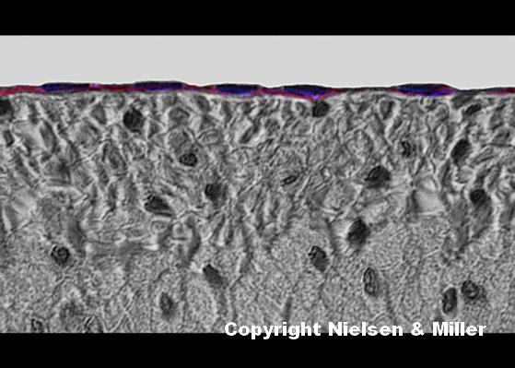

2) Identify the highlighted tissue.
____simple squamous epithelium_ or _Glandular epithelium__

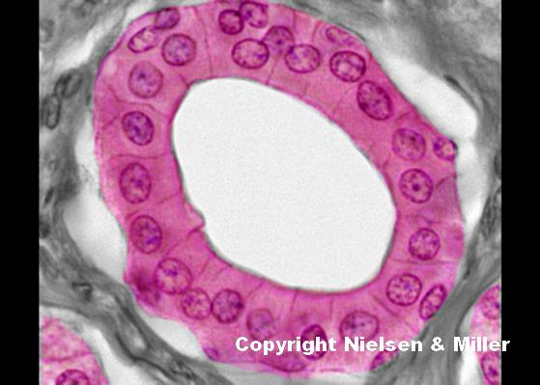

3) Identify the highlighted tissue.
____Simple columnar epithelium__ or _Nonciliated simple columnar epithelium__

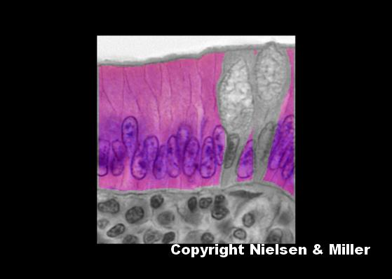

4) Identify the highlighted tissue.
___Stratified squamous epithelium___

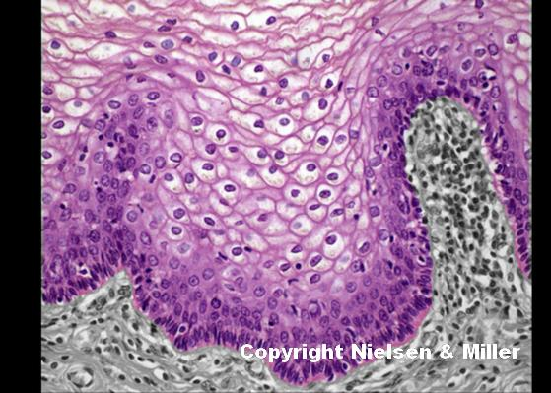

5) Identify the highlighted tissue.
___Transitional epithelium__

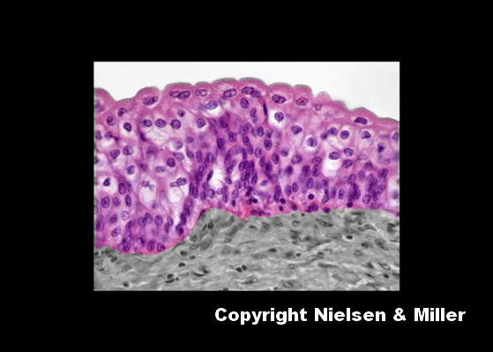

6) Identify the highlighted tissue.
___Pseudostratified columnar epithelium__ or _Pseudostratified ciliated columnar epithelium__

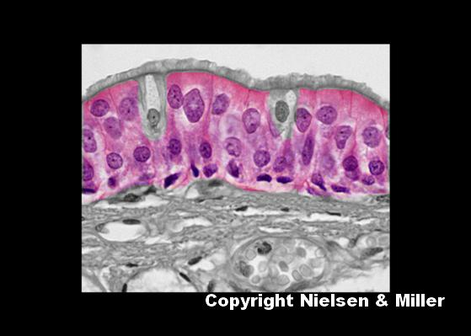

7) Identify the highlighted cells.
__fibroblast cells__

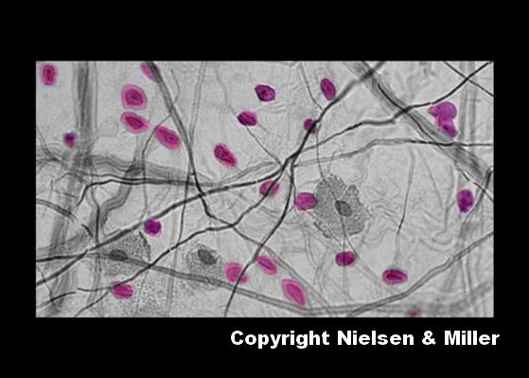

8) Identify the highlighted structures.
___nucleus of fat cells_ or _Nuclei of adipocytes in adipose tissue_

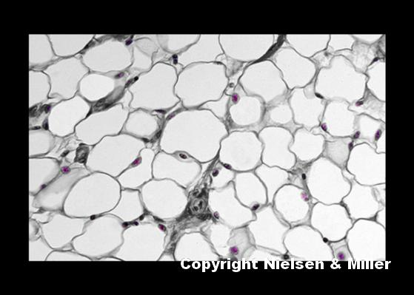

9) Identify the highlighted cells.
__Reticular cells__

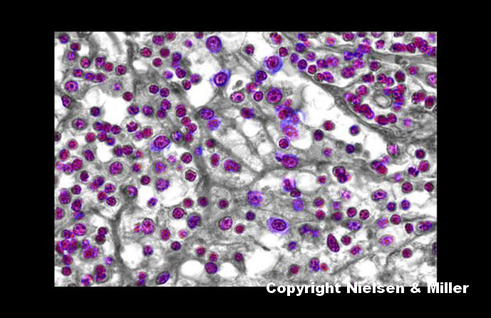

10) Identify the highlighted fibers.
___Collagen fibers___

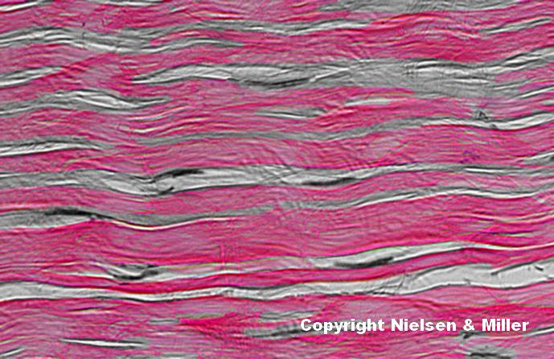

11) Identify the highlighted tissue.
__Dense irregular connective tissue__

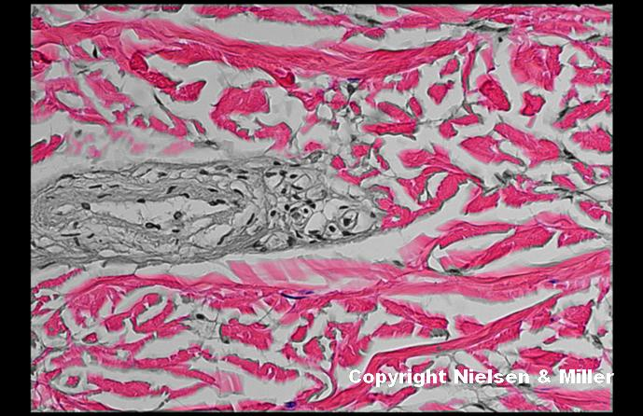

12) Identify the highlighted structures.
__Chondrocyte_ or __Lacuna_ or _Lacunae containing chondrocytes_

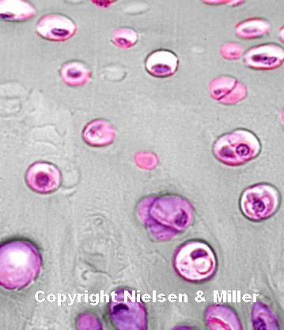

13) Identify the highlighted cells.
___Red blood cells__ or __RBCs____ or __Erythrocytes__

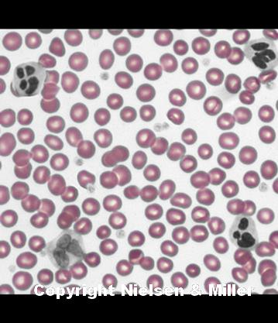

14) Identify the highlighted cells.
__White blood cells__ or __WBCs___ or __Neutrophils__

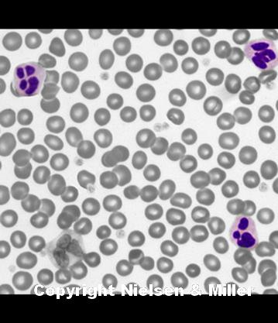

15) Identify the highlighted structure.
__Intercalated disc__

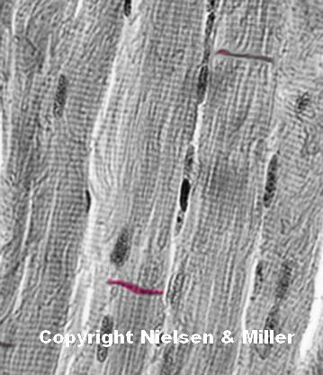

16) Identify the highlighted structures.
___Dendrites___

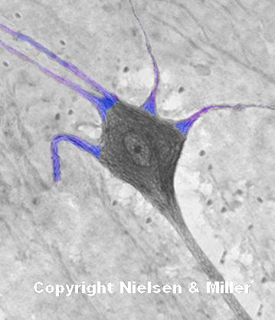

17) Identify the highlighted structure.
___axon__

