1
Cost Accounting: Information for Decision Making
Solutions to Review Questions

Among the goals of an organization, a central one is to create and increase value. Cost accounting systems are designed to provide information to decision makers in the organization with the information they need to accomplish this goal. Therefore, the designers of the cost accounting system need to understand how value is created in the organization in order to design systems for their particular organization.

Financial accounting is designed to provide information about the firm to external users. External users include investors, creditors, government authorities, regulators, customers, competitors, suppliers, labor unions, and so on. Cost accounting systems are designed to provide information to internal users (managers).
This difference is important, because it affects the design of the systems. Financial accounting systems are based on standards or rules. This allows the user to compare the results of different firms. Managerial accounting systems do not require rules. Each firm is free to develop managerial accounting systems that best serve the needs of the decision makers (managers).

B Providing cost information for financial reporting
A Identifying the best store in a chain
C Determining which plant to use for production

The value chain is the set of activities that transforms raw resources into the goods and services end users purchase and consume. The supply chain includes the set of firms and individuals that sells goods and services to the firm. The distribution chain is the set of firms and individuals that buys and distributes goods and services from the firm.

The customers of cost accounting are managers, from plant managers to the CEO.

Value-added activities are activities that customers perceive as adding utility to the goods or services they purchase. Nonvalue-added activities do not add value to the goods or services. By classifying costs this way, the cost accounting system can help the manager identify areas (processes) that can be improved, lowering costs and adding value to the organization.

Answers will vary, but should include some of the following:

Title | Major Responsibilities and Major Duties
Chief financial officer (CFO) | - Manages entire finance and accounting function
Treasurer | - Manages liquid assets  - Conducts business with banks and other financial institutions  - Oversees public issues of stock and debt
Controller | - Plans and designs information and incentive systems
Internal auditor | - Ensures compliance with laws, regulations, and company policies and procedures  - Provides consulting and auditing services within the firm
Cost accountant | - Records, measures, estimates, and analyzes costs  - Works with financial and operational manager to provide relevant information for decisions

No. Sarbanes-Oxley is a law and violations of it are legal issues. Codes of ethics are necessary to help accountants and managers identify situations that might develop into ethical conflicts, understand what they could do in these situations, and to learn what to do when they believe that an ethical violation has occurred.

Solutions to Critical Analysis and Discussion Questions

We would not agree. The role of accountants is to help manage the organization. Part of that role is to report results. Another part is to design systems that assist other managers in making decisions to improve performance. This role requires that accountants understand how value is created in their organizations.

The calculation of cost depends on the decision being made. Therefore, the first question to ask is, “What decision (or decisions) are you trying to make?”

Costs that you could ask to be reimbursed might include the fuel, a share of the maintenance costs, “wear and tear,” or depreciation, and insurance. To avoid disagreements, it would be necessary to negotiate an agreement (even if only informally) between you and your friend considering all factors. For example, you might agree that she should pay for the gas and any other supplies (e.g., oil) needed on the trip.
If you are going along, you might change the agreement so that you split these costs. Alternatively, you might say that because you are going anyway, she can ride along for nothing.

Although it is not the “job” of accounting to determine strategy, accounting provides important information to those who do determine strategy. If the cost accounting system provides inaccurate information, the firm may end up with an unintended strategy, because managers are making decisions based on faulty information.

Executive performance evaluation systems are designed for a specific company’s needs. The systems should be flexible to adapt to the circumstances that exist in that company. A common set of accounting principles would tend to reduce flexibility and usefulness of these systems. As long as all parties know the accounting basis used by the system, the exact rules can be designed in whatever manner the parties deem appropriate.

Although not-for-profit organizations are not seeking to make a profit, they must remain financially viable to accomplish their missions. Cost accounting information can help managers of not-for-profit organizations by highlighting the costs of various activities, identifying sources of revenue, and measuring performance of managers. In terms of organizational survival, cost accounting information can be just as (or more) important for a not-for-profit as for a for-profit firm.

Airlines are characterized by the need to own a substantial amount of capacity costs. Managers at airlines require very sophisticated load management information that predicts the number of passengers flying on a particular route on a particular day. If they set a single price that would cover their costs given a certain number of passengers, they risk flying with empty seats. Once the plane takes off, they cannot sell the seat. Therefore, they need a flexible pricing system. Such a system requires detailed cost information about passengers and aircraft.
The costs are unlikely to be much different among passengers. The variable costs are relatively low (per passenger) and may include food and beverage, some baggage handling cost, some ticket processing costs, and, depending on the plane, a (very) small amount of fuel.

The cost accounting issues for Nabisco are the same as for Carmen’s Cookies in the sense that managers at Nabisco want the same kind of information as Carmen: what are the costs of cookies, who is performing the best, and so on.
The cost accounting issues are different in the size and complexity of the operations at Nabisco compared to Carmen’s Cookies.

In decision-making, managers or supervisors may wish to take actions that they believe will increase the firm’s value that are difficult to justify given available information. Often, these situations arise when managers are using their intuition and their experience to identify new business opportunities and cannot point to data that support their views. For example, a marketing manager might view investment in a new advertising campaign as necessary for remaining competitive even though it appears to increase costs. Because the accountant does not have expertise in this area, she cannot verify the information the marketing manager is using.
In a few cases, however, a marketing manager may wish to pursue a project because of personal reasons (for example, because he was the champion of the product), and hopes to have an economic analysis to justify additional advertising support. In these situations, care must be taken to ascertain the economic merits of the plan, and, if the plan cannot be justified on economic grounds, the manager must make the case for the project on another basis.
The final responsibility for the decision rests with the manager. Therefore, plans that cannot be justified on a cost analysis basis may still be adopted at the discretion of operating management. The controller should be clear that the project is justified on a basis other than (easily measured) costs.
In the control area, the accountant is charged with the responsibility of making certain that plans are executed in an optimal and efficient manner. In some cases this may be viewed as placing restrictions on management actions. Under these circumstances the marketing manager may view the accounting function as placing too great a constraint on him while the accountant may view the marketing manager as attempting to circumvent the rules.

This is a tricky question. The problem is that if each firm tries to minimize its own cost, some of the necessary processes might not be done satisfactorily. For example, if every firm decides not to hold inventory as a way to lower costs, customers might not be able to obtain products in a timely manner and look elsewhere. The goal is to increase value, not minimize costs.

The purpose of bonuses is to provide incentives to managers to “work harder” when the owner (or, for example, the CEO) cannot observe the manager’s efforts. As we will see, all performance incentive systems have the potential for abuse. However, eliminating them also eliminates the benefits of bonus plans. The firm needs to balance the costs of potential abuses with the benefits from better decision-making by managers.

The cost accountant provides information to decision makers in the firm. He or she needs to provide the best information possible, given the costs. As information technology improves, the cost of information falls and the quality of information the cost accountant can provide improves.

Studying cost accounting will most likely increase Carmen’s chances of success with her store. As illustrated in the chapter, she has a better idea of the costs of her business and the financial status of its different operations. Of course, it cannot guarantee success. A successful business depends on many things, including identifying the right products, efficient operations, and good marketing. Cost accounting helps managers make better decisions about these aspects, but cannot forecast trends or overcome bad managerial decision-making.

There are two types of costs the airline or hotel incur with such upgrades. One type of cost results from the incremental resources that are a part of the upgraded service (perhaps a free meal on the airline or the costs of cleaning a larger room). These costs will be shown in the accounting records. In addition to these “direct” costs, there are “opportunity” costs. These costs arise when customers purchase a economy airline fare or smaller room in the hopes of an upgrade. If these customers would have purchased a first-class airfare or a more expensive room, this represents a lost opportunity. These opportunity costs will not be recorded in the accounting records.

Solutions to Exercises
- (10 Min.) Value Chain and Classification of Costs: Apple, Inc.

Cost |  | Stage in the Value Chain
Programmer costs for a new operating system. |  | 4. Research & Development
Costs to ship computers to customers. |  | 6. Distribution
Call center costs for support calls. |  | 3. Customer Service
Salaries for employees working on new product designs. |  | 5. Design
Costs to purchase advertising in university stores. |  | 1. Marketing
Costs of memory chips to make computers. |  | 2. Production
- (5 Min.) Supply Chain and Supply Chain Costs: Coastal Cabinets.
It is important that costs are minimized in the supply chain. Because it is cheaper for Coastal Cabinets to carry the inventory, the resolution should result in Coastal Cabinets carrying the inventory. You might suggest that the two firms share the inventory savings through price discounts or other contractual agreements.
- (10 Min.) Accounting Systems: McDonald’s.
Decision Maker | System
a. Investor* | Financial (F)
b. Marketing manager | Cost (C)
c. Competitor* | Financial (F)
d. Labor organization* | Financial (F)
e. Advertising manager | Cost (C)
*Note that all these decision makers might like information from the cost accounting system, but they would be unlikely to be given access to this information.
- (10 Min.) Accounting Systems: Ford Motor Company.
Answers will vary, but examples include the following.
Manager | Example Decision
a. Plant manager | How to layout the plant.
b. Purchasing manager | Which supplier to use.
c. Quality supervisor | Where to focus quality improvement efforts.
d. Personnel manager | Where to recruit workers
e. Maintenance supervisor | Whether to repair or replace a machine
- (10 min.) Cost Data for Managerial Purposes: Delta Airlines.
a. Differential costs are costs that would change, which are the labor costs in this situation. Other costs would presumably not be affected by the change in labor. Other issues include the quality and dependability of the new approach.
Differential costs next year are $0.60 (= $2.00 – $1.40) calculated as follows:

 |  |  | Labor Cost
 |  | Old Method |  | New Method
Next year |  | $2.00 |  | $1.40 [= (1 – .30) x $2.00]

b. Management would use the information to help decide whether to use the new method. Management would also want to know the effect of quality (lost bags, delays in delivering bags to the baggage claim, etc.).
- (20 Min.) Cost Data for Managerial Purposes: Betty’s Fashions.

Considering the following costs as differential shows that closing the City Division will lower profits for the chain.

Betty’s Fashions, City Division
Divisional Income Statement
Differential Revenues and Costs
For the Year Ending January 31

Sales revenue | $ 8,600,000 | Differentiala
Costs
Advertising | 350,000 | Differentialb
Cost of goods sold | 4,300,000 | Differentiala
Divisional administrative salaries | 580,000 | Differential
Selling costs (sales commissions) | 1,160,000 | Differentiala
Rent | 1,470,000 | Differential
Share of corporate administration | –0– | Not differential
Total costs | $ 7,860,000
Net differential gain before income tax | $ 740,000
Tax expense at 40% rate | 296,000 | Differential
Net differential gain from store | $ 444,000
a These revenues and costs are differential if the sales (and the associated cost of sales) will be lost to the chain. If customers go to other stores in the chain when the City Division is closed, these revenues and costs will not be differential.
b If some of the advertising is “brand” advertising that benefits all stores, some of the advertising costs may not be differential.

- (20 Min.) Cost Data for Managerial Purposes: State University Business School.

Considering the following costs as differential shows that dropping the BBA degree will lower profits for the school.

State University Business School
Degree Income Statement
Differential Revenues and Costs
For the Academic Year Ending June 30

Revenue | $ 6,000,000 | Differentiala
Costs
Advertising – BBA program | 225,000 | Differentialb
Faculty salaries | 3,060,000 | Differentiala
Degree operating costs | 390,000 | Differentiala
Building maintenance | 555,000 | Differentiala
Classroom costs | 1,275,000 | Differentiala
Allocated school administration costs | –0– | Not differential
Total costs | $ 5,505,000
Net differential gain from BBA program | $ 495,000
a These revenues and costs are differential to the school, but might not be to the university if students will transfer to other programs and if the faculty and buildings will continue to be maintained by the university.
b If some of the advertising is “brand” advertising that benefits all programs, some of the advertising costs may not be differential.

- (20 Min.) Cost Data for Managerial Purposes: State University Business School.

a. The following differential analysis shows that the combined contribution of the BBA program will be positive.

State University Business School
Degree Income Statement
Differential Revenues and Costs, BBA Programs
For the Academic Year Ending June 30

Revenue | $ 6,000,000 x 2 | $12,000,000
Costs
Advertising – BBA program | 225,000 + (225,000 x 3) | 900,000
Faculty salaries | 3,060,000 x 2 | 6,120,000
Degree operating costs | 390,000 x 1.5 | 585,000
Building maintenance | unchanged | 555,000
Classroom costs | unchanged | 1,275,000
Classroom rental | given | 300,000
Differential school administration costs | given | 30,000
Total costs |  | $9,765,000
Net gain from BBA programs |  | $ 2,235,000

b. The Dean should consider whether there are sufficient applicants with necessary qualifications. Similarly, the Dean should ensure that there is sufficient faculty to expand the program to this extent.
- (20 Min.) Cost Data for Managerial Purposes––Budgeting

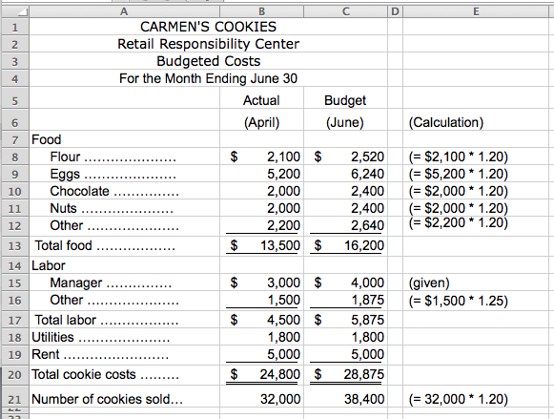
- Trends in Cost Accounting
Answers will vary.
- Activity-based costing might be used in the Design component to help designers identify designs that will lead to less costly production requirements.
- Benchmarking might be used in Purchasing to ensure the firm is not paying too much for inputs.
- Cost of quality might be used in Customer Service to monitor the costs associated with producing defective units.
- Customer relationship management might be used in Marketing to identify profitable customers.
- Lean accounting might be used in production to help identify and avoid waste.

- Trends in Cost Accounting
Title |  | Responsibility
5 CFO |  | Signs off on financial statements.
3 Treasurer |  | Determines where to invest cash balances.
4 Controller |  | Maintains accounting records.
1 Internal auditor |  | Ensures procurement rules are followed.
2 Cost accountant |  | Evaluates costs of products.
- (15 Min.) Ethics and Channel Stuffing: Continental Condiments.
a. As a management accountant, Maria has a responsibility to perform her professional duties with competence in accordance with relevant laws and regulations. Channel stuffing borders on illegal activity, especially if it is done to defraud investors by presenting results that are not achieved. As a professional, she must communicate both favorable and unfavorable information in an objective and fair manner. Thus, she cannot simply ignore the fact that the managers are engaging in this behavior.
b. Maria should first follow Continental’s established policy on the resolution of ethical conflict (assuming there is one!). If there isn’t an established policy Maria should confront the next higher level of management that she believes is not involved in the marketing scheme. This could be the Controller or the CFO. If the matter remains unresolved she should take the issue to the Audit Committee and the Board of Directors. Perhaps Maria should seek a confidential discussion with an objective advisor, such as her personal attorney. When all levels of internal review have been exhausted without satisfactory results, Maria should resign and submit an informative memorandum to the chairman of the Board of Directors.

- (15 Min.) Ethics and Cost Analysis: State University Business School.
a. As a management accountant, Jon has a responsibility to perform his professional duties with competence in accordance with relevant laws and regulations. Choosing a location in which the decision maker has a financial interest when a lower cost equivalent location is unethical and may be illegal. As a professional, he must communicate both favorable and unfavorable information in an objective and fair manner. Thus, he cannot simply ignore the fact that the dean is engaging in this behavior.
b. Jon should first follow the School’s (or University’s) established policy on the resolution of ethical conflict (assuming there is one!). If there isn’t an established policy Jon should confront the next higher level of management (the University CFO for example) that he believes is not involved in the decision. If the matter remains unresolved he should take the issue to the oversight board for the University (Regents or Trustees, for example).
Solutions to Problems
- (15 Min.) Responsibility for Ethical Action: Giant Engineering.
a. As a management accountant Dewi has a responsibility to perform her professional duties with competence in accordance with relevant laws and regulations. Clearly, overbilling the federal government is a violation of the law. As such, Dewi might have both a legal and ethical responsibility to take some action. As a professional, she must communicate both favorable and unfavorable information in an objective and fair manner. Thus, she cannot simply ignore the fact that Giant is involved in illegal contracting activities.
b. The first possible course of action is to discuss the situation with the controller. This is an appropriate approach to the problem. Always take a problem to your immediate supervisor first. If the controller indicates that he or she is aware of the situation and that you should not worry about it, then take the matter up with your controller’s superior. Move up the layers of management until someone is concerned and will deal with the problem. She should also consult her personal attorney to learn her legal rights and responsibilities in this situation.
As for the second course of action, the proper authorities should be notified by someone in the company. The local newspaper, however, is not the proper authority. Dewi should discuss the matter with the Board of Directors only after exhausting possibilities of discussing the matter with internal management.
- (20 Min.) Cost Data for Managerial Purposes: Imperial Devices.

This problem demonstrates the ambiguity of cost-based contracting and, indeed, the measurement of “cost.” This problem can stimulate a lively discussion in class.
Recommended prices may range from the $324 suggested by the state government to the $522 charged by Imperial Devices. The key is to negotiate the cost-based price prior to the signing of the contract. Considerations that affect the base costs are reflected in the following options:
Options:
A. Only the differential production costs could be considered as the cost basis.
B. The total cost per device for normal production of 60,000 devices could be used as the cost basis.
C. The total cost per device for production of 66,000 devices, excluding marketing costs, could be used as the cost basis.
D. The total cost per device for production of 66,000 devices, including marketing costs, could be used as the cost basis.
 |  | Costs |  |  |  |  |  |  |  | Unit Cost Options  (One Unit = One Device)
 |  |  |  |  |  |  |  |  | A |  |  |  |  | B |  |  |  | C |  |  |  | D
Materials (variable) |  |  | $75.00 |  |  |  |  | $75.00 |  |  |  |  | $75.00 |  |  |  | $75.00 |  |  |  | $75.00
Labor (variable) |  |  | 150.00 |  |  |  |  | 150.00 |  |  |  |  | 150.00 |  |  |  | 150.00 |  |  |  | 150.00
Supplies (variable) |  |  | 45.00 |  |  |  |  | 45.00 |  |  |  |  | 45.00 |  |  |  | 45.00 |  |  |  | 45.00
Indirect costs (fixed) |  |  | 2,700,000 |  |  |  |  | N/A |  |  |  |  | 45.00 |  | a |  | 40.91 |  | b |  | 40.91
Marketing (variable) |  |  | 30.00 |  |  |  |  | N/A |  |  |  |  | 30.00 |  |  |  | N/A |  |  |  | 30.00
Administrative (fixed) |  |  | 5,400,000 |  |  |  |  | N/A |  |  |  |  | 90.00 |  | c |  | 81.82 |  | d |  | 81.82
Per device cost basis |  |  |  |  |  |  |  | $270.00 |  |  |  |  | $435.00 |  |  |  | $392.73 |  |  |  | $422.73
Per device price  (Cost + 20%) |  |  |  |  |  |  |  | $324.00 |  |  |  |  | $522.00 |  |  |  | $471.28 |  |  |  | $507.28

a $45.00 = $2,700,000 ÷ 60,000 units.
b $40.91 = $2,700,000 ÷ 66,000 units.
c $90.00 = $5,400,000 ÷ 60,000 units.
d $81.82 = $5,400,000 ÷ 66,000 units.
We believe the most justifiable options exclude marketing costs and reflect the potential production level of 66,000 devices. These are Options A and C. (As stockholders in Imperial Devices, we would prefer Option C.) Also, depending on the resolution of the term “cost,” we may want to consider whether the 20 percent markup in the next contract is sufficient.
- (20 Min.) Cost Data for Managerial Purposes: Marco and Jenna.
a. Answers will vary. The $0.13 that Marco proposes would be the incremental costs of the trip. The $0.56 rate used by the IRS includes depreciation on the car, some of which is likely to occur regardless of the miles driven.
b. If Jenna was not going to take the trip, then some of the “wear and tear” costs, for example for tires, would be avoided. Therefore, it would make sense to include these costs in the sharing. (Measuring these costs is more difficult.) However, as noted above, some of the costs in the IRS rate will be incurred regardless of the miles driven.

- (20 Min.) Cost Data for Managerial Purposes: T-Comm.
This problem demonstrates the ambiguity in measuring “costs.”
South Division’s controller included the “per unit” fixed costs, which were calculated for allocation purposes under normal production volume, when he or she calculated the per unit cost of the additional production. The controller charged North Division on that basis, ignoring the differential costs as a basis for interdivision sales.
Possible options available are as follows:
A. Use the full per unit cost for normal production of 2,400 units.
B. Use only differential costs as the cost basis.
C. Use differential costs plus a share of fixed costs, based on actual production volume (with North’s order) of 3,000 units.

 | Costs |  |  |  |  | Unit Cost Options:
 |  |  |  |  |  |  | A |  |  |  | B |  |  | C
Direct materials (variable) |  | $ 200 a |  |  | $ 200 |  |  |  |  | $ 200 |  |  | $ 200
Direct Labor (variable) |  | 96 b |  |  | 96 |  |  |  |  | 96 |  |  | 96
Other variable costs |  | 64 c |  |  | 64 |  |  |  |  | 64 |  |  | 64
Fixed costs |  | 2,016,000 |  |  | 840 |  |  | d |  | N/A |  |  | 672 |  | e
Per unit cost |  |  |  |  | $ 1,200 |  |  |  |  | $ 360 |  |  | $ 1,032
Cost plus 15% |  |  |  |  | 1,380 |  |  |  |  | 414 |  |  | 1,186.80
Total price (600 units) |  |  |  |  | $828,000 |  |  |  |  | $248,400 |  |  | $712,080
a $200 = $480,000 ÷ 2,400 units.
b $96 = $230,400 ÷ 2,400 units.
c $64 = $153,600 ÷ 2,400 units.
d $840 = $2,016,000 ÷ 2,400 units.
e $672 = $2,016,000 ÷ 3,000 units.

If fixed costs are not differential and South has no alternative uses of the excess capacity (between 3,000 units available capacity and 2,400 units used), then Option B is the most defensible. Options A and C overstate the differential cost of production which could inappropriately affect North Division’s decisions about buying internally or externally, or about pricing its product, among other decisions. (If option B is used and managers forget that there are fixed costs of production, then it is also possible that North Division’s pricing decision could be affected inappropriately.)

- (20 Min.) Cost Data for Managerial Purposes: Campus Package Delivery.
a.
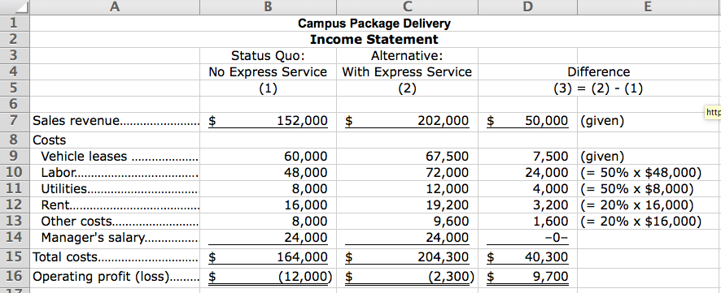

b. The decision to expand and offer the express service results in differential profits of $9,700, so it is profitable to expand. Note that only differential costs and revenues figured in the decision. The manager’s salary did not change, so it did not affect the decision.
c. Managers need to consider whether the new service will have an affect on their current business (perhaps reducing demand).

- (20 Min.) Cost Data for Managerial Purposes: KC Services.
a.
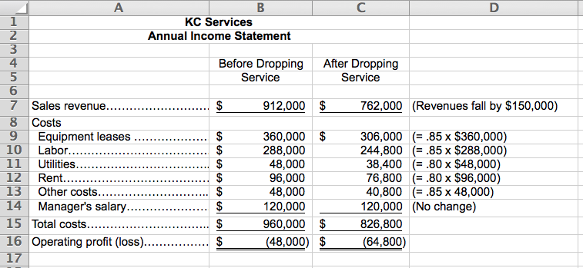

b. The decision to drop the lawn service results in a differential loss of $16,800 [= ($48,000) – ($64,800)], so it is not profitable to drop that service. Note that only differential costs and revenues figured in the decision. The manager’s salary did not change, so it did not affect the decision.
c. The manager should consider whether there are other, more profitable uses that the resources could be used for instead of lawn services.

- (20 Min.) Cost Data for Managerial Purposes: B-You
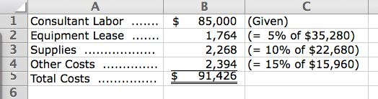
- The following differential costs would be incurred:

b. Since acceptance of the contract would result in a decrease of operating profits by $1,426 (=$90,000 paid according to the contract – $91,426 in differential costs), it would seem that the contract should be rejected. Of course, as a practical matter the amount is so small that differential profit probably would not be the deciding factor. Errors in estimation alone could change the decision easily.
c. Other factors would include (1) whether this will enable the company to get into a new, profitable line of business; (2) what other opportunities the company has for expanding; and (3) whether the contract will provide for more revenues in the future. In short, the company must consider the long run as well as the first year’s results.
- (20 Min.) Cost Data for Managerial Purposes: Tom’s Tax Services.
a. The following differential costs would be incurred:

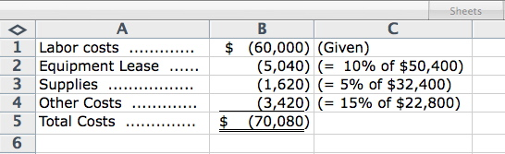

b. Since the addition of the customer would result in an increase of operating profits by $4,920 (=$75,000 in revenues from the store – $70,080 differential costs), Tom could offer to lower the fees by this amount and not lose money on the client.
c. Other factors would include (1) whether this will lead to demands by other clients for lower fees; (2) what other opportunities the company has for its tax professionals; and (3) whether the business is likely to expand in the future. In short, Tom must consider the long run as well as the first year’s results.
- (20 Min.) Cost Data for Managerial Purposes––Budgeting
a.
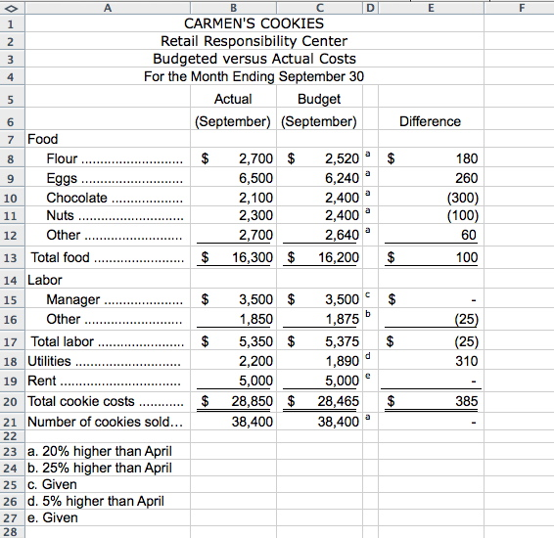
b. The three items that we would investigate would be (a) utilities; (b) chocolate; and, (c) eggs. These three have the largest difference between what we actually incurred and the budget. Even though we incurred less cost for the chocolate than expected, we would still investigate this to understand why. For example, if we are using a lower quality chocolate or less chocolate in the cookies than budgeted, this might eventually affect sales adversely.

- (20 Min.) Cost Data for Managerial Purposes––Budgeting
a.
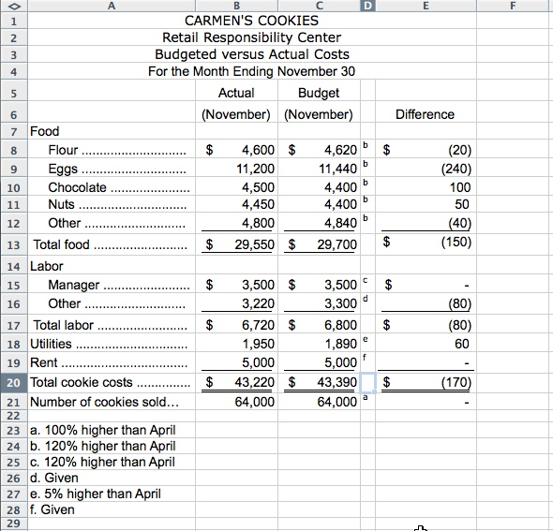

b. The three items that we would investigate would be (a) eggs; (b) chocolate; and, (c) other labor. These three have the largest difference between what we actually incurred and the budget. Even though we incurred less cost for the eggs than expected, we would still investigate this to understand why. For example, if we are using fewer eggs in the cookies than budgeted, this might affect their quality and, as a result, future sales adversely.

- (20 Min.) Cost Data for Managerial Purposes––Finding Unknowns:Quince Products.

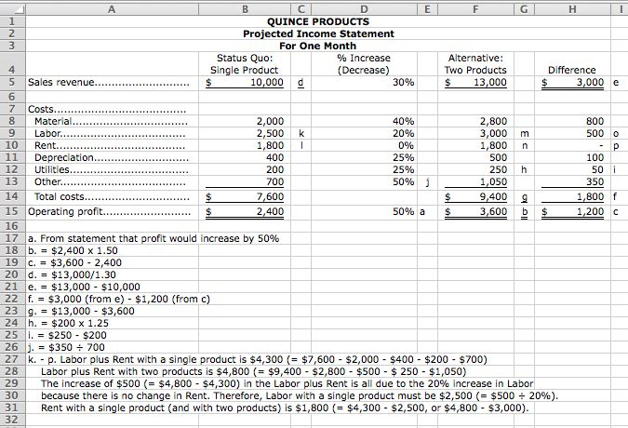

Solutions to Integrative Cases
- (20 Min.) Identifying Unethical Action – Appendix
a. We recommend that Accountant B be retained to help Quince Products with their expansion plans. Accountant B has experience with small companies and growth. Although Accountant A has experience in the local area, the experience is with not-for-profit firms and, therefore, might not be particularly applicable. We would not retain Accountant C because he or she is willing to share information from another company’s experience. Therefore, he or she might be willing to divulge our information to another competitor.
b. Accountant C is violating the IMA’s code of ethics, specifically the portion of the code dealing with confidentiality. Accountant C could use general knowledge of expansion plans gained as part of his or her work, but, unless legally obligated to, cannot offer to share another company’s experience.

- (20 Min.) Cost Data for Managerial Purposes––Finding Unknowns

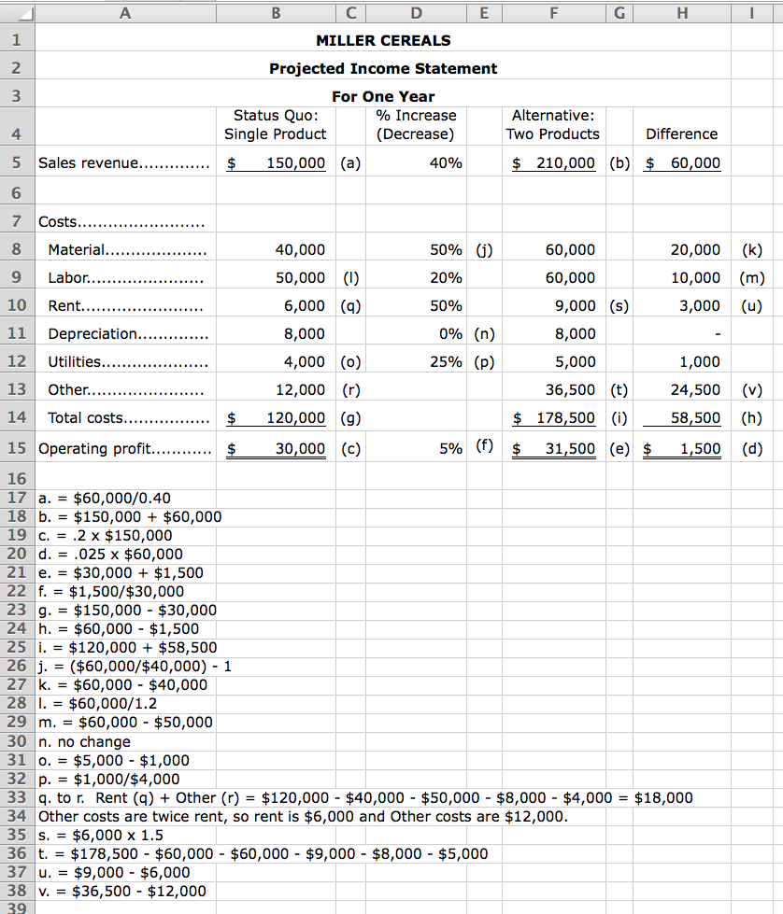

- (20 Min.) Identifying Unethical Actions (Appendix)
Yes. This action would violate both the Integrity and Credibility Principles.

- (20 Min.) Responsibility for Unethical Action
a. We can understand, but not justify, what Charles did. He was under considerable pressure in both his professional and personal life and he probably felt that he had no choice. The problem is that his behavior was unethical and illegal.
b. People in this situation should contact a personal attorney (not the company attorney) for advice. The next step would normally be to contact the most trustworthy member of the board of directors. If the board failed to take action, Charles could have used the IMA confidential call-in number or contacted the Securities and Exchange Commission.
Charles told us that he should have developed a sufficient financial reserve so he could have quit when his boss told him to manipulate the numbers. Also, he should have contacted the former CFO during the first few months after he took the CFO job.
c. Answers will vary. Here is what actually happened. The Securities and Exchange Commission and the U.S. Department of Justice investigated this fraud. Both Charles and his boss were brought up on criminal and civil charges. Both did jail time. Charles has had difficulty getting a good job. He says that prospective employers shy away from hiring him because he has to answer “yes” to the question on employment forms: “Have you ever been convicted of a felony?”

